**Week 6(React)**

**Exercise : 1. ReactJS-HOL**

**//App.js**

import React from 'react';

function App() {

  return (

    <div>

      <h1>Welcome to the first session of React</h1>

    </div>

  );

}

export default App;

**Output:**

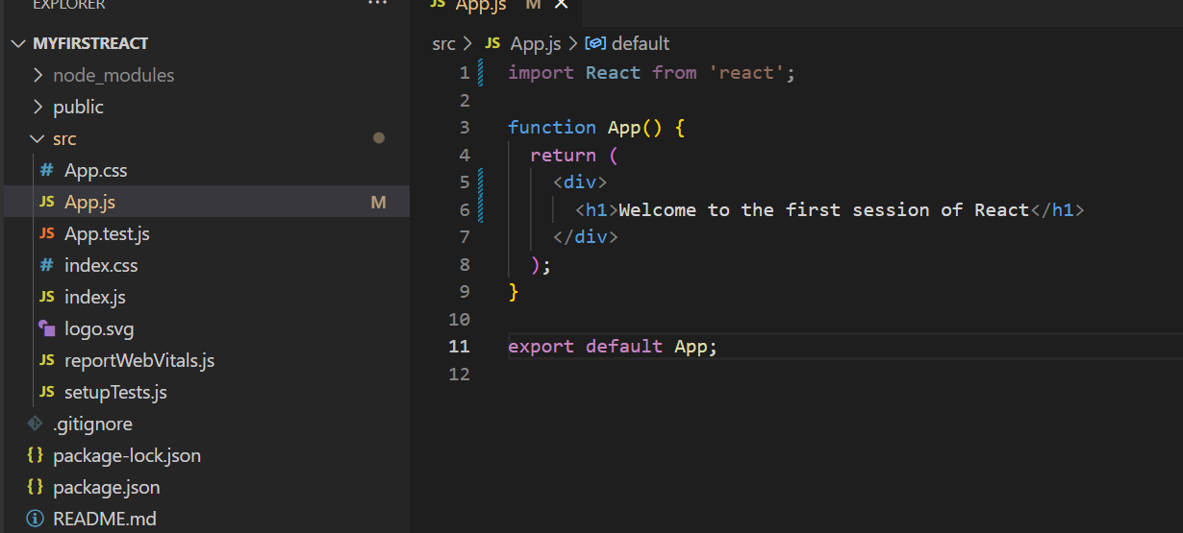

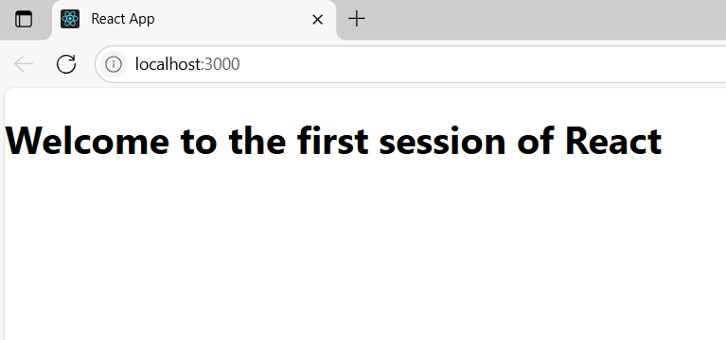

**Exercise : 2. ReactJS-HOL**

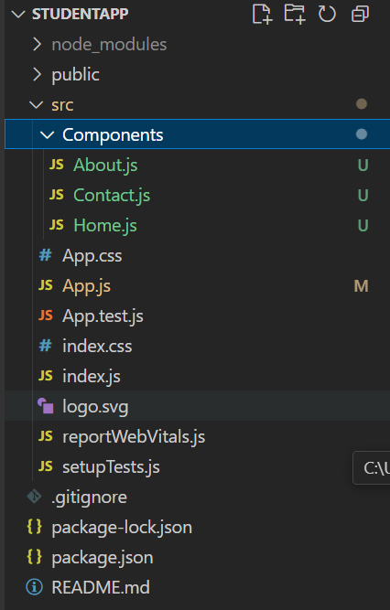

**//App.js**

import React from 'react';

import Home from './Components/Home';

import About from './Components/About';

import Contact from './Components/Contact';

function App() {

  return (

    <div>

      <Home />

      <About />

      <Contact />

    </div>

  );

}

export default App;

**//studentapp/src/Components**

**//Home.js**

import React, { Component } from 'react';

class Home extends Component {

render() {

return (

<div>

<h1>Welcome to the Home page of Student Management Portal</h1>

</div>

);

}

}

export default Home;

**//About.js**

import React, { Component } from 'react';

class About extends Component {

render() {

return (

<div>

<h1>Welcome to the About page of the Student Management Portal</h1>

</div>

);

}

}

export default About;

**//Contact.js**

import React, { Component } from 'react';

class Contact extends Component {

render() {

return (

<div>

<h1>Welcome to the Contact page of the Student Management Portal</h1>

</div>

);

}

}

export default Contact;

**Output:**

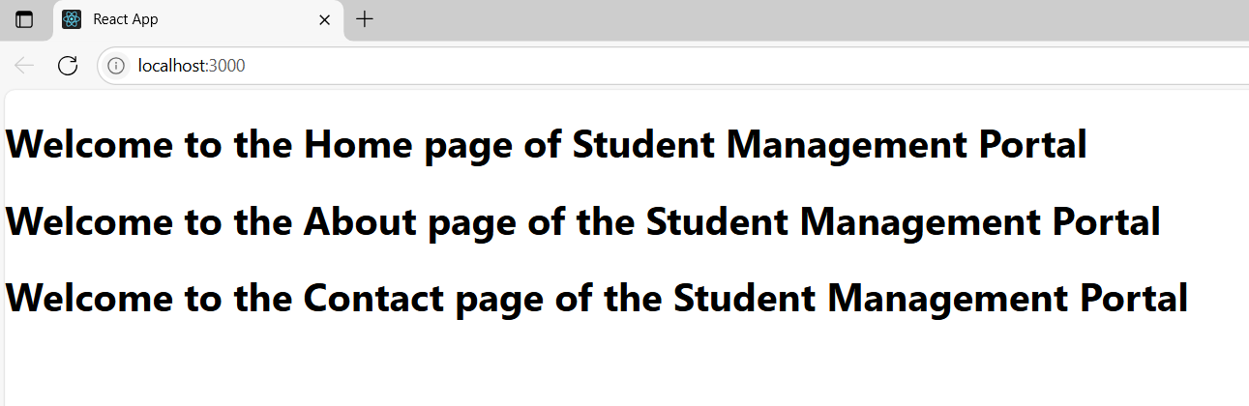

**Exercise :** **3. ReactJS-HOL**

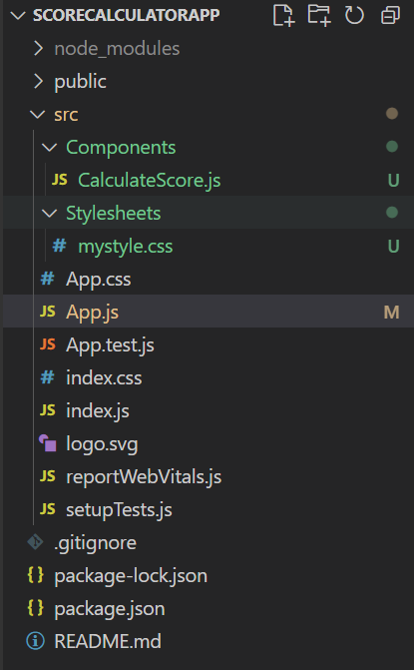

**src/Components/CalculateScore.js**

import React from 'react';

import '../Stylesheets/mystyle.css';

function CalculateScore() {

const name = "Ayush Raj";

const school = "ABC Public School";

const total = 480;

const goal = 500;

const average = (total / goal) * 100;

return (

<div className="score-container">

<h2>Student Score Details</h2>

<p><strong>Name:</strong> {name}</p>

<p><strong>School:</strong> {school}</p>

<p><strong>Total Score:</strong> {total}</p>

<p><strong>Goal Score:</strong> {goal}</p>

<p><strong>Average Percentage:</strong> {average.toFixed(2)}%</p>

</div>

);

}

export default CalculateScore;

**src/Stylesheets/mystyle.css**

.score-container {

margin: 30px;

padding: 20px;

border: 2px solid #007bff;

border-radius: 10px;

background-color: #f0f8ff;

font-family: Arial, sans-serif;

}

.score-container h2 {

color: #007bff;

text-align: center;

}

**//App.js**

import React from 'react';

import CalculateScore from './Components/CalculateScore';

function App() {

return (

<div className="App">

<CalculateScore />

</div>

);

}

export default App;

**Output:**

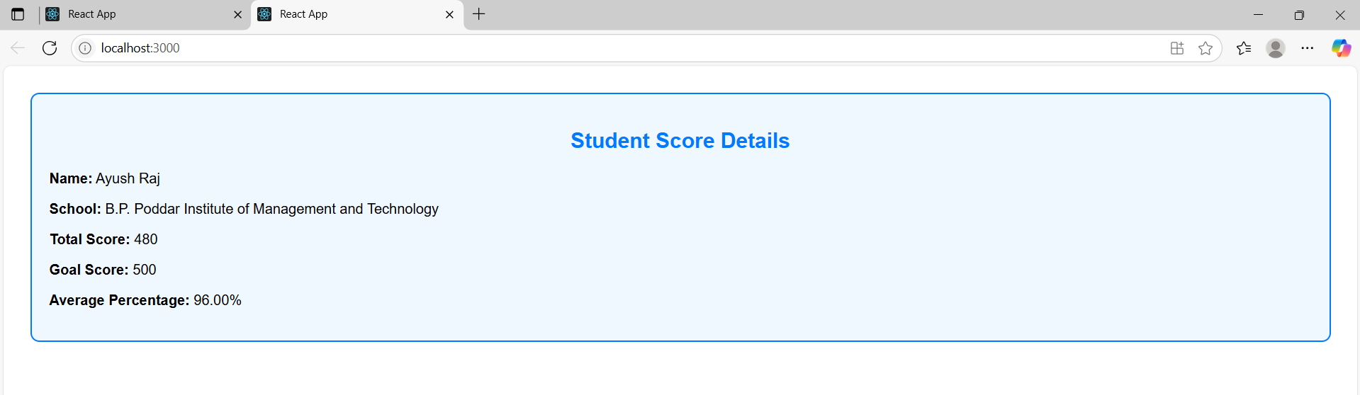

**Exercise:** **4. ReactJS-HOL**

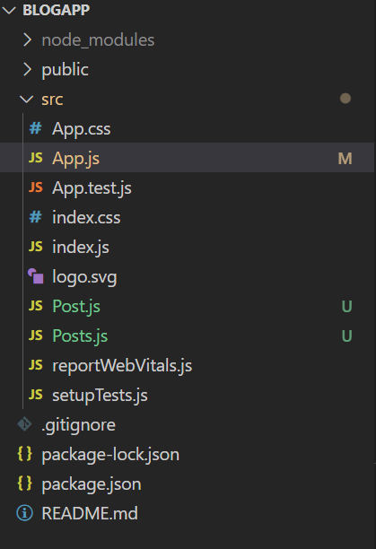

**src/Post.js**

import React from 'react';

class Post extends React.Component {

render() {

return (

<div style={{border: '1px solid gray', padding: '10px', margin: '10px 0'}}>

<h3>{this.props.title}</h3>

<p>{this.props.body}</p>

</div>

);

}

}

export default Post;  
  
**src/Posts.js**

import React from 'react';

import Post from './Post';

class Posts extends React.Component {

constructor(props) {

super(props);

this.state = {

posts: [],

error: null

};

}

loadPosts = () => {

fetch('https://jsonplaceholder.typicode.com/posts')

.then((response) => {

if (!response.ok) {

throw new Error('Failed to fetch posts');

}

return response.json();

})

.then((data) => {

this.setState({ posts: data.slice(0, 10) }); // Display only first 10 posts

})

.catch((error) => {

this.setState({ error });

});

}

componentDidMount() {

this.loadPosts();

}

componentDidCatch(error, info) {

alert("An error occurred: " + error.message);

}

render() {

const { posts, error } = this.state;

if (error) {

return <h2>Error loading posts.</h2>;

}

return (

<div>

<h2>Posts from Blog</h2>

{posts.map(post => (

<Post key={post.id} title={post.title} body={post.body} />

))}

</div>

);

}

}

export default Posts;

**src/App.js**

import React from 'react';

import Posts from './Posts';

function App() {

return (

<div className="App">

<h1>Welcome to BlogApp</h1>

<Posts />

</div>

);

}

export default App;

**Output:**

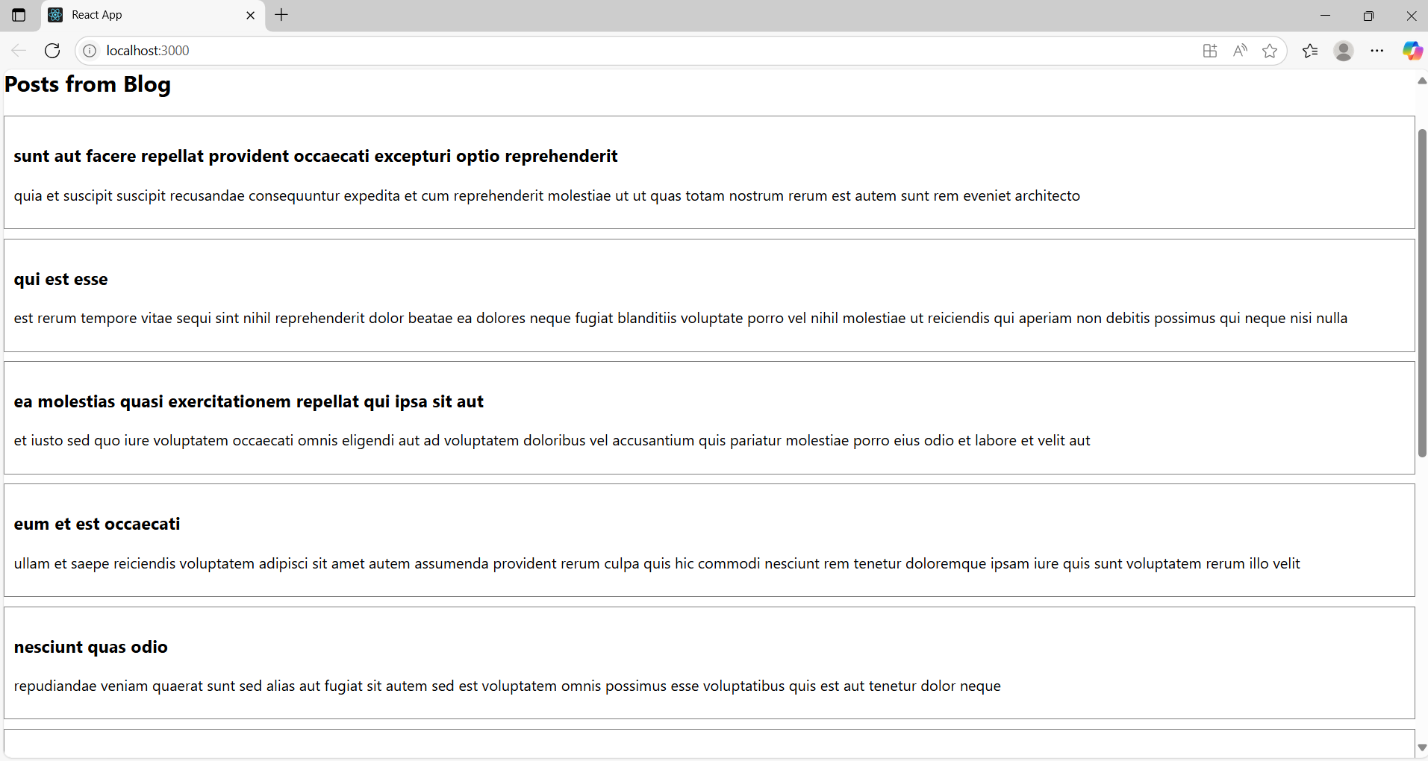

**Exercise: 5. ReactJS-HOL**

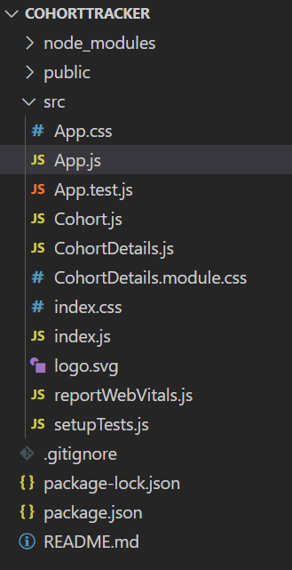

**src/CohortDetails.module.css**

.box {

width: 300px;

display: inline-block;

margin: 10px;

padding: 10px 20px;

border: 1px solid black;

border-radius: 10px;

}

dt {

font-weight: 500;

}

**src/CohortDetails.js:**

import React from 'react';

import styles from './CohortDetails.module.css';

function CohortDetails({ cohort }) {

const titleStyle = {

color: cohort.status === 'ongoing' ? 'green' : 'blue'

};

return (

<div className={styles.box}>

<h3 style={titleStyle}>{cohort.name}</h3>

<dl>

<dt>Status:</dt>

<dd>{cohort.status}</dd>

<dt>Start Date:</dt>

<dd>{cohort.startDate}</dd>

<dt>End Date:</dt>

<dd>{cohort.endDate}</dd>

</dl>

</div>

);

}

export default CohortDetails;

**src/App.js:**

import React from 'react';

import CohortDetails from './CohortDetails';

function App() {

const cohorts = [

{

name: 'React Bootcamp',

status: 'ongoing',

startDate: '2024-06-01',

endDate: '2024-08-01'

},

{

name: 'Spring Boot Fundamentals',

status: 'completed',

startDate: '2024-04-01',

endDate: '2024-06-01'

}

];

return (

<div>

<h2>My Academy Cohorts</h2>

{cohorts.map((cohort, index) => (

<CohortDetails key={index} cohort={cohort} />

))}

</div>

);

}

export default App;

**Output:**

