**Week 7(React)**

**Exercise : 9. ReactJS-HOL**

**//App.js**

import React from 'react';

import ListofPlayers from './components/ListofPlayers';

import IndianPlayers from './components/IndianPlayers';

function App() {

  const flag = true; // change this to false to test IndianPlayers

  return (

    <div className="App">

      <h1>Cricket App</h1>

      {flag ? <ListofPlayers /> : <IndianPlayers />}

    </div>

  );

}

export default App;

**//** **IndianPlayers.js**

import React from 'react';

const IndianPlayers = () => {

  const players = ["Rohit", "Virat", "Gill", "Rahul", "Hardik", "Jadeja"];

  // Destructuring to get odd and even index players

  const oddPlayers = players.filter((_, index) => index % 2 !== 0);

  const evenPlayers = players.filter((_, index) => index % 2 === 0);

  const T20Players = ["Rohit", "Surya", "Gill"];

  const RanjiPlayers = ["Jaiswal", "Sarfaraz", "Iyer"];

  const allPlayers = [...T20Players, ...RanjiPlayers]; // Merge feature of ES6

  return (

    <div>

      <h2>Odd Index Players:</h2>

      {oddPlayers.map((p, i) => <p key={i}>{p}</p>)}

      <h2>Even Index Players:</h2>

      {evenPlayers.map((p, i) => <p key={i}>{p}</p>)}

      <h2>Merged T20 + Ranji Players:</h2>

      {allPlayers.map((p, i) => <p key={i}>{p}</p>)}

    </div>

  );

};

export default IndianPlayers;

**//ListofPlayers.js**

import React from 'react';

const ListofPlayers = () => {

const players = [

{ name: "Rohit", score: 89 },

{ name: "Virat", score: 95 },

{ name: "Gill", score: 68 },

{ name: "Rahul", score: 73 },

{ name: "Hardik", score: 65 },

{ name: "Jadeja", score: 71 },

{ name: "Shami", score: 45 },

{ name: "Bumrah", score: 60 },

{ name: "Kuldeep", score: 78 },

{ name: "Surya", score: 99 },

{ name: "Iyer", score: 50 }

];

const filteredPlayers = players.filter(player => player.score >= 70);

return (

<div>

<h2>All Players:</h2>

{players.map((player, index) => (

<p key={index}>{player.name} - {player.score}</p>

))}

<h2>Players with score &#8805; 70:</h2>

{filteredPlayers.map((player, index) => (

<p key={index}>{player.name} - {player.score}</p>

))}

</div>

);

};

export default ListofPlayers;

**//Output:**

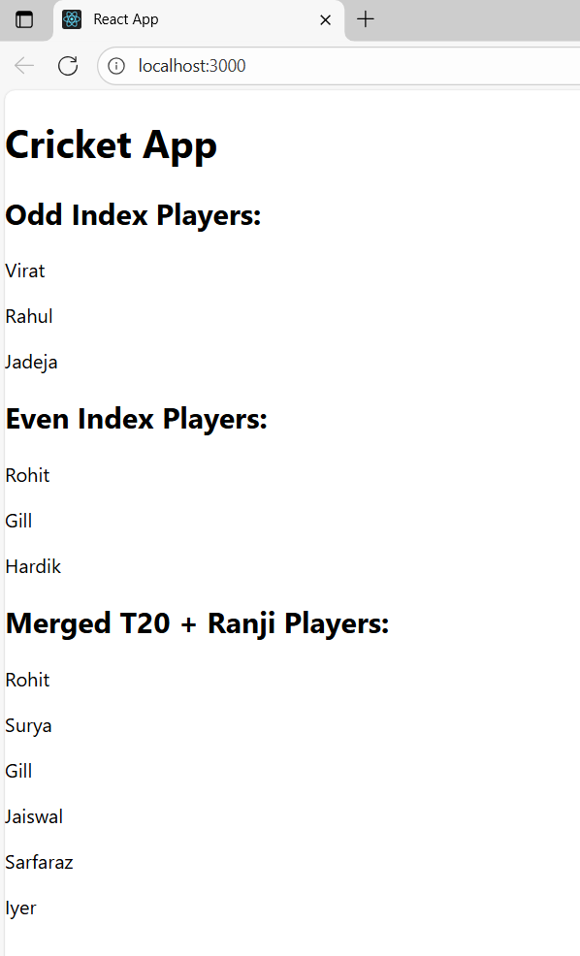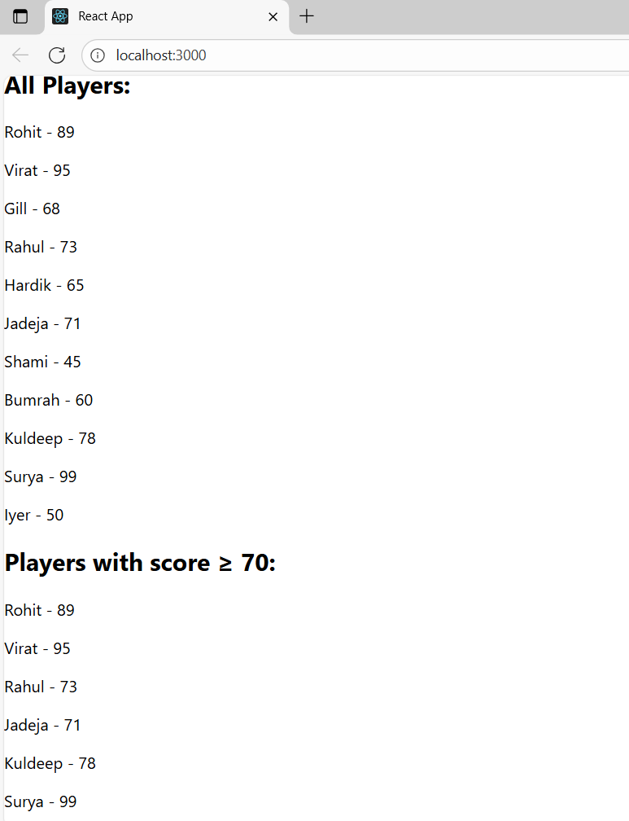

**Exercise : 10. ReactJS-HOL**

**//App.js**

import React from 'react';

// React.createElement example (not commonly used directly in JSX apps)

const headingElement = React.createElement("h1", { className: "main-heading" }, "Office Space Rental App");

// Object representing one office

const office1 = {

name: "Tech Park Office",

rent: 75000,

address: "123, MG Road, Bangalore"

};

// Array of office objects

const officeList = [

{ name: "Cozy Cabin", rent: 55000, address: "Koramangala, Bangalore" },

{ name: "Startup Suite", rent: 65000, address: "Indiranagar, Bangalore" },

{ name: "Luxury Work Den", rent: 95000, address: "HSR Layout, Bangalore" }

];

function App() {

return (

<div className="App">

{/* Rendering the headingElement */}

{headingElement}

{/* Display image with JSX attribute */}

<img

src="https://images.unsplash.com/photo-1580587771525-78b9dba3b914"

alt="Office Space"

width="400"

style={{ borderRadius: "10px", margin: "20px 0" }}

/>

{/* Single object render */}

<h2>Featured Office:</h2>

<p><strong>Name:</strong> {office1.name}</p>

<p><strong>Rent:</strong>

<span style={{ color: office1.rent < 60000 ? "red" : "green" }}>

₹{office1.rent}

</span>

</p>

<p><strong>Address:</strong> {office1.address}</p>

{/* Loop through list of offices */}

<h2>Available Offices:</h2>

{officeList.map((office, index) => (

<div key={index} style={{ border: "1px solid #ccc", padding: "10px", marginBottom: "10px" }}>

<p><strong>Name:</strong> {office.name}</p>

<p><strong>Rent:</strong>

<span style={{ color: office.rent < 60000 ? "red" : "green" }}>

₹{office.rent}

</span>

</p>

<p><strong>Address:</strong> {office.address}</p>

</div>

))}

</div>

);

}

export default App;

**//Output:**

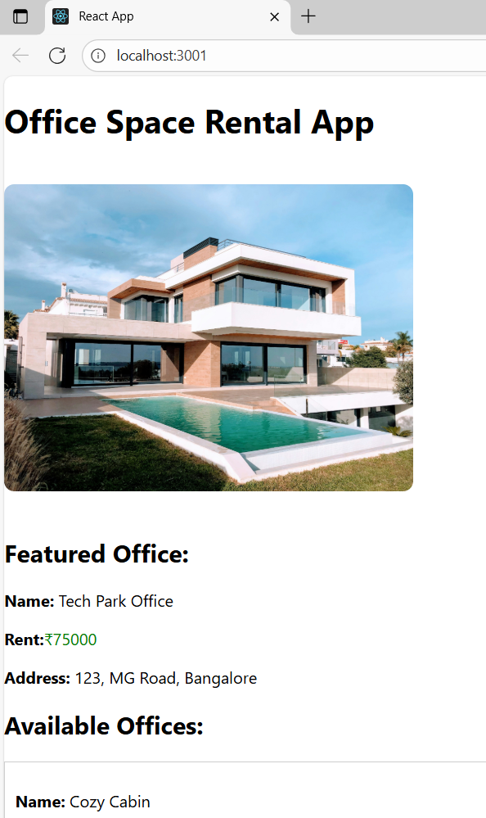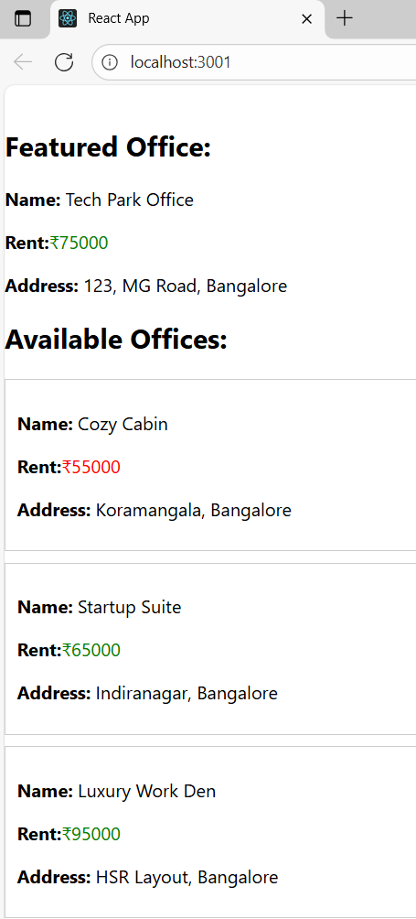

**Exercise :** **11. ReactJS-HOL**

**//App.js**

import React from 'react';

import Counter from './Counter';

import CurrencyConvertor from './CurrencyConvertor';

function App() {

  return (

    <div className="App" style={{ padding: "30px" }}>

      <h1>Event Examples App</h1>

      <Counter />

      <CurrencyConvertor />

    </div>

  );

}

export default App;

**//Counter.js**

import React, { Component } from 'react';

class Counter extends Component {

  constructor(props) {

    super(props);

    this.state = {

      count: 0

    };

    // Binding for `this`

    this.increment = this.increment.bind(this);

    this.sayHello = this.sayHello.bind(this);

    this.handleIncrement = this.handleIncrement.bind(this);

    this.sayWelcome = this.sayWelcome.bind(this);

    this.onPress = this.onPress.bind(this);

  }

  increment() {

    this.setState({ count: this.state.count + 1 });

  }

  decrement = () => {

    this.setState({ count: this.state.count - 1 });

  }

  sayHello() {

    console.log("Hello! This is a static message.");

  }

  handleIncrement() {

    this.increment();

    this.sayHello();

  }

  sayWelcome(message) {

    alert(message);

  }

  onPress(event) {

    alert("I was clicked");

    console.log("Synthetic Event:", event);

  }

  render() {

    return (

      <div style={{ marginBottom: '20px' }}>

        <h2>Counter: {this.state.count}</h2>

        <button onClick={this.handleIncrement}>Increase</button>

        <button onClick={this.decrement}>Decrease</button>

        <br /><br />

        <button onClick={() => this.sayWelcome("Welcome to React Events!")}>

          Say Welcome

        </button>

        <br /><br />

        <button onClick={this.onPress}>OnPress Synthetic Event</button>

      </div>

    );

  }

}

export default Counter;

**//CurrencyConvertor**

import React, { Component } from 'react';

class CurrencyConvertor extends Component {

  constructor(props) {

    super(props);

    this.state = {

      rupees: '',

      euros: null

    };

  }

  handleChange = (event) => {

    this.setState({ rupees: event.target.value });

  };

  handleSubmit = (event) => {

    event.preventDefault(); // Prevent page reload

    const rupees = parseFloat(this.state.rupees);

    const euroRate = 0.011; // Example rate

    const euros = (rupees * euroRate).toFixed(2);

    this.setState({ euros });

  };

  render() {

    return (

      <div>

        <h2>Currency Convertor (INR ➝ EUR)</h2>

        <form onSubmit={this.handleSubmit}>

          <input

            type="number"

            placeholder="Enter amount in ₹"

            value={this.state.rupees}

            onChange={this.handleChange}

          />

          <button type="submit">Convert</button>

        </form>

        {this.state.euros && (

          <p>Equivalent in Euros: €{this.state.euros}</p>

        )}

      </div>

    );

  }

}

export default CurrencyConvertor;

**//Output:**

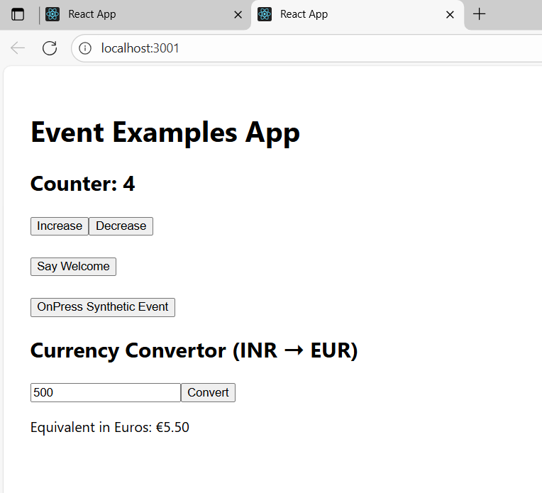 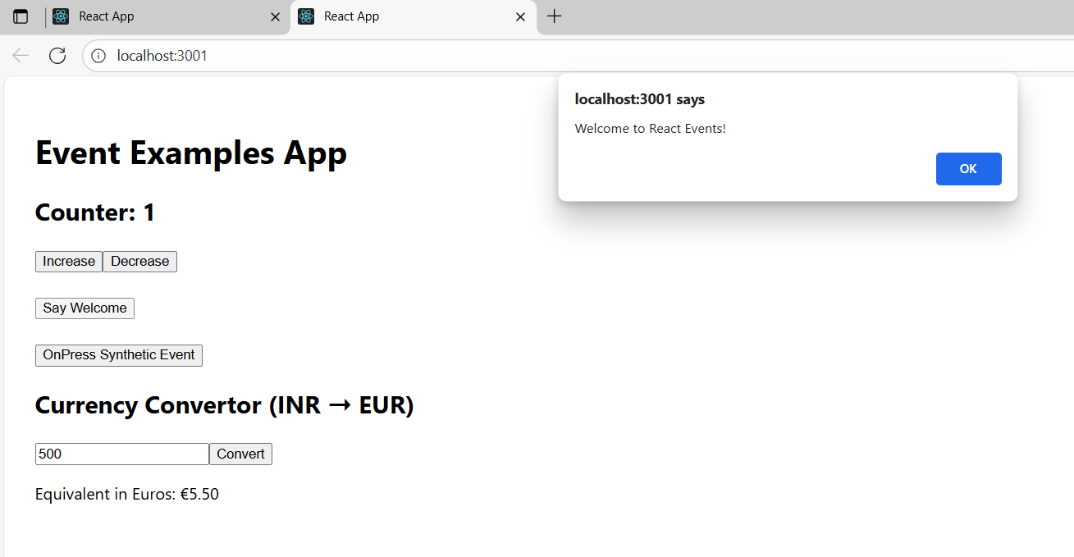

**Exercise: 12. ReactJS-HOL**

**//App.js**

import React, { useState } from 'react';

import GuestPage from './GuestPage';

import UserPage from './UserPage';

function App() {

const [isLoggedIn, setIsLoggedIn] = useState(false);

// Element variable for button

let button;

if (isLoggedIn) {

button = <button onClick={() => setIsLoggedIn(false)}>Logout</button>;

} else {

button = <button onClick={() => setIsLoggedIn(true)}>Login</button>;

}

// Conditional rendering of page

let content;

if (isLoggedIn) {

content = <UserPage />;

} else {

content = <GuestPage />;

}

return (

<div className="App" style={{ padding: '20px' }}>

<h1>Ticket Booking App</h1>

{button}

<hr />

{content}

</div>

);

}

export default App;

**//GuestPage.js**

import React from 'react';

const GuestPage = () => {

return (

<div>

<h2>Welcome Guest</h2>

<p>Explore available flights, but you must log in to book.</p>

<ul>

<li>Flight: Delhi ➝ Mumbai - ₹3500</li>

<li>Flight: Bangalore ➝ Chennai - ₹2200</li>

<li>Flight: Kolkata ➝ Hyderabad - ₹4000</li>

</ul>

</div>

);

};

export default GuestPage;

**//** **UserPage.js**

import React from 'react';

const UserPage = () => {

return (

<div>

<h2>Welcome, User</h2>

<p>You can now book your flights:</p>

<ul>

<li>Flight: Delhi ➝ Mumbai - ₹3500 <button>Book</button></li>

<li>Flight: Bangalore ➝ Chennai - ₹2200 <button>Book</button></li>

<li>Flight: Kolkata ➝ Hyderabad - ₹4000 <button>Book</button></li>

</ul>

</div>

);

};

export default UserPage;

**//Output:**

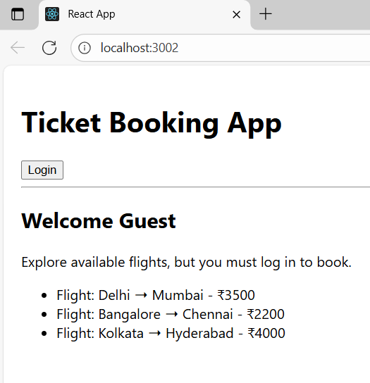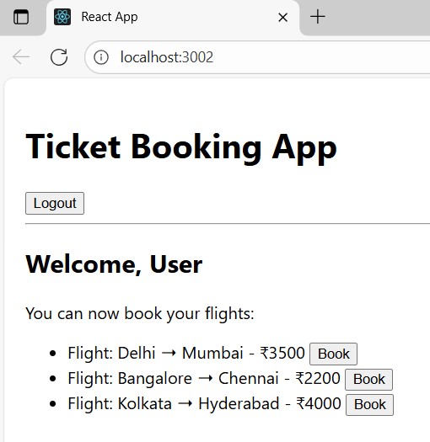

**Exercise: 13. ReactJS-HOL**

**//App.js**

import React, { useState } from 'react';

import BookDetails from './BookDetails';

import BlogDetails from './BlogDetails';

import CourseDetails from './CourseDetails';

function App() {

const [activeTab, setActiveTab] = useState('books');

let content;

if (activeTab === 'books') {

content = <BookDetails />;

} else if (activeTab === 'blogs') {

content = <BlogDetails />;

} else {

content = <CourseDetails />;

}

return (

<div className="App" style={{ padding: '20px' }}>

<h1>Blogger App</h1>

<button onClick={() => setActiveTab('books')}>Books</button>

<button onClick={() => setActiveTab('blogs')}>Blogs</button>

<button onClick={() => setActiveTab('courses')}>Courses</button>

<hr />

{content}

<hr />

<h3 style={{ color: 'gray' }}>

Currently viewing: {activeTab === 'books' ? "Books" : activeTab === 'blogs' ? "Blogs" : "Courses"}

</h3>

{activeTab === 'books' && <p>You're viewing the list of books.</p>}

{activeTab === 'blogs' && <p>You're viewing the list of blogs.</p>}

{activeTab === 'courses' && <p>You're viewing the list of courses.</p>}

</div>

);

}

export default App;

**//BlogDetails.js**

import React from 'react';

const blogs = [

{ id: 1, title: 'Understanding JSX', author: 'Sarah Doe' },

{ id: 2, title: 'React Hooks Overview', author: 'John Smith' }

];

const BlogDetails = () => {

return (

<div>

<h2>Blog Details</h2>

{blogs.map((blog) => (

<div key={blog.id}>

<p><strong>{blog.title}</strong> - {blog.author}</p>

</div>

))}

</div>

);

};

export default BlogDetails;

**//BookDetails.js**

import React from 'react';

const books = [

{ id: 1, title: 'React for Beginners', author: 'Dan Abramov' },

{ id: 2, title: 'Learning ES6', author: 'Kyle Simpson' },

{ id: 3, title: 'JS in Depth', author: 'Nicholas Zakas' }

];

const BookDetails = () => {

return (

<div>

<h2>Book Details</h2>

{books.map((book) => (

<div key={book.id}>

<p><strong>{book.title}</strong> by {book.author}</p>

</div>

))}

</div>

);

};

export default BookDetails;

**//CourseDetails.js**

import React from 'react';

const courses = [

{ id: 1, name: 'Frontend Mastery', level: 'Beginner' },

{ id: 2, name: 'React + Redux', level: 'Intermediate' },

{ id: 3, name: 'Full Stack Dev', level: 'Advanced' }

];

const CourseDetails = () => {

return (

<div>

<h2>Course Details</h2>

{courses.map((course) => (

<div key={course.id}>

<p>{course.name} - <em>{course.level}</em></p>

</div>

))}

</div>

);

};

export default CourseDetails;

**//Output:**

