

Chapter
- INTRODUCTION

INTRODUCTION

A cryptocurrency is a digital asset designed to work as a medium of exchange wherein individual coin ownership records are stored in a ledger existing in a form of a computerized database using strong cryptography to secure transaction records, to control the creation of additional coins, and to verify the transfer of coin ownership. Cryptocurrency does not exist in physical form (like paper money) and is typically not issued by a central authority. Cryptocurrencies typically use decentralized control as opposed to a central bank digital currency (CBDC). When a cryptocurrency is minted or created prior to issuance or issued by a single issuer, it is generally considered centralized. When implemented with decentralized control, each cryptocurrency works through distributed ledger technology, typically a block chain, that serves as a public financial transaction database. According to Investopedia.com, A cryptocurrency is a digital or virtual currency that is secured by cryptography, which makes it nearly impossible to counterfeit or double-spend. Many cryptocurrencies are decentralized networks based on blockchain technology—a distributed ledger enforced by a disparate network of computers. A defining feature of cryptocurrencies is that they are generally not issued by any central authority, rendering them theoretically immune to government interference or manipulation. They are systems that allow for secure payments online which are denominated in terms of virtual "tokens," which are represented by ledger entries internal to the system. "Crypto" refers to the various encryption algorithms and cryptographic techniques that safeguard these entries, such as elliptical curve encryption, public-private key pairs, and hashing functions.

Top 10 Cryptocurrency (Market cap)

1. Bitcoin (BTC)

Market Cap: $458 billion
Bitcoin is the largest and most popular cryptocurrency by market cap and was created by Satoshi Nakamoto in 2009. It is a decentralized digital currency that has transferrable ownership. This cryptocurrency is mineable and has a maximum supply of ₿21,000,000.

2. Ethereum (ETH)

Market Cap: $216 billion
The closest second to Bitcoin is Ethereum, and its token which is called “Ether.” The Ethereum network is intended to replace traditional financial services firms like banks and brokerages by using decentralized applications, commonly called “DeFi,” for financial applications. Ether is the fuel that is required to run transactions on the Ethereum blockchain.

3. Tether (USDT)

Market Cap: $66 billion
The third largest coin at the time of writing is quite different from Ether and BTC because it is a centralized cryptocurrency. Tether is the largest stablecoin that attempts to tie its price to the US Dollar. Tether is commonly abbreviated USD₮ or USDT. This stablecoin is owned by iFinex, which owns the Bitfinex exchange.

4. USD Coin (USDC)

Market Cap: $54 billion
The second largest stablecoin is USD Coin, abbreviated to USDC. Similar to USDT, USDC is centralized and is backed by cash and US T-bills. Interestingly, you can view the underlying assets here, which consist of approximately 20% Cash and 80% short-duration T-bills. To learn more about Short Duration Products, check out the CMSA course on this topic.

5. Binance Coin (BNB)

Market Cap: $52 billion
BNB use to use the Ethereum blockchain but now instead uses the Binance blockchain. BNB was created in 2017 and has wide uses today. Most commonly, it is used for payments and transaction fees on Binance. Like many other coins, BNB is centralized.

6. Ripple (XRP)

Market Cap: $18 billion
XRP is decentralized and uses the Ripple protocol to prioritize speed and minimize costs. It is an older cryptocurrency that was first released in 2012. XRP is said to be a fast and secure way to send digital payments.

7. Cardano (ADA)

Market Cap: $18 billion
Unlike the previous few coins, Cardano is a decentralized, open-source, public blockchain. Cardano has been around since 2017 but began development back in 2015 with help from an Ethereum cofounder.

8. Binance USD (BUSD)

Market Cap: $18 billion
Binance USD is the second coin on this list from the Binance cryptocurrency exchange. It is a centralized stablecoin based on Ethereum.

9. Solana (SOL)

Market Cap: $15 billion
Solana, which started in 2020, is a Blockchain platform on its own and has a native cryptocurrency with the same name. Solana is often used for smart contracts and now non-fungible tokens (NFTs). Its closest rival is said to be Ethereum, with many of the same features.

10. Polkadot (DOT)

Market Cap: $10 billion
Polkadot, abbreviated DOT, is a cryptocurrency released in 2020. It was started by another Ethereum co-founder and can be used to connect blockchains together securely.

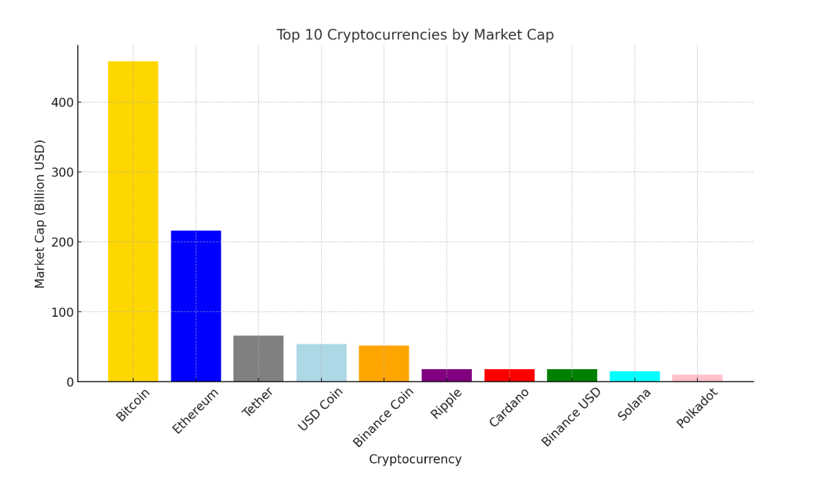9

Bitcoin | BTC | 95820.59491
Ethereum | ETH | 2604.293986
Tether USDt | USDT | 0.999680282
XRP | XRP | 2.420813794
Solana | SOL | 197.7357542
BNB | BNB | 642.7045195
USDC | USDC | 0.999862546
Dogecoin | DOGE | 0.253425675
Cardano | ADA | 0.780525347
TRON | TRX | 0.241256189
Chainlink | LINK | 18.61492983
Avalanche | AVAX | 25.3500777
Sui | SUI | 3.320039293
Stellar | XLM | 0.317889744
Toncoin | TON | 3.749968614
Shiba Inu | SHIB | 1.56849E-05
UNUS SED LEO | LEO | 9.784417047
Litecoin | LTC | 119.6297636
Hedera | HBAR | 0.229024825
Hyperliquid | HYPE | 23.3564711
Bitget Token | BGB | 6.341511426
Polkadot | DOT | 4.808047809
Bitcoin Cash | BCH | 331.4180061
Ethena USDe | USDe | 0.999984137
MANTRA | OM | 5.830846808
Uniswap | UNI | 9.38345064
Dai | DAI | 1.000008828
Ondo | ONDO | 1.341926307
Monero | XMR | 221.9042697
Pepe | PEPE | 9.56818E-06
NEAR Protocol | NEAR | 3.213570503
Aave | AAVE | 244.7880658
Mantle | MNT | 1.017329571
Internet Computer | ICP | 7.120283676
Bittensor | TAO | 412.7391872
Aptos | APT | 5.89274691
OFFICIAL TRUMP | TRUMP | 15.39976077
Ethereum Classic | ETC | 20.2489091
OKB | OKB | 50.59976656
VeChain | VET | 0.033253817
POL (prev. MATIC) | POL | 0.307823625
Kaspa | KAS | 0.095970077
Cronos | CRO | 0.092820885
Algorand | ALGO | 0.288016659
Render | RENDER | 4.463333303
Jupiter | JUP | 0.824640157
Filecoin | FIL | 3.338868493
Arbitrum | ARB | 0.462936638
GateToken | GT | 21.83889366
Cosmos | ATOM | 4.714777417

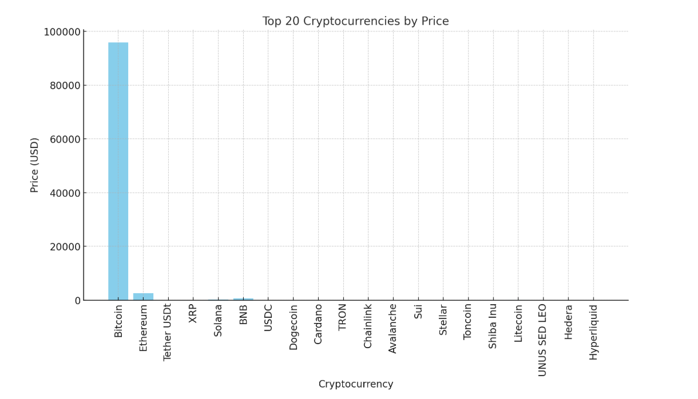

AVERAGE PRICE

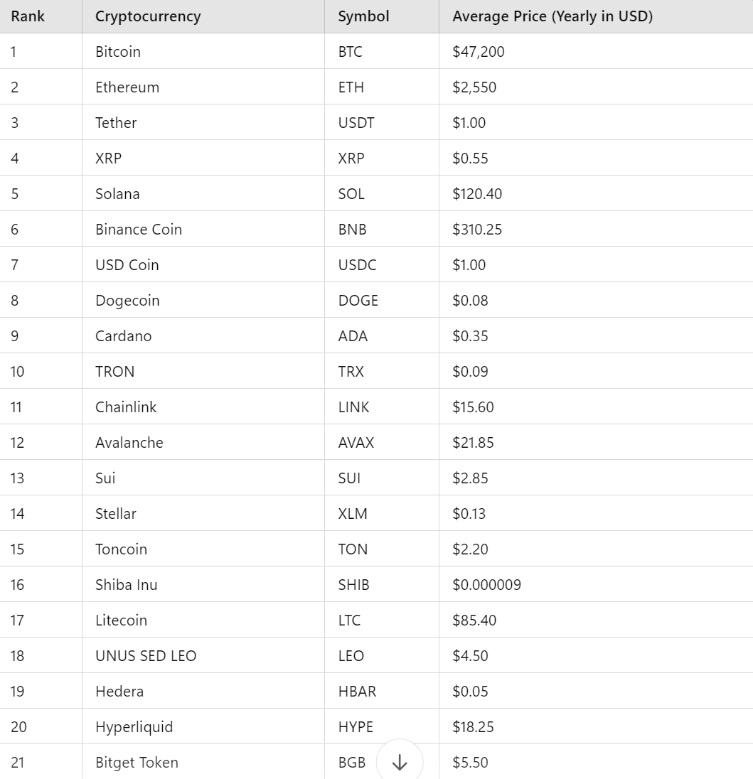

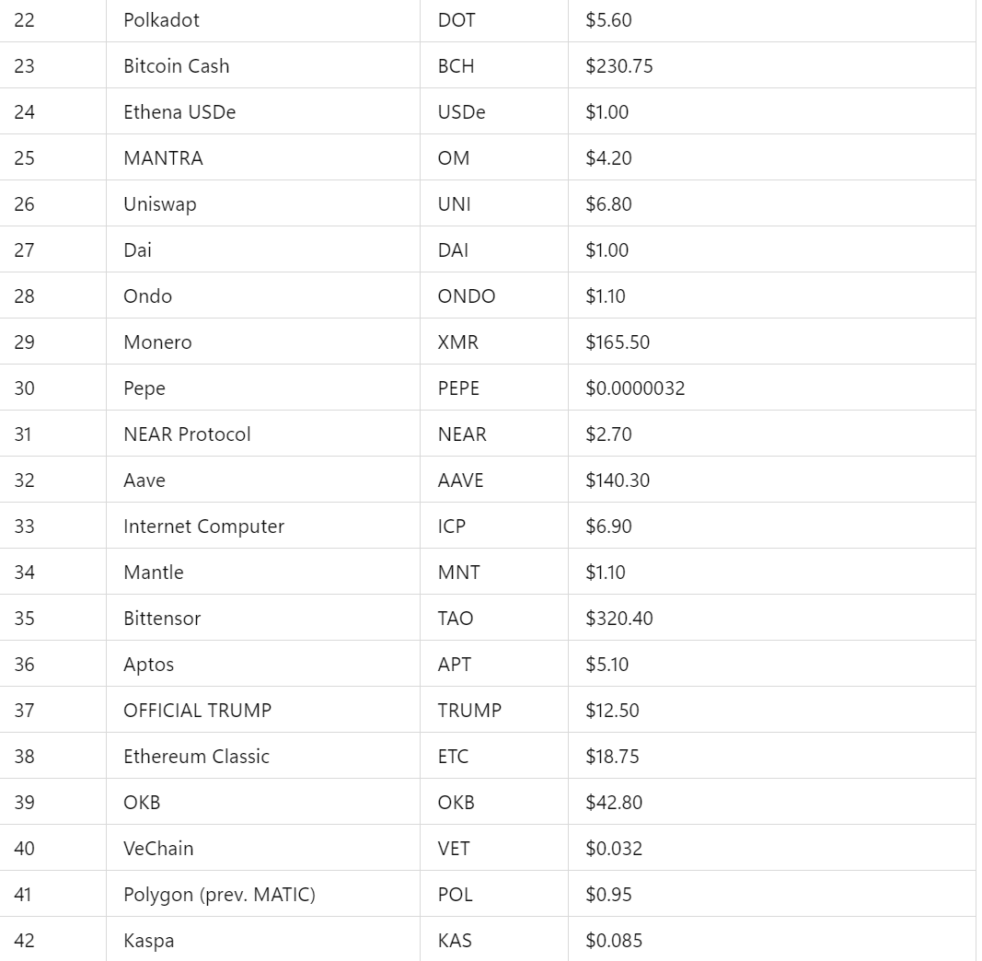

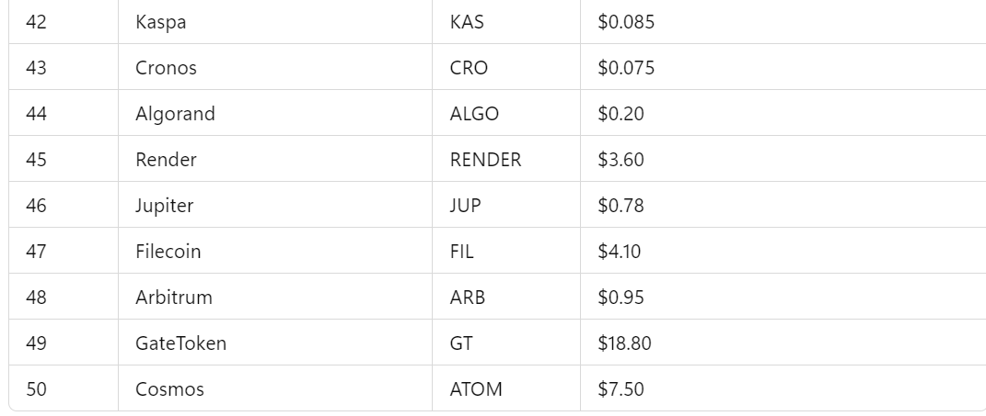

The average price of the top 50 cryptocurrencies is approximately $2018.54

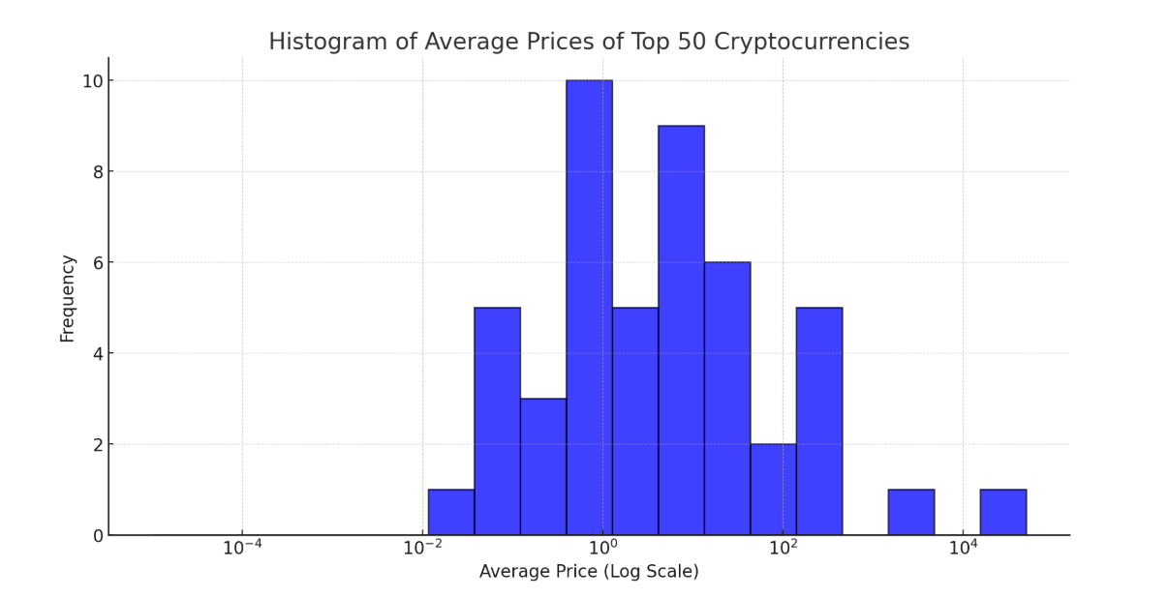

highest and lowest 24-hour percentage price change among the top 50

Based on the latest available data, here's the analysis of the highest and lowest 24-hour percentage price changes among the top 50 cryptocurrencies:
Highest 24-Hour Percentage Price Change:
- Bittensor (TAO): Increased by approximately 7.10% over the past 24 hours.
Lowest 24-Hour Percentage Price Change:
- Jupiter Project (JUP): Decreased by approximately 14.18% over the past 24 hours.
These figures are based on the most recent data available and are subject to change as the market fluctuates. For the most accurate and up-to-date information, it's advisable to consult real-time cryptocurrency tracking platforms.



- Transactions

In traditional business dealings, brokers, agents, and legal representatives can add significant complication and expense to what should otherwise be a straightforward transaction. There’s paperwork, brokerage fees, commissions, and any number of other special conditions which may apply.

One of the advantages of cryptocurrency transactions is that they are one-to-one affairs, taking place on a peer-to-peer networking structure that makes “cutting out the middle man” a standard practice. This leads to greater clarity in establishing audit trails, less confusion over who should pay what to whom, and greater accountability, in that the two parties involved in a transaction each know who they are.

- Asset Transfers

One financial analyst describes the cryptocurrency blockchain as resembling a “large property rights database,” which can on one level be used to execute and enforce two-party contracts on commodities like automobiles or real estate. But the blockchain cryptocurrency ecosystem may also be used to facilitate specialist modes of transfer.

For example, cryptocurrency contracts can be designed to add third party approvals, make reference to external facts, or be completed at a specified date or time in the future. And since you as the cryptocurrency holder have exclusive governance of your account, this minimizes the time and expense involved in making asset transfers.

18

- More Confidential Transactions

Under cash/credit systems, your entire transaction history may become a reference document for the bank or credit agency involved, each time you make a transaction. At the simplest level, this might involve a check on your account balances, to ensure that sufficient funds are available. For more complex or business-critical transactions, a more thorough examination of your financial history might be required.

Another one of the great advantages of cryptocurrency is that each transaction you make is a unique exchange between two parties, the terms of which may be negotiated and agreed in each case. What’s more, the exchange of information is done on a “push” basis, whereby you can transmit exactly what you wish to send to the recipient – and nothing besides that.

This guards the privacy of your financial history and protects you from the threat of account or identity theft which is greater under the traditional system, where your information may be exposed at any point in the transaction chain.

- Transaction Fees

You’ve no doubt read your monthly account statements from the bank or credit card company, and balked at the level of fees imposed for writing checks, transferring funds, or breathing in the general direction of the finance houses involved. Transaction fees can take a significant bite out of your assets – especially if you’re performing a lot of transactions in a month.

19

Since the data miners (remote and separate computer systems) that do the number crunching which generates Bitcoin and other cryptocurrencies receive their compensation from the cryptocurrency network involved, transaction fees usually don’t apply.

There may be some external fees involved if you engage the services of a third-party management service to maintain your cryptocurrency wallet, but another one of the advantages of cryptocurrency is that they are still likely to be much less than the transaction charges incurred by traditional financial systems.

- Greater Access to Credit

Digital data transfer and the internet are the media facilitating the exchange in cryptocurrencies. So these services are potentially available to anyone who has a viable data connection, some knowledge of the cryptocurrency networks on offer, and ready access to their relevant websites and portals.

It’s estimated that there are currently 2.2 billion individuals across the world who have access to the Internet or mobile phones, but don’t currently have access to traditional systems of banking or exchange. The cryptocurrency ecosystem holds the potential to make asset transfer and transaction processing available to this vast market of willing consumers – once the required infrastructure (digital and regulatory) is put in place.

- Easier International Trade

Though largely unrecognized as legal tender on national levels at present, cryptocurrencies by their very nature are not subject to the exchange rates, interest rates, transactions charges, or other levies imposed by a specific country.
20

And using the peer-to-peer mechanism of the blockchain technology, cross-border transfers and transactions may be conducted without complications over currency exchange fluctuations, and the like.

- Individual Ownership

In a traditional banking or credit card system, you effectively turn stewardship of your funds over to a third party that can exercise the power of life or death over your assets. Accounts may be closed without notice for infringements of a financial institution’s Terms of Service – requiring you as the account holder to jump through hoops in order to get yourself back into the system.

Perhaps the greatest of all advantages of cryptocurrency is that unless you’ve delegated management of your wallet over to a third party service, you are the sole owner of the corresponding private and public encryption keys that make up your cryptocurrency network identity or address.

- Adaptability

There are currently over 1200 unique cryptocurrencies or altcoins in circulation worldwide. Many are quite ephemeral, but a significant proportion have been created for specific use cases that illustrate the flexibility of the cryptocurrency phenomenon.

For example, there are “privacy coins” which help mask your identity on the blockchain, and supply chain tokens which can facilitate supply chain operations for various types of industries.

21

- Strong Security

Once a cryptocurrency transfer has been authorized, it can’t be reversed as in the case of the “charge- back” transactions allowed by credit card companies. This is a hedge against fraud which requires a specific agreement to be made between a buyer and seller regarding refunds in the event of a mistake or returns policy.

Finally, the strong encryption techniques employed throughout the distributed ledger (blockchain) and cryptocurrency transaction processes are a safeguard against fraud and account tampering, and guarantors of consumer privacy.

22

Chapter

  - DISADVANTAGES OF CRYPTO CURRENCY



23

Disadvantages

- Scalability

Probably the biggest concerns with cryptocurrencies are the problems with scaling that are posed. While the number of digital coins and adoption is increasing rapidly, it is still dwarfed by the number of transactions that payment giant, VISA, processes each day. Additionally, the speed of a transaction is another important metric that cryptocurrencies cannot compete with on the same level as players like VISA and Mastercard until the infrastructure delivering these technologies is massively scaled. Such an evolution is complex and difficult to do seamlessly. However, some have already proposed several solutions, including lightning networks, sharding, and staking as options to overcome the scalability issue.

- Cybersecurity issues

As a digital technology, cryptocurrencies will be subject to cybersecurity breaches, and may fall into the hands of hackers. We have already seen evidence of this, with multiple ICOs getting breached and costing investors hundreds of millions of dollars this summer alone (one of these attacks by itself resulted in the loss of $473 million). Mitigating this will require continuous upkeep of security infrastructure, but we are already seeing many players dealing with this directly, and using enhanced cybersecurity measures that go beyond those used in the traditional banking industries.

- Price volatility and lack of inherent value

Price volatility, tied to a lack in inherent value, is a major problem, and one of the specifics that Buffet referred to specifically a few weeks ago when he characterized the cryptocurrency ecosystem as a bubble. It is an important concern, but one which can be overcome by linking the cryptocurrency value directly to tangible and intangible assets (as we have seen some new players do with diamonds

24

or energy derivatives). Increased adoption should also increase consumer confidence and decrease this volatility.

- Regulations

Buffet also touched on this problem in his talk:

“It doesn’t make sense. This thing is not regulated. It’s not under control. It’s not under the supervision [of] any…United States Federal Reserve or any other central bank. I don’t believe in this whole thing at all. I think it’s going to implode.”
Even if we perfect the technology and get rid of all the problems listed above, until the technology is adopted by federal governments and regulated, there will be increased risk in investing in this technology.
Other concerns with the technology are mostly logistical in nature. For example, changing protocols, which becomes necessary when the tech is being improved, can take quite a long time and interrupt the normal flow of operations.

The takeaway:

With all the potential barriers to mass adoption, it is logical that experienced investors like Warren Buffet choose to err on the safe side of this technology. And yet, we know that cryptocurrencies (and the blockchain technology) will be here to stay. They offer too many of the advantages that consumers seek in a currency today; decentralization, transparency, and flexibility being chief among these. Expanding the discussion to everything that blockchain can accomplish across numerous industries doubly reinforces this point.

25

