Technical Design Document

Project name: **HappyEasyFly**

Name : Ayush Gupta

Employee Id : 46022394

**Introduction:**

**HappyEasyFly** is created to meet the needs of online flight reservation system with 1 actors: User. The architecture implemented in Spring boot.

**Functional Requirements:**

**For the User:**

* Login/Register
* Search Flights
* Create Booking
* View booked Tickets
* Cancel Tickets

**Services:**

* **User Service:** Register a new account and login(as a user) and get booked tickets and cancel tickets.
* **Flight Service:** View all flights based on the details provided by the user, book tickets and getting the details of passengers.

**Overall Architecture Diagram:**

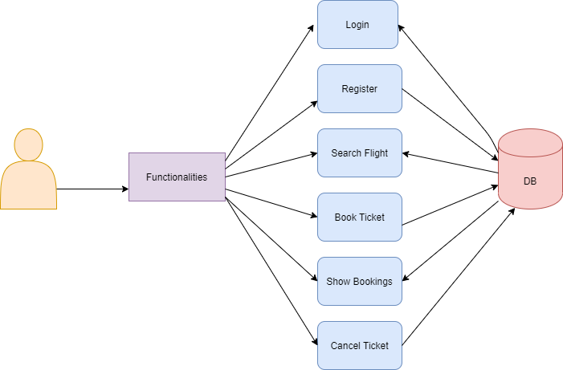

**Overall Entity Relationship Diagram:**

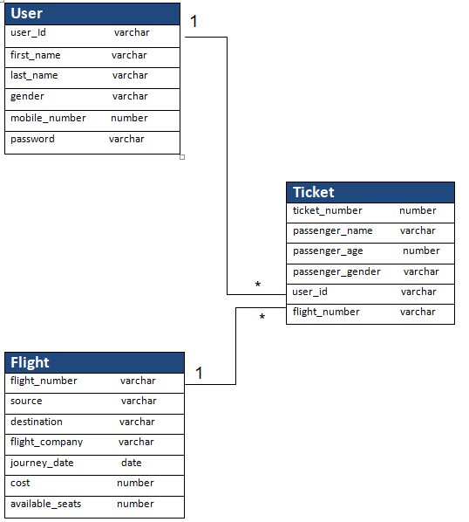

**Sequence Diagrams**

**Login and Register:**

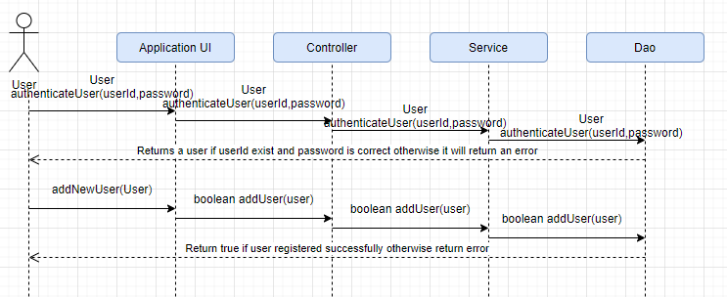

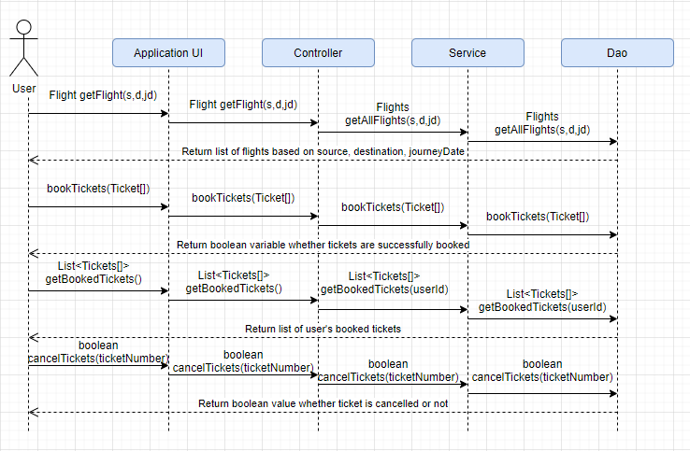

**Class Diagrams**

User class and Ticket class:

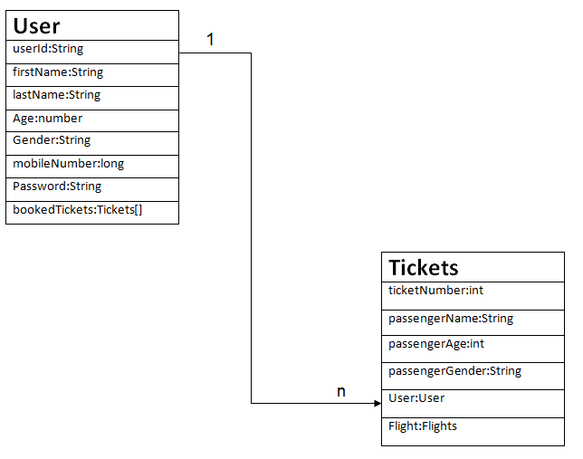

Flight class and Ticket class:

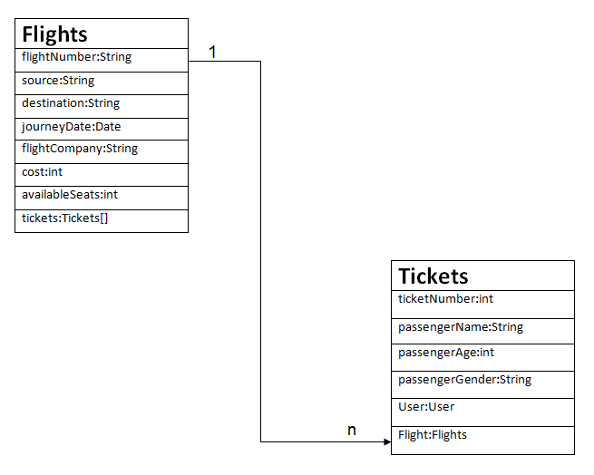

**Activity Diagrams**

**Registration:**

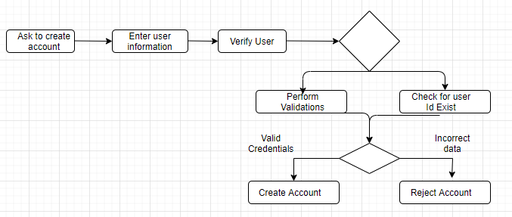

**Login:**

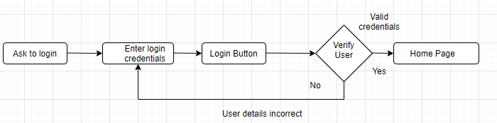

**Search Flights:**

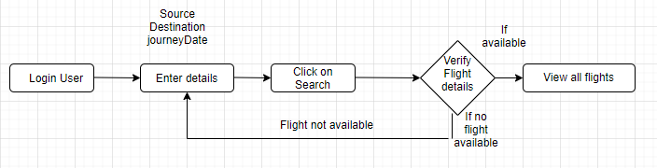

**Book Ticket:**

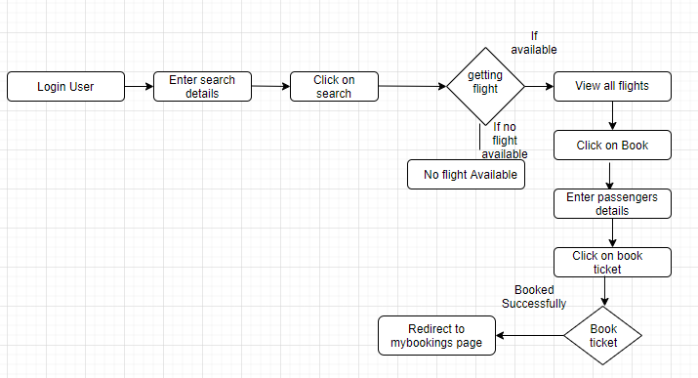

**Get Booked Tickets:**

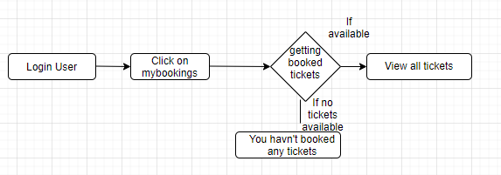

**Cancel Ticket:**

