7.1: Elasticity Task

🔅Integrating LVM with Hadoop and providing Elasticity to DataNode Storage

🔅Automating LVM Partition using Python-Script.

In This Task We automated LVM Partition using Python Script and using that we integrated LVM with Hadoop and Also provided elasticity to the Data Node.

These are the Steps which we did:

Step-1) We created A menu based on Python which will help to do this Task. Firstly as we run the menu.py file than it ask for password and we will entered the password.

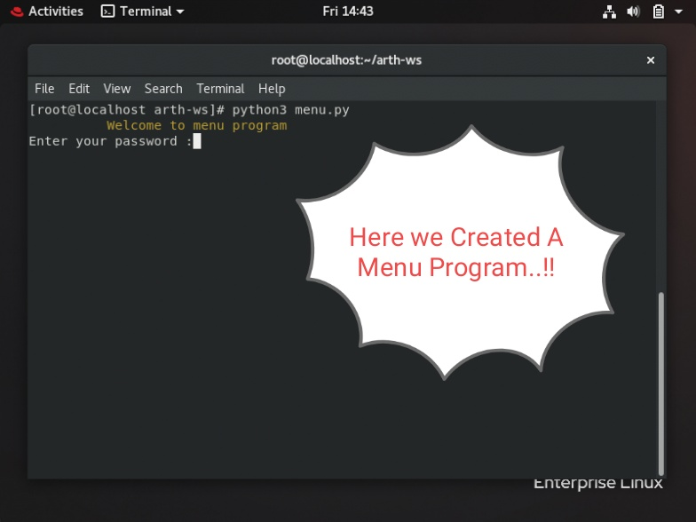

Step-2) Now it will ask whether to run remotely then say y and after that we give the remote IP. And after that Selected Option 1 which asks for password of remote OS and In Remote OS as per the condition that is Start Namenode it will start the Namenode.

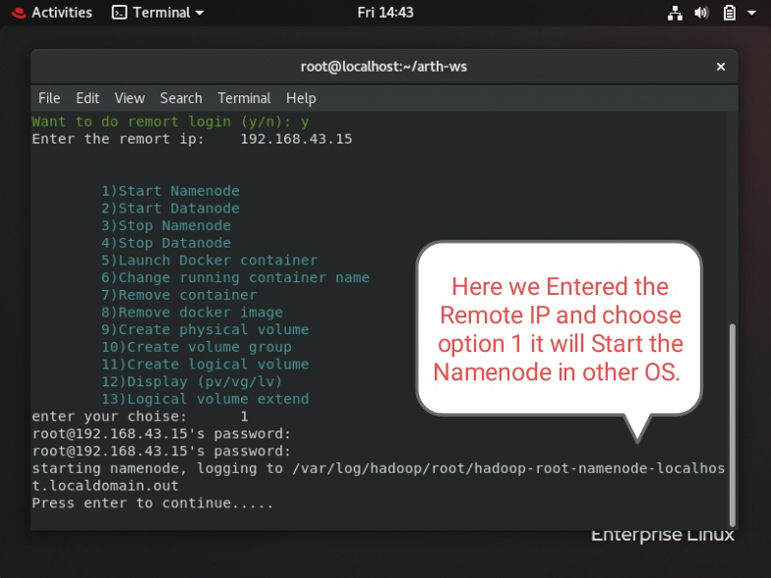

To check we use jps command in NameNode.

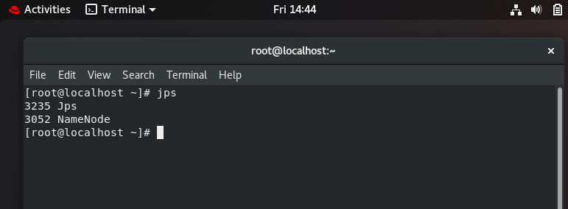

Step3) After that we choose Option 9 than it will create a physical Volume. Here we entered the hard disk name /dev/sdb which created Successfully.

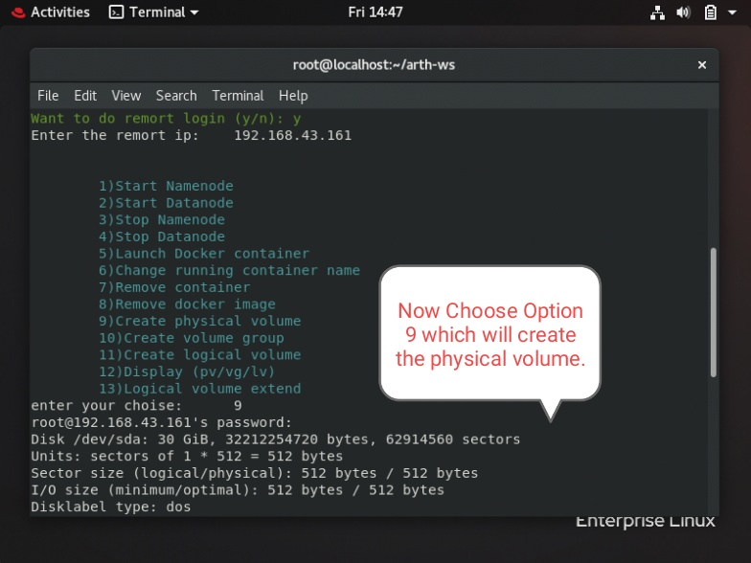

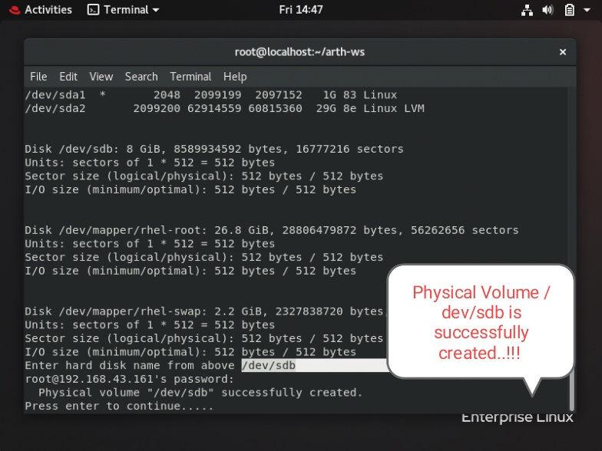

Step-4) On choosing Option-4 It will create the volume group and ask for vg name than we give vg name as vg1 and ask for pv name which is successfully created.

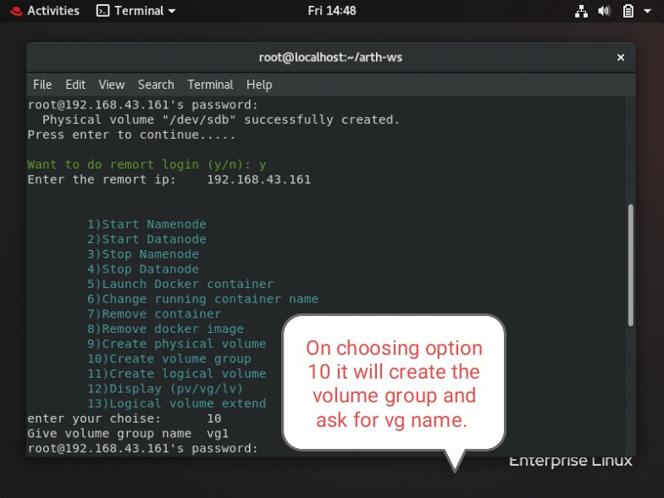

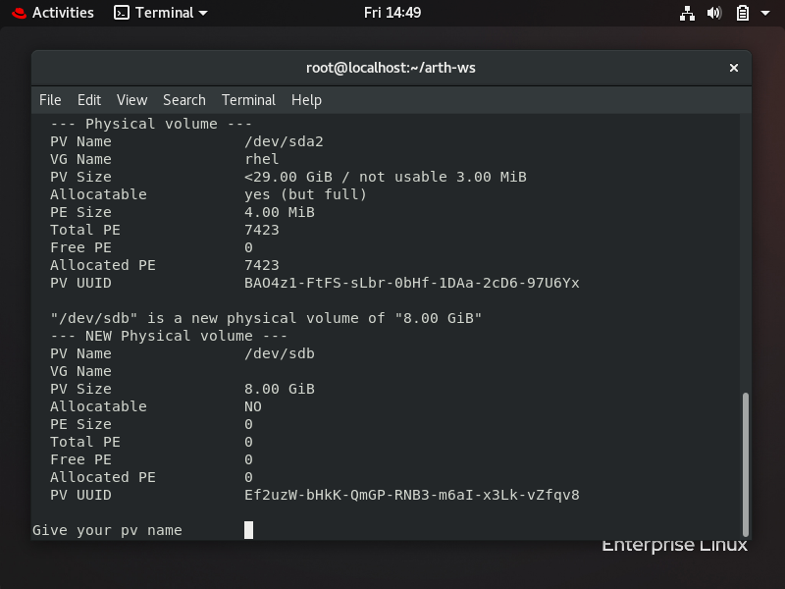

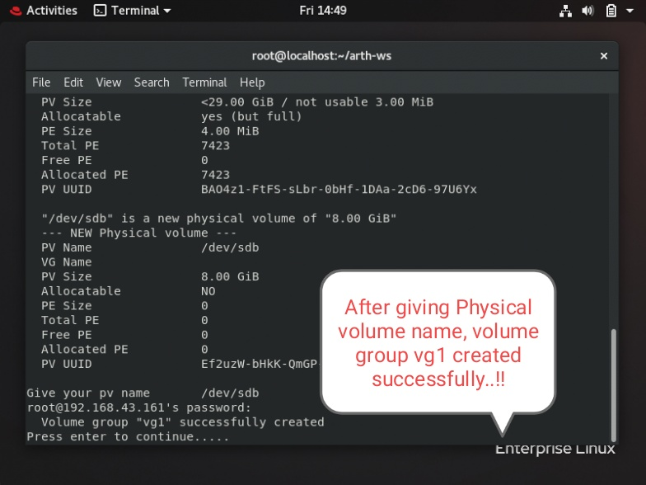

Step-5) After this we choose Option 11 to create the logical volume. It will ask logical volume name and its size.

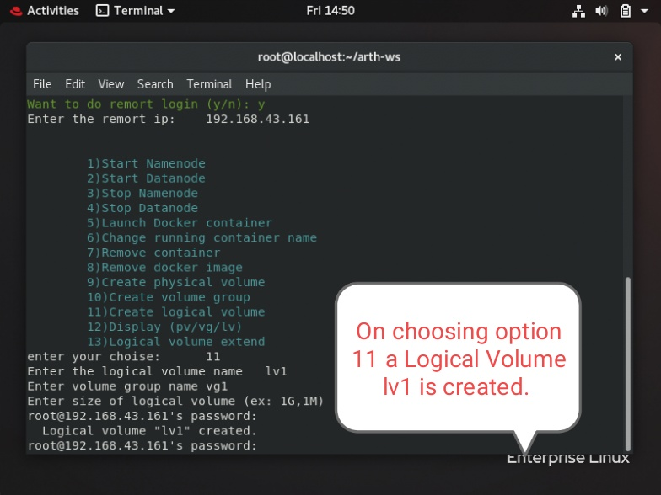

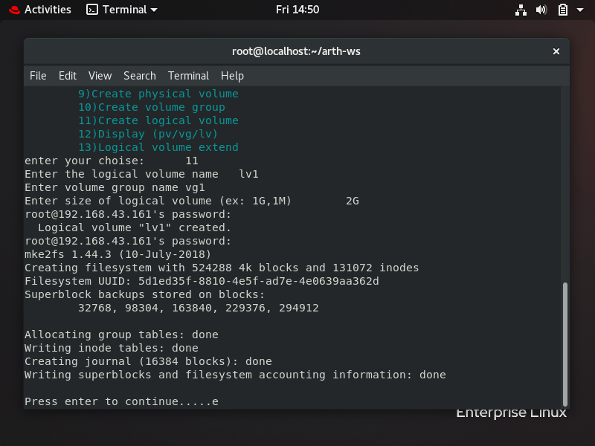

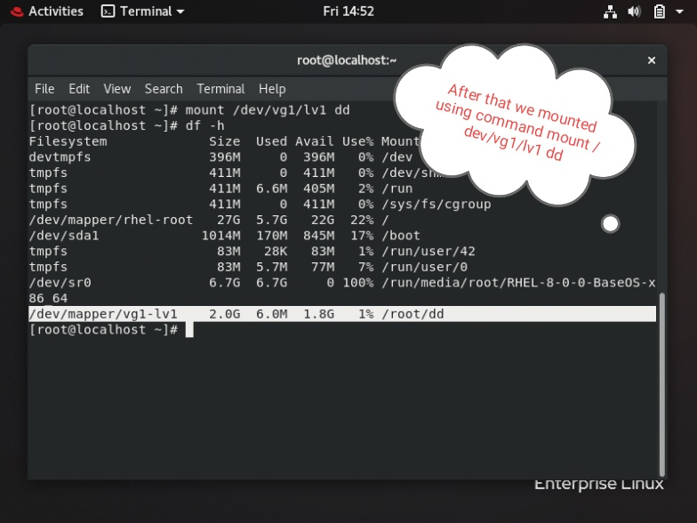

Step-6) To start the DataNode we choose Option-4 and through jps command we checked that datanode is active or not and then configured the hdfs-site-xml file.

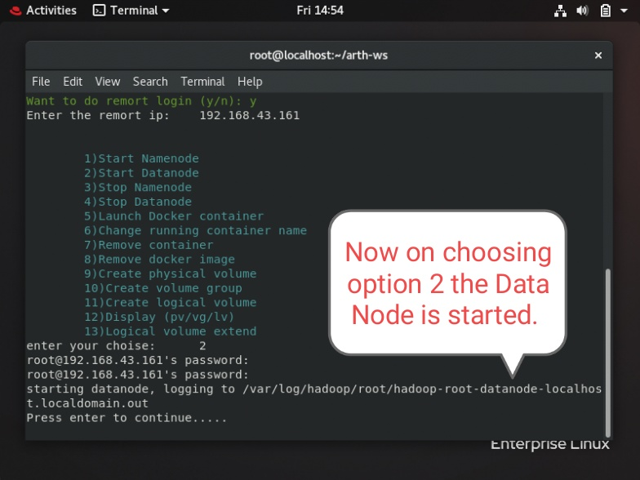

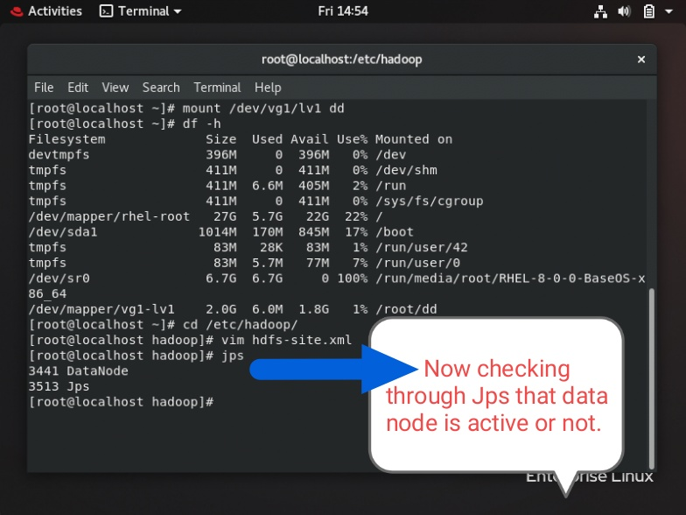

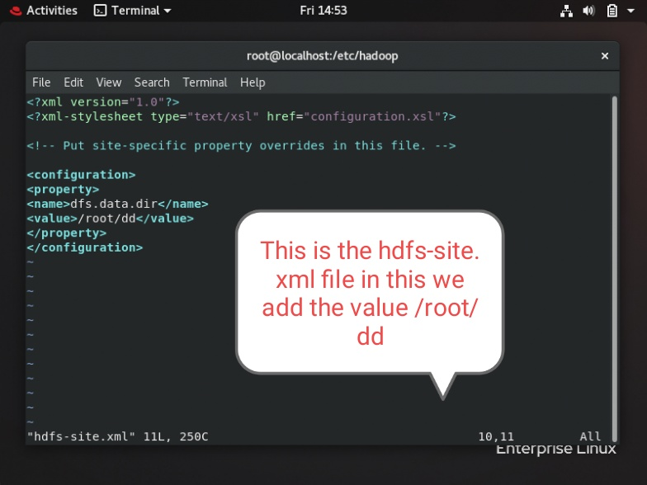

Step-7) Now in Namenode we checked by using command dfsadmin -report which configured capacity of 1.91 GB.

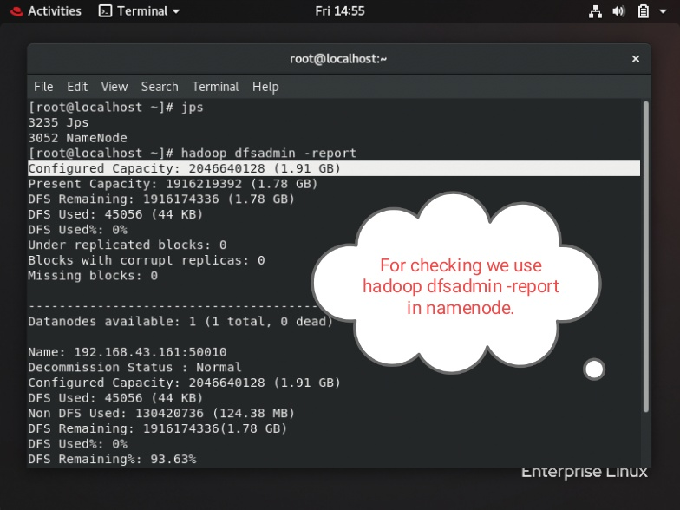

Step-8) After that We choose Option 13 for creating Logical volume extension. Here it asked for logical volume and volume group name and finally it will increase the size which was initially 1.91 and now increased to 2.89 GB.

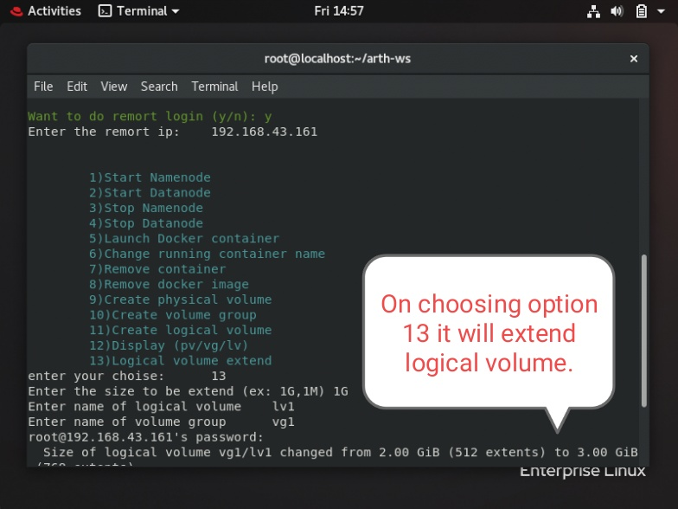

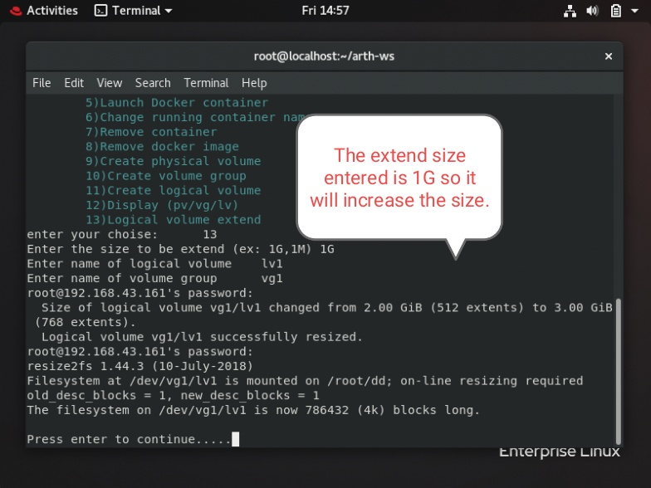

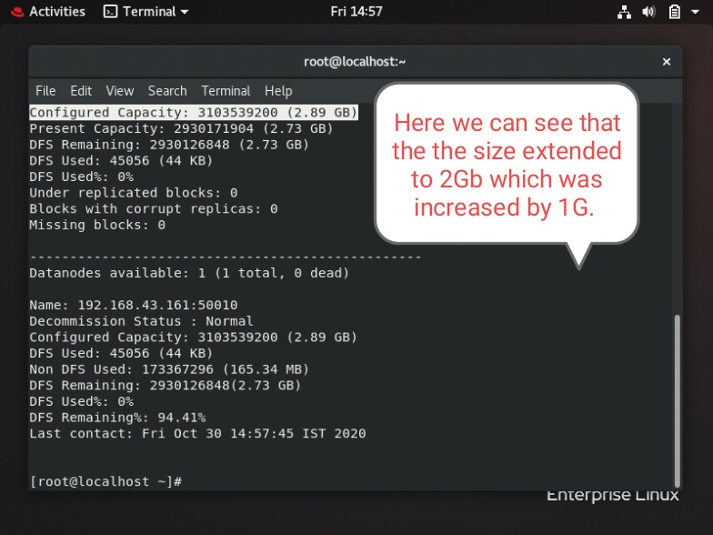

So By these Steps we can Integrate LVM with Hadoop and providing Elasticity to DataNode Storage and Automated LVM Partition using Python-Script.