**Multi cloud K8s cluster over AWS, Azure, and GCP cloud!!**

🔥Infrastructure:

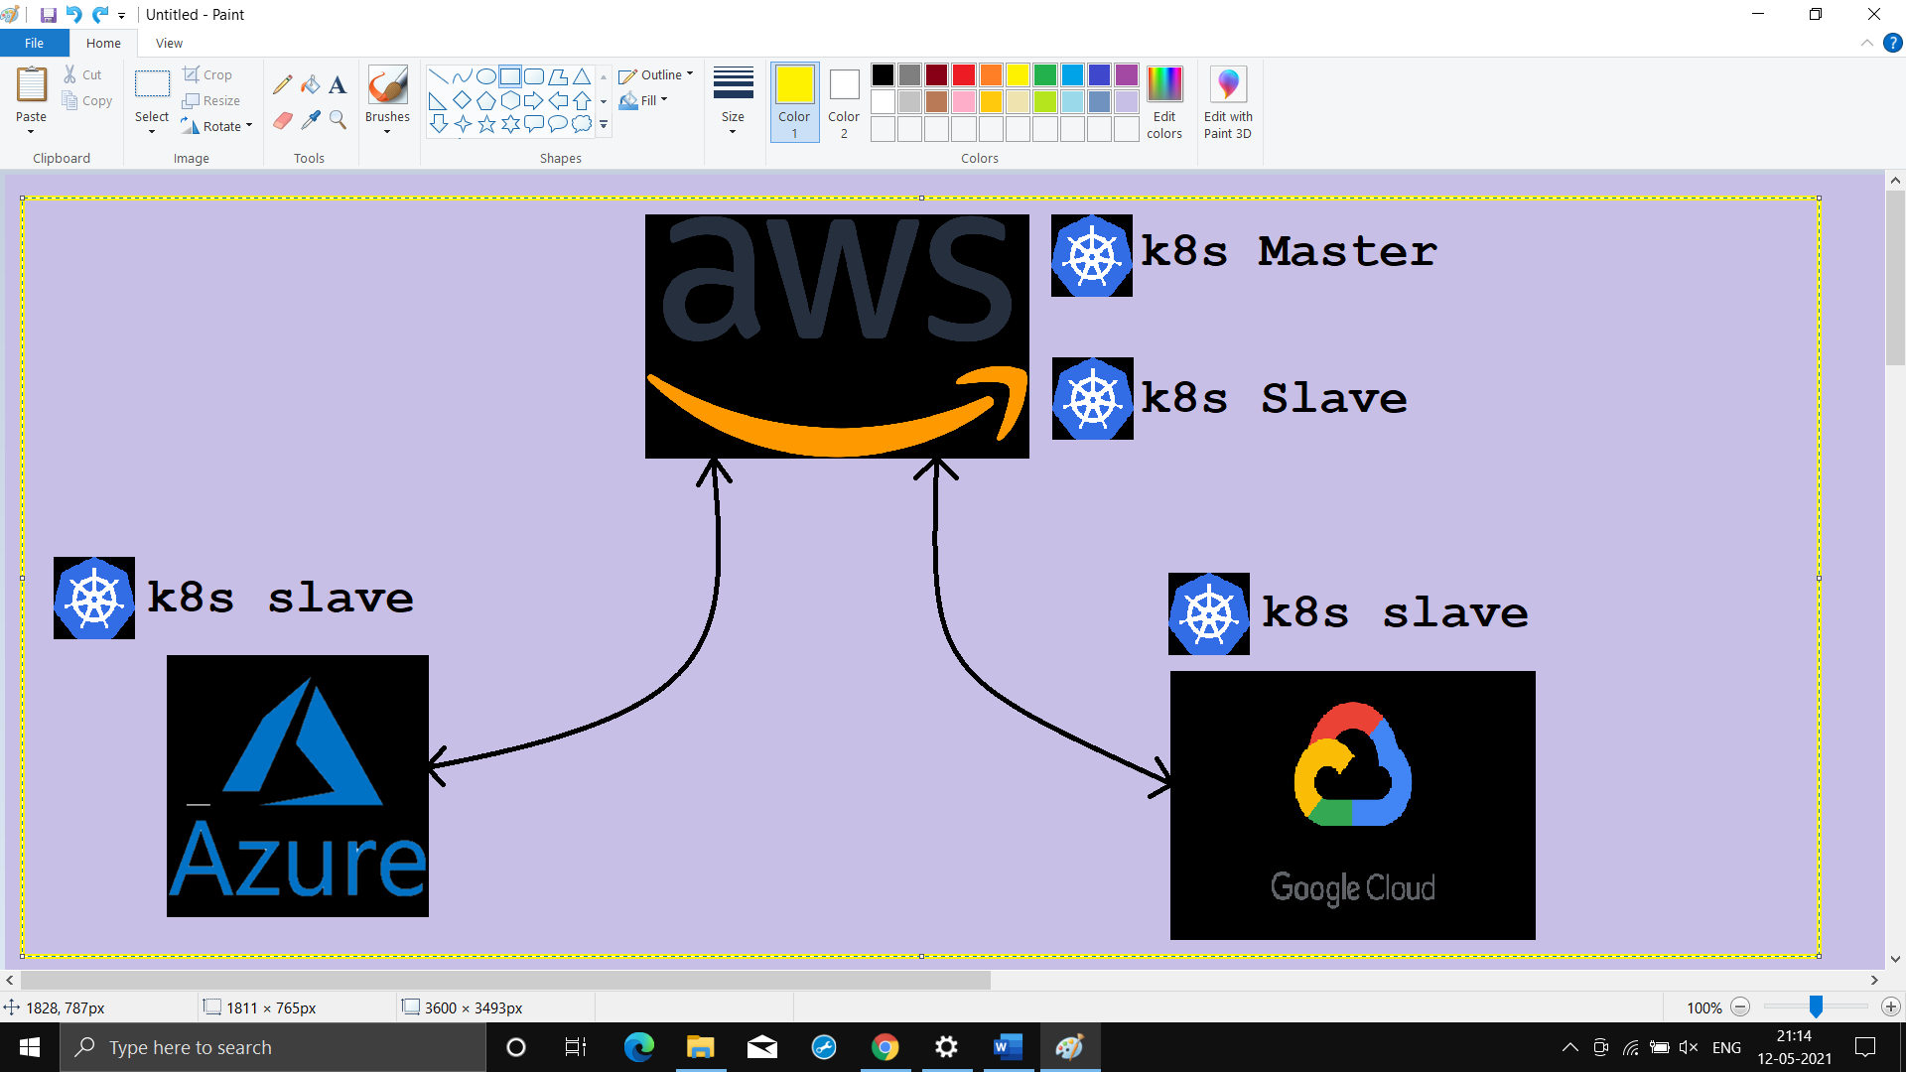

🎯K8s Master & one slave over **AWS**:

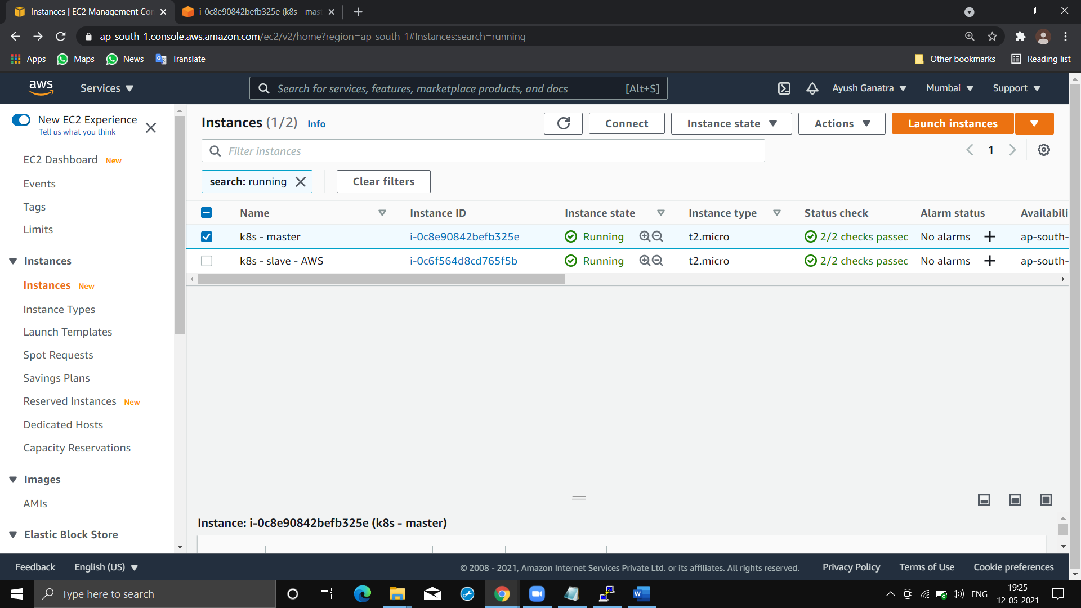

Region:

ap-south-1

(**Mumbai**)

🎯One K8s slave over **AZURE**:

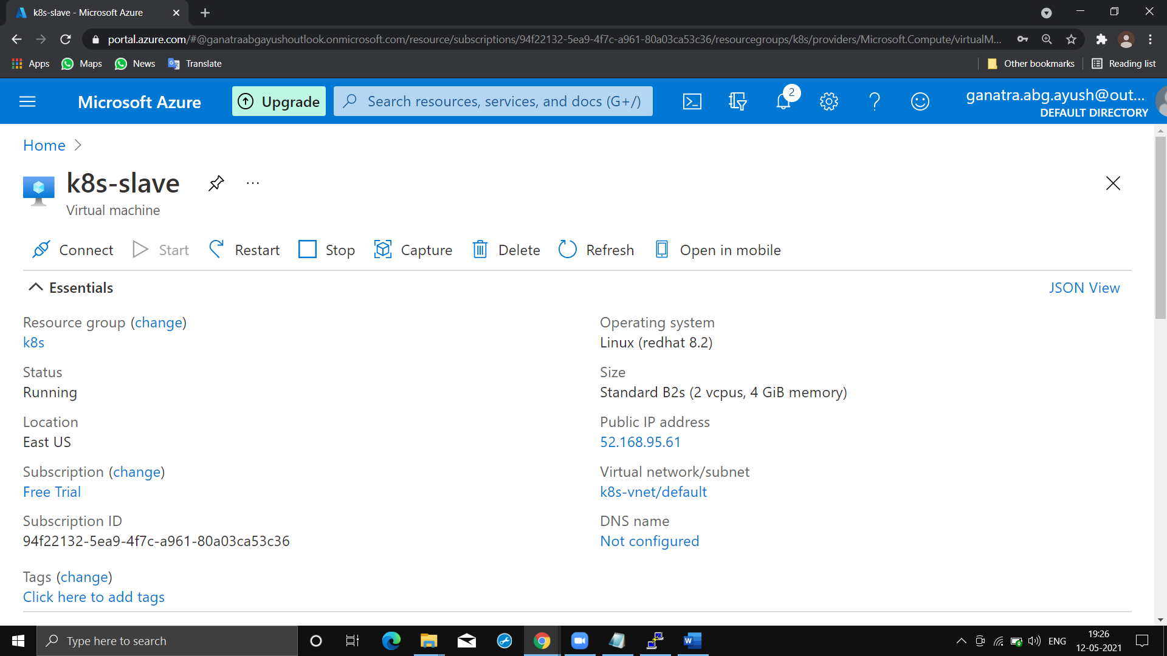

Region:

East US

(Virginia)

🎯One K8s slave over **GCP**:

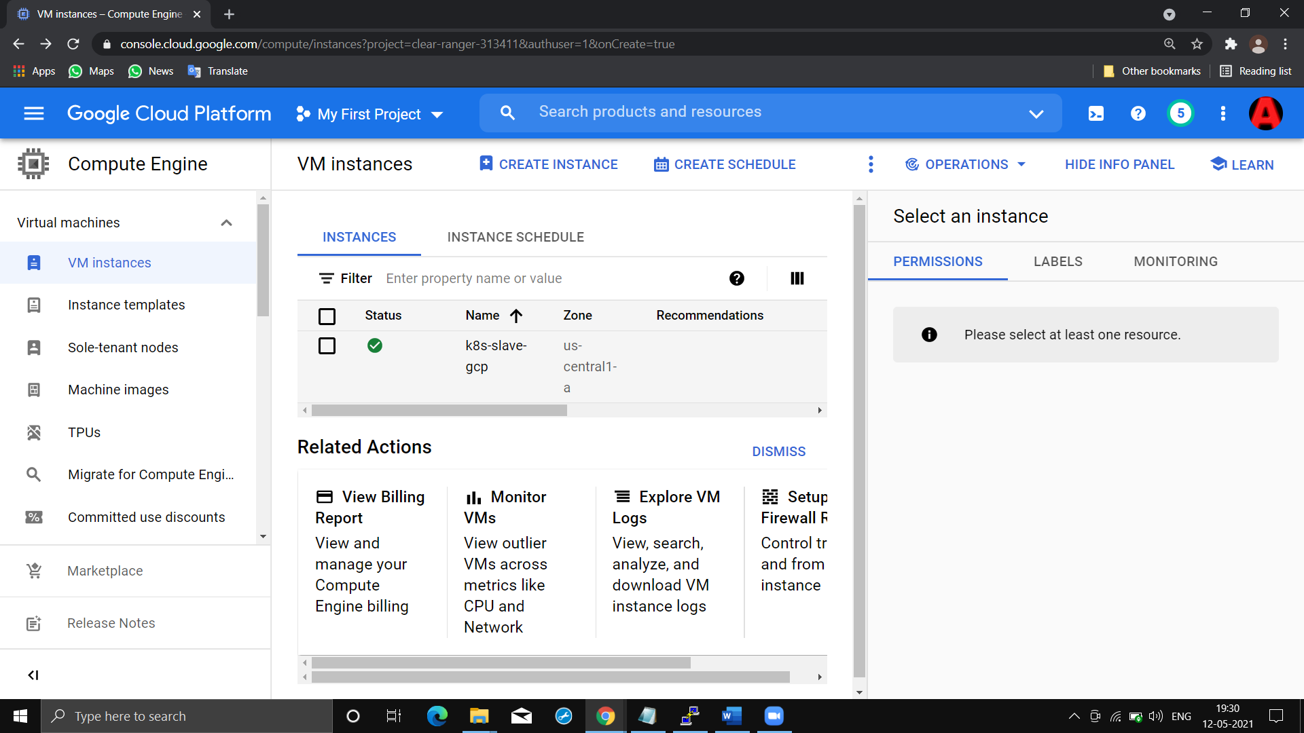

Region:

East US

(Council Bluffs, Iowa)

🎯**Output** from Master:

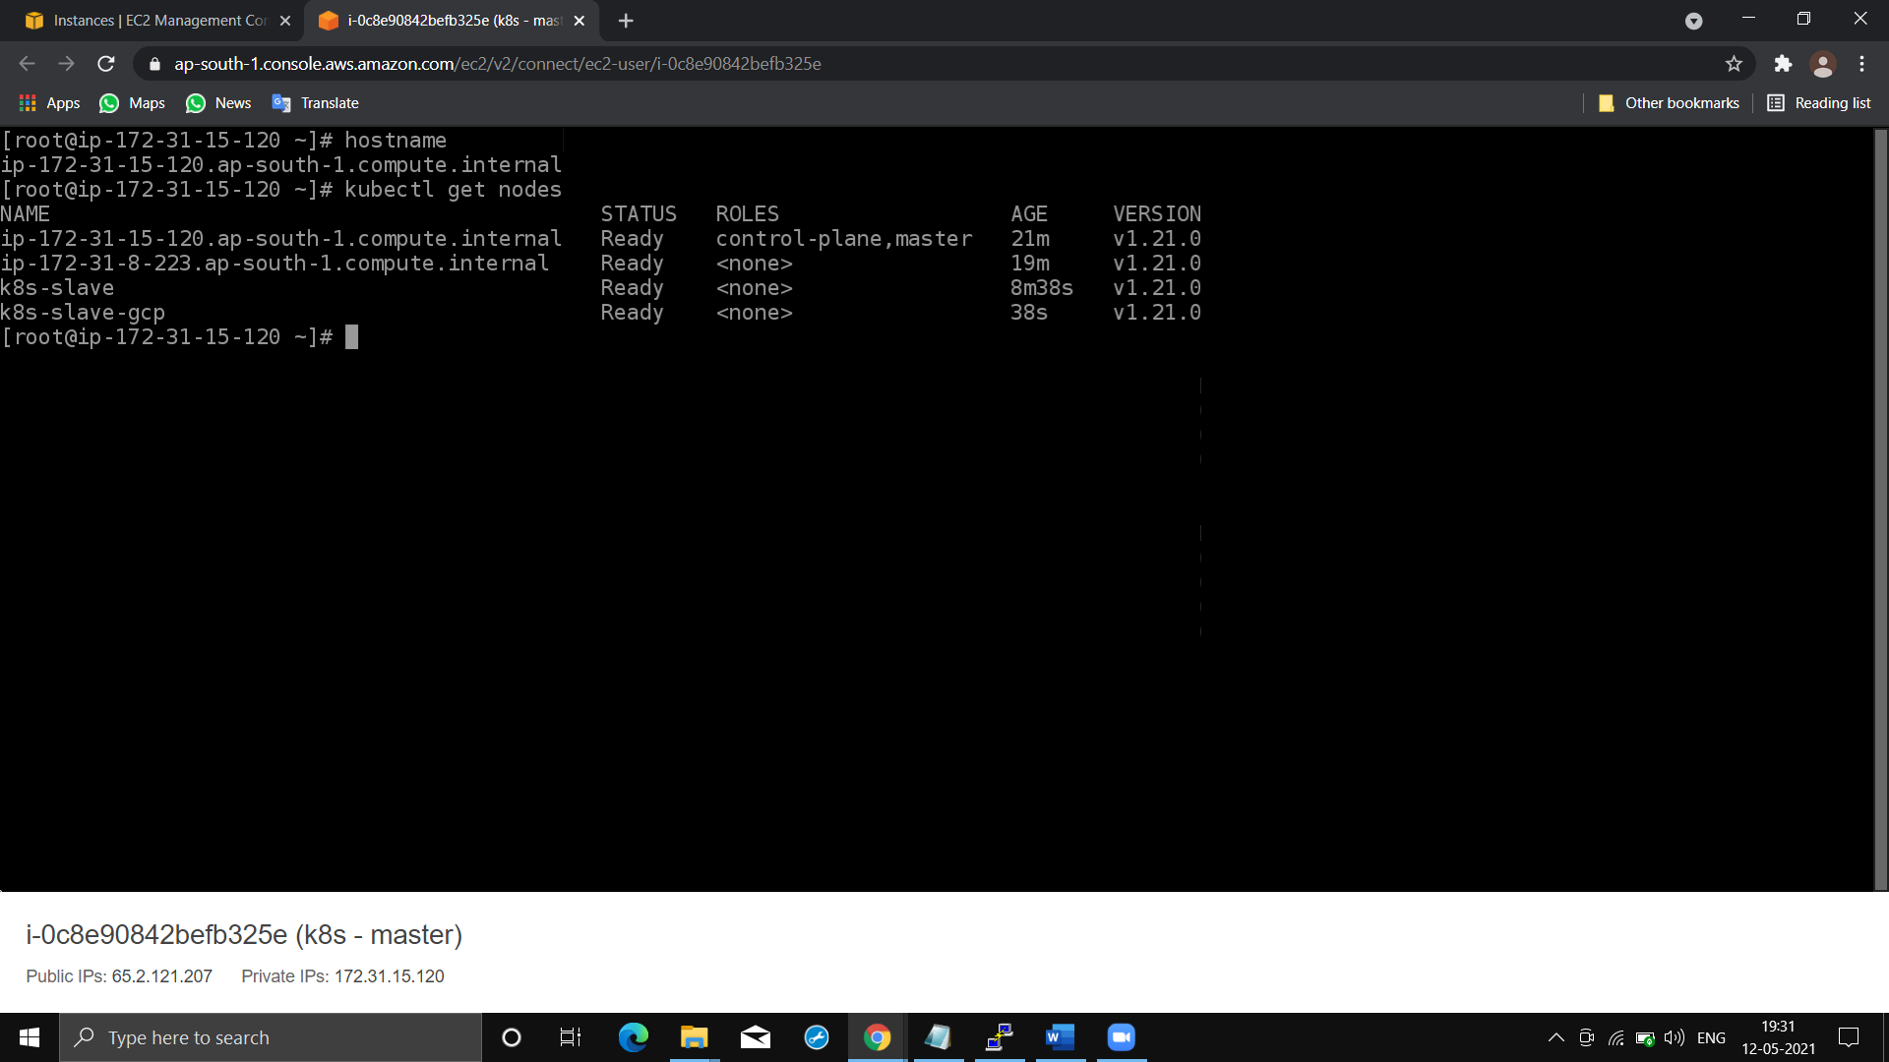

🔸Here, **k8s-slave-gcp** is from **GCP**, **k8s-slave** from **AZURE**, **ip-172-31-8-23.ap-south-1** is from **AWS** !!!

🔸We have **master** present in **AWS.**

🔸**Imp.** Points for configuration k8s cluster over multi cloud:

👉We generally join slave with help of token generated by master.

But, if we initiate k8s master using “**kubeadm init”** command & after that if we generate token, it would be generated with the ***private ip*** of master. Hence, only those instance, which are present in VPC of master instance, can become slave.

👉But if we want slaves from internet(public world), then we *can’t simply replace private ip to public ip in token*, it will not work!!!

👉At time of initialization we need to specify that master will work on this ip(public). For that we can use

--**control-plane-endpoint=*Public_ip_master***

with **kubeadm init** command.

Then master would be configured on its public ip!!!

🔥Then with help of token we can connect slaves from internet(Public World)!!!!