Assignment-1

Name – Ayush Patil

Roll no – TYCOC210

Batch - C3

Title - Write a program to compute square of 20-digit large integer numbers using divide and conquer strategy.

Theory -

1. The Karatsuba algorithm is a fast multiplicationb algorithm.

2. The basic principle of Karatsuba's algorithm is [divide-and-conquer](https://en.wikipedia.org/wiki/Divide-and-conquer_algorithm), using a formula that allows one to compute the product of two large numbers and using three multiplications of smaller numbers.

3. The time complexity of Karatsuba algorithm for fast multiplication is **O(n^log3)**.

Solved Example - 123*321

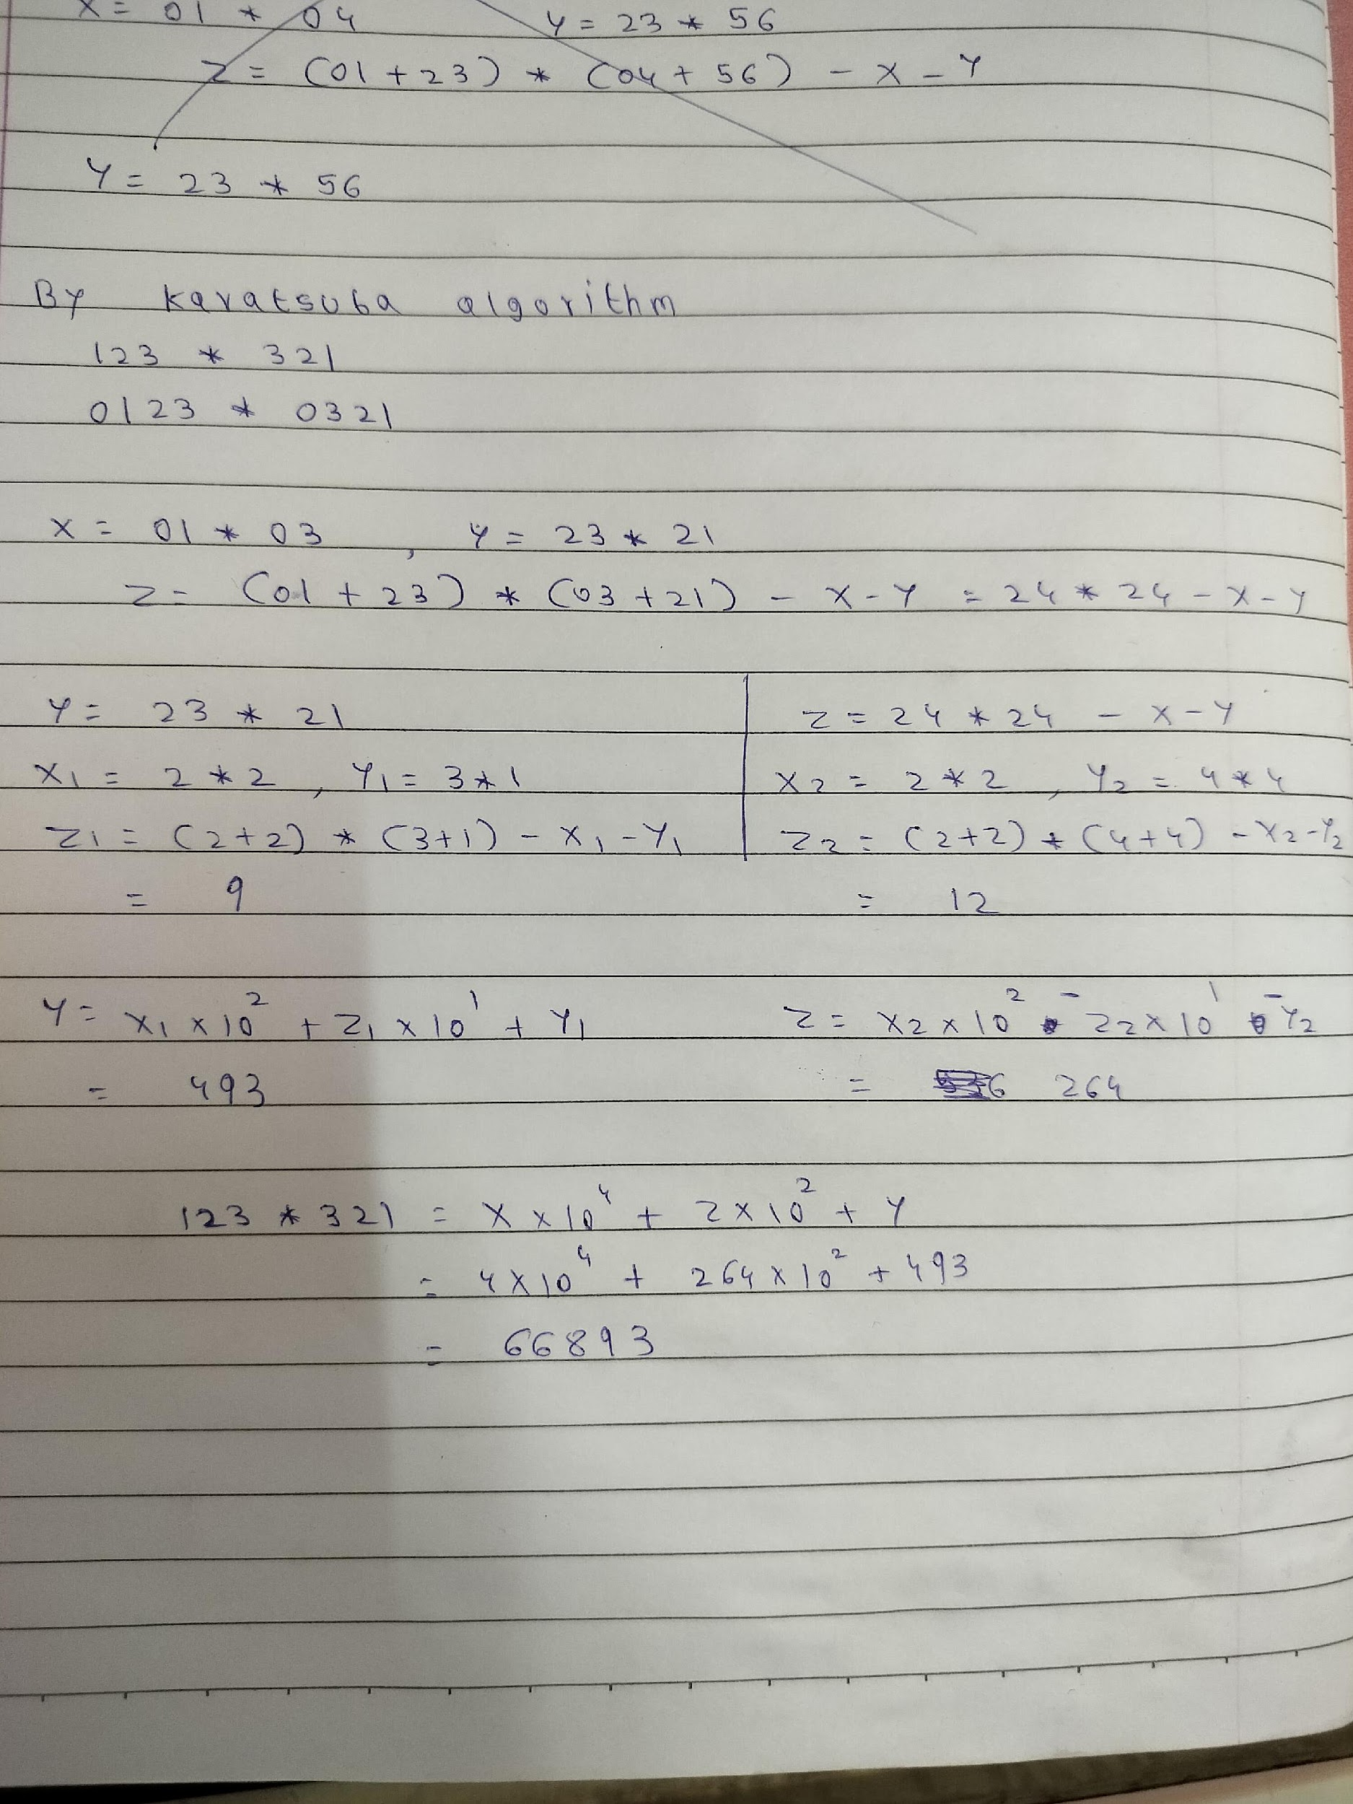

Code -

from math import ceil, floor

def karatsuba(x,y):

if x < 10 and y < 10:

return x*y

n = max(len(str(x)), len(str(y)))

m = ceil(n/2)

x_H = floor(x / 10**m)

x_L = x % (10**m)

y_H = floor(y / 10**m)

y_L = y % (10**m)

a = karatsuba(x_H,y_H)

d = karatsuba(x_L,y_L)

e = karatsuba(x_H + x_L, y_H + y_L) - a - d

return int(a*(10**(m*2)) + e*(10**m) + d)

a = int(input("enter number: "))

print(karatsuba(a,a))

Output -

