**Stock Market Analysis: INTC, MSFT, GOOGL and AAPL**

**INTC (4 Sept 2004 to 4 Sept 2020)**

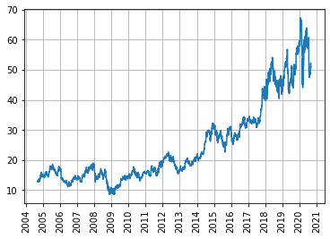

The above plot depicts the stock performance of the Intel corporation on yearly basis. The stock price dipped below $10 in 2009 and reached the maximum price of around $67 in 2020.

**MSFT, GOOGL, AAPL, INTC (4 Sept 2004 to 4 Sept 2020)**

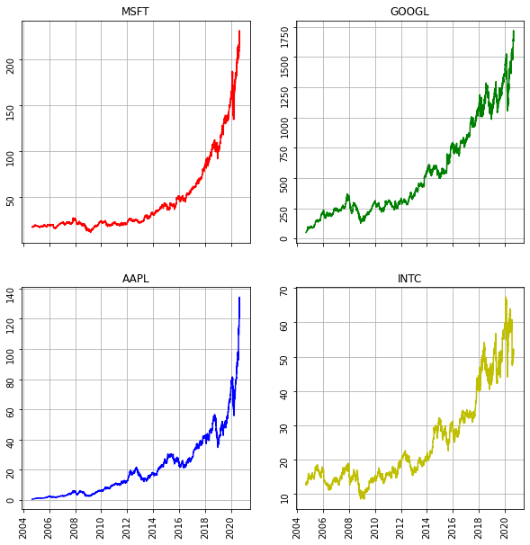

Stocks of MSFT and AAPL have performed fairly well till now. GOOGL and INTL saw their stock prices dipping in 2009.

All these stocks observed a dip in their prices in 2020.

**MSFT ( Jan 2018 to Dec 2018)**

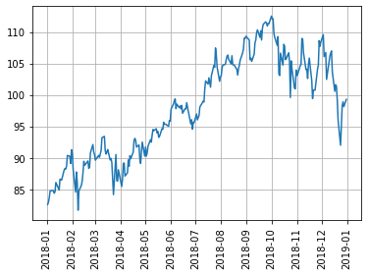

The plot depicts the monthly stock performance of MSFT for the year 2018. The stock prices increase sharply from Jan 2018 to Oct 2018 and then starts to slightly decline in value after that. So, stocks of MSFT performed well from Jan to Oct in the year 2018.

**MSFT, GOOGL, AAPL, INTC ( Jan 2018 to Dec 2018)**

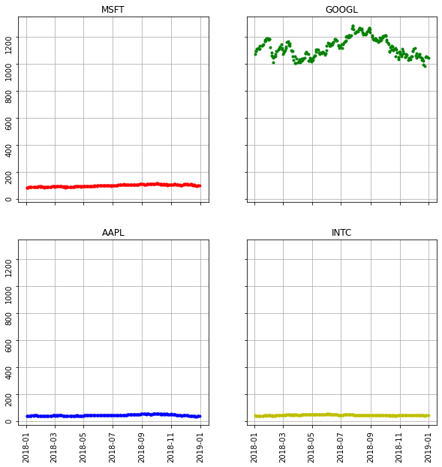

The plots show the monthly stock performance for the year 2018. The stock prices of MSFT, AAPL and INTC are stable. Stocks of GOOGL shows fluctuations. The prices peaked in August, maybe a new product was launched and started to decline in value after August.

At this point we are not able to visualize and compare stocks of different companies because they are not in the same level as they have different prices. We need the concept of moving averages in order to compare them.

**MSFT Quarterly performance 2018**

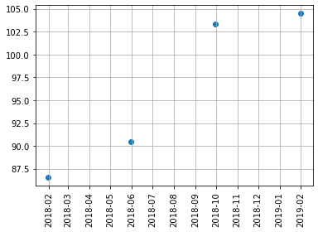

The above plot shows quarterly performance of MSFT stock. For the year 2018, MSFT exhibited good quarterly performance. Note: each dot represents mean stock price for one quarter (3 months).

**MSFT, GOOGL, AAPL, INTC Quarterly performance 2018**

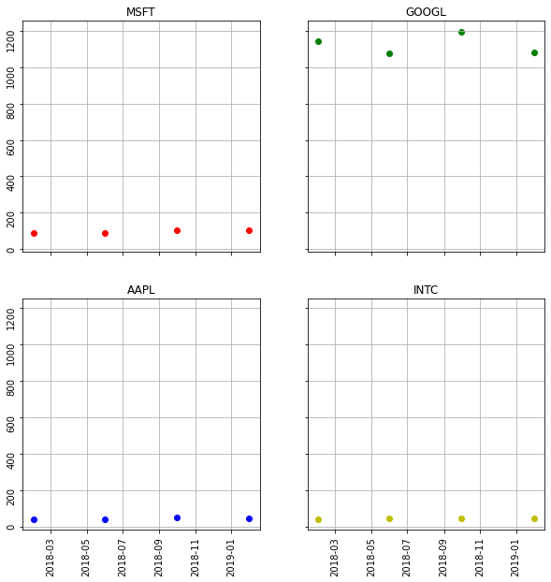

The above plot shows the stock performance on quarterly basis. MSFT, AAPL and INTC stock prices are stable for the year 2018. GOOGL shows fluctuations showing a dip in its performance in second and fourth quarter.

**MSFT Weekly performance**

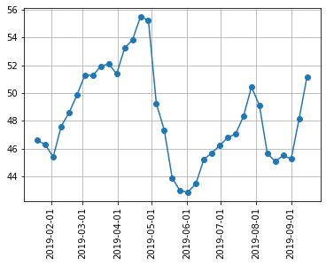

The above plot shows weekly performance of the INTC stock from 15 Jan to 15 Sept 2019. The stock price hits low for the 1st week of June 2019.

**MSFT, GOOGL, AAPL, INTC Weekly performance**

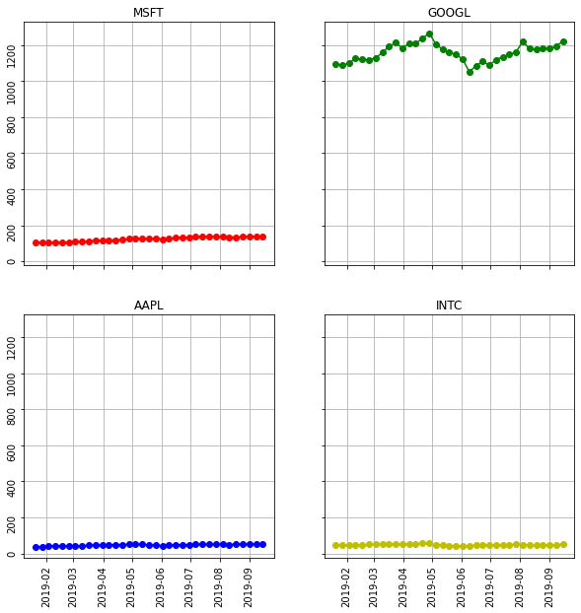

Weekly performance (15 Jan to 15 Sept 2019) of MSFT, GOOGL, AAPL and INTC stocks. Performance of MSFT, AAPL and INTC is stable. Google stocks show fluctuations around this period, hitting low somewhere in 2nd week of June 2019.

Note: The y axis scales of the above plot and the previous plot are different.

**Analyzing difference between levels (Resampling weekly)**

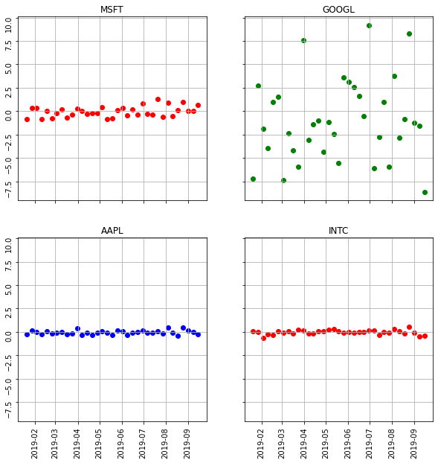

The above plot shows difference price (Open – Close), profit of each stocks from 15 Jan 2019 to 15 Sept 2019 on weekly basis. As it can be seen from the difference that Stocks of AAPL, INTC and MSFT are stable whereas google stock shows large number of highs and lows in its difference value.

**Histogram: daily percent change MSFT (bins = 50)**

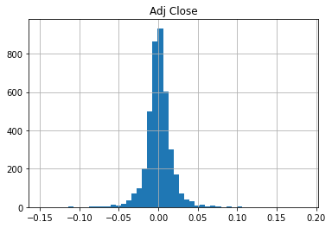

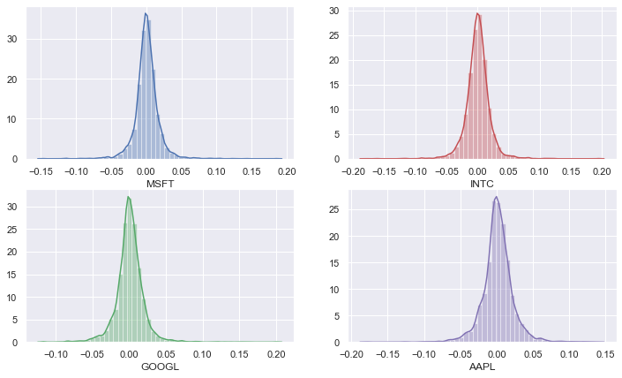

All the above stocks look relatively stable, neither generate a lot of profit nor result in lot of loss. In terms of percent, more profit can be made in INTC and GOOGL stocks as they can go up by 20% as compared to AAPL which can go up by 15%. MSFT and GOOGL stocks will result in lesser loss as compared to the other two.

**Volatility of Microsoft stocks**

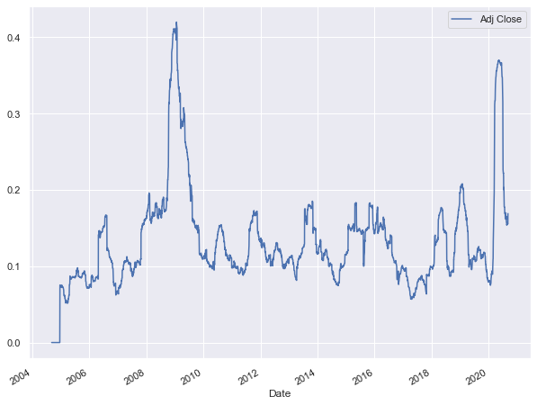

MSFT is less volatile and stable.

**Rolling mean (Trends and seasonality)**

**Window size = 75**

Trends: Short term investment (42 days): follow the orange line

Seasonality: Long term investment (252 days): follow the green line

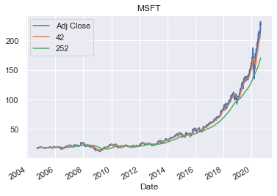

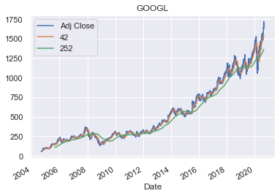

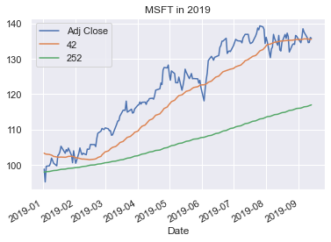

In 2019, MSFT gives better return for short term investment as opposed to long term investment.

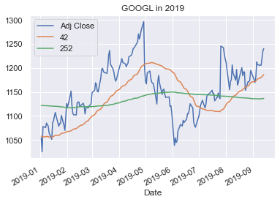

GOOGL stocks give stable returns for long term investments as opposed to short term investment in which stock prices goes up and then comes down.

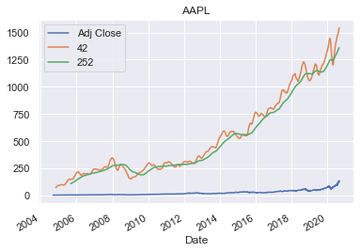

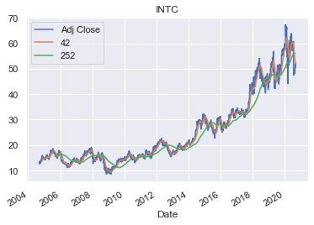

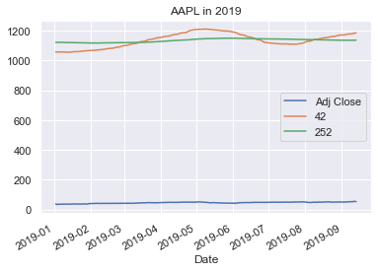

In 2019, Apple stocks give stable returns for long term investment and does not fluctuate much for short term investments as well.

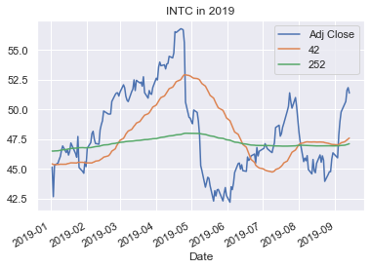

It is advisable to invest in INTC for long term because of the stability.