**Big O Notation:-**

Big O Notation is a way to describe how fast or slow an algorithm is. It helps us understand how the time or memory needed by a program grows when the amount of data increases.

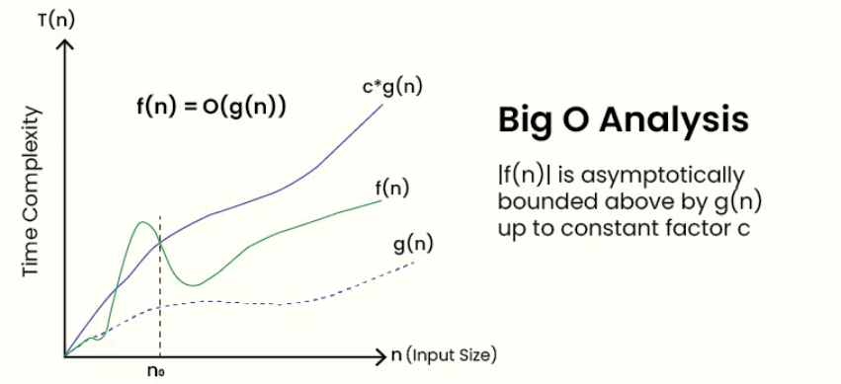

**Complexity Chart:-**

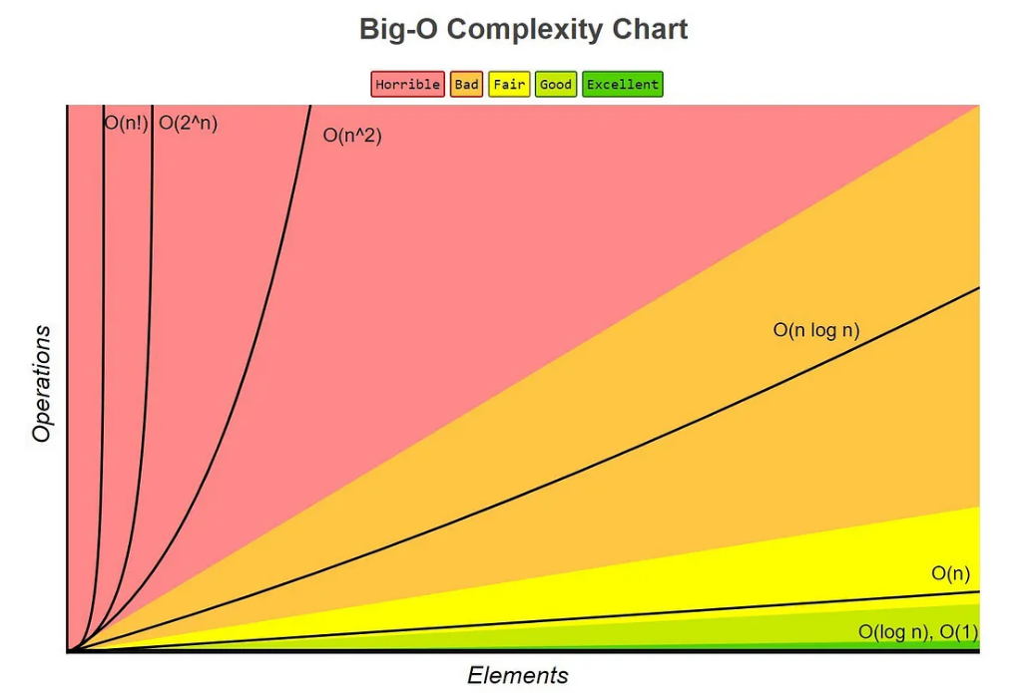

**Best, Average, Worst Case:-**

Best Case – The fastest it can run (e.g., the item you're searching for is the first one).

Average Case – What usually happens with random inputs.

Worst Case – The slowest it can run (e.g., the item is last or not there at all).

**For Linear Search:-**

* **Best Case -> O(1)**
* **Average Case -> O(N)**
* **Worst Case -> O(N)**

**For Binary Search:-**

* **Best Case -> O(1)**
* **Average Case -> O(Log N)**
* **Worst Case -> O(Log N)**

**Which is Better For E-commerce Platform?**

* **For an e-commerce platform, binary search is more suitable because it's faster (O(Log N)) and works well with sorted data, which is common in product lists. It provides quick results especially when there are many products.**
* **Linear search (O(N)) can still be useful for small or unsorted data, but it's slower for large datasets.**
* **Overall, binary search is better for performance and is ideal when the product list is sorted.**

**Ayush Kumar (6363303)**