**Superset id:- 6363303**

**Exercise 1: Create a Stored Procedure**

**Q.1**

**1. Define the stored procedure with a parameter for DepartmentID.**

**2. Write the SQL query to select employee details based on the DepartmentID.**

**3.Create a stored procedure named `sp_InsertEmployee`.**

**Exercise 1:- Create a Stored Procedure**

**Stored procedure with a parameter for DepartmentID**

CREATE PROCEDURE sp_GetEmployeesByDepartment

@DepartmentID INT

AS

BEGIN

SELECT EmployeeID, FirstName, LastName, Salary, JoinDate

FROM Employees

WHERE DepartmentID = @DepartmentID;

END;

**Execute a SQL query to select employee details based on the DepartmentID:-**

EXEC sp_GetEmployeesByDepartment @DepartmentID = 4;



**Stored procedure to insert a new employee:-**

CREATE PROCEDURE sp_InsertEmployee

@FirstName VARCHAR(50),

@LastName VARCHAR(50),

@DepartmentID INT,

@Salary DECIMAL(10,2),

@JoinDate DATE

AS

BEGIN

INSERT INTO Employees (FirstName, LastName, DepartmentID, Salary, JoinDate)

VALUES (@FirstName, @LastName, @DepartmentID, @Salary, @JoinDate);

END;

**Exercise 4: Execute a Stored Procedure**

EXEC sp_GetEmployeesByDepartment @DepartmentID = 2;



**Exercise 5: Return Data from a Stored Procedure**

CREATE PROCEDURE sp_GetEmpCount

@DepartmentID INT

AS

BEGIN

SELECT COUNT(*) AS EmployeeCount

FROM Employees

WHERE DepartmentID = @DepartmentID;

END;

EXEC sp_GetEmpCount @DepartmentID = 3;



**Exercise 2 : Functions**

**Exercise 1:- Create a scalar function to calculate the annual salary of an employee.**

CREATE FUNCTION fn_CalculateAnnualSalary (@Salary DECIMAL(10,2))

RETURNS DECIMAL(10,2)

AS

BEGIN

RETURN @Salary * 12;

END;

GO

SELECT EmployeeID, FirstName, LastName,

dbo.fn_CalculateAnnualSalary(Salary) AS AnnualSalary

FROM Employees;

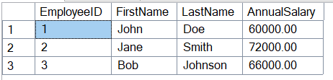

**Ex.2 Create a table-valued function to return employees in a specific department.**

CREATE FUNCTION fn_GetEmployeesByDepartment (@DeptID INT)

RETURNS TABLE

AS

RETURN (

SELECT EmployeeID, FirstName, LastName, DepartmentID, Salary, JoinDate

FROM Employees

WHERE DepartmentID = @DeptID

);

GO

SELECT * FROM dbo.fn_GetEmployeesByDepartment(2);



**Ex.3 Create a user-defined function to calculate the bonus for an employee..**

CREATE FUNCTION fn_CalculateBonus (@Salary DECIMAL(10,2))

RETURNS DECIMAL(10,2)

AS

BEGIN

RETURN @Salary * 0.10;

END;

GO

SELECT EmployeeID, FirstName, LastName,

dbo.fn_CalculateBonus(Salary) AS Bonus

FROM Employees;

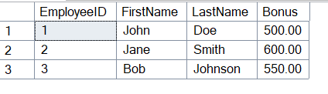

**Ex.4 Modify the `fn_CalculateBonus` function to return `Salary * 0.15`.**

ALTER FUNCTION fn_CalculateBonus (@Salary DECIMAL(10,2))

RETURNS DECIMAL(10,2)

AS

BEGIN

RETURN @Salary * 0.15;

END;

GO

SELECT EmployeeID, FirstName, LastName,

dbo.fn_CalculateBonus(Salary) AS NewBonus

FROM Employees;

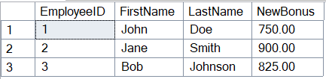

**Ex.5 Delete the `fn_CalculateBonus` function.**

DROP FUNCTION fn_CalculateBonus;

GO

**Ex.6 Execute the `fn_CalculateAnnualSalary` function.**

SELECT EmployeeID, FirstName, LastName,

dbo.fn_CalculateAnnualSalary(Salary) AS AnnualSalary

FROM Employees;

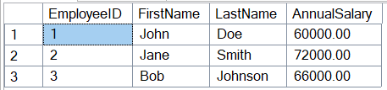

**Ex.7 Return the annual salary for a specific employee using `fn_CalculateAnnualSalary`.**

SELECT FirstName, LastName,

dbo.fn_CalculateAnnualSalary(Salary) AS AnnualSalary

FROM Employees

WHERE EmployeeID = 1;



**Ex.8 Return employees from the Finance department using**

**`fn_GetEmployeesByDepartment`.**

SELECT * FROM dbo.fn_GetEmployeesByDepartment(3);



**Ex.9 Create a nested user-defined function to calculate the total compensation for an employee.**

CREATE FUNCTION fn_CalculateBonus (@Salary DECIMAL(10,2))

RETURNS DECIMAL(10,2)

AS

BEGIN

RETURN @Salary * 0.15;

END;

GO

CREATE FUNCTION fn_CalculateTotalCompensation (@Salary DECIMAL(10,2))

RETURNS DECIMAL(10,2)

AS

BEGIN

RETURN dbo.fn_CalculateAnnualSalary(@Salary) + dbo.fn_CalculateBonus(@Salary);

END;

GO

SELECT EmployeeID, FirstName, LastName,

dbo.fn_CalculateTotalCompensation(Salary) AS TotalCompensation

FROM Employees;

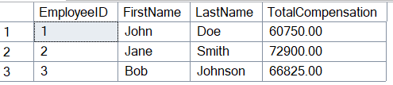

**Ayush Kumar (6363303)**