Software Engineering Pre-Implementation Use Case Specification

SmartCart Distributed E-Commerce Platform
Document Identifier: UCS-SIMPLE-001
Document Version: 1.0.0 (Pre-Implementation Baseline)
Lifecycle Phase: Requirements Engineering & Pre-Implementation Modeling
Specification Standard: OMG Unified Modeling Language (UML) 2.5 / ISO/IEC/IEEE 29148
Engineering Team: Group 03 (TeamID 03)
Date: October 19, 2026
Status: Approved Engineering Baseline
Project Repository:
https://github.com/Ayush17314/SmartCartDeliverables Drive: https://drive.google.com/drive/folders/1q9IY8r2_aUCeogiUsT0tpODwt3hF6PHL?usp=sharing

Executive Summary
In classical Software Engineering (SE), the Use Case Model is formulated during the Requirements Analysis Phase—strictly before system design and coding commence. Its primary objective is to capture the functional scope of the proposed system from the perspective of its external users (actors), establishing a clear, unambiguous behavioral contract between stakeholders, developers, and quality assurance engineers.
This document presents the simplified, pre-implementation Use Case Model for the SmartCart E-Commerce Platform, organized around:
1. Core Actors: Member (Registered Customer), Admin (Store Administrator), and Payment Gateway (External System Actor).
2. Shared / System Use Cases: Common capabilities accessible across roles (Authentication, Catalog Search, Product Details).
3. Member Use Cases: End-to-end customer purchasing workflow (Shopping Cart, Checkout, Tracking, Reviews).
4. Admin Use Cases: Operational management capabilities (Product catalog, Order fulfillment, Promotions, Analytics).
5. Relationship Mechanics: Exhaustive analysis of <<include>> (mandatory dependencies) versus <<extend>> (conditional/optional extensions) relationships.

1. System Use Case Diagram
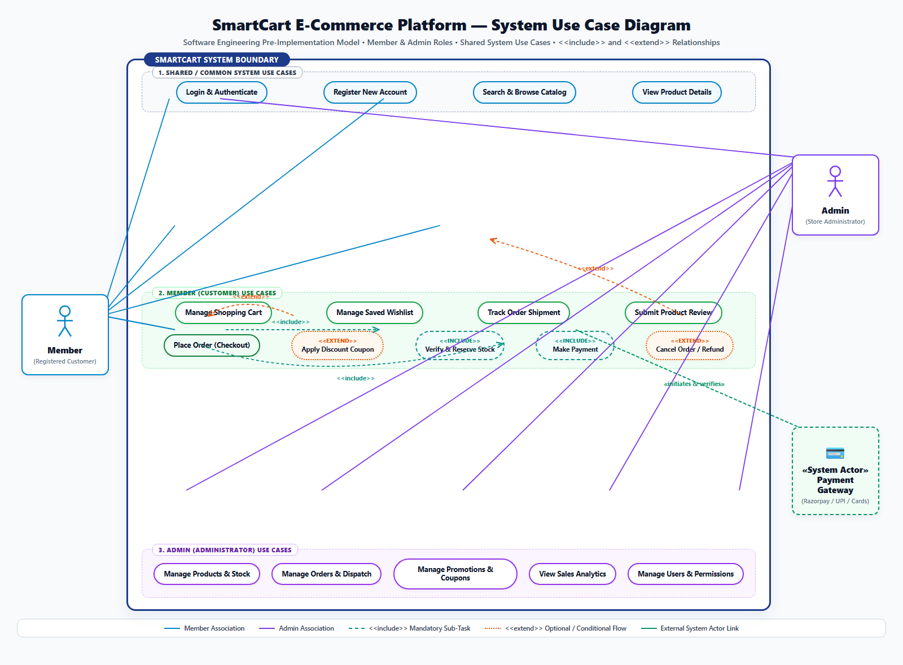
The visual diagram below represents the simplified, pre-implementation UML 2.5 Use Case Diagram for the SmartCart platform:
┌────────────────────────────────────────────────────────────────────────────────────────┐
│ SMARTCART E-COMMERCE SYSTEM BOUNDARY │
├────────────────────────────────────────────────────────────────────────────────────────┤
│ │
│ [ 1. SHARED / SYSTEM USE CASES ] │
│ (•) Login & Authenticate │
│ (•) Register New Account │
│ (•) Search & Browse Catalog │
│ (•) View Product Details │
│ │
│ [ 2. MEMBER (CUSTOMER) USE CASES ] │
│ (•) Manage Shopping Cart │
│ (•) Manage Saved Wishlist │
│ (•) Track Order Shipment │
│ (•) Submit Product Review │
│ (•) Place Order (Checkout) ────────────────────────────────────────────────────────┐ │
│ │ │ │
│ ├── <<include>> ──► (•) Verify & Reserve Stock │ │
│ ├── <<include>> ──► (•) Make Payment ─── [Payment Gateway API] │ │
│ └── <<extend>> ◄── (•) Apply Discount Coupon (Extension Point: Promo Code) │ │
│ │ │
│ (•) Cancel Order / Refund ── <<extend>> ──► Track Order Shipment │ │
│ │ │
│ [ 3. ADMIN (ADMINISTRATOR) USE CASES ] │
│ (•) Manage Products & Stock │
│ (•) Manage Orders & Dispatch (CONFIRMED -> SHIPPED -> DELIVERED) │
│ (•) Manage Promotions & Coupons │
│ (•) View Sales Analytics & Reports │
│ (•) Manage Users & Permissions │
│ │
└────────────────────────────────────────────────────────────────────────────────────────┘

2. Core Concepts: Pre-Implementation Use Case Modeling
In the Software Engineering Life Cycle (SDLC), authoring the use case model prior to implementation serves four crucial engineering purposes:
- Scope Demarcation: The System Boundary rectangle clearly separates what the SmartCart application is responsible for executing versus what external entities (users, third-party payment gateways) handle.
- Black-Box Functional Modeling: Use cases describe what the system shall do to deliver measurable business value to an actor, without prescribing how internal database queries or code algorithms are written.
- Actor Role Separation: Clearly decouples public shopping privileges from administrative operations, laying the groundwork for Role-Based Access Control (RBAC).
- Test Case Derivation: Each use case, along with its <<include>> and <<extend>> branches, directly maps to high-level integration and acceptance test scenarios.

3. Actor Classification & Profiles
An Actor represents any external entity that interacts with the system. Actors are roles, not individuals:
┌───────────────┐ ┌───────────────┐
│ Member │ │ Admin │
│ (Customer) │ │(Administrator)│
└───────┬───────┘ └───────┬───────┘
│ │
▼ ▼
[Public Storefront & Cart] [Administrative Control]
[Purchasing & Tracking] [Catalog, Dispatch, Reports]
│ │
└───────────────────────┬───────────────────────┘
▼
┌───────────────────────────┐
│ «System Actor» Gateway │
│ (Razorpay / UPI / Cards) │
└───────────────────────────┘

3.1 Primary Human Actors

1. Member (Registered Customer)
- Role Definition: The primary end-user who visits the e-commerce storefront to purchase products.
- Operational Scope:
- Authenticates into personal account.
- Searches catalog, applies category filters, and inspects product specifications.
- Adds items to cart, adjusts quantities, and saves items to wishlist.
- Executes checkout transactions, applies coupons, and completes payments.
- Tracks shipment status and requests cancellations/refunds when eligible.

2. Admin (Store Administrator)
- Role Definition: The operational authority responsible for inventory control, order fulfillment, marketing promotions, and platform governance.
- Operational Scope:
- Authenticates via secure administrative login.
- Creates, edits, and archives product listings; updates warehouse stock levels.
- Advances order fulfillment states (CONFIRMED $\rightarrow$ SHIPPED $\rightarrow$ DELIVERED); assigns courier tracking.
- Configures coupon promotional codes and discount thresholds.
- Inspects real-time sales revenue, volume metrics, and user permissions.

3.2 External System Actor

3. Payment Gateway (Razorpay / Banking Network)
- Role Definition: An external, autonomous cloud partner system that interacts with SmartCart over secure HTTPS protocols to handle financial transactions.
- Operational Scope:
- Accepts payment initialization intents from the SmartCart checkout process.
- Authenticates digital cards, UPI handles, and net banking credentials.
- Emits cryptographic confirmation signatures (HMAC-SHA256) and asynchronous webhook event notifications.
- Executes financial refund reversals upon authorized administrative cancellation.

4. Functional Grouping of Use Cases

4.1 Group 1: Shared / Common System Use Cases
These use cases represent core baseline functionality shared across user roles or accessible to all visitors:
Use Case Name | Participating Actors | Functional Description
Login & Authenticate | Member, Admin | Verifies user credentials (email/password) using cryptographic hashing; returns an authenticated session.
Register New Account | Member (Guest) | Onboards a new customer by recording contact details, shipping address, and password.
Search & Browse Catalog | Member, Admin | Provides multi-attribute text search, category filtering, and sorting by price or popularity.
View Product Details | Member, Admin | Displays comprehensive product descriptions, high-resolution images, real-time stock availability, and verified customer ratings.

4.2 Group 2: Member (Customer) Use Cases
These use cases encapsulate the core commercial shopping experience:
Use Case Name | Primary Actor | Functional Description
Manage Shopping Cart | Member | Enables adding products, modifying item quantities, removing items, and calculating server-authoritative line subtotals.
Manage Saved Wishlist | Member | Allows saving desired items for future consideration and provides a single-click move-to-cart operation.
Place Order (Checkout) | Member | The central purchasing workflow coordinating cart validation, stock reservation, and payment initiation.
Make Payment | Member, Payment Gateway | Facilitates monetary settlement through digital channels (UPI, Credit/Debit cards via Razorpay) or offline Cash on Delivery (COD).
Track Order Shipment | Member | Provides real-time visibility into order progress ( PENDING $\rightarrow$ CONFIRMED $\rightarrow$ SHIPPED $\rightarrow$ DELIVERED ).
Cancel Order / Refund | Member | Permits cancellation and initiates financial refund if the order has not yet been dispatched by the warehouse.
Submit Product Review | Member | Allows verified buyers to submit star ratings (1–5) and written feedback for delivered merchandise.

4.3 Group 3: Admin (Administrator) Use Cases
These use cases encompass store operations, fulfillment, and business oversight:
Use Case Name | Primary Actor | Functional Description
Manage Products & Stock | Admin | Grants full CRUD permissions over catalog listings; records inventory adjustments with mandatory audit justifications.
Manage Orders & Dispatch | Admin | Inspects incoming orders, verifies payments, marks orders as SHIPPED , and attaches carrier tracking identifiers.
Manage Promotions & Coupons | Admin | Creates, edits, and deactivates promotional discount codes ( PERCENTAGE or FIXED ), setting expiration dates and minimum spends.
View Sales Analytics | Admin | Displays aggregated dashboards summarizing revenue, order volume, best-selling products, and active customer counts.
Manage Users & Permissions | Admin | Manages user account statuses (active/suspended), provisions staff invitations, and assigns role permissions.

5. Relationship Mechanics: <<include>> vs. <<extend>>
In UML use case modeling, relationships between use cases are governed by strict semantic rules. Understanding the distinction between <<include>> and <<extend>> is a central requirement of software engineering requirements analysis:
┌────────────────────────────────────────────────────────────────────────┐
│ INCLUDE vs. EXTEND COMPARISON │
├───────────────────────────────┬────────────────────────────────────────┤
│ <<include>> (Mandatory) │ <<extend>> (Optional / Conditional) │
├───────────────────────────────┼────────────────────────────────────────┤
│ • Base ALWAYS executes it. │ • Base executes WITHOUT it normally. │
│ • Unconditional sub-routine. │ • Triggered ONLY at Extension Point. │
│ • Arrow: Base ──► Included │ • Arrow: Extending ──► Base │
│ • Example: Checkout includes │ • Example: Coupon code optionally │
│ Stock Check & Payment. │ extends Checkout. │
└───────────────────────────────┴────────────────────────────────────────┘

5.1 The <<include>> Relationship (Mandatory Dependency)

Definition
An <<include>> relationship indicates that the base use case unconditionally incorporates the behavior of another use case. The base use case cannot complete successfully without executing the included use case. It represents mandatory, reusable logic factored out of multiple use cases.

Notation
- Drawn as a dashed arrow pointing from the Base Use Case to the Included Use Case:
$$\text{Base Use Case} \xrightarrow{\quad\text{<>}\quad} \text{Included Use Case}$$

Concrete Examples in SmartCart:
- Place Order $\xrightarrow{\text{<>}}$ Verify & Reserve Stock
- Rationale: An order must always verify that inventory is in stock and atomically reserve that stock. An order can never be placed without reserving inventory.
- Place Order $\xrightarrow{\text{<>}}$ Make Payment
- Rationale: Placing an order must always initiate a financial settlement (either by creating a Razorpay digital intent or scheduling a Cash on Delivery collection).
- Make Payment $\xrightarrow{\text{<>}}$ Verify Payment (Payment Gateway)
- Rationale: Digital payment completion must always verify the cryptographic HMAC-SHA256 signature returned by the external gateway before acknowledging success.

5.2 The <<extend>> Relationship (Optional / Conditional Flow)

Definition
An <<extend>> relationship indicates that a use case conditionally augments or inserts behavior into another base use case. The base use case is completely functional on its own and does not know about the extending use case. The extension occurs only when a specific condition (Extension Point) is satisfied.
[!NOTE]
In software engineering discussions, students and developers often refer to "include / exclude" when contrasting mandatory sub-tasks (<<include>>) with optional, conditional branches (<<extend>>). In formal UML, the correct term for optional/conditional insertion is <<extend>>.

Notation
- Drawn as a dashed arrow pointing from the Extending Use Case to the Base Use Case:
$$\text{Extending Use Case} \xrightarrow{\quad\text{<>}\quad} \text{Base Use Case}$$

Concrete Examples in SmartCart:
- Apply Discount Coupon $\xrightarrow{\text{<>}}$ Place Order
- Extension Point: Customer enters a promotional discount code during checkout.
- Condition: [Customer supplies a valid coupon code].
- Behavior: If the customer has no coupon, the base checkout proceeds normally without this step. Only when a coupon is supplied does this extension execute to compute a price reduction.
- Cancel Order / Refund $\xrightarrow{\text{<>}}$ Track Order Shipment
- Extension Point: Customer reviews an existing order on the tracking dashboard.
- Condition: [Order Status == PENDING or CONFIRMED (Not yet SHIPPED)].
- Behavior: Customers tracking an order normally just view delivery milestones. Only if the order is still prior to warehouse dispatch can they conditionally invoke cancellation and refund.

5.3 Comparative Matrix: <<include>> vs. <<extend>>
Evaluation Criteria | <<include>> (Mandatory) | <<extend>> (Optional / Conditional)
Necessity | Mandatory: The base use case cannot complete without it. | Optional: The base use case completes successfully with or without it.
Arrow Direction | Points from Base to Included use case. | Points from Extending to Base use case.
Trigger Mechanism | Invoked unconditionally during normal main flow. | Invoked only when a defined Extension Point condition evaluates to true.
Base Case Awareness | Base use case explicitly knows about and calls the included case. | Base use case is agnostic of the extension; the extending case specifies where it hooks in.
Primary SE Purpose | Code reusability; decomposing complex transactions. | Modeling optional features, special business rules, or alternative exceptions.
SmartCart Example | Place Order includes Verify Stock & Make Payment . | Apply Coupon extends Place Order ; Cancel extends Track Order .

6. Tabular Specifications for Core Use Cases

UC-01: Place Order (Checkout)
- Primary Actor: Member (Registered Customer)
- Secondary Actors: Payment Gateway (External), Inventory System
- Relationship Stereotypes: <<include>> Verify & Reserve Stock, <<include>> Make Payment, <<extend>> Apply Discount Coupon
- Preconditions: Member is authenticated; shopping cart has $\ge 1$ item; shipping address is provided.
- Postconditions: Order created in PENDING state; inventory reserved; payment recorded; cart cleared.
┌────────┐ ┌────────────────────┐ ┌─────────────────┐
│ Member │ │ SmartCart Platform │ │ Payment Gateway │
└───┬────┘ └─────────┬──────────┘ └────────┬────────┘
│ 1. Initiate Checkout │ │
├───────────────────────────►│ │
│ │ 2. <<include>> Check Stock │
│ │ 3. <<extend>> Apply Coupon │
│ │ 4. <<include>> Make Payment │
│ ├────────────────────────────────►│
│ │ 5. Verify Signature │
│ 6. Order Confirmed (201) │◄────────────────────────────────┤
│◄───────────────────────────┤ │
Step | Actor / System Action
1 | Member initiates checkout by submitting shipping address and payment method choice.
2 | <<include>> Verify & Reserve Stock: System checks inventory availability. If sufficient, temporarily reserves stock; if insufficient, checkout aborts with an out-of-stock message.
3 | <<extend>> Apply Discount Coupon: (Extension Point: Promo Code) If Member entered a promo code, system validates discount rules and deducts percentage/fixed amount from order total.
4 | System calculates taxes and shipping costs, generating final total amount.
5 | <<include>> Make Payment: System invokes Payment Gateway intent (Razorpay) or flags order as Cash on Delivery (COD).
6 | System clears Member's cart, saves order record, and emits confirmation receipt.

UC-02: Manage Products & Stock (Admin)
- Primary Actor: Admin (Store Administrator)
- Preconditions: Admin has successfully logged in with administrative privileges.
- Postconditions: Catalog listing is updated or created; inventory stock is adjusted with an audit trail.
Step | Actor / System Action
1 | Admin navigates to the Product Management dashboard.
2 | Admin selects an existing product to edit or clicks "Add New Product".
3 | Admin updates product title, category, price, description, and warehouse stock quantity.
4 | Admin enters a mandatory audit note explaining the stock adjustment (e.g., "Restocked from supplier shipment #4102" ).
5 | System validates that price is non-negative and explanation note is provided.
6 | System commits the changes to database, generates a fresh entity version (ETag), and logs the audit event.
7 | System displays confirmation notification to Admin.

7. Traceability to Microservices Implementation
This pre-implementation use case model directly guided the modular architecture of SmartCart across its eight microservices:
Use Case Package | Model Scope | Implementing Microservice | Allocated Port | Database Persistence
Shared Auth | Login, Registration | Auth Service | 4001 | MongoDB ( smartcart_auth )
Shared Catalog | Search, Product Details | Product Service | 4002 | MongoDB ( smartcart_products )
Member Cart | Shopping Cart, Wishlist | Cart & Wishlist Services | 4003 / 4004 | MongoDB ( smartcart_cart , _wishlist )
Member Orders | Place Order, Tracking, Cancel | Order Service | 4005 | MongoDB ( smartcart_orders )
Payments | Make Payment, Razorpay API | Payment Service | 4006 | MongoDB ( smartcart_payments )
Notifications | Transactional Receipts | Notification Service | 4007 | MongoDB ( smartcart_notifications )
System Resilience | Rate Limiting, Idempotency | API Gateway | 4000 | MySQL 8.4 ( smartcart )

8. Conclusion
The simplified pre-implementation Use Case Model provides a clear, standard Software Engineering representation of SmartCart. By categorizing interactions into Shared System Use Cases, Member Use Cases, and Admin Use Cases, and by strictly formalizing <<include>> and <<extend>> relationships, this specification established the binding functional baseline that enabled the seamless, modular construction of the platform.

End of Software Engineering Pre-Implementation Use Case Specification — SmartCart E-Commerce Platform

