System Use Case Specification & Behavioral Modeling

SmartCart E-Commerce Platform — Lab-3 Deliverable
Document Identifier: LAB3-UCS-SMARTCART-001
Document Version: 2.0.0 (Lab-3 Approved Baseline)
Lab Assignment: Lab-3 — Use Case Modeling & Pre-Implementation Behavioral Specification
Specification Standard: OMG Unified Modeling Language (UML) 2.5 / ISO/IEC/IEEE 29148
Lifecycle Phase: Requirements Analysis & Pre-Implementation Modeling
Engineering Team: Group 03 (TeamID 03)
Date of Release: October 2026
Status: Approved Engineering Baseline
Project Repository:
https://github.com/Ayush17314/SmartCartDeliverables Drive: https://drive.google.com/drive/folders/1q9IY8r2_aUCeogiUsT0tpODwt3hF6PHL?usp=sharing

Executive Summary
In Software Engineering (SE), the Use Case Model is the primary functional specification formulated during the Requirements Analysis Phase, created strictly prior to system design, database implementation, and coding. Its objective is to capture the functional requirements of the system from the external perspective of its users (actors), establishing a clear, unambiguous behavioral contract.
For Lab-3, this specification document accompanies and formally defines the SmartCart E-Commerce System Use Case Diagram. The system model comprises:
1. Three Distinct Actors:
- Customer: The primary storefront end-user.
- Admin: The internal operational store administrator.
- «System Actor» Payment Gateway: The external partner service managing digital payment verification and settlement.
2. Three Functional System Blocks:
- Shared Use Cases (Blue Box): Baseline services common to both Customer and Admin (Login & Authenticate, Register Account, Search Catalog, View Product Details).
- Customer Use Cases (Green Box): End-to-end shopping and fulfillment transactions (Manage Cart, Place Order (Checkout), Check Stock, Apply Coupon, Make Payment, Track Order, Cancel Order, Submit Review).
- Admin Use Cases (Orange Box): Operational management capabilities (Manage Products & Stock, Manage Orders & Dispatch, Manage Coupons, View Analytics).
3. Rigorous UML Relationship Semantics:
- «include» Relationships: Mandatory, unconditional sub-processes (Place Order includes Check Stock and Make Payment).
- «extend» Relationships: Optional, conditional branches at designated extension points (Apply Coupon extends Place Order; Cancel Order extends Track Order).
- External System Association: Make Payment connects directly to the external Payment Gateway.

1. System Use Case Diagram
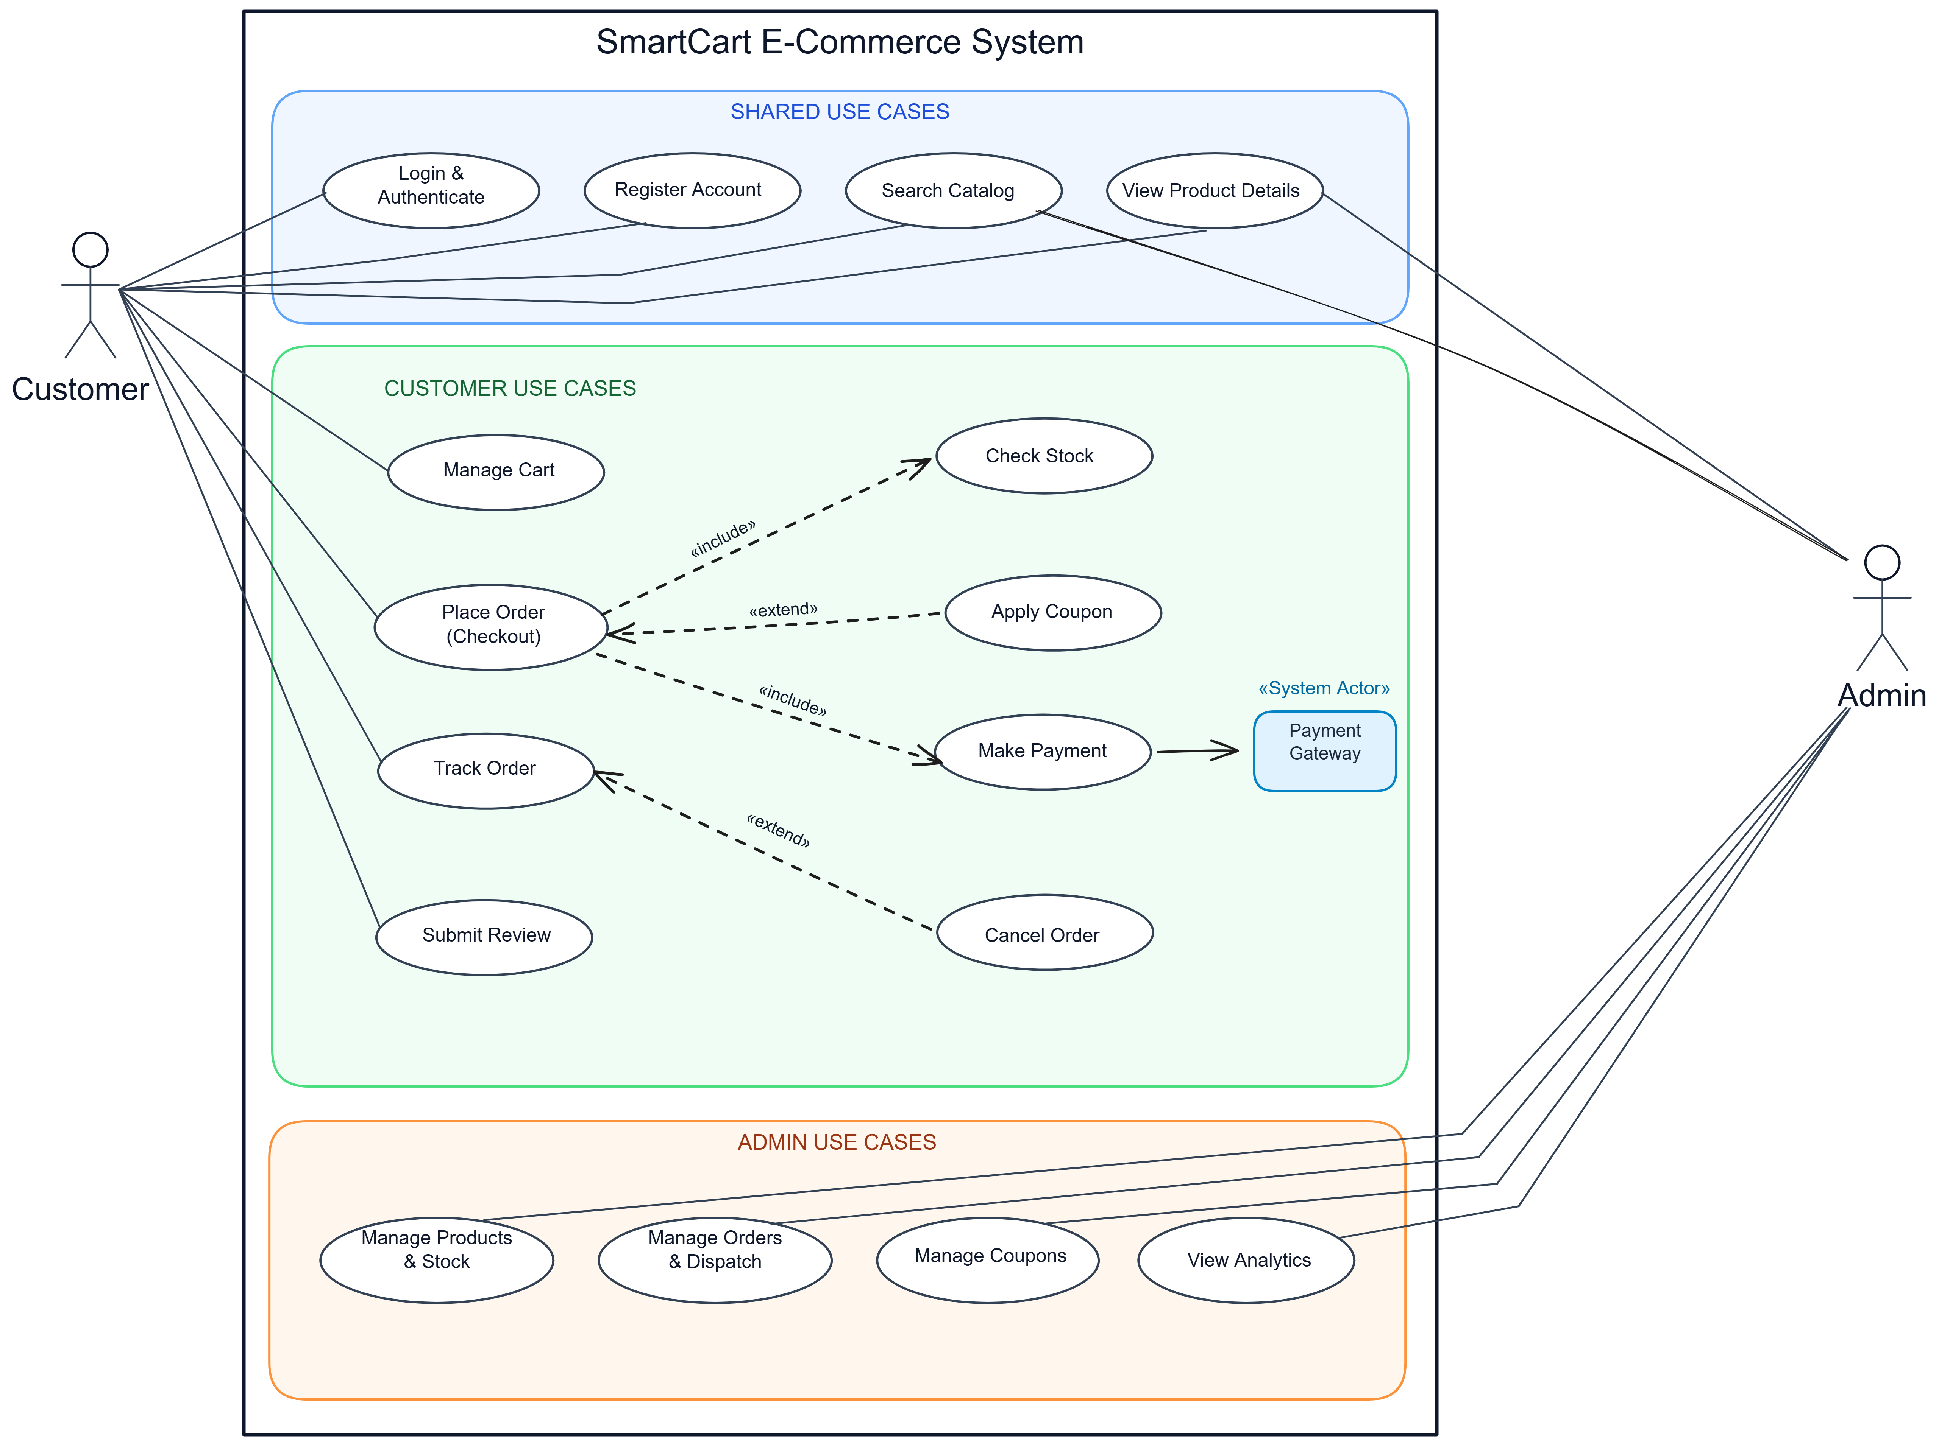
The visual diagram below represents the authoritative UML 2.5 Use Case Diagram for the SmartCart E-Commerce System as established for Lab-3:
┌────────────────────────────────────────────────────────────────────────────────────────┐
│ SMARTCART E-COMMERCE SYSTEM BOUNDARY │
├────────────────────────────────────────────────────────────────────────────────────────┤
│ │
│ [ SHARED USE CASES ] │
│ (•) Login & Authenticate <────────────────────────────────────────── Customer, Admin │
│ (•) Register Account <────────────────────────────────────────────── Customer │
│ (•) Search Catalog <──────────────────────────────────────────────── Customer, Admin │
│ (•) View Product Details <────────────────────────────────────────── Customer, Admin │
│ │
│ [ CUSTOMER USE CASES ] │
│ (•) Manage Cart <─────────────────────────────────────────────────── Customer │
│ (•) Place Order (Checkout) <──────────────────────────────────────── Customer │
│ │ │
│ ├── «include» ──► (•) Check Stock │
│ ├── «include» ──► (•) Make Payment ───► [ «System Actor» Payment Gateway ] │
│ └── «extend» ◄── (•) Apply Coupon │
│ │
│ (•) Track Order <─────────────────────────────────────────────────── Customer │
│ └── «extend» ◄── (•) Cancel Order │
│ (•) Submit Review <───────────────────────────────────────────────── Customer │
│ │
│ [ ADMIN USE CASES ] │
│ (•) Manage Products & Stock <─────────────────────────────────────── Admin │
│ (•) Manage Orders & Dispatch <────────────────────────────────────── Admin │
│ (•) Manage Coupons <──────────────────────────────────────────────── Admin │
│ (•) View Analytics <──────────────────────────────────────────────── Admin │
│ │
└────────────────────────────────────────────────────────────────────────────────────────┘

2. UML Modeling Principles & Notation Conventions
In accordance with the OMG Unified Modeling Language (UML 2.5) and ISO/IEC/IEEE 29148 requirements engineering standards, the Use Case model employs standardized visual and behavioral components:
┌──────────────┐ Association Line ┌───────────────────────────────────┐
│ ├─────────────────────────────────┤ ( Use Case Ellipse ) │
│ Actor │ │ «Discrete Business Function» │
│ (Role/System)│ └─────────────────┬─────────────────┘
└──────────────┘ │
┌──────────────────────┴──────────────────────┐
│ │
«include» «extend»
(Mandatory Flow) (Optional Branch)
▼ ▼
┌───────────────────────────────┐ ┌───────────────────────────────┐
│ Included Use Case │ │ Extension Use Case │
│ (e.g., Check Stock) │ │ (e.g., Apply Coupon) │
└───────────────────────────────┘ └───────────────────────────────┘

2.1 The System Boundary
- The System Boundary (represented by the bold outer rectangle labeled SmartCart E-Commerce System) isolates the internal functional responsibilities of SmartCart from external actors.
- Everything inside the boundary is engineered as part of the SmartCart software platform. Everything outside represents external users or external third-party cloud services.

2.2 Actors
An Actor represents an idealized role played by an external entity when interacting directly with the system:
- Human Actors: Depicted as stick figures (Customer, Admin).
- System Actors: Depicted as rectangular components or stereotyped nodes («System Actor» Payment Gateway).

2.3 Use Cases
A Use Case (represented by a horizontal oval/ellipse) defines a complete set of user-initiated actions that produce an observable result of value to a specific actor.

2.4 Structural Grouping (Domain Packages)
To maintain visual clarity, cohesion, and functional separation, the use cases are partitioned into three dedicated visual zones:
1. Shared Use Cases (Blue Box): Common baseline functions.
2. Customer Use Cases (Green Box): Commercial shopping and order processing.
3. Admin Use Cases (Orange Box): Store administration, catalog governance, and operational analytics.

3. Actor Profiles & Operational Responsibilities
The SmartCart platform defines three primary actors interacting with the system boundary:
┌──────────────┐ ┌──────────────┐
│ Customer │ │ Admin │
│ (Storefront) │ │(Operations) │
└──────┬───────┘ └──────┬───────┘
│ │
▼ ▼
[Public & Account Portals] [Admin Management Suite]
[Purchasing & Tracking] [Catalog, Dispatch, Analytics]
│ │
└──────────────────────┬───────────────────────┘
▼
┌───────────────────────────┐
│ «System Actor» Gateway │
│ (Razorpay / Banking APIs) │
└───────────────────────────┘

3.1 Primary Human Actors

1. Customer (Registered Storefront User)
- Role Classification: Primary Human End-User.
- Operational Scope: Interacts with the public storefront and authenticated customer account interface.
- Direct Associations:
- Login & Authenticate
- Register Account
- Search Catalog
- View Product Details
- Manage Cart
- Place Order (Checkout)
- Track Order
- Submit Review
- Key Objectives: Discover merchandise, manage items in cart, complete secure payment checkouts, monitor parcel shipping, and submit reviews for delivered goods.

2. Admin (Store Administrator)
- Role Classification: Primary Human Operational Actor.
- Operational Scope: Interacts with the authenticated Administrative Management Suite.
- Direct Associations:
- Login & Authenticate
- Search Catalog
- View Product Details
- Manage Products & Stock
- Manage Orders & Dispatch
- Manage Coupons
- View Analytics
- Key Objectives: Maintain catalog listings, manage warehouse inventory stock, advance order fulfillment statuses (CONFIRMED $\rightarrow$ SHIPPED $\rightarrow$ DELIVERED), configure promotional discount coupons, and analyze store revenue performance.

3.2 External System Actor

3. Payment Gateway (Razorpay / Banking Network)
- Role Classification: Secondary Cloud System Actor («System Actor»).
- Operational Scope: Secure financial network communicating over HTTPS REST/Webhook APIs.
- Direct Association: Connects directly with Make Payment.
- Key Objectives: Authorizes digital payment cards, UPI handles, and net banking transactions; verifies cryptographic HMAC-SHA256 signatures; and emits asynchronous payment confirmation webhooks.

4. Subsystem Breakdown: The Three Functional Blocks

4.1 Block 1: Shared Use Cases (Blue Box)
The Shared Use Cases block groups fundamental functions accessible across user roles:
Use Case Name | Connected Actors | Functional Description & Business Objective
Login & Authenticate | Customer, Admin | Verifies user credentials (email and password) via cryptographic hashing; establishes an authenticated session token for role-protected routes.
Register Account | Customer | Onboards new shoppers by recording personal identity, contact email, delivery address, and encrypted credentials.
Search Catalog | Customer, Admin | Provides multi-criteria keyword searching, category filtering, and sorting by price or date to locate inventory items.
View Product Details | Customer, Admin | Renders comprehensive product specifications, high-definition images, price calculations, real-time stock levels, and aggregated reviews.

4.2 Block 2: Customer Use Cases (Green Box)
The Customer Use Cases block encapsulates the core e-commerce shopping experience, order lifecycle, and fulfillment:
Use Case Name | Relationships | Functional Description & Business Objective
Manage Cart | Direct Association | Enables adding products, modifying line-item quantities, removing items, and inspecting server-calculated subtotal amounts.
Place Order (Checkout) | • «include» Check Stock  • «include» Make Payment  • «extend» Apply Coupon | The central checkout transaction. Validates the cart, reserves required stock, evaluates optional promo codes, and coordinates payment.
Check Stock | «include» from Place Order | Verifies product inventory availability in the warehouse database and locks the required quantities during checkout.
Apply Coupon | «extend» to Place Order | Conditionally calculates percentage or fixed discounts when the customer enters a valid promotional code.
Make Payment | • «include» from Place Order  • Links to Payment Gateway | Manages monetary settlement via digital payment gateways (Razorpay UPI/Cards) or offline Cash on Delivery (COD).
Track Order | • Direct Association  • «extend» Cancel Order | Provides real-time visibility into order shipping milestones ( PENDING $\rightarrow$ CONFIRMED $\rightarrow$ SHIPPED $\rightarrow$ DELIVERED ).
Cancel Order | «extend» to Track Order | Conditionally enables order cancellation and financial refund initiation if the parcel has not yet been dispatched by the warehouse.
Submit Review | Direct Association | Allows verified buyers of delivered products to submit star ratings (1–5) and written feedback.

4.3 Block 3: Admin Use Cases (Orange Box)
The Admin Use Cases block provides store operators with full administrative oversight, fulfillment control, and business governance:
Use Case Name | Connected Actors | Functional Description & Business Objective
Manage Products & Stock | Admin | Full CRUD control over catalog items: creating new products, updating prices/descriptions, archiving items, and adjusting stock quantities with audit notes.
Manage Orders & Dispatch | Admin | Inspects customer orders, verifies payment receipts, updates fulfillment statuses ( CONFIRMED $\rightarrow$ SHIPPED $\rightarrow$ DELIVERED ), and enters courier tracking numbers.
Manage Coupons | Admin | Configures marketing campaigns: creating coupon codes, setting discount values ( PERCENTAGE or FIXED ), defining minimum spend thresholds, and setting expiration dates.
View Analytics | Admin | Displays aggregated business intelligence dashboards: gross revenue, total order volume, average order value, low-stock alerts, and top-selling merchandise.

5. Relationship Analysis: «include» vs. «extend»
Understanding the architectural distinction between «include» and «extend» is a central evaluation requirement in Software Engineering requirements modeling:
┌────────────────────────────────────────────────────────────────────────┐
│ INCLUDE vs. EXTEND COMPARISON │
├───────────────────────────────┬────────────────────────────────────────┤
│ «include» (Mandatory) │ «extend» (Optional / Conditional) │
├───────────────────────────────┼────────────────────────────────────────┤
│ • Base ALWAYS executes it. │ • Base executes WITHOUT it normally. │
│ • Unconditional sub-routine. │ • Triggered ONLY at Extension Point. │
│ • Arrow: Base ──► Included │ • Arrow: Extending ──► Base │
│ • Example: Place Order │ • Example: Apply Coupon │
│ includes Check Stock. │ extends Place Order. │
└───────────────────────────────┴────────────────────────────────────────┘

5.1 The «include» Relationship (Mandatory Sub-Tasks)

Definition
An «include» relationship denotes that the base use case unconditionally incorporates the behavior of the included use case. The base use case cannot be considered complete without the execution of the included use case.

Arrow Direction
A dashed arrow directed from the Base Use Case to the Included Use Case:
$$\text{Base Use Case} \xrightarrow{\quad\text{«include»}\quad} \text{Included Use Case}$$

Specific Instances in SmartCart:
- Place Order (Checkout) $\xrightarrow{\text{«include»}}$ Check Stock
- Engineering Rationale: An e-commerce system can never complete a sale without validating that the inventory actually exists in the warehouse. Stock verification and reservation is a mandatory step of every order checkout.
- Place Order (Checkout) $\xrightarrow{\text{«include»}}$ Make Payment
- Engineering Rationale: An order cannot be confirmed without establishing financial consideration. The checkout process must unconditionally invoke payment processing (digital payment intent or COD record).

5.2 The «extend» Relationship (Optional / Conditional Extensions)

Definition
An «extend» relationship denotes that the extending use case conditionally adds behavior to the base use case. The base use case is functionally complete on its own and executes without the extension under normal circumstances. The extending behavior is triggered only when a specific condition (Extension Point) is satisfied.

Arrow Direction
A dashed arrow directed from the Extending Use Case to the Base Use Case:
$$\text{Extending Use Case} \xrightarrow{\quad\text{«extend»}\quad} \text{Base Use Case}$$

Specific Instances in SmartCart:
- Apply Coupon $\xrightarrow{\text{«extend»}}$ Place Order (Checkout)
- Extension Point: Checkout Review / Promo Code Entry.
- Condition: [Customer supplies a valid promotional coupon code].
- Engineering Rationale: Customers regularly place orders at standard retail prices without entering coupons. The base checkout flow completes successfully without this step. The discount logic is executed only if a coupon code is supplied.
- Cancel Order $\xrightarrow{\text{«extend»}}$ Track Order
- Extension Point: Order Shipment Progress Dashboard.
- Condition: [Order Status == PENDING or CONFIRMED (Prior to warehouse dispatch)].
- Engineering Rationale: Customers tracking their orders typically only observe dispatch milestones. Cancellation is an optional, conditional action permitted only while the order remains in an unfulfilled, pre-dispatch state.

5.3 Comparative Matrix: «include» vs. «extend»
Criterion | «include» Relationship | «extend» Relationship
Necessity | Mandatory: The base use case cannot complete without it. | Optional: The base use case executes normally with or without it.
Execution Trigger | Runs unconditionally during base execution. | Runs only when a specific Extension Point condition is met.
Arrow Direction | Points from Base to Included use case. | Points from Extending to Base use case.
Base Case Awareness | Base use case explicitly invokes the included use case. | Base use case is agnostic of the extension; the extending case hooks into it.
Software Engineering Goal | Factoring out common, reusable functionality. | Encapsulating optional features, promotional rules, or conditional exceptions.

6. Detailed Tabular Use Case Specifications

UC-01: Place Order (Checkout)
- Primary Actor: Customer
- Secondary Actor: Payment Gateway («System Actor»)
- Relationships: «include» Check Stock, «include» Make Payment, «extend» Apply Coupon
- Preconditions: Customer is authenticated; shopping cart contains at least one active product; shipping address is provided.
- Postconditions: Order is created in PENDING status; inventory is reserved; payment is initialized; shopping cart is cleared.
┌──────────┐ ┌────────────────────┐ ┌─────────────────┐
│ Customer │ │ SmartCart Platform │ │ Payment Gateway │
└────┬─────┘ └─────────┬──────────┘ └────────┬────────┘
│ 1. Initiate Checkout │ │
├───────────────────────────►│ │
│ │ 2. «include» Check Stock │
│ │ 3. «extend» Apply Coupon │
│ │ 4. «include» Make Payment │
│ ├───────────────────────────────►│
│ │ 5. Verify Signature │
│ 6. Order Confirmed (201) │◄───────────────────────────────┤
│◄───────────────────────────┤ │
Step | Participant | Action / System Event
1 | Customer | Navigates to checkout and confirms shipping address and payment method.
2 | System | «include» Check Stock: Checks inventory database. If items are in stock, locks quantities; if unavailable, aborts checkout with an out-of-stock notification.
3 | Customer / System | «extend» Apply Coupon: (Extension Point: Promo Code Entry) If Customer submits a promo code, validates active status, minimum spend, and deducts discount.
4 | System | Computes shipping costs, applicable taxes, and final order total.
5 | System | «include» Make Payment: Creates payment order intent and connects with Payment Gateway (or sets status as COD).
6 | System | Clears customer cart, sets order state to PENDING , and displays order confirmation receipt.

UC-02: Manage Products & Stock
- Primary Actor: Admin
- Preconditions: Admin is authenticated with valid administrative privileges.
- Postconditions: Product catalog is updated; inventory levels are adjusted; audit record is preserved.
Step | Participant | Action / System Event
1 | Admin | Accesses the Admin Portal Product Management module.
2 | Admin | Selects an existing item to update or creates a new product listing.
3 | Admin | Enters product title, category, description, selling price, and warehouse stock quantity.
4 | Admin | Submits changes with a mandatory audit note explaining stock updates (e.g., "Supplier replenishment batch #809" ).
5 | System | Validates input constraints (non-negative price, stock integer $\ge 0$).
6 | System | Saves changes to the product catalog database and displays a success confirmation.

UC-03: Track Order & Cancel Order
- Primary Actor: Customer
- Relationships: «extend» Cancel Order
- Preconditions: Customer is authenticated and has previously placed an order.
- Postconditions: Order delivery status is displayed; if cancelled, status updates to CANCELLED, inventory is released, and refund is queued.
Step | Participant | Action / System Event
1 | Customer | Navigates to the Order History section and selects a specific order.
2 | System | Retrieves and displays real-time tracking timeline ( PENDING $\rightarrow$ CONFIRMED $\rightarrow$ SHIPPED $\rightarrow$ DELIVERED ).
3 | Customer | (Extension Point: Cancel Order) If order is still in PENDING or CONFIRMED state, Customer clicks "Cancel Order" and selects a cancellation reason.
4 | System | Verifies that shipment has not yet occurred.
5 | System | Updates order status to CANCELLED , automatically releases reserved inventory back to warehouse stock, and queues refund via Payment Gateway.
6 | System | Displays cancellation confirmation and sends notification email.

7. Traceability Matrix: Use Cases to Microservices Architecture
To ensure alignment between the pre-implementation Use Case model and the underlying distributed codebase, the table below maps each use case directly to its corresponding microservice and REST endpoint:
Functional Block | Diagram Use Case | Microservice Subsystem | Port | Primary REST Endpoint
Shared | Login & Authenticate | Auth Service | 4001 | POST /api/auth/customer-login  POST /api/auth/staff-login
Shared | Register Account | Auth Service | 4001 | POST /api/auth/register
Shared | Search Catalog | Product Service | 4002 | GET /api/products?search=&category=
Shared | View Product Details | Product Service | 4002 | GET /api/products/:id
Customer | Manage Cart | Cart Service | 4003 | GET /api/cart  POST /api/cart/items
Customer | Place Order (Checkout) | Order Service | 4005 | POST /api/orders
Customer | Check Stock | Product Service | 4002 | GET /api/products/:id  PATCH /api/products/:id/stock
Customer | Apply Coupon | Order Service | 4005 | POST /api/promotions/validate
Customer | Make Payment | Payment Service | 4006 | POST /api/payments/create  POST /api/payments/verify/:id
Customer | Track Order | Order Service | 4005 | GET /api/orders/:id
Customer | Cancel Order | Order Service | 4005 | POST /api/orders/:id/cancel
Customer | Submit Review | Product Service | 4002 | POST /api/reviews
Admin | Manage Products & Stock | Product Service | 4002 | POST /api/products  PUT /api/products/:id
Admin | Manage Orders & Dispatch | Order Service | 4005 | PATCH /api/orders/:id/status
Admin | Manage Coupons | Order Service | 4005 | POST /api/promotions  GET /api/promotions
Admin | View Analytics | Order / Product Svcs | 4005 | GET /api/admin/analytics

8. Conclusion
The SmartCart E-Commerce System Use Case Model established in Lab-3 provides a clean, textbook-compliant, pre-implementation behavioral specification. By structuring system operations into Shared, Customer, and Admin blocks, and formally declaring the «include» and «extend» relationships alongside the external Payment Gateway, this specification guarantees that all functional requirements are verifiable, traceable, and ready for rigorous software engineering evaluation.

End of Lab-3 System Use Case Specification — SmartCart E-Commerce Platform

