
INDIAN INSTITUTE OF INFORMATION TECHNOLOGY
VADODARA

CS545
SOFTWARE ENGINEERING
PROJECT REPORT
Master of Computer Applications (MCA)
Second Year
Project Title:
SmartCart Distributed E-Commerce Platform
Group No.: Group 05 (TeamID 05)
Submitted By:  Ayush Kumar Dubey 20251651030  Abhinav Jain 20251651003  Anuj Gupta 20251651025  Bharath Kumar MP 20251651031  Kaushik Nanda Upadhaya 20251651050 | Submitted To:  Faculty Name: Dr. Rishabh Gupta  Department: Masters in Computer Application (MCA - 2nd Year)  Indian Institute of Information Technology  Vadodara, Gujarat
Indian Institute of Information Technology Vadodara
Autumn 2026-27

CERTIFICATE
This is to certify that Members of Group 3, Ayush Kumar Dubey, Abhinav Jain, Anuj Gupta, Bharath Kumar MP and Kaushik Nanda Upadhaya Enrollment Number ________________, students of the Master of Computer Applications (MCA) programme at the Indian Institute of Information Technology Vadodara, have completed the laboratory work for CS545 – Software Engineering, covering all the Experiments, during the academic year 2026-27.
The work has been submitted as part of the course requirements for the laboratory curriculum.
Date: __________________
Place: Gandhinagar / Vadodara
Faculty Signature: __________________
Faculty Name: _____________________

DECLARATION
We hereby declare that the work presented in this Software Engineering Lab Report is our original work, completed as part of the CS545 Software Engineering course.
The diagrams, tables, analysis, and other contents have been prepared by me for the SmartCart Distributed E-Commerce Platform. Any external references or resources used have been appropriately acknowledged.
Group No:- 05
Student Names and Enrollment Numbers :
Ayush Kumar Dubey 20251651030
Abhinav Jain 20251651003
Anuj Gupta 20251651025
Bharath Kumar MP 20251651031
Kaushik Nanda Upadhaya 20251651050

Signature: _________________________________________________________________
Date: __________________

ACKNOWLEDGEMENT
We would like to express our sincere gratitude to our course faculty and laboratory instructors for CS545 Software Engineering at the Indian Institute of Information Technology Vadodara for their continuous support and guidance during our laboratory sessions.
Their instruction on software requirements specifications, process models, and UML behavioral modeling helped us structure the SmartCart project systematically from requirements to design.
I also thank the Department of Computer Science & Engineering for providing the lab facilities, and my group members for their active collaboration and discussions during the preparation of this report.
Ayush Kumar Dubey 20251651030
Abhinav Jain 20251651003
Anuj Gupta 20251651025
Bharath Kumar MP 20251651031
Kaushik Nanda Upadhaya 20251651050
MCA Second Year, IIIT Vadodara

TABLE OF CONTENTS
Experiment No. / Section Title | Page No.
1. Lab Experiment 1: Software Requirements Specification (SRS) | 6
2. Lab Experiment 2: Software Process Model Specification & Comparative Analysis | 10
3. Lab Experiment 3: System Use Case Specification & Behavioral Modeling | 14
Conclusion | 18
References | 19

LAB EXPERIMENT 1
Preparation of Software Requirements Specification (SRS)
for SmartCart Distributed E-Commerce Platform
1. Aim
To prepare a formal Software Requirements Specification (SRS) for the SmartCart Distributed E-Commerce Platform in accordance with IEEE Std 830-1998 and ISO/IEC/IEEE 29148:2018 standards, identifying stakeholder roles, functional requirements, non-functional requirements, business constraints, external interfaces, and requirement review criteria.
2. Problem Statement
Traditional monolithic retail systems suffer from single points of failure, tight coupling between cart and inventory databases, client-side price tampering risks, and unverified third-party payment callbacks. High traffic during peak sales creates database deadlocks and slow checkout times.
To solve these issues, SmartCart is designed as a distributed e-commerce web platform using Node.js, Express, MongoDB, MySQL, and Next.js 15. The system separates the business domains into independent microservices Auth, Product Catalog, Cart, Wishlist, Order Orchestration, Payment, and Notifications. An API Gateway handles client routing, request rate limiting, durable idempotency tracking, and Razorpay HMAC-SHA256 signature verification.
3. Software Requirements Specification (SRS)
3.1 Purpose
The purpose of this SRS is to define the functional, behavioral, and quality requirements of SmartCart before writing code. It establishes a clear technical contract for our development team, covers the boundaries of all services, and sets the baseline for verification.
3.2 Scope
The major functions in the scope of SmartCart include:
- • User Authentication: User registration, bcrypt password hashing, login, and Role-Based Access Control (RBAC) for customers, support staff, inventory staff, admins, and super admins.
- • Product Catalog: Full-text search, category and brand filters, dual cursor/offset pagination, and dynamic HTTP ETag caching (304 Not Modified).
- • Cart & Wishlist: Server-authoritative cart subtotal calculation and wishlist move-to-cart operations.
- • Order Management: Multi-service checkout saga with atomic stock reservation and compensatory rollbacks if payment fails.
- • Payments: Razorpay checkout in Paise (UPI and Card payments), HMAC-SHA256 signature verification, and offline Cash on Delivery (COD).
- • Fulfillment & Returns: Order status lifecycle (PENDING to CONFIRMED to SHIPPED to DELIVERED) and 30-day return evaluation.
- • Edge Resilience: API Gateway rate limiting (120 req/60s), durable MySQL idempotency key checks, and RFC 7807 problem details error responses.
3.3 Stakeholders / User Classes
S. No. | Stakeholder / User | Role & System Responsibilities
1 | Store Customer  (customer) | Browses products, manages cart and wishlist, places orders, completes Razorpay or COD payments, tracks parcel delivery, and submits return requests within 30 days.
2 | Customer Support  (support) | Read-only access to customer orders and profiles; reviews return requests, approves or rejects returns with justification, and queues refund actions.
3 | Inventory Staff  (inventory_staff) | Manages catalog listings, updates stock counts, checks low-stock thresholds, and enters mandatory audit reasons for all stock adjustments.
4 | Store Admin  (admin) | Updates order fulfillment states (CONFIRMED to SHIPPED to DELIVERED), enters courier tracking numbers, creates discount coupons, and moderates reviews.
5 | Super Admin  (super_admin) | Platform owner with full system permissions (*); completes 2-step OTP verification, invites staff, authorizes refunds via Razorpay API, and sets storewide tax/shipping rates.
3.4 Assumptions
1. External Cloud Availability: The system assumes continuous connectivity to Razorpay Payment Gateway and Resend Email APIs, with fallback to structured console logging during offline testing.
2. Containerized Network: Backend services run inside a private Docker bridge network, accessible only through the API Gateway (Port 4000) or Next.js BFF (Port 3000).
3. HTTP/1.1 Compliance: Web clients support modern HTTP standards including HttpOnly cookies, dynamic ETag validation (If-None-Match), and Idempotency-Key headers.
4. Functional Requirements
The following functional requirements specify the primary capabilities of the system. Each requirement is written using "The system shall ...":
ID | Functional Requirement Statement | Priority
FR-01 | The system shall authenticate users using bcrypt-hashed passwords (>= 10 salt rounds) and issue signed JWT tokens stored in HttpOnly, SameSite=Lax cookies. | High
FR-02 | The system shall provide product keyword searching, category filters, cursor pagination, and dynamic HTTP ETags returning 304 Not Modified for unchanged data. | High
FR-03 | The system shall maintain persistent server-side shopping carts and recalculate item subtotals on the server to prevent client-side price modification. | High
FR-04 | The system shall orchestrate a distributed checkout saga (placeOrder) that reserves stock, applies valid coupons, and releases stock if payment fails. | High
FR-05 | The system shall process digital online payments via Razorpay in Paise and verify HMAC-SHA256 signatures before confirming orders. | High
FR-06 | The system shall enforce an order lifecycle (PENDING to CONFIRMED to SHIPPED to DELIVERED) and allow return requests within 30 days of delivery. | Medium
FR-07 | The system shall enforce durable idempotency at the API Gateway using MySQL to prevent duplicate charges or orders during network retries. | High
FR-08 | The system shall send transactional emails for account verification, password resets, Super Admin OTP logins, order invoices, and shipping alerts. | Medium
5. Non-Functional Requirements
ID | Category | Non-Functional Requirement
NFR-01 | Performance | The API Gateway reverse-proxy overhead shall be under 15ms at the 95th percentile. Catalog queries with matching If-None-Match headers shall return HTTP 304 with 0-byte payload.
NFR-02 | Security | Passwords must be hashed with bcrypt (>= 10 rounds). Session tokens must be stored in HttpOnly cookies. Cross-service secret checks must use constant-time comparison.
NFR-03 | Usability | The user interface must be responsive across mobile (<=640px), tablet, and desktop (>=1280px) viewports with skeleton loaders to prevent layout shifts.
NFR-04 | Reliability / Backup | The API Gateway circuit breaker shall open after 5 consecutive service failures within 15 seconds, returning HTTP 503 with Retry-After: 15. Daily backups shall run for all databases.
6. Constraints / Business Rules
ID | Constraint / Business Rule
BR-01 | Database Isolation Constraint: Each microservice must own its database exclusively (MySQL for Gateway; MongoDB for Auth, Product, Cart, Order, Payment, Notification). Direct cross-database joins are prohibited.
BR-02 | Server-Side Pricing Rule: Line item subtotals, taxes, shipping fees, and order totals must be calculated by backend services. Submitted client prices are ignored.
BR-03 | 30-Day Return Policy: A customer can only initiate a return if the order status is DELIVERED and within 30 days of delivery. Older orders cannot be returned.
BR-04 | Audited Inventory Rule: Every manual stock adjustment must include the staff userId and a mandatory reason string (>= 3 characters) recorded in the stockHistory collection.
7. External Interface Requirements
7.1 User Interface
The system includes five main user interface modules built with Next.js 15:
- 1. Storefront Catalog Screen: Search bar, category drawer, brand/price filters, and product grid with star ratings.
- 2. Cart & Checkout Screen: Slide-over drawer with quantity controls, coupon input, shipping address form, and payment method selector.
- 3. Customer Dashboard: Order tracking timeline (Confirmed to Shipped to Delivered) with carrier links and return button.
- 4. Staff Workbench: Stock modification table with mandatory reason popup, low-stock alerts, and return evaluation workbench.
- 5. Super Admin Console: 2-step verification login, staff invitation generator, store configuration, and refund processing.
7.2 Input Requirements
S. No. | Input | Description
1 | User Credentials | Customer name, unique email address, password (minimum 8 characters), and phone number.
2 | Product & Stock Details | Title, category, brand, description, price, stock quantity, images, and stock change reason.
3 | Checkout & Shipping Data | Recipient name, full street address, city, state, postal code, coupon code, and payment method (UPI, Card, COD).
4 | Payment Gateway Payloads | Razorpay order ID, payment ID, and cryptographic HMAC signature received from checkout.
7.3 Output Requirements
S. No. | Output | Description
1 | Product Catalog Feed | JSON product listings with cursor pagination links, star ratings, and real-time stock status.
2 | Order Receipt & Invoice | Itemized order confirmation showing line items, discounts, shipping fees, taxes, and grand total.
3 | Transactional Emails | Automated emails for account signup, password resets, Super Admin OTPs, order confirmation, and shipping updates.
4 | Problem Details Errors | Standardized RFC 7807 JSON error responses with type URI, status code, title, and validation error arrays.
8. Requirement Review
1. Are all requirements clear and understandable?
Yes. All requirements are written clearly using standard RFC 2119 keywords ("shall", "must"). Each requirement specifies explicit inputs, expected system behavior, and outputs without vague terminology.
2. Are any requirements contradictory?
No. The requirements have been checked to ensure consistency. Price calculations are strictly server-authoritative, order lifecycle transitions follow a clear non-reversible sequence, and each database is owned by one service only.
3. Are the requirements testable? Give one example.
Yes. Every requirement can be verified with automated test suites. For example, FR-05 (Payment Signature Verification) is testable: generating a valid HMAC-SHA256 signature asserts HTTP 200 OK and payment status SUCCESS. Sending an altered signature string returns HTTP 400 Bad Request with an error code and marks payment FAILED.
9. Result
In this experiment, a complete Software Requirements Specification (SRS) for the SmartCart Distributed E-Commerce Platform was formulated following IEEE Std 830-1998 guidelines. The functional requirements, non-functional quality attributes, business constraints, external interfaces, and verification review were systematically documented.
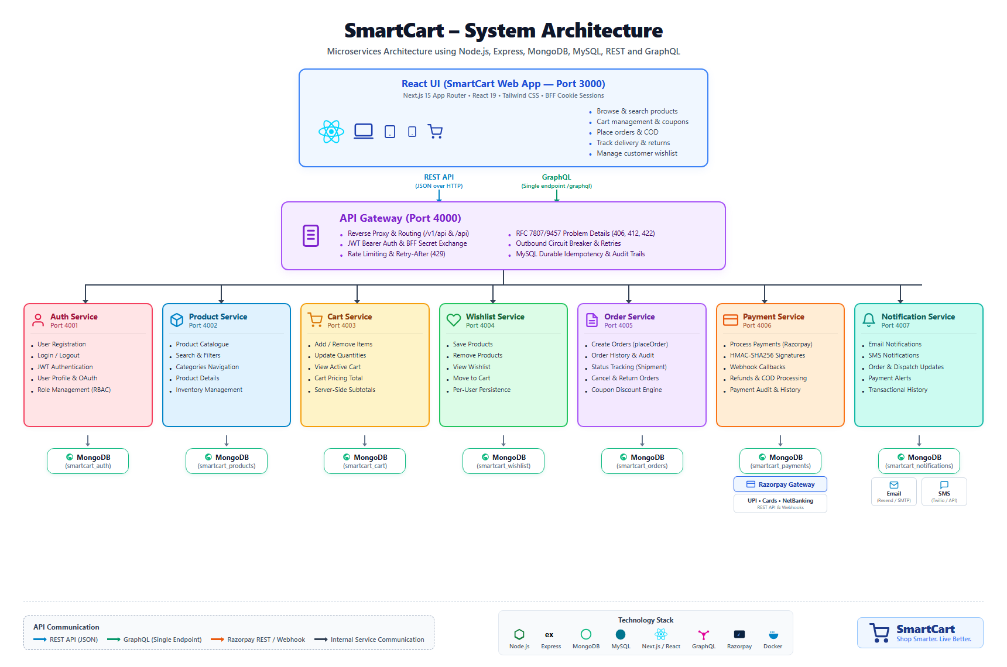

Figure 1.1: SmartCart Distributed Architecture & Service Decomposition

LAB EXPERIMENT 2
Software Process Model Specification & Comparative Analysis
for SmartCart Distributed E-Commerce Platform
1. Aim & Objectives
To compare and evaluate primary software development life cycle (SDLC) process models Waterfall, Incremental, Prototyping, Spiral, and Agile (Scrum) against the engineering needs of the SmartCart e-commerce platform, and to justify why an Agile-Incremental Hybrid Model is the most effective approach for a distributed microservices architecture.
2. Problem Statement & Engineering Context
Selecting an SDLC model directly affects delivery predictability, technical risk management, and overall software quality. SmartCart consists of eight decoupled services, multiple databases, and external cloud integrations (Razorpay and Resend). Choosing a model that requires frozen requirements upfront or delays testing until the end increases the risk of integration failure.
3. Comparative Evaluation of Process Models
The table below compares five major process models across key software engineering factors:
Factor | Waterfall | Incremental | Prototype | Spiral | Agile (Scrum)
Requirements | Stable / Frozen | Partly Stable | Unclear / Fluid | Can Change | Changing / Stories
Early Delivery | Low (End only) | Yes (Staged) | Sample Mockups | Possible | Yes (Sprint end)
Customer Feedback | Low / Post-test | Medium / Staged | High / UI Focus | High / Quadrants | Very High / Continuous
Risk Handling | Low (Late disc.) | Medium-High | Medium (UI only) | Very High (Formal) | Medium (Automated)
Microservice Fit | Poor (Monolithic) | Excellent (Staged) | Fair (Disposable) | Moderate | Excellent (CI/CD)
Cost of Change | Very High | Low-Medium | Moderate | Medium | Low
4. Analysis of Models & Why Agile-Incremental Model Was Chosen
- • Why Waterfall Fails: Waiting until all eight microservices are coded before testing creates a "big bang" integration disaster. Late discovery of database transaction bugs or webhook errors causes massive delays.
- • Why Prototyping Is Incomplete: Disposable mockups help design user interfaces, but an e-commerce backend requires production-grade ACID database tables, circuit breakers, and HMAC signature validation from day one.
- • Why Spiral Has High Overhead: Designed for ultra-high-budget aerospace and defense systems. Its heavy risk-governance documentation and cost-benefit calculations create excessive overhead for web applications.
- • Why Pure Agile Needs Upfront Structure: Pure Agile works well for customer-facing features, but can neglect upfront architectural planning (port allocations, protocol standards, schema boundaries), leading to messy inter-service dependencies.
- • The Optimal Choice — Agile-Incremental Hybrid: Combines upfront architectural stability with iterative sprint releases. Microservices are built, integrated, and verified service-by-service across six clear increments.
5. SmartCart Phased Delivery Roadmap
- • Increment 1 (Foundations): Raw HTTP server setup, API Gateway routing skeleton, and environment variable isolation.
- • Increment 2 (Domain Services & Saga): Auth, Product Catalog, Cart, and Order Orchestration services with isolated database schemas.
- • Increment 3 (External Partner Edge): Razorpay payment gateway, HMAC signature validation, webhook handlers, and transactional email notifications.
- • Increment 4 (Resilience & REST): Plural REST endpoints, OpenAPI 3.0 documentation, durable MySQL idempotency, and circuit breakers.
- • Increment 5 (Advanced HTTP Semantics): Dynamic ETags (304), optimistic concurrency (If-Match / 412), content negotiation, and rate limiting (429).
- • Increment 6 (Error Standardization): Uniform RFC 7807 Problem Details error formatting across all services, multi-field validation arrays, and testing.
6. Case Analyses: Real-World Scenarios in SmartCart
• Case 1: Microservice Decomposition: Building services incrementally allowed us to test Auth and Product services independently before writing the Order checkout saga that calls both.
• Case 2: Payment Partner Risk: Razorpay integration was isolated into Increment 3. We built both online Razorpay payment and offline COD, allowing testing without incurring financial gateway fees.
• Case 3: Decoupled Frontend Development: Using OpenAPI schemas and mock endpoints, our frontend team built the Next.js 15 UI in parallel with backend service development.
7. Result & Conclusion
The Agile-Incremental Hybrid Model provided the architectural discipline needed for microservices while giving our team the flexibility to deliver working software early and manage external partner risks. It proved to be the most practical and effective model for SmartCart.

LAB EXPERIMENT 3
System Use Case Specification & Behavioral Modeling
for SmartCart Distributed E-Commerce Platform
1. Aim & Objectives
To model the functional behavior of the SmartCart E-Commerce Platform using OMG UML 2.5 Use Case Diagrams and specifications. The objective is to define the system boundary, identify user and external system actors, organize use cases into functional blocks, analyze «include» and «extend» relationships, and detail step-by-step event flows.
2. System Use Case Diagram
The diagram below represents the complete UML 2.5 Use Case Model for the SmartCart platform:
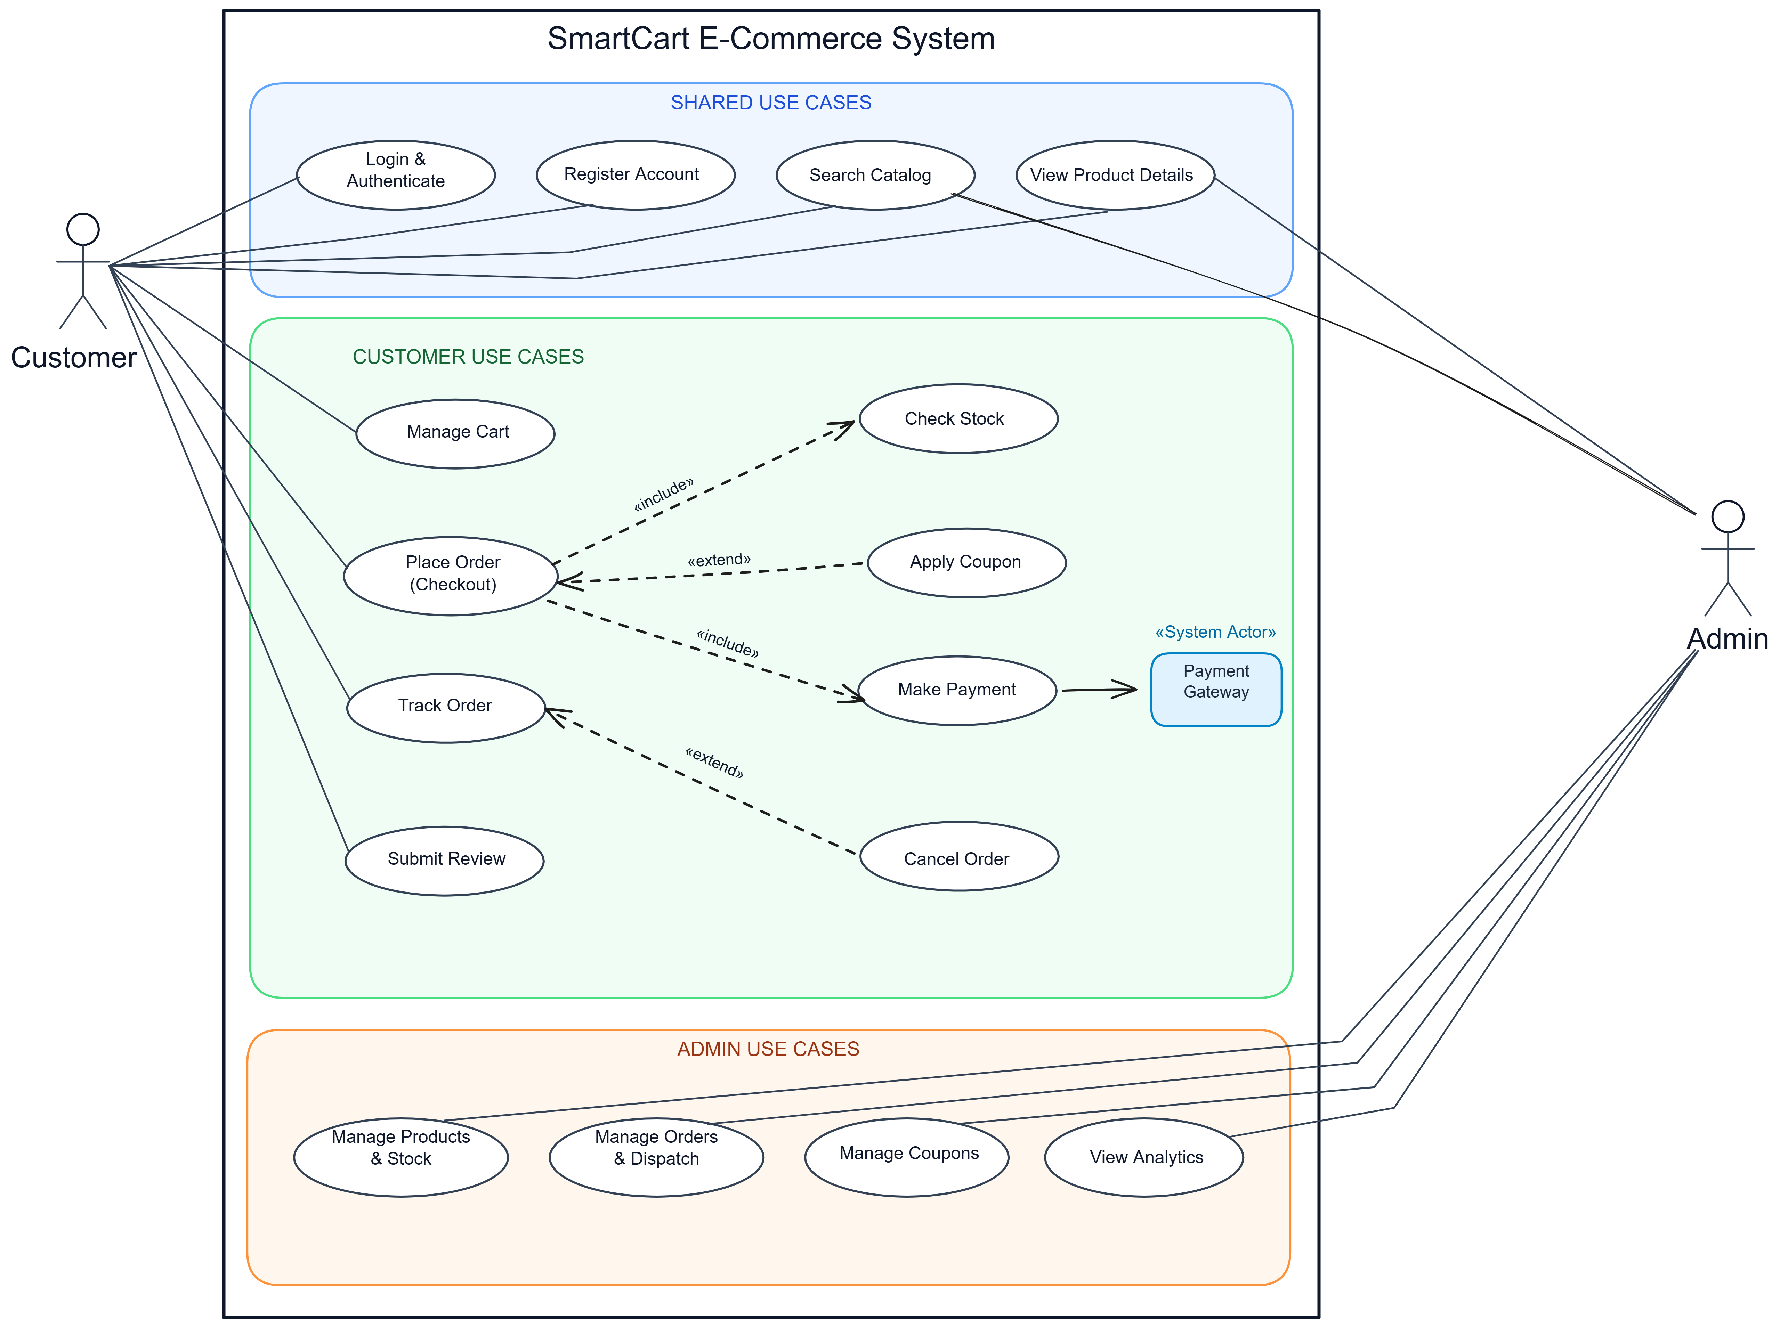
Figure 3.1: SmartCart E-Commerce System UML 2.5 Use Case Diagram
3. Actor Profiles
- 1. Customer: Storefront end-user who searches products, manages cart items, places orders, makes digital/COD payments, tracks shipments, and submits reviews.
- 2. Admin: Internal store operator who manages product listings, adjusts inventory stock with audit notes, updates order delivery statuses, and manages coupons.
- 3. Payment Gateway («System Actor»): External cloud payment network communicating over HTTPS to authorize digital payments (UPI/Card), verify HMAC signatures, and dispatch webhooks.
4. Functional Blocks & Subsystem Breakdown
4.1 Shared Use Cases
Use Case Name | Connected Actors | Functional Description
Login & Authenticate | Customer, Admin | Verifies email and password using bcrypt; issues role-scoped JWT session token.
Register Account | Customer | Onboards new shoppers with contact info, shipping address, and encrypted credentials.
Search Catalog | Customer, Admin | Keyword search with category filters and price sorting to locate merchandise.
View Product Details | Customer, Admin | Displays product descriptions, prices, real-time stock levels, and customer reviews.
4.2 Customer Use Cases
Use Case Name | Relationships | Functional Description
Manage Cart | Direct Association | Adds products, modifies quantities, and recalculates server-side subtotals.
Place Order (Checkout) | «include» Check Stock  «include» Make Payment  «extend» Apply Coupon | Coordinates checkout saga: reserves stock, evaluates promo codes, and initiates billing.
Check Stock | «include» from Place Order | Mandatory inventory check locking required product quantities during checkout.
Apply Coupon | «extend» to Place Order | Optional discount calculation executed when a valid coupon code is entered.
Make Payment | «include» from Place Order  Links to Payment Gateway | Executes payment via Razorpay (UPI/Card) or registers Cash on Delivery (COD).
Track Order | Direct Association  «extend» Cancel Order | Displays shipping milestones (PENDING to CONFIRMED to SHIPPED to DELIVERED).
Cancel Order | «extend» to Track Order | Conditionally allows cancellation and refunds if order has not yet been dispatched.
Submit Review | Direct Association | Enables verified buyers of delivered products to submit star ratings and feedback.
4.3 Admin Use Cases
Use Case Name | Connected Actors | Functional Description
Manage Products & Stock | Admin | CRUD operations on catalog items and stock counts with mandatory audit notes.
Manage Orders & Dispatch | Admin | Inspects orders, updates fulfillment statuses, and enters courier tracking numbers.
Manage Coupons | Admin | Creates percentage/fixed discount promotions with minimum spend and expiry dates.
View Analytics | Admin | Displays sales revenue dashboards, total order count, and low-stock alerts.
5. Relationship Analysis: «include» vs. «extend»
• «include» Relationship (Mandatory): An unconditional sub-process without which the base use case cannot complete. In SmartCart, Place Order unconditionally includes Check Stock (cannot sell unavailable stock) and Make Payment (order requires financial settlement). The dashed arrow points from Base Use Case to Included Use Case.
• «extend» Relationship (Optional / Conditional): An optional branch that runs only under specific conditions at designated Extension Points. In SmartCart, Apply Coupon extends Place Order (runs only if customer enters a promo code), and Cancel Order extends Track Order (runs only if order is in pre-dispatch status). The dashed arrow points from Extending Use Case to Base Use Case.
6. Tabular Use Case Specification: UC-01 Place Order
Primary Actor: Customer | Secondary Actor: Payment Gateway («System Actor»)
Preconditions: Authenticated customer, active items in shopping cart, delivery address confirmed.
Postconditions: Order created in PENDING status, stock reserved, payment initialized, cart cleared.
Step | Participant | Action / System Event
1 | Customer | Navigates to checkout, confirms shipping address, and selects payment method.
2 | System | «include» Check Stock: Verifies warehouse stock in Product Service and locks quantities.
3 | Cust / Sys | «extend» Apply Coupon: If promo code supplied, checks validity and deducts discount.
4 | System | Calculates shipping fees, applicable taxes, and final order total.
5 | System | «include» Make Payment: Creates Razorpay payment intent in Paise or registers COD.
6 | System | Clears cart, assigns PENDING status, returns HTTP 201 Created, and displays receipt.
7. Microservices Traceability Matrix
Use Case | Microservice Subsystem | Port | Primary REST Endpoint
Login & Register | Auth Service | 4001 | POST /api/auth/customer-login  POST /api/auth/register
Catalog & Stock | Product Service | 4002 | GET /api/products  PATCH /api/products/:id/stock
Cart Management | Cart Service | 4003 | GET /api/cart  POST /api/cart/items
Checkout & Tracking | Order Service | 4005 | POST /api/orders  GET /api/orders/:id
Payment Processing | Payment Service | 4006 | POST /api/payments/create  POST /api/payments/verify/:id
Notifications | Notification Service | 4007 | POST /api/notifications/dispatch
8. Result & Conclusion
The UML 2.5 Use Case Model established a clear behavioral specification for SmartCart. Factoring requirements into Shared, Customer, and Admin packages and declaring include/extend relationships provides our development team with clear, testable goals.

REFERENCES
[1] ISO/IEC/IEEE 29148:2018, "Systems and software engineering — Life cycle processes — Requirements engineering," IEEE, 2018.
[2] IEEE Std 830-1998, "IEEE Recommended Practice for Software Requirements Specifications," IEEE Computer Society, 1998.
[3] Object Management Group (OMG), "OMG Unified Modeling Language (OMG UML) Specification, Version 2.5.1," Dec. 2017.
[4] R. S. Pressman and B. R. Maxim, Software Engineering: A Practitioner's Approach, 9th ed., McGraw-Hill Education, 2020.
[5] I. Sommerville, Software Engineering, 10th ed., Pearson Education, 2016.
[6] GeeksforGeeks, "Software Engineering – Requirements Engineering and SRS Guidelines," [Online]. Available: https://www.geeksforgeeks.org/software-engineering-software-requirement-specifications-srs/
[7] GeeksforGeeks, "Unified Modeling Language (UML) – Use Case Diagrams," [Online]. Available: https://www.geeksforgeeks.org/unified-modeling-language-uml-use-case-diagrams/
[8] GeeksforGeeks, "Software Engineering – SDLC Process Models (Waterfall, Incremental, Spiral, Agile)," [Online]. Available: https://www.geeksforgeeks.org/software-engineering-software-development-life-cycle-sdlc/
[9] YouTube, Gate Smashers, "Software Engineering Complete Lecture Playlist – SRS, Process Models, and UML Diagrams," [Online]. Available: https://www.youtube.com/@GateSmashers
[10] YouTube, Abdul Bari, "Software Engineering & Object-Oriented Analysis and Design (OOAD) Lecture Series," [Online]. Available: https://www.youtube.com/@abdul_bari
[11] YouTube, Web Dev Simplified, "Microservices Architecture and Razorpay Payment Gateway Integration Tutorials," [Online]. Available: https://www.youtube.com/@WebDevSimplified
[12] M. Fowler, Patterns of Enterprise Application Architecture, Addison-Wesley, 2002.
[13] M. Nottingham, E. Wilde, and S. Dalal, RFC 7807: Problem Details for HTTP APIs, IETF, 2016.
[14] SmartCart Core Engineering Team, "SmartCart Distributed E-Commerce Platform GitHub Repository," 2026. [Online]. Available: https://github.com/Ayush17314/SmartCart

