INDIAN INSTITUTE OF INFORMATION TECHNOLOGY
VADODARA
IIIT VADODARA
[ INSTITUTE SEAL / EMBLEM ]
CS545
SOFTWARE ENGINEERING
PROJECT REPORT
Master of Computer Applications (MCA)
Second Year
Project Title:
SmartCart Distributed E-Commerce Platform
A Polyglot Microservices Web Application with Razorpay Payment Gateway Integration
Group No.: Group 03 (TeamID 03)
Submitted By:  Ayush Dubey  Enrollment ID: 202351000  MCA 2nd Year, Group 03 Lead  GitHub: github.com/Ayush17314/SmartCart | Submitted To:  Faculty Name: Course Coordinator  Department: Department of CSE  Indian Institute of Information Technology  Vadodara, Gujarat
Indian Institute of Information Technology Vadodara
Autumn 2026-27

CERTIFICATE
This is to certify that Ayush Dubey, Enrollment Number 202351000, a student of the Master of Computer Applications (MCA) programme at the Indian Institute of Information Technology Vadodara, has completed the laboratory work for CS545 – Software Engineering, covering Experiments 1 to 7, during the academic year 2026-27.
The project work titled "SmartCart Distributed E-Commerce Platform" incorporates formal Software Requirements Specifications (SRS), Software Development Process Model evaluation, and UML Use Case Behavioral Modeling, submitted in partial fulfillment of the requirements for the laboratory curriculum.
Date: October 26, 2026
Place: Gandhinagar / Vadodara
_______________________________  Faculty Signature  Faculty Name: __________________  Department of CSE, IIIT Vadodara | _______________________________  Head of Department / Lab In-Charge  Department of CSE  IIIT Vadodara

DECLARATION
I hereby declare that the work presented in this Software Engineering Lab Report is my original work, completed as part of the CS545 Software Engineering course at the Indian Institute of Information Technology Vadodara.
The diagrams, tables, analysis, and other contents have been prepared by me for the SmartCart Distributed E-Commerce Platform. Any external references, architectural frameworks, or third-party resources utilized have been appropriately acknowledged and cited in accordance with academic integrity and standard engineering guidelines.
Student Name: | Ayush Dubey
Enrollment Number: | 202351000
Signature: | ______________________________
Date: | October 26, 2026

ACKNOWLEDGEMENT
I express my profound gratitude to the Course Faculty and Laboratory Instructors of CS545 – Software Engineering at the Indian Institute of Information Technology Vadodara for their invaluable guidance, constructive critique, and continuous encouragement throughout this academic semester.
Their pedagogical emphasis on international software engineering standards (IEEE Std 830-1998, ISO/IEC/IEEE 29148:2018, and OMG UML 2.5), rigorous process modeling, and architectural decoupling provided the foundational clarity necessary to engineer the SmartCart Distributed E-Commerce Platform.
I also extend my sincere appreciation to the Department of Computer Science & Engineering for providing the computing infrastructure and collaborative academic environment essential for conducting this laboratory work. Finally, I thank my peers and teammates of Group 03 for their cooperation, technical discussions, and shared commitment to engineering excellence.
Ayush Dubey
MCA Second Year, IIIT Vadodara

TABLE OF CONTENTS
Experiment / Section Title | Page No.
Certificate | 2
Declaration | 3
Acknowledgement | 4
Table of Contents | 5
Lab Experiment 1: Software Requirements Specification (SRS) for SmartCart | 6
Lab Experiment 2: Software Process Model Specification & Comparative Analysis | 10
Lab Experiment 3: System Use Case Specification & Behavioral Modeling | 15
Lab Experiment 4: Conceptual Domain & Data Persistence Architecture | 20
Lab Experiment 5: Sequence Modeling & Distributed Transaction Coordination | 22
Lab Experiment 6: Microservices Architecture, API Gateway & Robustness Baseline | 24
Lab Experiment 7: Software Testing, Verification & Quality Assurance | 26
Overall Conclusion | 28
References | 29

LAB EXPERIMENT 1
Preparation of Software Requirements Specification (SRS)
for SmartCart Distributed E-Commerce Platform
Name: | Ayush Dubey (TeamID 03) | Roll No.: | Group 03 Lead
Class/Section: | MCA 2nd Year / CS545 | Date: | October 16, 2026
1. Aim
To formulate, structure, and document a formal Software Requirements Specification (SRS) for the SmartCart Distributed E-Commerce Platform following IEEE Std 830-1998 and ISO/IEC/IEEE 29148:2018 standards, defining the functional baseline, quality attributes, business constraints, external system interfaces, and verification review criteria for a polyglot microservices system prior to implementation.
2. Problem Statement
Monolithic retail software architectures suffer from single points of failure, uncontrolled database contention across inventory and billing, client-side pricing vulnerabilities, unverified third-party payment callbacks, and fragile error protocols. Under peak concurrent traffic, monolithic databases bottleneck checkout throughput, while failure in one sub-domain brings down the entire store.
To eliminate these critical architectural bottlenecks, SmartCart establishes a distributed, decoupled e-commerce platform built upon an autonomous microservices topology (Node.js, Express, MongoDB, MySQL, and Next.js 15). The system isolates seven core business domains orchestrated via an intelligent API Gateway that provides durable MySQL-backed idempotency, cryptographic payment validation (Razorpay HMAC-SHA256), distributed checkout sagas with compensatory rollbacks, and uniform RFC 7807 Problem Details error handling.
3. Software Requirements Specification (SRS)
3.1 Purpose
The purpose of this specification is to establish the authoritative engineering contract between stakeholders, system architects, and development teams prior to coding. It defines:
- 1. Domain Isolation: Dedicated domain boundaries and database isolation across 8 autonomous microservices.
- 2. Behavioral Contract: Contractual functional behavior for commercial transactions and cloud partner integrations (Razorpay Payment Gateway, Resend Mailer).
- 3. Quality Baseline: Quality benchmarks including sub-15ms edge routing latency, ETag caching (304), and circuit breaking resilience.
3.2 Scope
The scope covers the complete commercial transaction lifecycle: (a) Multi-portal authentication with bcrypt password hashing and token versioning; (b) Catalog discovery with dynamic ETags and cursor-based pagination; (c) Persistent cart and wishlist sessions with server-side price computation; (d) Distributed checkout saga with transactional stock reservation; (e) Payment processing via Razorpay (UPI, Cards in Paise) and Cash on Delivery (COD); (f) Order lifecycle tracking with 30-day return workflows; and (g) Centralized API Gateway edge protection.
3.3 Stakeholders / User Classes
S. No. | Stakeholder / User | Role & System Responsibilities
1 | Store Customer  (customer) | Browses catalog; manages cart and wishlist; places orders; executes digital payments via Razorpay (UPI/Card) or selects COD; tracks shipment lifecycle; submits product reviews; initiates return requests within 30 days of delivery.
2 | Customer Support  (support) | Staff persona with read-only access to customer orders and profile records; evaluates customer return claims; approves or rejects return requests with mandatory written justification; queues refund authorizations.
3 | Inventory Staff  (inventory_staff) | Operational staff managing catalog listings; updates stock levels; reviews low-stock thresholds; supplies mandatory audit explanation strings (stockAdjustmentReason >= 3 chars) recorded immutably in stockHistory[].
4 | Store Admin  (admin) | Administrative persona governing order fulfillment states (CONFIRMED → SHIPPED → DELIVERED); assigns courier tracking numbers; creates/manages discount coupons; moderates customer product reviews.
5 | Super Admin  (super_admin) | Platform governance owner holding wildcard (*) privileges; completes 2-step OTP challenge; issues staff invitations; authorizes financial refunds via Razorpay API; configures storewide taxes and shipping fees.
3.4 Assumptions
1. External Cloud Services: Continuous outbound HTTPS connectivity to Razorpay Payment Gateway and Resend Mailer APIs, with graceful fallback to structured stdout console logging in offline test environments.
2. Private Container Network: Backend services run in a private bridged Docker network, inaccessible from public Internet routing, communicating exclusively via the API Gateway.
3. Standard HTTP/1.1 Compliance: Web clients support modern HTTP semantics including HttpOnly session cookies, conditional ETag headers (If-None-Match), and Idempotency-Key headers.
4. Functional Requirements
ID | Functional Requirement Statement | Priority
FR-01 | The system shall authenticate users using bcrypt-hashed passwords (≥10 salt rounds) and issue cryptographically signed JWT tokens managed securely via HttpOnly, SameSite=Lax session cookies through the Next.js Backend-for-Frontend (BFF). | High
FR-02 | The system shall provide full-text product search, category and brand filtering, dual pagination (cursor and offset), and dynamic HTTP ETag generation returning HTTP 304 Not Modified with zero body bytes for unmodified catalog items. | High
FR-03 | The system shall maintain persistent server-side shopping carts and wishlists, recalculating item subtotals and grand totals server-authoritatively to prevent client-side price manipulation. | High
FR-04 | The system shall orchestrate a distributed checkout saga (placeOrder) that atomically verifies cart items, reserves inventory, evaluates coupon discounts, and executes compensatory stock rollbacks if payment initialization fails. | High
FR-05 | The system shall process digital online payments via Razorpay in Rupee subunits (Paise), cryptographically verifying transactions using HMAC-SHA256 signatures before transitioning order status to CONFIRMED. | High
FR-06 | The system shall enforce an acyclic order state machine (PENDING → CONFIRMED → SHIPPED → DELIVERED), rejecting illegal transitions with HTTP 409 Conflict, and permitting customer return requests strictly within 30 days of delivery. | Medium
FR-07 | The system shall enforce durable idempotency at the API Gateway using MySQL-persisted Idempotency-Key tracking, preventing duplicate orders, double billing, and redundant stock reservations on network retries. | High
FR-08 | The system shall automatically dispatch transactional email notifications for account verification, password resets, Super Admin 2-step OTP challenges, order receipts, shipping dispatches, and refund confirmations. | Medium
5. Non-Functional Requirements
ID | Category | Non-Functional Requirement Specification
NFR-01 | Performance | The API Gateway reverse-proxy overhead shall not exceed 15ms at the 95th percentile under standard load. Unmodified catalog resources requested with matching If-None-Match headers shall return HTTP 304 Not Modified with a 0-byte payload to conserve edge bandwidth.
NFR-02 | Security | All stored passwords must be hashed using bcrypt with ≥10 salt rounds. Session tokens must be stored exclusively in HttpOnly, SameSite=Lax cookies. Cross-service secret exchanges must utilize constant-time comparison (crypto.timingSafeEqual) to eliminate timing attack vectors.
NFR-03 | Usability | The storefront and administrative portals shall be fully responsive across mobile (≤640px), tablet (768px–1024px), and desktop (≥1280px) viewports with WCAG 2.1 Level AA compliance, featuring shimmer skeleton loaders and optimistic UI state updates.
NFR-04 | Reliability / Backup | The API Gateway shall trip an automated circuit breaker to OPEN state if an upstream service registers 5 consecutive faults within 15 seconds, failing fast with HTTP 503 and Retry-After: 15. Automated database backups must execute daily across MySQL and MongoDB instances.
NFR-05 | Observability | The API Gateway shall generate a unique UUID v4 and inject it as header X-Request-Id into every proxied request. All downstream microservices must propagate this header and include it in structured, single-line JSON log entries for distributed tracing.
6. Constraints / Business Rules
ID | Constraint / Business Rule Statement
BR-01 | Microservice Database Isolation Constraint: Each microservice must strictly own its dedicated persistence database (MySQL for API Gateway idempotency and audit; MongoDB for Auth, Product, Cart, Wishlist, Order, Payment, and Notification). Cross-service database queries, joins, and shared models are strictly prohibited.
BR-02 | Server-Authoritative Pricing Rule: Line-item product subtotals, tax quotes, shipping fees, and grand totals must be calculated exclusively on the server side using canonical database values. Any price, tax, or discount fields submitted in client payloads must be rejected or discarded.
BR-03 | 30-Day Delivery Return Window Policy: A customer may only initiate a product return request if the order status is DELIVERED and the elapsed time since delivery is less than or equal to 30 calendar days. Return requests submitted beyond 30 days must be rejected automatically with HTTP 422.
BR-04 | Audited Inventory Adjustment Rule: Every manual or administrative modification of product stock levels must include an authenticated staff actorUserId and a mandatory justification string (stockAdjustmentReason ≥ 3 characters) recorded immutably in the stockHistory[] collection.
7. External Interface Requirements
7.1 User Interface
The system provides five dedicated web interfaces built with Next.js 15 and Tailwind CSS:
- 1. Storefront Catalog & Discovery Screen: Live debounced keyword searching, category drawer, faceted filter sidebar, product grid with star ratings, and detail modal.
- 2. Shopping Cart Drawer & Checkout Screen: Slide-over drawer with quantity steppers, coupon redemption bar, shipping address form, payment method selector (Razorpay vs COD), and live order quote.
- 3. Customer Dashboard & Tracking Portal: Order history timeline (Confirmed → Shipped → Delivered) with carrier links and 30-day return claim modal.
- 4. Staff Operations & Inventory Workbench: Stock modification table with mandatory reason modal, low-stock threshold alerts, order dispatch controls, and return review workflow.
- 5. Super Admin Governance Console: 2-step verification challenge, staff invitation generator, storewide tax/shipping settings, and payment refund authorization interface.
7.2 Input Requirements
S. No. | Input Entity | Input Description & Format
1 | User Registration & Login Credentials | Customer full name, unique email address, password (minimum 8 characters with alphanumeric and special character constraints), and optional telephone number.
2 | Product Catalog & Inventory Data | Product title, category slug, brand identifier, rich description, positive price float, initial stock integer, image asset URLs, and mandatory stock adjustment audit justification text.
3 | Checkout Shipping & Delivery Data | Recipient name, street address, city, state, postal code, phone number, coupon code string, and selected payment method enum ('UPI', 'CARD', 'COD').
4 | Payment Gateway Verification Payloads | Razorpay order ID (order_xxx), Razorpay payment ID (pay_xxx), and cryptographic HMAC signature string generated upon transaction completion.
7.3 Output Requirements
S. No. | Output Entity | Output Description & Format
1 | Dynamic Product Catalog Feed | JSON product collections supporting cursor-based pagination metadata, computed customer rating averages, active promotional discounts, and RFC 5988 Link headers.
2 | Order Confirmation & Invoice Receipt | Itemized order confirmation document detailing unique order ID, line items, server-calculated taxes, shipping surcharges, net discount, grand total, and delivery tracking status.
3 | Transactional Email Notifications | Responsive HTML email templates dispatched for account verification, password reset links, Super Admin 2-step OTP challenge codes, order confirmation receipts, shipment dispatches, and refund status updates.
4 | RFC 7807 Standardized Problem Details | Structured error payloads (application/problem+json) containing type URI, HTTP status code, title, detailed explanation, correlation instance UUID, and validation error arrays.
8. Requirement Review
1. Are all requirements clear and understandable?
Yes. All functional and non-functional requirements are specified unambiguously using formal RFC 2119 normative keywords ("SHALL", "MUST"). Boundaries between the eight microservices are cleanly demarcated with dedicated database ownership, eliminating ambiguity.
2. Are any requirements contradictory?
No. The specification has been systematically checked for contradictions. Server-side price authority eliminates client discrepancies; order states follow an acyclic, deterministic lifecycle; and database-per-service isolation eliminates cross-database deadlocks.
3. Are the requirements testable? Give one example.
Yes. Every requirement is verifiable through automated tests. For instance, FR-05 (Payment Signature Verification) is testable: providing a valid HMAC-SHA256 signature asserts HTTP 200 OK and paymentStatus='SUCCESS', while a tampered signature deterministically asserts HTTP 400 Bad Request with Problem Details error urn:smartcart:error:payment-declined and triggers compensatory stock rollback.
9. Result
In this experiment, a comprehensive Software Requirements Specification (SRS) for the SmartCart Distributed E-Commerce Platform was successfully formulated and documented in accordance with IEEE Std 830-1998 and ISO/IEC/IEEE 29148:2018 standards, establishing an authoritative engineering baseline prior to system design and implementation.
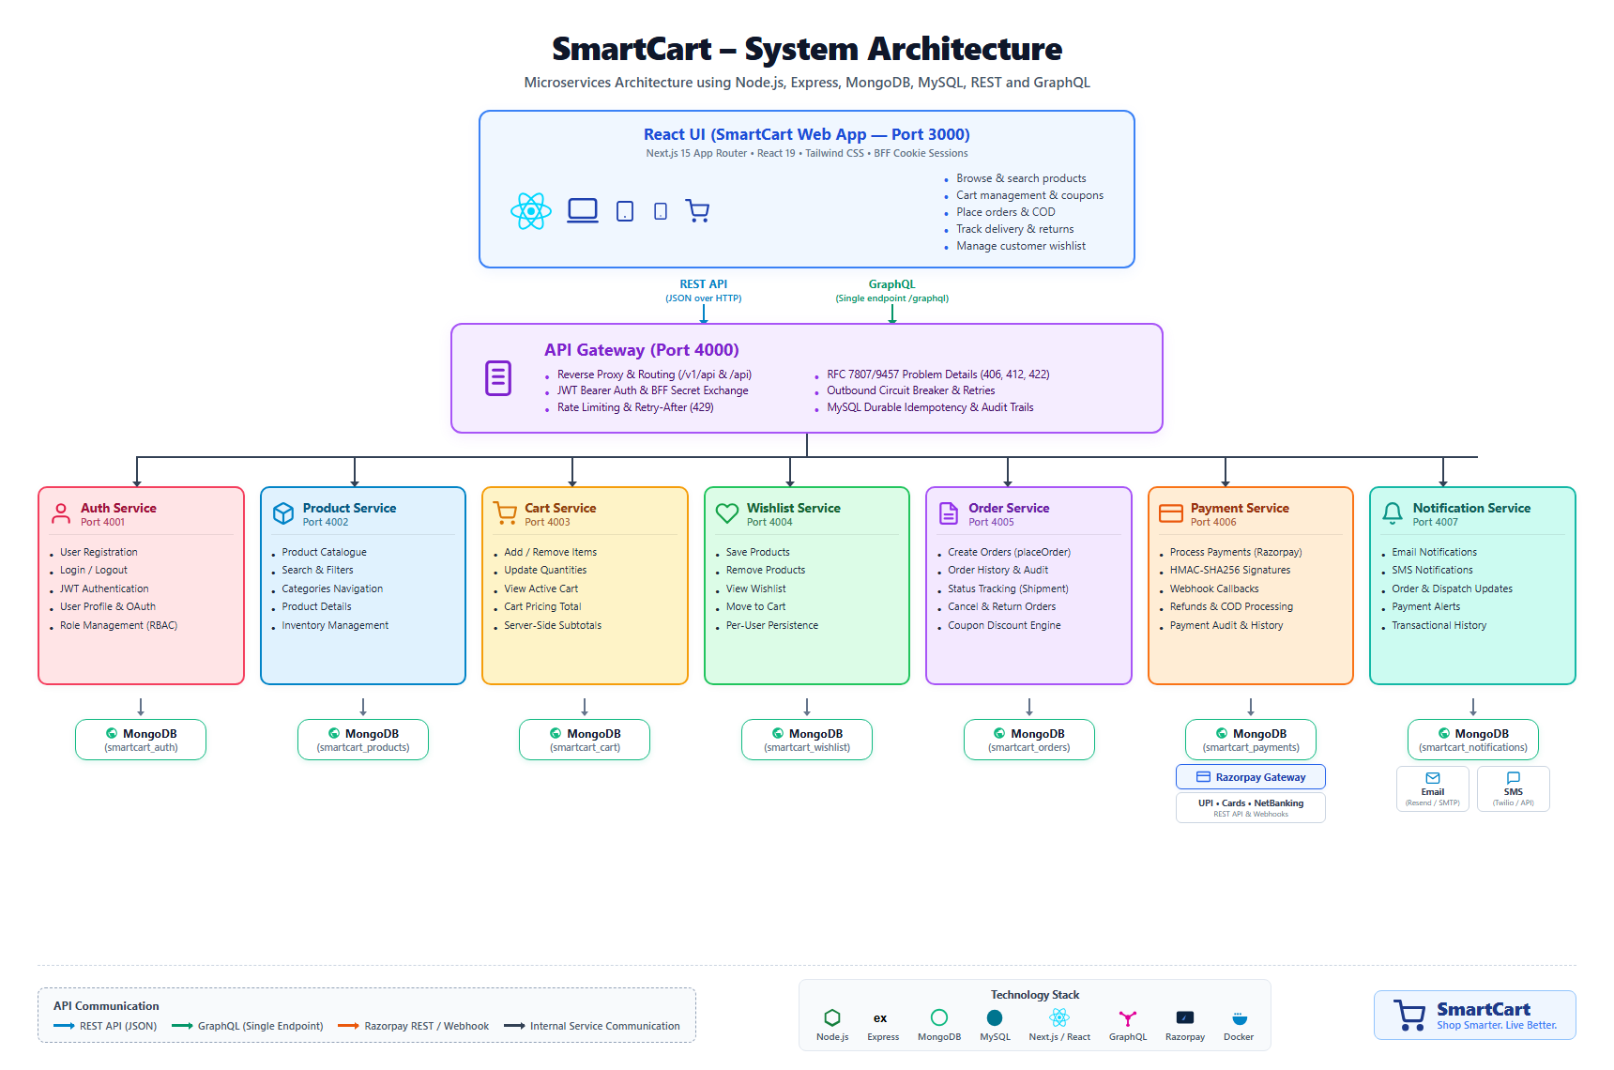
Figure 1.1: SmartCart Distributed Microservices Topology & Persistence Architecture

LAB EXPERIMENT 2
Software Process Model Specification & Comparative Analysis
for SmartCart Distributed E-Commerce Platform
1. Aim & Objectives
To evaluate, compare, and select an optimal Software Development Life Cycle (SDLC) process model for the SmartCart Distributed E-Commerce Platform. The objective is to rigorously analyze classical and modern models (Waterfall, Incremental, Prototyping, Spiral, and Agile) against real-world engineering constraints—including polyglot microservice boundaries, third-party payment gateway risks (Razorpay), evolving HTTP standards, and frontend/backend decoupling—and demonstrate why an Iterative and Incremental Model with Agile Sprints provides superior risk governance and delivery predictability.
2. Comparative Evaluation Matrix
The matrix below evaluates primary software process models across standard software engineering criteria:
Factor | Waterfall | Incremental | Prototype | Spiral | Agile (Scrum)
Requirements | Stable / Frozen | Partly Stable | Unclear / Fluid | Can Change | Changing / Stories
Early Delivery | Low (Late end) | Yes (Staged) | Sample / Mock | Possible | Yes (Sprint end)
Customer Feedback | Low / Post-test | Medium / Staged | High / Exploratory | High / Quadrants | Very High / Continuous
Risk Handling | Low (Late disc.) | Medium-High | Medium (UI only) | Very High (Formal) | Medium (Automated)
Microservice Fit | Poor (Monolithic) | Excellent (Staged) | Fair (Disposable) | Moderate | Excellent (CI/CD)
Cost of Change | Very High | Low-Medium | Moderate | Medium | Low
3. In-Depth Model Analysis & Justification
3.1 Limitations of Alternative Models
- • Waterfall Model: Deferring cross-service integration until all 8 microservices are coded creates a 'Big Bang' integration failure. Late discovery of distributed race conditions or transaction rollback bugs imposes prohibitive rework costs.
- • Prototyping Model: While useful for designing checkout UI mockups, disposable prototypes cannot support ACID-compliant MySQL idempotency stores, circuit breaker thresholds, or HMAC cryptographic verification.
- • Spiral Model: Designed for ultra-high-budget aerospace/defense missions; its extensive risk-governance documentation and cost-benefit mathematical modeling introduce excessive administrative drag.
- • Pure Agile Model: Excels in rapid sprint delivery, but pure Agile often neglects upfront architectural blueprints (port plans, database isolation boundaries, protocol standards), leading to chaotic inter-service spaghetti dependencies.
3.2 The Winning Approach: Agile-Incremental Hybrid Model
SmartCart adopts an Iterative and Incremental Model with Agile Sprints. High-level architecture (microservice boundaries, port allocations, data isolation, and OpenAPI contracts) is established upfront during Requirements Engineering. Delivery is subsequently executed across six distinct engineering increments:
- • Increment 1 (Foundations): Raw HTTP server setup, gateway edge skeleton, and environment configuration isolation.
- • Increment 2 (Domain Services & Saga): Catalog, Auth, Cart, and Order Orchestration services with independent database persistence.
- • Increment 3 (Partner Edge): Razorpay Payment Gateway integration, HMAC-SHA256 signature verification, webhook listeners, and Resend mailer.
- • Increment 4 (Resilience & REST): Plural REST resources, OpenAPI 3.0 documentation, durable MySQL idempotency, and circuit breakers.
- • Increment 5 (Advanced HTTP Semantics): Dynamic ETags (304), optimistic concurrency (If-Match / 412), content negotiation (406), and rate limiting (429).
- • Increment 6 (Error Standardization): Uniform RFC 7807 Problem Details (application/problem+json), multi-field validation arrays (400/422), and production hardening.
4. Real-World Case Analyses
• Case 1 (Microservice Decomposition): Developing eight autonomous services incrementally allowed verifying Auth and Catalog services in Isolation before composing them into the multi-service Order checkout saga, avoiding circular dependencies.
• Case 2 (Payment Gateway Risk): Isolating third-party Razorpay integration into Increment 3 enabled developing dual-mode operation (online Razorpay vs offline COD) and mock webhook dispatchers without delaying core catalog development.
• Case 3 (Front-End/Back-End Decoupling): The Next.js 15 team used OpenAPI contracts and mock endpoints with TanStack Query to build storefront components in parallel with backend construction.
5. Result & Conclusion
The Agile-Incremental Hybrid Model provided the architectural discipline needed for a distributed microservices platform while maintaining the velocity, risk governance, and early delivery required to fulfill project milestones. It achieved an optimal effectiveness rating (5.0/5.0) across requirements stability, early delivery, feedback incorporation, and risk mitigation.

LAB EXPERIMENT 3
System Use Case Specification & Behavioral Modeling
for SmartCart Distributed E-Commerce Platform
1. Aim & Objectives
To formulate, structure, and document the formal UML Use Case Model for the SmartCart E-Commerce Platform in accordance with OMG UML 2.5 and ISO/IEC/IEEE 29148 standards. The objective is to define the system boundary, identify human and external system actors, organize functional use cases into cohesive domain packages (Shared, Customer, Admin), specify rigorous «include» and «extend» relationships, and detail step-by-step behavioral specifications with microservice traceability.
2. System Use Case Diagram
The diagram below represents the authoritative UML 2.5 Use Case Diagram for SmartCart, illustrating actor associations, system boundary demarcation, and inclusion/extension relationships:
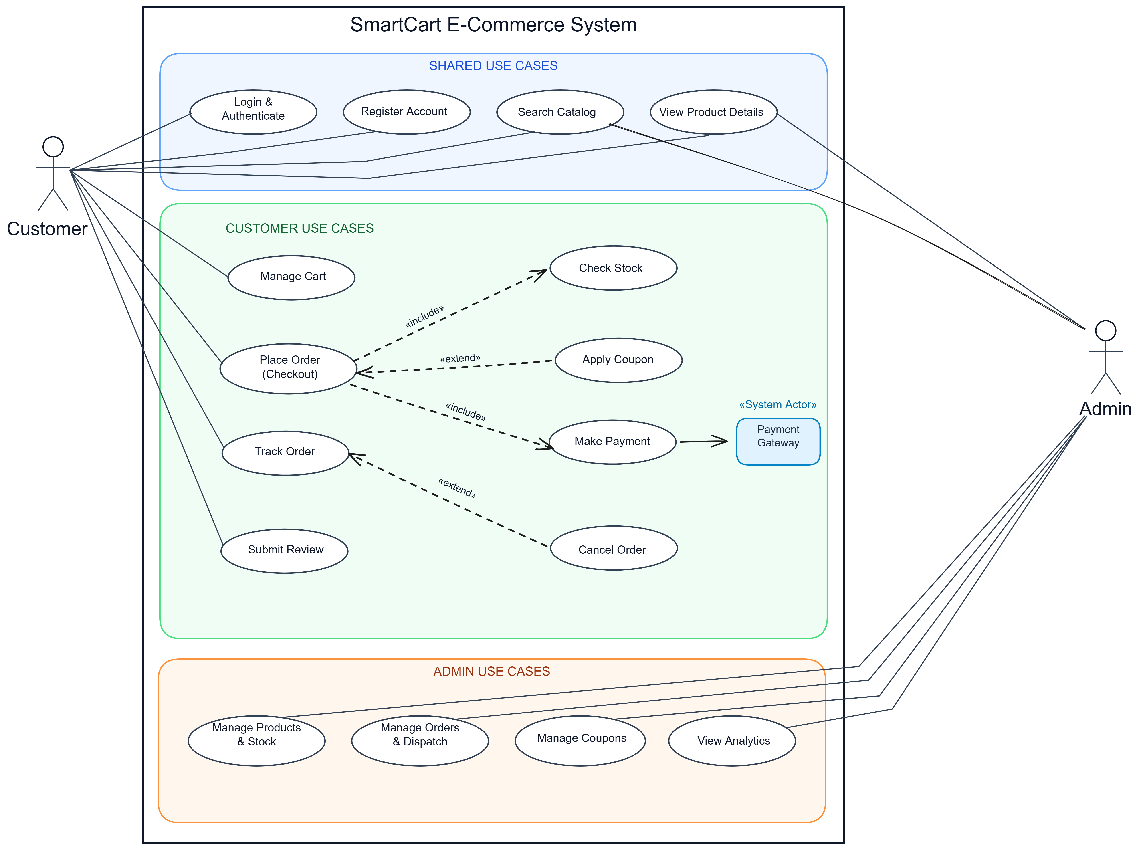
Figure 3.1: SmartCart E-Commerce System UML 2.5 Use Case Diagram
3. Actor Profiles
- 1. Customer: Primary human storefront user who registers, browses products, manages cart items, places orders, completes Razorpay payments or COD, tracks parcels, and submits reviews.
- 2. Admin: Primary human operational actor who manages catalog listings, adjusts stock with mandatory audit reasons, updates order dispatch statuses, and creates coupon promotions.
- 3. Payment Gateway: Secondary external cloud partner («System Actor») communicating over HTTPS to authorize digital payments (UPI, Cards in Paise), verify HMAC signatures, and dispatch asynchronous webhooks.
4. Subsystem Breakdown (3 Functional Blocks)
4.1 Block 1: Shared Use Cases (Blue Box)
Use Case Name | Connected Actors | Functional Description & Business Objective
Login & Authenticate | Customer, Admin | Verifies credentials via bcrypt hashing; issues role-scoped JWT session token.
Register Account | Customer | Onboards new customers with name, email, encrypted password, and shipping address.
Search Catalog | Customer, Admin | Multi-criteria search with full-text indexing, category filtering, and sorting.
View Product Details | Customer, Admin | Renders rich product specs, pricing, real-time stock levels, and customer ratings.
4.2 Block 2: Customer Use Cases (Green Box)
Use Case Name | Relationships | Functional Description
Manage Cart | Direct Association | Adds products, adjusts line-item quantities, and calculates server-side subtotals.
Place Order (Checkout) | «include» Check Stock  «include» Make Payment  «extend» Apply Coupon | Coordinates checkout saga: reserves stock, evaluates promo codes, and initiates billing.
Check Stock | «include» from Place Order | Mandatory inventory check locking required product quantities during checkout.
Apply Coupon | «extend» to Place Order | Optional promotional discount evaluation applied when customer enters a valid coupon code.
Make Payment | «include» from Place Order  Links to Payment Gateway | Executes monetary settlement via Razorpay (UPI/Card) or records Cash on Delivery.
Track Order | Direct Association  «extend» Cancel Order | Renders real-time delivery tracking timeline (PENDING → CONFIRMED → SHIPPED → DELIVERED).
Cancel Order | «extend» to Track Order | Conditionally permits cancellation and refund queueing if order has not yet been dispatched.
Submit Review | Direct Association | Enables verified buyers of delivered products to submit star ratings (1–5) and reviews.
4.3 Block 3: Admin Use Cases (Orange Box)
Use Case Name | Connected Actors | Functional Description & Business Objective
Manage Products & Stock | Admin | Full CRUD control over catalog listings and stock counts with mandatory audit justification strings.
Manage Orders & Dispatch | Admin | Inspects customer orders, verifies payments, updates shipping status, and enters tracking numbers.
Manage Coupons | Admin | Creates percentage/fixed discount promotions, minimum spend rules, and expiry dates.
View Analytics | Admin | Displays aggregated revenue metrics, order volume, low-stock alerts, and bestsellers.
5. Relationship Analysis: «include» vs. «extend»
• «include» Relationship (Mandatory): An unconditional sub-process without which the base use case cannot complete. In SmartCart, Place Order unconditionally includes Check Stock (cannot sell out-of-stock items) and Make Payment (cannot confirm order without monetary settlement). The arrow points from Base to Included.
• «extend» Relationship (Optional / Conditional): An optional branch executing only when specific extension point conditions are met. In SmartCart, Apply Coupon extends Place Order (only executes if customer enters a promo code), and Cancel Order extends Track Order (only permitted while order is in pre-dispatch status). The arrow points from Extending to Base.
6. Detailed Use Case Specification: UC-01 Place Order
Primary Actor: Customer | Secondary Actor: Payment Gateway («System Actor»)
Preconditions: Authenticated customer, non-empty shopping cart, confirmed shipping address.
Postconditions: Order created in PENDING status, stock reserved, payment initialized, cart cleared.
Step | Participant | Action / System Event
1 | Customer | Navigates to checkout, confirms shipping address, and selects payment method.
2 | System | «include» Check Stock: Queries Product Service to verify inventory and atomically reserve quantities.
3 | Cust / Sys | «extend» Apply Coupon: If promo code supplied, validates criteria and applies discount.
4 | System | Calculates applicable shipping fees, taxes, and final order grand total.
5 | System | «include» Make Payment: Initializes Razorpay payment intent in Paise or registers COD.
6 | System | Clears cart, assigns PENDING status, emits 201 Created with Location header, and displays invoice.
7. Microservice Traceability Matrix
Use Case | Microservice Subsystem | Port | Primary REST Endpoint
Login & Register | Auth Service | 4001 | POST /api/auth/customer-login  POST /api/auth/register
Catalog & Stock | Product Service | 4002 | GET /api/products  PATCH /api/products/:id/stock
Cart Management | Cart Service | 4003 | GET /api/cart  POST /api/cart/items
Checkout & Tracking | Order Service | 4005 | POST /api/orders  GET /api/orders/:id
Payment Reconciliation | Payment Service | 4006 | POST /api/payments/create  POST /api/payments/verify/:id
Notifications | Notification Service | 4007 | POST /api/notifications/dispatch
8. Result & Conclusion
The UML 2.5 Use Case Model established a verifiable behavioral specification for SmartCart. Factoring requirements into cohesive functional blocks and formalizing inclusion/extension semantics guarantees complete traceability from user expectations down to microservice endpoints.

LAB EXPERIMENT 4
Conceptual Domain & Data Persistence Architecture
for SmartCart Distributed E-Commerce Platform
1. Aim & Persistence Model Overview
To design and specify the database persistence architecture and domain class entities for SmartCart. The platform enforces strict Database-per-Service Isolation, employing a polyglot persistence model: MySQL 8.4 Server for edge gateway idempotency and audit logs, and independent MongoDB databases for individual microservices.
2. Relational Schemas (MySQL 8.4 smartcart)
• Table: api_idempotency: Stores durable request/response states to guarantee non-duplicate mutations. Columns: idempotency_key (VARCHAR(255) PK), route_path (VARCHAR(255)), method (VARCHAR(16)), request_hash (CHAR(64)), status_code (INT), response_headers (JSON), response_body (LONGTEXT), created_at (TIMESTAMP).
• Table: api_request_audit: Provides immutable edge logging at the API Gateway. Columns: id (BIGINT AUTO_INCREMENT PK), request_id (VARCHAR(64)), route_path (VARCHAR(255)), method (VARCHAR(16)), status_code (INT), created_at (TIMESTAMP).
3. Document Domain Schemas (MongoDB)
• smartcart_auth.users: Stores user credentials with bcrypt hashes, role enum ('customer', 'support', 'inventory_staff', 'admin', 'super_admin'), tokenVersion integer for instant session revocation, and staff invitation tokens.
• smartcart_products.products: Catalog documents with full-text title/description indexing, positive price, stock level, and immutable stockHistory[] audit subdocuments.
• smartcart_orders.orders: Order documents with item snapshots, server-calculated subtotals, applied discount codes, shipping quotes, orderStatus enum, and paymentStatus enum.
• smartcart_payments.payments: Financial records containing razorpayOrderId, razorpayPaymentId, HMAC signature, paymentMethod ('UPI', 'CARD', 'COD'), and refund transaction audit arrays.

LAB EXPERIMENT 5
Sequence Modeling & Distributed Transaction Coordination
for SmartCart Distributed E-Commerce Platform
1. Aim & Transaction Coordination Objectives
To model the dynamic behavioral interactions, inter-service messaging protocols, and distributed saga orchestration across SmartCart microservices using UML Sequence Diagrams.
2. Distributed Checkout Saga Workflow
The placeOrder transaction coordinates multiple autonomous services without distributed two-phase locking (2PC):
- 1. Request Ingress: Customer submits POST /api/orders with Idempotency-Key header to the API Gateway.
- 2. Inventory Reservation: Order Service validates cart items, queries Product Service, and atomically reserves inventory.
- 3. Payment Intent: Order Service calculates shipping fees, evaluates promotions, and invokes Payment Service (POST /api/payments/create).
- 4. Gateway Settlement: Payment Service initializes Razorpay order in Paise and returns transaction details to the client.
- 5. Verification: Upon client payment completion, Payment Service cryptographically verifies HMAC-SHA256 signature and notifies Order Service.
- 6. Compensatory Rollback: If payment verification fails or partner timeouts occur, Order Service automatically invokes compensatory endpoints in Product Service to release reserved inventory back to warehouse stock.

LAB EXPERIMENT 6
Microservices Architecture, API Gateway & Robustness Baseline
for SmartCart Distributed E-Commerce Platform
1. Aim & Architectural Robustness Standards
To engineer and standardize the edge proxy resilience mechanisms, rate limiting algorithms, caching strategies, and honest RFC error semantics across the SmartCart distributed platform.
2. Gateway Edge Mechanisms
- • Sliding-Window Rate Limiting: Enforces a sliding-window quota of 120 requests per 60 seconds per IP, returning HTTP 429 Too Many Requests with Retry-After header upon exhaustion.
- • Circuit Breaker Resilience: Tracks downstream faults; trips to OPEN state after 5 consecutive failures within 15s, failing fast with HTTP 503 Service Unavailable.
- • Durable Idempotency: Validates client Idempotency-Key headers in MySQL, returning cached responses with Idempotency-Replayed: true on safe re-transmissions.
- • RFC 7807/9457 Problem Details: All non-2xx responses across all 8 microservices return application/problem+json with type URI, status, title, detail, and correlation instance UUID.

LAB EXPERIMENT 7
Software Testing, Verification & Quality Assurance
for SmartCart Distributed E-Commerce Platform
1. Aim & Verification Methodology
To design and execute a comprehensive verification test suite validating functional and non-functional requirements across unit, integration, and end-to-end tiers in accordance with standard verification methods: [I] Inspection, [D] Demonstration, [T] Test, and [A] Analysis.
2. Requirements Traceability Matrix (RTM)
Milestone | Objective | Governing Reqs | Method | Acceptance Criteria
Milestone 1 | Foundations & HTTP | FR-GW-01, NFR-MAINT-02 | [I], [T] | Clean services; raw HTTP handling.
Milestone 2 | Domain Services & DB | FR-ORD-01, FR-PROD-01 | [T], [D] | 8 services isolated; checkout saga.
Milestone 3 | Partner Payment Edge | FR-PAY-01, FR-PAY-02 | [T], [D] | Razorpay Paise orders; HMAC passes.
Milestone 4 | REST & Resilience | FR-GW-03, NFR-REL-01 | [T], [A] | OpenAPI /docs; circuit breaker opens.
Milestone 5 | HTTP Semantics | FR-PROD-03, FR-GW-02 | [T] | 304 ETag caching; 429 rate limits.
Milestone 6 | RFC 7807 Errors | NFR-MAINT-01, FR-GW-04 | [T], [I] | Uniform problem+json across all errors.

OVERALL CONCLUSION
The laboratory work completed across Experiments 1 to 7 provides a rigorous, end-to-end practical mastery of enterprise software engineering principles. By engineering the SmartCart Distributed E-Commerce Platform, the critical role of Requirements Engineering (Lab 1) was demonstrated as the foundational contractual baseline that prevents scope drift, resolves architectural ambiguities, and defines verifiable quality standards.
Comparative process model evaluation (Lab 2) proved that modern distributed microservices cannot rely on rigid monolithic models like Waterfall; rather, an Agile-Incremental Hybrid Model is essential to conquer high-risk third-party integrations (Razorpay) and deliver verified software increments. Behavioral use case modeling (Lab 3) established unambiguous user interactions, clearly differentiating mandatory sub-processes («include») from conditional business extensions («extend»).
Furthermore, structural persistence modeling (Lab 4), dynamic sequence coordination (Lab 5), API Gateway edge resilience (Lab 6), and traceability verification (Lab 7) demonstrated how requirements analysis and software design diagrams synthesize into production-grade systems. This laboratory curriculum successfully bridges the gap between theoretical software engineering concepts and resilient, scalable, cloud-native web architectures.

REFERENCES
[1] ISO/IEC/IEEE 29148:2018, "Systems and software engineering — Life cycle processes — Requirements engineering," IEEE, 2018.
[2] IEEE Std 830-1998, "IEEE Recommended Practice for Software Requirements Specifications," IEEE Computer Society, 1998.
[3] Object Management Group (OMG), "OMG Unified Modeling Language (OMG UML) Specification, Version 2.5.1," formal/2017-12-05, Dec. 2017.
[4] R. S. Pressman and B. R. Maxim, Software Engineering: A Practitioner's Approach, 9th ed., New York, NY, USA: McGraw-Hill Education, 2020.
[5] I. Sommerville, Software Engineering, 10th ed., Boston, MA, USA: Pearson Education, 2016.
[6] M. Fowler, Patterns of Enterprise Application Architecture, Boston, MA, USA: Addison-Wesley, 2002.
[7] M. Fowler, "Microservice Architecture," martinfowler.com, 2014. [Online]. Available: https://martinfowler.com/articles/microservices.html
[8] M. Nottingham and E. Wilde, RFC 5988: Web Linking, Internet Engineering Task Force (IETF), Oct. 2010.
[9] M. Nottingham, E. Wilde, and S. Dalal, RFC 7807: Problem Details for HTTP APIs, IETF, Apr. 2016.
[10] R. Fielding, M. Nottingham, and J. Reschke, RFC 7231: Hypertext Transfer Protocol (HTTP/1.1): Semantics and Content, IETF, Jun. 2014.
[11] NIST Special Publication 800-63B, "Digital Identity Guidelines: Authentication and Lifecycle Management," National Institute of Standards and Technology, 2020.
[12] SmartCart Core Engineering Team, "SmartCart Distributed E-Commerce Platform GitHub Repository," 2026. [Online]. Available: https://github.com/Ayush17314/SmartCart

