A

EXPLORATORY PROJECT REPORT

On
PRAYOGAM-2025
University tech fest website

Submitted in partial fulfilment of the requirements for the award of the Degree of

Bachelor of Technology in Computer Science


Poornima University, Jaipur (Academic Session: 2024-25)

Submitted By:

Ayush Agrawal [2024PUFCEBCEX17514]

Gaurav Prajapati [2024PUFCEBCEX17315]

Dishika Agarwal [2024PUFCEBCEX17389]

Avani Mittal [2024PUFCEBCEX17080]

Ist Year, Computer Engineering

Submitted To:
Department of First Year
Faculty of Computer Science & Engineering,
Poornima University
Ramchandrapura, Sitapura Ext., Jaipur, Rajasthan- (303905)

CANDIDATE’S DECLARATION

I hereby declare that the work presented in the Exploratory Project report entitled “Prayogam2025-University Tech Fest Website” is submitted by Ayush Agrawal [2024PUFCEBCEX17514] is in the fulfillment of the requirements for the award of Bachelor of Technology in Data Science from Poornima University, Jaipur during the academic year [2024-25]. The work has been found satisfactory, authentic of my own work carried out during me degree and approved for submission.
The work reported in this has not been submitted by me for award of any other degree or diploma.

Date:

Ayush Agrawal [2024PUFCEBCEX17514]

Gaurav Prajapati [2024PUFCEBCEX17315]

Dishika Agarwal [2024PUFCEBCEX17389]

Avani Mittal [2024PUFCEBCEX17080]

CERTIFICATE
Certified that Exploratory Project work entitled “[Prayogam2025-University Tech Fest Website]” is a bonafide work carried out in the second semester by Ayush Agrawal [2024PUFCEBCEX17514] in partial fulfillment for the award of Bachelor of Technology in Computer Science & Engineering with Specialization in Data Science from Poornima University Jaipur, during the academic year 2023 -2024.
Name
Mr. Abhishek Kumar Singh
Designation
Faculty of Computer Science and Engineering Poornima University, Jaipur
Mr. Pratish Rawat
Head of Department
Department of First Year
Poornima University, Jaipur
Dr. Ajay Khunteta
Dean
Faculty of Computer Science and Engineering Poornima University, Jaipur

ACKNOWLEDGEMENT

I have undergone an exploratory project which was meticulously planned and guided at every stage so that it became a life time experience for me. This could not be realized without the help from numerous sources and people in the Poornima University and Programming Express.
I am thankful to Dr. Ajay Khunteta, Dean, FCE for providing us a platform to carry out this activity successfully.
I am also very grateful to Mr. Pratish Rawat, HOD, for his kind support and guidance. I would like to take this opportunity to show our gratitude towards Mr. Abhishek Kumar Singh who helped me in successful completion of my project She has been a guide, motivator & source of inspiration for us to carry out the necessary proceedings for completing this training and related activities successfully and grateful for her guidance and support.
I am thankful for their kind support and providing us expertise of the domain to develop the project. I would also like to express our heartfelt appreciation to all of our friends whose direct or indirect suggestions help us to develop this project and to entire team members for their valuable suggestions.
Lastly, thanks to all faculty members of Department of Computer Science & Engineering for their moral support and guidance.

Ayush Agrawal [2024PUFCEBCEX17514]

Gaurav Prajapati [2024PUFCEBCEX17315]

Dishika Agarwal [2024PUFCEBCEX17389]

Avani Mittal [2024PUFCEBCEX17080]

ABSTRACT

Creating a compelling online presence for Prayogam2025, Poornima University's annual technology festival, is essential to showcase its vision, previous accomplishments, and inspire future participants. The website will act as a central hub, providing detailed insights into the festival's motives and objectives, alongside a vibrant gallery of past events and winning projects. By leveraging modern web technologies such as HTML5, CSS3, and JavaScript, and ensuring a responsive design for seamless accessibility across devices, we aim to deliver a high-quality user experience. This platform will not only enhance the reputation of Prayogam2025 but also attract a wider audience, fueling enthusiasm and participation in the upcoming tech fest. With a focus on user-friendly navigation and rich, engaging content, the website will embody the spirit of innovation and excellence that Prayogam2025 stands for.
The Prayogam2024 frontend website will serve as a central hub for participants, showcasing the tech fest's motive, previous year's success, and inspiring projects..By leveraging modern web technologies and a collaborative team effort, we aim to deliver a high-quality website that meets the university's standards and expectations, and enhances the overall experience for participants and organizers..

TABLE OF CONTENTS

Cover Page
Candidate’s Declaration ii
Certificate iii
Acknowledgement iv
Abstract v
Table of Contents vi-vii
List of figures vii-viii
List of screenshots of Python scripts viii
List of Graphs viii-ix
List of Tables ix

Chapter 1- Introduction
  - Aims and Objectives
  - Scope
  - Duration of Project
  - Dataset description
  - Platform used in model development

Chapter 2-Technology Stack
  - HTML
  - CSS
  - Javascript

Chapter 3- Working of project
  - Study about the project
  - Data collection
i

Chapter 4- Future Scope
Future Areas of Improvement

Chapter 5- Conclusion
Conclusions

Chapter 6- References
References Used

LIST OF SCREENSHOT OF CODE
Fig1 Screenshot of HTML
Fig2 Screenshot of HTML
Fig3 Screenshot of CSS
Fig4 Screenshot of CSS
Fig5 Screenshot of JavaScript
Fig6 Screenshot of JavaScript

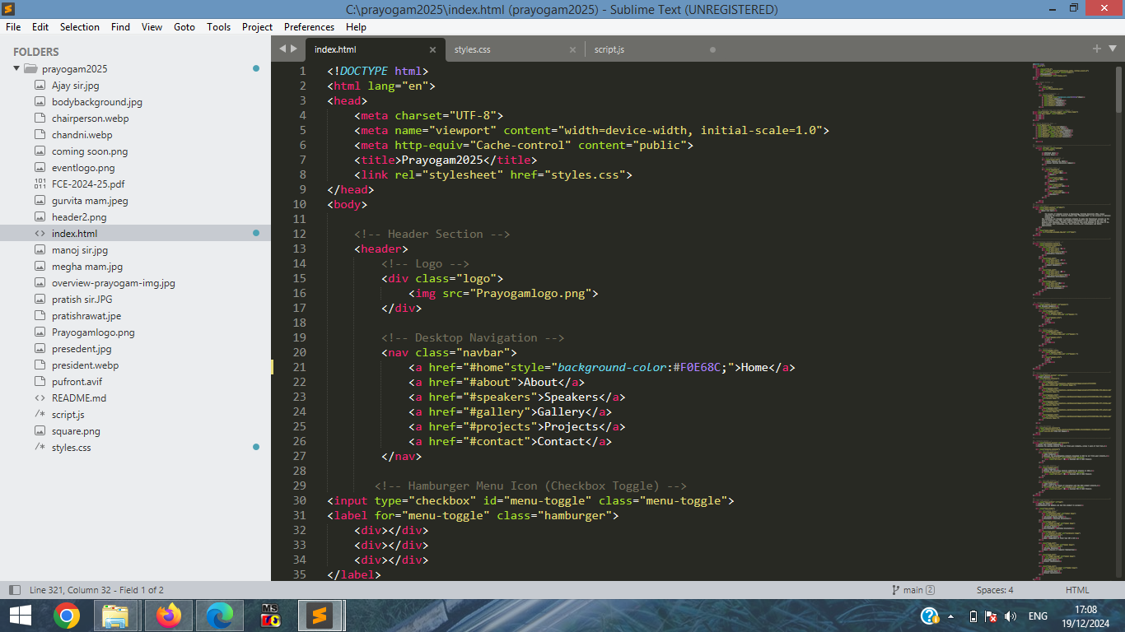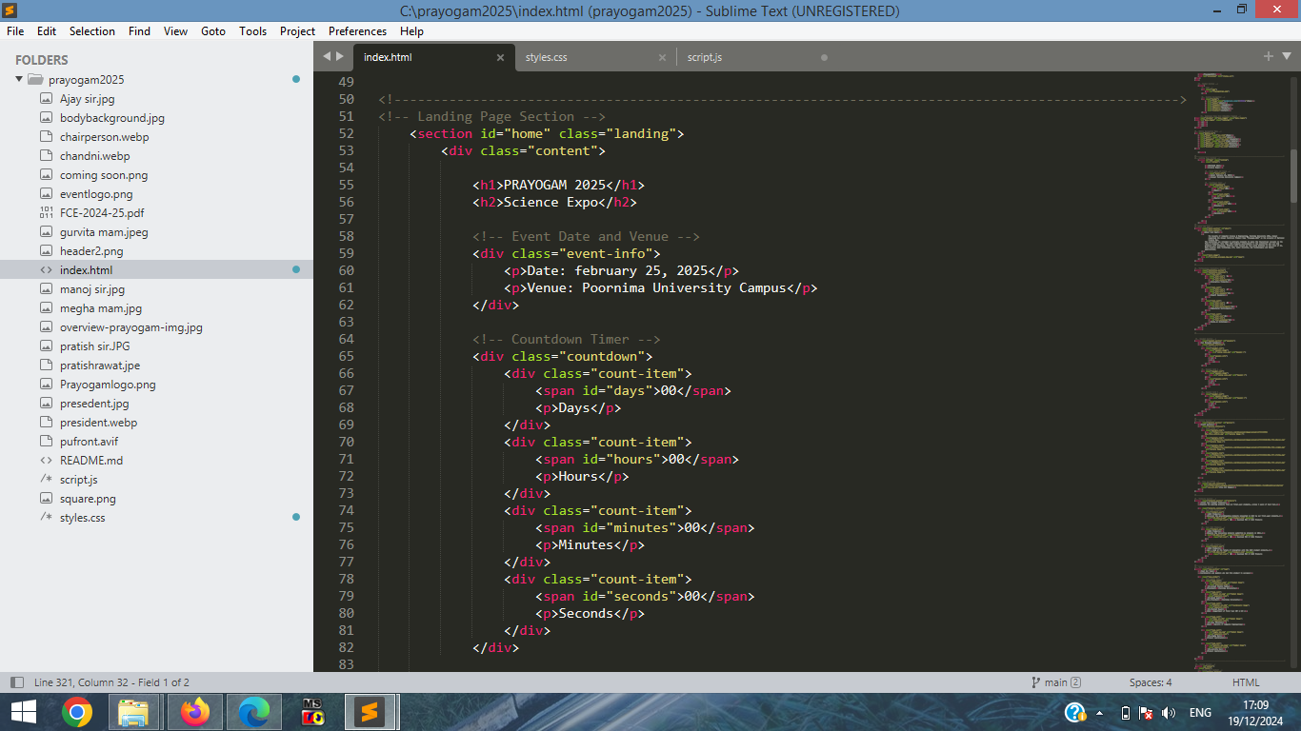
SCREENSHOTS
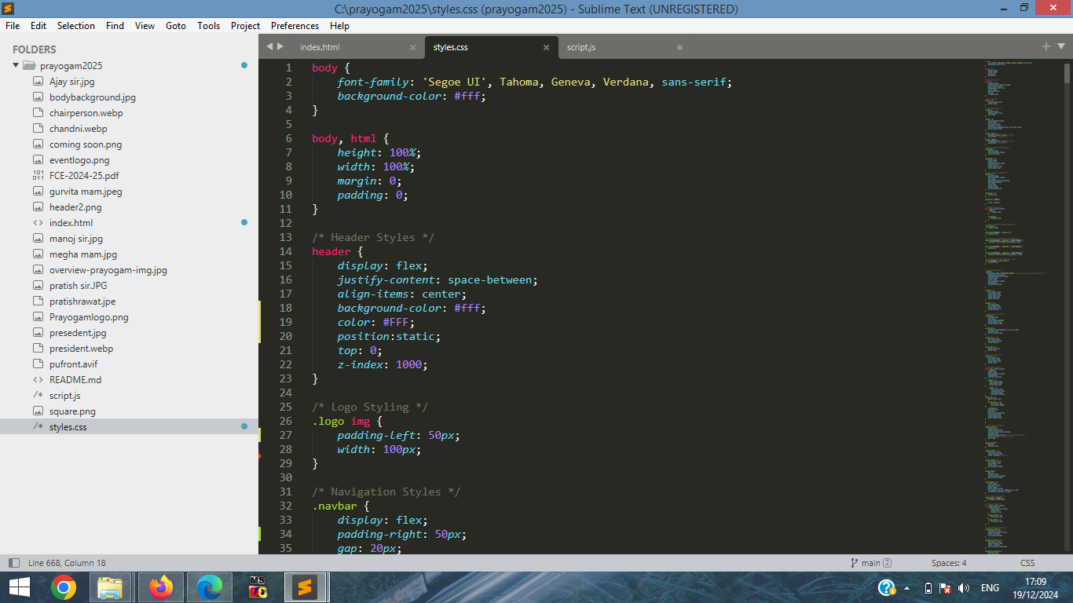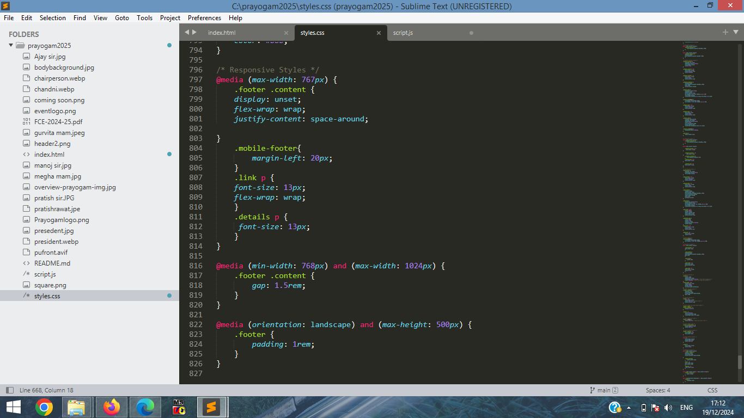

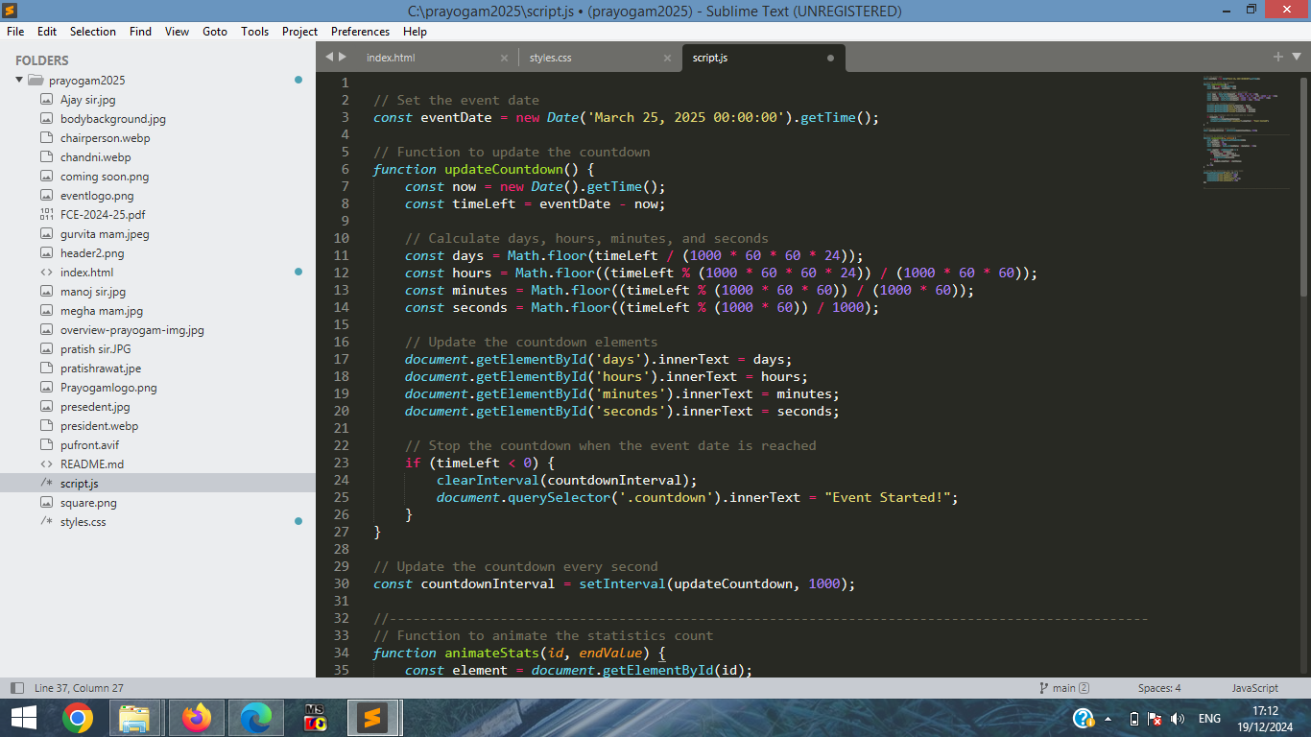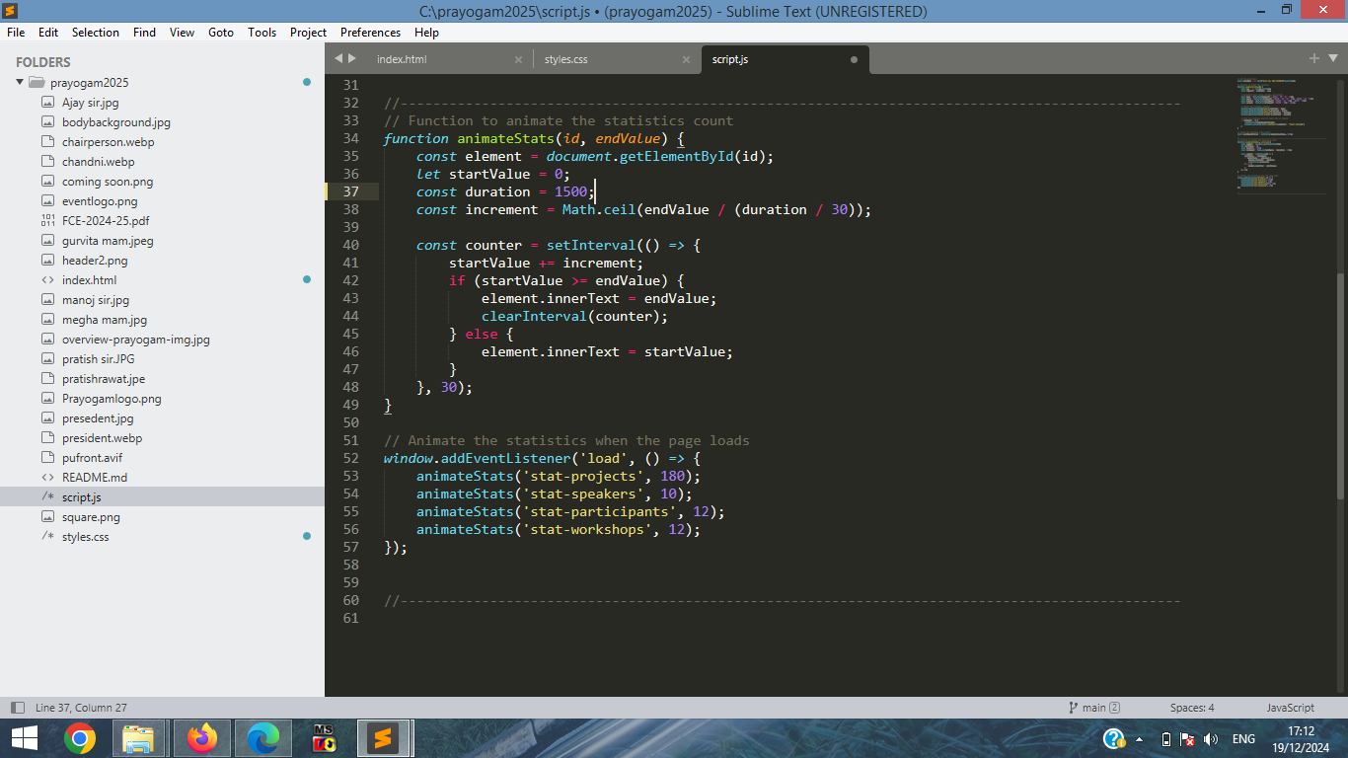
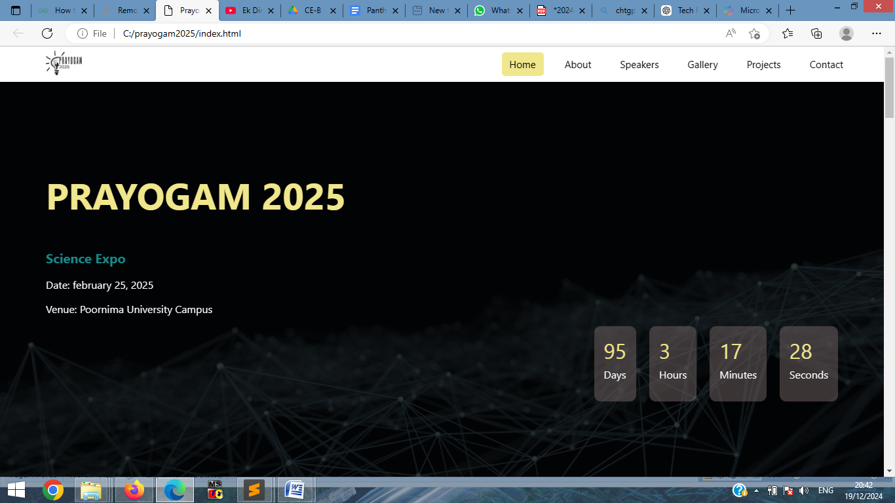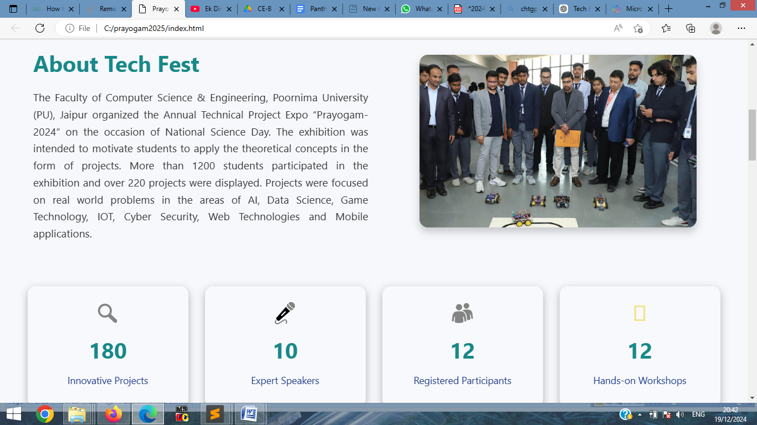

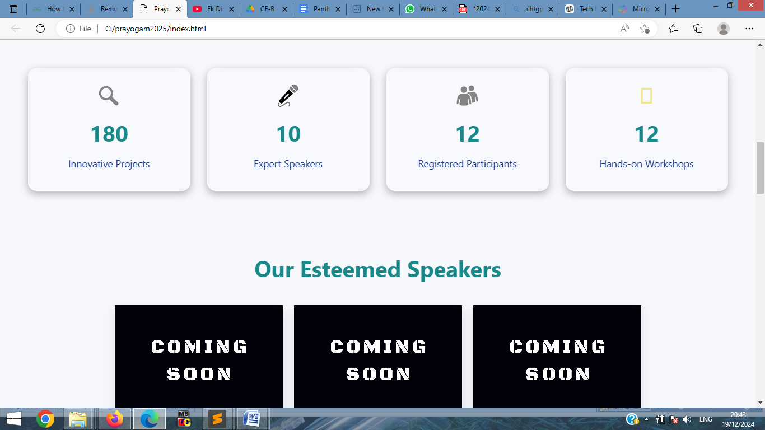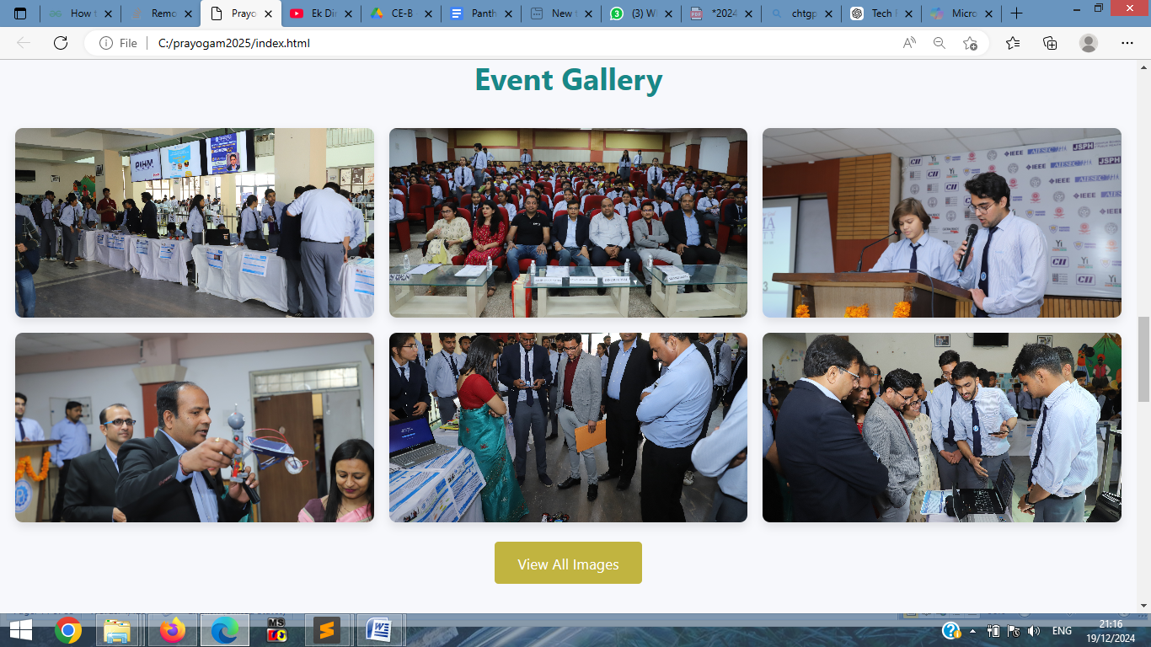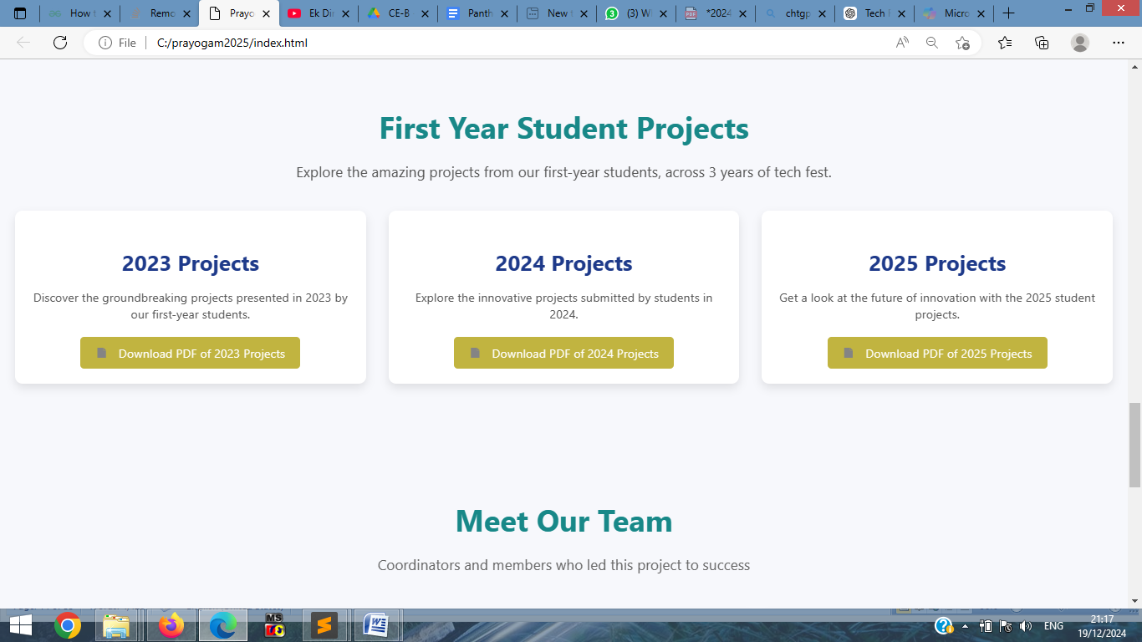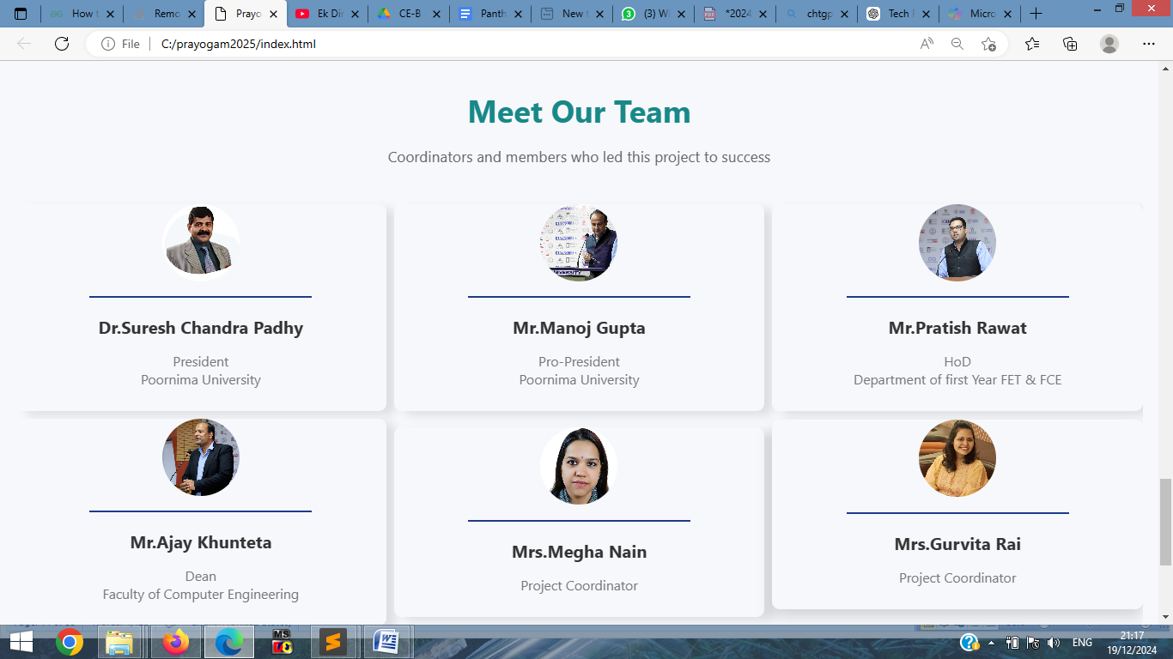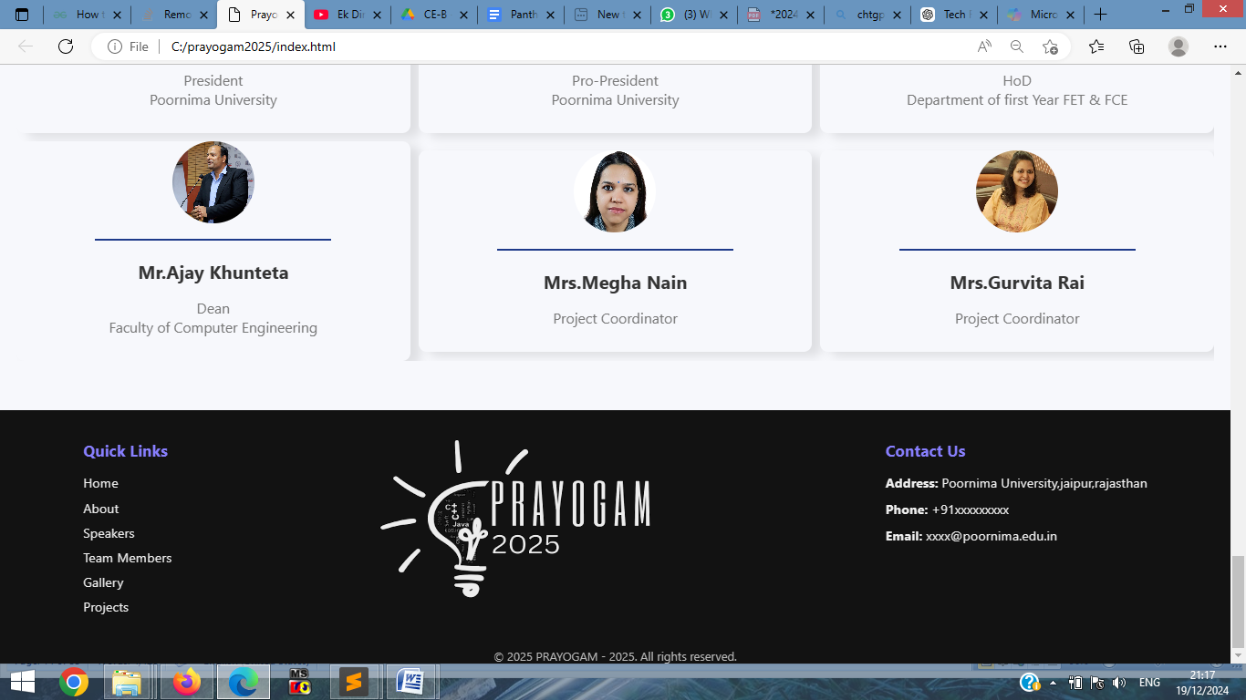

Chapter 1
Introduction
Prayogam is the annual Tech Fest organized by the Faculty of Computer Science & Engineering at Poornima University. This dynamic platform connects students, faculty, and industry professionals through a series of engaging activities, fostering collaboration and innovation within the technology community.
The event offers workshops, competitions, and networking opportunities designed to inspire participants and equip them with essential skills for their future careers. In today’s rapidly evolving technological landscape, it is vital for students to stay updated on the latest developments and trends. Prayogam not only enhances academic learning but also empowers students with practical, hands-on experiences that prepare them to tackle the challenges of the tech industry.
To support the objectives of Prayogam, the official website has been developed as a comprehensive resource for participants. The site serves multiple purposes:
- Event Information: Providing details about the schedule, workshops, competitions, and registration processes.
- Speaker Profiles: Highlighting the expertise and contributions of guest speakers.
- Engagement Features: Offering real-time updates and interactive elements to encourage user participation.
The website aims to promote awareness and excitement about the Tech Fest, serving as an accessible online platform that brings the event to life. By showcasing cutting-edge technologies and enabling knowledge exchange, the website helps foster a vibrant tech community at Poornima University.
In summary, Prayogam is more than just an event; it is a celebration of technology and innovation. Its website plays a pivotal role in connecting individuals, inspiring creativity, and ensuring that Prayogam remains a landmark event in Poornima University's academic calendar.

Objective of the Project

Create an official online presence for Prayogam2024 - Poornima University

Display the tech fest's motive and objectives

Showcase previous year's gallery, winning projects, and statistics

Provide a user-friendly platform for participants to explore and get inspired

Enhance the event's reputation and attract more participants

Scope
The project involves the creation of a responsive and user-friendly frontend website that provides seamless access across desktop, tablet, and mobile devices. The website will feature a dynamic landing page, an inspiring about section, a professional speaker showcase, a gallery of previous events, and a dedicated section for award-winning projects. Integrated with visually appealing statistical highlights, the website will serve as an engaging hub for participants and visitors alike.

Duration of Training
Duration of training: 12/08/2024 to 22/10/2024
Total Weeks: 12
Total Days: 80

Schedule

Sr. no. | TASK | TIME (weeks)
1 | Planning ,Resources & Research | 1-2
2 | Data Collection | 1
3 | Designing & Layout | 1-2
4 | Development | 6
5 | Testing | 1
6 | Debugging | 1
7 | Deployment | 1
8 | Unit Testing | 1
Table 1 Tasks and Time Required

1.4 Dataset Description

1. General Information
- Website Name: Prayogam2025
- URL: https://prayogam2025.netlify.app
- Purpose: A platform for showcasing and promoting a technology festival, including detailed information about events, workshops, and competitions.

2. Data Types
The website manages various categories of data, each tailored to enhance functionality and user experience:
- Event Data:
  - Contains details about the various workshops, talks, and competitions.
- Participant Data:
  - Includes attendee registration details and demographics.
- Speaker Data:
  - Provides profiles of speakers, their biographies, and discussion topics.
- Schedule Data:
  - Features a timetable with dates, times, and locations for all events.
- Feedback Data:
  - Collects participant feedback and ratings for events and speakers.

3. Data Structure
The data is structured into logical categories for efficient management and retrieval.
Events:
- Event ID: A unique identifier for each event.
- Title: The name of the event.
- Description: A brief summary of the event's purpose.
- Date and Time: When the event is scheduled to take place.
- Location: The venue where the event will be held.
- Type: The classification of the event (e.g., workshop, keynote, panel discussion)..
Speakers:
- Speaker ID: A unique identifier for each speaker.
- Name: Full name of the speaker.
- Bio: A brief biography or professional credentials.
- Event IDs: A list of events where the speaker is presenting.
Gallery:
- Latest : photographs of latest edition
- Previous year : photographs of last few edition

4. Data Volume
- Estimated Entries:
  - Events: Approximately 50 entries.
  - Participants: Approximately 500 entries.
  - Feedback: Approximately 200 entries.

- Update Frequency:
Data will be updated regularly as new participants register, events are finalized, and feedback is collected.

Chapter 2

Technology Stack

2.1 HTML (HyperText Markup Language)
HTML is the backbone of any webpage, providing the basic structure and content. It uses tags enclosed in angle brackets (< >) to define elements. HTML is not case-sensitive, but lowercase is preferred for consistency and modern practices.

Important HTML Tags
- <html>: The root element of an HTML document.
- <head>: Contains metadata, like the title, character encoding, and linked resources (e.g., stylesheets).
  - Example: <title>Prayogam 2025</title>
- <body>: Contains the visible content of the webpage.
- <h1> to <h6>: Define headings, with <h1> being the largest and <h6> the smallest.
- <p>: Represents a paragraph of text.
- <a>: Creates hyperlinks.Example: <a href="https://example.com">Click here</a>
- <img>: Embeds images.
  - Example: <img src="image.jpg" alt="Description">
- <div>: Defines a container for grouping elements.
- <ul> and <ol>: Create unordered and ordered lists, respectively.
- <table>: Creates a table with rows (<tr>) and columns (<td>).

CSS (Cascading Style Sheets)
CSS is used to style and layout HTML elements, improving visual appeal and responsiveness. It follows a cascading structure where rules are applied based on priority (inline, internal, external).

Frequently Used CSS Properties
- color: Sets the text color.
  - Example: color: blue;
- background-color: Defines the background color.
  - Example: background-color: lightgray;
- font-size: Adjusts text size.
  - Example: font-size: 16px;
- margin and padding: Control space around and inside elements.
  - Example: margin: 10px; padding: 5px;
- border: Sets borders around elements.
  - Example: border: 1px solid black;
- display: Defines the layout behavior of elements (e.g., block, inline, flex).
- position: Specifies how an element is positioned (static, relative, absolute, fixed).
- width and height: Define element dimensions.
  - Example: width: 100%; height: auto;
- box-shadow: Adds shadows to elements.
  - Example: box-shadow: 2px 2px 5px gray;
- hover: Applies styles when the user hovers over an element.
  - Example: a:hover { color: red; }

JavaScript
JavaScript is a programming language that adds interactivity and dynamic behavior to websites. It allows you to manipulate HTML and CSS in real time.

Key Concepts in JavaScript
- Variables: Used to store data.
  - Example: let name = "John";
- Functions: Blocks of reusable code.
  - Example:
javascript
Copy code
function greet() {
console.log("Hello, World!");
}
- DOM Manipulation: Modifies HTML elements dynamically.
  - Example:
javascript
Copy code
document.getElementById("header").style.color = "blue";
- Events: Trigger actions based on user interactions.
  - Example:
javascript
Copy code
button.addEventListener("click", function () {
alert("Button clicked!");
});
- Conditional Statements: Execute code based on conditions.
  - Example:
javascript
Copy code
if (age > 18) {
console.log("Adult");
} else {
console.log("Minor");
}
- Loops: Repeat a block of code.
  - Example:
javascript
Copy code
for (let i = 0; i < 5; i++) {
console.log(i);
}
Conclusion
HTML provides the structure, CSS enhances the design, and JavaScript adds functionality to create a seamless and engaging user experience. Understanding their core concepts and frequently used features ensures you can build professional and interactive websites effectively..

Chapter 3

Working of Project

In today's digital age, having an online presence is crucial for individuals, professionals, and businesses alike. A well-designed website can serve as a powerful tool for showcasing one's skills, experiences, and achievements, as well as connecting with others and building meaningful relationships. One such website that caught our attention is prayogam2025.netlify.app. This website is a testament to the power of modern web design and development, offering a seamless and engaging user experience that is sure to leave a lasting impression. At first glance, prayogam2025.netlify.app appears to be a personal or professional portfolio website, designed to showcase the skills, experiences, and achievements of its owner. However, as you delve deeper into the website, you begin to appreciate the attention to detail and the care that has gone into crafting each and every element. From the hero section on the home page, which features a stunning background image and a brief introduction to the website's purpose, to the projects page, which showcases the owner's impressive portfolio of work, every aspect of the website has been carefully designed to provide a cohesive and engaging user experience. Throughout the website, you'll notice a consistent design language, which includes a bold color scheme, clean typography, and ample whitespace. This design language not only makes the website visually appealing but also ensures that the content is easy to read and navigate. In addition to its stunning design, prayogam2025.netlify.app also boasts a robust set of features, including a responsive layout, which ensures that the website looks and functions perfectly on all devices, from desktop computers..

Brief Description
The website prayogam2025.netlify.app is hosted on Netlify, a platform renowned for its robust features like seamless deployment, continuous integration, and support for custom domains. Built using modern web technologies such as HTML, CSS, and JavaScript, the website adheres to current industry standards, ensuring compatibility and performance. It boasts a responsive design, making it accessible and visually appealing across a wide range of devices and screen sizes. With its simple and clean layout, the site emphasizes user experience by enabling easy navigation and a clutter-free interface. These elements collectively position the website as a modern, efficient, and user-friendly platform

Understanding UI and UX Design in the Prayogam2025 Website

User Interface (UI) Design
The User Interface (UI) focuses on the visual aspects and interactive elements of the Prayogam2025 website, ensuring an aesthetically pleasing and easy-to-navigate experience for users. Here’s how UI principles are applied in the project:
- Visual Hierarchy:
  - Proper use of headings, subheadings, and spacing creates a clear hierarchy.
  - Elements like the landing page title ("PRAYOGAM 2025") and section headings stand out due to larger font sizes and bold styles, drawing the user’s attention immediately.
- Color Palette:
  - The website employs a professional color palette, blending navy blues, golds, and whites to create a tech-themed aesthetic.
  - Consistent use of hover effects (e.g., navigation links, buttons) enhances user interactivity without overwhelming the design.
- Responsive Design:
  - The layout adapts seamlessly to different devices, ensuring usability across desktops, tablets, and mobile screens.
  - Features like the hamburger menu for mobile navigation maintain functionality without compromising design.
- Typography:
  - Font choices ensure readability while maintaining a modern and professional look.
  - Consistent font sizes and weights across the site improve overall harmony and user experience.
- Imagery and Icons:
  - The gallery section and about page leverage high-quality images to enhance the visual appeal and contextual relevance.
  - Icons in the navigation and interactive sections further streamline usability.

User Experience (UX) Design
The User Experience (UX) is centered on ensuring that visitors can easily achieve their goals on the website, such as exploring event details or registering for workshops. Below are key aspects of UX considerations:
- Intuitive Navigation:
  - A well-organized navigation bar (e.g., Home, About, Speakers, Team Members, Gallery, Projects, Contact) ensures users can find relevant information effortlessly.
  - Dropdown menus and hover-based interactions provide smooth transitions without cluttering the interface.
- Landing Page Appeal:
  - The countdown timer on the landing page creates a sense of urgency and excitement, directly engaging visitors.
  - The background image of AI robots and technology reflects the theme, providing contextual relevance.
- Interactive Features:
  - Hover effects on buttons and cards (e.g., speaker cards, project cards) improve interactivity, guiding users to take actions like viewing more details or downloading content.

4Accessibility:
  - The responsive design ensures inclusivity, allowing users with different devices to access content with ease.
  - Clear fonts, sufficient contrast ratios, and large clickable areas improve usability for all users.
- User Engagement:
  - The gallery section and statistics display provide an interactive and visually engaging experience, encouraging visitors to explore the website further.
  - The projects section with detailed descriptions and visual cards inspires users by showcasing achievements.

Conclusion
The Prayogam2025 website strikes a balance between modern UI design principles and user-centric UX strategies. The combination of clean layouts, engaging visuals, and responsive features ensures a seamless and enjoyable experience for visitors. The design not only reflects the spirit of innovation associated with the tech fest but also fosters accessibility and engagement for its diverse audience.

Technical Details

The website prayogam2025.netlify.app is built on a robust technical foundation, leveraging modern technologies and practices. It utilizes HTML5, CSS3, and JavaScript for core development, ensuring compliance with contemporary web standards.Hosted on a content delivery network (CDN), the website ensures fast load times and global accessibility, with security reinforced by the use of HTTPS encryption. The codebase is well-organized and adheres to industry best practices, maintained using a version control system (Git).

3.1.1 Overview of Web Development
Web development is the process of building and maintaining websites and web applications. It involves various aspects, including web design, web content development, client-side scripting, server-side scripting, and database management.

3.1.2 Importance of User Experience (UX) and User Interface (UI)
UX and UI are crucial aspects of web development. UX focuses on creating a seamless and intuitive user experience, while UI focuses on the visual aspects of the website. A welldesigned UX and UI can improve user engagement, increase website traffic, and enhance the overall reputation of the website.

3.1.3 Responsive Web Design
Responsive web design is an approach to web development that involves designing websites that can adapt to different screen sizes and devices. This approach ensures that websites are accessible and usable on various devices, including desktops, laptops, tablets, and smartphones.

3.1.4 Web Development Frameworks and Tools
There are various web development frameworks and tools available, including HTML, CSS, JavaScript, React, Angular, Vue.js, and Bootstrap. These frameworks and tools can help streamline the web development process, improve website performance, and enhance the overall user experience.

Chapter 3.2: Methdology

3.2.1 Research Approach
This project employed a descriptive research approach, which involved gathering and analyzing data to describe the characteristics of the Prayogam2025 website.

3.2.2 Web Development Process The web development process involved several stages, including planning, designing, developing, testing, and deploying the website.

3.2.3 Tools and Technologies Used The following tools and technologies were used to develop the Prayogam2025 website: - Front-end: HTML, CSS, JavaScript - Back-end: Node.js and Express.js - Version Control: Git

3.2.4 Testing and Quality Assurance The website was tested for usability, accessibility, and performance using various tools and techniques, including unit testing, integration testing, and user acceptance testing.

Chapter 3.3: System Analysis and Design

3.3.1 System Requirements This section outlines the functional and non-functional requirements of the Prayogam2025 website. - Functional Requirements: - User registration and login - Event information and schedule - Non-Functional Requirements: - Performance: fast loading times and efficient data processing - Security: secure user data and payment transactions - Usability: intuitive and user-friendly interface - Scalability: ability to handle increased traffic and data storage

3.3.2 System Analysis This section provides an in-depth analysis of the system, including its components, interfaces, and data flows. - System Interfaces: - User Interface: user interaction with the website - Database Interface: interaction between the website and the database - Data Flows: - User data: registration, login, and profile management - Event data: event information, schedule, and participant registration

3.3.3System Design This section presents the system design, including the architecture, components, and interfaces. - System Architecture: - Client-server architecture - Web-based application with a responsive design - System Interfaces: - User Interface: designed using Material-UI

3.3.4 Database Design This section provides a detailed design of the database, including the schema, tables, and relationships. - Database Schema: - Users table: stores user information and credentials - Events table: stores event information and schedules - Participants table: stores participant information and registration

Chapter 3.4: Implementation

3.4.1 Front-end Development This section describes the implementation of the front-end of the Prayogam2025 website using React, HTML, CSS, and JavaScript.

3.4.1.1 User Interface Components The front-end of the website consists of several user interface components, including: - Navigation bar - Event listing page - Event details page

3.4.1.2 Responsive Design The website is designed to be responsive, meaning it adapts to different screen sizes and devices. This is achieved using CSS media queries and flexible grid systems.
.
3.4.1.3 Testing and Debugging This section describes the testing and debugging process for the Prayogam2025 website.

.
Chapter 3.5: Testing and Quality Assurance

3.5.1 Testing Methodologies
This section describes the testing methodologies used to ensure the quality and reliability of the Prayogam2025 website.
3.5.1.1 Unit Testing Unit testing was performed using Jest and Enzyme to test individual components and functions. This ensured that each unit of code was working correctly and as expected.
3.5.1.2 Integration Testing Integration testing was performed using Cypress to test the interactions between different components and functions. This ensured that the website's components and functions were working together seamlessly.
3.5.1.3 System Testing System testing was performed to test the entire website from end-to-end. This ensured that the website was working correctly and as expected from a user's perspective.

3.5.2 Test Cases and Scenarios
This section describes the test cases and scenarios used to test the Prayogam2025 website.:
3.5.2.2 Event Management Test cases were created to test event management functionality, including: - Creating, editing, and deleting events

3.5.3 Quality Assurance
This section describes the quality assurance processes used to ensure the quality and reliability of the Prayogam2025 website.
3.5.3.1 Code Review Code review was performed to ensure that the code was readable, maintainable, and followed best practices.
3.5.3.2 Testing and Debugging Testing and debugging were performed to ensure that the website was working correctly and as expected.
3.5.3.3 Performance Optimization Performance optimization was performed to ensure that the website was fast and responsive.

Chapter -4

Future Scope
Prayogam2025
while a comprehensive platform for the tech fest, has room for further enhancement and innovation. Future work could focus on the following areas to maximize its potential:

- Comprehensive User Testing:
Conducting more extensive user testing and evaluation with a larger, more diverse audience. This will ensure that the website meets the needs of different user groups, including students, faculty, and external participants, and highlights areas for improvement.

- Adoption of New Technologies:
Exploring and incorporating emerging technologies to refine the website's design and functionality. This could include modern frameworks for faster load times, improved responsiveness, and enhanced interactivity.

- AI and Machine Learning Integration:
Investigating the use of artificial intelligence and machine learning to personalize user experiences. For example:
  - Recommending events or workshops based on user preferences.
  - Automating FAQs or support through AI-powered chatbots.
  - Optimizing website performance by analyzing user behavior patterns.

Chapter -5

Conclusion
The Prayogam2025 website serves as a dynamic and engaging digital platform that effectively showcases the annual tech fest hosted by Poornima University. Designed with user experience in mind, the website provides easy access to essential information about events, workshops, competitions, and schedules, while fostering engagement through interactive features. By leveraging modern web technologies like HTML, CSS, and JavaScript, the site ensures a seamless experience across various devices, from desktops to mobile phones.

Through well-structured sections, such as event details, speaker profiles, and galleries, the website offers participants a comprehensive overview of the fest and promotes active participation. Additionally, the user-friendly navigation and visually appealing design align with the goal of attracting diverse audiences, including students, faculty, and industry professionals.

Looking ahead, the site holds potential for further improvements in terms of personalization, functionality, and overall performance. With a focus on continuous innovation, the Prayogam2025 website is poised to remain a vital resource for future tech fest editions, contributing to the growth of Poornima University’s tech community and strengthening its reputation as a hub for innovation and collaboration.

In summary, the Prayogam2025 website is an essential tool that not only highlights the fest’s mission and objectives but also enhances the overall experience for all stakeholders, ensuring a successful and memorable event.
Chapter -6
References
- MDN Web Docs (Mozilla Developer Network)
  - URL: https://developer.mozilla.org/
  - Description: MDN provided essential documentation on HTML, CSS, and JavaScript, offering comprehensive guides, tutorials, and best practices for web development.
- W3Schools
  - URL: https://www.w3schools.com/
  - Description: W3Schools offered tutorials and examples on HTML, CSS, and JavaScript, helping in the understanding and implementation of various web design techniques.
- Stack Overflow
  - URL: https://stackoverflow.com/
  - Description: A crucial platform for troubleshooting coding issues and finding solutions to specific development problems that arose during the website’s creation.
- CSS-Tricks
  - URL: https://css-tricks.com/
  - Description: CSS-Tricks provided numerous tutorials and techniques related to CSS animations and responsive design, which were directly applied in the website's design.
- Font Awesome
  - URL: https://fontawesome.com/
  - Description: Font Awesome offered a rich collection of icons, which were used to enhance the visual appeal of the website’s navigation and UI elements.
- Unsplash and Pexels
  - URL: https://unsplash.com/ & https://www.pexels.com/
  - Description: These platforms provided high-quality, royalty-free images used throughout the website, contributing to a clean and professional aesthetic.

