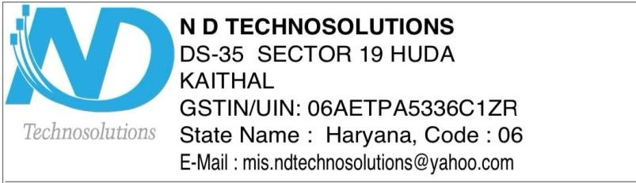

**Safety Certificate**

It is certified that the Solar Power Plant of capacity 2 KW installed by N D Techno Solutions at Bruce Wayne, Gotham, Invoice No. ME/2024-25/359, Dated: 29-03-2025, in this system we have installed one inverter of capacity 3 KW and 4 modules of 540 watt

Make of Inverter : Luminous

Make of Module : Luminous

Number of Earthing : 3

Surge Protection Device : Yes

We, ND Techno Solutions, DS-35, Sector – 19, HUDA, Kaithal, Haryana, certify that this system is installed as per MNRE guidelines and is safe (all the safety measures are being taken care of ).

Thanking you.

Yours truly,

N D Techno Solutions

Auth. Signatory



**Warranty/Guarantee and Declaration Certificate**

It is Certified that the ON GRID SOLAR POWER PLANT of capacity 2 KWinstalled by ND Techno Solutions to Bruce Wayne, Gotham, Invoice No. ME/2024-25/359, Dated: 29-03-2025, is warranted for 5 years from the date of commissioning with 5 year AMC of complete system and with the warranty of modules for their output peak watt capacity, which would not be less than 90% at the end of 10 years and 80% at the end of 25 years.

It also Certified that the On grid Solar Power Plant installed is in compliance with the latest minimum.

|  |  |  |  |
| --- | --- | --- | --- |
| Sr..No. | Item | Make | Capacity of Item tested |
| 1. | Inverter | Luminous | 3 KW |
| 2. | Module | Luminous | 540 W |

**ND Techno Solutions**

Signature



**Serial No. & List of Polycrystalline Silicon Photovoltaic Modules**

**TO WHOMSOEVER IT MAY CONCERN**

This is to certify that 4 nos. of 540 W Solar PV modules Made by Luminous ,having following serial numbers are supplied to Bruce Wayne, Gotham, Invoice No. ME/2024-25/359, Dated: 29-03-2025. It is also certified that all modulus are indigenous / manufactured in INDIA.

Module Sr.No.(­­­­­­ 540 W each)

|  |  |
| --- | --- |
| ab1 | ab2 |
| ab3 | ab4 |
|  |  |
|  |  |
|  |  |
|  |  |
|  |  |
|  |  |
|  |  |
|  |  |
|  |  |
|  |  |

**For N D Techno Solutions**

Signature