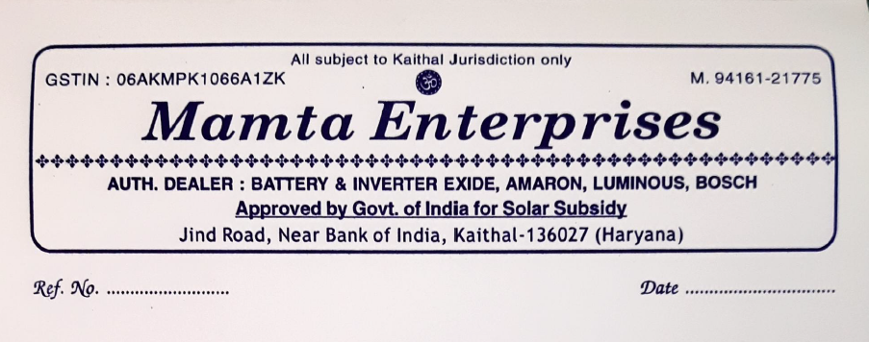

**Safety Certificate**

It is certified that the Solar Power Plant of capacity {net_solar_capacity} KW installed by Mamta Enterprises at {consumer_name}, {consumer_address}, Invoice No. {invoice_number}, Dated: {invoice_date}, in this system we have installed one inverter of capacity {inverter_capacity} KW and {no_of_panels} modules of {panel_capacity} watt

Make of Inverter : {inverter_brand}

Make of Module : {panel_brand}

Number of Earthing : 3

Surge Protection Device : Yes

We, Mamta Enterprises, near Bank of India, Jind Road, Kaithal, HR, certify that this system is installed as per MNRE guidelines and is safe (all the safety measures are being taken care of ).

Thanking you.

Yours truly,

For Mamta Enterprises

Auth. Signatory



**Warranty/Guarantee and Declaration Certificate**

It is Certified that the ON GRID SOLAR POWER PLANT of capacity {net_solar_capacity} KWinstalled by Mamta Enterprises to {consumer_name}, {consumer_address}, Invoice No. {invoice_number}, Dated: {invoice_date}, is warranted for 5 years from the date of commissioning with 5 year AMC of complete system and with the warranty of modules for their output peak watt capacity, which would not be less than 90% at the end of 10 years and 80% at the end of 25 years.

It also certified that the On-grid Solar Power Plant installed is in compliance with the latest minimum.

|  |  |  |  |
| --- | --- | --- | --- |
| Sr..No. | Item | Make | Capacity of Item tested |
| 1. | Inverter | {inverter_brand} | {inverter_capacity} KW |
| 2. | Module | {panel_brand} | {panel_capacity} W |

**For Mamta Enterprises**

Signature



**Serial No. & List of Polycrystalline Silicon Photovoltaic Modules**

**TO WHOMSOEVER IT MAY CONCERN**

This is to certify that {no_of_panels} nos. of {panel_capacity} W Solar PV modules Made by {panel_brand} ,having following serial numbers are supplied to {consumer_name}, {consumer_address}, Invoice No. {invoice_number}, Dated: {invoice_date}. It is also certified that all modulus are indigenous / manufactured in INDIA.

Module Sr.No.(­­­­­­ {panel_capacity} W each)

|  |  |
| --- | --- |
| {serial_number_1} | {serial_number_2} |
| {serial_number_3} | {serial_number_4} |
| {serial_number_5} | {serial_number_6} |
| {serial_number_7} | {serial_number_8} |
| {serial_number_9} | {serial_number_10} |
| {serial_number_11} | {serial_number_12} |
| {serial_number_13} | {serial_number_14} |
| {serial_number_15} | {serial_number_16} |
| {serial_number_17} | {serial_number_18} |
| {serial_number_19} | {serial_number_20} |
| {serial_number_21} | {serial_number_22} |
| {serial_number_23} | {serial_number_24} |

**For Mamta Enterprises**

Signature