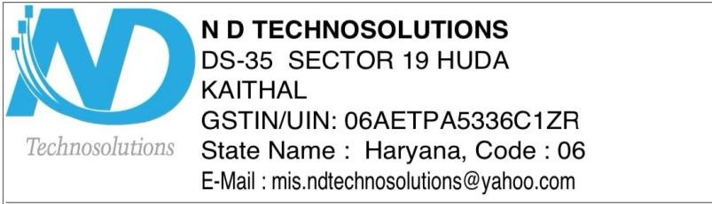

**Safety Certificate**

It is certified that the Solar Power Plant of capacity {net_solar_capacity} KW installed by N D Techno Solutions at {consumer_name}, {consumer_address}, Invoice No. {invoice_number}, Dated: {invoice_date}, in this system we have installed one inverter of capacity {inverter_capacity} KW and {no_of_panels} modules of {panel_capacity} watt

Make of Inverter : {inverter_brand}

Make of Module : {panel_brand}

Number of Earthing : 3

Surge Protection Device : Yes

We, ND Techno Solutions, DS-35, Sector – 19, HUDA, Kaithal, Haryana, certify that this system is installed as per MNRE guidelines and is safe (all the safety measures are being taken care of ).

Thanking you.

Yours truly,

N D Techno Solutions

Auth. Signatory



**Warranty/Guarantee and Declaration Certificate**

It is Certified that the ON GRID SOLAR POWER PLANT of capacity {net_solar_capacity} KWinstalled by ND Techno Solutions to {consumer_name}, {consumer_address}, Invoice No. {invoice_number}, Dated: {invoice_date}, is warranted for 5 years from the date of commissioning with 5 year AMC of complete system and with the warranty of modules for their output peak watt capacity, which would not be less than 90% at the end of 10 years and 80% at the end of 25 years.

It also Certified that the On grid Solar Power Plant installed is in compliance with the latest minimum.

|  |  |  |  |
| --- | --- | --- | --- |
| Sr..No. | Item | Make | Capacity of Item tested |
| 1. | Inverter | {inverter_brand} | {inverter_capacity} KW |
| 2. | Module | {panel_brand} | {panel_capacity} W |

**ND Techno Solutions**

Signature



**Serial No. & List of Polycrystalline Silicon Photovoltaic Modules**

**TO WHOMSOEVER IT MAY CONCERN**

This is to certify that {no_of_panels} nos. of {panel_capacity} W Solar PV modules Made by {panel_brand} ,having following serial numbers are supplied to {consumer_name}, {consumer_address}, Invoice No. {invoice_number}, Dated: {invoice_date}. It is also certified that all modulus are indigenous / manufactured in INDIA.

Module Sr.No.(­­­­­­ {panel_capacity} W each)

|  |  |
| --- | --- |
| {serial_number_1} | {serial_number_2} |
| {serial_number_3} | {serial_number_4} |
| {serial_number_5} | {serial_number_6} |
| {serial_number_7} | {serial_number_8} |
| {serial_number_9} | {serial_number_10} |
| {serial_number_11} | {serial_number_12} |
| {serial_number_13} | {serial_number_14} |
| {serial_number_15} | {serial_number_16} |
| {serial_number_17} | {serial_number_18} |
| {serial_number_19} | {serial_number_20} |
| {serial_number_21} | {serial_number_22} |
| {serial_number_23} | {serial_number_24} |

**For N D Techno Solutions**

Signature