Assignment 1

String and String Buffer

Why is String immutatable in Java

Memory alloacation

Stack and Heap Working

New Terms like

* String pool
* Heap and Stack
* How immutatable memory helps in optimizibng Java Code.

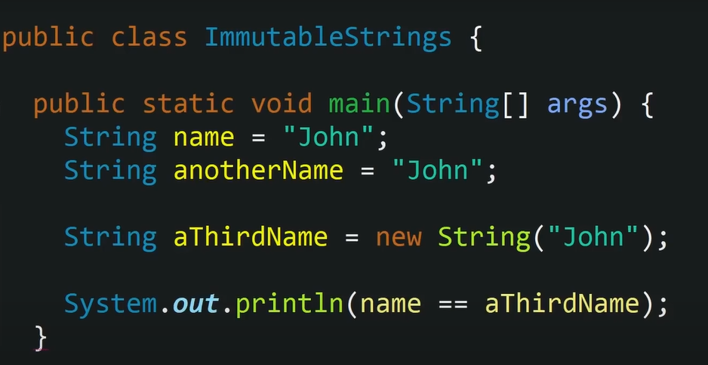

Output of Above code: False

This is because the anothername and a thirdName are pointing towards two different Memory location in String Pool.

Working of String

String Pool

string num=”Name”;

1. “Name”
2. “Name”

string nos=”Name”;

string get= new String(“Name”)

Then the variables

Num and nos are actually

Pointers pointing to same

memory address of

String pool.

What new we learned

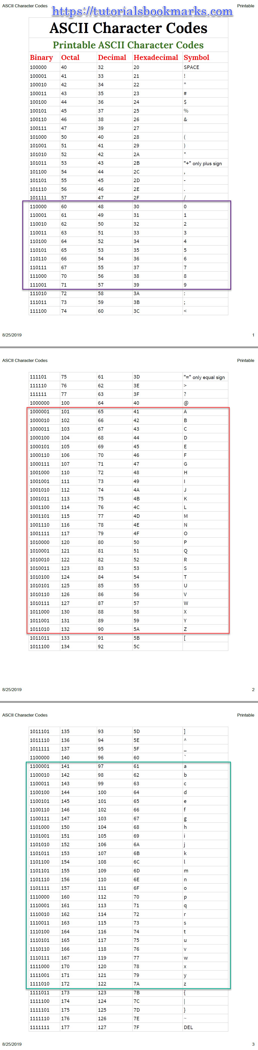

|  |  |  |
| --- | --- | --- |
| **Escape Sequence** | **Meaning** | **Explanation** |
| \a | Alarm or Beep | A beep sound is generated |
| \b | Backspace | Backspace |
| \f | Form Feed | Form Feed page break(Return) |
| \n | New Line | Shift the cursor control to the new line |
| \r | Carriage Return | Shift the cursor to the beginning of the current line |
| \t | Tab (Horizontal) | Shift the cursor to a couple of spaces(Eight blank spaces) to the right in the same line |
| \v | Vertical Tab | Vertical Tab |
| \\ | Backslash | Print the backslash character |
| \’ | Single Quote | Display the single-quotation mark. |
| \” | Double Quote | Print the double-quotation mark |
| \? | Question Mark | Display the question mark |
| \nnn | octal number | Represent an octal number |
| \xhh | hexadecimal number | Represent a hexadecimal number |
| \0 | Null | Termination of the string |

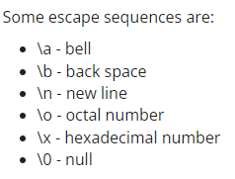

**File Handling**

**Stream**

**Operations**

**Read and Write function**

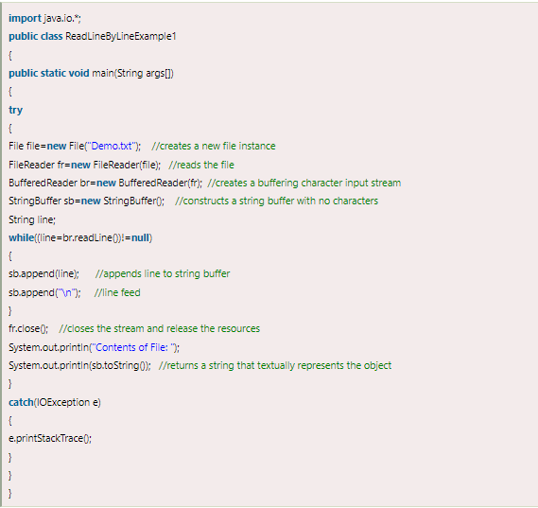

**Removal of White Spaces from the string.**

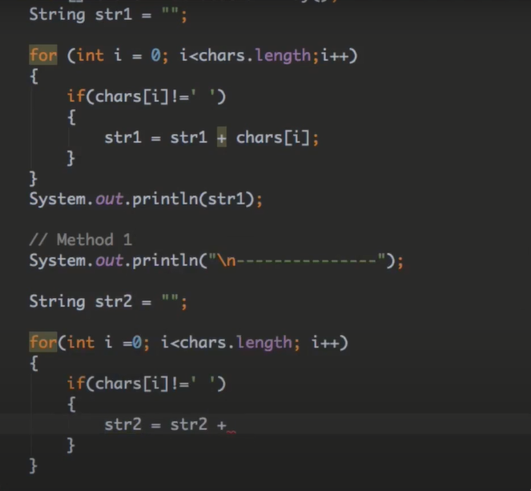

**Replacing White Spaces**

