**PRACTICAL - 1**

**AIM:**

Explore the Jira as a project management tool for agile development. Execute the following Activity in Jira Tool:

1. Free Trial Setup
2. Create an Epic
3. Create an Issue
4. Create Story
5. Create Subtask
6. Create Sprint

**THEORY:**

* Jira Software is part of a family of products designed to help teams of all types manage work. Originally, Jira was designed as a bug and issue tracker. But today, Jira has evolved into a powerful work management tool for all kinds of use cases, from requirements and test case management to agile software development.
* Jira is a suite of agile work management solutions that powers collaboration across all teams from concept to customer, empowering you to do the best work of your life, together. Jira offers several products and deployment options that are purpose-built for Software, IT, Business, Ops teams, and more. Read on to see which is right for you.
* Jira helps teams plan, assign, track, report, and manage work and brings teams together for everything from agile software development and customer support to start-ups and enterprises.
* With templates and solutions crafted for every team and Jira as your common language - work moves fluently and transparently across your organization.

**OUTPUT:**

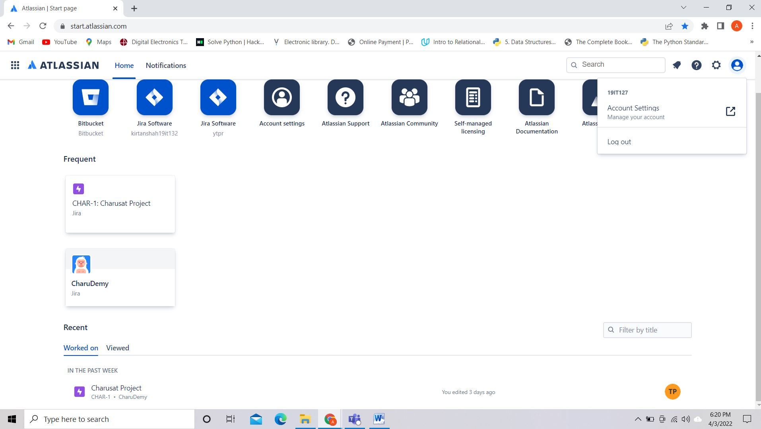

1.1 Setup Free trail

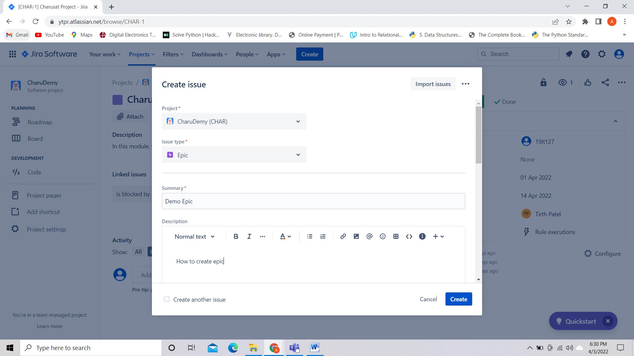

1.2 Create an Epic

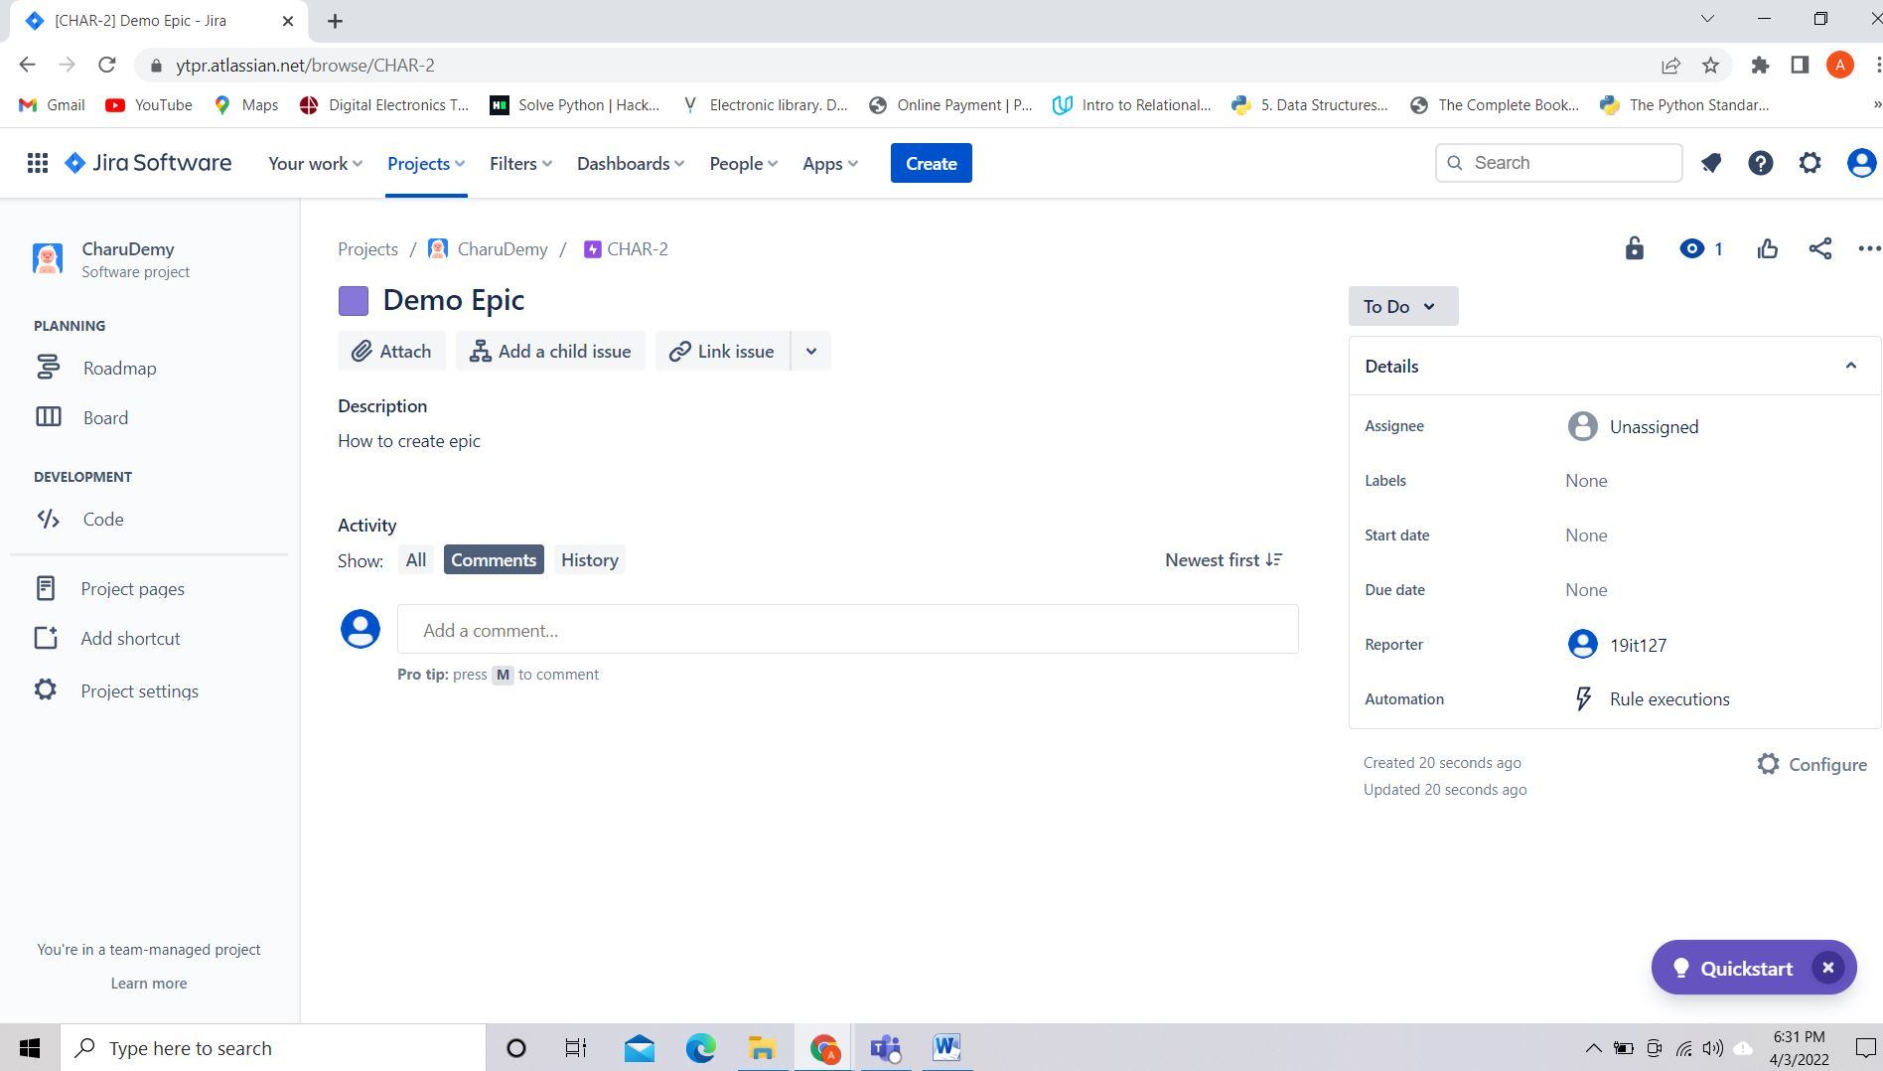

1.3 Issue Created

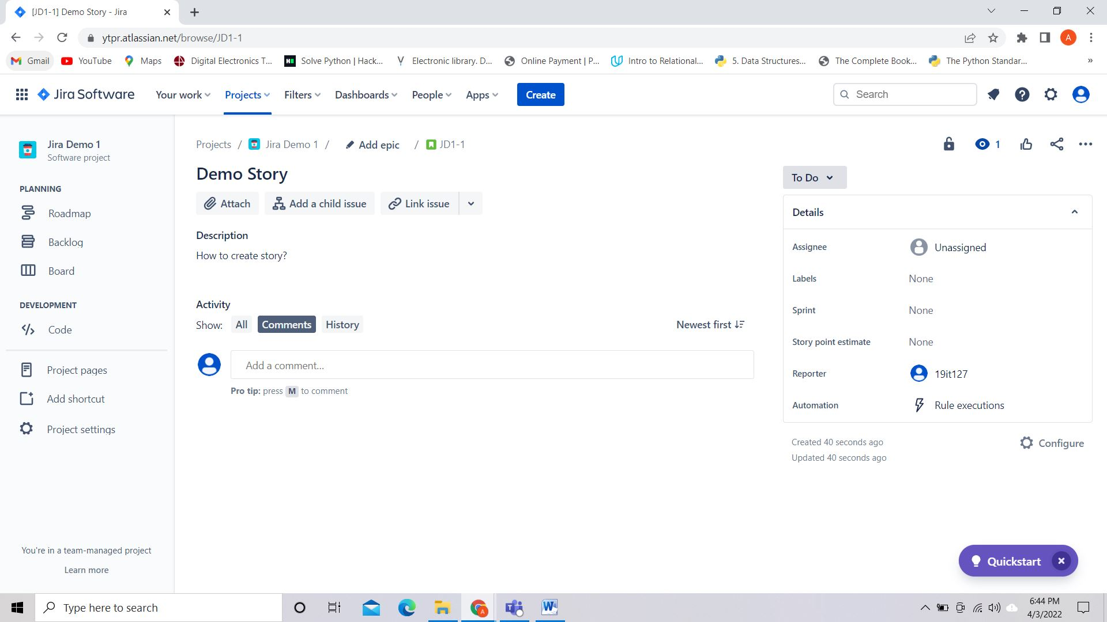

1.4 Creating a story

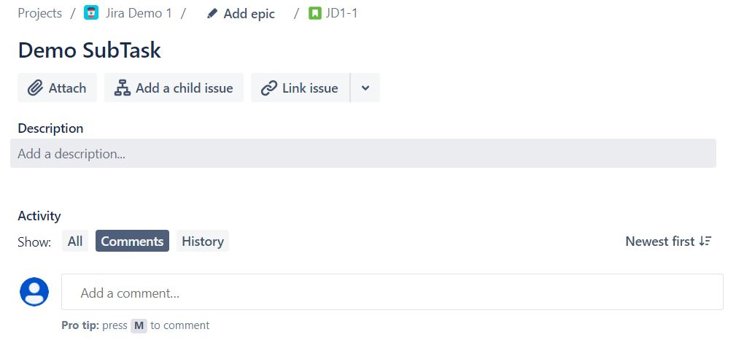

1.5 Create a demo subtask

**LATEST APPLICATIONS:**

* Jira helps to plan and manage the project for the teams working on project and show the roadmap of project.
* Teams which are practicing an agile methodology like scrum or kanban, the Jira board creates a visual representation of all work in flight so everyone on the team has visibility into each unit of work’s current status and can quickly identify blockers in the workflow.
* The Jira issue also functions as a “release hub” by surfacing information from Git solutions like Bitbucket and GitHub.
* User stories that aren’t prioritized for the current sprint can be tracked in the backlog until the team has the bandwidth to tackle it.
* Jira integrates with Opsgenie and Confluence to help teams streamline incident response and management, and take post-incident actions.

**LEARNING OUTCOME:**

* Creating a story in Jira.
* How to plan and manage the project.
* How ticket are used?
* Creating subtask and sprint.

**REFERENCES:**

* <https://www.youtube.com/watch?v=uM_m6EzMg3k>
* <https://www.youtube.com/watch?v=HzJzB0nQYlk>