# Table of Contents

1.0. High Fedility

2.0. Medium Fedility

3.0. low Fedility

# 1.0. High Fedility

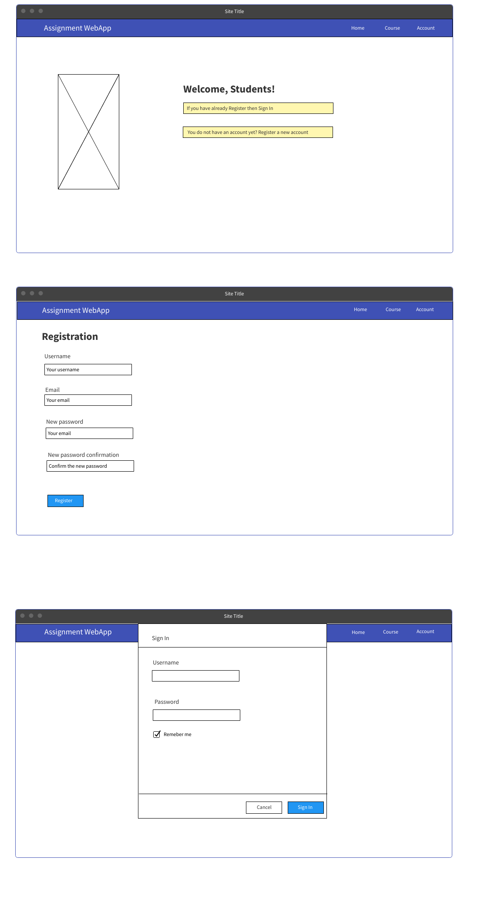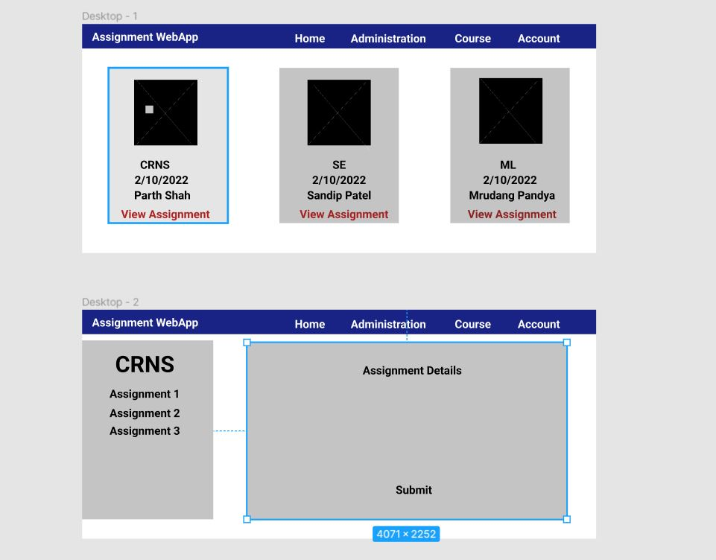

# 2.0. Medium Fedility

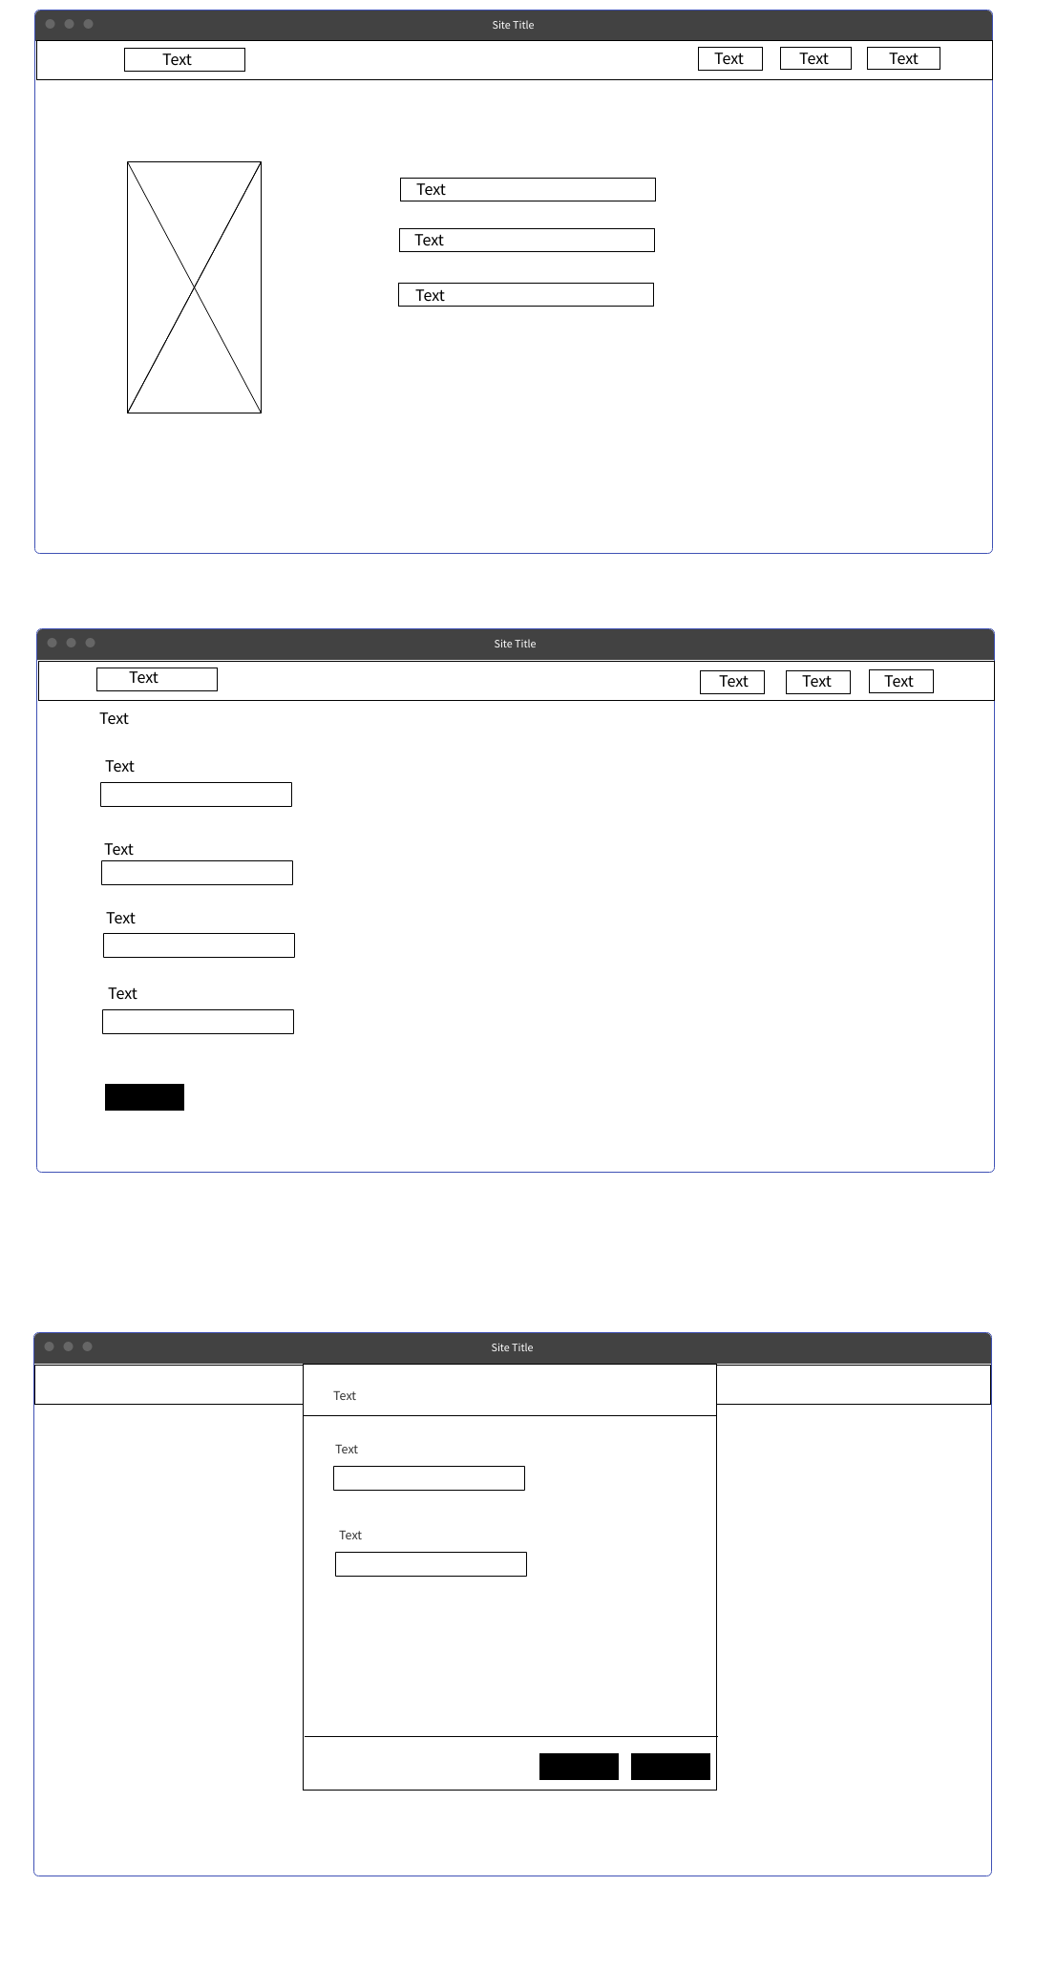

# 3.0. low Fedility

