PROJECT REPORT

**on**

#### “Food-Delivery-App”

Department of Computer Engineering & Applications

**GLA UNIVERSITY, MATHURA-281406**



**SESSION- 2022-23**

**SUBMITTED BY: - SUBMITTED TO: -**

**Ayush Kaushal (201500178) Mr.Bhanu Kapoor**

**Mrigank Gahoi (201500415)**

**Dhruv Gupta (201500221)**

## Declaration

We hereby declare that the work which is being presented in the Full Stack Project “**Food-Delivery-App”,** in partial fulfilment of the requirements for Full Stack Project viva voce, is an authentic record of our own work carried by the team members under the supervision of our mentor Mr. Bhanu kapoor.

Group Members:

Ayush Kaushal (201500178)

Mrigank Gahoi (201500415)

Dhruv Gupta (201500221)

Course: B.Tech (Computer Science and Engineering) Year: 3rd

Semester: 6th

Supervised By

Mr. Bhanu Kapoor, Technical Trainer,

GLA University, Department of Computer Engineering & Application

**Department of computer Engineering and Applications GLA University, Mathura**

**GLA**

**17 km Stone NH#2, Mathura Delhi Road, P.O. – Chaumuhan Mathura-281406**

## Certificate

This is to certify that the above statements made by the candidates are correct to the best of my/our knowledge and belief.

Supervisor Mr. Bhanu kapoor

Technical Trainer

Dept of CEA, GLA University

Project Mentor Program Coordinator

(Mr. Bhanu Kapoor ) (Mr. Shubash C Agrawal)

## About the Project

The "Online Food Delivery App" has been developed to override the problems prevailing in the practicing manual system. This software is supported to eliminate and, in some cases, reduce the hardships faced by this existing system. Moreover, this system is designed for the particular need of the company to carry out operations in a smooth and effective manner

The application is reduced as much as possible to avoid errors while entering the data. It also provides error message while entering invalid data. No formal knowledge is needed for the user to use this system. Thus, by this all it proves it is user-friendly. Online Food Ordering System, as described above, can lead to error free, secure, reliable and fast management system. It can assist the user to concentrate on their other activities rather to concentrate on the record keeping. Thus, it will help organization in better utilization of resources

## Motivation

The motivation of Online Food Delivery App is to automate the existing manual system by the help of computerized equipment’s and full-fledged computer software, fulfilling their requirements, so that their valuable data/information can be stored for a longer period with easy accessing and manipulation of the same. The required software and hardware are easily available and easy to work with

Online Food Ordering System, as described above, can lead to error free,

secure, reliable and fast management system. It can assist the user to concentrate on

their other activities rather to concentrate on the record keeping.

Online Food Ordering System, as described above, can lead to error free,

secure, reliable and fast management system. It can assist the user to concentrate on

their other activities rather to concentrate on the record keeping.

Online Food Ordering System, as described above, can lead to error free,

secure, reliable and fast management system. It can assist the user to concentrate on

their other activities rather to concentrate on the record keeping.

Online Food Ordering System, as described above, can lead to error free,

secure, reliable and fast management system. It can assist the user to concentrate on

their other activities rather to concentrate on the record keeping.

Online Food Ordering System, as described above, can lead to error free,

secure, reliable and fast management system. It can assist the user to concentrate on

their other activities rather to concentrate on the record keeping.

Online Food Ordering System, as described above, can lead to error free, secure, reliable and fast management system. It can assist the user to concentrate on their other activities rather to concentrate on the record keeping.

Online Food Ordering System, as described above, can lead to error free,

secure, reliable and fast management system. It can assist the user to concentrate on

their other activities rather to concentrate on the record keeping.

## Requirements

1. **Software Requirements:**
   * Language Used: JS(REACT), Bootstrap
   * User Interface Design: HTML, CSS, Bootstrap, React
   * Web Browser: Google Chrome and Microsoft Edge
   * Front End: HTML, CSS, React
   * GitHub: GitHub is a code hosting platform for version control and collaboration. It lets you and others work together on projects from anywhere. GitHub Repository: A GitHub repository can be used to store a development project. It can contain folders and any type of files (HTML, CSS, JavaScript, Documents, Data, Images). A GitHub repository should also include a license file and a README file about the project. A GitHub repository can also be used to store ideas, or any resources that you want to share.
2. **Hardware Requirement:**

* Processor: AMD Ryzen 5 5600U With Radeon Graphics 2.30GHz
* Operating System: Windows
* Ram: 8GB
* Hardware Devices: Laptop
* Hard Disk: Minimum as per bran

#### Acknowledgement

We thank the almighty for giving us the courage and perseverance in completing the project. This project itself is an acknowledgement for all those people who have given us their heartfelt co-operation in making this project a grand success.

We extend our sincere thanks to Mr. Bhanu Kapoor,

Technical Trainer at “GLA University, Mathura” for providing his valuable guidance at every stage of this project work. We are profoundly grateful towards the unmatched services rendered by him. And last but not least, we would like to express our deep sense of gratitude and earnest thanks giving to our dear parents for their moral support and heartfelt cooperation in doing the project.

**“FOOD-DELIVERY-APP”**

#### Abstract

With the increasing popularity of food delivery, the traditional telephone order food has inconvenience to the customers and the food delivery store. How to make the food-delivery more quickly and conveniently has become a concern of people. So this report explores and develops new takeaway apps that are easier and more object-oriented than existing apps. Food-delivery app has easy and simple features, but now the food-delivery app is no more convenient for people, the overall is relatively old, not novel enough, cannot attract new users. Based on this feature, we decided to design a system for people.

#### Contents

**Acknowledgment** 07

**Abstract** 08

1. **Introduction** Error! Bookmark not defined.
2. **Technologies Used:** Error! Bookmark not defined.

HTML **Error! Bookmark not defined.**

CSS **Error! Bookmark not defined.**

BOOTSTRAP… 13

JAVASCRIPT 14

1. List of Figures 15-22
2. **Conclusion** 23
3. **Bibliography** 24

#### Introduction

. The online food deliver service is a local restaurant and food cooperative website or application for customers to provide more interactive menu so that the ordering process could be carried out. Ordering food online is designed for its more flexibility and performance, some website or application are make sure that the system has enough navigation function through the picture information or significant logo to guide customer like students follow the steps to finish the ordering food process, apart from that it has been constructed to dealing with large number of orders simultaneously to prevent the food overload

The online food ordering service is a local restaurant and food cooperative website or

application for customers to provide more interactive menu so that the ordering process could

be carried out. Ordering food online is designed for its more flexibility and performance,

some website or application are make sure that the system has enough navigation function

through the picture information or significant logo to guide customer like students follow the

steps to finish the ordering food process, apart from that it has been constructed to dealing

with large number of orders simultaneously to prevent the food overload

**Technologies Used**

## HTML:

**HTML** stands for Hypertext Markup Language. It is used to design web pages using a markup language. HTML is the combination of Hypertext and Markup language. Hypertext defines the link between web pages. A markup language is used to define the text document within the tag which defines the structure of web pages. This language is used to annotate (make notes for the computer) text so that a machine can understand it and manipulate text accordingly. Most markup languages (e.g., HTML) are human-readable. The language uses tags to define what manipulation has to be done on the text. HTML is a markup language used by the browser to manipulate text, images, and other content, in order to display it in the required format. HTML was created by Tim Berners-Lee in 1991. The first-ever version of HTML was HTML 1.0, but the first standard version was HTML 2.0, published in 1995.

#### Elements and Tags:

HTML uses predefined [tags](https://www.geeksforgeeks.org/html-html-tag/#%3A~%3Atext%3DThe%20tag%20in%20HTML%2CDOCTYPE%3E%20tag) and [elements](https://www.geeksforgeeks.org/html-elements/) which tell the browser how to properly display the content. Remember to include closing tags. If omitted, the browser applies the effect of the opening tag until the end of the page.

#### HTML page structure:

The basic structure of an HTML page is laid out below. It contains the essential building-block elements (i.e., doctype declaration, HTML, head, title, and body elements) upon which all web pages are created.

Basic/built-in text editors are Notepad (Windows) and TextEdit (Macs). Basic text editors are entirely sufficient for when you are just getting started. As you progress, there are many feature- rich text editors available which allow for greater function and flexibility.

#### CASCADING STYLE SHEETS (CSS):

**C**ascading **S**tyle **S**heets, fondly referred to

as **CSS**, is a simply designed language intended to simplify the process of making web pages presentable. CSS allows you to apply styles to web pages. More importantly, CSS enables you to do this independent of the HTML that makes up each web page. It describes how a webpage should look: it prescribes colours, fonts, spacing, and much more. In short, you can make your website look however you want. CSS lets developers and designers define how it behaves, including how elements are positioned in the browser.

While html uses tags, CSS uses rulesets. CSS is easy to learn and understand, but it provides powerful control over the presentation of an HTML document.

* + - **CSS saves time:** You can write CSS once and reuse the same sheet in multiple HTML pages.
    - **Easy Maintenance:** To make a global change simply change the style, and all elements in all the webpages will be updated automatically.
    - **Search Engines:** CSS is considered a clean coding technique, which means search engines will not have to struggle to “read” its content.
    - **Superior styles to HTML:** CSS have a much wider array of attributes than HTML, so you can give a far better look to your HTML page in comparison to HTML attributes.
    - **Offline Browsing:** CSS can store web applications locally with the help of an offline cache. Using this we can view offline websites.
    - CSS comprises style rules that are interpreted by the browser and then applied to the corresponding elements in your document.

A style rule set consists of a selector and declaration block. The selector points to the HTML element you want to style.

* + - The declaration block contains one or more declarations separated by semicolons.
    - Each declaration includes a CSS property name and a value, separated by a colon. CSS declaration always ends with a

semicolon, and declaration blocks are surrounded by curly braces.

**Inheritance, the Cascade, and Specificity** are the big three. Understanding these concepts will allow you to write very powerful stylesheets and save time by writing fewer CSS rules.

#### CSS Box Model:

* + - * Every element in CSS can be represented using the BOX model
      * It allows us to add a border and define space between the content
      * It helps the developer to develop and manipulate the elements
      * It consists of 4 edges
        + Content edge – It comprises of the actual content
        + Padding edge – It lies in between content and border edge
        + Border edge – Padding is followed by the border edge
        + Margin edge – It is an outside border and controls the margin of the element.

#### BOOTSTRAP:

Bootstrap is a [free, open source](https://www.techtarget.com/whatis/definition/Free-and-open-source-software-FOSS-or-free-libre-open-source-software-FLOSS) [front-](https://www.techtarget.com/whatis/definition/front-end)

[end](https://www.techtarget.com/whatis/definition/front-end) development framework for the creation of websites and web apps. Designed to

enable [responsive](https://www.techtarget.com/whatis/definition/responsive-design) development of [mobile-](https://www.techtarget.com/searchmobilecomputing/definition/mobile-first)

[first](https://www.techtarget.com/searchmobilecomputing/definition/mobile-first) websites, Bootstrap provides a collection of syntax for template designs.

As a framework, Bootstrap includes the basics for responsive web development, so developers only need to insert the code into a pre-defined grid system. The [Bootstrap framework](https://www.theserverside.com/quiz/12-tough-Bootstrap-5-quiz-questions-for-web-developers) is built on Hypertext Markup Language ([HTML](https://www.theserverside.com/definition/HTML-Hypertext-Markup-Language)), cascading style sheets ([CSS](https://www.theserverside.com/definition/cascading-style-sheet-CSS)) and [JavaScript](https://www.theserverside.com/definition/JavaScript). Web developers using Bootstrap can build websites much faster without spending time worrying about basic commands and functions.

Bootstrap makes responsive web design a reality. It makes it possible for a web page or app to detect the visitor's screen size and orientation and automatically adapt the display accordingly. The mobile-first approach

assumes [smartphones](https://www.techtarget.com/searchmobilecomputing/definition/smartphone), [tablets](https://www.techtarget.com/searchmobilecomputing/definition/tablet-PC) and task-specific mobile apps are employees' primary tools for

getting work done. Bootstrap addresses the requirements of those technologies in design and includes [UI](https://www.techtarget.com/searchapparchitecture/definition/user-interface-UI) components, layouts, JavaScript tools and the implementation framework. The software is available precompiled or as [source code](https://www.techtarget.com/searchapparchitecture/definition/source-code).

Mark Otto and Jacob Thornton developed Bootstrap at Twitter to improve the consistency of tools used on the site and to reduce maintenance.

The software was formerly known as Twitter Blueprint and is sometimes referred to as Twitter Bootstrap.

Bootstrap Protocol ([BOOTP](https://www.techtarget.com/searchnetworking/definition/BOOTP)) is an internet protocol in which a network user can be configured automatically to receive an [IP](https://www.techtarget.com/whatis/definition/IP-address) [address](https://www.techtarget.com/whatis/definition/IP-address) and have an OS booted without user involvement. A network administrator manages the BOOTP server, which assigns the IP address automatically from a pool of addresses for a specific duration.

Bootstrapped websites often need an increase in speed. A [content delivery network](https://www.techtarget.com/searchnetworking/definition/CDN-content-delivery-network) helps resolve this issue and delivers static content to users faster. It is the best approach to simultaneously enhance user engagement and page loading speed.

#### JAVA SCRIPT:

JavaScript is a dynamic computer programming language. It is lightweight and most used as a part of web pages, whose implementations allow client- side script to interact with the user and make dynamic pages. It is an interpreted programming language with object-oriented capabilities.

JavaScript was first known as **Live Script,** but Netscape changed its name to JavaScript, possibly because of the excitement being generated by Java. JavaScript made its first appearance in Netscape 2.0 in 1995 with the name **Live Script**. The general- purpose core of the language has been embedded in Netscape, Internet Explorer, and other web browsers.

The [ECMA-262 Specification](http://www.ecma-international.org/publications/index.html) defined a standard version of the core JavaScript language.

* + - JavaScript is a lightweight, interpreted programming language.
    - Designed for creating network-centric applications.
    - Complementary to and integrated with Java.
    - Complementary to and integrated with HTML.
    - Open and cross-platform

Client-side JavaScript is the most common form of the language. The script should be included in or referenced by an HTML document for the code to be interpreted by the browser.

* + It means that a web page need not be a static HTML, but can include programs that interact with the user, control the browser, and dynamically create HTML content.

### The JavaScript client-side mechanism provides many advantages over traditional CGI server-side scripts. For example, you might use JavaScript to check if the user has entered a valid e-mail address in a form field.

* + The JavaScript code is executed when the user submits the form, and only if all the entries are valid, they would be submitted to the Web Server.

### JavaScript can be used to trap user-initiated events such as button clicks, link navigation, and other actions that the user initiates explicitly or implicitly.

One of major strengths of JavaScript is that it does not require expensive development tools. You can start with a simple text editor such as Notepad. Since it is an interpreted language inside the context of a web browser, you do not even need to buy a compiler.

To make our life simpler, various vendors have come up with very nice JavaScript editing tools. Some of them are listed here −

* + - **Microsoft FrontPage** − Microsoft has developed a popular HTML editor called FrontPage. FrontPage also provides web developers with a few JavaScript tools to assist in the creation of interactive websites.
    - **Macromedia Dreamweaver MX** − Macromedia Dreamweaver MX is a very popular HTML and JavaScript editor in the professional web development crowd. It provides several handy prebuilt JavaScript components, integrates well with databases, and conforms to new standards such as XHTML and XML.
    - **Macromedia Home Site 5** − Home Site 5 is a well-liked HTML and JavaScript editor from Macromedia that can be used to manage personal websites effectively.

**List of Figures**

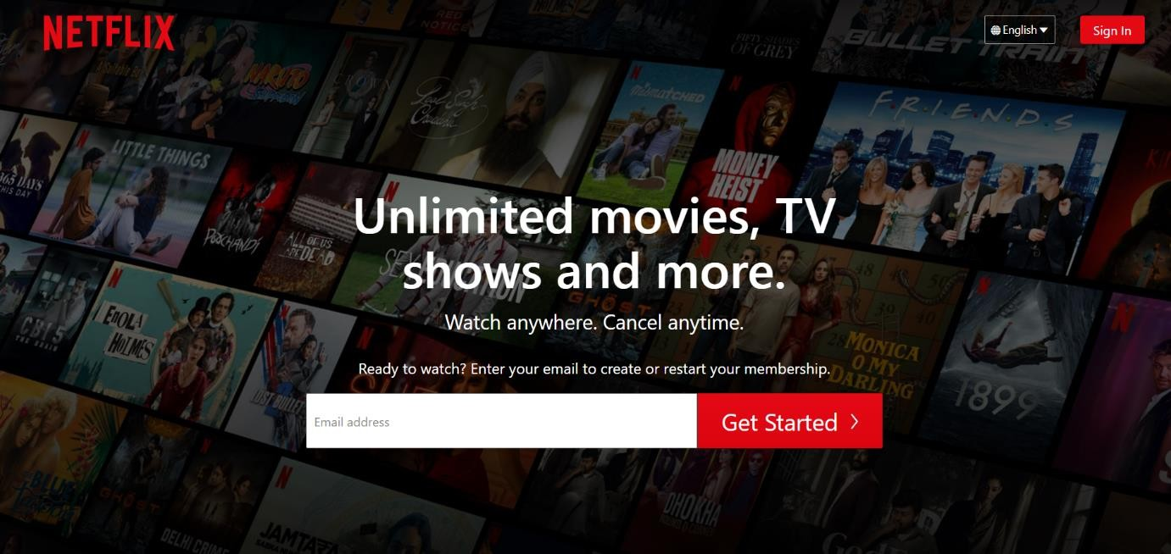

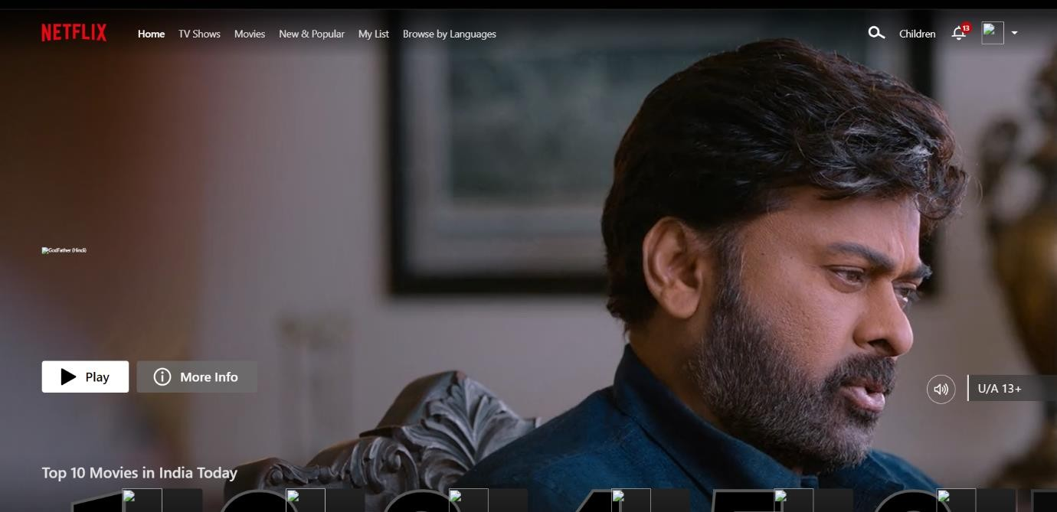



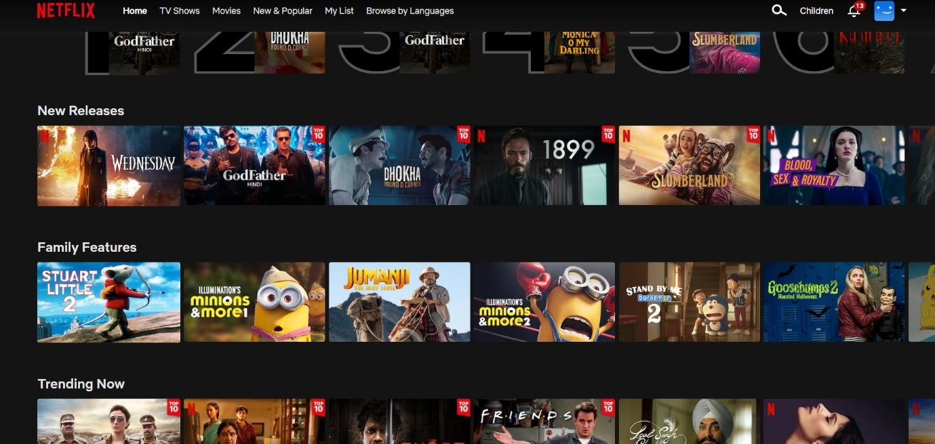

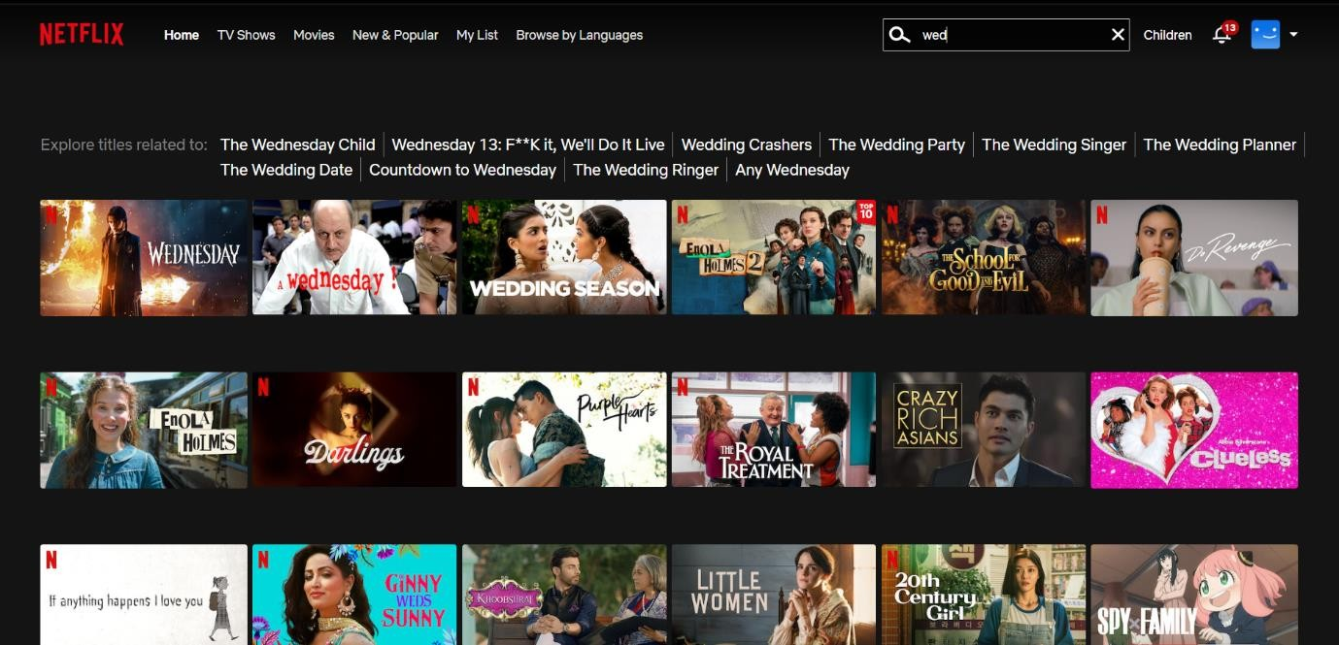

# Conclusion

We have completed our project within time limit with the coordination of our team members under the supervision of our mentor Mr. Bhanu Kapoor.

Our project repository is available at: <https://github.com/>Aayush12

# Bibliography

[**www.google.com**](http://www.google.co/)[**www.geeksforgeeks.org**](http://www.geeksforgeeks.org/)[**www.youtube.co**](http://www.youtube.com/)**m**