**Question 1-** Write a Python program to replace all occurrences of a space, comma, or dot with a colon.

Ans- import re

text = 'Python Exercises, PHP exercises.'

print(re.sub("[ ,.]", ":", text))

**Another Example of if string take input from user. Then program will be run this form**

text=input( "Enter a sentance")

import re

print(re.sub("[ ,.]",":",text))

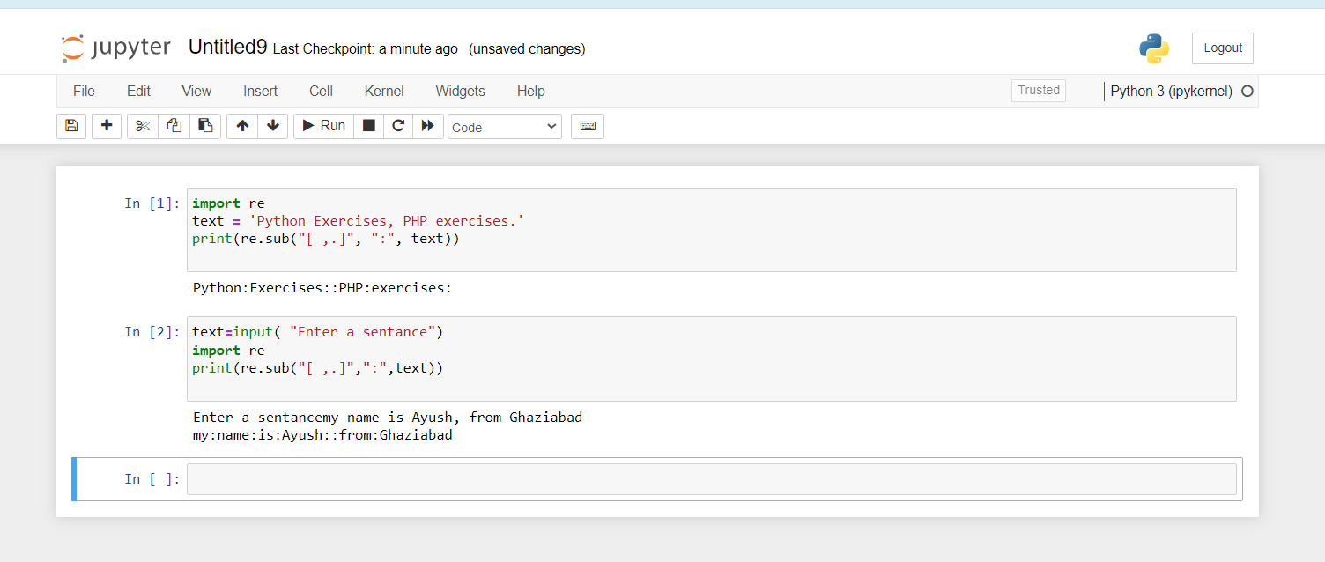

**Question 2-** Create a dataframe using the dictionary below and remove everything (commas (,), !, XXXX, ;, etc.) from the columns except words.

Ans- def my_assignment1():

print("Ends")

#another

text=input( "Enter a sentance")

import re

#text = 'Python Exercises, PHP exercises.

print(re.sub("[ ,.]",":",text))

#call the function

my_assignment()

#another

text=input( "Enter a sentance")

import re

#text = 'Python Exercises, PHP exercises.

print(re.sub("[ ,.]",":",text))

my_assignment1()l

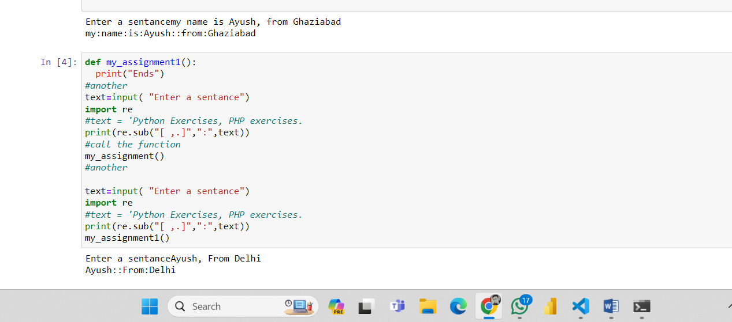

**Question 3-** Create a function in python to find all words that are at least 4 characters long in a string. The use of the re.compile() method is mandatory.

Ans-

**Question 25-** Write a Python program to remove continuous duplicate words from Sentence using Regular Expression.

**Ans-** # Define a function to return a string with unique words

def unique_list(text_str):

    # Split the input string into a list of words

    l = text_str.split()

    # Initialize an empty list to store unique words

    temp = []

    # Iterate through each word in the list

    for x in l:

        # Check if the word is not already in the temporary list

        if x not in temp:

            # If true, add the word to the temporary list

            temp.append(x)

    # Join the unique words into a string and return the result

    return ' '.join(temp)

# Initialize a string

text_str = "Hello hello world world"

# Print the original string

print("Original String:")

print(text_str)

# Print a newline for better formatting

print("\nAfter removing duplicate words from the said string:")

# Call the function to remove duplicate words and print the result

print(unique_list(text_str))

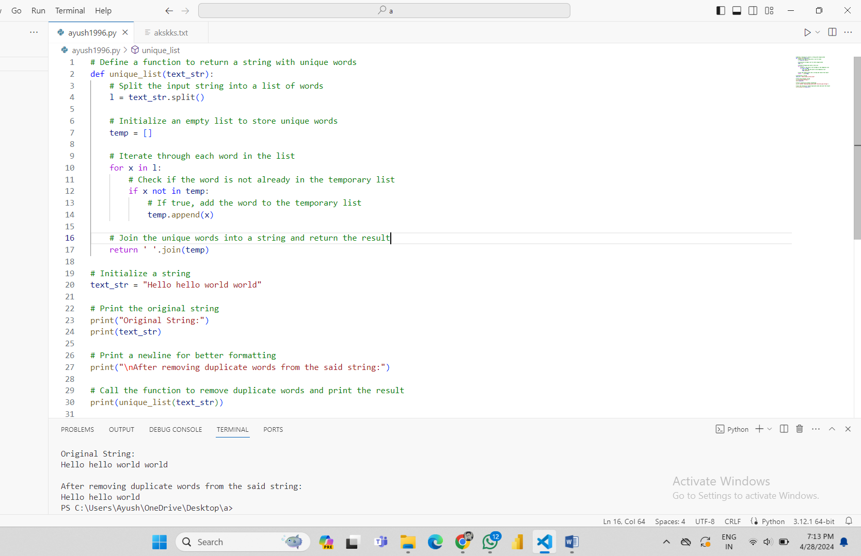

**Question 27-**Write a python program using RegEx to extract the hashtags.

**Ans-** import re

def extract_hashtags(text):

  hashtags = re.findall(r'#\w+', text)

  return hashtags

# Sample text

text = 'RT @kapil_kausik: #Doltiwal I mean #xyzabc is "hurt" by #Demonetization as the same has rendered USELESS <ed><U+00A0><U+00BD><ed><U+00B1><U+0089> "acquired funds" No wo'

# Extract hashtags

hashtags = extract_hashtags(text)

# Print the extracted hashtags

print(hashtags)

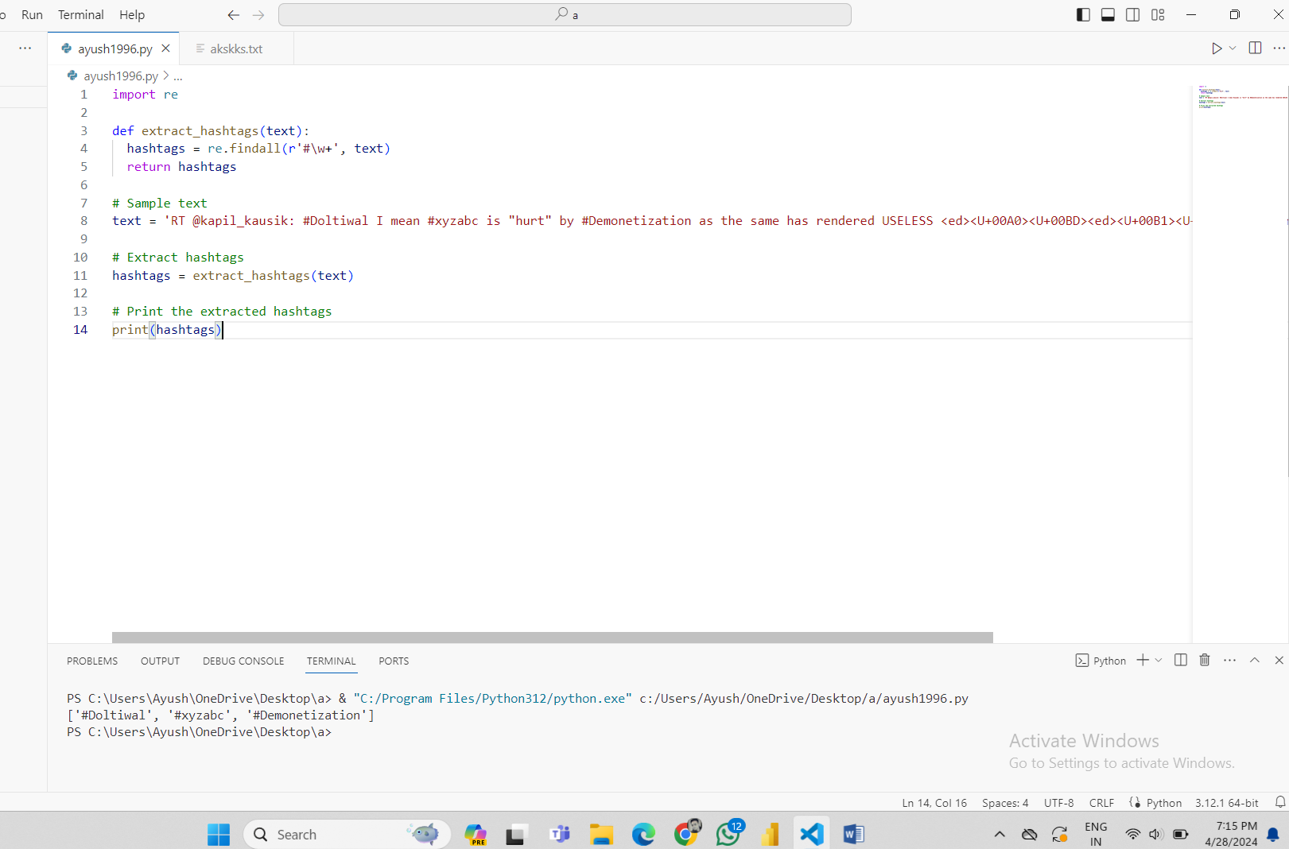

**Question 28-** Write a python program using RegEx to remove <U+..> like symbols

Check the below sample text, there are strange symbols something of the sort <U+..> all over the place. You need to come up with a general Regex expression that will cover all such symbols.

**Ans-** import re

input_text = "@Jags123456 Bharat band on 28??<ed><U+00A0><U+00BD><ed><U+00B8><U+0082>Those who are protesting #demonetization are all different party leaders"

pattern = r"<U\+\w{4}>"

output_text = re.sub(pattern, "", input_text)

print(output_text)

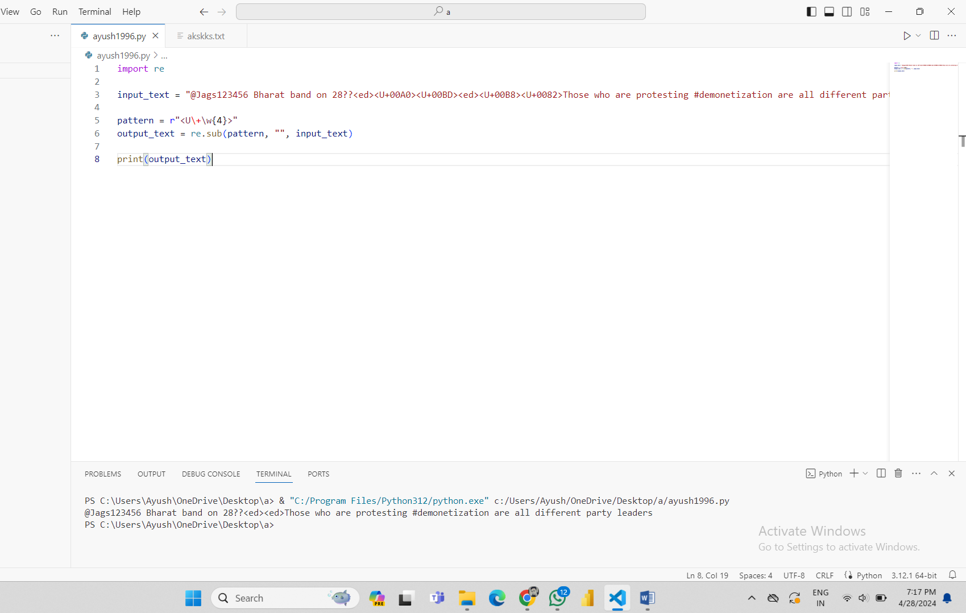

**Question 30-** Create a function in python to remove all words from a string of length between 2 and 4.

The use of the re.compile() method is mandatory.

**Ans-** import re

text = "The quick brown fox jumps over the lazy dog."

# remove words between 1 and 4

shortword = re.compile(r'\W*\b\w{1,4}\b')

print(shortword.sub('', text))

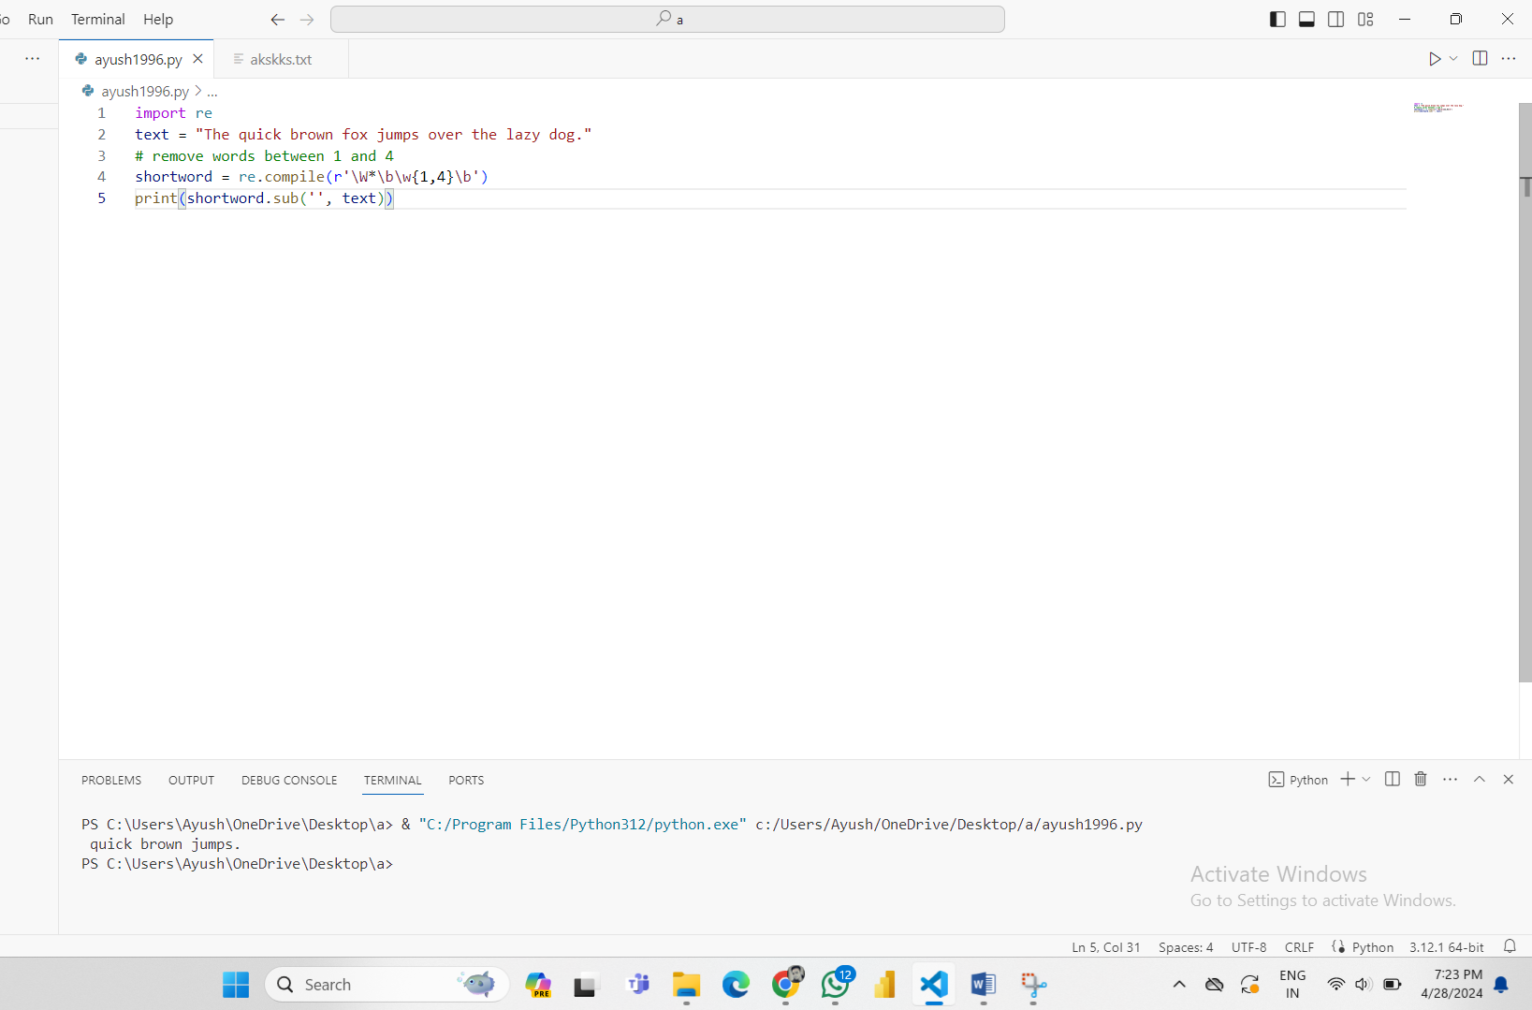

**Question 7-** Write a regular expression in Python to split a string into uppercase letters.

**Ans-** import re

text = "ImportanceOfRegularExpressionsInPython"

print(re.findall('[A-Z][^A-Z]*', text))

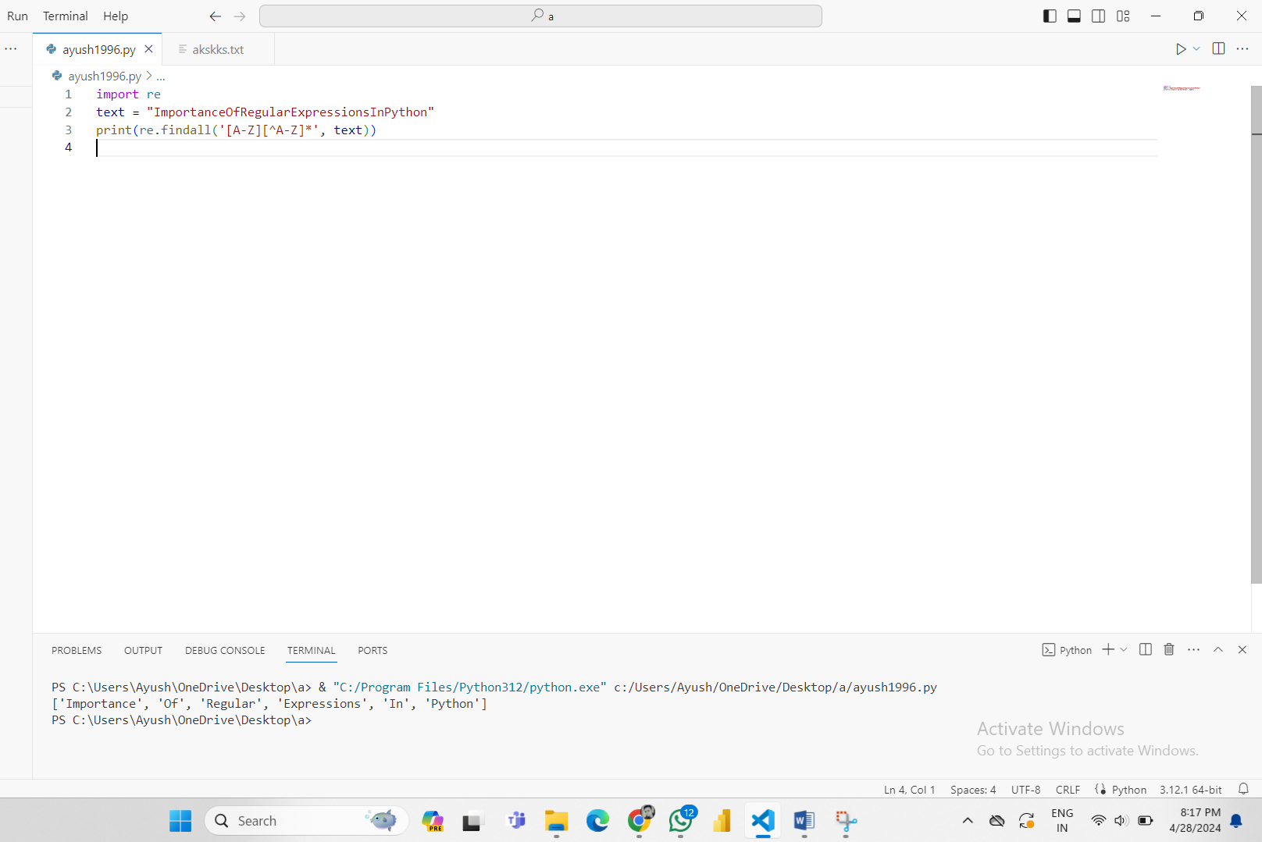

**Question 8-** Create a function in python to insert spaces between words starting with capital letters or with numbers.

**Ans-** import re

def capitalwordsspaces(str1):

    return re.sub (r"(\w) ([A-Z])", r"\1 \2", str1)

print(capitalwordsspaces("RegularExpression1IsAn2ImportantTopic3InPython"))

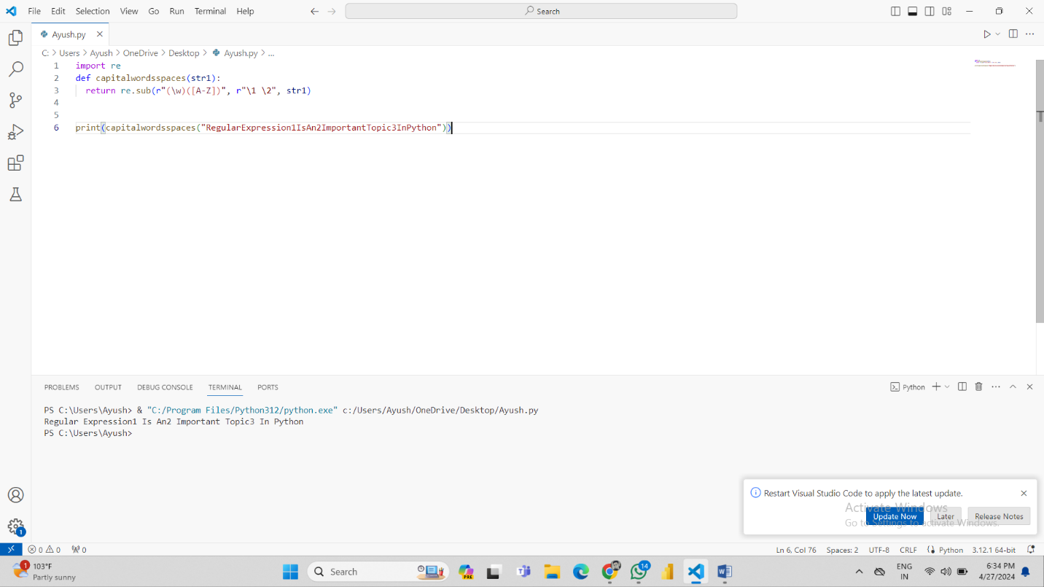

**Question 11-** Write a Python program to match a string that contains only upper and lowercase letters, numbers, and underscores.

**Ans-** import re

def text_match(text):

        patterns = '^[a-zA-Z0-9_]*$'

        if re.search(patterns,  text):

                return 'Found a match!'

        else:

                return('Not matched!')

print(text_match("I don't want anything to drink."))

print(text_match("One_Dog_Barks_Loudly_1"))

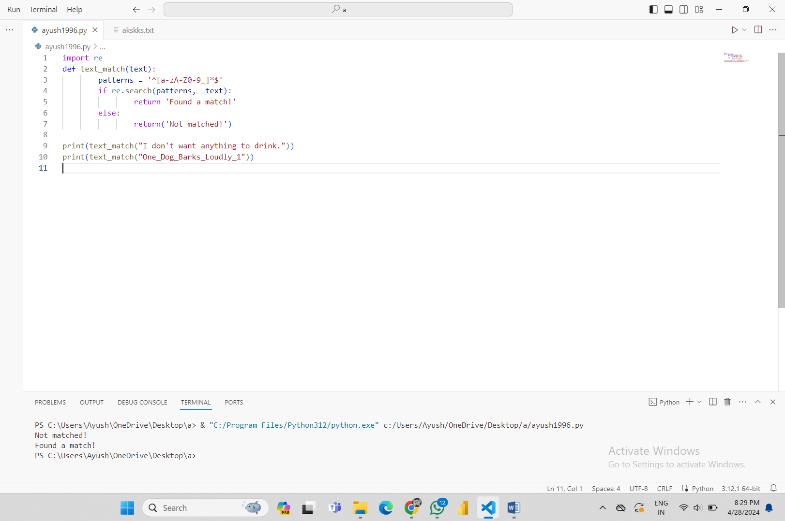

**Question 12-** Write a Python program where a string will start with a specific number.

**Ans-** import re

def match_num(string):

    text = re.compile(r"^6")

    if text.match(string):

        return True

    else:

        return False

print(match_num('5-1747648'))

print(match_num('6-4586458'))

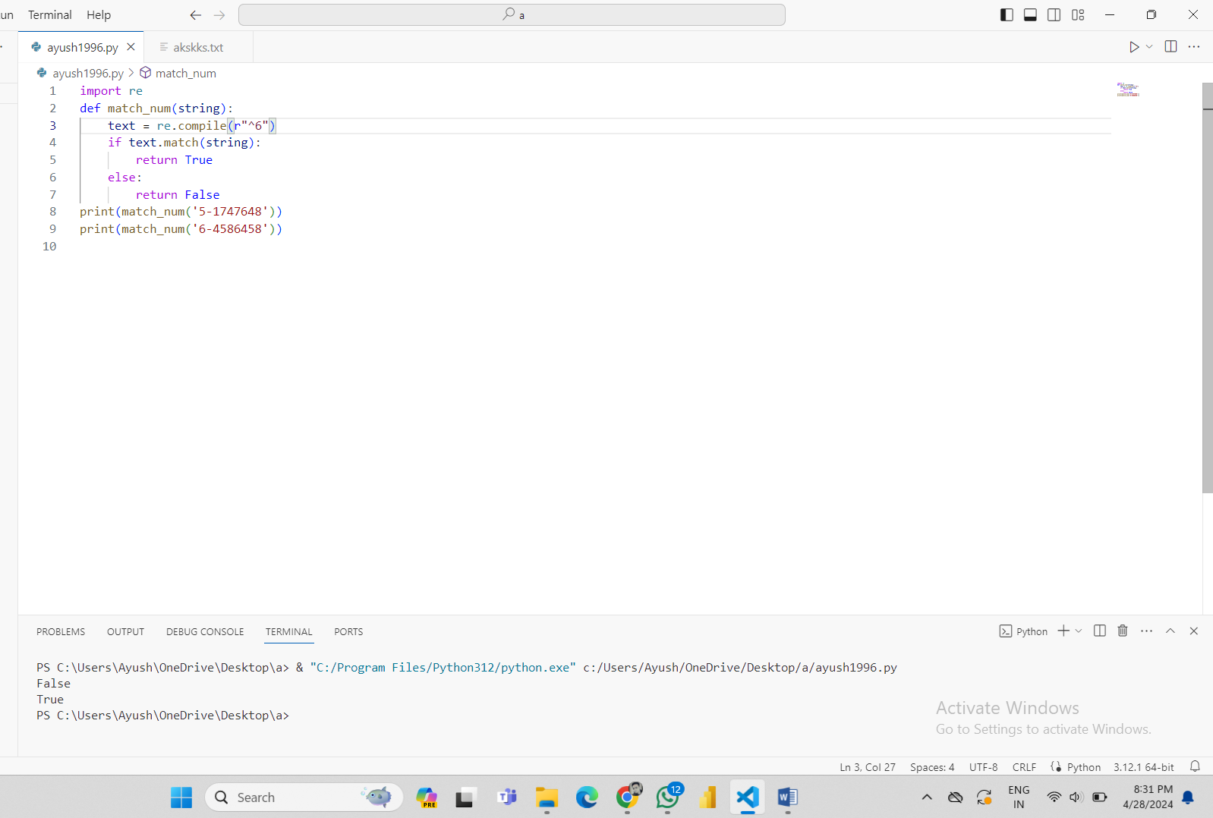

**Question 13-** Write a Python program to remove leading zeros from an IP address

**Ans-** import re

ip = "196.06.196.127"

string = re.sub('\.[0]*', '.', ip)

print(string)

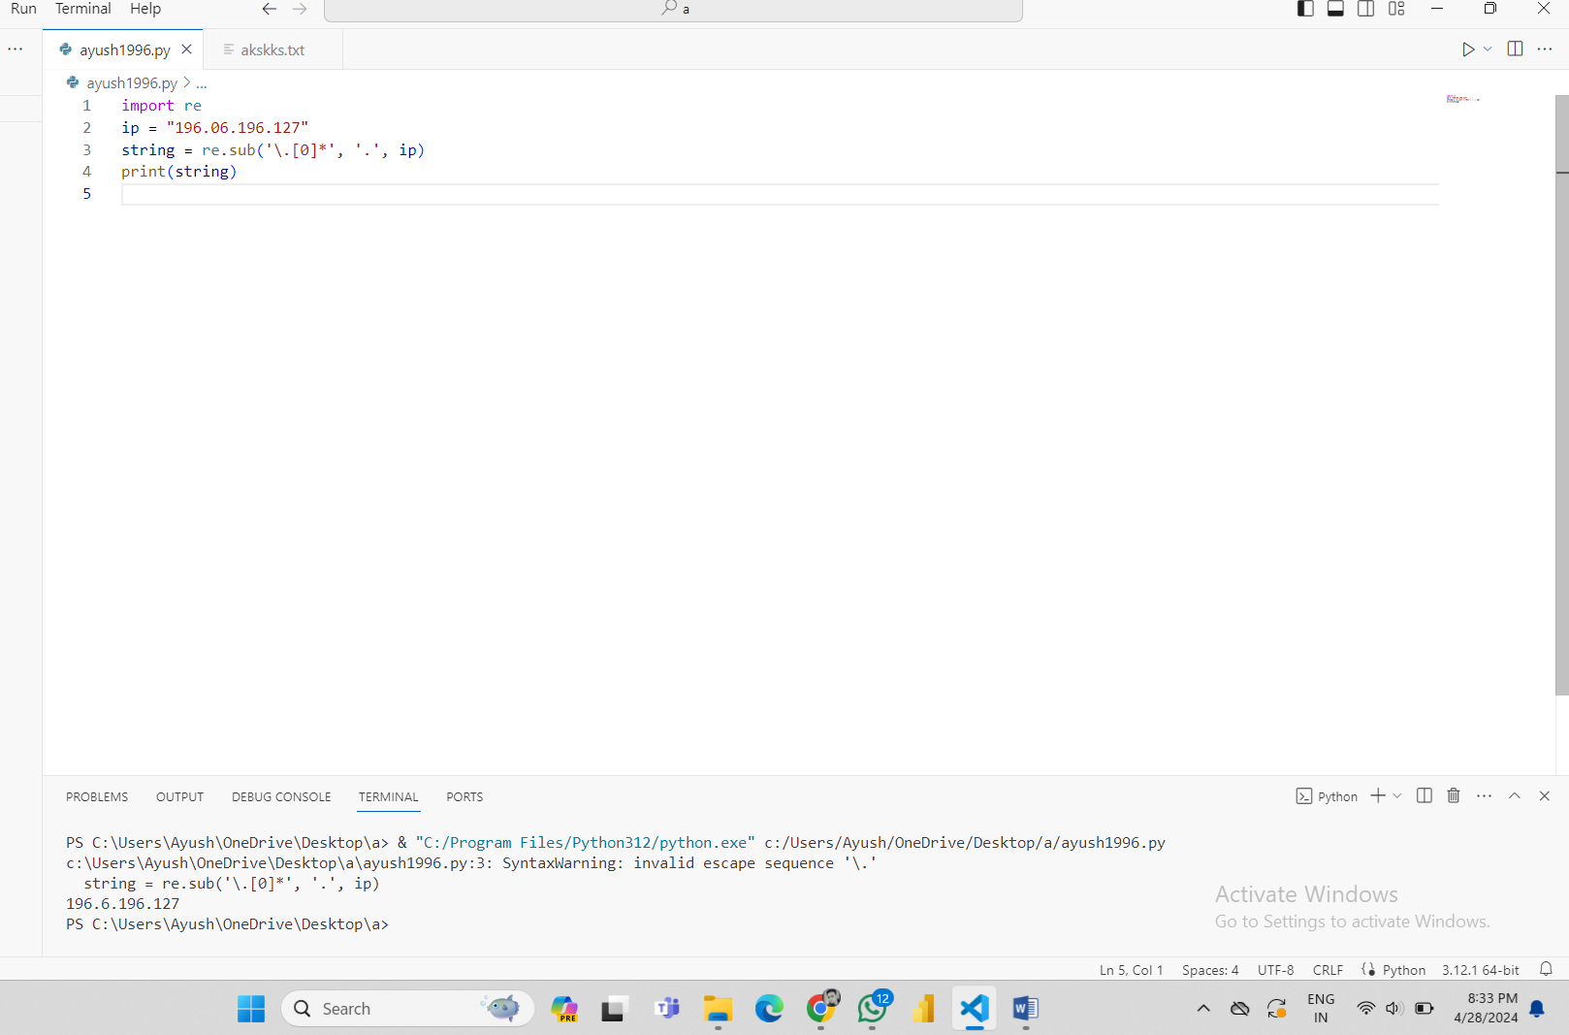

**Question 15-** Write a Python program to search some literals strings in a string.

**Ans-** import re

pattern = [ 'brown', 'jumps', 'Cow' ]

text = 'The quick brown fox jumps over the lazy dog.'

for pattern in pattern:

    print('Searching for "%s" in "%s" ->' % (pattern, text),)

    if re.search(pattern,  text):

        print('Matched!')

    else:

        print('Not Matched!')

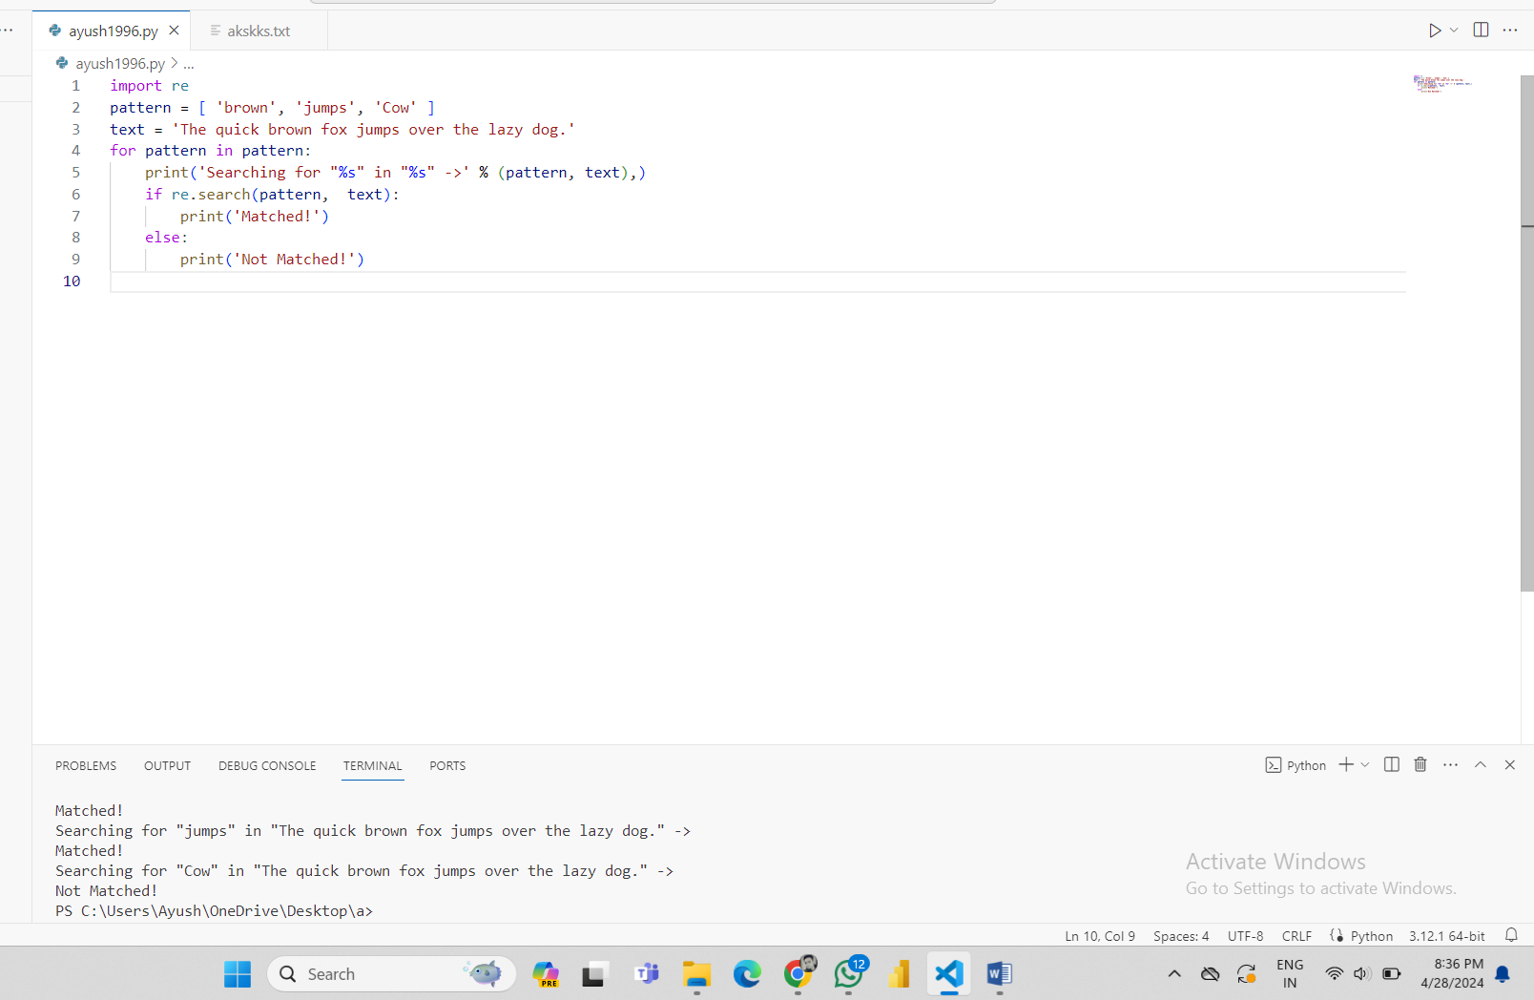

**Question 16-** Write a Python program to search a literals string in a string and also find the location within the original string where the pattern occurs

**Ans-** import re

patterns = 'jumps'

text = 'The quick brown fox jumps over the lazy dog.'

match = re.search(patterns, text)

s = match.start()

e = match.end()

print('Found "%s" in "%s" from %d to %d ' % \

    (match.re.pattern, match.string, s, e))

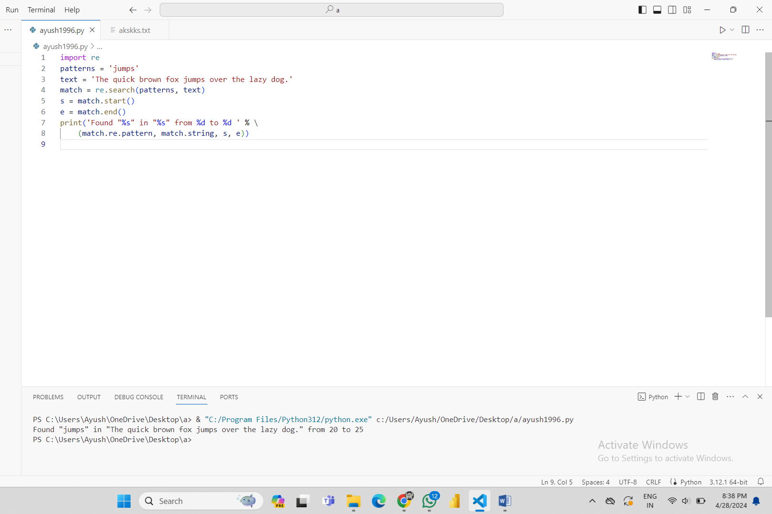

**Question 17-** Write a Python program to find the substrings within a string.

**Ans-** import re

text = 'Python exercise, PHP exercises, C# exercise'

patterns = 'exercises'

for match in re.findall(patterns, text):

    print('Found "%s"' % match)

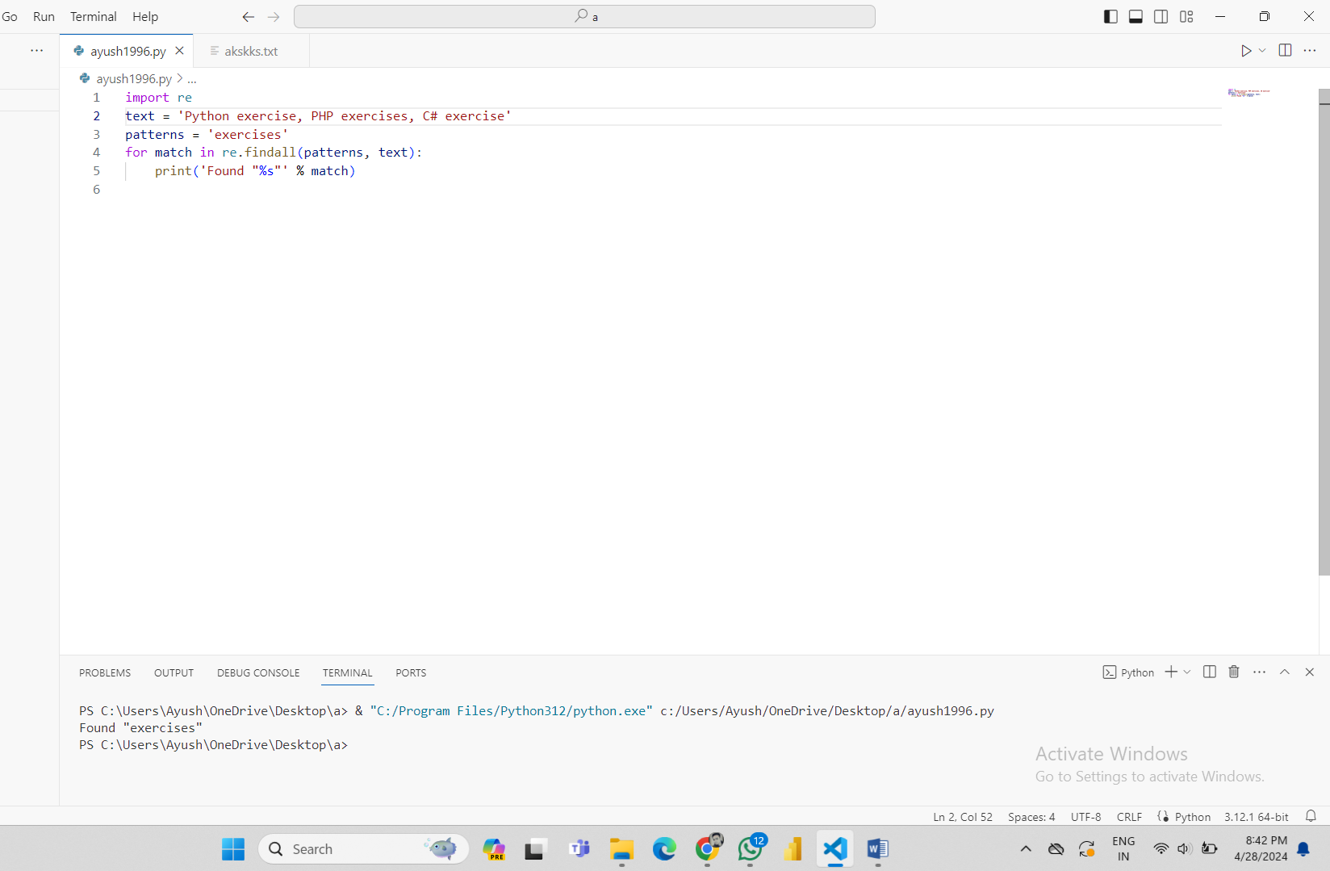

**Question 18-** Write a Python program to find the occurrence and position of the substrings within a string.

**Ans-** import re

text = 'Python exercise, PHP exercise, C# exercises'

pattern = 'exercises'

for match in re.finditer(pattern, text):

    s = match.start()

    e = match.end()

    print('Found "%s" at %d:%d' % (text[s:e], s, e))

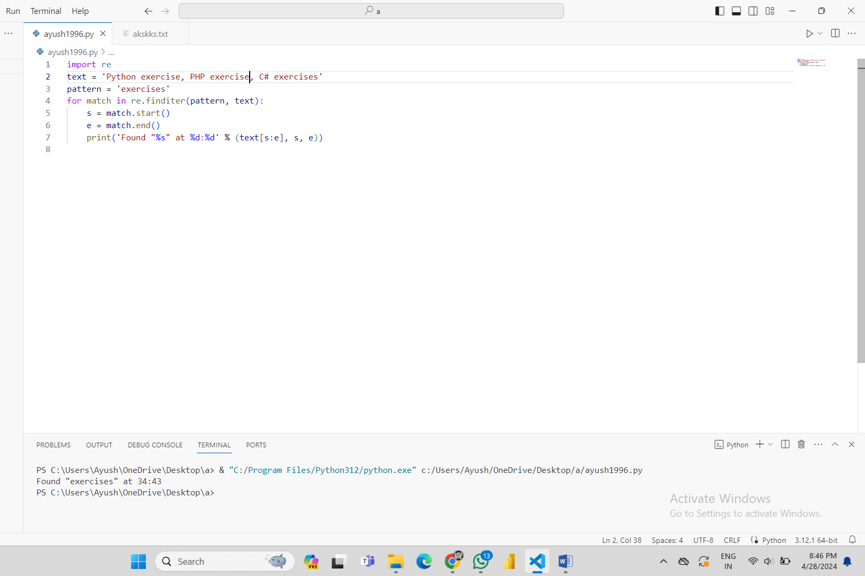

**Question 19-** Write a Python program to convert a date of yyyy-mm-dd format to dd-mm-yyyy format.

**Ans-** import re

def change_date_format(dt):

        return re.sub(r'(\d{4})-(\d{1,2})-(\d{1,2})', '\\3-\\2-\\1', dt)

dt1 = "2024-04-28"

print("Original date in YYY-MM-DD Format: ",dt1)

print("date in DD-MM-YYYY Format: ",change_date_format(dt1))

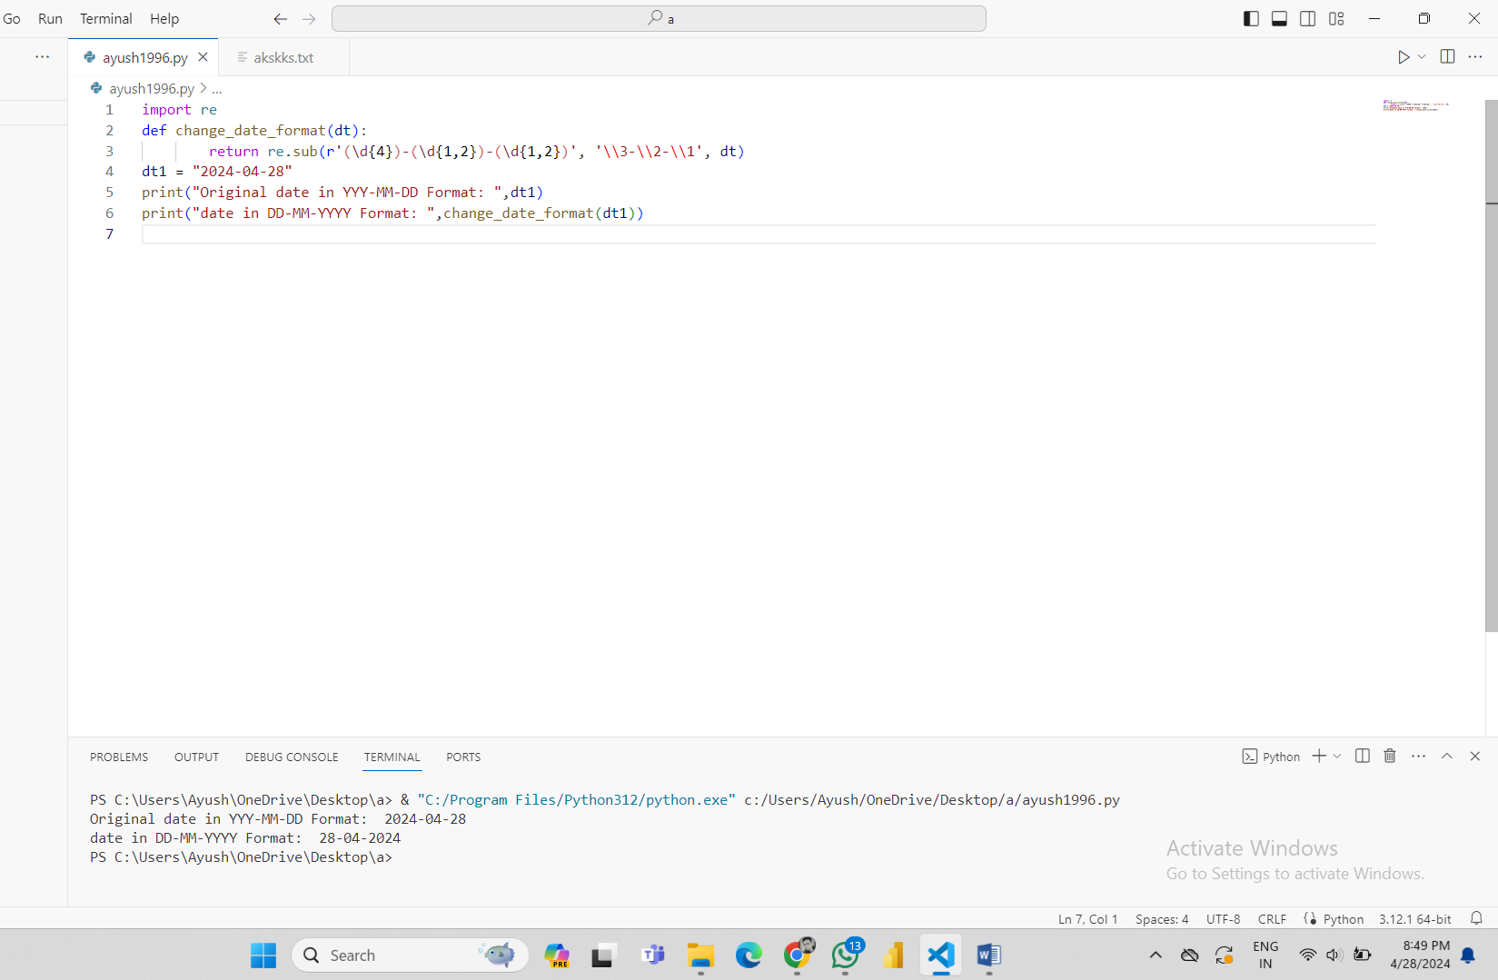

**Question 20-** Create a function in python to find all decimal numbers with a precision of 1 or 2 in a string. The use of the re.compile() method is mandatory.

**Ans-** import re

string = "01.12 0132.123 2.31875 145.8 3.01 27.25 0.25"

x=re.findall("\d+\.\d+",string)

print(x)

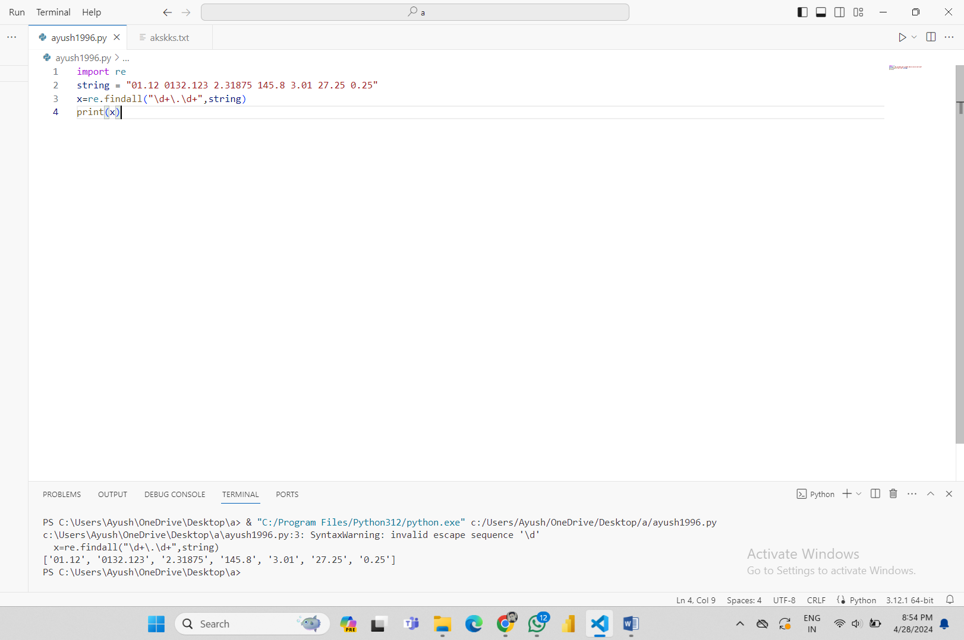

**Question 21-** Write a Python program to separate and print the numbers and their position of a given string.

**Ans-** import re

# Input.

text = "The following example 50 creates an ArrayList with a capacity of 10 elements."

for m in re.finditer("\d+", text):

    print(m.group(0))

    print("Index position:", m.start())

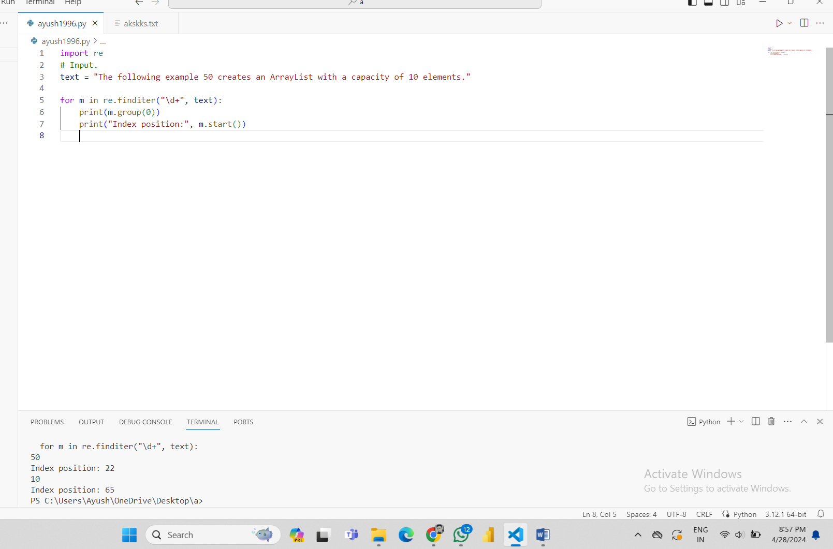

**Question 22-** Write a regular expression in python program to extract maximum/largest numeric value from a string.

Ans- import re

# Extract all numeric values from the string.

occ = re.findall("\d+", "'My marks in each semester are: 947, 896, 926, 524, 734, 950, 642'")

# convert the numeric values from string to int.

num_list = map(int, occ)

# Find and print the max

print(max(num_list))

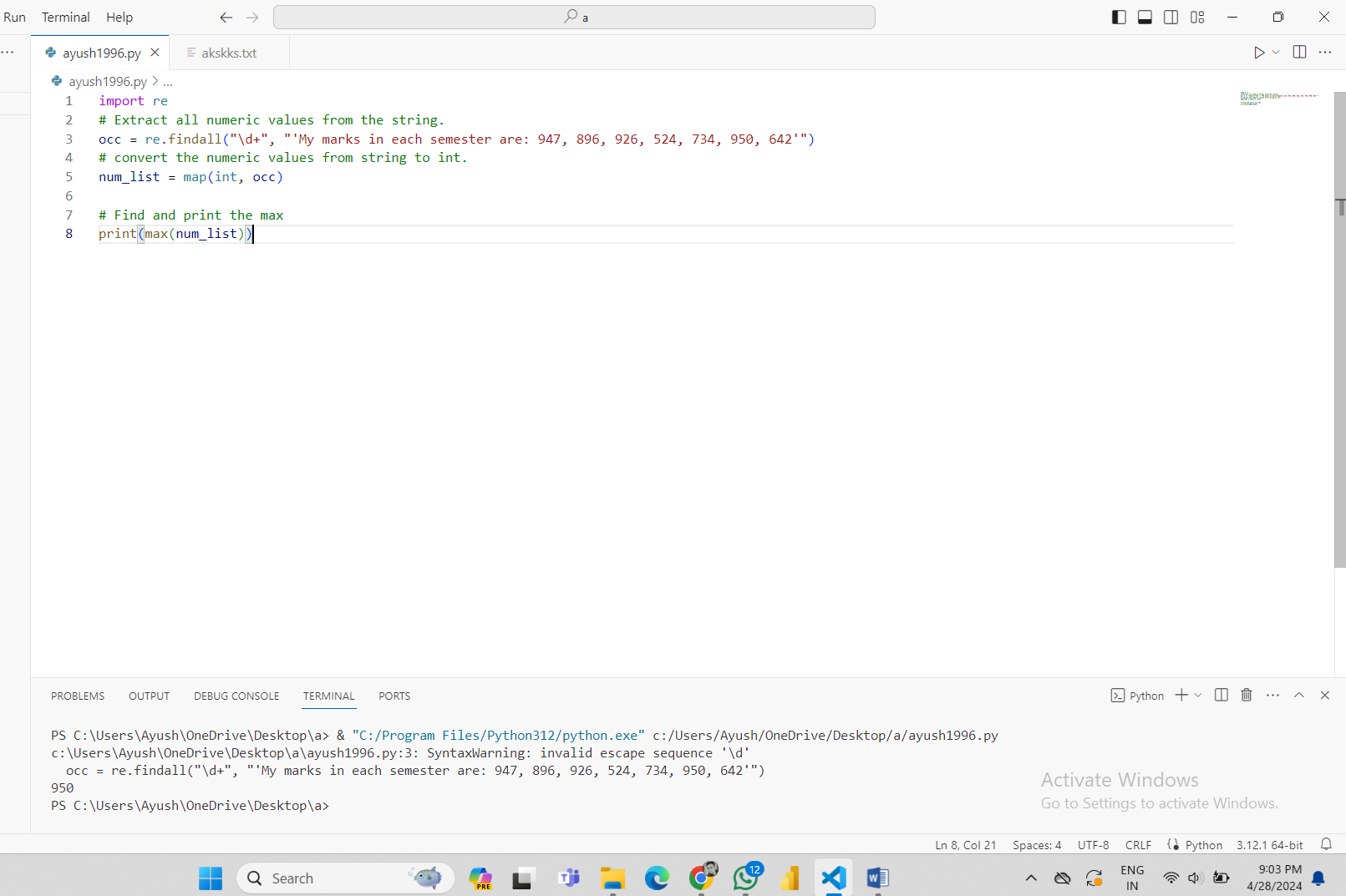

**Question 23-** Create a function in python to insert spaces between words starting with capital letters.

**Ans-** import re

def capital_words_spaces(str1):

  return re.sub(r"(\w)([A-Z])", r"\1 \2", str1)

print(capital_words_spaces("RegularExpressionIsAnImportantTopicInPython"))

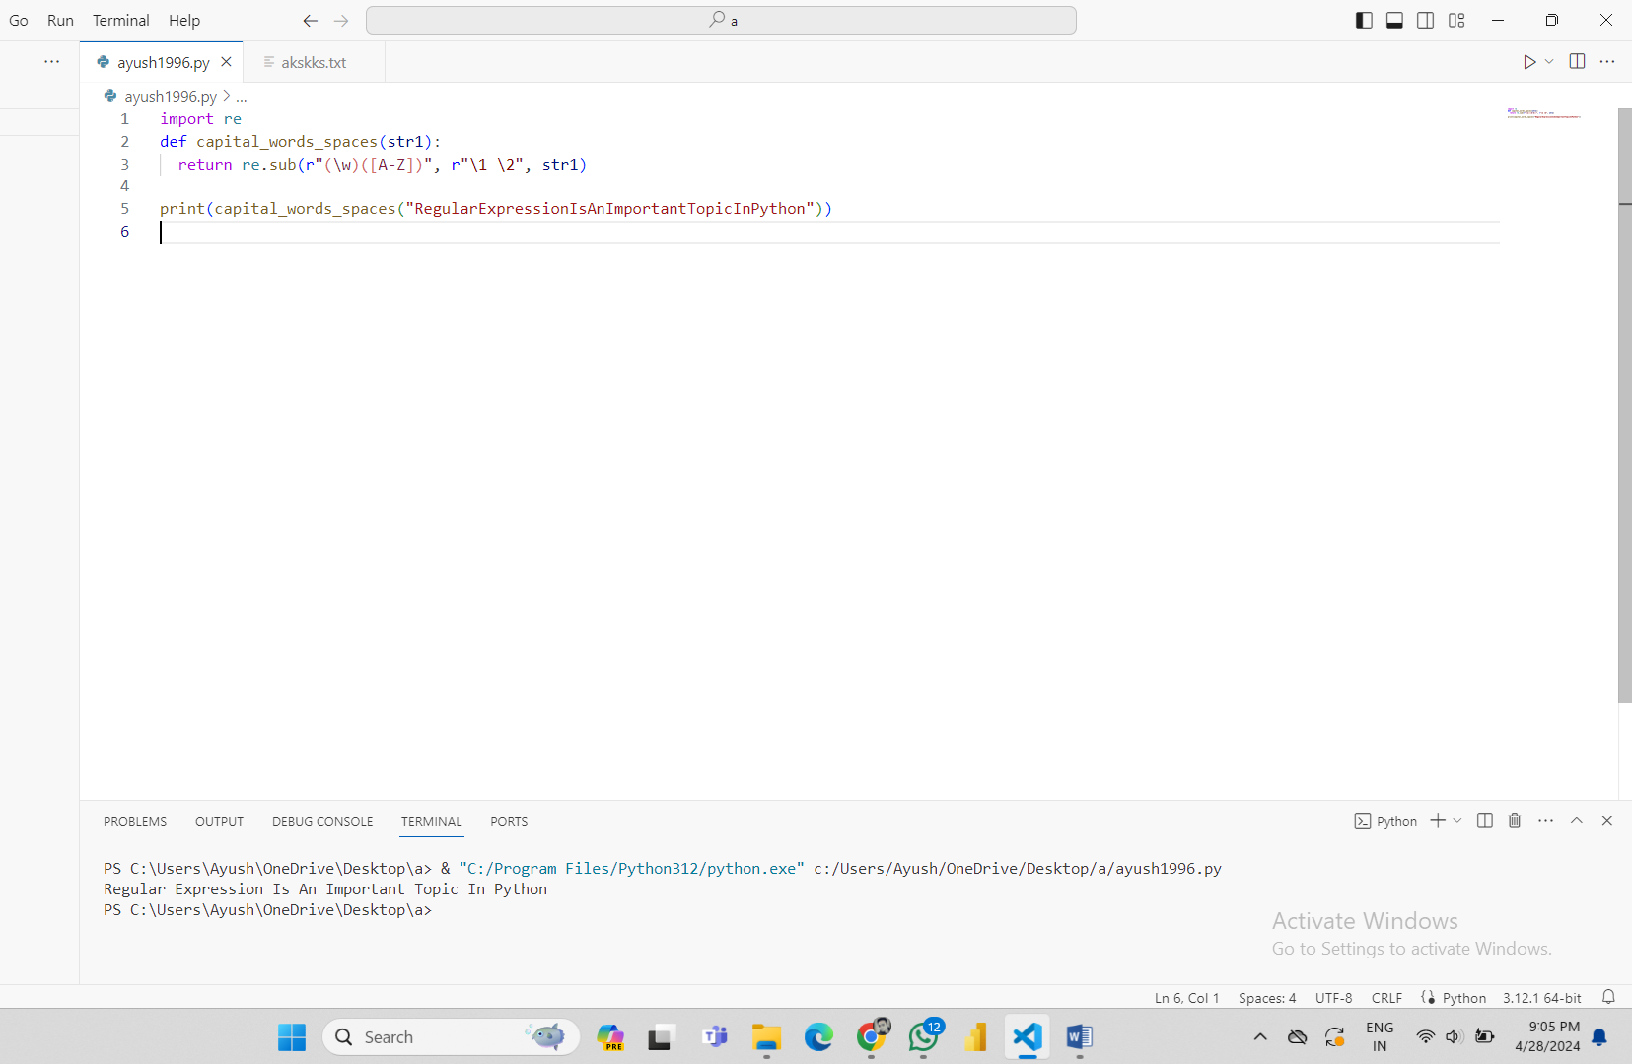

**Question 24-** Python regex to find sequences of one upper case letter followed by lower case letters

**Ans-** import re

def text_match(text):

        patterns = '[A-Z]+[a-z]+$'

        if re.search(patterns, text):

                return 'Found a match!'

        else:

                return('Not matched!')

print(text_match("Ayush"))

print(text_match("tyagi"))

