A Project Report
on
“SMART PLANNER LMS”

Submitted in partial fulfillment of the requirements
For the award of the degree of Bachelor of Technology in Computer Science & Engineering
B. Tech (CSE)
8th Semester

Submitted by
AYUSH CHAURASIYA
(B2255R10106007)
Session 2022-2026

Under the Guidance of
Dr. Akhilesh A. Waoo
Dean CS, AKS University, SATNA, MP

Department of Computer Science & Engineering Faculty of Engineering and Technology

AKS University, Satna (M.P)

CERTIFICATE

This certify that the project report entitled “SMART PLANNER LMS” submitted by partial fulfilment of the requirement for the degree of Bachelor of Engineering in Technology in January-June 2026 AKS University, Satna is a bonafide project work carried out by AYUSH CHAURASIYA (B2255R10106007), under my supervision. The subject of the project report has been approved by supervisor. This is also to certify that it is his/her original work and no part of this project is report has been submitted for any other degree/diploma.
All the assistance the and help received during the course of the investigation has been duly acknowledged.
- I am satisfied that the report presented by AYUSH CHAURASIYA (B2255R10106007) is worthy of consideration for award of the degree.
- I certify:
  - That he pursued the prescribed course for project.
  - That he/she bears good moral character.

Place: AKSU, Satna ………………………………
Date:…/…./……… External’s Signature

……………………………... ………………………………
Guide Head of Department
Dr. Akhilesh A. Waoo Dr. Chandra Shekhar Gautam
Dean CS, AKS University

SELF DECLARATION

I hereby declare that the work presented in this project entitled “SMART PLANNER LMS " towards the partial fulfilment of the requirement for the award of Degree in B.Tech in Department of Computer Science, AKS University, Satna (M.P.) is an authentic record of my own work.

I have not submitted the matter embodied in the project for the award of any other degree or diploma to any other institute or university.

…………………………..
Signature of Candidate
Ayush Chaurasiya

ACKNOWLEDGEMENT

It is a great opportunity for me in taking this opportunity to express my sincere thanks and
appreciation to my supervisor and Dean of Computer Science,Prof. (Dr.)Akhilesh A.Waoo.
I consider myself lucky enough to have such a great project.
At this moment of accomplishment, first of all, I pay homage to my guide, Dr. Akhilesh A.
Waoo, HoD, CSE - Dr. Chandrashekhar Gautam from AKS University Satna (M.P.). This
work would not have been possible without his guidance, support, and encouragement. Under
his guidance, I successfully overcame many difficulties and learned a lot.
Give Thanks to Your Project Client
I am deeply and forever indebted to my parents for their love, support, and encouragement
throughout my entire life.

Internship Letter
. 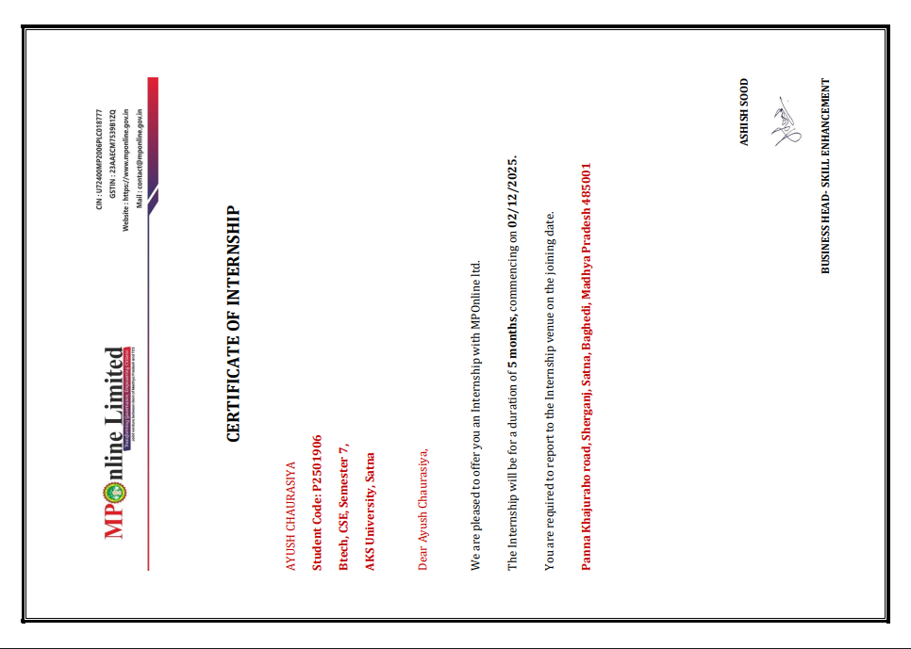

ABSTRACT

The LMS Smart Planner is a web-based application designed to simplify and improve the way students and teachers manage academic activities. In many educational environments, students rely on multiple tools for notes, assignments, reminders, and time management. This scattered approach often leads to confusion, reduced focus, and inefficient use of time. The LMS Smart Planner addresses this problem by providing a single, integrated platform that combines learning management with productivity tools.
The system allows students to access course materials, manage assignments, and track their progress in one place. A key feature of the platform is the task management board, which helps students organize their work visually by showing completed and pending tasks. This makes it easier for users to plan their activities and avoid missing deadlines. In addition, the system includes a built-in focus timer based on the Pomodoro technique, which encourages structured study sessions and improves concentration.
Teachers also benefit from the system by being able to upload study materials, assign tasks, and monitor student performance. They can provide feedback directly within the platform, which improves communication and helps students understand their progress more clearly. Administrators have control over user management and system settings, ensuring smooth operation of the application.
The LMS Smart Planner is developed using modern and efficient technologies. The frontend is built with React.js to provide a fast and interactive user experience. The backend is developed using FastAPI, which handles data processing and communication between the frontend and database. MySQL is used as the database to store user information, tasks, courses, and reports in a structured and secure manner.
The system is designed to be simple, user-friendly, and accessible on standard devices through a web browser. It does not require advanced hardware or technical knowledge, making it suitable for a wide range of users. By combining essential academic tools into one platform, the LMS Smart Planner helps users stay organized, manage time effectively, and improve overall productivity.

TABLE OF CONTENT

- Introduction 1
- Objective of the Project 2
- Scope of the Project 4
- Definition of problem 6
- Benefits of the Project 8
- Main Module 10
- Technical Overview 14
- System Configuration 17
- Block Diagram 20
- DFD DIAGRAM 22
- ER DIAGRAM 24
- Code 24
- Project Explanation 30
- Project Testing and Result 48
- Conclusion 48
- Bibliography and Reference 56
- Student Profile 58
- Plagiarism Report 59
- Output of LMS 61
- PPT Handouts 63

Introduction

In today’s fast-paced academic environment, students are expected to handle multiple responsibilities at the same time. They attend lectures, complete assignments, prepare for exams, and often participate in additional activities. To manage all these tasks, students usually depend on different digital tools such as note-taking apps, task managers, reminder systems, and online learning platforms. Although these tools are useful, using too many separate applications can lead to confusion, reduced focus, and poor time management.
The LMS Smart Planner is designed to address this problem by providing a single, integrated platform that combines learning and productivity features. Instead of switching between multiple apps, users can access everything they need in one place. This includes course materials, task management tools, progress tracking, and a built-in study timer. By bringing these features together, the system helps students stay organized and use their time more effectively.
The platform is developed for three main types of users: students, teachers, and administrators. Students can manage their daily academic tasks, view assignments, and track their progress in a simple and clear way. Teachers can upload study materials, assign tasks, and monitor how students are performing. They can also provide feedback directly through the system, which improves communication and reduces delays. Administrators are responsible for managing users and maintaining the overall system, ensuring smooth operation.
One of the key strengths of the LMS Smart Planner is its user-friendly design. The interface is simple, clean, and easy to understand, making it accessible even for users with basic technical knowledge. The system avoids unnecessary complexity and focuses only on features that are truly helpful for academic management.
Another important feature is the focus timer, which is based on the Pomodoro technique. This helps students concentrate on their studies by dividing time into short, productive sessions followed by small breaks. This method improves concentration and reduces distractions.
Overall, the LMS Smart Planner aims to simplify academic life by combining essential tools into one system. It helps users stay organized, manage their time better, and improve their overall productivity in a structured and efficient way.

Objective of the Project
The LMS Smart Planner is developed with the aim of making academic management easier, more organized, and more efficient for both students and teachers. In many cases, students struggle to keep track of their assignments, manage their time properly, and stay focused during study sessions. This project is designed to solve these problems by providing a single platform that combines all essential academic tools.
One of the main objectives of this system is to create a centralized environment where students can handle all their academic activities. Instead of using different applications for notes, tasks, and reminders, everything is available in one place. This reduces confusion and helps students save time.
Another important objective is to improve time management. Many students find it difficult to follow a proper study schedule. The LMS Smart Planner includes a built-in focus timer that helps users study in a structured way. By using timed study sessions and short breaks, students can improve concentration and avoid distractions.
The project also focuses on improving task management. Students can easily create, update, and track their assignments using a visual task board. This makes it easier to understand which tasks are completed and which are still pending. It also helps in avoiding last-minute stress before deadlines.
Communication between students and teachers is another key objective. Teachers can assign tasks, monitor progress, and give feedback directly through the system. This creates a better learning environment where students can understand their performance and improve accordingly.
The system is also designed to be simple and user-friendly. It should be easy to use for everyone, even those with basic technical knowledge. The interface is kept clean and clear so that users can quickly understand how to use the platform without confusion.

• Provide a centralized academic management system
• Improve time management and focus
• Simplify task tracking and assignment handling
• Enhance communication between students and teachers
• Reduce dependency on multiple applications
• Offer a clean and easy-to-use interface

Objective Summary
Area | Purpose
Centralization | Combine all tools into one platform
Time Management | Help users use time effectively
Task Handling | Organize and track assignments
Communication | Improve interaction and feedback
Usability | Ensure simple and easy operation

Scope of the Project
The LMS Smart Planner is designed to support the daily academic activities of students, teachers, and administrators within an educational environment. The scope of this project focuses on providing a structured and centralized system that simplifies learning management and improves productivity. It is suitable for use in schools, colleges, and coaching institutes where managing assignments, study materials, and progress tracking is important.
The system mainly works as a web-based platform, which means users can access it through a browser on devices like laptops or desktops. As long as there is an internet connection, the system can be used from anywhere. This makes it flexible and convenient for both students and teachers.
The project includes three main types of users, and each user has different access and responsibilities within the system.
• Students can log in to their personal dashboard
• They can view and manage their assignments using a task board
• They can access course materials like notes and videos
• They can use the focus timer to improve study habits
• They can track their progress through simple visual indicators
• Teachers can upload study materials for different subjects
• They can assign tasks and set deadlines
• They can monitor student performance and task completion
• They can provide feedback directly within the system
• Administrators can manage all users in the system
• They can control access and maintain system settings
• They ensure the system runs smoothly without issues
The platform focuses on essential and practical features rather than complex functionalities. It is designed to be simple so that users can easily understand and use it without needing technical training.

Scope Overview
Area | Description
User Access | Separate roles for Student, Teacher, Admin
Task Management | Create, update, and track assignments
Course Content | Store and access study materials
Time Management | Built-in focus timer for study sessions
Progress Tracking | Simple visual tracking of work status
There are also some limitations within the current scope of the project.
• The system requires an internet connection and does not support offline use
• It does not include advanced features like AI-based recommendations
• Analytics are basic and limited to simple graphs and progress views
• The system is mainly designed for web use and does not include a mobile app
Even with these limitations, the project has good potential for future improvements. Features like mobile application support, advanced analytics, and smart suggestions can be added later. The current scope focuses on building a strong and simple foundation that solves the main problems faced by students in managing their academic work.

Definition of problem
In today’s academic environment, students face several challenges when it comes to managing their studies effectively. Even though technology has provided many tools to support learning, these tools are often scattered across different platforms. As a result, instead of improving productivity, they sometimes create confusion and reduce efficiency.
One of the main problems is the use of multiple applications for different purposes. Students typically use one app for notes, another for tracking tasks, and another for setting timers or reminders. Constantly switching between these applications breaks concentration and wastes time. It also makes it difficult to maintain a smooth study flow.
Another major issue is poor task management. Students often forget deadlines or lose track of assignments because there is no single place where all tasks are organized. This leads to last-minute stress and incomplete work. Without a clear system, students cannot easily identify which tasks are completed and which are still pending.
Time management is also a common problem. Many students struggle to plan their study time properly. They either spend too much time on one subject or get distracted easily. The lack of a structured study method reduces productivity and affects overall performance.
Communication between students and teachers is often limited as well. In many cases, feedback is delayed or not properly recorded. Students may not clearly understand their mistakes or progress, which affects their learning process.

• Students use multiple apps for different academic needs
• Switching between apps reduces focus and wastes time
• Difficulty in tracking assignments and deadlines
• Lack of a clear system to organize tasks
• Poor time management and study planning
• Limited and unstructured communication with teachers
• No proper way to track progress visually

Problem Overview
Problem Area | Description
Multiple Platforms | Different apps for tasks, notes, and timers
Task Tracking | Assignments are not properly organized
Time Management | No structured study schedule
Focus Issues | Frequent distractions due to app switching
Communication Gap | Limited feedback and interaction

These problems directly affect student productivity and academic performance. There is a strong need for a system that combines all essential features into one platform, making it easier for students to stay organized, focused, and efficient in their studies.

Benefits of the Project

The LMS Smart Planner offers a practical solution to many of the problems faced by students and teachers in managing academic activities. By combining multiple tools into one platform, the system helps users stay organized, focused, and more productive in their daily work.
One of the biggest benefits of this project is that it reduces the need to use multiple applications. Students no longer have to switch between different tools for notes, tasks, and timers. Everything is available in one place, which saves time and reduces confusion.
The system also improves task management. With the help of a visual task board, students can easily create, update, and track their assignments. They can clearly see which tasks are completed and which are still pending. This helps in better planning and reduces last-minute stress.
Another important benefit is improved focus. The built-in study timer encourages students to follow a structured study pattern. By studying in short, focused sessions with breaks, students can maintain better concentration and avoid distractions.
The project also strengthens communication between students and teachers. Teachers can assign work, monitor progress, and give feedback directly through the system. This makes the learning process more interactive and helps students understand their performance clearly.
In addition, the system provides a clear view of progress. Students can track their work using simple indicators or graphs, which helps them stay motivated and aware of their academic status.

• Reduces dependency on multiple applications
• Saves time by combining all tools in one platform
• Improves task organization and assignment tracking
• Helps students stay focused with a study timer
• Provides clear visibility of completed and pending work
• Enhances communication between students and teachers
• Reduces stress through better planning and management
• Encourages disciplined study habits

Benefits Overview
Feature Benefit
Centralized System | All tools available in one place
Task Board | Easy tracking of assignments
Focus Timer | Better concentration and time use
Progress Tracking | Clear understanding of academic status
Teacher Feedback | Direct and quick communication

Overall, the LMS Smart Planner makes academic work more structured and manageable. It supports students in developing better study habits while also helping teachers guide and monitor progress effectively.

Main Module

The LMS Smart Planner is divided into several modules so that each part of the system handles a specific function. This makes the system easy to understand, develop, and maintain. Each module works independently but is connected with others to provide a smooth overall experience.

The modules are designed in a simple way so that even during a viva, you can explain them clearly without confusion.

User Module

The User Module is responsible for handling all users in the system. It manages registration, login, and user roles.

• Allows users to create accounts and log in securely
• Supports three roles: Student, Teacher, and Admin
• Controls what each user can access in the system
• Stores user details like name, email, and role

This module ensures that each user sees only the features that are meant for them.

Task Module

The Task Module helps students manage their daily academic work. It works like a visual board where tasks can be organized.

• Students can create new tasks or assignments
• Tasks can be updated, moved, or deleted
• Tasks are divided into sections like To-Do and Completed
• Helps students clearly see their workload

This module makes assignment tracking simple and reduces confusion.

Focus Module

The Focus Module is designed to improve concentration during study time. It is based on the Pomodoro technique.

• Provides a timer (usually 25 minutes study + 5 minutes break)
• Helps students avoid distractions
• Encourages structured study sessions
• Improves productivity and time management

This module is especially useful during exam preparation.

Course Module

The Course Module manages all learning materials. It acts as a storage space for academic content.

• Teachers can upload notes, videos, and resources
• Students can access materials anytime
• Organizes content subject-wise
• Keeps all study materials in one place

This reduces the need for external platforms for learning content.

Reports Module

The Reports Module is used to track progress and share feedback.

• Students can submit their progress or completed work
• Teachers can review submissions
• Teachers can give feedback and comments
• Helps in monitoring overall performance

This module improves communication and helps students understand their progress.

Module Summary Table
Module Name | Main Function
User Module | Handles login, roles, and user data
Task Module | Manages assignments and task tracking
Focus Module | Provides study timer for concentration
Course Module | Stores and manages learning materials
Reports Module | Tracks progress and feedback

Technical Structure (Frontend, Backend, Database)

To make the system work properly, the project is built using three main parts: Frontend, Backend, and Database. These work together to create a complete application.

Frontend (User Interface)

The frontend is what users see and interact with. It is designed to be simple and responsive.

• Built using React.js
• Provides fast and interactive user experience
• Displays dashboard, tasks, and course content
• Uses CSS for styling and layout
• Handles user input like clicks and form data

The frontend focuses on making the system easy to use and visually clear.

Backend (Server Side)

The backend acts as the brain of the system. It processes user requests and handles logic.

• Built using Fast API (Python)
• Manages login authentication and user roles
• Handles task creation, updates, and deletion
• Connects frontend with the database
• Ensures data is processed quickly and securely
Whenever a user performs an action, the backend processes it and sends the correct response.

Database (Data Storage)
The database stores all the information of the system in an organized way.

• Uses MySQL database
• Stores user data, tasks, courses, and reports
• Data is stored in tables for easy access
• Ensures data safety and consistency
• Supports quick retrieval of information

Technical Overview Table
Component | Technology Used | Purpose
Frontend | React.js, CSS | User interface and interaction
Backend | Fast API (Python) | Handles logic and server operations
Database | MySQL | Stores all system data

All these modules and technical components work together to create a complete and efficient system. The structure is simple, clear, and easy to explain, making it suitable for both development and presentation.

Technical Overview

The technical overview explains how the LMS Smart Planner is built and how different technologies work together to create the complete system. The project follows a simple and clear architecture so that it is easy to understand, develop, and explain during viva.

The system is mainly divided into three parts:

• Frontend (what the user sees)
• Backend (how the system works internally)
• Database (where data is stored)

All these components are connected and work together to handle user requests and display results.

Frontend (User Interface)

The frontend is the visible part of the system that users interact with. It is responsible for displaying information and taking input from users.

• Built using React.js
• Provides a fast and smooth user experience
• Uses components to organize different parts of the interface
• Displays dashboards, task boards, and course materials
• Uses CSS for styling and layout design
• Handles user actions like clicks, form inputs, and navigation

React helps in making the interface dynamic, which means the page updates without reloading again and again.

Backend (Server Side)

The backend is the core part of the system that handles all the logic and processing. It works behind the scenes.

• Built using FastAPI (Python)
• Handles user authentication (login and signup)
• Processes requests from the frontend
• Manages task operations like create, update, delete
• Connects with the database to store and retrieve data
• Ensures data is handled securely

Whenever a user performs an action, the request is sent to the backend, which processes it and sends back the correct response.

Database (Data Storage)

The database is used to store all the information in an organized manner. It ensures that data is safe and can be accessed whenever needed.

• Uses MySQL database
• Stores user details (name, email, role)
• Stores tasks and their status
• Stores course materials and reports
• Uses tables to organize data properly
• Supports quick data retrieval

System Working Flow

The system follows a simple flow of data:

• User interacts with the frontend
• Frontend sends request to backend
• Backend processes the request
• Backend communicates with database
• Database returns required data
• Backend sends response to frontend
• Frontend displays output to user

Technical Overview Table
Component | Technology Used | Role
Frontend | React.js, CSS | User interface and interaction
Backend | FastAPI (Python) | Handles logic and requests
Database | MySQL | Stores all system data

Key Technical Features
• Fast performance due to React and FastAPI
• Clean and simple architecture
• Secure handling of user data
• Easy to maintain and update
• Scalable for future improvements

System Configuration

Hardware Requirements
SN | Component | Discription
1 | Processor | Intel i3 or above (or equivalent)
2 | RAM | Minimum 4 GB (8 GB recommended )
3 | Hard disk | At least 500 GB of storage space
4 | Monitor | 14-15-inch or above display with 1024×768 resolution
5 | Keyboard & mouse | Standard input devices

Software Requirements
1 | Operating System | Windows 10 / Linux / macOS
2 | Programming Language | Python 3.x
3 | Framework | FastAPI
4 | Frontend | React.js, CSS
5 | Web Browser | Google Chrome, Mozilla Firefox, Microsoft Edge
6 | Code Editor / IDE | Visual Studio Code / PyCharm / Sublime Text
7 | Database | MySQL

Installation steps
The installation process of the LMS Smart Planner is simple and does not require advanced technical knowledge. The project is developed using React.js for the frontend, FastAPI for the backend, and MySQL for the database. Before running the project, all required software and tools must be installed properly.

The following steps explain the complete installation process.

Required Software

Before starting the installation, make sure the following software is available on the system:

• Python 3.x
• Node.js and npm
• MySQL Database
• Visual Studio Code or any code editor
• Web Browser (Chrome, Edge, or Firefox)

Step 1: Install Python

Python is required to run the FastAPI backend.

• Download Python from the official Python website
• Run the installer and complete the setup
• Enable the “Add Python to PATH” option during installation
• Verify installation using the command:

python --version
Step 2: Install Node.js

Node.js is required for running the React frontend.

• Download Node.js from the official website
• Install it using default settings
• Verify installation using:

node -v
npm -v
Step 3: Install MySQL

MySQL is used as the database for storing project data.

• Download and install MySQL Server
• Create a new database for the project
• Remember the username and password for database connection

Example database creation:

CREATE DATABASE lms_smart_planner;
Step 4: Open Project in VS Code

• Open Visual Studio Code
• Select the project folder
• Open terminal inside VS Code

This allows running both frontend and backend easily.

Block Diagram

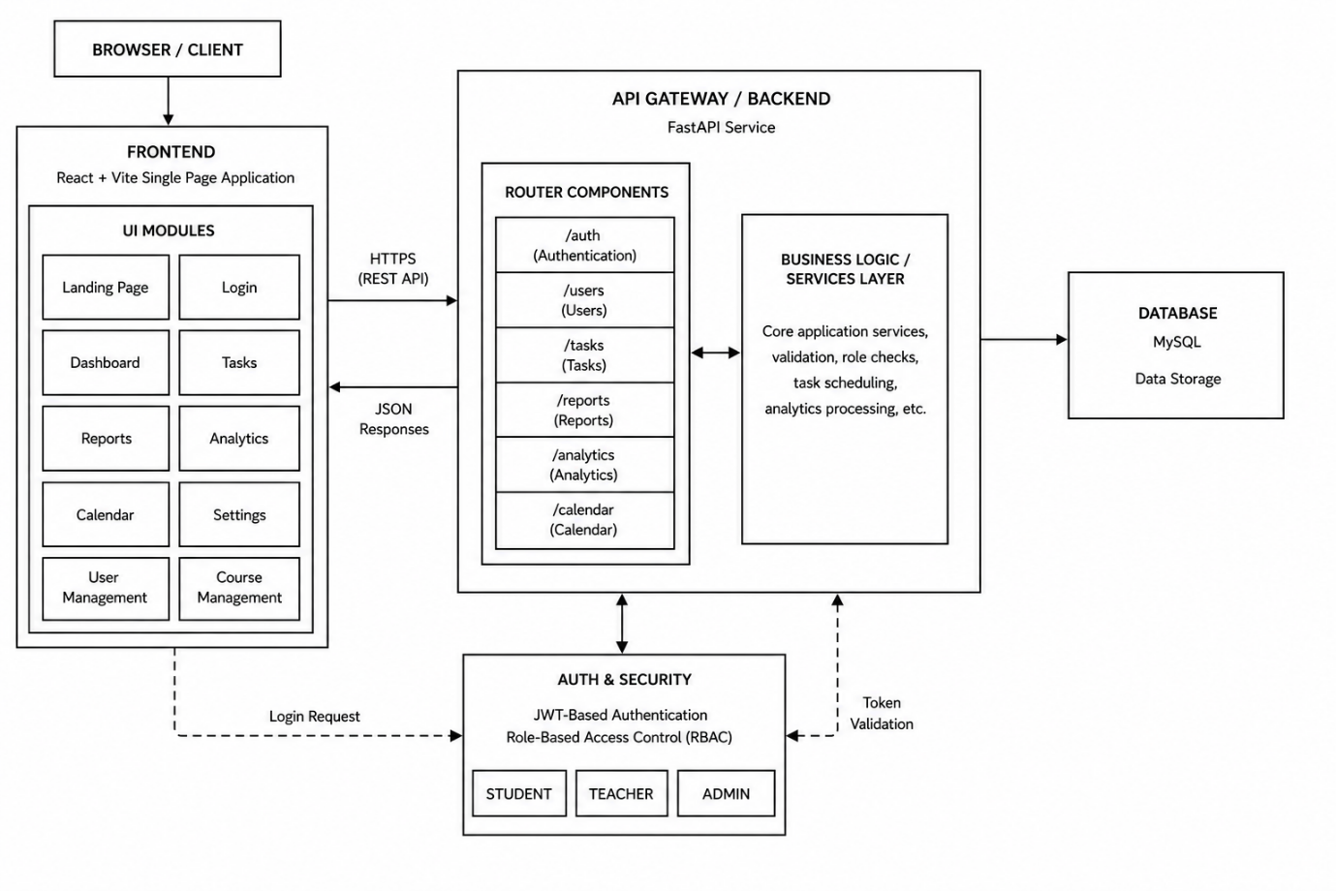

Block Diagram Explanation

The block diagram of the LMS Smart Planner represents the overall structure and working flow of the system. It shows how different parts of the application are connected and how information moves between them. The block diagram is useful because it provides a simple visual understanding of the system architecture without going into technical complexity.
The LMS Smart Planner mainly consists of three important blocks:
• Frontend
• Backend
• Database
These three blocks work together to perform all operations of the system.
The first block is the frontend, which is the user interface of the application. This is the part that users directly interact with through a web browser. Students, teachers, and administrators use the frontend to log in, manage tasks, access study materials, and view reports. The frontend is developed using React.js and CSS to provide a responsive and interactive interface. It collects user input and sends requests to the backend for processing.
The second block is the backend, which acts as the main processing unit of the system. The backend is developed using FastAPI with Python. It receives requests from the frontend, processes the data, applies business logic, and communicates with the database. For example, when a user logs in, the backend verifies login credentials and sends the correct response back to the frontend. It also handles task management, feedback systems, course uploads, and progress tracking.
The third block is the database, which stores all project-related information securely. MySQL is used as the database management system. The database stores user details, assignments, courses, reports, and feedback records. Whenever the backend needs information, it communicates with the database to retrieve or update data.
The working process of the block diagram is simple:
• User interacts with frontend
• Frontend sends request to backend
• Backend processes request
• Backend accesses database if needed
• Database sends data back to backend
• Backend returns response to frontend
• Frontend displays result to user

DFD Diagram

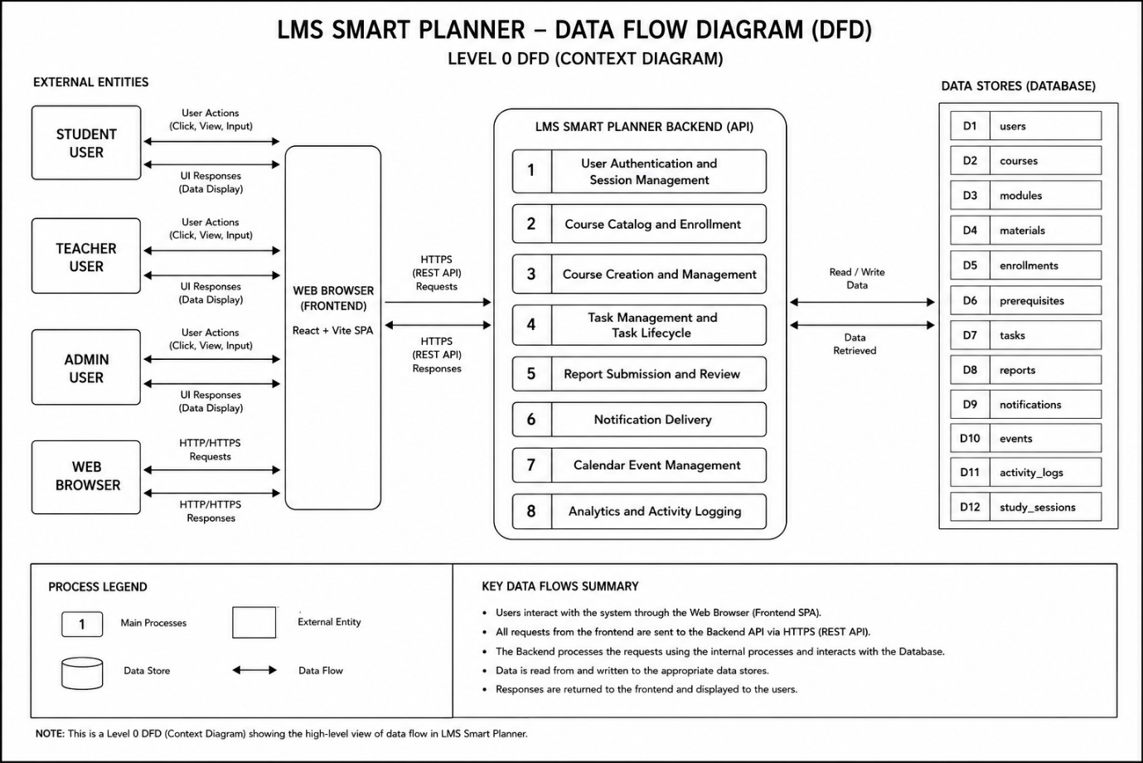

DFD Diagram Explanation
The Data Flow Diagram (DFD) is used to represent how data moves within the LMS Smart Planner system. It explains the flow of information between users, processes, and the database. The DFD helps in understanding how input data is processed and converted into meaningful output.
The main purpose of the DFD is to show the interaction between different parts of the system in a simple way. It focuses mainly on the movement of data rather than the technical implementation.
The LMS Smart Planner DFD includes the following main components:
• Users
• Processes
• Data Storage
• Data Flow
Users of the system include students, teachers, and administrators. These users provide input to the system such as login details, task information, and course data.
Processes are the operations performed by the system. Examples include login verification, task management, course management, and report generation. Each process receives data, performs operations, and produces output.
Data storage refers to the database where information is stored permanently. The MySQL database stores user records, assignments, course materials, and reports.
Data flow represents the movement of information between users, processes, and database tables.
For example, during login:
• User enters email and password
• Login request is sent to backend
• Backend checks user data from database
• If information is correct, access is granted
• Dashboard is displayed to user
Similarly, task management works as follows:
• Student creates a task
• Task information is sent to backend
• Backend stores task in database
• Updated task list is shown on dashboard

ER Diagram

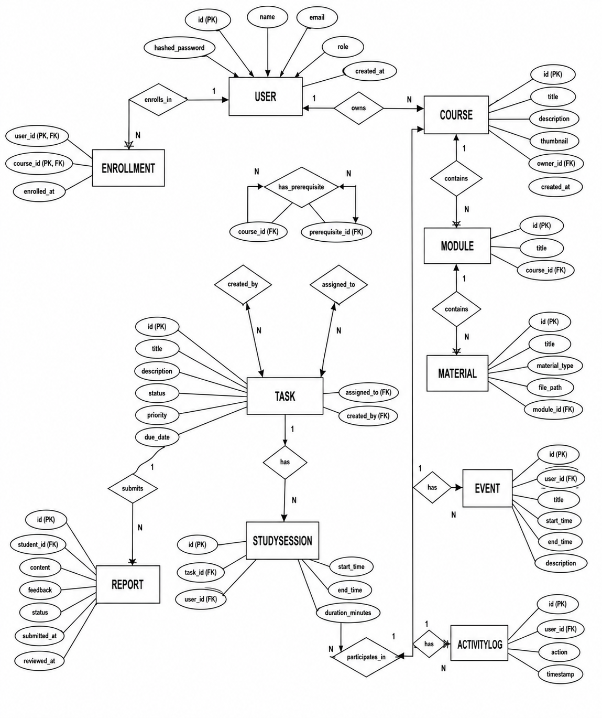

ER Diagram Explanation
The Entity Relationship (ER) Diagram represents the database structure of the LMS Smart Planner system. It shows how different database tables are connected and how information is related within the application. The ER diagram is important because it helps in organizing data properly and maintaining relationships between different entities.
An entity represents an object or data category within the system. In the LMS Smart Planner project, the main entities are:
• Users
• Tasks
• Courses
• Reports
Each entity contains specific information stored in the database.
The Users entity stores all information related to students, teachers, and administrators.

User Table Includes
• User ID
• Name
• Email
• Password
• Role
The Tasks entity stores assignment and task-related information.

Task Table Includes
• Task ID
• Task Title
• Description
• Status
• User ID
The Courses entity stores educational materials and subject information.
The Reports entity stores feedback and progress information.

Report Table Includes
• Report ID
• Student Progress
• Teacher Comments
• Submission Date
Relationships are created between these entities to connect related data.

Code
index.html
<!doctype html>
<html lang="en">
<head>
<meta charset="UTF-8" />
<link rel="icon" type="image/svg+xml" href="/favicon.svg" />
<link rel="icon" type="image/x-icon" href="/favicon.svg" />
<meta name="viewport" content="width=device-width, initial-scale=1.0" />
<title>frontend</title>
</head>
<body>
<div id="root"></div>
<script type="module" src="/src/main.jsx"></script>
</body>
</html>

login.jsx
import React, { useState, useContext } from 'react';
import { AuthContext } from '../context/AuthContext';
import { motion } from 'framer-motion';
import './Login.css';

const Login = () => {
const { login, register } = useContext(AuthContext);
const [isLogin, setIsLogin] = useState(true);

const [name, setName] = useState('');
const [email, setEmail] = useState('');
const [password, setPassword] = useState('');
const [error, setError] = useState('');

const handleSubmit = async (e) => {
e.preventDefault();
setError('');
try {
if (isLogin) {
await login(email, password);
} else {
await register(name, email, password);
}
} catch (err) {
setError(err.response?.data?.detail || 'Authentication failed');
}
};

const handleDemoLogin = async (role) => {
try {
const demoEmail = role === 'admin' ? 'admin@example.com' : 'student@example.com';
await login(demoEmail, '1234');
} catch (err) {
setError('Demo login failed');
}
};

return (
<div className="login-container">
<motion.div
className="login-card glass-panel"
initial={{ opacity: 0, y: 50 }}
animate={{ opacity: 1, y: 0 }}
transition={{ duration: 0.5, ease: "easeOut" }}
>
<h1 className="login-title">
{isLogin ? 'Welcome Back' : 'Join LMS Platform'}
</h1>
<p className="login-subtitle">
{isLogin ? 'Enter your details to access your dashboard.' : 'Create an account to start tracking.'}
</p>

{error && <div className="error-message">{error}</div>}

<form onSubmit={handleSubmit} className="login-form">
{!isLogin && (
<div className="form-group">
<label>Name</label>
<input
type="text"
className="input-field"
value={name}
onChange={(e) => setName(e.target.value)}
required
placeholder="Enter full name"
/>
</div>
)}

<div className="form-group">
<label>Email</label>
<input
type="email"
className="input-field"
value={email}
onChange={(e) => setEmail(e.target.value)}
required
placeholder="Enter email"
/>
</div>

<div className="form-group">
<label>Password</label>
<input
type="password"
className="input-field"
value={password}
onChange={(e) => setPassword(e.target.value)}
required
placeholder="Enter password"
/>
</div>

<button type="submit" className="btn btn-primary login-btn">
{isLogin ? 'Sign In' : 'Sign Up'}
</button>
</form>

<div className="demo-credentials">
<p>Demo Credentials:</p>
<div className="demo-buttons">
<button type="button" className="btn btn-outline" onClick={() => handleDemoLogin('admin')}>Admin</button>
<button type="button" className="btn btn-outline" onClick={() => handleDemoLogin('student')}>Student</button>
</div>
</div>

<div className="login-toggle">
{isLogin ? "Don't have an account? " : "Already have an account? "}
<span onClick={() => setIsLogin(!isLogin)}>
{isLogin ? 'Create one' : 'Log in'}
</span>
</div>
</motion.div>
</div>
);
};

export default Login;

Landingpage.jsx
import React, { useContext } from 'react';
import { Link } from 'react-router-dom';
import { FiBookOpen, FiClock, FiShield, FiUsers, FiCheckCircle, FiArrowRight } from 'react-icons/fi';
import { AuthContext } from '../context/AuthContext';
import './LandingPage.css';

const LandingPage = () => {
const { user } = useContext(AuthContext);

return (
<div className="landing-container">
{/* Hero Section */}
<section className="hero-section">
<div className="hero-content">
<div className="badge-new">NEW: Smart Planner 2.0 is here</div>
<h1 className="hero-title">
The Next Generation <span className="text-gradient">Learning Management</span> System
</h1>
<p className="hero-subtitle">
A complete platform for students and teachers to organize content, track progress, and achieve academic excellence with ease.
</p>
<div className="hero-actions">
{user ? (
<Link to="/dashboard" className="btn btn-primary btn-lg">Go to Dashboard <FiArrowRight /></Link>
) : (
<Link to="/login" className="btn btn-primary btn-lg">Get Started <FiArrowRight /></Link>
)}
<Link to="/catalog" className="btn btn-secondary btn-lg">Explore Courses</Link>
</div>
</div>
<div className="hero-visual">
<div className="glass-card hero-preview">
<div className="preview-header">
<div className="dot red"></div>
<div className="dot yellow"></div>
<div className="dot green"></div>
</div>
<div className="preview-content">
<div className="skeleton title"></div>
<div className="skeleton text"></div>
<div className="skeleton text short"></div>
<div className="preview-stats">
<div className="skeleton circle"></div>
<div className="skeleton circle"></div>
<div className="skeleton circle"></div>
</div>
</div>
</div>
</div>
</section>

{/* Features Section */}
<section className="features-section">
<h2 className="section-title">Built for Modern Education</h2>
<div className="features-grid">
<div className="feature-card glass-panel">
<div className="feature-icon"><FiClock /></div>
<h3>Smart Planning</h3>
<p>Automatically prioritize your tasks and track your study streaks with our intelligent scheduling system.</p>
</div>
<div className="feature-card glass-panel">
<div className="feature-icon"><FiBookOpen /></div>
<h3>Content Management</h3>
<p>Upload and organize materials into modules. Support for PDFs, videos, and interactive links.</p>
</div>
<div className="feature-card glass-panel">
<div className="feature-icon"><FiShield /></div>
<h3>Secure RBAC</h3>
<p>Enterprise-grade Role-Based Access Control ensures data privacy and role-specific workflows.</p>
</div>
<div className="feature-card glass-panel">
<div className="feature-icon"><FiUsers /></div>
<h3>Collaboration</h3>
<p>Direct integration between students and teachers for enrollment, feedback, and resource sharing.</p>
</div>
</div>
</section>

{/* Role Breakdown */}
<section className="roles-section">
<div className="role-content">
<h2 className="section-title">One Platform, Three Experiences</h2>
<div className="roles-list">
<div className="role-item">
<div className="role-icon"><FiCheckCircle /></div>
<div>
<h4>For Students</h4>
<p>Personalized dashboards, daily task planning, and easy access to course materials.</p>
</div>
</div>
<div className="role-item">
<div className="role-icon"><FiCheckCircle /></div>
<div>
<h4>For Teachers</h4>
<p>Powerful course creation, module organization, and automated student tracking.</p>
</div>
</div>
<div className="role-item">
<div className="role-icon"><FiCheckCircle /></div>
<div>
<h4>For Admins</h4>
<p>Full system analytics, user management, and centralized resource control.</p>
</div>
</div>
</div>
</div>
<div className="role-visual">
{/* Mock visual element */}
<div className="floating-elements">
<div className="float-card c1">124 Courses</div>
<div className="float-card c2">8.2k Students</div>
<div className="float-card c3">99.9% Uptime</div>
</div>
</div>
</section>

{/* CTA Section */}
<section className="cta-section">
<div className="cta-card glass-panel">
<h2>Ready to transform your learning experience?</h2>
<p>Join thousands of users who are already excelling with our platform.</p>
<Link to="/login" className="btn btn-primary btn-lg">Create Free Account</Link>
</div>
</section>

<footer className="landing-footer">
<p>&copy; 2026 LMS Smart Planner. All rights reserved.</p>
</footer>
</div>
);
};

export default LandingPage;

MySql-
CREATE DATABASE IF NOT EXISTS lms_db;
USE lms_db;

-- Table: users
CREATE TABLE IF NOT EXISTS users (
id INT AUTO_INCREMENT PRIMARY KEY,
username VARCHAR(50) UNIQUE,
email VARCHAR(100) UNIQUE,
hashed_password VARCHAR(255),
role ENUM('student', 'teacher', 'admin') DEFAULT 'student',
is_active BOOLEAN DEFAULT TRUE,
is_admin BOOLEAN DEFAULT FALSE,
study_streak INT DEFAULT 0,
bio TEXT,
profile_photo VARCHAR(255),
INDEX (username),
INDEX (email)
);

-- Table: courses
CREATE TABLE IF NOT EXISTS courses (
id INT AUTO_INCREMENT PRIMARY KEY,
title VARCHAR(100),
description TEXT,
department VARCHAR(100),
semester VARCHAR(50),
subject VARCHAR(100),
owner_id INT,
FOREIGN KEY (owner_id) REFERENCES users(id) ON DELETE SET NULL,
INDEX (title),
INDEX (department),
INDEX (semester),
INDEX (subject)
);

-- Table: enrollments
CREATE TABLE IF NOT EXISTS enrollments (
user_id INT,
course_id INT,
enrolled_at DATETIME DEFAULT CURRENT_TIMESTAMP,
PRIMARY KEY (user_id, course_id),
FOREIGN KEY (user_id) REFERENCES users(id) ON DELETE CASCADE,
FOREIGN KEY (course_id) REFERENCES courses(id) ON DELETE CASCADE
);
-- Table: modules
CREATE TABLE IF NOT EXISTS modules (
id INT AUTO_INCREMENT PRIMARY KEY,
title VARCHAR(100),
`order` INT DEFAULT 0,
course_id INT,
FOREIGN KEY (course_id) REFERENCES courses(id) ON DELETE CASCADE
);

-- Table: materials
CREATE TABLE IF NOT EXISTS materials (
id INT AUTO_INCREMENT PRIMARY KEY,
title VARCHAR(100),
file_path VARCHAR(255),
material_type VARCHAR(50),
version INT DEFAULT 1,
views INT DEFAULT 0,
module_id INT,
FOREIGN KEY (module_id) REFERENCES modules(id) ON DELETE CASCADE
);

-- Table: tasks
CREATE TABLE IF NOT EXISTS tasks (
id INT AUTO_INCREMENT PRIMARY KEY,
title VARCHAR(100),
description TEXT,
course_id INT NULL,
user_id INT,
deadline DATETIME,
estimated_hours FLOAT DEFAULT 1.0,
is_completed BOOLEAN DEFAULT FALSE,
needs_revision BOOLEAN DEFAULT FALSE,
next_revision_date DATETIME NULL,
FOREIGN KEY (course_id) REFERENCES courses(id) ON DELETE SET NULL,
FOREIGN KEY (user_id) REFERENCES users(id) ON DELETE CASCADE,
INDEX (title)
);

Project Explanation

The LMS Smart Planner is a web-based academic management and productivity system developed to simplify the daily activities of students, teachers, and administrators. The main purpose of the project is to provide all important academic tools within a single platform so that users do not need to depend on multiple applications for managing studies, assignments, reminders, and progress tracking.

In many educational environments, students often face problems such as poor organization, lack of focus, missed deadlines, and difficulty managing study materials. Teachers also experience challenges in monitoring student progress and maintaining proper communication. The LMS Smart Planner is designed to solve these issues through a simple, organized, and user-friendly system.

The project combines learning management features with productivity tools. It helps students manage assignments, access study materials, track progress, and improve concentration using a built-in focus timer. Teachers can upload resources, assign tasks, review student work, and provide feedback directly within the platform. Administrators manage the entire system and maintain proper control over users and settings.

The system is designed with simplicity as a major priority. The interface is clean and easy to understand, making it suitable even for users with basic computer knowledge. The project avoids unnecessary complexity and focuses mainly on practical and useful features.

Overall Working of the System

The LMS Smart Planner works through a simple step-by-step process.

• Users open the application through a web browser
• Users log in using their credentials
• The system verifies details through the backend
• The database checks user information
• After successful login, the appropriate dashboard is displayed
• Users can then access features based on their role

The complete system works using three main components:

• Frontend
• Backend
• Database

These three parts work together continuously to process requests and display information properly.

Frontend Explanation

The frontend is the visible part of the application that users interact with directly. It is responsible for displaying information and handling user interaction.

Technologies Used

• React.js
• CSS

React.js is used because it provides a fast and interactive user experience. The frontend updates information dynamically without needing to refresh the page repeatedly.

Functions of Frontend

• Displays login page
• Shows dashboard interface
• Displays task boards and course materials
• Handles buttons, forms, and user actions
• Sends requests to backend
• Displays output received from backend

The frontend is designed to be responsive and visually simple so users can easily navigate through the platform.

Backend Explanation

The backend acts as the brain of the system. It handles all processing, logic, and communication between the frontend and database.

Technology Used

• FastAPI (Python)

FastAPI is lightweight and fast, making it suitable for web applications that require quick data processing.

Functions of Backend

• Handles login authentication
• Verifies user roles
• Processes task operations
• Manages course materials
• Sends and receives data from database
• Controls application logic

Whenever a user performs any action, such as creating a task or viewing assignments, the request first goes to the backend for processing.

Database Explanation

The database is responsible for storing all project data securely and systematically.

Technology Used

• MySQL

The database stores all important information required by the application.

Data Stored in Database

• User details
• Email and passwords
• Tasks and assignments
• Course information
• Reports and feedback
• Task status updates

The database uses tables to organize information efficiently.

Main Tables
Table Name Purpose
Users | Stores user information
Tasks | Stores assignment details
Courses | Stores subject materials
Reports | Stores feedback and progress

The database helps retrieve information quickly whenever users request data.

User Module

The User Module is responsible for handling all user-related activities in the system.

Main Features

• User registration
• Login system
• Role management
• User profile management

The module supports three types of users:

• Student
• Teacher
• Admin

Each user role has different permissions and access levels.

Role-Based Access
User Role | Access
Student | Tasks, timer, course materials
Teacher | Assign tasks, upload materials, feedback
Admin User management and system control

Role-based access improves security and keeps the system organized.

Student Dashboard

The student dashboard is the main workspace for students. It provides all important academic tools in one place.

Features Available for Students

• View assignments
• Create and manage tasks
• Access notes and videos
• Track progress
• Use focus timer
• Submit reports

The dashboard is designed to reduce confusion and help students stay organized.

Task Management System

The Task Module is one of the core features of the project. It helps students organize their assignments visually.

Functions of Task Module

• Add tasks
• Edit tasks
• Delete tasks
• Change task status
• Track completed work

Tasks are divided into categories such as:

• To-Do
• In Progress
• Completed

This structure makes assignment tracking simple and easy to understand.

Advantages

• Better task organization
• Reduced chances of forgetting work
• Clear progress tracking
• Improved planning

Focus Timer Module

The Focus Module helps students maintain concentration while studying.
The timer is based on the Pomodoro technique.

Pomodoro Method
• 25 minutes focused study
• 5 minutes break
• Repeat cycle

Features

• Start timer
• Stop timer
• Countdown display
• Session tracking

Benefits

• Better focus
• Less distraction
• Improved productivity
• Better time management

This module encourages students to follow disciplined study habits.

Course Management Module

The Course Module manages all educational materials.

Teachers Can Upload

• Notes
• PDFs
• Videos
• Assignment instructions

Students Can

• View materials
• Download resources
• Access content anytime

All study materials remain organized subject-wise inside the system.

Teacher Dashboard

The teacher dashboard allows teachers to manage student activities and academic content.

Features for Teachers

• Upload study materials
• Assign tasks
• Monitor student work
• Give feedback
• Review reports

Teachers can easily identify students who are completing work on time and students who need improvement.

Teacher Activities

• Add comments on assignments
• Suggest improvements
• Review student progress

Student Benefits

• Understand mistakes
• Improve performance
• Receive guidance directly

This creates a more interactive learning environment.

Admin Panel

The Admin Panel controls the overall system.

Admin Responsibilities

• Add new users
• Remove users
• Manage roles
• Maintain database
• Monitor system activity

Admins ensure that the application functions smoothly and securely.

Login and Authentication System

The system includes a secure login process.

Login Process

• User enters email and password
• Backend verifies credentials
• Database checks stored information
• Correct dashboard is displayed

Security Features

• Role-based access
• Restricted admin controls
• Protected user data

These features help maintain system security.

Data Flow in the System

The LMS Smart Planner follows a smooth data flow process.

System Flow

• User sends request through frontend
• Frontend sends data to backend
• Backend processes request
• Backend communicates with database
• Database returns data
• Backend sends response to frontend
• Frontend displays output

This flow continues throughout system usage.

Performance of the System

The system is designed to provide fast and smooth performance.

Performance Features

• Fast page loading
• Quick task updates
• Smooth navigation
• Efficient database operations

The application performs well even with multiple users accessing the system.

Advantages of LMS Smart Planner

• Centralized academic management
• Simple and user-friendly interface
• Better organization of tasks
• Improved concentration and productivity
• Easy communication between users
• Secure data management
• Reduced use of multiple applications
• Efficient progress tracking

Future Improvements

The current version of the system focuses on essential features, but future enhancements can be added.

Possible Future Features

• Mobile application support
• AI-based task recommendations
• Advanced analytics
• Notifications and reminders
• Video meeting integration

Project Testing and Result

Software Testing

Software testing is an important part of the development process. It helps ensure that the LMS Smart Planner works correctly, securely, and efficiently without errors. Testing was performed on different modules of the system to verify that all features function properly under normal conditions.

The main purpose of testing is to identify problems before the system is used by actual users. Each module was tested separately as well as together with the complete system.

The testing process focused on:

• Correct functionality
• User access control
• Task management accuracy
• Database operations
• System performance
• Security validation

Types of Testing Performed

Several types of testing were conducted during the development of the project.

Login Testing

Login testing was performed to check whether users can access the system correctly using valid credentials.

Testing Activities

• Verified correct username and password login
• Checked invalid login attempts
• Tested role-based dashboard access
• Ensured unauthorized users cannot access the system

Result

• Valid users successfully logged in
• Incorrect credentials displayed error messages
• Users were redirected to correct dashboards

Task Management Testing

This testing checked whether tasks can be created, updated, and deleted properly.

Testing Activities

• Added new tasks
• Updated task status
• Deleted tasks
• Checked task display on dashboard

Result

• Tasks were added successfully
• Task updates worked correctly
• Deleted tasks were removed immediately
• Dashboard displayed updated information properly

Database Testing

Database testing ensured that data was stored and retrieved correctly from MySQL.

Testing Activities

• Checked user data storage
• Verified task information saving
• Tested report and feedback storage
• Checked database connection stability

Result

• Data was stored successfully
• Records were retrieved correctly
• Database connection remained stable

Security Testing

Security testing was performed to ensure users cannot access restricted areas.

Testing Activities

• Checked admin page restrictions
• Verified user role permissions
• Tested unauthorized access attempts

Result

• Students could not access admin controls
• Teacher and admin permissions worked correctly
• Unauthorized access was blocked successfully

User Interface Testing

This testing checked whether the frontend interface works smoothly and is easy to use.

Testing Activities

• Verified button functionality
• Tested form submission
• Checked responsive layout
• Tested navigation between pages

Result

• Interface worked smoothly
• Navigation was simple and responsive
• Forms submitted data correctly

Performance Testing

Performance testing ensured the system performs efficiently without delays.

Testing Activities

• Tested page loading speed
• Checked response time during task operations
• Verified multiple user interactions

Result
• Pages loaded quickly
• Task operations completed smoothly
• System remained stable during usage

Testing Summary Table
Testing Type | Purpose | Result
Login Testing | Verify user authentication | Successful
Task Testing | Check task operations | Successful
Database Testing | Verify data storage and retrieval | Successful
Security Testing | Prevent unauthorized access | Successful
UI Testing | Check interface usability | Successful
Performance Testing | Measure system efficiency | Successful
Result and Analysis

The LMS Smart Planner was successfully developed and tested. The system achieved the main objectives of improving academic management, task organization, and study productivity.

The application performed smoothly during testing and all major modules worked correctly. Users were able to log in, manage tasks, access study materials, and track progress without facing major issues.

Observed Results
User Authentication

• Login system worked correctly
• Role-based access functioned properly
• Users were redirected to correct dashboards

Task Management

• Students successfully created and updated tasks
• Task status changed correctly
• Completed and pending tasks were displayed clearly

Focus Timer

• Timer counted accurately
• Study and break sessions worked properly
• Students could start and stop the timer easily

Course Management

• Teachers uploaded materials successfully
• Students accessed resources without problems
• Files were displayed correctly on dashboard

Database Operations

• Data storage was accurate
• Information retrieval was fast
• No major database errors occurred during testing

System Performance Analysis

The system provided good overall performance.

Performance Highlights

• Fast dashboard loading
• Smooth page navigation
• Quick response during operations
• Stable database connectivity

The use of React.js and FastAPI helped improve speed and responsiveness.

User Experience Analysis

The interface was designed to be simple and user-friendly.

Observations

• Users could understand features easily
• Navigation was clear and organized
• Task boards improved assignment management
• Timer feature helped improve concentration

The clean layout reduced confusion and made the platform easier to use.

Advantages Observed During Testing

• Centralized academic management
• Better organization of tasks
• Improved focus using study timer
• Faster communication between users
• Reduced dependency on multiple applications

Result Summary Table
Feature Tested | Outcome
Login System | Worked correctly
Task Management | Successfully managed tasks
Timer Module | Functioned accurately
Course Module | Materials uploaded and accessed properly
Database | Stored and retrieved data successfully
Security | Restricted unauthorized access

Conclusion

The LMS Smart Planner was successfully developed as a web-based academic management and productivity system for students, teachers, and administrators. The project was created to solve common academic problems such as poor task management, lack of focus, scattered study materials, and the need to use multiple applications for different purposes.

The system combines important academic tools into a single platform, making it easier for users to organize and manage their daily activities. Students can manage assignments, track progress, access course materials, and improve concentration using the built-in focus timer. Teachers can upload resources, assign tasks, monitor performance, and provide feedback directly through the platform. Administrators can manage users and maintain the overall system effectively.

The project was developed using React.js for the frontend, FastAPI for the backend, and MySQL for the database. These technologies helped create a fast, responsive, and user-friendly application. The interface was kept simple so that users with basic technical knowledge could easily understand and use the system.

Bibliography and Reference

The development of the LMS Smart Planner project was supported by various online resources, official documentation, and educational websites that provided guidance throughout the planning, designing, coding, and testing phases of the system. These references helped in understanding the technologies used in the project and provided solutions for implementing different features successfully.

Python official documentation was used to understand the backend programming concepts and syntax required for building the server-side functionality of the application. It provided detailed explanations about Python libraries, functions, and programming structures used during development.

React.js documentation was referred to for developing the frontend interface of the project. It helped in understanding component-based architecture, state management, routing, and user interface handling. The documentation also provided examples and best practices for creating responsive and interactive web pages.

FastAPI official documentation played an important role in backend development. It was used for understanding API creation, request handling, routing, and communication between the frontend and backend systems. The framework documentation helped in building a fast and organized backend structure for the project.

MySQL documentation and tutorials were used to design and manage the project database. These resources helped in understanding table creation, data storage, SQL queries, and database connectivity with Python. Proper database management was important for storing user details, tasks, reports, and course materials securely.

W3Schools was another helpful learning platform used during the project development process. It provided simple tutorials and examples related to HTML, CSS, JavaScript, and basic web development concepts. The website was especially useful for frontend styling and improving the user interface design of the system.

Reference Table-
No. | Reference Name | Website Link
1 | Python Official Documentation | https://docs.python.org/
2 | React.js Documentation | https://react.dev/
3 | FastAPI Documentation | https://fastapi.tiangolo.com/
4 | MySQL Documentation | https://dev.mysql.com/doc/
5 | W3Schools | https://www.w3schools.com/

Student Profile

Name: AYUSH CHAURASIYA

Course: BTECH.CSE

Semester / Year: :8th SEMESTER/4th YEAR

Student code: B2255R10106007

College Name: AKS UNIVERSITY ,SATNA

Project Title: SMART PLANNER LMS

Project Duration: 5 Months

Project Guide: Dr. Akhilesh A. Waoo

Project Submitted To: DEPARTMENT OF COMPUTER SCIENCE /IT

Plagiarism Report

This is to certify that the project entitled " SMART PLANNER LMS" submitted by AYUSH CHAURASIYA, student of B.Tech (CSE) ,AKS UNIVERSITY, SATNA is an original work carried out by him during his final year project.
The project report has been checked for plagiarism using standard plagiarism detection tools and manual verification methods. The overall Similarity Index of the submitted work is found to be 12%, which is well within the permissible limits as per university academic guidelines.
All the references, sources, and materials used in this project have been properly acknowledged and cited. No part of this report has been copied or reproduced from any other source without proper reference.
Hence, this project is declared to be free from plagiarism and is approved for academic submission.

Project Details
Student Name: AYUSH CHAURASIYA
Course: B.Tech (CSE)
Institute: AKS UNIVERSITY
Project Title: SMART PLANNER LMS
Similarity Index: 12%
Original content- 88%

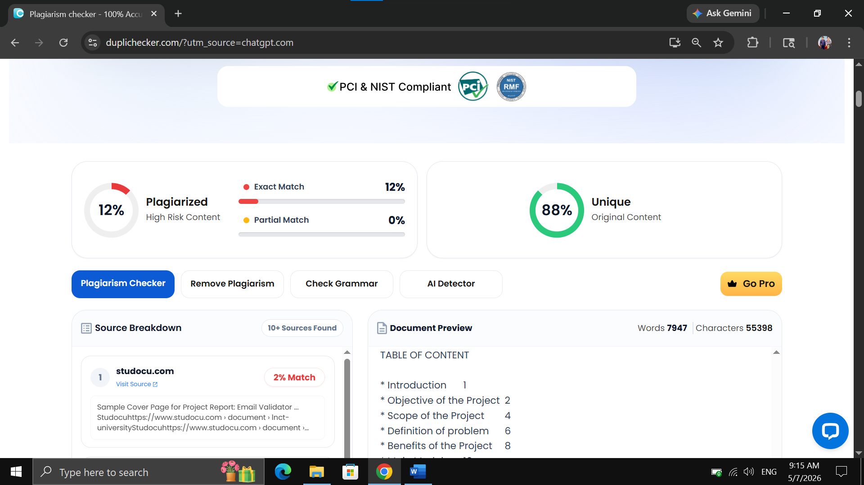

Output of LMS
Frontpage
The front page of the LMS Smart Planner provides an overview of the platform and its main features. It includes navigation options, project information, and quick access to login or dashboard sections. The page is designed with a clean and modern interface to create a user-friendly experience.
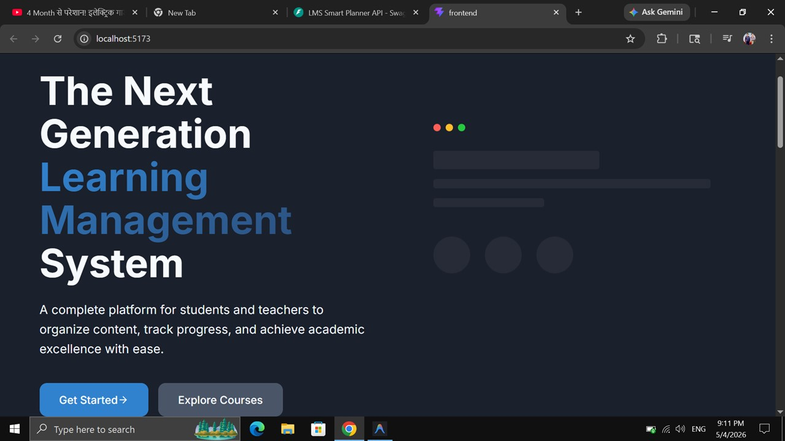

Admin Panel Output
The admin panel allows administrators to manage users and monitor system activities. Admins can control access permissions, maintain records, and ensure smooth functioning of the platform. The panel provides complete control over the system.

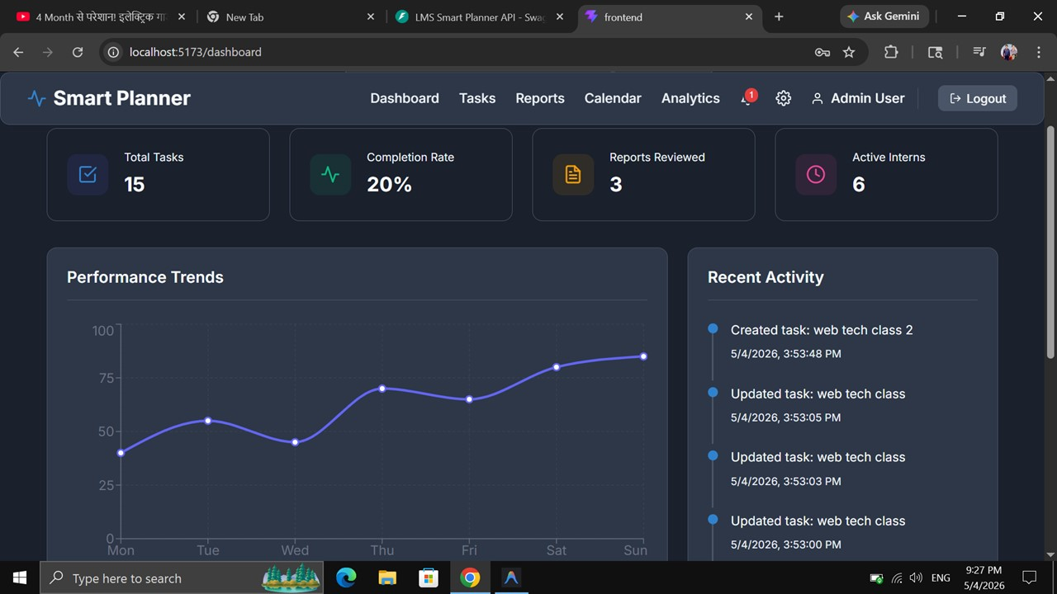

Task Management Output

The task management module allows students to create, update, and organize assignments visually. Tasks are divided into categories such as To-Do, In Progress, and Completed. This helps users manage deadlines and monitor work status efficiently.

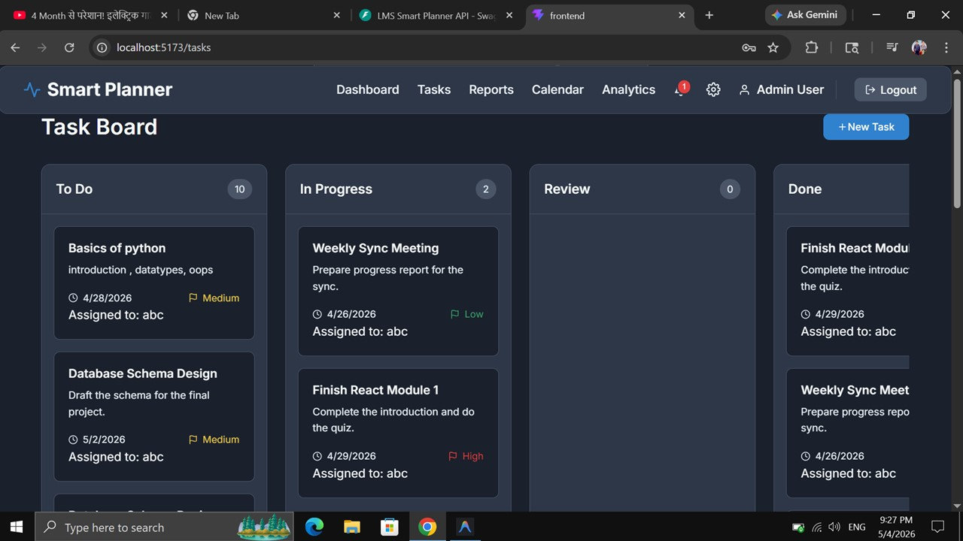

Analytics Page
The analytics page displays student progress and task completion details using simple graphs and statistics. Users can easily view completed tasks, pending assignments, and overall productivity status. This page helps students and teachers track academic performance effectively.

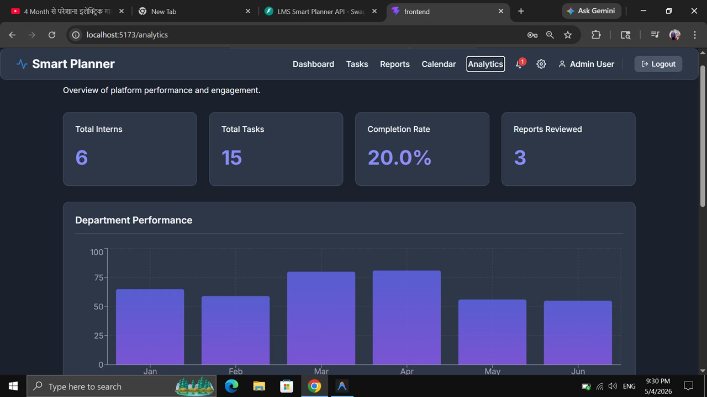

PPT Handouts

