Individual Weekly Report for Ayush Mehta

AI Powered Cooking Assistant Web App

July 21, 2025

# Accomplishments

* Met with the expert to discuss about the project
* Found the recipe generation API
* Tested the APIs
* Started working on the prototype

# Weekly Activities

| Activity / Task / Work | Hours | Status |
| --- | --- | --- |
| Finished the React course from Scrimba. Learned and practiced fetching data from an API and displaying it through React components. Learned about the Hugging Face APIs from the course. | 10 | Complete |
| Meeting with the expert | 1 | Complete |
| Created accounts on Google cloud and Hugging Face website. Explore through the website. Explored models from Hugging Face. Read the documentation on how to generate API keys and integrate them in the website or projects in general. Tested the APIs locally. | 4 | Complete |
| Set up the GitHub Repo and cloned it locally. Completed the Flask and React setup. Started working on the front-end page. | 10 | In progress |
| Worked on weekly report 4 | 1 | Complete |
| **Weekly Total** | **26** |  |
| Previous Weekly Cumulative Total (Carry Over) | 60 |
| **Current Cumulative Total** | **86** |

# Plans for Next Week

| Activity / Task / Work | Est Hours |
| --- | --- |
| Continue working on the project. | 15 |
| Find an API or database to help validate food ingredients typed by user or detected by Google vision API | 3 |
| Work on the Slide Show | 2 |

# Response to Feedback

I received helpful feedback from the expert, Aashima, regarding API testing and managing latency from API calls. She recommended using Postman, a powerful and efficient tool for testing APIs. I plan to explore it further to improve the reliability and speed of my API testing. She also advised me to consider strategies for handling latency, including retry logic and managing failed API calls, which I will incorporate into my development process.

# Other Reflections

Over the past week, I completed the React course on Scrimba and now feel confident in building frontend components using React. I also explored the Hugging Face API and found a free model suitable for recipe generation, which aligns well with the goals of my project. I successfully made API calls to Hugging Face using JavaScript and also discovered that the same can be done in Python using the openai library, which simplifies the process a lot for me.

I also worked with the Google Vision API. I created a student account that provides $300 in free credits for one year, set up a new project, and enabled Vision API. Using Google Cloud documentation, I generated the necessary JSON key file for authentication and used it to test image-to-ingredient detection. I was able to extract ingredients from images successfully using this API, which will be valuable for the ingredient scanning feature in my project.

# Comments, Issues, Notes, Anything Else?

No comments or issues as of now.

# Evidence of Work

Below is the screenshot of last project that I completed from React course from Scrimba website. This last project was similar to my project where user can input some ingredients and get recipe suggestions using Hugging Face API for free.

Screenshot of the code

Screenshots of the website

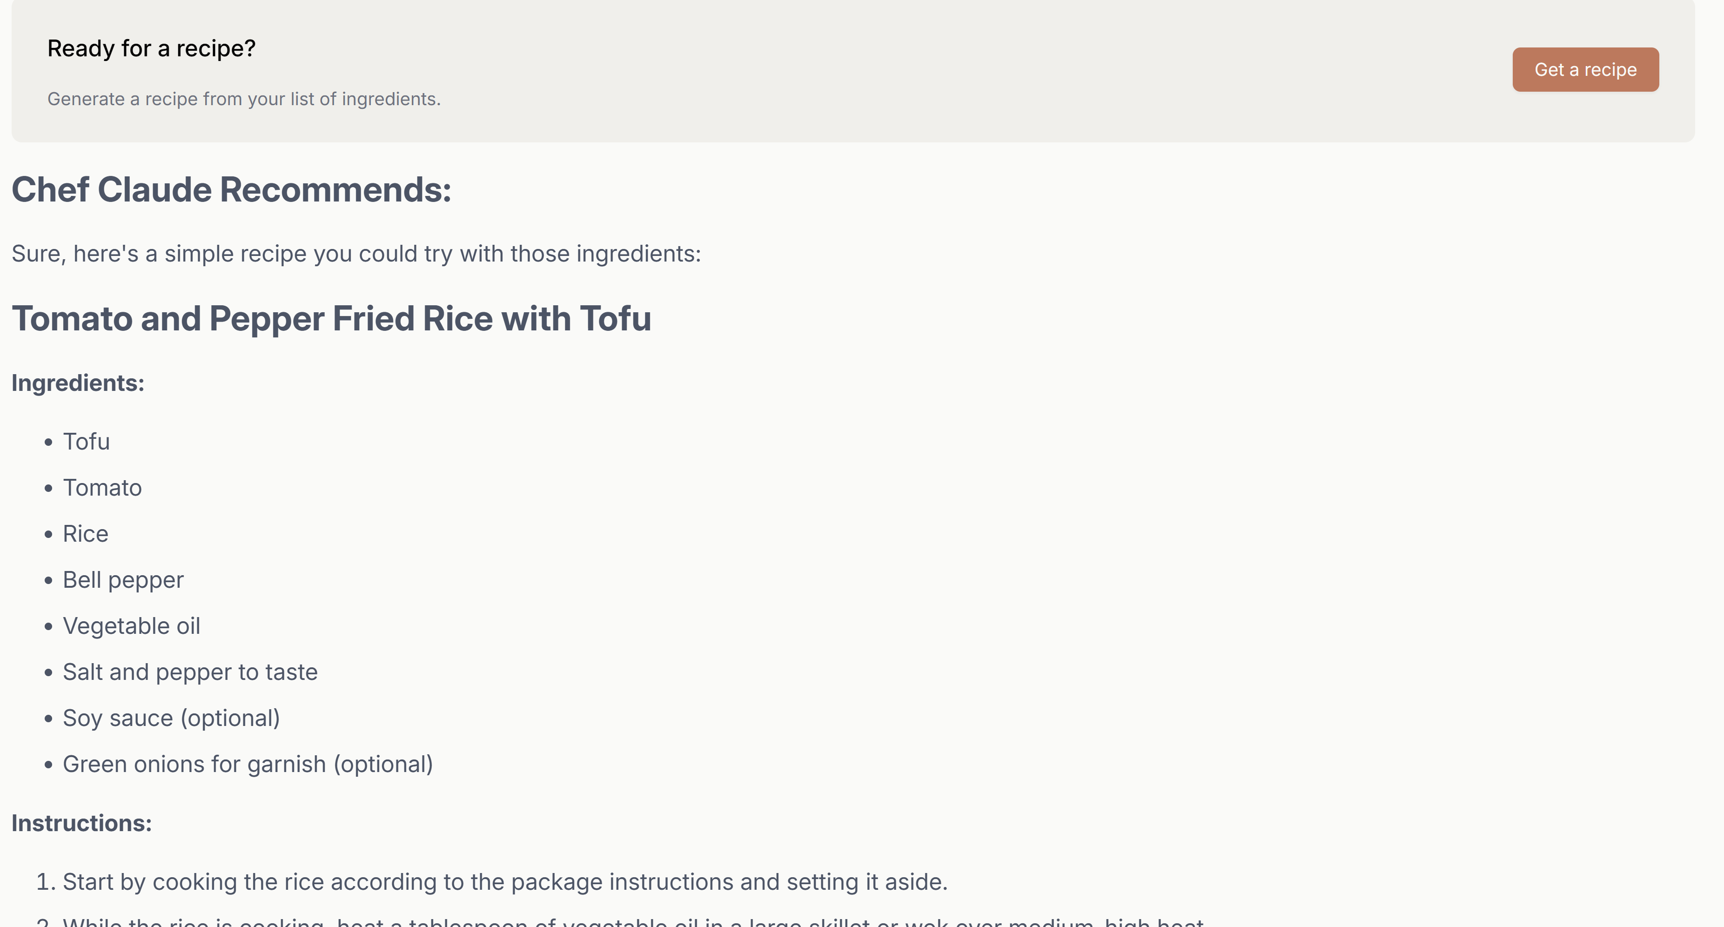

Below is the screenshot of my prototype. I have built the frontend so far and soon begin the implementation of backend.

# Interaction Report

Interaction Type: Expert

Interaction Date: July 18th, 2025

Attendees: Aashima Mehta, Ayush Mehta

## Summary of Interaction

## During my meeting with Aashima, we discussed the overall structure and features of my project, focusing particularly on the data flow of the application. She suggested integrating a database to store information such as calorie data and recipe details, which would enhance the app’s functionality and performance.

## We also discussed the external APIs I plan to use. Aashima recommended using Postman to test these APIs efficiently and emphasized the importance of handling potential issues such as API latency, failed requests, and retry logic.

## Action Items

* Learn about the postman tool to test the APIs.
* Design a strategy to handle API latency, including retries and error handling, when implementing the backend.

## Reflection on the Interaction

This meeting gave me a much clearer understanding of API integration. I learned how to approach API testing, which tools are most effective, and what architectural decisions to consider, especially around database use and handling unreliable API behavior.