

**🎮 Enhanced Gaming Experience**

* **PS5 Pro Game Boost**: Improves performance and stability for over 8,500 backward-compatible PS4 and PS5 games. [LevelUp+3Tom's Guide+3The Economic Times+3](https://www.tomsguide.com/gaming/playstation/ps5-pro-officially-announced-heres-what-it-can-do?utm_source=chatgpt.com)
* **8K Gaming Support**: Supports 8K resolution for compatible games and content.
* **Game Library**: Over 50 titles optimized for PS5 Pro, including first-party games like *Marvel’s Spider-Man 2* and *The Last of Us Part II Remastered*, and third-party titles such as *Final Fantasy 7 Rebirth* and *Assassin’s Creed: Shadows*

**🔧 Key Specifications**

* **GPU**: 67% more compute units and 28% faster memory than the standard PS5, resulting in up to 45% faster rendering. [The Sun+6The Economic Times+6LevelUp+6](https://economictimes.indiatimes.com/news/international/business/sony-playstation-5-pro-launched-with-major-improvements-check-price-specs-launch-date/articleshow/113236556.cms?utm_source=chatgpt.com)
* **Ray Tracing**: Improved ray tracing capabilities for more dynamic light reflections and refractions. [Tom's Guide+3LevelUp+3GameSpot+3](https://www.levelup.com/en/news/802957/PS5-Pro-is-Sonys-most-powerful-console-release-date-price-upgrades-and-more-details?utm_source=chatgpt.com)
* **AI Upscaling**: Introduces PlayStation Spectral Super Resolution (PSSR), an AI-driven upscaling technology similar to Nvidia's DLSS, enhancing image quality without compromising frame rates. [LOS40+8Tom's Guide+8GameSpot+8](https://www.tomsguide.com/gaming/playstation/ps5-pro-officially-announced-heres-what-it-can-do?utm_source=chatgpt.com)
* **Storage**: Comes with a 2TB SSD, offering more than double the storage of the original PS5. [The Sun](https://www.thesun.co.uk/tech/30363298/ps5-pro-release-date-price-reveal/?utm_source=chatgpt.com)
* **Connectivity**: Supports Wi-Fi 7, Bluetooth 5.1, and includes multiple USB-C and USB-A ports. [TechRadar](https://www.techradar.com/news/ps5-pro?utm_source=chatgpt.com)
* **Dimensions**: Approximately 388 x 89 x 216 mm; weighs around 3.1 kg

ps5 pro max

The **PlayStation 5 Pro** is Sony's latest high-performance console, officially launched on **November 7, 2024**, priced at **$699.99** (approximately ₹58,000–₹65,000 in India). This model offers significant upgrades over the original PS5, focusing on enhanced graphics, faster performance, and advanced AI-driven features.

**🔄 Comparison with PS5**

**💰 Pricing & Availability in India**

While the PS5 Pro is available globally, pricing and availability in India may vary. It's advisable to check with local retailers or the official PlayStation India website for the most accurate and up-to-date information.

|  |  |  |
| --- | --- | --- |
| Feature | PS5 | PS5 |
| GPU | Standard | 67% more compute units |
| Ray Tracing | Basic | Enhanced |
| AI Upscaling | No | **Yes (PSSR)** |
| Storage | 825GB | 2TB SSD |
| 8K Gaming Support | No | **Yes** |
| Backward Compatibility | Yes | Yes (with Game Boost) |

The PS5 Pro is designed for gamers seeking top-tier performance and visual fidelity. Its advanced features make it a compelling choice for those looking to experience the latest games at their best.

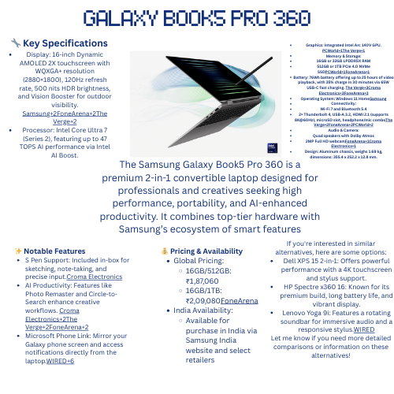

[galaxy book5 pro 360](https://www.canva.com/design/DAGmRbx6I_M/8qBd8FXRSSBtE5wHPzwqIw/edit)