A

Mini Project Report on

## HELPMEDICO 24/7

Submitted in partial fulfillment of the requirements for the degree of

BACHELOR OF ENGINEERING

IN

**Computer Science & Engineering**

Artificial Intelligence & Machine Learning by

Aditi Gujar (23106099)

Karina Jain (23106097)

Vaishnavi Bagmar (23106071)

Saniya Dhopavkar (23106021)

Under the guidance of

## Prof. Kanchan Wankhede



**Department of Computer Science & Engineering (Artificial Intelligence & Machine Learning)**

**A. P. Shah Institute of Technology**

**G. B. Road, Kasarvadavali, Thane (W)-400615 University Of Mumbai**

**2024-2025**

**A. P. SHAH INSTITUTE OF TECHNOLOGY**

## CERTIFICATE

This is to certify that the project entitled “HelpMedico 24/7**”** is a bonafide work of Aditi Gujar (23106099), Karina Jain (23106097), Vaishnavi Bagmar (23106071), Saniya Dhopavkar (23106021) submitted to the University of Mumbai in partial fulfillment of the requirement for the award of **Bachelor of Engineering** in **Computer Science & Engineering (Artificial Intelligence & Machine Learning).**

Prof. Kanchan Wankhede Dr. Jaya Gupta Mini Project Guide Head of Department



**A. P. SHAH INSTITUTE OF TECHNOLOGY**

## Project Report Approval

This Mini project report entitled “**HelpMedico 24/7*”*** by **Aditi Gujar, Karina Jain, Vaishnavi Bagmar, Saniya Dhopavkar** is approved for the degree of ***Bachelor of Engineering*** in ***Computer Science &Engineering***, (AIML) ***2024-25***.

External Examiner:

Internal Examiner:

Place: APSIT, Thane Date:

**Declaration**

We declare that this written submission represents my ideas in my own words and where others' ideas or words have been included, I have adequately cited and referenced the original sources. I also declare that I have adhered to all principles of academic honesty and integrity and have not misrepresented or fabricated or falsified any idea/data/fact/source in my submission. I understand that any violation of the above will be cause for disciplinary action by the Institute and can also evoke penal action from the sources which have thus not been properly cited or from whom proper permission hasnot been taken when needed.

|  |  |  |  |
| --- | --- | --- | --- |
| Aditi Gujar | Karina Jain | Vaishnavi Bagmar | Saniya Dhopavkar |
| (23106099) | (23106097) | (23106071) | (23106021) |

### ABSTRACT

As the global population continues to grow, ensuring accessible and efficient healthcare services is crucial for enhancing their quality of life. This project aims to develop a dedicated web application that caters to the unique health and medical needs of citizens. The app is designed to provide a comprehensive range of features, including personalized care plans, real-time teleconsultations, medication reminders, emergency alerts, and seamless access to medical records. By integrating artificial intelligence (AI) and user-friendly interfaces, the application will empower individuals to manage their health independently while staying connected with healthcare professionals and caregivers.

A significant focus of this project is on preventive care, ensuring that individuals receive timely health screenings, lifestyle recommendations, and tailored medical guidance to various health risks. The integration of location-based services will help connect users with nearby healthcare facilities, pharmacies, and emergency response teams.

By leveraging technology, this project seeks to bridge the gap between individuals and healthcare services, making medical assistance more accessible, efficient, and proactive. The proposed solution aims to not only enhance healthcare management but also promote independence, well-being, and a higher standard of living. Through continuous monitoring, data analytics, and collaboration with healthcare providers, this initiative aspires to redefine healthcare, ensuring a safer, healthier, and more fulfilling life for individuals.

**Keywords**: Healthcare, Web Application, Prevention Care.

**Index**

|  |  |  |  |
| --- | --- | --- | --- |
| Index | | | Page no. |
| Chapter-1 | | |  |
|  | Introduction | | 7 |
|  |  |  |  |
| Chapter-2 | | |  |
|  | Literature Survey | | 10 |
|  | 2.1 | History |  |
|  | 2.1 | Review |  |
|  |  |  |  |
| Chapter-3 | | |  |
|  | Problem Statement | | 15 |
|  |  |  |  |
| Chapter-4 | | |  |
|  | Experimental Setup | | 17 |
|  | 4.1 | Hardware setup |  |
|  | 4.2 | Software Setup |  |
|  |  |  |  |
| Chapter-5 | | |  |
|  | Proposed system and Implementation | | 19 |
|  | 5.1 | Block Diagram of proposed system |  |
|  | 5.2 | Description of Block diagram |  |
|  | 5.3 | Implementation |  |
|  |  |  |  |
| Chapter-6 | | |  |
|  | Conclusion | | 28 |
|  |  |  |  |
| References | | | 30 |
|  |  |  |  |

# CHAPTER 1 INTRODUCTION

**INTRODUCTION**

With the advancement of medical science and an increasing life expectancy, the global population is growing at an unprecedented rate. As individuals age, they experience various health-related challenges, including chronic diseases such as diabetes, hypertension, arthritis, and cardiovascular conditions. Additionally, age- related cognitive decline, reduced mobility, and difficulties in medication management further complicate their healthcare needs. Traditional healthcare systems often struggle to provide continuous and personalized care, leading to delays in medical attention, increased dependency, and a decline in their overall quality of life. To address these challenges, technology-driven solutions such as web healthcare applications have emerged as a promising way to enhance healthcare accessibility and improve the well-being of individuals.

This project aims to develop a comprehensive web healthcare application tailored specifically for the elderly population. The application will serve as a one-stop solution for various healthcare needs, offering features such as real-time consultations with doctors, personalized care plans based on individual health conditions, automated medication reminders, and seamless access to electronic medical records. Additionally, the app will provide emergency response features such as SOS alerts and direct connectivity with nearby hospitals, pharmacies, and ambulance services.

To ensure ease of use, the application will be designed with accessibility in mind. The user interface will feature large fonts, simplified navigation, and support to accommodate seniors with varying levels of digital literacy. The goal is to create an intuitive and inclusive platform that enables individuals to take control of their healthcare needs without external assistance. Furthermore, the app will facilitate real-time communication between individuals, their families, and healthcare professionals, fostering a connected healthcare ecosystem that ensures timely medical intervention when needed.

By leveraging cutting-edge technology, this project seeks to bridge the gap between individuals and essential healthcare services, providing them with a reliable, efficient, and user-friendly solution for managing their health. The ultimate objective is to empower individuals to lead healthier, more independent, and fulfilling lives while reducing the burden on healthcare systems. As digital healthcare solutions continue to evolve, this initiative aims to set a benchmark for individual-focused healthcare innovation, ensuring that individuals receive the medical attention and support they deserve.

# CHAPTER 2 LITERATURE SURVEY

### LITERATURE SURVEY

**2.1-HISTORY**

The concept of healthcare has evolved significantly over the centuries, from traditional home-based care to modern, technology-driven healthcare solutions. In earlier societies, individuals were primarily cared for within their families and local communities, with minimal medical intervention. As medical advancements progressed, institutional healthcare services such as hospitals, nursing homes, and care centres became more prominent, addressing the growing healthcare needs of growing populations.

Historically, individual care was largely informal and dependent on family support systems. As societies industrialized and urbanization increased, the traditional family structure changed, leading to the establishment of care homes and specialized hospitals. By the mid-20th century, developed nations began introducing structured healthcare programs, including Medicare in the United States (established in 1965), which aimed to provide financial assistance for medical care among citizens.

During this period, advancements in medical science significantly improved life expectancy, leading to a rise in age-related diseases such as Alzheimer's, osteoporosis, and cardiovascular disorders. Governments and healthcare organizations started focusing on geriatric medicine, developing specialized treatments and policies to support the population.

The late 20th and early 21st centuries saw rapid technological advancements that transformed healthcare services, including those targeted at elderly individuals. Digital solutions such as online appointment scheduling and virtual doctor consultations made healthcare services more accessible, especially for seniors with mobility challenges.

By the 2010s, web applications began playing a crucial role in individual healthcare. Apps for medication reminders, remote health monitoring, and emergency alerts emerged, providing individuals with greater independence and convenience. The development of artificial intelligence (AI) and machine learning further enhanced digital healthcare, enabling predictive analytics for early disease detection and personalized healthcare recommendations.

The COVID-19 pandemic in 2020 further accelerated the adoption of digital healthcare, as many individuals were the most vulnerable populations. Telemedicine and remote healthcare solutions became essential, reducing the need for in-person visits while ensuring continuous medical care.

**2.2-LITERATURE REVIEW**

|  |  |  |  |
| --- | --- | --- | --- |
| Research  Papers | Summary | Limitations | Adaptation |
| Kumar & Singh (2022) | AI enhances elderly care via  automation. | Privacy concerns and high costs. | Secure AI with personalized recommendations. |
| Häkkinen (2021) | Discusses mHealth adoption  challenges. | Low motivation for long-term  use. | Gamification and engagement tools. |
| Batsis & Pitzer (2021) | Telemedicine improves healthcare access. | Digital literacy and internet access  issues. | User-friendly UI and tech training. |
| Lupton (2020) | Digital health promotes  self-  management. | Digital divide and  low tech  literacy. | Community workshops and guides. |
| Chan, Goss & Edwards (2020) | Heath apps aid chronic disease  management. | Complex navigation challenges. | Simplified UI/UX. |
| Wang, Zhang & Wang (2020) | Reviews usability issues in  Health apps. | Small screens and cognitive  load. | Larger fonts and contrast settings. |

|  |  |  |  |
| --- | --- | --- | --- |
| Wildenhos Peute & Jaspers (2019) | Reviews usability issues in Health  apps. | Small screens and cognitive  load. | Larger fonts and contrast settings. |
| Lee & Kim | Emergeny | False | AI sensors to |
| (2018) | alert | alarms and | reduce false |
|  | systems | integration | positives. |
|  | improve | issues. |  |
|  | response |  |  |
|  | time. |  |  |

# CHAPTER 3 PROBLEM STATEMENT

### PROBLEM STATEMENT

The global population is increasing rapidly, creating a significant challenge for healthcare systems worldwide. Individuals often face various health issues such as chronic diseases, cognitive decline, and mobility limitations, which make it difficult for them to access timely healthcare services. This demographic also experiences social isolation and may have limited access to medical facilities, particularly in rural or underserved areas. As a result, there is a growing need for innovative solutions that enable individuals to manage their health independently, receive timely medical advice, and stay connected with healthcare providers.

Web healthcare applications have the potential to address these challenges by offering accessible, cost-effective, and personalized healthcare solutions. However, despite the potential advantages, individuals face numerous barriers to adopting and effectively using Health apps, including complex interfaces, concerns about privacy and security, and the affordability of necessary devices and internet connectivity.

The problem this project seeks to address is how to design and implement a user- friendly web healthcare application that meets the specific healthcare needs of individuals, improves their health management, and facilitates better communication with healthcare providers. Furthermore, the project aims to overcome the barriers to adoption by addressing concerns such as usability, privacy, security, and accessibility, ensuring that the application is accessible to all, regardless of their technological expertise or socio-economic status.

This project aims to develop a web healthcare application that not only improves healthcare access for individuals but also enhances their ability to live independently and maintain a good quality of life.

# CHAPTER 4 EXPERIMENTAL SETUP

### EXPERIMANTAL SETUP

#### Hardware Setup

For the development and deployment of HelpMedico 24/7, the following hardware components are required:

* + 1. Smartphone or Tablet: To run the web application.
    2. Cloud Server: Stores and manages event data, user information, and real- time updates.
    3. Internet Connectivity: Ensures seamless synchronization and communication between the frontend and backend services.
    4. Push Notification Services: Required for real-time event updates and alerts.

#### Software Setup

* + 1. HTML & CSS: For structuring and designing a user-friendly and responsive interface.
    2. JavaScript: Enhancing interactivity and dynamic functionality for a seamless user experience.
    3. Back-End Development:

MySQL: Efficient database management to store and retrieve user data securely.

# CHAPTER 5 PROPOSED SYSTEM AND

**IMPLEMENTATION**

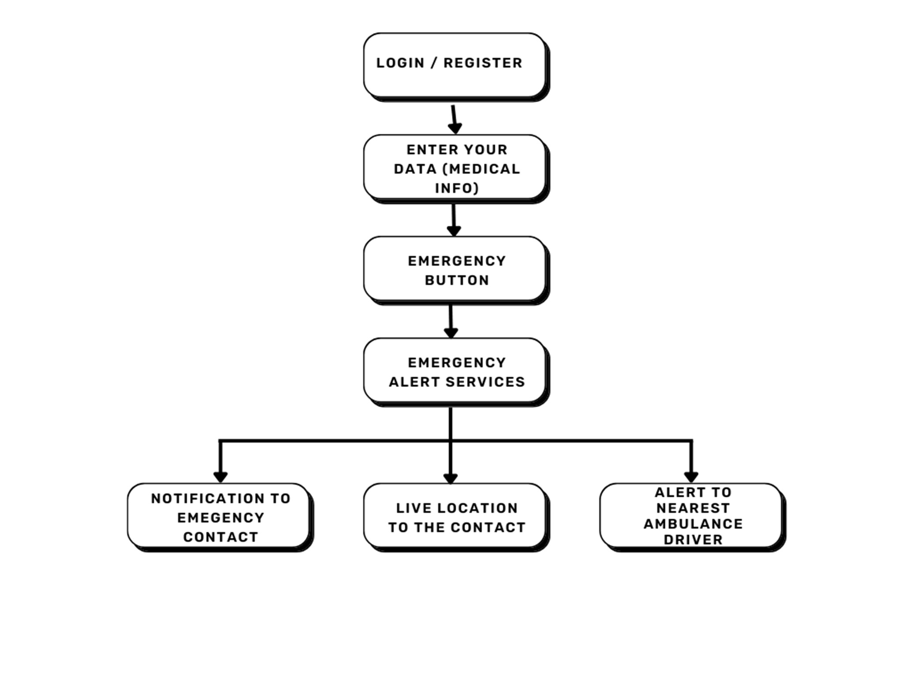

#### Block diagram of proposed system

* 1. **Description of block diagram**

1. Login/Register:
   1. Users must sign in or create an account to access the system.
   2. This helps in securely storing personal and medical data for future use.
2. Medical History:
   1. The system maintains a record of the user’s medical history, including past illnesses, medications, allergies, and emergency conditions.
   2. Doctors and emergency responders can quickly access this information during critical situations.
3. Emergency Button:
   1. A dedicated emergency button is available for users to trigger an alert in case of a medical emergency (e.g., heart attack, sudden fall, breathing issues).
4. Emergency Alert Services:
   1. Once the emergency button is activated, the system initiates an alert to predefined healthcare providers, caregivers, or emergency response teams.
5. Notification Alert:
   1. The system sends real-time notifications to relevant parties, ensuring quick response to the emergency situation.
6. Live Location to Emergency Contacts:
   1. The system shares the patient’s live location with emergency responders for rapid assistance.
   2. Simultaneously, emergency contacts (family members, caregivers, or doctors) are notified to take immediate action.
7. Alert to nearest AMBULANCE driver:

This emergency alert system instantly notifies nearby ambulance drivers in critical situations. It shares real-time location and essential patient details to speed up response time. Designed to save lives, it bridges the gap between emergencies and medical help.

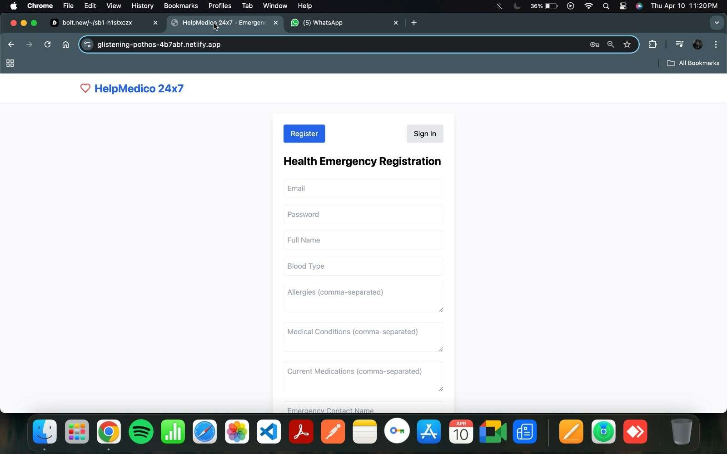

#### Implementation

*Fig. 5.3.1: Registration page*

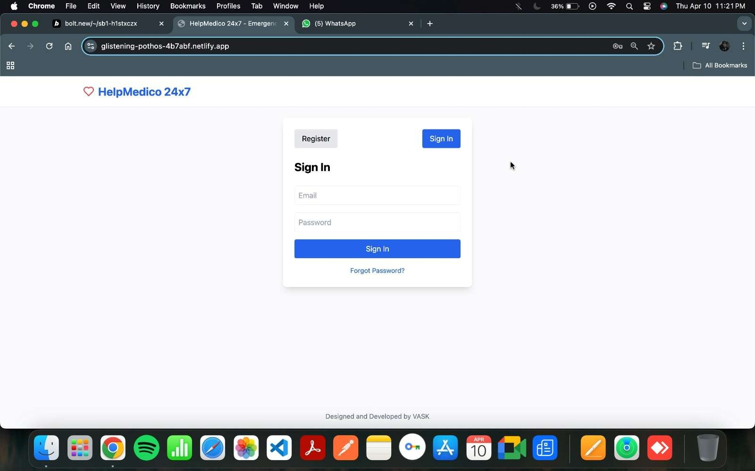

*Fig.5.3.2: Signed in page*

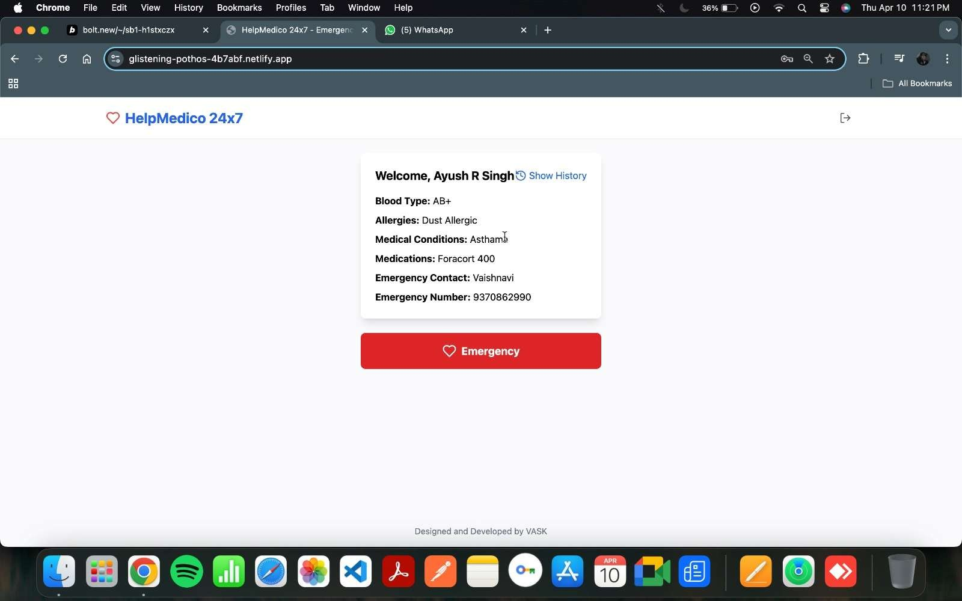

*Fig.5.3.3: Dashboard Screen*

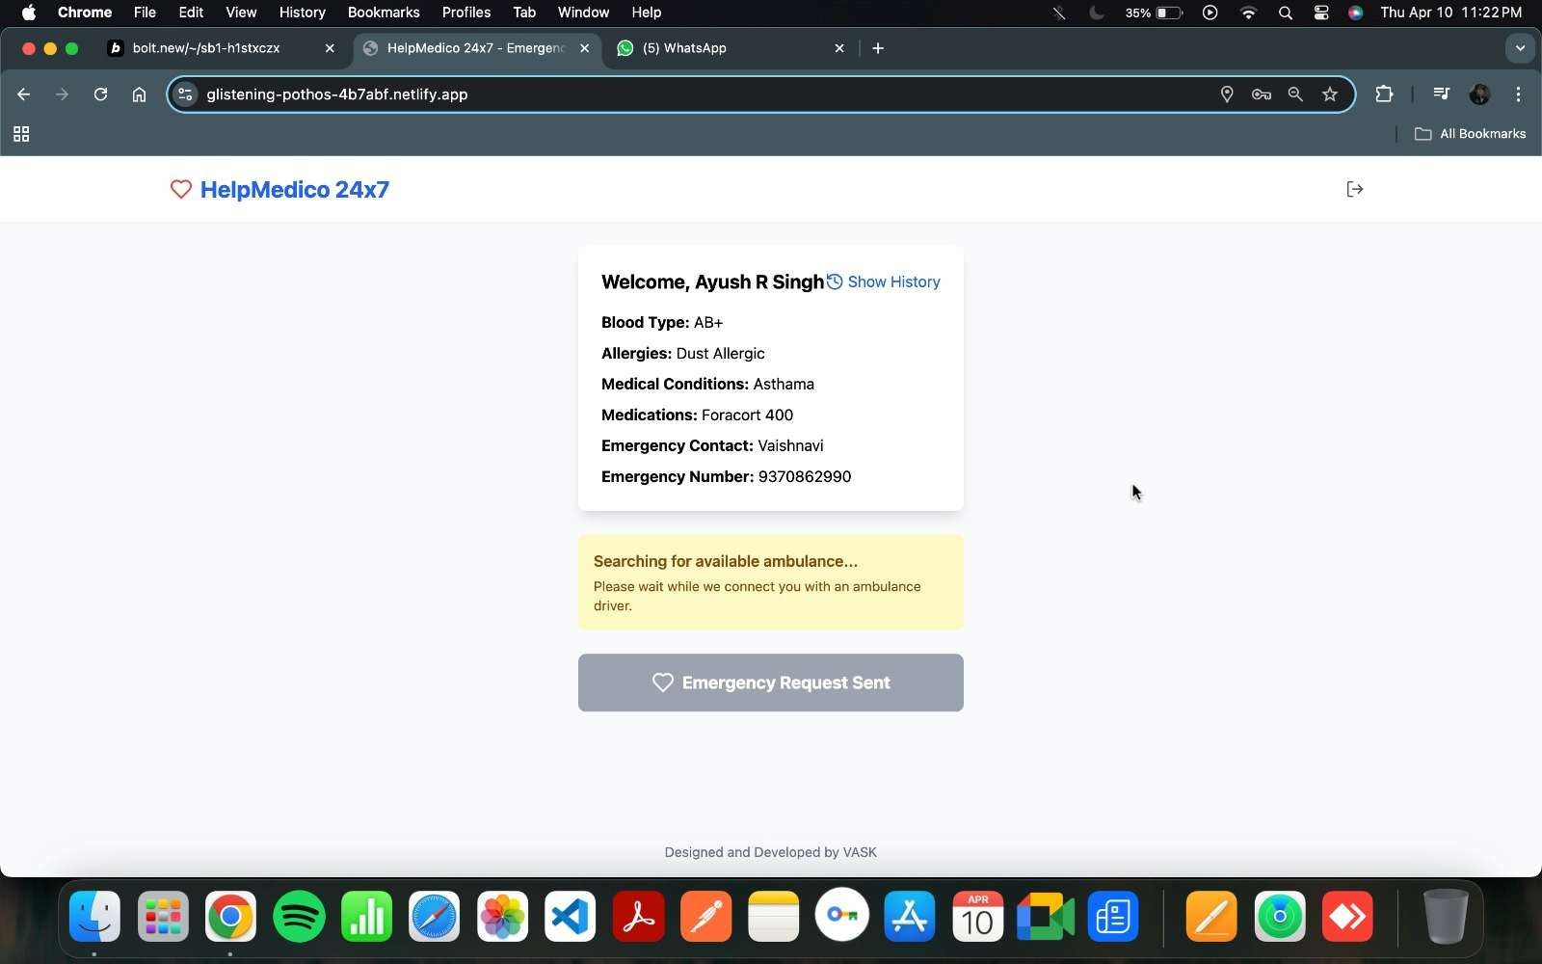

*Fig.5.3.4: Ambulance Notification Sent Message*

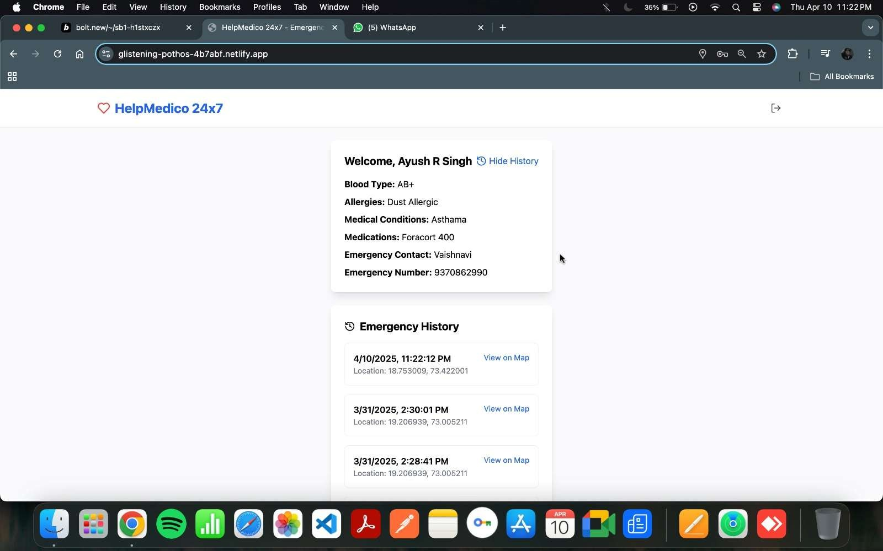

*Fig.5.3.5.Emergency Records*

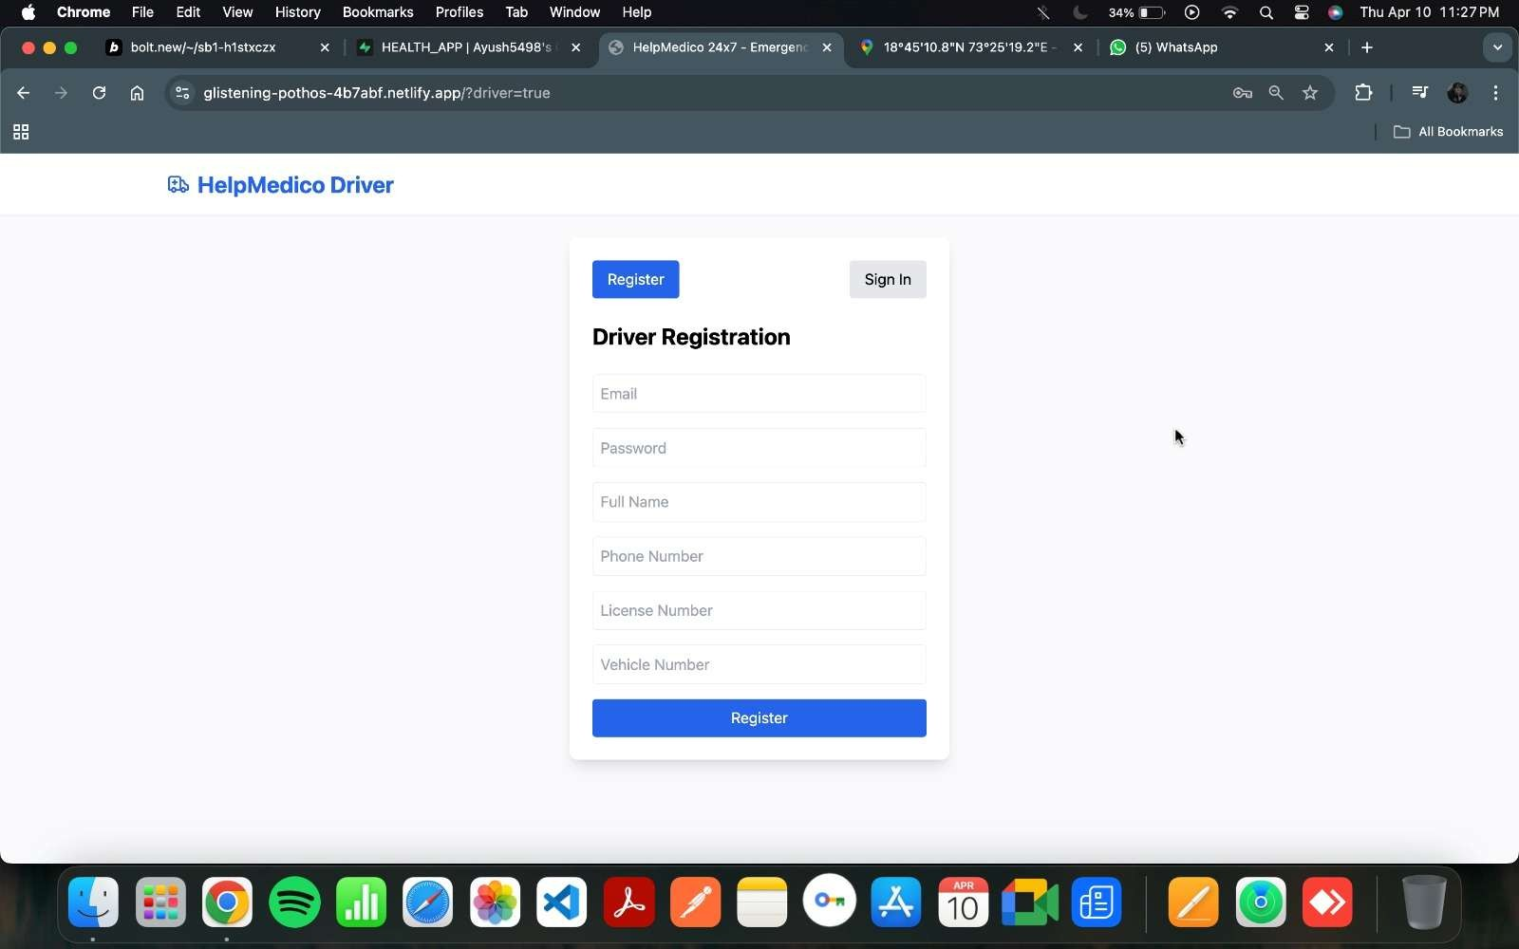

*Fig.5.3.6. Driver Registration Screen*

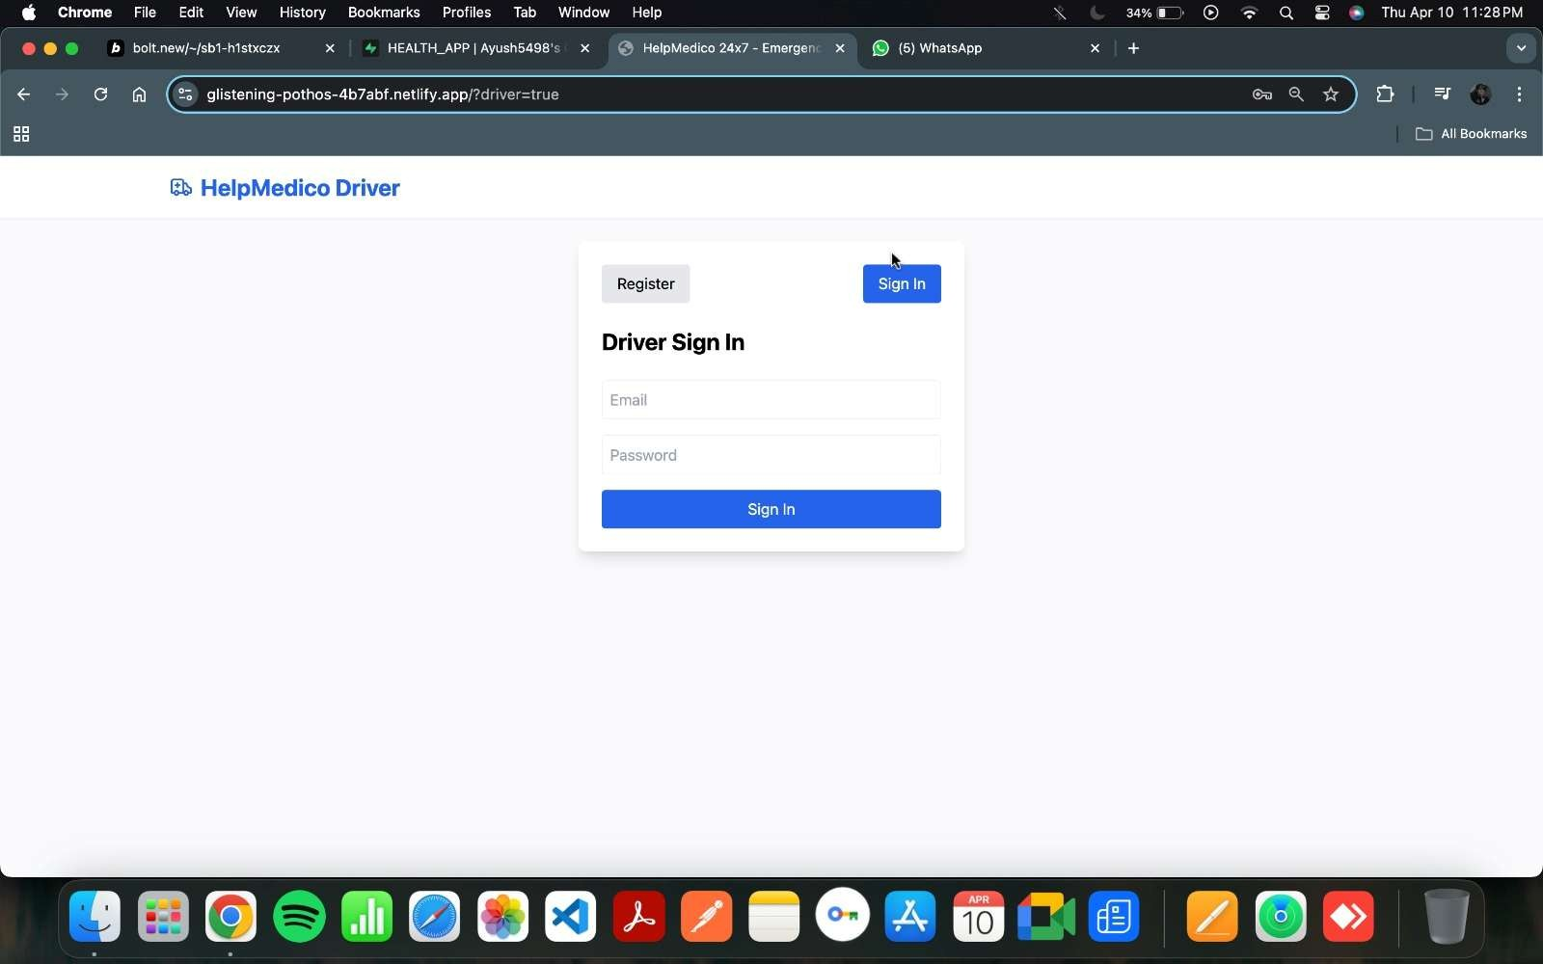

*Fig.5.3.7. Driver Sign In Screen*

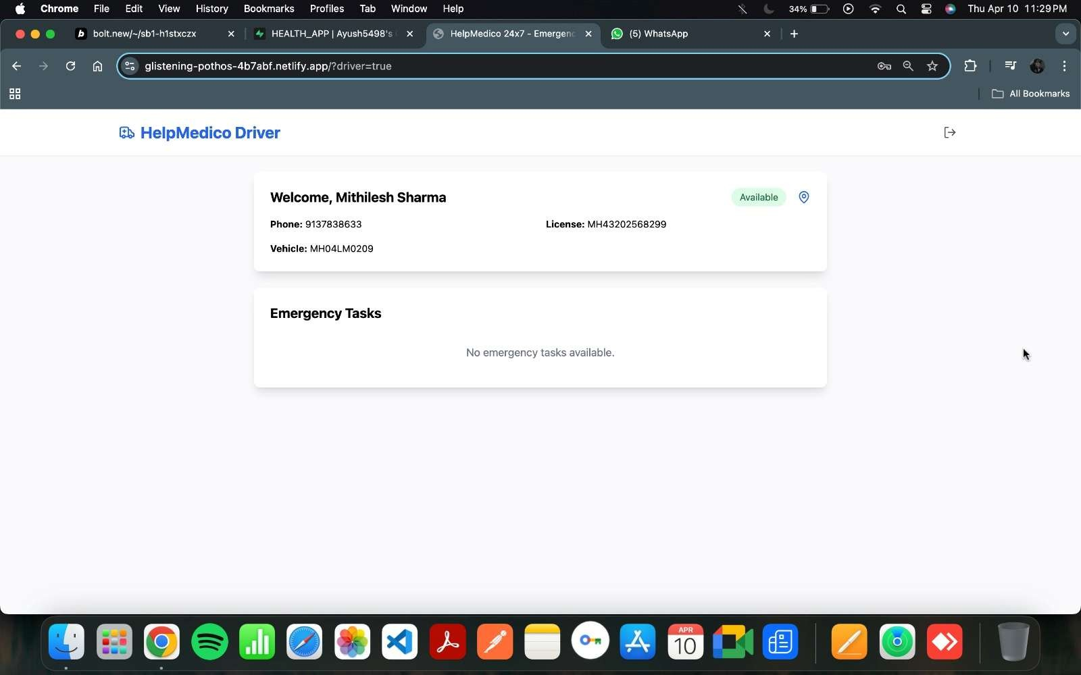

*Fig.5.3.7. Driver Dashboard*

#### Advantages

* + 1. Easy Accessibility – Seniors can access healthcare services from any device with an internet connection, reducing the need for physical visits.
    2. Real-Time Health Monitoring – Wearable devices and sensors track vital signs, enabling early detection of health issues.
    3. Medication & Appointment Reminders – Automated alerts help seniors take medications on time and keep up with doctor visits.
    4. Emergency Assistance – Integrated alert systems provide quick emergency responses and GPS tracking.
    5. Personalized Healthcare Plans – AI-driven recommendations for diet, exercise, and chronic disease management.
    6. User-Friendly Interface – Large fonts, voice assistance, and multilingual support for easy navigation.
    7. Social Connectivity – Virtual communities and mental health support to reduce isolation.
    8. Cost Savings – Reduces hospital visits and emergency treatments, lowering healthcare expenses.
    9. Secure Health Records – Digital medical records ensure easy access and secure data storage.
    10. Smart Home Integration – Works with automated pill dispensers, motion sensors, and voice assistants for enhanced elderly.

# CHAPTER 6 CONCLUSION

**CONCLUSION**

Web and mobile healthcare applications play a crucial role in enhancing healthcare accessibility and management for elderly individuals. These technologies provide solutions for chronic disease management, telemedicine, real-time health monitoring, and emergency response, improving the overall well- being of seniors. However, challenges such as digital literacy, usability, privacy concerns, and accessibility must be addressed to maximize their effectiveness. By developing user-friendly, secure, and affordable applications, we can empower the elderly to manage their health independently and improve their quality of life. Future advancements in AI and remote healthcare will further enhance these solutions, making healthcare more efficient and accessible for aging populations.

### REFERENCES

**Research paper**

1. **Batsis, J. A., & Pitzer, S. D. (2021)**. "Telemedicine in Older Adults: A Systematic Review and Implications for the Future."

**Link**: Telemedicine in Older Adults

1. **Chan, A. K., Goss, C. W., & Edwards, C. L. (2020)**. "Mobile Health Applications for Chronic Disease Management: An Overview of Effectiveness and Usability for Older Adults."

**Link**: Mobile Health Applications for Chronic Disease Management

1. **Kumar, A., & Singh, A. (2022)**. "Artificial Intelligence in Healthcare: A Review of Applications and Challenges for Elderly Care."

**Link**: AI in Healthcare for Elderly Care

1. **Wildenbos, G. A., Peute, L. W., & Jaspers, M. W. (2019)**. "Usability of Mobile Health Applications for Older Adults: A Systematic Review."

**Link**: Usability of Mobile Health Applications

1. **Lupton, D. (2020)**. "Digital Health and the Elderly: The Role of Mobile Health Technologies in Improving Well-being."

**Link**: Digital Health and the Elderly

1. **Lee, S. Y., & Kim, H. (2018)**. "Emergency Medical Alert Systems for the Elderly: A Review of Current Trends and Future Directions."

**Link**: Emergency Medical Alert Systems for the Elderly

1. **Giger, J. N., & Plichta, S. B. (2021)**. "Mobile Health Apps for Older Adults: A Systematic Review of the Literature."

**Link**: Mobile Health Apps for Older Adults

1. **Häkkinen, M. (2021)**. "Mobile Health Applications for Elderly People: Opportunities and Challenges."

**Link**: Mobile Health Applications for Elderly People

1. **Wang, X., Zhang, X., & Wang, Z. (2020)**. "A Review of Mobile Health Applications in Elderly Care: Key Features, Challenges, and Future Directions."

**Link**: Mobile Health Applications in Elderly Care

**ACKNOWLEDGEMENT**