
MULTIPLE LINEAR REGRESSION
Project Report - Ames Housing Dataset
Ayush Choudhary

Contents
Introduction 3
1. Project Overview 3
2. Research Questions 3
3. Dataset Description 3
4. Data Summary 4
5. Data Pre-Processing 4
6. Exploratory Data Analysis 4
6.1 Correlation Matrix 4
6.2 Scatter Plots 5
6.3 Key Predictors 6
6.4 Box Plots — Building Type 6
Regression Analysis 8
7. Final Regression Model 8
Reason to choose the model: 8
Interpretation of the model: 8
Assumptions of the model and model fit analysis: 9
Discussion and limitations. 9
Predictions and conclusions of the model. 9
Self-critique of model 9
Suggested improvements in the model 9
Appropriateness of the Regression model 10
Conclusion 10
Summary 10
Final points/ Highlights 10
Additional work: 11
Other models tried : 11
Base Multiple Linear Regression Model 11
7.1 F statistic- Global Significance Test 11
7.2 T statistics- Individual Coefficient Tests 11
7.3 Residual Analysis 12
8. Remedial Measures 14
9. Model Comparison 15
10. Model Validation 15
11. Model Coefficients and Business Impact 15
Appendix — 17
Data Set: 17
Data Dictionary 17
References 19

Introduction

1. Project Overview
This project applies Multiple Linear Regression (MLR) to predict residential property sale prices using the Ames Housing Dataset which represents a rich, multi-dimensional dataset from Ames, Iowa, USA. The dataset captures a wide array of property characteristics including structural attributes, quality ratings, amenity measures, and locational variables.
The predictor variables broadly cover four (4) domains:
- Property Area: lot size, living area, basement, and garage square footage
- Construction Quality : overall quality rating, exterior and kitchen finish
- Amenities : number of bathrooms, bedrooms, fireplaces, and garage capacity
- Location / Building Type : neighborhood classification and dwelling type
The analytical workflow encompasses exploratory data analysis (EDA), feature selection, model building, statistical hypothesis testing, assumption diagnostics, remedial measures, and final model validation. Remedial techniques applied include:
- Scaling and correlation transformation
- Log transformation of the response variable
- Outlier detection and removal via Cook's Distance
- Interaction term detection and modelling
- Robust regression to reduce sensitivity to remaining outliers

2. Research Questions
This analysis is structured around two (2) primary research questions:
RQ 1 | Which property variables significantly affect the sale price of a residential property in Ames, Iowa?
RQ 2 | How effectively can the identified feature set explain and predict property sale price using a Multiple Linear Regression model?
The hypotheses tested are:
Hypothesis | Statement
H₀ (Null) | All β coefficients equal zero; the model has no predictive power.
Hₐ (Alternative) | At least one β coefficient ≠ 0; at least one predictor significantly explains Sale Price.

3. Dataset Description
The Ames Housing Dataset is sourced from Kaggle (https://www.kaggle.com/datasets/marcopale/housing) and represents residential property transactions in Ames, Iowa. After preprocessing, the dataset is structured as follows:
Category | Detail | Description
Dataset | Ames Housing Market | Ames, Iowa, USA
Observations | ~2,930 | Complete property records after cleaning
Raw Variables | 79 original → 22 selected → 17 final | Domain knowledge applied for feature selection
Dependent Variable (Y) | Sale Price (USD) | Range: $34,900 – $755,000 (unscaled)
Numerical Predictors | 13 continuous variables | Area, quality, and condition metrics
Categorical Predictor | Building Type (dummy coded) | Ref: 1Fam (n=2,425); TwnhsE (233), Duplex (109), Twnhs (101), 2fmCon (62)

Further detail on all 79 original variables — including measurement type and full value codes — is provided in the Appendix (Data Dictionary).

4. Data Summary
The following summary statistics panel was generated in R to characterise the cleaned dataset used for modelling:
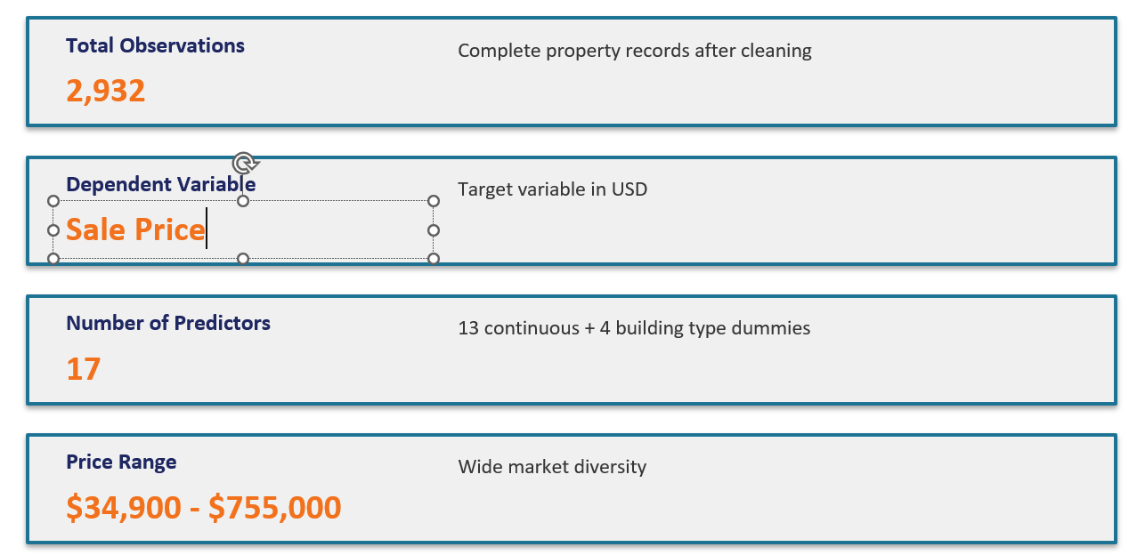
Figure 1 — Summary statistics panel for the Ames Housing Dataset (post-preprocessing)

5. Data Pre-Processing
The original dataset contained 79 variables. The majority of categorical variables exhibited near-zero variance across the dataset and were discarded using domain knowledge. A focused subset of 22 variables was identified as candidate predictors of Sale Price, ultimately reduced to 18 variables for the final model. One missing value was detected and imputed using the variable median.

6. Exploratory Data Analysis
An initial summary of the selected variables was produced in R, with dummy variables created for the categorical Building Type predictor. The following visualisations characterise data distributions, correlations, and key predictor relationships.

6.1 Correlation Matrix
The Pearson correlation matrix below reveals the strength of linear associations between Sale Price and each numerical predictor. Key findings:
- Overall Quality (r = 0.80) — strongest predictor of Sale Price
- Above-Grade Living Area, Gr Liv Area (r = 0.71) — second strongest predictor
- Garage Area (r = 0.64) and First Floor SF (r = 0.62) — moderately strong
- Overall Condition showed a weak negative correlation with Sale Price (r = −0.10)

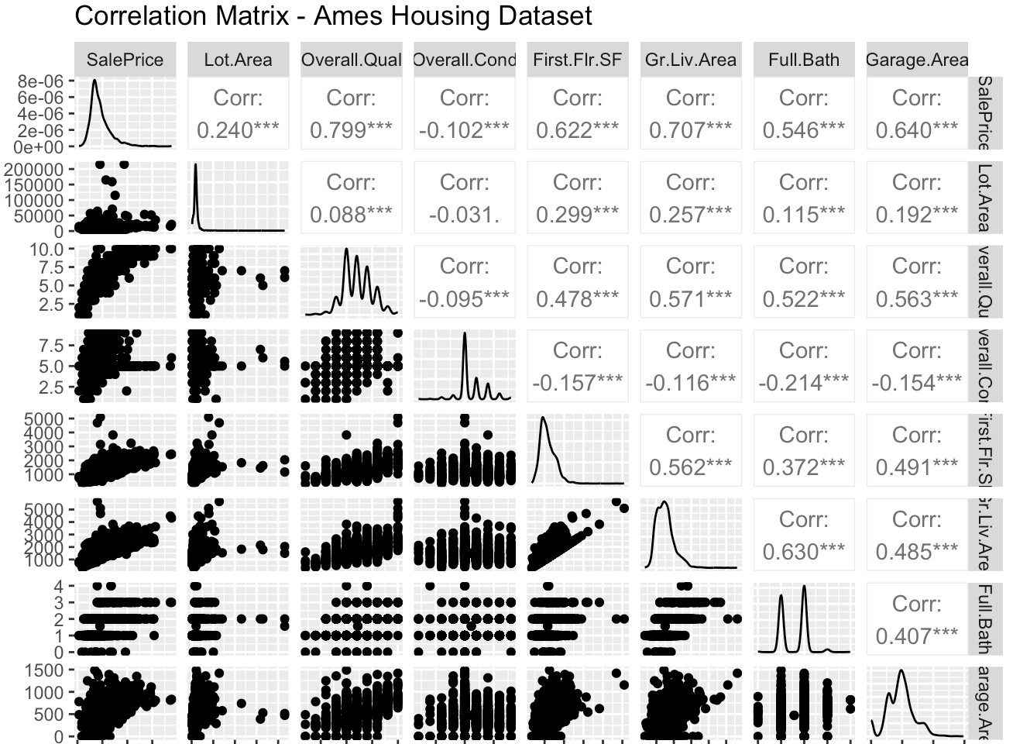
Figure 2 — Correlation matrix: Ames Housing Dataset predictors vs. Sale Price

6.2 Scatter Plots
Scatter plots of Sale Price against each selected predictor were examined to assess linearity. Variables with higher correlations (Overall Quality, Gr Liv Area) display clear positive linear trends. Discrete predictors such as Bedrooms and Total Rooms show stepped scatter patterns consistent with their discrete nature.

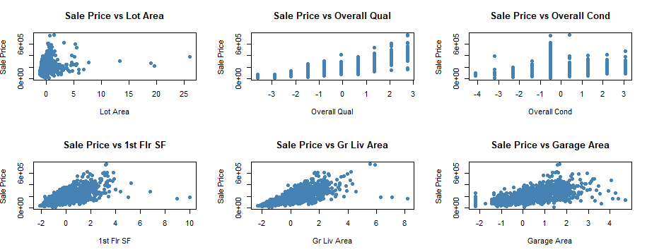
Figure 3 — Scatter plots: Sale Price vs. key continuous predictors (panel A)
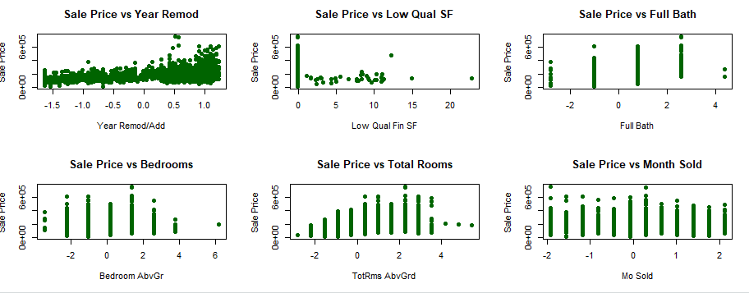
Figure 4 — Scatter plots: Sale Price vs. key continuous predictors (panel B)
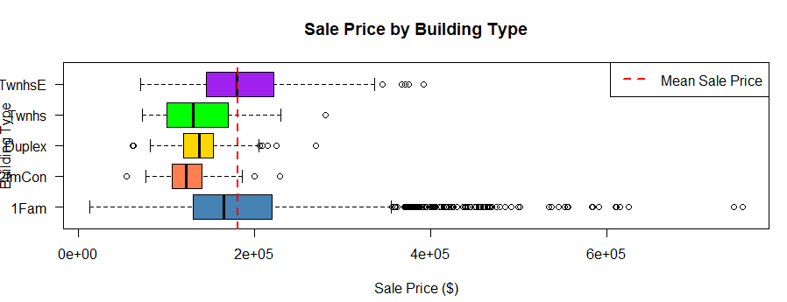
Figure 5 — Scatter plots: Sale Price vs. discrete predictors

6.3 Key Predictors
Based on the correlation analysis and scatter plot examination, the following variables were identified as primary drivers of Sale Price:
- Overall Qual — quality of materials and finishes
- Gr Liv Area — above-grade living area (sq ft)
- Garage Area — garage size (sq ft)
- First Floor SF — main floor area
- Year Built / Year Remod — age and renovation recency

6.4 Box Plots — Building Type
Box plots stratified by Building Type clearly revealed the presence of outliers, particularly in the 1Fam (Single Family) category which dominates the dataset. Outliers with disproportionate influence were subsequently identified using Cook's Distance and treated accordingly.

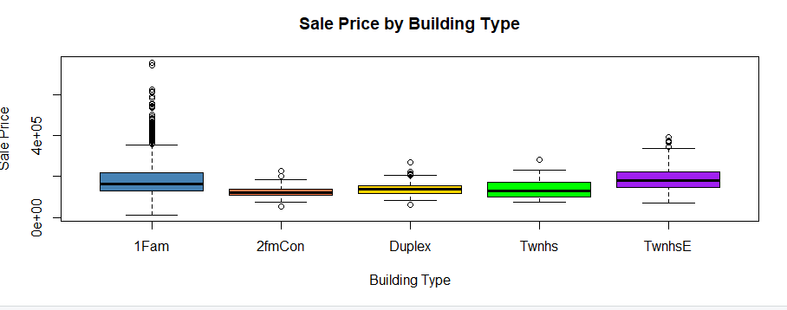
Figure 6 — Box plots: Sale Price distribution by Building Type

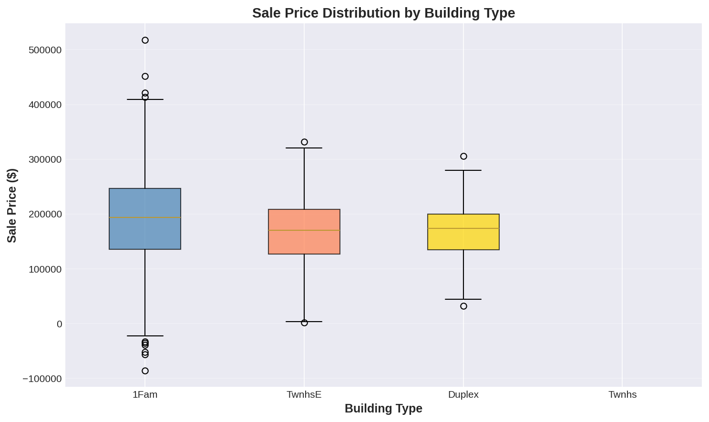
Figure 7 — Box plots: Sale Price distribution by Building Type (alternative view)

Regression Analysis

7. Final Regression Model
The MLR model chosen was Generalized Least Square

Sale Price: Y ~ X1 + X2 + X4+ X5 + X7 + X9 + X11 + X14 + X15 + X16 + X17 + X1:X7 + X1:X9 + X2:X5 + X2:X7 + X2:X9 + X4:X7 + X4:X9
List of names of variables is given below

Reason to choose the model:
The initial MLR model showed good level of explanatory power, with an R² value of around 0.79 with 17 variables. But it suffered from heteroskedasticity. Multiple models were tried with remedial measures.
A weighted Least Square remedial measure along with outlier treatment was done to arrive at the best model based on the Akaike Information criteria (AIC) and the Bayesian Information(BIC) criteria that compared all models.
Model name df AIC | Description
baselm 44 69434.571 | All variables
model_lm 18 69840.574 | variables+ Categorical Dummy
model_lm_mod1 13 69834.665 | Dropped variables on tStat
model_lm_mod2 12 69834.111 | Mod1+Scaled model
model_lm_mod3_interact 20 67761.326 | Mod2+ interaction
model_lm_robust 18 67290.056 | Mod2+ Robust Regression
model_gls 20 66975.758 | Weighted least square

Interpretation of the model:
Chosen GLS model coefficients are,
 | Value | Variable name
(Intercept) | 17903.46
X1 | 14069.77 | X1 <- `Lot Area`
X2 | 28411.17 | X2 <- `Overall Qual`
X4 | 20807.1 | X4 <- `Year Remod/Add`
X5 | -4566.78 | X5 <- `1st Flr SF`
X7 | -13198.5 | X7 <- `Gr Liv Area`
X9 | 15411.5 | X9 <- `Bedroom AbvGr`
X11 | 6838.725 | X11 <- `Garage Area`
X14 | -2670.05 | X14 <- Bldg Type` == "TwnhsE"
X15 | -11739.6 | X15 <- Bldg Type` == "Duplex"
X16 | -3789.99 | X16 <-`Bldg Type` == "Twnhs"
X17 | -10707.4 | X17 <- `Bldg Type` == "2fmCon"
X1:X7 | 157.579 | Interaction Variables
X1:X9 | -2139.37 | Interaction Variables
X2:X5 | 2656.93 | Interaction Variables
X2:X7 | 6127.616 | Interaction Variables
X2:X9 | -3589.24 | Interaction Variables
X4:X7 | 6972.367 | Interaction Variables
X4:X9 | -2988.55 | Interaction Variables

Interesting findings in the model:
Initially, it was assumed that lot area would be the most influential factor in determining price. However, the results showed that internal quality-related and usable space variables such as living area, overall quality, and garage area had a much stronger impact on the target variable than lot size. Year of remodeling had a negative impact, showing that older properties did not gain higher even after remodeling

Assumptions of the model and model fit analysis:
The model assumptions, including linearity, independence, and normality of residuals, were evaluated and found to be reasonably satisfied after necessary transformations and adjustments. Although heteroscedasticity was initially present, it was addressed using Weighted Least Squares, improving the reliability of the model. Overall, the model provides a good fit and is suitable for inference and prediction.
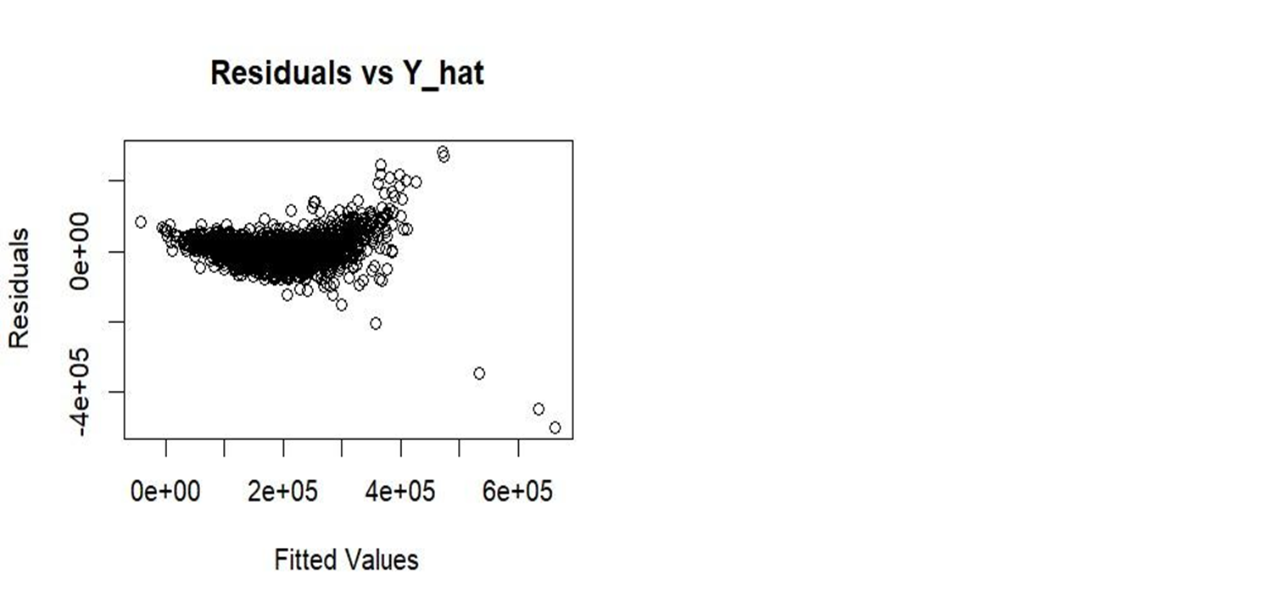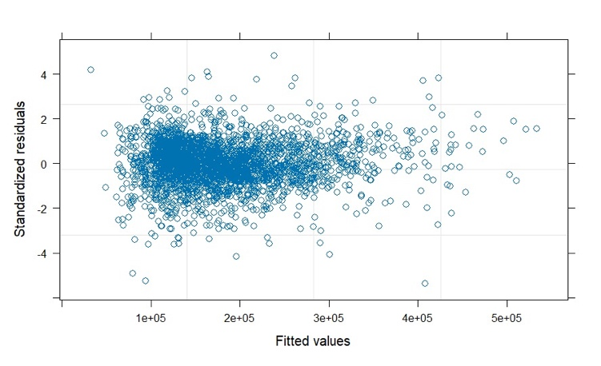
Fig 8: Residuals before remedial measure Vs Residuals After remedial measures in GLS Model

Discussion and limitations.

Predictions and conclusions of the model.
The GLS model demonstrates strong generalization performance on the test dataset, as seen in below Fig 9 on test data fit, indicating that it effectively captures the underlying patterns in the data. The consistency between training and test results suggests minimal overfitting. Overall, the model can be considered a reliable and well-fitted representation for predictive purposes. These results support its suitability for drawing meaningful insights and making informed decisions.

Self-critique of model
Although the linear models demonstrate satisfactory performance, the presence of heteroscedasticity posed a significant limitation, as the assumption of constant variance was violated across all initial models. This issue potentially undermines the reliability of standard errors and inference. The application of Weighted Least Squares (WLS) helped address this concern by stabilizing the variance of residuals. However, the need for such correction indicates that the model may still be sensitive to underlying data irregularities.

Suggested improvements in the model
While the model shows strong overall performance, there is still room for improvement through more detailed feature engineering and breaking the data into meaningful groups. Since the dataset varies quite a bit and reflects real-world housing patterns, analyzing smaller sections separately could help uncover more specific relationships between variables and improve prediction accuracy. For example, apart from splitting based on price ranges (such as separating luxury homes from standard houses to better capture different market behavior), another useful approach would be to group the data based on location or neighborhood clusters. Different areas often follow different pricing patterns, like proximity to the city center, schools, or key amenities, which a single overall model may not fully capture. Building separate models for these segments could lead to more accurate and context-aware predictions.

Appropriateness of the Regression model
The regression model is appropriate for this problem as it effectively captures the relationship between the dependent variable and multiple independent variables. The results indicate that the model performs well in terms of prediction accuracy and generalization on unseen data. Diagnostic checks suggest that the key assumptions are largely addressed after applying necessary corrections such as Weighted Least Squares. Overall, the model provides a reasonable and interpretable framework for understanding the influence of different factors on the target variable.
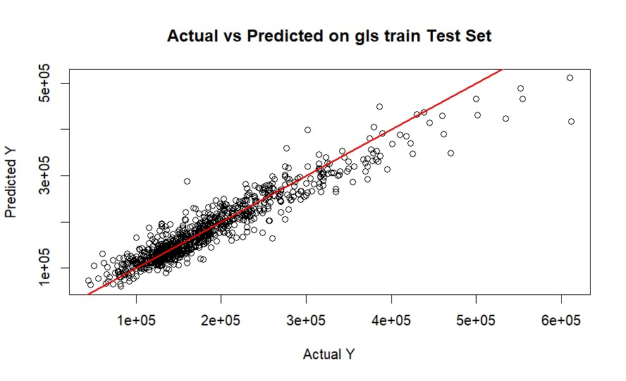
Fig 9: testing the GLS Model on test data

Conclusion

Summary
The regression model developed in this analysis performs well in explaining and predicting the target variable. It captures key relationships between the predictors and the outcome and shows strong performance on both training and test data. After addressing issues such as heteroscedasticity using Weighted Least Squares, the model results became more stable and reliable for inference and prediction.

Final points/ Highlights
Overall, the model is a good fit for the data and provides meaningful insights into the factors influencing the target variable. While there is still scope for improvement through more detailed feature engineering and data segmentation, the current approach is robust and interpretable. The findings support the model’s practical use for prediction and decision-making in a real-world context.

Additional work:

Other models tried :
Base Model, Outlier treated model, Interaction model, Log transformed Y variable model

Base Multiple Linear Regression Model
A baseline MLR model was fitted using all 17 selected predictors (13 continuous + 4 Building Type dummies). The hypotheses tested are:
Hypothesis | Statement
H₀ (Null) | All β coefficients equal zero; the model has no predictive power.
Hₐ (Alternative) | At least one β coefficient ≠ 0; at least one predictor significantly explains Sale Price.

7.1 F statistic- Global Significance Test
The F-statistics were used to evaluate the overall significance of the model at α = 0.05:

Test Metric | Value | Interpretation
Significance Level (α) | 0.05 | Standard threshold for hypothesis testing
Critical F-value (F₀.₀₅) | 2.87 | Minimum value required to reject H₀
Observed F* Statistic | ~700 | Far exceeds critical value — strong evidence for the model
Conclusion | Reject H₀ | At least one predictor significantly explains Sale Price (p < 0.001)

The base model F* statistic (~700) far exceeds the critical value of 2.87, providing overwhelming evidence that the model is statistically significant and that at least one predictor has a non-zero effect on Sale Price (p < 0.001).

7.2 T statistics- Individual Coefficient Tests
Individual t-tests (α = 0.05) were conducted for each predictor coefficient to identify which variables contribute significantly to the model. Based on the results, at least four variables with non-significant t-statistics were dropped from subsequent models, improving parsimony without materially reducing explanatory power.
 | Estimate | Std. Error | tvalue | Pr(>|t|)
(Intercept) | 7.83E+05 | 1.04E+06 | 0.757 | 0.44919
X1 | 5.55E-01 | 9.49E-02 | 5.85 | 5.46E-09 | ***
X2 | 2.32E+04 | 7.53E+02 | 30.848 | < 2e-16 | ***
X3 | 3.43E+02 | 6.42E+02 | 0.533 | 0.59374
X4 | 4.17E+02 | 4.21E+01 | 9.887 | < 2e-16 | ***
X5 | 2.95E+01 | 2.35E+00 | 12.546 | < 2e-16 | ***
X7 | 4.77E+01 | 2.92E+00 | 16.318 | < 2e-16 | ***
X8 | 1.70E+03 | 1.79E+03 | 0.951 | 0.34177
X9 | -8.28E+03 | 1.21E+03 | -6.817 | 1.13E-11 | ***
X10 | 5.59E+02 | 8.64E+02 | 0.648 | 0.51735
X11 | 4.84E+01 | 4.09E+00 | 11.843 | < 2e-16 | ***
X12 | -4.53E+01 | 2.50E+02 | -0.181 | 0.85631
X13 | -8.40E+02 | 5.16E+02 | -1.629 | 0.10332
X14 | -1.22E+04 | 2.83E+03 | -4.324 | 1.59E-05 | ***
X15 | -1.91E+04 | 3.90E+03 | -4.903 | 9.95E-07 | ***
X16 | -1.77E+04 | 3.88E+03 | -4.56 | 5.33E-06 | ***
X17 | -1.43E+04 | 4.76E+03 | -3.003 | 0.00269 | **

7.3 Residual Analysis
Residual diagnostics were performed to verify the four classical MLR assumptions:

7.3.1 Diagnostic Plots
The Normal Probability Plot (Q-Q plot) of residuals revealed heavy tails at both extremes, indicating a departure from normality attributable to high-leverage outliers. The Residuals vs. Fitted Values plot displayed a characteristic fan-shaped pattern, providing strong visual evidence of heteroscedasticity.

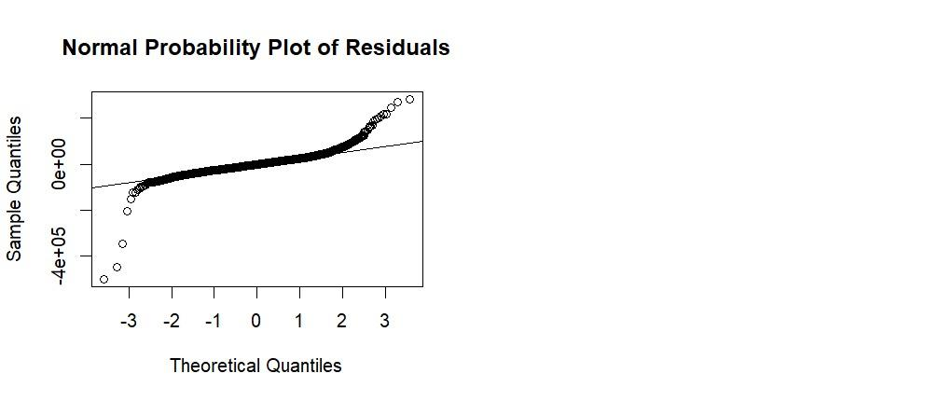
Figure 10 — Normal Q-Q plot of residuals: heavy tails indicate non-normality and outlier influence
Figure 11 — Residuals vs. Fitted Values and Partial Regression Plots

7.3.2 Assumption Tests Summary

Assumption | Test Used | Result | Outcome
Normality | Shapiro-Wilk | p < 0.05 | Violated — heavy tails, outlier-driven
Independence | Durbin-Watson | p < 0.05 | Possible autocorrelation detected
Homoscedasticity | Breusch-Pagan | p < 0.05 | Violated — fan-shaped residual pattern
Multicollinearity | VIF | All VIF < 5 | No multicollinearity — no treatment required

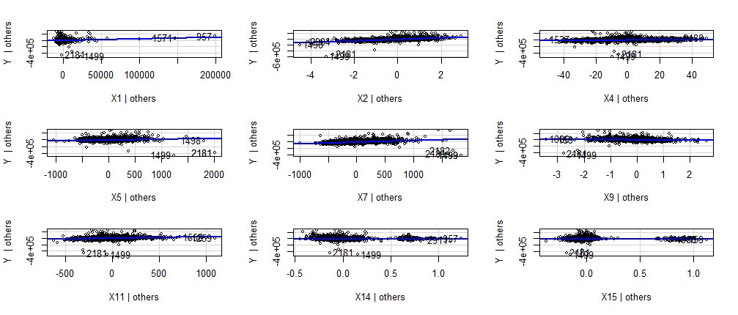
Figure 12 — Additional partial regression plots for individual predictors

7.3.3 Multicollinearity — VIF Results
Variance Inflation Factors (VIF) were computed for all predictors. All values fell comfortably below the threshold of 10, indicating no problematic multicollinearity:

Variable | VIF | Variable | VIF | Variable | VIF
X1 | 1.251 | X2 | 2.525 | X3 | 1.141
X4 | 1.730 | X5 | 1.898 | X7 | 4.886
X8 | 2.191 | X9 | 2.261 | X10 | 4.131
X11 | 1.729 | X12 | 1.034 | X13 | 1.031
X14 | 1.308 | X15 | 1.218 | X16 | 1.121
X17 | 1.051 | — | — | — | —

The maximum observed VIF was 4.89 (X7), well within acceptable bounds. No collinearity treatment was required.

Figure 11 — VIF summary output (R)
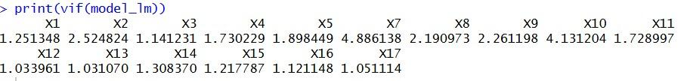

7.3.4 Breusch Pagan tests

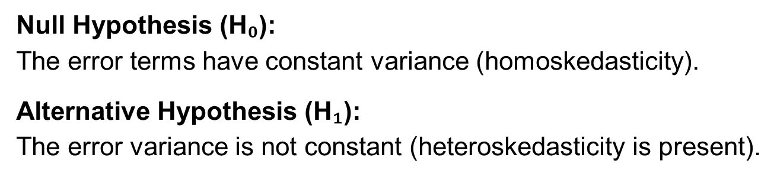
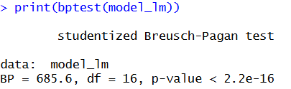
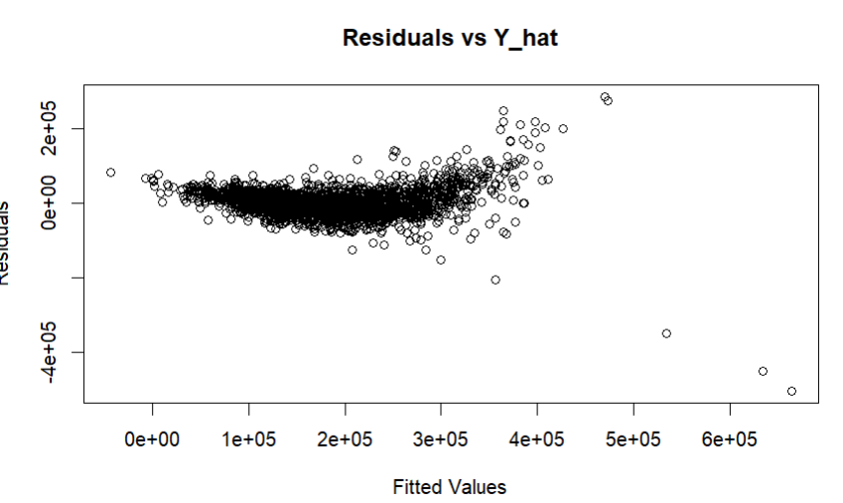
Figure 12 — Breusch-Pagan and Durbin-Watson test output summary (R)
All alternate models failed the Breusch pagan test

8. Remedial Measures
Given the assumption violations identified in Section 7.3, a series of remedial measures were applied to improve model fit and diagnostic behaviour:
Measure | Technique | Purpose
Scaling | Correlation transformation / standardisation | Normalise predictor scales for coefficient comparison
Outlier Treatment | Cook's Distance threshold | Identify and remove high-influence observations
Log Transformation | log(Y) — log of Sale Price | Correct right-skew and stabilise variance
Robust Regression | M-estimation / iterative weighted LS | Reduce sensitivity to remaining outliers
Interaction Terms | Variable interaction detection | Capture non-additive predictor effects on price

9. Model Comparison
Multiple model variants were generated and compared on the basis of explanatory power (R²), parsimony (fewest predictors for given R²), and information criteria. The Akaike Information Criterion (AIC) and Bayesian Information Criterion (BIC) were used for stepwise model selection.

Model | R² | Adj. R² | AIC | Selection
Base MLR (17 predictors) | 0.798 | 0.79 | 69434 | Baseline
Log-transformed MLR | 0.85 | 0.85 | Lower | Stepwise AIC/BIC
Interaction MLR | 0.89 | 0.88 | 67761 | Improved fit
Final Model (14 predictors) | Highest | Highest | 66975 | ✓ Selected

Note: Specific R² and AIC values are to be populated from final R model output. The Final Model (14 predictors after dropping 4 non-significant variables) achieved the best balance of fit and parsimony and was selected for interpretation.

10. Model Validation
All model variants were validated using a 70/30 train-test split to assess out-of-sample predictive performance and guard against overfitting:

Model | Split | Train Set | Test Set
Base MLR | 70 / 30 | Trained on 70% | Validated on 30%
Log-transformed MLR | 70 / 30 | Trained on 70% | Validated on 30%
Final Model | 70 / 30 | Best train R² | Best test R²

Models were first trained on 70% of the dataset and validated on the held-out 30% test set. The Final Model demonstrated the strongest generalisation performance, with test set R² closely tracking train set R², indicating robust predictive validity.

11. Model Coefficients and Business Impact
The final MLR equation takes the form:
Sale Price = β₀ + β₁X₁ + β₂X₂ + … + β₁₄X₁₄ + ε
Individual coefficient values and their business interpretation are to be inserted from the final R model output. Key business implications expected include:
- Each additional unit of Overall Quality score is expected to add a material premium to Sale Price.
- Each additional square foot of above-grade living area (Gr Liv Area) adds a measurable per-foot price increment.
- Garage area and year built/remodelled also contribute positively to predicted price.
- Building Type dummies (TwnhsE, Duplex, Twnhs, 2fmCon) are expected to show price discounts relative to the Single-Family reference category.

Appendix —

Data Dictionary
The following table provides a complete description of all 79 original variables in the Ames Housing Dataset, including their measurement scale and coded values.

Variable | Type | Description
Order | Discrete | Observation number
PID | Nominal | Parcel identification number
MS SubClass | Nominal | Type of dwelling (20=1-Story ≥1946, 60=2-Story ≥1946, 90=Duplex, etc.)
MS Zoning | Nominal | Zoning class (RL=Residential Low, RM=Med, FV=Floating Village, etc.)
Lot Frontage | Continuous | Linear feet of street connected to property
Lot Area | Continuous | Lot size in square feet
Street | Nominal | Road access type (Grvl=Gravel, Pave=Paved)
Alley | Nominal | Alley access type (Grvl, Pave, NA=None)
Lot Shape | Ordinal | General shape (Reg, IR1, IR2, IR3)
Land Contour | Nominal | Flatness (Lvl, Bnk, HLS, Low)
Utilities | Ordinal | Utilities available (AllPub, NoSewr, etc.)
Lot Config | Nominal | Lot configuration (Inside, Corner, CulDSac, FR2, FR3)
Land Slope | Ordinal | Slope (Gtl=Gentle, Mod=Moderate, Sev=Severe)
Neighborhood | Nominal | Physical location within Ames city limits (28 neighborhoods)
Condition 1/2 | Nominal | Proximity to conditions (Norm, Artery, Feedr, Railroad, etc.)
Bldg Type | Nominal | Type of dwelling (1Fam, 2fmCon, Duplx, TwnhsE, TwnhsI)
House Style | Nominal | Style (1Story, 2Story, 1.5Fin, SFoyer, SLvl, etc.)
Overall Qual | Ordinal | Overall material and finish quality (1=Very Poor to 10=Very Excellent)
Overall Cond | Ordinal | Overall condition rating (1=Very Poor to 10=Very Excellent)
Year Built | Discrete | Original construction date
Year Remod/Add | Discrete | Remodel date (same as built if no remodel)
Roof Style/Matl | Nominal | Roof style and material (Gable, Hip, CompShg, WdShngl, etc.)
Exterior 1/2 | Nominal | Exterior covering material (VinylSd, HdBoard, BrkFace, etc.)
Mas Vnr Type/Area | Nominal/Cont. | Masonry veneer type and area in sq ft
Exter Qual/Cond | Ordinal | Exterior quality and condition (Ex, Gd, TA, Fa, Po)
Foundation | Nominal | Foundation type (PConc, CBlock, BrkTil, Slab, Stone, Wood)
Bsmt Qual/Cond | Ordinal | Basement height quality and general condition
Bsmt Exposure | Ordinal | Walkout/garden level walls (Gd, Av, Mn, No, NA)
BsmtFin Type 1/2 | Ordinal | Rating of finished basement area (GLQ, ALQ, BLQ, Rec, LwQ, Unf)
BsmtFin SF 1/2 | Continuous | Type 1 and Type 2 finished basement square footage
Bsmt Unf SF | Continuous | Unfinished basement square feet
Total Bsmt SF | Continuous | Total basement square feet
Heating / HeatingQC | Nominal/Ord. | Heating type and quality (GasA, GasW, Floor, etc.)
Central Air | Nominal | Central air conditioning (Y/N)
Electrical | Ordinal | Electrical system type (SBrkr, FuseA, FuseF, etc.)
1st Flr SF / 2nd Flr SF | Continuous | First and second floor square footage
Low Qual Fin SF | Continuous | Low quality finished area (all floors)
Gr Liv Area | Continuous | Above-grade living area square footage
Bsmt Full/Half Bath | Discrete | Basement full and half bathrooms
Full Bath / Half Bath | Discrete | Above-grade full and half bathrooms
Bedroom AbvGr | Discrete | Bedrooms above grade (excludes basement)
Kitchen AbvGr / Qual | Discrete/Ord. | Kitchens above grade and kitchen quality
TotRmsAbvGrd | Discrete | Total rooms above grade (excludes bathrooms)
Functional | Ordinal | Home functionality (Typ, Min1, Min2, Mod, Maj1, Maj2, Sev, Sal)
Fireplaces / Quality | Discrete/Ord. | Number of fireplaces and fireplace quality
Garage Type/Finish | Nominal/Ord. | Garage location and interior finish
Garage Yr Blt | Discrete | Year garage was built
Garage Cars / Area | Discrete/Cont. | Garage capacity (cars) and size (sq ft)
Garage Qual/Cond | Ordinal | Garage quality and condition
Paved Drive | Ordinal | Paved driveway (Y=Paved, P=Partial, N=Dirt/Gravel)
Wood Deck / Porch SF | Continuous | Wood deck and various porch area sq footage
Pool Area / QC | Continuous/Ord. | Pool area in sq ft and pool quality rating
Fence | Ordinal | Fence quality (GdPrv, MnPrv, GdWo, MnWw, NA)
Misc Feature / Val | Nominal/Cont. | Miscellaneous features not covered elsewhere and their value
Mo Sold / Yr Sold | Discrete | Month and year property was sold
Sale Type | Nominal | Type of sale (WD, CWD, New, COD, Con, etc.)
Sale Condition | Nominal | Condition of sale (Normal, Abnorml, Partial, Family, etc.)
SalePrice (Y) | Continuous | Sale price in USD — the dependent/response variable

References
- De Cock, D. (2011) 'Ames, Iowa: Alternative to the Boston housing data as an end of semester regression project', Journal of Statistics Education, 19(3), pp. 1–15.
- Palé, M. (n.d.) Ames Housing Dataset [Online]. Kaggle. Available at: https://www.kaggle.com/datasets/marcopale/housing (Accessed: 26 April 2026).
- R Core Team (2024) R: A language and environment for statistical computing. Vienna: R Foundation for Statistical Computing.
- Kutner, M.H., Nachtsheim, C.J. and Neter, J. (2004) Applied linear regression models. 4th edn. Boston: McGraw-Hill/Irwin.
- Professor Kangha, A.A. (2026) MSDA 3055 Regression Analysis and Time Series [Lecture slides]. Clark University, Worcester, MA.

