HIRESCAN
Project Understanding and Data Flow Diagrams
Test Management Tool | Pre-development Design

1. Project Overview
HireScan is a private test management platform intended to support technical assessments during an organization's hiring process. It allows administrators to register candidates for specific tests, create tests, upload question banks, conduct timed assessments, automatically evaluate submissions, and review performance analytics.
The platform is not intended to be a public test-series website. Candidates do not sign up freely or browse all tests. An administrator imports candidate details and links each candidate to the tests they are permitted to take.

2. Users and Their Responsibilities

2.1 Administrator
The administrator manages the assessment process. The admin interface will support candidate registration, test creation, question-bank uploads, test activation/deactivation, result review, analytics, and report exports.

2.2 Candidate
The candidate signs in using their registered email address and an OTP sent to that email. The candidate dashboard shows only active tests for which the candidate has been registered. Candidates can take an assigned test, submit answers, and view their score, pass/fail status, and topic-wise feedback.

3. Functional Understanding

3.1 Candidate Registration
Candidate data will be imported from CSV files exported from Google Forms. The CSV is associated with a particular test, so each imported candidate is registered for that test. The system should support viewing, editing, and deleting registration records and should prevent duplicate registrations for the same candidate and test.
The fields mentioned in the specification include email, name, WhatsApp number, college name/address, qualification, passing year, and other. Exact column names and required fields should be confirmed against the final CSV template.

3.2 Test and Question-Bank Management
Administrators can create multiple tests. Each test has a unique test ID, name, description, duration in minutes, passing marks, and configured number of questions. Tests can be activated or deactivated independently.
Question banks are imported through CSV files. The listed columns include question text, four options, correct option, topic, and potentially suggestions. Questions may also be tagged by difficulty to support deeper analytics. The specification recommends a question bank approximately 20 times the size of the number of questions delivered in a test (for example, 200 bank questions for a 10-question test). This ratio should be confirmed as a strict rule or a recommendation.

3.3 Candidate Assessment Flow
- The candidate enters their registered email and verifies access using an email OTP.
- The system displays active tests for which the candidate has a valid registration.
- The candidate selects an eligible test and reviews any test instructions.
- When the test starts, a countdown timer begins and a randomized question set is presented.
- The candidate's answers are saved during the attempt.
- The candidate submits manually, or the system finalizes the attempt when the timer expires.
- The specification also requests auto-submission on browser closure. Because browsers and network connections cannot guarantee a closure event reaches the server, the exact fallback behaviour should be agreed with the guide.
- The system calculates the score and passing status, marks the attempt as completed, and displays results and topic-wise feedback.
A candidate must not be allowed to retake the same test after completion. This restriction applies separately to each test; the candidate can still take other tests for which they are registered.

3.4 Results, Analytics, and Reports
The candidate result view is expected to show the score, correct/incorrect answers, pass/fail status, and topic-wise performance with improvement suggestions. The admin analytics area can include overall pass rates, average/highest/lowest scores, question-wise accuracy, question difficulty analysis, topic-wise performance, rankings, attempt patterns, test completion status, and hiring trends.
The reference requirements also mention CSV report exports, PDF result generation, automated emails, tab-switch monitoring, and several advanced reports. Some of these are marked optional in the specification, so their final inclusion should be confirmed with the guide.

4. Main Business Rules
Rule | Understanding
Private access | There is no public sign-up or open registration. Candidate records are created through the admin's registration process.
Test-specific eligibility | Candidates can view and attempt only tests for which they are registered.
Active status | A candidate can start a test only when it is active and they are eligible for it.
One attempt per test | Once submitted/completed, the candidate cannot retake that same test.
Independent tests | Completing one test does not prevent the candidate from taking other assigned tests.
Randomization | Question selection and/or order is randomized for each candidate's attempt.
Automatic evaluation | The application calculates the score and pass/fail status based on stored correct answers and configured passing marks.
Submission finality | Manual submission and timer expiry finalize the attempt; browser-closure handling needs a defined, reliable policy.
Question-bank sufficiency | The bank must contain enough eligible questions to produce the configured test size.
Validated imports | Candidate and question CSV data must be checked for missing or invalid values before being saved.

5. Security and Reliability Considerations
- Email OTPs should expire, be single-use, and have limits on repeated requests and verification attempts.
- Admin-only operations must require administrator authorization. Candidate access to tests and results must be checked on the server.
- Correct answers should not be exposed to the browser before submission; scores and pass/fail status must be calculated server-side.
- Django CSRF protection should be retained for custom HTML forms, and database operations should use Django ORM or safe parameterized queries.
- Candidate data, results, and report downloads should be accessible only to authorized users.
- Sessions should expire after a period of inactivity, with secure logout behaviour.
- Inputs and CSV files should be validated to prevent malformed data and inconsistent registrations.
- Secrets such as email credentials and production secret keys should be kept outside source code. Production deployment should use HTTPS and avoid exposing debug tracebacks.
- Tab-switch detection and disabling copy/paste or right-click may deter some behaviour but cannot guarantee that cheating is prevented.
- The application should handle refreshes, network interruption, duplicate submissions, and timer expiry without creating duplicate attempts or corrupting results.

6. DFD Level 0 — Context Diagram
DFD Level 0 presents HireScan as one overall process. It focuses on the external entities that exchange information with the system, rather than showing its internal modules or database tables.
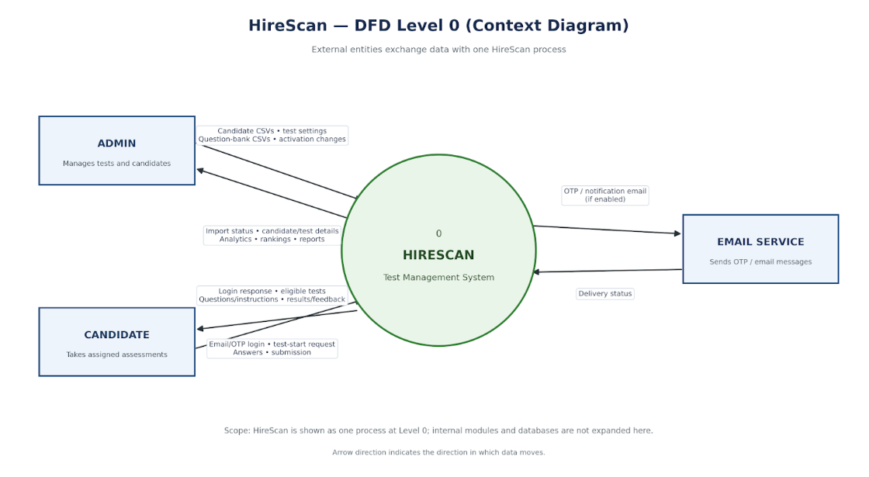

External data flows
- Admin to HireScan: candidate CSV uploads, test configuration, question-bank uploads, activation/deactivation actions, and requests for analytics or reports.
- HireScan to Admin: import status, candidate/test information, test results, analytics, rankings, and generated reports.
- Candidate to HireScan: email/OTP authentication requests, test-start requests, answers, and submission actions.
- HireScan to Candidate: authentication outcome, assigned tests, questions, timer/test status, score, pass/fail result, and topic-wise feedback.

7. DFD Level 1 — Major Internal Processes
DFD Level 1 expands the single HireScan process into the main processes that handle candidate registration, test configuration, test delivery, evaluation, and analytics. Data-store labels are conceptual and will be refined during ER diagram design.
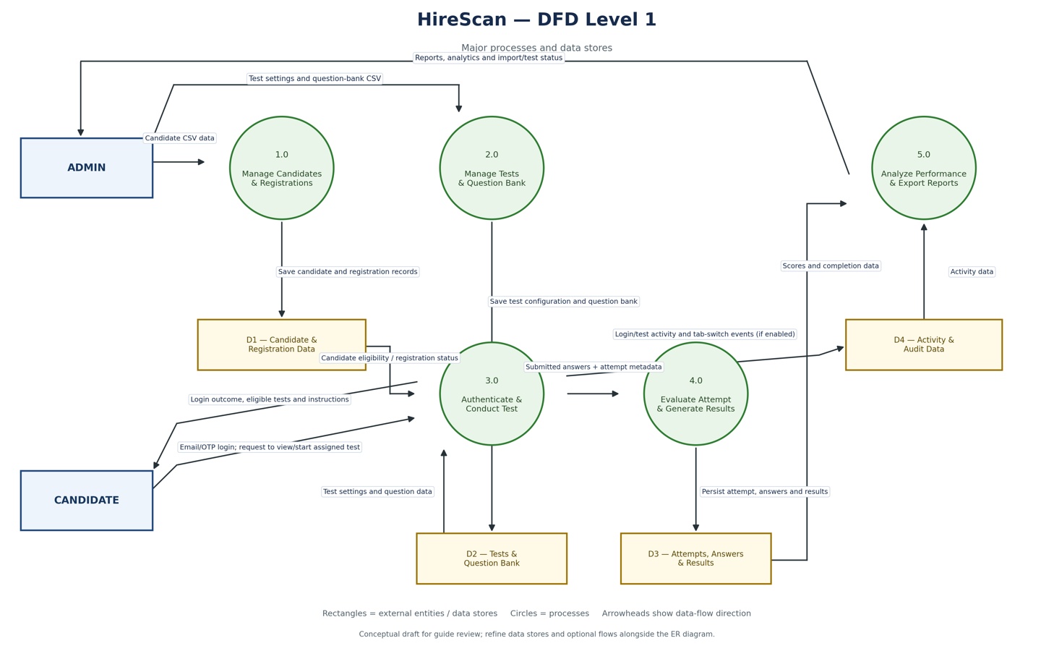
1.0 — Manage Candidates and Registrations. Imports and validates candidate CSV data, creates or updates candidate records, and associates each candidate with a specific test. It reads/writes candidate and registration data.
2.0 — Manage Tests and Question Bank. Creates tests, saves settings, imports and validates question banks, and controls activation status. It stores test settings and question data.
3.0 — Authenticate and Conduct Test. Verifies candidate OTP, checks eligibility, serves randomized questions, tracks the attempt timer, saves answers, and receives submission events.
4.0 — Evaluate Attempt and Generate Results. Finalizes an attempt, evaluates answers, calculates score and pass/fail status, saves results, and prepares topic-wise feedback.
5.0 — Analyze Performance and Export Reports. Uses result and activity data to generate individual reports, test summaries, question analysis, topic-wise analytics, rankings, completion reports, and CSV/PDF exports.

Conceptual data stores
Data store | Information held
D1 — Candidate and Registration Data | Candidate contact/education details and the relationship between candidates and tests.
D2 — Tests and Question Bank | Test ID, duration, passing marks, activation state, question text, options, correct option, topic, and optional difficulty/suggestions.
D3 — Attempts, Answers, and Results | Attempt status, start/end timestamps, saved answers, submission method, score, pass/fail status, and time taken.
D4 — Activity and Audit Data | Relevant authentication, submission, tab-switch, and administrative events when these features are enabled.

8. Points to Confirm Before Finalizing the Design
The following items are interpretations or unresolved details in the supplied specification. Confirming them now will help ensure that the prototypes, ER diagram, DFDs, and implementation agree with the guide's expectations.
- Whether the 20× question-bank size is compulsory or recommended.
- Expected behaviour after browser closure or network loss, including whether an attempt can be resumed.
- Whether candidates should see the correct answers after submitting or only scores and topic-wise feedback.
- Which advanced/optional features are mandatory for the submission: anomaly detection, tab-switch alerts, comparison/progress reports, PDF exports, and automated emails.
- Final candidate CSV and question-bank CSV column names, including whether the suggestions field is required.
- The expected number/type of admin roles and how admin accounts will be created.

9. Proposed Overall Workflow
- Admin creates a test and configures duration, passing marks, question count, and activation status.
- Admin imports the question bank and candidate registrations using the agreed CSV formats.
- Candidate signs in with email OTP and sees only active tests linked to their registration.
- Candidate attempts a randomized, timed test while answers are saved.
- The system finalizes and evaluates the attempt, then displays the result and topic-wise feedback.
- Admin reviews analytics and exports reports to support hiring decisions.

10. Conclusion
My understanding is that HireScan combines candidate eligibility management, configurable assessments, automatic evaluation, and hiring analytics in a private platform. The main design priority is to keep candidate-to-test registration, attempt state, question randomization, submission handling, and result calculation consistent and secure. The attached DFDs represent the initial understanding of the data movement and should be reviewed with the guide alongside the screen prototypes and ER diagram before coding.

