Experiment 4
- toUpperCase()
<!DOCTYPE html>
<html lang="en">
<head>
<meta charset="UTF-8" />
<title>String Methods with User Input</title>
<style> body {
font-family: Arial, sans-serif; background: #fafafa; padding: 20px;
}
.container { background: #fff; padding: 15px 20px; border-radius: 8px; max-width: 400px; margin: 20px auto;
box-shadow: 0 0 8px rgba(0,0,0,0.1);
}
h2 {
text-align: center;

color: #333;
}
label {
display: block; margin-top: 15px; font-weight: bold; color: #555;
}
input[type="text"] { width: 100%; padding: 8px; margin-top: 5px;
border: 1px solid #ccc; border-radius: 4px; font-size: 14px;
}
button {
margin-top: 12px; padding: 8px 12px;
background-color: #007bff; border: none;
color: white; font-size: 15px;

border-radius: 4px; cursor: pointer; width: 100%;
}
button:hover {
background-color: #0056b3;
}
.result {
margin-top: 12px; background: #e9ecef; padding: 10px; border-radius: 4px; color: #222;
min-height: 24px;
}
</style>
</head>
<body>

<div class="container">
<h2>String Methods Demo</h2>

<!-- toUpperCase -->

<label for="inputToUpper">Enter text to convert to uppercase:</label>
<input type="text" id="inputToUpper" placeholder="Type something..." />
<button onclick="convertToUpper()">Convert to Uppercase</button>
<div id="resultUpper" class="result"></div>

<script>
function convertToUpper() {
let text = document.getElementById('inputToUpper').value; if (text.trim() === '') {
document.getElementById('resultUpper').textContent = 'Please enter some text.';
return;
}
let upper = text.toUpperCase(); document.getElementById('resultUpper').textContent = `Uppercase: ${upper}`;
}
</script>
</body>
</html>

OUTPUT

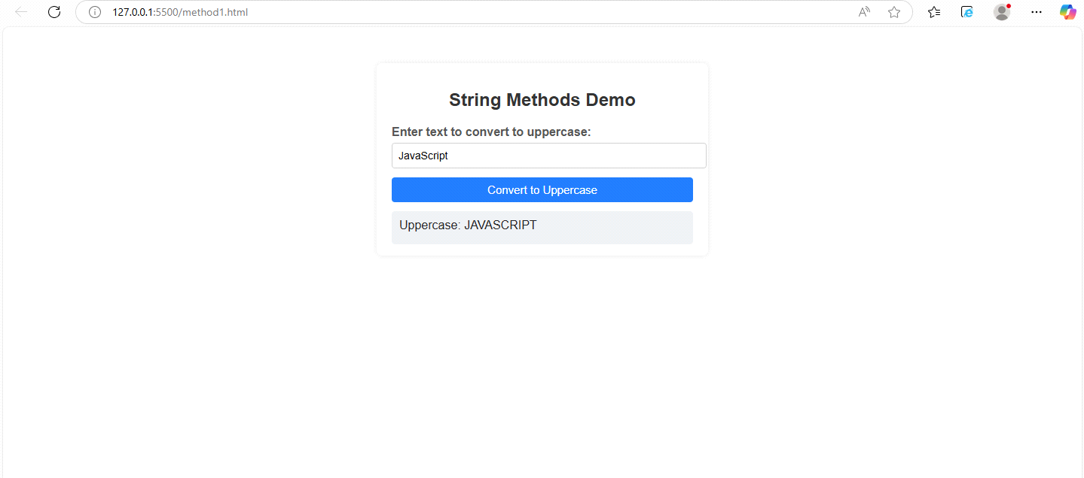

regx()

<!DOCTYPE html>
<html lang="en">
<head>
<meta charset="UTF-8" />
<title>String Methods with User Input</title>
<style> body {
font-family: Arial, sans-serif; background: #fafafa; padding: 20px;
}
.container {

background: #fff; padding: 15px 20px; border-radius: 8px; max-width: 400px; margin: 20px auto;
box-shadow: 0 0 8px rgba(0,0,0,0.1);
}
h2 {
text-align: center; color: #333;
}
label {
display: block; margin-top: 15px; font-weight: bold; color: #555;
}
input[type="text"] { width: 100%; padding: 8px; margin-top: 5px;
border: 1px solid #ccc; border-radius: 4px; font-size: 14px;
}

button {
margin-top: 12px; padding: 8px 12px;
background-color: #007bff; border: none;
color: white; font-size: 15px;
border-radius: 4px; cursor: pointer; width: 100%;
}
button:hover {
background-color: #0056b3;
}
.result {
margin-top: 12px; background: #e9ecef; padding: 10px; border-radius: 4px; color: #222;
min-height: 24px;
}
</style>
</head>
<body>

<div class="container">
<h2>String Methods Demo</h2>

<!-- Regex test -->
<label for="inputRegex">Enter string to check if only digits:</label>
<input type="text" id="inputRegex" placeholder="Digits only?" />
<button onclick="checkDigits()">Check Digits Only</button>
<div id="resultRegex" class="result"></div>

<script>

function checkDigits() {
let text = document.getElementById('inputRegex').value; if (text.trim() === '') {
document.getElementById('resultRegex').textContent = 'Please enter some text.';
return;
}
let regex = /^\d+$/;
let result = regex.test(text); document.getElementById('resultRegex').textContent = result
? `"${text}" contains only digits.`
: `"${text}" does NOT contain only digits.`;
}

</script>

</body>
</html>

OUTPUT
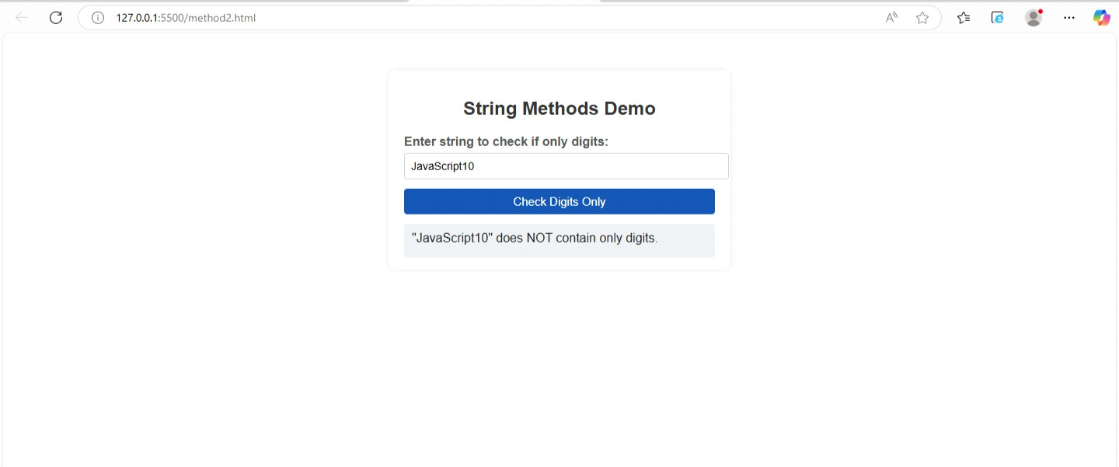

localeCompare()

<!DOCTYPE html>
<html lang="en">
<head>
<meta charset="UTF-8" />
<title>String Methods with User Input</title>
<style>

body {
font-family: Arial, sans-serif; background: #fafafa; padding: 20px;
}
.container { background: #fff; padding: 15px 20px; border-radius: 8px; max-width: 400px; margin: 20px auto;
box-shadow: 0 0 8px rgba(0,0,0,0.1);
}
h2 {
text-align: center; color: #333;
}
label {
display: block; margin-top: 15px; font-weight: bold; color: #555;
}
input[type="text"] { width: 100%;

padding: 8px; margin-top: 5px;
border: 1px solid #ccc; border-radius: 4px; font-size: 14px;
}
button {
margin-top: 12px; padding: 8px 12px;
background-color: #007bff; border: none;
color: white; font-size: 15px;
border-radius: 4px; cursor: pointer; width: 100%;
}
button:hover {
background-color: #0056b3;
}
.result {
margin-top: 12px; background: #e9ecef; padding: 10px; border-radius: 4px;

color: #222;
min-height: 24px;
}
</style>
</head>
<body>

<div class="container">
<h2>String Methods Demo</h2>

<!-- localeCompare -->
<label for="inputCompare1">Enter first string for comparison:</label>
<input type="text" id="inputCompare1" placeholder="First string" />
<label for="inputCompare2">Enter second string for comparison:</label>
<input type="text" id="inputCompare2" placeholder="Second string" />
<button onclick="compareStrings()">Compare Strings</button>
<div id="resultCompare" class="result"></div>
</div>

<script>

function compareStrings() {
let str1 = document.getElementById('inputCompare1').value; let str2 = document.getElementById('inputCompare2').value; if (str1.trim() === '' || str2.trim() === '') {

document.getElementById('resultCompare').textContent = 'Please enter both strings.';
return;
}
let cmp = str1.localeCompare(str2); let msg = '';
if (cmp < 0) {
msg = `"${str1}" comes before "${str2}"`;
} else if (cmp > 0) {
msg = `"${str1}" comes after "${str2}"`;
} else {
msg = `"${str1}" and "${str2}" are equal`;
}
document.getElementById('resultCompare').textContent = msg;
}
</script>

</body>
</html>

OUTPUT

