**HYPERPARAMETER TUNING**

**VGG19 -Only last layer trainable --10 classes - Padding(2,2)**

**Same grayscale matrix concatenated 3 times for creating RGB image**

**Adam Optimization Used**

**Rest we vary epochs and batch size to increase validation accuracy and reduce validation loss**

**Dataset:** Fashion MNIST

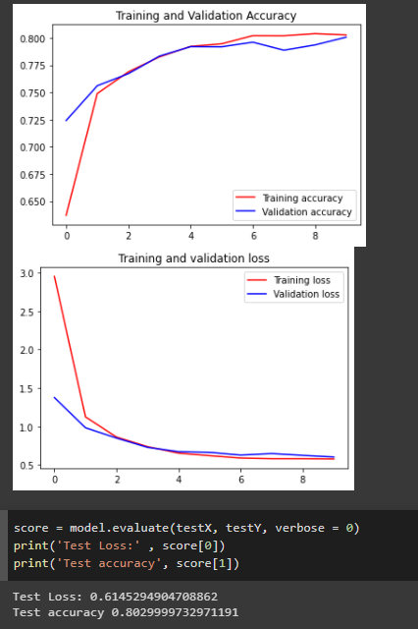

**10** iterations

**Train Loss** : 0.5898

**Validation Loss**: 0.6041

**Train Accuracy:** 80.11

**Validation Accuracy:** 80.06

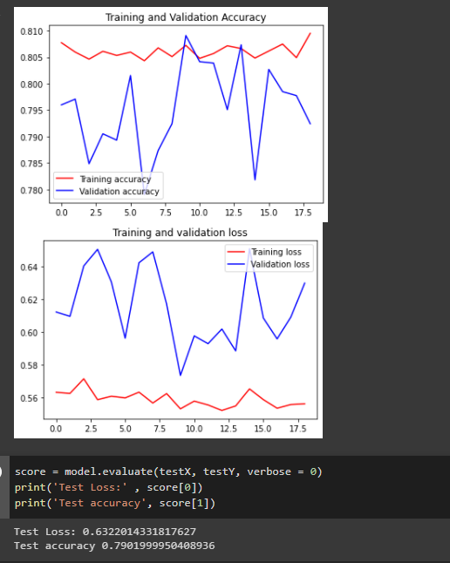

Training extended for **10** more epochs : very **bad** outcomes

**Training loss** : 0.5561  **training accuracy**: 80.95

**Validation loss** : 0.6297  **Validation accuracy:** 79.24

**21st** epoch gives nice result; we now start hyperparameter tuning by loading these

loss: 0.5577 - accuracy: 0.8048 - val_loss: 0.5975 - val_accuracy: 0.8041

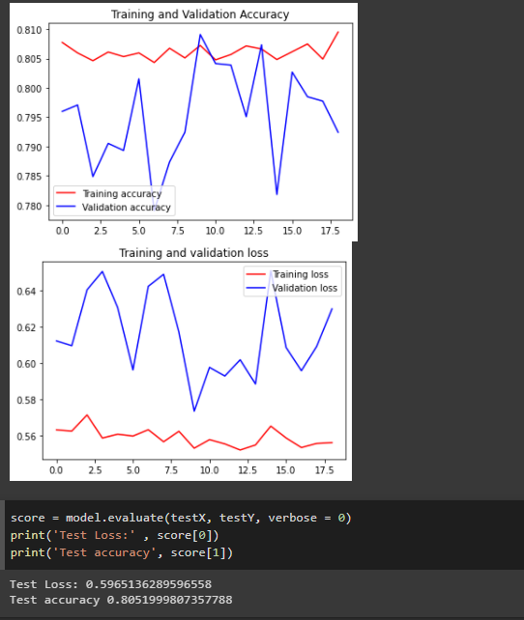

**Training it for 15** epochs more: with ; **64 batch size**

We get a **good** result at **42**nd epoch

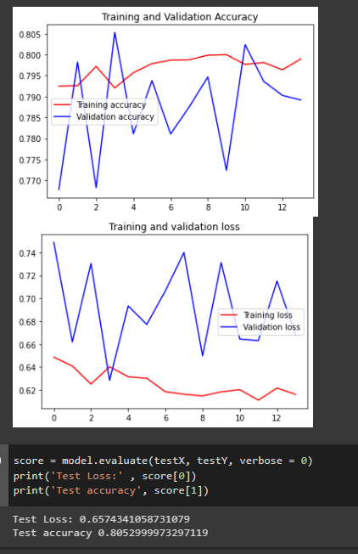

**Train Loss**: 0.6204 **Train accuracy:** 0.7976

**Validation loss**: 0.6645 **Validation accuracy**: 0.8024

We got the above result when loaded those weights

**BEST TILL NOW : [**Finally Chosen**]**

Batch_size = **1024**

At epoch **56** we hit a nice setmark

**Train loss** : 0.4627 **Train Accuracy**:82.98

**Validation loss**: 0.5323  **Validation Accuracy**: 81.81

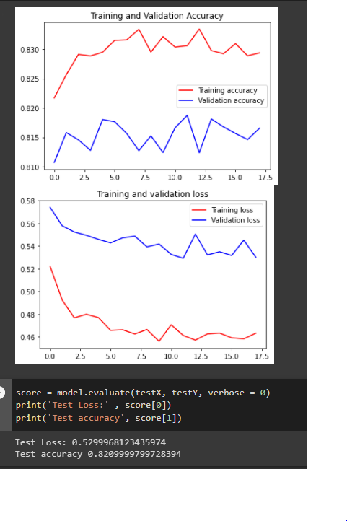

**Btach_size chosen : 4096**

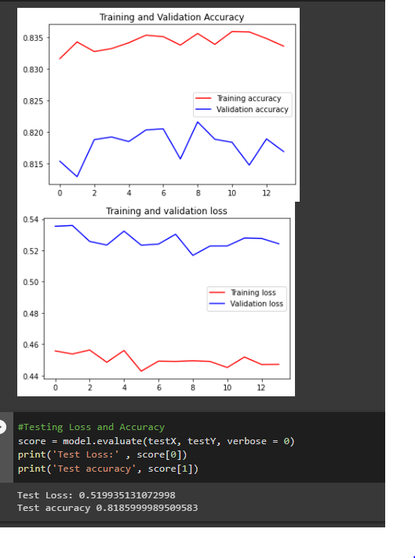

Some deterioration and oscillations(which were expected ) slight overfitting observed

65th epoch gave some respectable result.

**Training loss**: 0.4494 **Training accuracy**: 0.8356

**val_loss:** 0.5168 -  **val_accuracy:** 0.8216