Game Design Document

Fill up the following document

1. Write the title of your project.

Mission Pluto

1. What is the goal of the game?

The goal of the game is to reach the pluto.

1. Write a brief story of your game.

There is an curious boy named Tony. Who think about the pluto , that where the pluto actually gone . so he made the game in which he went to find and explore the pluto in his Space craft.

1. Which are the playing characters of this game?

* Playing characters are the ones who respond to the user based on the input from the user.
* Cars, monkeys, dinos, wizards, etc., are the playing characters in the game.

|  |  |  |
| --- | --- | --- |
| Number | Character Name | What can this character do? |
| 1 | A artifficial Shield | It will protect the spaceCraft from the stars,allians etc. |
| 2 |  |  |
| 3 |  |  |
| 4 |  |  |
| 5 |  |  |
| 6 |  |  |
| 7 |  |  |
| 8 |  |  |

1. Which are the Non-Playing Characters of this game?

* Non-Playing characters are the ones that don't have an action or behavior when the user interacts with the game.
* Hurdles, stones, bananas, coins, etc., are non-playing characters in the game.

|  |  |  |
| --- | --- | --- |
| Number | Character Name | What can this character do? |
| 1 | Stars | Randomly spawn |
| 2 | metioroids | Randomly spawn |
| 3 | Alian Ships | Randomly spawn |
| 4 |  |  |
| 5 |  |  |
| 6 |  |  |
| 7 |  |  |
| 8 |  |  |

Draw your imagination of this game. What does this game look like?

* Draw the game either on your computer or on paper.
* Add images of the game scenes to show each of the playing and non-playing characters at least once.

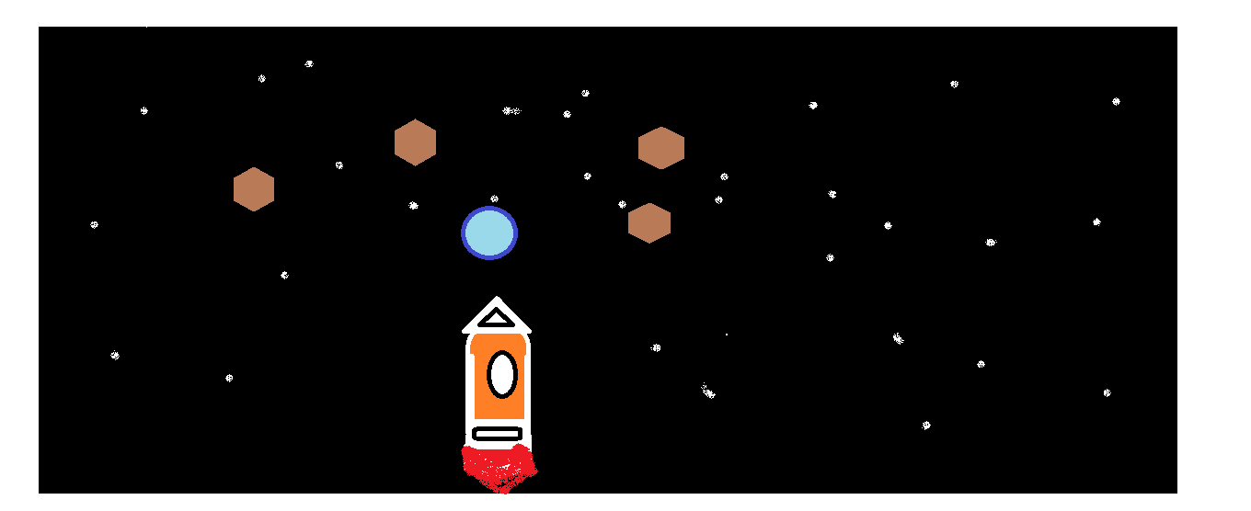

How do you plan to make your game engaging?

In ths game the obstacles like stars , alian ship will randomaly spawn and attract to spacecraft and the artificial shield will protect the ship from the obstacles and as distace btween pluto and spacecraft will decrease ,, the amount of spawning of the obstacles will increase.