Assignment 2 - LLM, Deep Learning & AI: Research Questions
Ayush Mishra | B.Tech CSE (AI/ML), RKGIT | Graduating 2027

Question 1 - Self-Assessment
Rating scale: A = can code independently, B = can code under supervision / with reference, C = little or no understanding.
Area | Rating | Justification
Machine Learning | A | I've built and shipped several end-to-end ML systems on my own: CrimeScope AI (Random Forest + KDE), a health insurance cost predictor, and the EventEase recommendation engine. That work covered feature engineering, model selection, evaluation, and Streamlit deployment. I'm comfortable with the full lifecycle, including drift monitoring concepts (PSI/CSI) and basic MLOps (MLflow, SageMaker).
Deep Learning | B | I can fine-tune and compose pre-trained architectures (YOLOv8n/s in CrowdMind AI, HOG+NMS pipelines) and reason about GPU/batch-size tradeoffs, but I haven't designed a novel architecture from scratch or trained one at scale yet. The CSRNet integration for CrowdMind AI is in progress, not finished. B is the honest rating here; I'm working toward A as my GenAI/NLP focus deepens.
AI (applied / agentic systems) | B+ | I've independently built a multi-agent MLOps tool (ML Experiment AutoPilot: LangGraph + MLflow + self-modifying memory) and an Enterprise RAG Agent (AWS Bedrock + FAISS), which I'd argue puts me at A on the application layer. Where I'm still at B is the harder systems-design side: orchestration failure modes, rigorous agent evaluation, production-grade guardrails. That's why this isn't a flat A.
LLMs | B+ | My applied LLM experience is real and recent: RLHF/safety annotation work (Coforge, Mercor), an LLM continuous-evaluation harness (IEEE paper in progress), and a Kaggle LLM-based radiology report editing pipeline. That's solid independent work at the application and evaluation layer. I'm not rating myself A because that would mean being comfortable with pretraining and alignment internals, which I haven't worked on yet. My LLM work so far is integration, evaluation, and RAG, not model internals.

Question 2 - Key Architectural Components of an LLM-Based Chatbot
A production LLM chatbot is not "a prompt plus an API call". It's a pipeline of distinct components that each scale independently. The high-level flow for a Retrieval-Augmented Generation (RAG) chatbot, the dominant real-world pattern because it grounds responses in a private, updatable knowledge base instead of the model's frozen training data, looks like this:
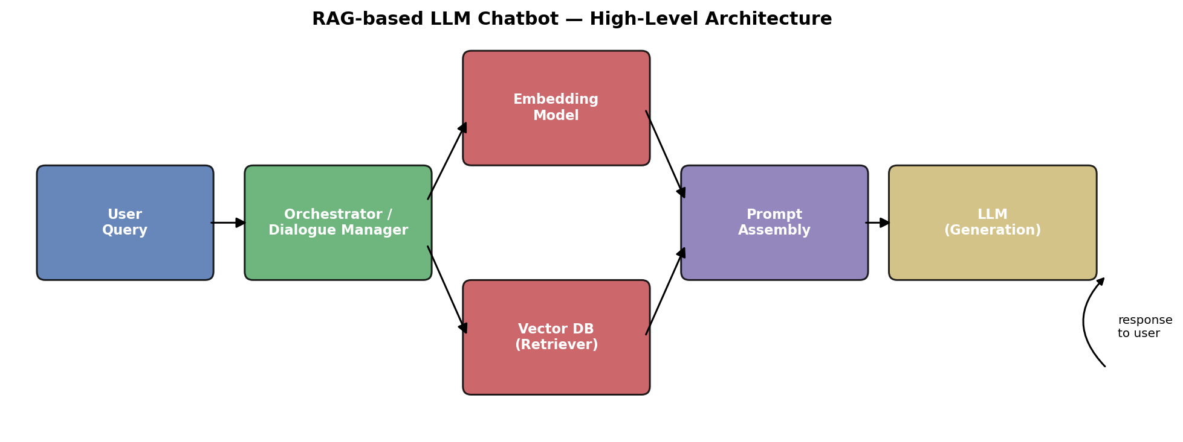

2.1 Component Breakdown
Component | Role | Typical Implementation
Input handling / guardrails | Sanitize input, detect prompt-injection attempts, apply PII/content filters before the query reaches the model. | Regex/classifier filters, moderation API
Orchestrator / dialogue manager | Owns conversation state, decides whether retrieval is needed, routes to tools/functions, manages multi-turn context. | LangGraph, LangChain, or a custom state machine
Embedding model | Converts the user query (and, offline, every knowledge-base chunk) into a dense vector for semantic search. | OpenAI/Cohere embedding APIs, sentence-transformers (self-hosted)
Vector database (retriever) | Approximate-nearest-neighbour search over embedded documents; supports metadata filtering. | FAISS, Qdrant, Pinecone, pgvector (see Q3)
Prompt assembly | Merges retrieved context, conversation history, and system instructions inside the model's context-window budget; handles truncation/re-ranking when context exceeds the limit. | Templating layer, token-budget-aware truncation
LLM (generation) | Produces the response conditioned on the assembled prompt. | Hosted API (GPT/Claude/Gemini) or self-hosted (Llama/Mistral via vLLM)
Output post-processing | Validates structure (e.g. JSON schema for tool calls), applies a second safety pass, formats citations. | Pydantic/JSON-schema validators, output moderation
Memory layer | Short-term: rolling conversation buffer. Long-term: user-specific facts persisted across sessions (summarized, not raw logs). | Redis/session store for short-term; a separate KV or vector store for long-term
Observability & evaluation | Logs latency, token cost, retrieval hit-rate, and runs regression evals so silent quality drift is caught before users notice. | Custom eval harness, MLflow, LangSmith-style tracing
Serving/infra layer | Rate limiting, caching identical/near-identical queries, load balancing across model replicas. | API gateway, semantic cache, autoscaled inference servers

2.2 Why This Shape, Not a Simpler One
- Retrieval is decoupled from generation on purpose: the knowledge base (vector DB) can be updated continuously without retraining or re-deploying the LLM. That's the practical argument for RAG over fine-tuning when the underlying facts change often, like the crop-advisory data in my KrishiAI+ project, which updates seasonally.
- The orchestrator, not the LLM, decides whether a turn even needs retrieval. Retrieving on every turn wastes latency and money on queries like "thanks" or "what did I just ask you".
- The evaluation/observability layer is not optional polish. Without it, a regression (say a bad prompt-template edit silently dropping retrieval quality) stays invisible until users complain. That's the exact gap my LLM continuous-evaluation harness project is built to close.

Question 3 - Vector Databases

3.1 What a Vector Database Actually Does
A vector database indexes high-dimensional embeddings (typically 384-3072 dimensions) and answers approximate-nearest-neighbour (ANN) queries, "give me the k stored vectors closest to this query vector", in sub-linear time. This matters because exact brute-force search (computing cosine similarity against every stored vector) is O(n·d) per query, which stops being viable somewhere in the low millions of vectors at interactive latency. Vector DBs trade a small amount of recall for large speed gains using approximate indexing structures:
- HNSW (Hierarchical Navigable Small World): a multi-layer graph where search descends from a coarse top layer to a fine bottom layer. Used by FAISS, Qdrant, Weaviate, pgvector. Very good recall/latency tradeoff, higher memory footprint.
- IVF (Inverted File Index): clusters vectors (e.g. via k-means) and searches only the nearest clusters. Lower memory, faster to build, slightly lower recall than HNSW at the same speed.
- Product Quantization (PQ): compresses vectors into short codes to cut memory further, usually combined with IVF (IVF-PQ in FAISS) for billion-scale corpora.
Beyond the ANN index, a production vector DB also needs metadata filtering (restricting search to a subset, e.g. only documents where region = 'Uttar Pradesh'), CRUD on vectors without a full re-index, and horizontal scaling. That's what separates "FAISS the library" from an actual vector database.

3.2 Hypothetical Problem
Problem: KrishiAI+, a multimodal agricultural decision-support app, needs semantic search over ~50,000 advisory documents and crop-disease image captions, filterable by crop type, region, and season, serving farmer queries in real time on a student/early-startup budget, with the corpus updated every growing season.

3.3 Comparison of Candidates
Vector DB | Deployment | Metadata filtering | Cost at this scale | Fit for KrishiAI+
FAISS | Library, self-managed (no server) | Manual (must build your own filter layer) | Free, just compute | Great for offline prototyping; painful once you need filtering + concurrent writes in production.
Pinecone | Fully managed cloud | Native, strong | Free tier is limited; paid tiers add real recurring cost | Excellent DX, but recurring cost is hard to justify for a pre-revenue student project.
Weaviate | Self-host or managed cloud | Native, strong (incl. hybrid search) | Free self-hosted; managed has a free tier | Strong option; heavier to operate self-hosted than Qdrant for a small team.
Qdrant | Self-host (Docker) or managed cloud | Native, very strong (payload filtering is a first-class feature) | Free self-hosted; generous managed free tier | Best fit, see 3.4
pgvector | Extension on existing Postgres | Full SQL WHERE clauses | Free if Postgres is already in the stack | Very attractive if the rest of the app already uses Postgres, avoids running a second database entirely.

3.4 Choice and Reasoning
My recommendation is Qdrant, with pgvector as the pragmatic fallback if the rest of KrishiAI+'s stack is already Postgres-based.
Reasoning:
- Filtering is the deciding factor, not raw ANN speed. At 50K documents, FAISS, Qdrant, and pgvector are all fast enough. The real requirement is filtering by crop/region/season before or alongside the vector search, and Qdrant's payload filtering (done at the index level, not as a post-filter) handles that natively.
- It's self-hostable at zero licensing cost via Docker, which matters on a student budget, and it still has a managed cloud tier I can migrate to without a rewrite if the project moves toward the research-paper and production stage already planned for KrishiAI+.
- Payload updates without full re-indexing support the seasonal-refresh requirement. Old advisories can be upserted or deleted as the agricultural data changes, without rebuilding the whole index.
- If KrishiAI+'s backend is already on Postgres for relational data (users, farm records), pgvector is the more defensible choice on operational simplicity alone: one database instead of two, at the cost of somewhat weaker ANN performance past a few hundred thousand vectors. At the stated 50K-document scale, that ceiling isn't a concern.

