

**DATA VISUALISATION – CSE3020**

**DIGITAL ASSIGNMENT II**

**NAME:**

**AYUSH SHARMA**

**REGISTRATION NUMBER:**

**15BCE1335**

**SUBMITTED TO:**

**PROF. PATTABIRAMAN. V**

**DATA VISUALISATION – CSE 3020**

**PROBLEM STATEMENT**

Explore the Java script framework (D3.js) using valid dataset and show the output of the same. Provide the details of the tool, dataset and its visual analytics outputs.

**DATA VISUALIZATION TOOL**

D3.js is a JavaScript library for manipulating documents based on data. D3 helps you bring data to life using HTML, SVG, and CSS. D3’s emphasis on web standards gives you the full capabilities of modern browsers without tying yourself to a proprietary framework, combining powerful visualization components and a data-driven approach to DOM manipulation.

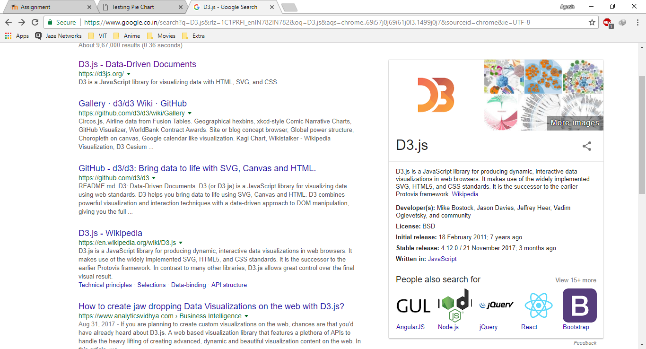

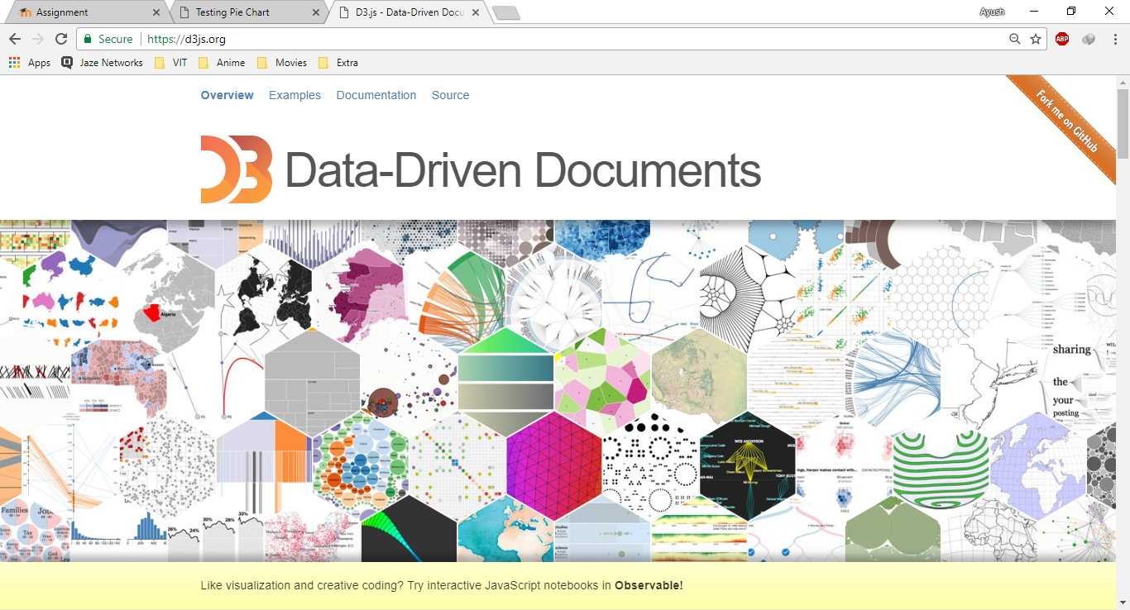

**DATASET**

For this assignment, I am using the Vertebral Column dataset available on UCI Repository in the following link.

<http://archive.ics.uci.edu/ml/datasets/vertebral+column>

**CODE**

1. First I gathered some information about the attributes distribution using tableau.

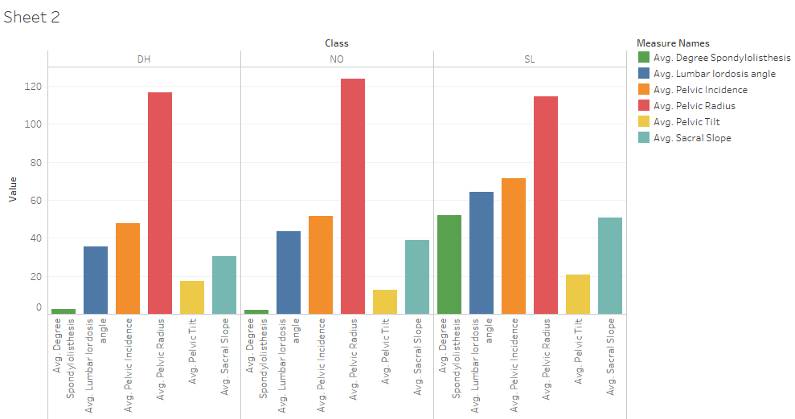

1. Then I created the dashboard using HTML, CSS and JavaScript with the D3 framework for the visualization of the attribute breakdown. The code/webpage has been included in this package. Just edit the file in notepad to make changes in the webpage.
2. The dashboard has a pie chart to show the class distribution in this dataset. There is a bar graph to show the average value of the attributes for each class or whole dataset and a line graph for the same. Everything is implemented using D3 library only.
3. Whenever we click on the class’s partition in the pie chart, the bar graph and the line graph modifies itself with great animation for the values with respect to classes.

**SCREENSHOT**

1. WHOLE DATASET

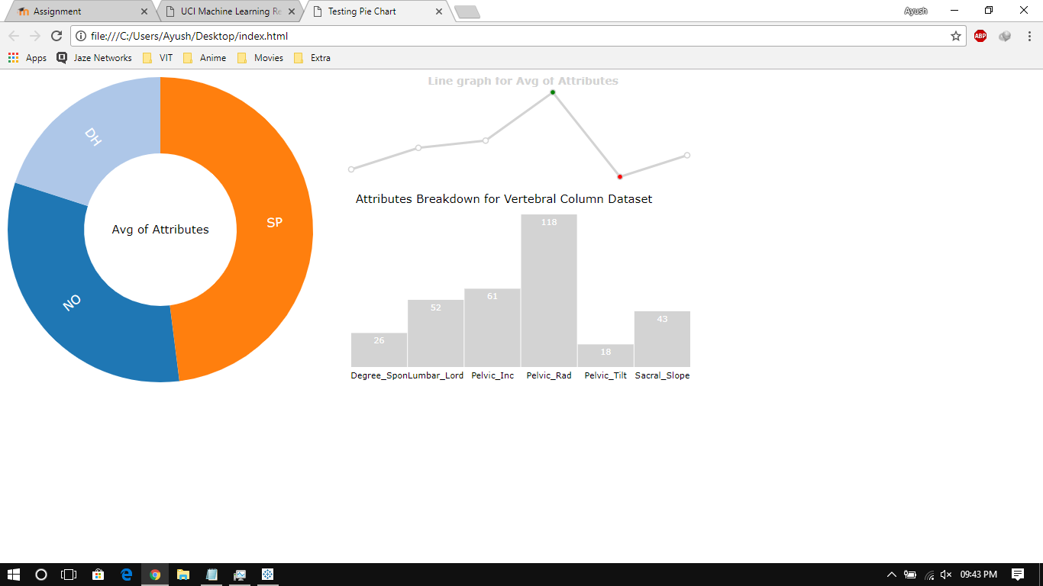

1. NORMAL CLASS (NO)

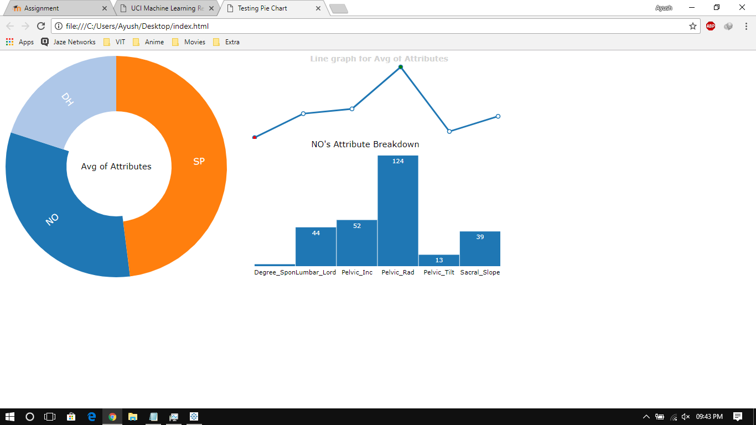

1. DISK HERNIA (DH)

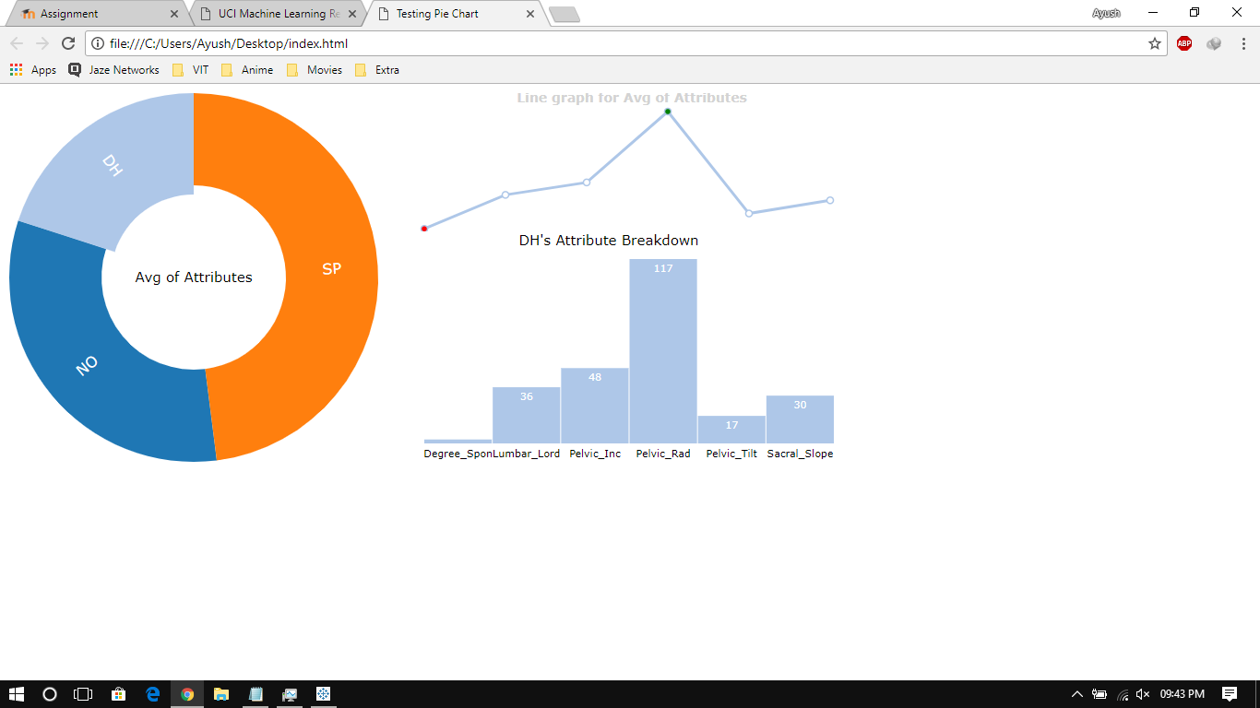

1. SPONDYLOLISTHESIS

