4.9 Handling File Uploads



This section will guide you to:

* Upload the Desktop file in Selenium WeDriver

**Development Environment**

* Eclipse IDE for Enterprise Java Developers Version Oxygen.3a Release (4.7.3a)
* JavaDevelopment Kit Version 8
* Selenium standalone server
* Autoit

This guide has mainly two subsections, namely:

4.9.1 Handing file upload by **SendKeys**

4.9.2 Handling file upload by **AutoIT script**

4.9.3 Pushing the code to the GitHub repositories

**Step 4.9.1:** Handling file upload by SendKeys

* Launch Eclipse and create a Java project.
* Create project: Click on file->New->Java project.
* Enter the project name as **UploadFile** and click on Finish.
* In the project explorer, expand **UploadFile.**
* Right-click on **src** and choose **New->Class.**
* In Package Name, enter **com.ecommerce** and in **Name** enter **Upload** and click on **Finish.**
* Locate the browse button using chropath/firebug.
* Set the path using SendKeys. And the code looks like below:

//Locating 'browse' button

WebElement browse =driver.findElement(By.id("uploadfile"));

//pass the path of the file to be uploaded using Sendkeys method

browse.sendKeys("D:\\SoftwareTestingMaterial\\UploadFile.txt");

**Step 4.9.2:** Handling file upload by AutoIT script

* Go to **Start->Autoit v3->Autoit window info.**
* Now drag the Finder toolbox to the object in which you are interested.

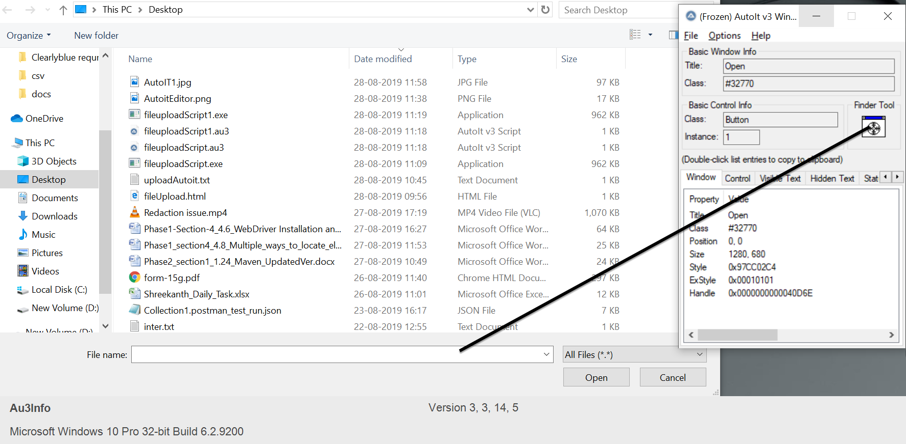

* Build an AutoIT script using **SciTE editor** and write the script using **ControlFocus, ControlsetText, and ControlClick** commands.
* And the script looks like below:

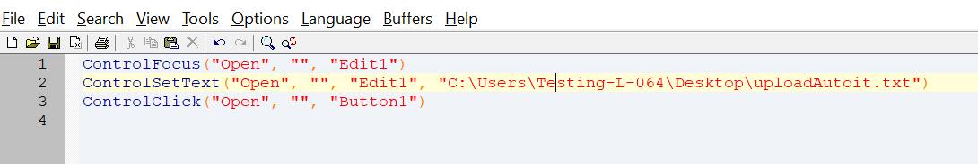

* Save the Script with **.au3** extension.
* Compile the **.au3** script which converts into **.exe** file.
* Pass the **.exe** path into selenium test script using method

**Runtime.getRuntime().exec(“C:\AutoIt\Autoitscript.exe”)**

* The complete script looks like this:

**import** java.io.IOException;

**import** java.util.concurrent.TimeUnit;

**import** org.openqa.selenium.By;

**import** org.openqa.selenium.WebDriver;

**import** org.openqa.selenium.firefox.FirefoxDriver;

**public** **class** AutoIt {

**private** **static** WebDriver driver = **null**;

**public** **static** void main(**String**[] args) **throws** **IOException**, **InterruptedException** {

driver = **new** FirefoxDriver();

driver.manage().timeouts().implicitlyWait(10, **TimeUnit**.SECONDS);

driver.get("http://toolsqa.com/automation-practice-form");

driver.findElement(By.id("photo")).click();

**Runtime**.getRuntime().exec("D:\AutoIt\AutoItTest.exe");

**Thread**.sleep(5000);

driver.close();

**Step 4.9.3:** Pushing the code to your GitHub repositories

Open your command prompt and navigate to the folder where you have created your files

cd <folder path>

Initialize your repository using the following command:

git init

Add all the files to your git repository using the following command:

git add . 

Commit the changes using the following command:

git commit . -m “Changes have been committed.”

Push the files to the folder you initially created using the following command:

git push -u origin master