4.11 Sikuli for UI Testing



This section will guide you to:

* Integrate Sikuli with Selenium WebDriver and interact with web elements

**Development Environment:**

* Eclipse IDE for Enterprise Java Developers Version Oxygen.3a Release (4.7.3a)
* JavaDevelopment Kit Version 8

This guide has mainly four subsections, namely:

4.11.1 Integrating Sikuli with Selenium WebDriver

4.11.2 Screen class in Sikuli

4.11.3 Pattern class in Sikuli

4.11.4 Pushing the code to your GitHub repositories

**Steps 4.11.1:** Integrating Sikuli with Selenium WebDriver

* Sikuli Jar files are already present in your practice labs. To learn about its directory path details, you can refer to the lab guide for Phase 1.
* Open Eclipse and create a new Java project
* Right-click on the project. Navigate through the given path: Build path->Configure build path->Add external Jars.
* Click on **Apply and OK.**

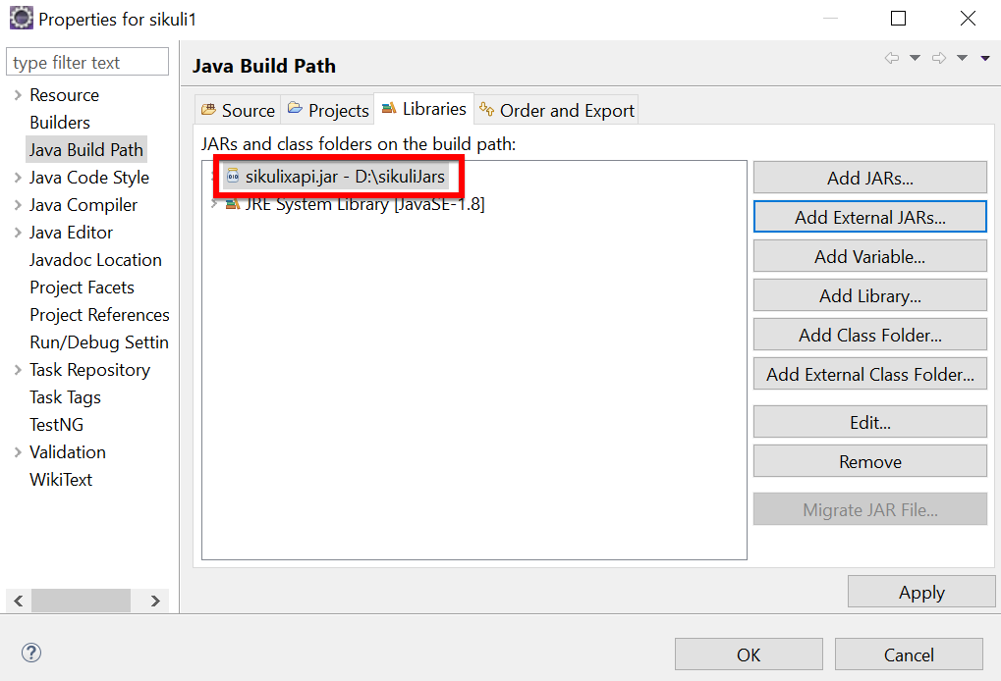

**Steps 4.11.2:** Screen class in Sikuli

* Screen class is a base class which contains some predefined methods to perform operations, such as click, double click, providing input to the text box and hover, etc.
* Below are the commonly used methods:
* Click

Syntax: Screen s = new Screen();

s.click()("imag.png”);

* doubleClick

Syntax: Screen s = new Screen();

s.doubleClick()("imag.png”);

* Type

Syntax: s.type(“imag.png”, “Text”);

* Hover

Syntax: s.hover(“imag.png”);

* Find

Syntax: s.find(“imag.png”);

**Steps 4.11.3:** Pattern class in Sikuli

* Pattern class is used to associate the image file to identify the element
* Pattern class takes the path of the image as a parameter
* Below are the commonly used methods:
* getFileName

Syntax: Pattern p = new Pattern(“D:\Test\imag.png”)

* Similar

Syntax: Pattern p1 = p.similar Pattern(“0.7f”);

* Exact

Syntax: Pattern p1 = p.exact();

The script looks like this:

**package** sikuli1;

**import** org.sikuli.script.FindFailed;

**import** org.sikuli.script.Pattern;

**import** org.sikuli.script.Screen;

**public** **class** SikuliClass {

**public** **static** void main(**String**[] args ) **throws** FindFailed {

Screen s = **new** Screen();

**Pattern** p = **new** **Pattern**("C:\\Users\\Testing\\Desktop\\siluli\\Capture.PNG");

s.doubleClick(p);

}

}

* Run the script and notice the action performed on the image (The path, which we have mentioned in the script).

**Steps 4.11.4:** Pushing the code to your GitHub repositories

* Open your command prompt and navigate to the folder where you have created your files.

cd <folder path>

* Initialize your repository using the following command:

git init

* Add all the files to your git repository using the following command:

git add .

* Commit the changes using the following command:

git commit . -m “Changes have been committed.”

* Push the files to the folder you initially created using the following command:

git push -u origin master