Strategic Product Placement Analysis: Unveiling Sales Impact with Tableau Visualization

Submitted to

LNCT Smartbridge Experiential Learning

Submitted by:-

Ayush Dubey (0157CS231051)

Chanchal Bairagi (0157CS231060)

Parth Bhawsar (0157CY231077)

Bhumika Mate (0103AD231058)



Department of Computer Science & Engineering

Lakshmi Narain College of Technology & Science, Bhopal (M.P.)

Session 2025-26

Strategic Product Placement Analysis: Unveiling Sales Impact with Tableau Visualization

Abstract
This project analyzes the impact of strategic product placement on retail sales performance using Tableau visualization tools.
The dataset was sourced from Kaggle and includes product category, product position, pricing, promotional impact, consumer demographics, seasonal trends, and sales volume.
The objective is to evaluate how product positioning influences purchasing behavior and revenue generation.
Interactive dashboards and stories were developed in Tableau to uncover meaningful patterns.
The results highlight the significant role of shelf positioning, pricing strategies, promotional activities, and foot traffic in driving sales performance.

Introduction
In competitive retail markets, product placement directly influences consumer buying behavior.
Retailers allocate self space based on visibility and promotional strategies to maximize sales.
This project uses business intelligence tools to analyze sales data and understand the measurable impact of product positioning on revenue.
Using Tableau dashboards and stories, raw retail data is transformed into actionable insights.

Problem Statement
Retail businesses invest heavily in store layout design and promotional strategies but often lack data-driven evidence to measure their effectiveness.
The core problem addressed is: How does strategic product placement influence sales performance, and how can Tableau visualization uncover patterns to improve decision-making?
Without proper analysis, retailers risk inefficient shelf utilization and missed revenue opportunities.

Objectives
• Analyze retail sales data from Kaggle.
• Evaluate impact of product position on sales volume.
• Examine relationship between pricing and sales performance.
• Analyze promotional impact on revenue.
• Study effect of foot traffic and demographics.
• Create interactive dashboards and stories in Tableau.
• Generate data-driven recommendations.

Data Collection
The dataset was obtained from Kaggle in CSV format and includes:
• Product Category
• Product Position
• Price
• Promotion Indicator
• Consumer Demographics
• Foot Traffic
• Seasonal Data
• Sales Volume
The dataset was inspected in Excel before loading into Tableau.

Data Cleaning and Preparation
Data preprocessing steps included:
• Removing duplicate records
• Handling missing values
• Standardizing category and position labels
• Converting date fields
• Validating numerical fields
• Checking for outliers
These steps ensured reliable analytical results.

Tools Used
• Microsoft Excel – Data cleaning
• Tableau Desktop – Dashboard and story creation
• Kaggle – Dataset source
• Bootstrap – Web embedding

Dashboard & Story Development
Dashboards created:
1. Product Position vs Sales
2. Promotion Impact Analysis
3. Price Comparison by Category
4. Average Sales by Category and Season
5. Foot Traffic and Sales Correlation
6. Consumer Demographics Analysis
A Tableau Story was developed to present insights step-by-step.
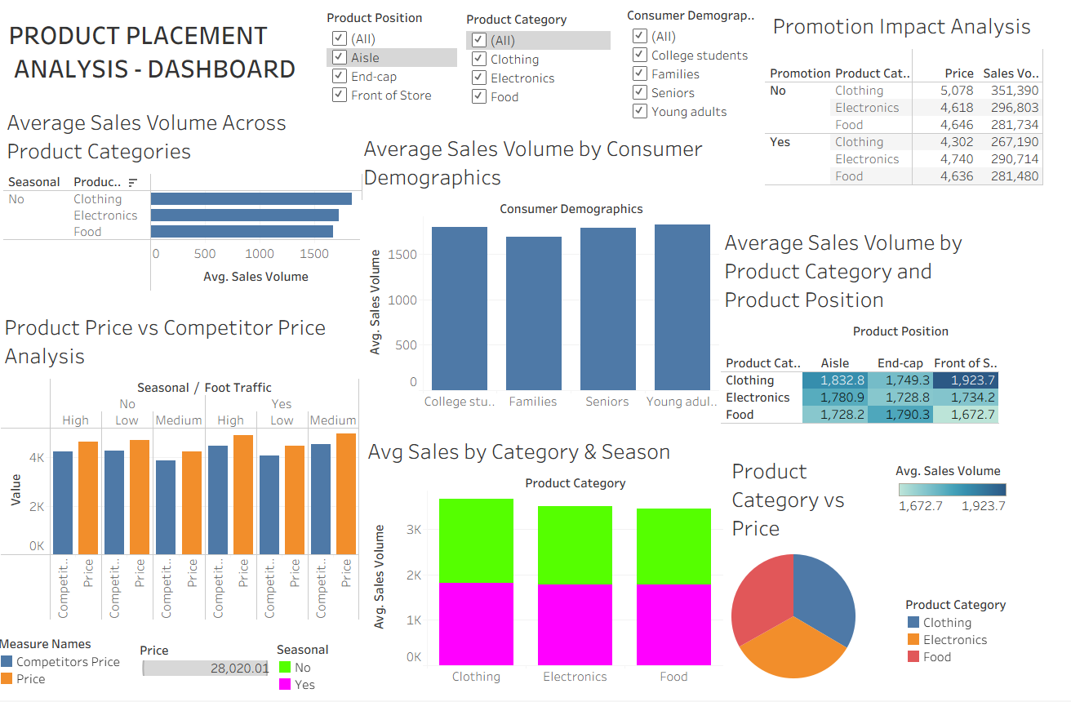

Analysis & Key Findings
• Eye-level placements generated higher average sales.
• Promotions significantly increased sales volume.
• Pricing influenced purchasing patterns.
• Higher foot traffic correlated with increased sales.
• Seasonal variations affected revenue distribution.
• Consumer demographics impacted product preferences.

Business Implications
Insights help retailers:
• Optimize self allocation
• Design effective promotions
• Implement pricing strategies
• Improve store layout
• Enhance customer targeting

Conclusion
The project demonstrates how strategic product placement influences sales performance using Tableau visualization.
Interactive dashboards provide actionable insights for data-driven retail decision-making.
The integration of pricing, promotions, positioning, and consumer behavior highlights the importance of analytics in retail strategy.

Future Scope
• Real-time retail data integration
• Predictive analytics models
• AI-based placement recommendations
• Multi-store comparison
• Live web-based analytics deployment

References
• Kaggle – https://www.kaggle.com
• Tableau – https://www.tableau.com
• Microsoft Excel Documentation
• Retail Analytics Literature

