**Defect Report for Gym Management System**

**ID**: DEF-001

**Project**: Gym Management System

**Product**: Trainer Management Module

**Release Version**: 2.3.1

**Module**: Trainer Profile Management

**Detected Build Version**: 2.3.1 Build 45

**Summary**:

1. Missing or Incorrect Data Type Handling
2. No User Role Check

**Description**:

1. **Missing or Incorrect Data Type Handling**: The code currently treats fields like time, mobile no, and pay_id as text inputs without validating or enforcing their expected data formats. Specifically, mobile no., should be validated as a numeric value, and time and pay_id should be validated to ensure they conform to expected formats (e.g., time should follow a standard time format).
2. **No User Role Check**: The script does not implement any checks to verify if the user has the appropriate role or permissions to add a trainer. This lack of authorization check can lead to unauthorized users performing actions they should not have access to.

**Steps to Replicate**:

1. For Missing or Incorrect Data Type Handling:
   * Submit the form with invalid or unexpected data in the mobile no, time, or pay_id fields (e.g., non-numeric values for mobile no).
2. For No User Role Check:
   * Attempt to access the trainer addition functionality with a user account that should not have permission to add trainers.

**Actual Result**:

1. The system accepts invalid or incorrectly formatted data for mobile no, time, and pay_id, potentially causing data integrity issues.
2. Users without proper authorization can add trainers, leading to potential security and access control issues.

**Expected Result**:

1. The system should validate and handle data types appropriately. For example, mobile no should be numeric, and time should follow a standard format.
2. The system should check the user's role or permissions before allowing access to add a trainer, ensuring only authorized users can perform this action.

**Attachments**:

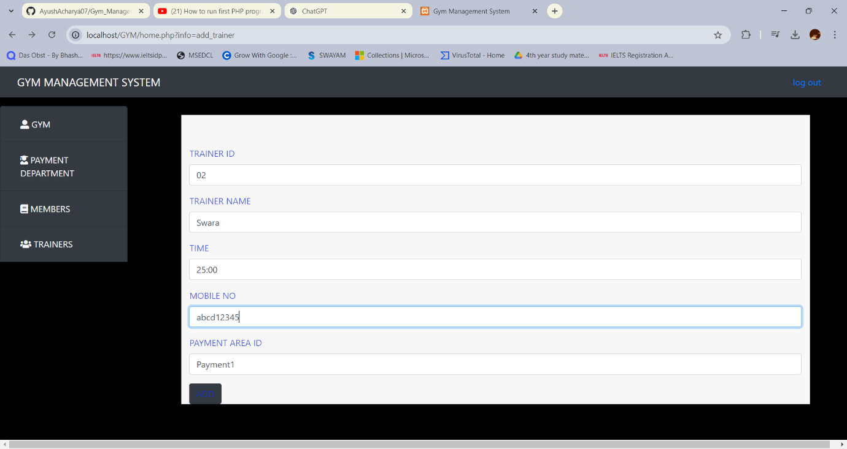

Attachment 1

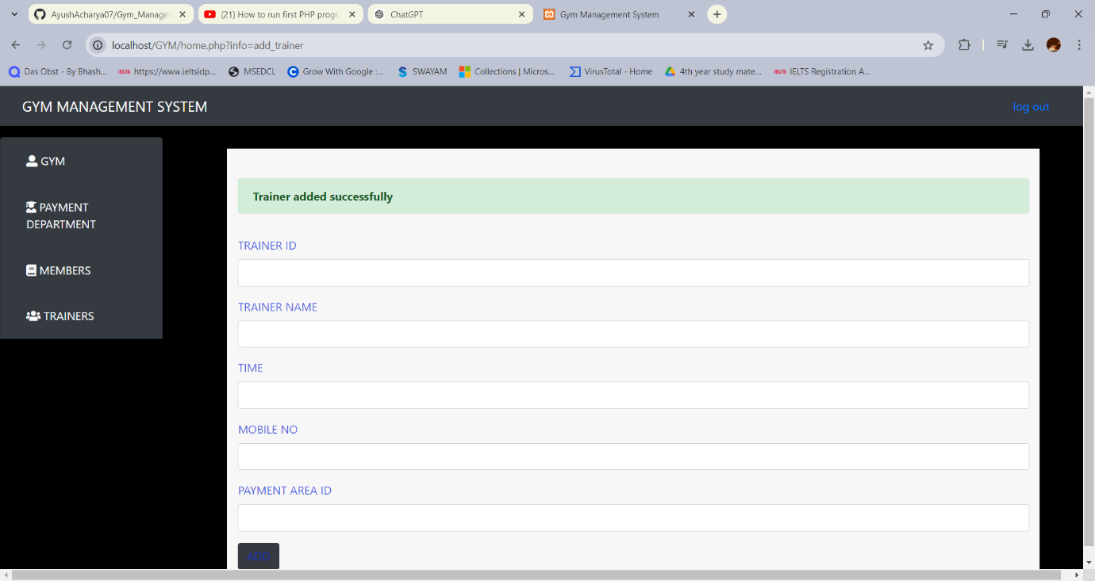

Attachment 2

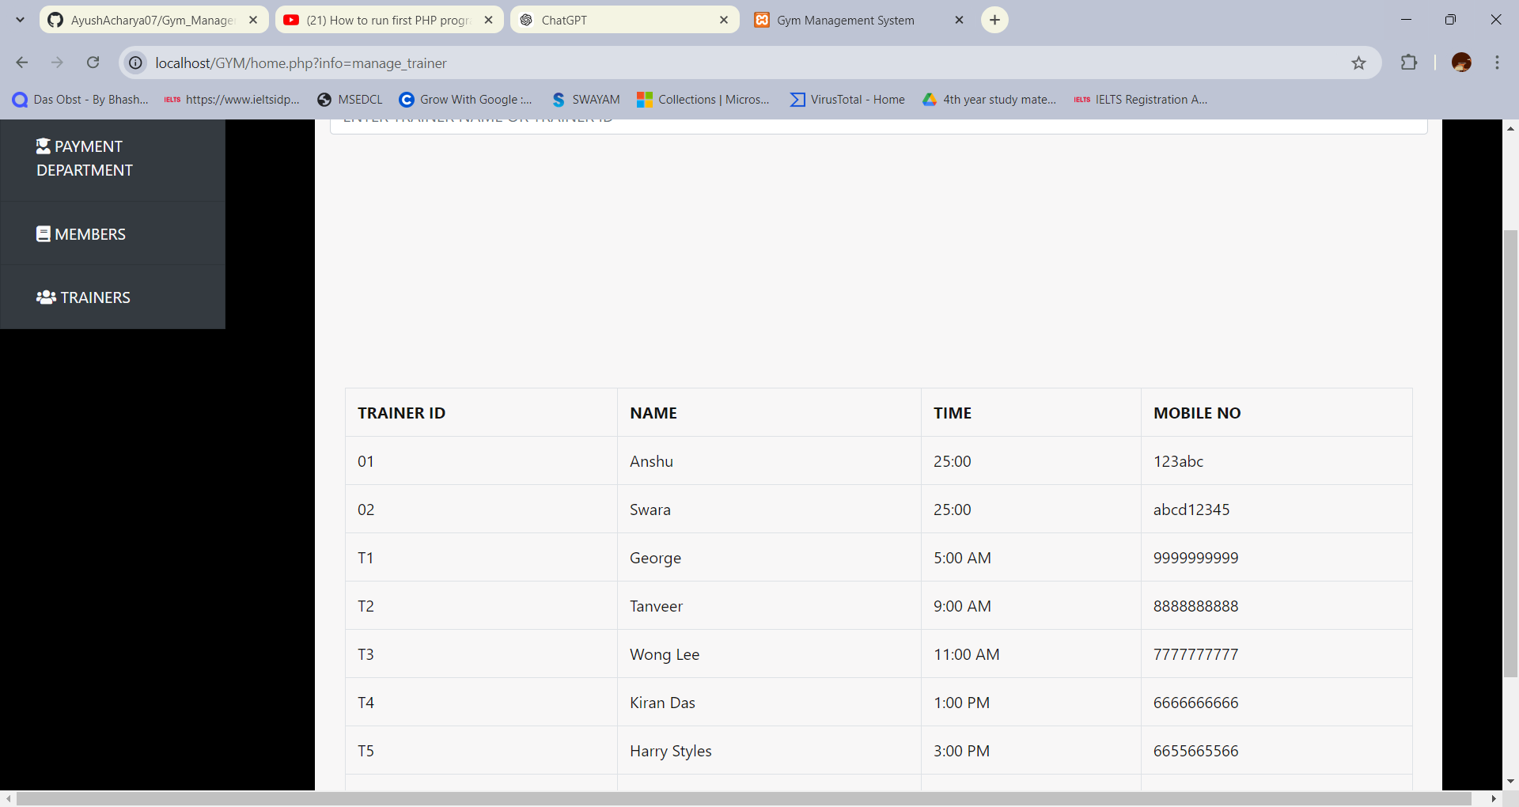

Attachment 3

**Remarks**:

* Implementing proper data validation and user role checks will enhance data integrity and security.

**Defect Severity**: High

**Defect Priority**: High

**Reported By**: Ayush Surendra Acharya

**Assigned To**: Sahil Shirvale

**Status**: Open

**Fixed Build Version**: 2.3.1 Build 46