1)Trainin Assign Issue

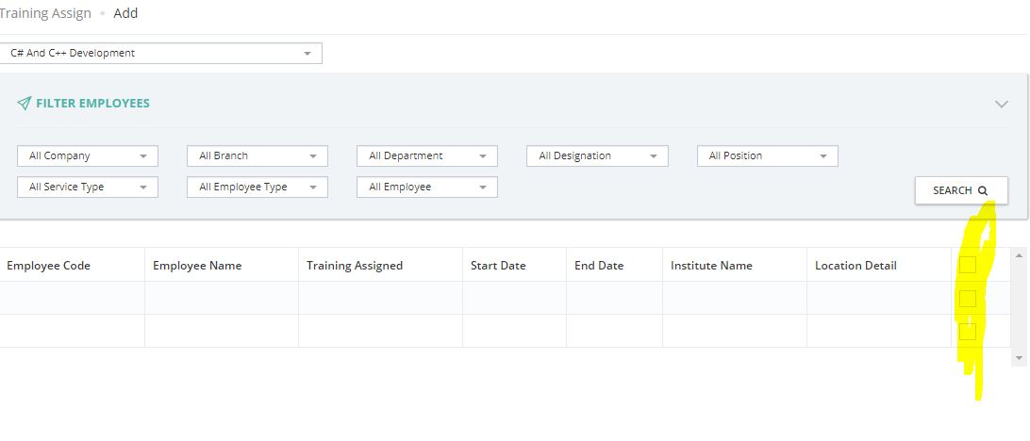

Not showing any employee list in training assign…

2) leave assign issue

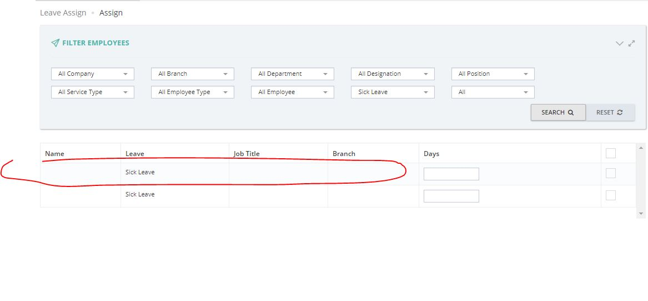

No employee details in leave assign.

3)service view issue

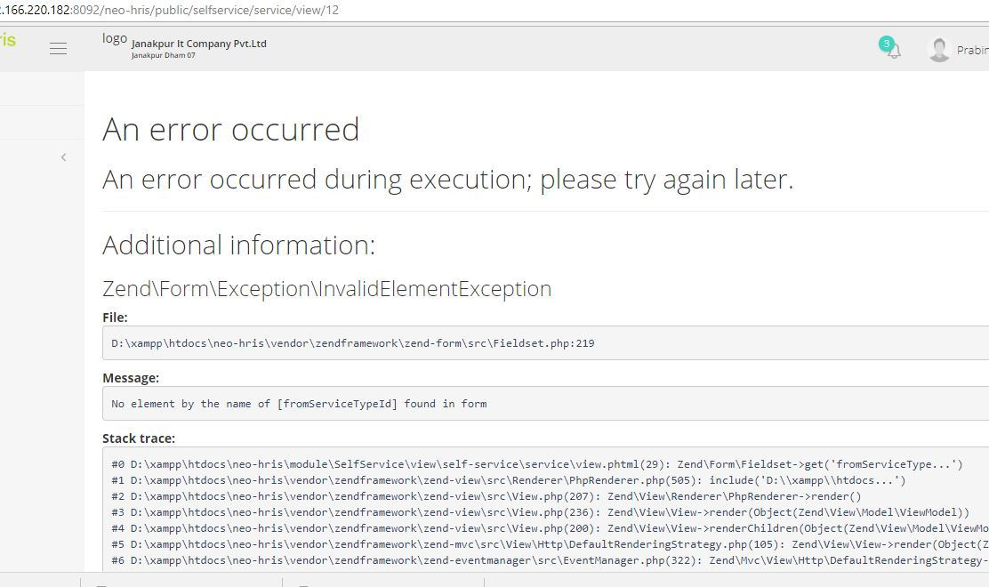

4)