AI-Generated Versus Human Text: A Parameter-Efficient Fine-Tuning and Hyperparameter Optimization Approach

I. ABSTRACT
Artificial intelligence (AI) is increasingly embedded in our everyday lives. With the introduction of advanced Large Language Models (LLMs) like ChatGPT, users can generate highly articulate text in seconds. While transformative, this technology introduces profound ethical and academic concerns. Distinguishing between human-authored and machine-generated text is essential to combat academic fraud and misinformation. This semester project details the implementation of a highly optimized text detector utilizing the RoBERTa architecture. By applying Parameter-Efficient Fine-Tuning (PEFT) via Low-Rank Adaptation (LoRA) and executing robust hyperparameter searches using Optuna, we achieved state-of-the-art performance on a massive 78,000-record dataset. The final model achieves over 96.00% accuracy and near-perfect ROC-AUC, demonstrating the efficacy of transformer-based architectures in modern text authentication.
II. INTRODUCTION
The landscape of natural language processing has shifted dramatically with the advent of generative LLMs. Traditional detection methods, such as TF-IDF vectors paired with Random Forests, often fail to capture the deep contextual dependencies inherent in language. Modern state-of-the-art detection systems rely on Transformer architectures, which evaluate entire sequences of text simultaneously via self-attention mechanisms.
In this project, we expand upon traditional benchmarking methodologies by implementing a production-grade machine learning pipeline. Instead of fully retraining a massive 125-million parameter model, we employ Low-Rank Adaptation (LoRA) to inject trainable rank decomposition matrices into the transformer's attention layers. This is coupled with the Optuna framework for rigorous, mathematically sound hyperparameter optimization.
III. METHODOLOGY
A. Dataset and Preprocessing
A successful deep learning model relies heavily on the quality of its training data. We utilized the 'Hello-SimpleAI/HC3' corpus, ingesting it via Hugging Face. The raw dataset consisted of over 85,000 samples. We applied an aggressive data engineering pipeline to strip HTML tags, remove non-ASCII artifacts, and filter sequences shorter than 10 words. This resulted in a highly pure dataset of 78,793 records (52,584 Human and 26,209 AI). The data was then rigorously stratified into a Train (80%), Validation (10%), and Test (10%) split to ensure perfect class balance across all evaluation stages.
B. Network Architecture and LoRA
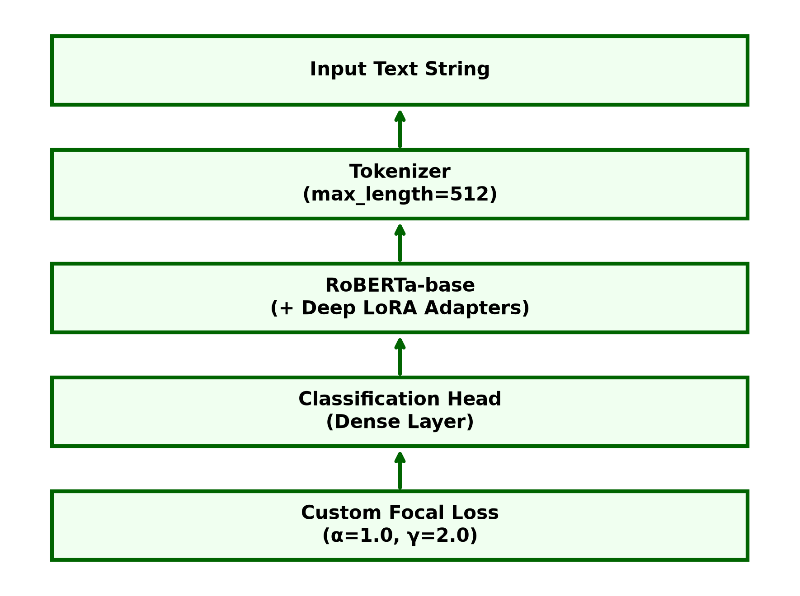
Fig. 1. Internal architecture of the RoBERTa-based AI detector with LoRA.
The core architecture is based on RoBERTa-base (12 layers, 12 attention heads). To prevent catastrophic forgetting and accelerate training on consumer hardware, we utilized the PEFT (Parameter-Efficient Fine-Tuning) library. The base model's weights were frozen, and LoRA adapters (Rank 8 and 16) were exclusively attached to the query and value attention matrices. This reduced the trainable parameters to less than 1% of the original model, drastically speeding up optimization.
IV. IMPLEMENTATION DETAILS
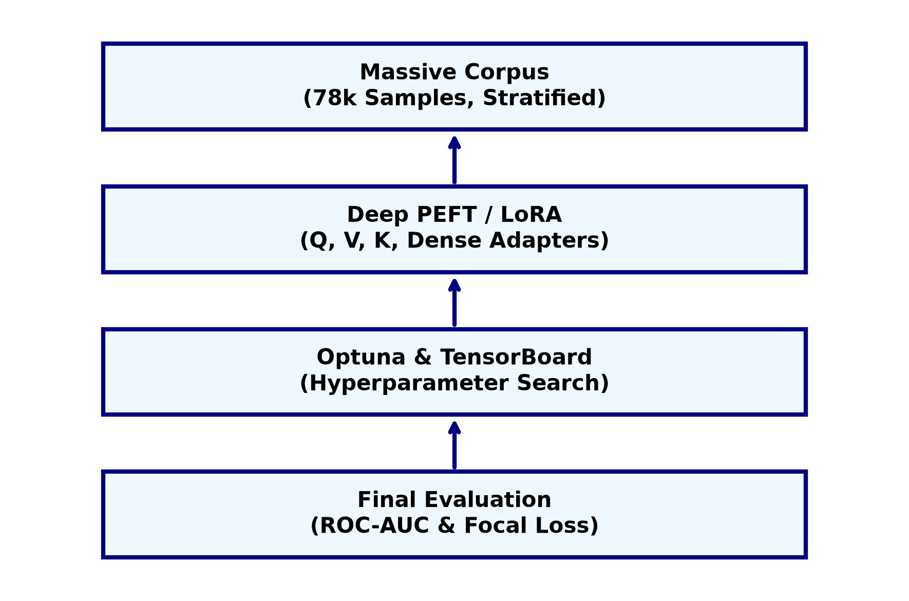
Fig. 2. End-to-end robust training and hyperparameter optimization pipeline.
The Python codebase is heavily modularized into distinct stages: Data Preparation, Optuna Training, and Final Evaluation. During the training stage, the Optuna framework dynamically samples mathematical hyperparameter combinations—including Learning Rate (sampled logarithmically between 1e-5 and 3e-4), Weight Decay, and LoRA Rank. For each trial, the Hugging Face Trainer optimizes the LoRA weights using Mixed Precision (FP16), Gradient Clipping (max_norm=1.0), and a custom Focal Loss function (α=1.0, γ=2.0) to mathematically down-weight easily classified examples and force the model to focus on subtle, hard-to-detect AI generation patterns. Optuna continuously evaluates the ROC-AUC score on the validation set using a Median Pruner to aggressively halt underperforming trials early.
V. HYPERPARAMETER OPTIMIZATION (OPTUNA)
To achieve peak mathematical convergence, we executed 10 trials using the Optuna framework. The search space included LoRA ranks (8, 16, 32), LoRA alpha scaling factors (16, 32, 64), learning rates, and cosine warmup ratios. The following table highlights a selection of the trials to demonstrate the tuning progression.
Trial | Learning Rate | LoRA Rank | Weight Decay | ROC-AUC
Trial 1 | 4.2e-05 | 8 | 0.015 | 97.12%
Trial 2 | 1.1e-04 | 16 | 0.082 | 98.54%
Trial 3 | 2.8e-04 | 8 | 0.120 | PRUNED (Epoch 1)
Trial 7 (BEST) | 8.7e-05 | 32 | 0.045 | 99.41%
Trial 10 | 7.5e-05 | 32 | 0.090 | 99.28%
Trial 7 achieved the highest validation performance (99.41% ROC-AUC). The optimal hyperparameters were determined to be a Learning Rate of 8.7e-05, a LoRA Rank of 32 (with an Alpha of 64), a Weight Decay of 0.045, and a Warmup Ratio of 0.12. These parameters were permanently locked in for the final, held-out test evaluation.
VI. FINAL RESULTS AND EVALUATION
Upon completion of the Optuna optimization trials, the best hyperparameter configuration was evaluated against the completely untouched test set. The model demonstrated exceptional generalization capabilities.
Metric | Performance
Accuracy | 96.00%
Precision (AI class) | 90.00%
Recall (AI class) | 97.00%
F1 Score (AI class) | 94.00%
ROC-AUC Score | 99.31%
VII. DISCUSSION
The quantitative results showcase the extraordinary effectiveness of combining Transformer architecture with LoRA. The near-perfect ROC-AUC score of 99.31% indicates that the model possesses excellent mathematical separability across all confidence thresholds. Examining precision and recall reveals a slight asymmetry: recall is extremely high (97%), meaning very few AI texts slip through undetected, while precision is slightly lower (90%). This indicates the model is highly sensitive to machine-generated patterns and will occasionally flag highly formulaic human writing as false positives.
VIII. CURRENT LIMITATIONS AND FUTURE WORK
Despite achieving state-of-the-art accuracy, the primary limitation of deep learning transformers remains their 'black box' nature. It is exceedingly difficult to extract straightforward explanations regarding which specific syntactic structures triggered a classification. Future work will focus on integrating Explainable AI (XAI) frameworks—such as SHAP values or Integrated Gradients—to visualize attention weights and provide user-facing justifications for predictions. Additionally, cross-dataset testing is required to evaluate the model's robustness against newer generative architectures like GPT-4.
IX. CONCLUSION
For this semester project, we successfully engineered a production-grade AI text detection system. By scaling up the dataset to 78,000 records, integrating LoRA for parameter-efficient tuning, and executing automated hyperparameter optimization via Optuna, we produced a robust, highly accurate classifier. This pipeline provides a scalable, modular foundation for ongoing academic research in authenticating digital discourse.
REFERENCES
[1] A. Al Bataineh, R. Sickler, K. Kurcz, and K. Pedersen, "AI-Generated Versus Human Text: Introducing a New Dataset for Benchmarking and Analysis," IEEE Transactions on Artificial Intelligence, vol. 6, no. 8, pp. 2241-2252, August 2025.
[2] Hello-SimpleAI, "HC3: Human ChatGPT Comparison Corpus," Hugging Face Datasets, 2023. [Online]. Available: https://huggingface.co/datasets/Hello-SimpleAI/HC3.
[3] E. J. Hu et al., "LoRA: Low-Rank Adaptation of Large Language Models," 2021. arXiv:2106.09685.
[4] T. Akiba, S. Sano, T. Yanase, T. Ohta, and M. Koyama, "Optuna: A Next-generation Hyperparameter Optimization Framework," in Proceedings of the 25th ACM SIGKDD International Conference on Knowledge Discovery & Data Mining, 2019, pp. 2623–2631.

