ABSTRACT…………….. #

STUDENT DECLARATION #

**TABLE OF CONTENTS**

1. INTRODUCTION 1

1.1 Context or Background #

1.2 Project Description #

1.3 Current Scenario #

1.4 Aims and Objectives #

2. REVIEW OF LITERATURE #

2.1 Languages to code #

2.2 Similar Applications #

2.3 Analysis and Comparison Table #

2.4 Summary #

3. REVIEW OF TECHNOLOGY #

3.1 Gantt Chart #

3.2 Work Breakdown Structure #

3.3 Use Case Diagram #

4. METHODOLOGY #

4.1 Considered Methodology #

4.2 Approached Methodology #

4.3 Phases of Methodology #

5. PRODUCT DESIGN #

5.1 Gantt Chart #

5.2 Work Breakdown Structure #

5.3 Use Case Diagram #

5.4 Class Diagram #

5.5 ER Diagram #

5.6 Wireframe #

5.7 Prototype Design #

6. SOFTWARE REQUIREMENT ANALYSIS #

6.1 System Features #

6.2 Work Breakdown Structure #

6.3 Use Case Diagram #

7. IMPLEMENTATION AND TESTING #

7.1 Gantt Chart #

7.2 Work Breakdown Structure #

7.3 Use Case Diagram #

8. PRODUCT EVALUATION #

8.1 Gantt Chart #

8.2 Work Breakdown Structure #

8.3 Use Case Diagram #

9. PROJECT EVALUATION #

9.1 Gantt Chart #

9.2 Work Breakdown Structure #

9.3 Use Case Diagram #

10. SUMMARY AND CONCLUSION #

10.1 Gantt Chart #

10.2 Work Breakdown Structure #

10.3 Use Case Diagram #

11. BILBLIOGRAPHY #

First Level Subhead for the Fifth Chapter #

First Level Subhead for the Fifth Chapter #

LIST OF TABLES #

LIST OF FIGURES #

LIST OF TABLES #

ACKNOWLEDGEMENTS iii

**INTRODUCTION**

* 1. **Context or Background**

The act of speaking in front of a live audience has long been referred to as public speaking. ‘‘Public speaking’’ became the general, mostly neutral, term for non-elocutionist oral communication in this emerging discipline (Keith, 2008). Today, it covers any type of public speaking, including pre-recorded speeches given all over long distances via technology. Public speaking assists political candidates, an accounting lesson for potential entrepreneurs or a presentation on projects best practices for an individuals. These individuals may underachieve at work or at school because of anxiety and often avoid speaking in classroom situations (Harris, Kemmerling and North, 2002). So, this mobile application is built for those people who want to improve presentation and public speaking skills.

* 1. **Project Description**

The project's main goal is to develop an Android application for those who wish to enhance their public speaking and presenting abilities by assisting them in developing confidence when giving a speech. In U.S., more than 61% of university students note a fear of speaking in public (Dwyer and Davidson, 2012). Many people might use this software because Android smartphones are more convenient and versatile than any other device. This application not only helps you to speak in public, but also helps you build confidence. With an application, people will be able to practice public speaking skills in a safe environment. They should not, however, be concerned about forgetting their lines or being judged by their peers. In front of any audience, they will feel confident and prepared. An application is not only helpful in listening and speaking but it can also help individual in body postures and hand movement while giving the presentation.

* 1. **Current Scenario**

Public speaking can be a very stressful task. Most people are afraid of it, yet the greatest way to learn is in a comfortable place with a helpful and encouraging audience. It allows user to create relationships in their entire community, which certainly benefits one’s business grow. It makes absolutely no difference if an individual is a teacher, a businessman, or a politician.

However, in meeting, conferences, online video links and presentations are all things they have to deal with on a daily basis. Public speakers must learn how to communicate with a wide variety of audiences, from small crowds to vast halls and auditoriums. The subtext of this change was that speaking was moving from the possession of a few—the talented, the elite, the platform performers—and in the direction of seeing public speaking as a form of communication that occurred in many contexts, and was justified by its success in those settings (Keith, 2008). They must accomplish things up in a particular amount of time with the best possible outcome or reach certain milestones. Furthermore, research has demonstrated that the effectiveness of psychological interventions in the reduction of social and public speaking anxiety differs depending on the measurements used to assess it (Ebrahimi, Pallesen, Kenter and Nordgreen, 2019). This is where Internet comes to handy as these skills of communications are must essentials basically for business purpose.

We cannot guarantee that all users will receive positive outcomes and feedback since virtual learning may not be as effective as classroom learning. For the most part, departments of English and speech and communication have accepted, sometimes gladly, the burden of teaching their students skills, the task of emphasizing functional ability (Keith, 2008). Even with all of the experience from the application, a user may still be scared and terrified to speak in front of a massive gathering.

* 1. **Aims and Objectives**

Talking about the recent context, development has made a solid impact on the society. It is the framework for any human society. As the society is grown up the needs and fulfill needs is increasing day by day. It’s a handy task for the developer as they must suit all of the people's and society's needs. So, this topic have been assigned and introduced to develop such an application called “**Improve Speech**” who really want to improve their public speaking skills and presentation skills.

Public speaking is an essential skill in the professional life. It enables you to communicate, market ideas, and express oneself clearly. Likewise this application, “**Improve Speech”** will guide and cover everything from how to start a speech to how to conclude it. The aims of this application are discussed below:

* Assisting the person in developing Vocabulary and Fluency
* Checking and balancing the pauses or breathing stops
* Analyze speech will ensure that all words are pronounced correctly
* Providing an opportunity to learn how to be a good listener
* There will be some notes or distinctive lines to attract the audience at the start of any topic or at the finish of any contents or presentations
* Given recent top news to engage audience in conversation so that they are not bored
* View the reports and feedback from the system
* To meet public demands or needs, we must improve our capabilities
* While checking punctuality it adds some recent words and phrases

**REVIEW OF LITERATURE**

Mobile technology has improved dramatically in recent years, allowing us to obtain information from any device, at any time. As a result, there is a huge need for mobile-friendly software. Modern applications empower shoppers to remain associated and get to data from any gadget, at any time. Estimating software is crucial for providing the most exact size figure and building confidence between developers and users. Almost each and every organizations and individuals uses modern technologies in order to promote good services and to enhance their business. So it’s up to the developer to plan and develop in such a way that it displays everything in an easy-to-understand style that is straightforward to navigate, making it easier for the user to understand and more secure. The products and services are an important component of the application "**Improve Speech**" and everything is presented in a professional manner. Furthermore, users can select a specific topic to better their knowledge on something specialized, making it available.

* 1. **Languages to Code**

This application will be developed in both java and HTML. This application's primary language is Java. However, HTML is also utilized to build a relatively basic user interface. The application is really simple to use and its user interface provides an easy and effective way to navigate among the pages, allowing the user to get what they are looking for fast and efficiently. An application performance is relatively excellent. There are no delays or lags when operating the service. The application makes use of jQuery for its user interface. To make things look attractive and seamless, the front end makes use of frameworks such as jQuery.

* 1. **Similar Applications**

These applications *Grammarly, Ummo, Orai, LikeSo* are similar applications to one another in functionality. *Grammarly* and *Ummo,* two web-based writing applications, perform similar responsibilities. *Grammarly* focuses on document grammar, spelling, and punctuation. Using artificial intelligence, *Ummo* can recognize complicated structures and idioms inside a phrase. *Ummo* is compatible with Gmail, *Evernote*, and Google Docs. Another free software that leverages artificial intelligence to provide comments and suggestions on written content is *Orai*. *LikeSo* is a social network that allows users to discover each other based on comparable interests or interests they communicate with other individuals.

* + 1. *Grammarly*

*Grammarly* supports streamlined and effective writing. It helps in identifying and replace complicated sentences with more efficient ones, refresh repetitive language, and uphold accurate spelling, punctuation, and grammar. *Grammarly* is a cloud-based typing assistance that evaluates spelling, grammar, punctuation, and other writing skills to help individual improve. It's similar to a spell checker, but for grammar. It improves an individual’s writing so that what user write is clear, effective, and error-free.

**

*Fig 1: Similar Application (Grammarly)*

*2.2.2 Ummo*

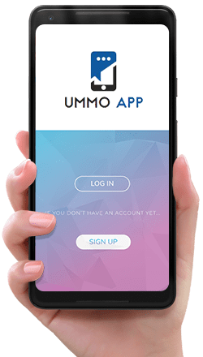

*Fig 2: Similar Application (Ummo)*

*2.2.3 Orai*

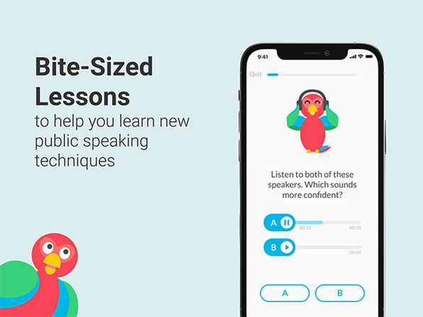

*Fig 3: Similar Application (Orai)*

*2.2.4 LikeSo*

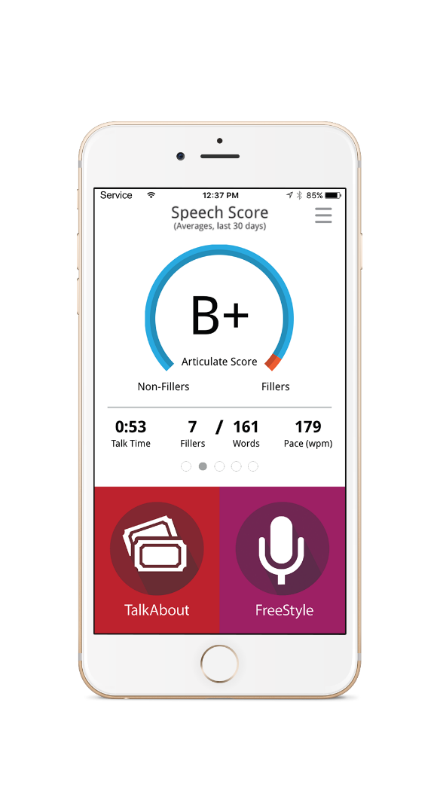

*Fig 4: Similar Application (LikeSo)*

* 1. **Used Platform**

A programming software is a tool or application used in software development to create, debug, maintain, or otherwise support other programs and applications. There are several different pieces of software that were used to develop this app. The design and development of this app took several months to build, from the way the user interacts with the app, to how it functions. Software used to design and develop this app includes Adobe Photoshop, Android Studio, QSEE SuperLite, Google Chrome, Github (code saving), Notepad++ (for notes), Firebase (for data storing). The used platforms and its purposed are discussed below:

* + 1. *Android Studio*

Android Studio is the official integrated development environment (IDE) for Android, developed by Google and based on IntelliJ IDEA. This platform is used for coding the “**Improve Speech**” application as it provides various tools, including a source code editor with features such as code refactoring, syntax highlighting and auto-completion. It is designed for customization, so that it can modify the window layout to suit development and developer style. The Editor Tool Window gives user the instant access to shortcuts and actions that let the programmer quickly import resources, improve code quality, manage device state, debug applications, and more. Android Studio uses the Instant Push functionality to push code and resource changes to a running application. A code editor helps programmers write code by providing code completion, refraction, and analysis (Contributor, 2018).

* + 1. *Firebase*

Firebase is Google's mobile platform that helps app developers build better experiences and grow their businesses. Its core mission is to assist the developers build better apps, grow their user base and increase engagement by providing products and its solutions. It provides cloud storage and is the must require tools for developer to implements its features like authentication, app analytics and crash reporting, cloud messaging, dynamic links, hosting, measuring retention and more. Since it is lightweight, cloud-based solution that helps to manage authentication and cloud hosting for mobile apps. It was also used to store user information and sync data in real time between the devices.

* + 1. *Google Chrome*

Google Chrome is a cross-platform web browser created by Google. It's made for fast searching, browsing and safe online activities. It is very fast and secure web browser built with an emphasis on web standards. It was first released in 2008 and has been rapidly growing in popularity ever since. Built using free software components from Apple WebKit and Mozilla Firefox, Chrome provides a great experience for all of your favorite websites. Similarly, Chrome was used as a case study, research and development of case studies in the appendix or supplement for developing an application. It was eventually ported to Linux, macOS, iOS, and Android, and is now the default browser on those platforms. The browser is also a key component of Chrome OS, acting as a platform for web apps (Wikipedia, 2022).

* + 1. *Notepad*

Notepad is a simple text editor that comes with all versions of Windows. It lets you create, open, and read plaintext files. It's a great place to quickly take notes in ASCII format, or to write small scripts. It uses the default Windows font and color scheme, but user can change these style attributes if you would like. Notepad will not open a file that has specific formatting or is not a plaintext file. (Hope, 2021). It is also the favorite application of several users because it is designed to be simple and effective.

* + 1. *Adobe Photoshop CC*

Adobe Photoshop CC is a piece of professional software that’s capable of editing, processing, compiling and manipulating digital images on all levels. From basic digital photo retouching to advanced 3D rendering, it offers more tools and options than designer would ever need. It was used to create both the company logo, and an application UI. Wireframe was also made using Photoshop and I used as vector art as a background image. Its graphic design software allows designer to create, edit and manipulate various graphics as well as digital art. It was created in 1988 by Thomas Knoll and John Knoll and the official distribution license of the program. There are many versions of Photoshop. (Walker, 2022).

* + 1. *Github*

GitHub is a version control system for tracking changes to computer files and coordinating work on those files among multiple people. It is widely used by developers to store their source code, which can be shared with others or kept private. Its repository was used to save the previous errors into the server for further use which provides an important feature for test case for an application while developing. Commonly, version control makes it simple to access prior versions of an individual’s work and see the differences between them. Work on programming in parallel with others without having to merge changes or check out files. GithHub can be used to save the previous into users PC, so they can make presentations of their work, and share it through social media.

* + 1. *QSEE SuperLite*

QSEE SuperLite is a general modeling environment that can accommodate a wide range of modeling tools. It can be used to build large and complex models, or small and simple ones, with any combination of blocks, base-level components and libraries. There is no need to learn a new language or toolset when switching from one task to another. It is designed for speed and performance and is perfectly suited to meet the needs of today's engineer. This was implemented to start with QSEE Super Lite, which is an extremely easy environment to create class diagrams and UML diagrams. It was developed by Dr. Mark Dixon. It is the result of many years of development work (QSEE, 2022).

* 1. **Analysis and Comparison Table**

**REVIEW OF TECHNOLOGY**

**METHODOLOGY**

**PRODUCT DESIGN**

* 1. **Grant Chart**
  2. **Work Break Down Structure**
  3. **Use Case Diagram**

A use case diagram is a UML following diagram a system from of the perspective of its users and their interactions with it. A use case diagram illustrates how actors engage with the system, their goals or needs, and how the system operates. It usually focuses on the actions and interaction between users and systems within.

A proposed Unified Modeling Language (UML) is made for the mobile application named “**Improve Speech**”. It consists of all the key features that was to be included in the application. The application consists of two major actors. They are:

1. User and
2. Admin

The User and the Admin role has been discussed in Fig: 1 and Fig: 2 separately. As the mentioned diagram keep the track while working on the development.

**

*Fig 1.1: User Use Case Diagram*

The above diagram Fig 1.1 discuses about the User role. Firstly when the User clicks into Register button the system redirects the user to register form. The User have to fill their basic information which will be essential to be used during registration. The system checks and validates the User inputted data. After successfully registration the new user record is inserted into database. The system then redirects the user to login page.

The login systems allow the user or the administrator to access an application. The User have to fill up their credentials which was used during registration. The system checks the entered credentials and redirects the User to its particular dashboard respectively.

After accessing to dashboard, User can now use the application features. Talking about its working, when the user clicks on recording button it analyses user voice and transform it into text. It checks the grammatical errors, checks breathes and pauses, fills and add up the words, checks the accuracy of the user. After all of these tasks have been completed, a report is created. The user can also manage their profiles, view profile, view reports. If they desire to sign out of the system, the system will log them out as well.

* 1. **Class Diagram**



*Fig 2.1: Admin Use Case Diagram*

* 1. **ER Diagram**
  2. **Wireframe**

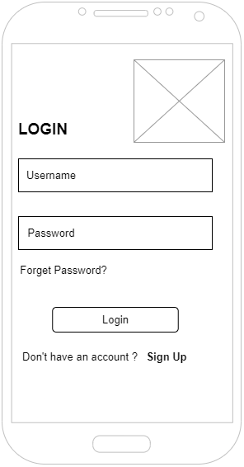

*Fig 5.6.1: Login wireframe*

The figure 5.6.1 is the wireframe for login page. It consists of two text field area placed for user email and password. There are also two buttons (i.e. Login and Sign Up). Log in is for logging the user and while the other is for user registration.

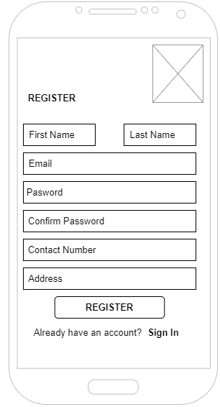

*Fig 5.6.2: Register wireframe*

The figure 5.6.2 is the wireframe for register page. It consists of all the details required for user for registration. It includes first name, last name, email, and password, confirm password, contact number and address. There are also two buttons (i.e. Register and Sign In).Register is for registering the new user and while the other is for redirecting the user for login.

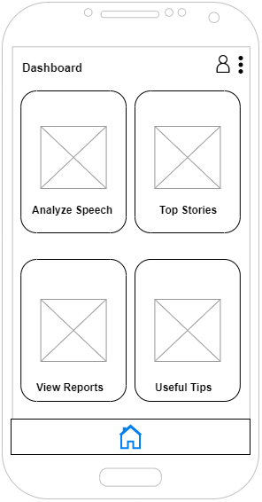

*Fig 5.6.3: Dashboard wireframe*

The figure 5.6.3 is the wireframe for dashboard page. It consists of four major buttons for redirecting the user for different purpose. At the top of the title the profile icon redirects user to view their profile. Pressing on breadcrumbs enables the dropdown link for Log out, which log out the user from the application.

Analyze speech for redirecting the user for testing, and checking grammar. Top stories is for redirecting the user for viewing top global news. View reports is for redirecting the user for viewing their progression. Useful tips is for redirecting the user for providing the user with public speaking tricks.

Lastly, the home icon is placed for redirecting the user to their main dashboard.

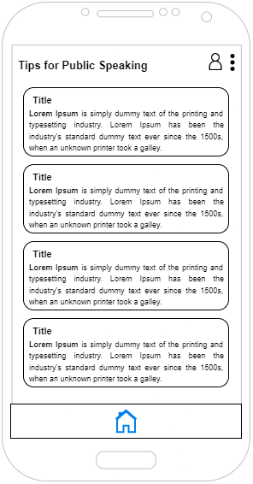

*Fig 5.6.4: Tips for public speaking wireframe*

The figure 5.6.4 is the wireframe for useful tips. It displays tips for user in order to enhance public speaking skills.

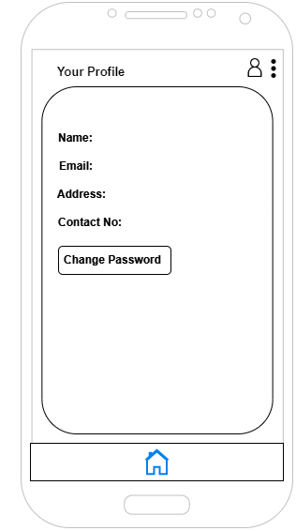

*Fig 5.6.5: Profile wireframe*

The figure 5.6.5 is the wireframe for profile page. It shows the details of the user. User can also change their password accordingly.

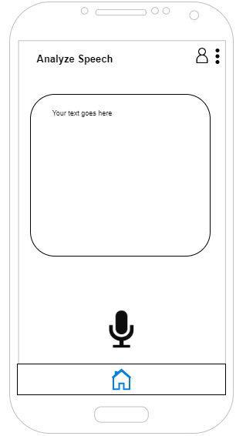

*Fig 5.6.6: Analyze speech wireframe*

The figure 5.6.6 is the wireframe for analyze speech page. It consists of text field and two buttons. The mic button is for getting the input from user voice and the check button is for checking the user’s grammatical errors.

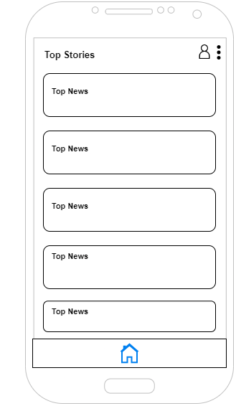

*Fig 5.6.7: Top stories Wireframe*

The figure 5.6.7 is the wireframe for top stories page. It displays the global news for the user.

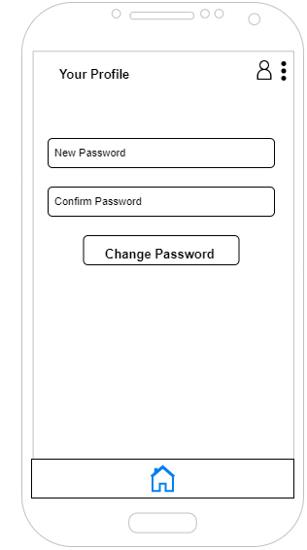

*Fig 5.6.8: Change password wireframe*

The figure 5.6.8 is the wireframe for change password page. It consists of two text field where user can change their password accordingly. The change password button checks and changes the user’s password.

* 1. **Prototype Design**

A prototype design was made based on the wireframe. It was used solid works to design the prototype while keeping the ideas and vision in mind. Then the built prototype is carried out to test its functions, quality and usability on real users

**SOFTWARE REQUIREMENT ANALYSIS**

**IMPLEMENTATION AND TESTING**

**PRODUCT EVALUATION**

**PROJECT EVALUATION**

**SUMMARY AND CONCLUSION**

**REFERENCES**

Contributor, T., 2018. What is Android Studio? - Definition from WhatIs.com. [Online] Available at: https://www.techtarget.com/searchmobilecomputing/definition/Android-Studio [Accessed 21 06 2022].

Dwyer, K. and Davidson, M., 2012. Is Public Speaking Really More Feared Than Death?. Communication Research Reports, 29(2), pp.99-107 [Accessed 14 05 2022].

Ebrahimi, O., Pallesen, S., Kenter, R. and Nordgreen, T., 2019. Psychological Interventions for the Fear of Public Speaking: A Meta-Analysis. Frontiers in Psychology, 10 [Accessed 08 03 2022].

Harris, S., Kemmerling, R. and North, M., 2002. Brief Virtual Reality Therapy for Public Speaking Anxiety. CyberPsychology &amp; Behavior, 5(6), pp.543-550 [Accessed 27 05 2022].

Hope, C., 2021. What is a Notepad?. [Online] Available at: https://www.computerhope.com/jargon/n/notepad.html [Accessed 21 06 2022].

Keith, W., 2008. On the Origins of Speech as a Discipline: James A. Winans and Public Speaking as Practical Democracy. Rhetoric Society Quarterly, 38(3), pp.239-258 [Accessed 13 05 2022].

QSEE, 2022. QSEE Technologies | Leeds Beckett University. [Online] Available at: <https://www.leedsbeckett.ac.uk/qsee-technologies/> [Accessed 23 05 2022].

Walker, A., 2022. What is Photoshop? Introduction, Meaning, Definition & History. [Online] Available at: https://www.guru99.com/introduction-to-photoshop-cc.html [Accessed 14 06 2022].

wikipedia, 2022. *Google Chrome - Wikipedia.* [Online] Available at: <https://en.wikipedia.org/wiki/Google_Chrome> [Accessed 07 06 2022].