Vocational Education and Training (VET) Performance & Strategic Delivery Report

Executive Summary
This report describes the analytical methodology and the key strategic insights from the VET master dataset. We have created a clear view of our training ecosystem based on data by bringing together Enrolment, Organization, Contract and Student records into a single analytical model. The analysis maps the use of targeted funding sources across regional footprints and profiles our student demographic base and tracks operational delivery against Annual Hours Curriculum (AHC) targets.

Scope and Methodology
The analysis includes four datasets from the VET workbook: Organization (providers), Contract (funding targets), Enrolment (unit level records) and Student (learners). We reviewed each for completeness, duplicates and consistency, fixed what could be safely fixed and then profiled it. They are linked by provider id by provider.

- Delivery Baseline
In our analysis, we cover the full Vocational Education and Training (VET) delivery footprint from 1 January 2023 to 31 December 2025 across 5 geographic regions. 8 registered training providers in the dataset, 3 public institutions and 5 private organizations with 23 active government funding contracts. During this three-year period, the delivery network provided teaching for 1,974 individual learners who made 5,505 distinct unit enrolments. Following the necessary data corrections, total contracted capacity across all funding streams is approximately 681,000 Annual Hours Curriculum (AHC).

- Data Audit and Cleansing Methodology
Before assessing provider performance, we conducted a data audit that identified three structural errors in the raw dataset that would otherwise skew executive reporting. First, the top-line contract targets were underestimated by approximately 10% due to data-entry misses: contracts DCVT-2008 and DCVT-2021 had zero total hours, despite having 68,310 hours allocated across their regional breakdowns, whereas contract DCVT-2020 was zero across all fields. Secondly, enrolment numbers by region were artificially inflated by 25% (from 5,500 actual enrolments) due to duplicate provider listings in the primary organization table that over-represented delivery in Darwin and Alice Springs. Third, the analysis of delivery revealed heavy concentration by sector with Community Services accounting for nearly a third of all enrolments. There were strong swings in monthly volumes from 90 enrolments per month in 2023 to 250 in 2024 before settling down to 120 in 2025.

Findings
- Funding Source Target Allocations
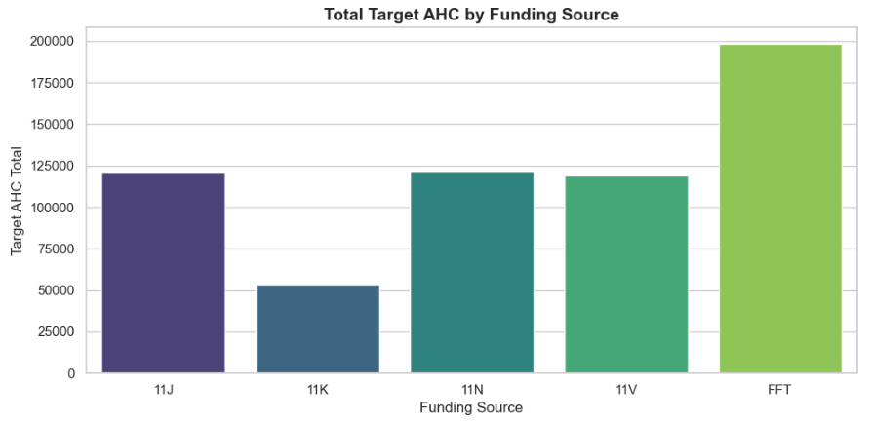
Figure 1
The distribution of the Total Target Annual Hours Curriculum (AHC) across five active sources of funding in the network is presented in Figure 1. The visual shows that the FFT stream is the dominant driver of training capacity with almost 200,000 target hours, far exceeding all other categories. In contrast, funding sources 11J, 11N and 11V are a highly standardized mid-tier, with each stream contributing approximately 120,000 target hours to the overall delivery baseline. Lastly, the 11K stream has the least allocation with about 50,000 hours. This indicates how much our strategy depends on the FFT contract to be able to achieve the other delivery goals of the organization.

- Regional Distribution of Contract Targets by Funding Source
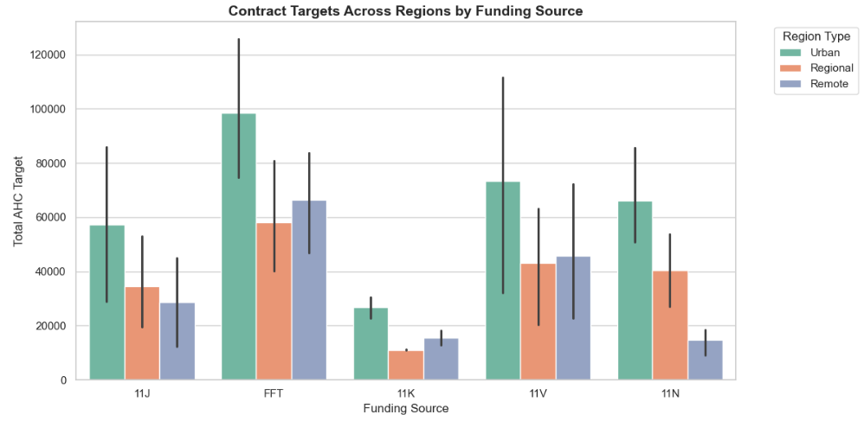
Figure 2
In figure 2, grouped bar chart The regional breakdown of Total Target Annual Hours Curriculum (AHC) by five key funding sources, grouped by Urban, Regional and Remote delivery zones. Across all funding streams visualized, Urban regions consistently experience the highest target allocations, most notably peaking within the FFT stream, approaching 100,000 AHC and serving as the dominant overall capacity driver. Generally, there is less money across the network for Regional and Remote targets, but funding streams such as FFT and 11V are more evenly spread geographically, with roughly equal or slightly more money for Remote targets than Regional. In addition, the large error bars for most of the categories indicate a high statistical variance between individual contracts in these funding pools, indicating large variations in the sizes of specific regional contracts.
- Organisation Types Across Regions
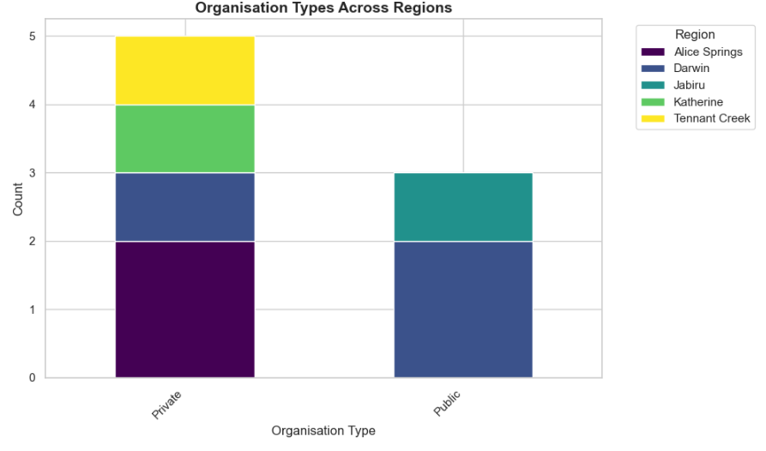
Figure 4
The bar chart shows the regional footprint of the network’s Registered Training Organizations (RTOs) in a stacked bar chart, with the RTOs grouped by operational model (Private and Public). The visualization shows the dominance of Private providers with five RTOs and a broader geographic range including Alice Springs, Darwin, Katherine and Tennant Creek. Conversely, the three Public RTOs are highly concentrated and operate only in Darwin and Jabiru. This distribution indicates that private organizations are the primary providers of training in remote and regional locations outside the major urban centers.
- Student Distribution by Age Group
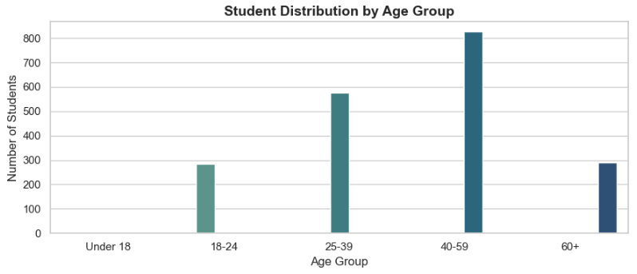
Figure 4
Figure 4. Bar chart represents the distribution of students in different age brackets. The data reveals a highly divided student body with two major demographic peaks.
The dominant segment is the "40-59" age group, which accounts for the biggest share of learners, with well over 800 students. The secondary peak falls in the “25-39” bracket, comprising about 550 to 600 students. Meanwhile, the younger and older cohorts are far less engaged; the “18-24” and “60+” brackets are both hovering just under 300 students. It is interesting to note that there are no students in the “Under 18” category, which may point to the fact that the current training programs are not reaching or targeted at school age students or those who have just left school.
This distribution is unique and indicates a training environment with a predominance of mature-age learners and established professionals. Presumably, this reflects upskilling programs or career transition programs rather than entry-level or foundational youth pathways.

- Top 10 Training Programs by Enrolment Volume
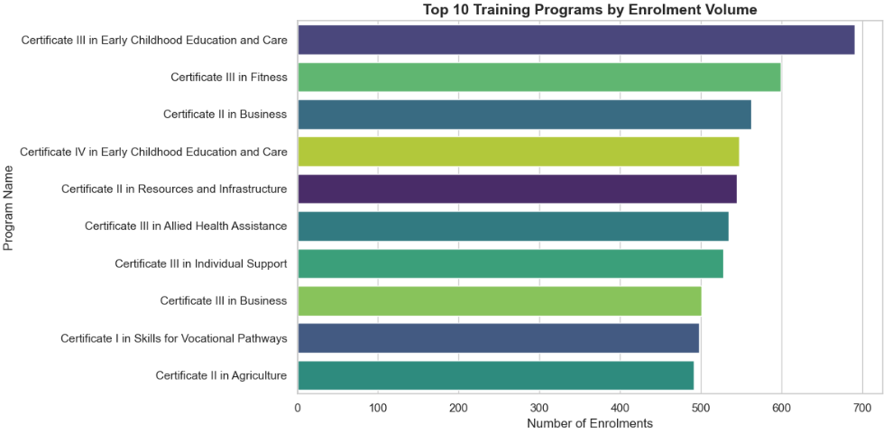
Figure 5
The above diagram shows the 10 most popular training programs by total enrolment volume. The data shows a strong preference for foundational and care focused qualifications, with the “Certificate III in Early Childhood Education and Care” clearly being the winner with almost 700 enrolments. This is followed by the “Certificate III in Fitness” with about 600 enrolments and the “Certificate II in Business” and “Certificate IV in Early Childhood Education and Care” each with around 550 students. The other programs in this group, which cover sectors from Allied Health to Agriculture, have very high and quite stable levels of engagement, with around 500 enrolments per program.

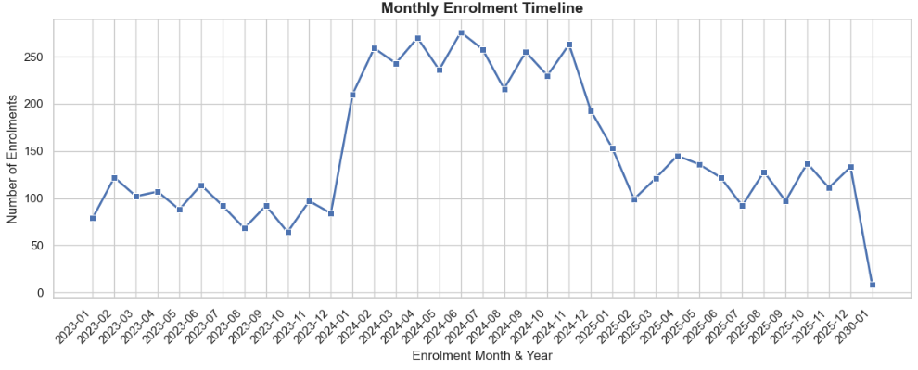
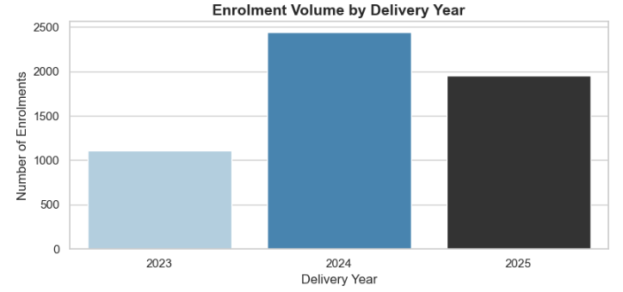
- Enrolment Delivery Trends (Yearly and Monthly)

Figure 6
Figures 6 shows a very volatile enrolment trajectory over the delivery time horizon with a massive spike in training activity in 2024 and a structural decline in 2025. The annual data demonstrates that the overall volume more than doubled from about 1,100 enrolments in 2023 to nearly 2,500 in 2024. This increase is clearly illustrated in the monthly timeline where activity reached its highest point in April 2024 with 275 individual enrolments. The rapid overheating was probably triggered by a particular targeted funding injection like our dominant Fee-Free TAFE contract which temporarily captured a backlog of learners transitioning into high demand sectors.
However, the data does suggest a steep structural correction heading into 2025 where monthly volumes fall back to a much lower baseline of 100 to 150 enrolments which is the key message for executive leadership that the 2024 peak was a localized anomaly that signaled market saturation (or hitting contract caps). Accordingly, all future budget and resource planning must move away from managing pure volume and instead be modelled only on the stabilized 2025 baseline, so as to reduce operational and financial risk

- Top RTO Market Share (% of Total Enrolments)
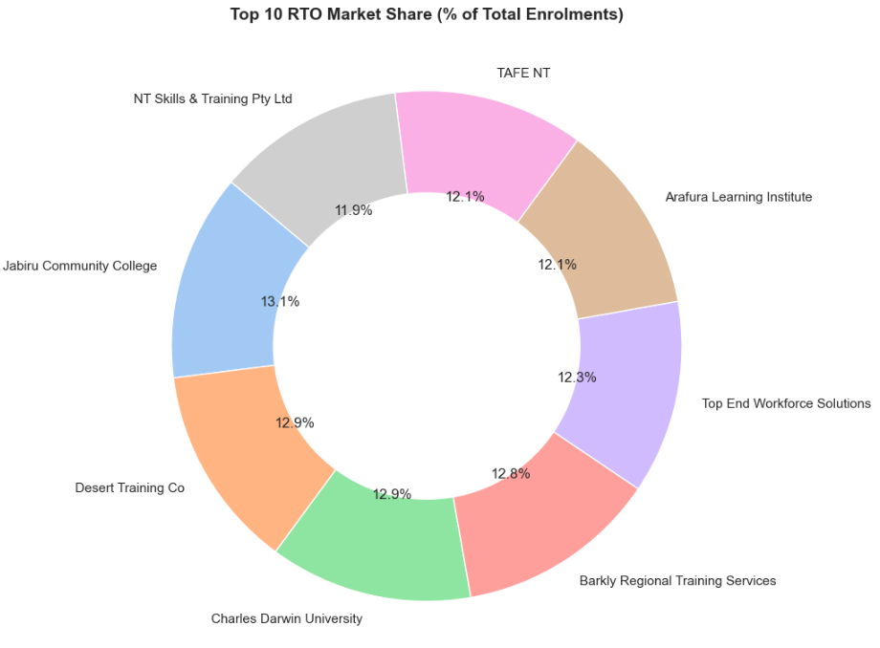
Figure 7
Figure 10 is a doughnut chart of the network’s Registered Training Organizations’ (RTOs’) proportional market share by total enrolment volume. The visualization shows the entire ecosystem of eight active providers in the network with an amazingly even distribution of training delivery. Market share is fairly distributed across all partners, with Jabiru Community College at 13.1% being the highest volume and NT Skills & Training Pty Ltd at 11.9% being the lowest. All other providers, including Desert Training Co (12.9%), Charles Darwin University (12.9%) and TAFE NT (12.1%) fall into a closely bunched 12-13% capacity range. From a strategic perspective, this near parity in market terms suggests a broad and highly diversified overall VET delivery network that is not overly reliant on any one dominant institution. This balanced ecosystem is inherently a mitigating factor against operational risk, with a localized disruption to one training provider impacting no more than 13% of the network’s total enrolment capacity.
Limitations
The combined analytical model provides a good basis for decision-making, but some limitations in the dataset and scope should be acknowledged:
- Historical Data Quality: The underlying data had major structural errors, with 10% of contract targets missing and enrolments inflated artificially by 25 per cent through duplication of providers. While these were corrected to form the current baseline, the presence of these errors highlights vulnerabilities in initial data entry and extraction processes.

- Privacy-Driven Aggregation: To guarantee strict compliance with data privacy protocols, all sensitive personal identifiers (such as national student identifiers) were masked or dropped during the cleansing phase. Therefore, we are unable to follow individual lifelong learner journeys across multiple programs or years.

- Absence of Qualitative Context: The dataset captures things that happened, and the huge 2024 enrolment surge and 2025 retraction are well reflected in the dataset. However, the dataset does not contain qualitative feedback that is necessary to provide definitive explanation of the why (e.g., policy triggers, student motivations for enrolment, or reasons for withdrawing from units).

Recommendations
Given the analytical results and delivery trends identified in this report, we recommend the following strategic actions:
- Support the 2025 Planning Baseline: Executive leadership must recognize the 2024 peak (275 monthly enrolments) as a localized, policy-driven anomaly. To avoid severe financial and operational risk, all forward-budgeting, resource allocation and contract capacity planning in the future should be strictly modelled on the stabilized 2025 baseline (100 to 150 monthly enrolments).

- Expand into remote areas using private providers: The data clearly shows that private organizations are the main drivers of training access outside major urban areas, while public institutions remain concentrated in hubs such as Darwin and Jabiru. To expand remote delivery, funding strategies need to deliberately secure and expand private RTO partnerships or explicitly mandate decentralization in future public contracts.

- Extend sector reach: The current ecosystem is heavily reliant on the Fee-Free TAFE (FFT) funding stream and skewed toward mature-age learners (40-59) upskilling in Community Services. We suggest exploring targeted funding incentives to capture the completely unrepresented “Under 18” demographic and to spur enrolment into underserviced technical or emerging industry sectors.

- Endorse Corrected Data Baseline: Prior to any provider-by-provider performance benchmarking, leadership must formally endorse the data corrections described in the methodology. Further, stricter validation should be enforced at the data entry level to avoid future zero-value target entries and duplicate organization records.

Summary
The development of this unified VET analytical model has turned fragmented, error-prone data silos into a trusted, single source of truth for executive reporting. The overarching network is structurally sound, with a very diversified market share and no RTO having more than 13% of the total enrolment volume. This even spread greatly diminishes the risks of localized operations.
However, the analysis also reveals a network highly sensitive to external funding catalysts, as evidenced by the unsustainable delivery surge in 2024 and the heavy concentration in specific demographics and sectors. By formally adopting the corrected 2025 delivery baseline, leadership can shift from volume management to strategic diversification, so that future government funding is used efficiently, equitably and sustainably across all regions.

Codebase & Reproducibility of Project
All scripts for data analysis, relational mapping and visualization used to produce this report are stored in a version-controlled repository. The full code pipeline can be found by reviewers at: GitHub Project Repository.

