ADVANCED DATA ANALYSIS AND VISUALIZATION IN LOGISTICS

Executive Summary
This report demonstrates an advanced exploratory data analysis (EDA) workflow using a hypothetical logistics dataset containing 1,200 shipment records. The simulated dataset represents shipment dates, regions, transport modes, carriers, distance, shipment volume, traffic intensity, weather disruption, warehouse handling time, delivery time, delay and transportation cost. The objective is to identify operational patterns, cost drivers and potential bottlenecks that could inform logistics management decisions.
The simulated operation achieves an overall on-time delivery rate of 29.2% with an average delivery time of 9.29 hours and average transport cost of 159.91 cost units per shipment. Because the data are hypothetical, these figures illustrate analytical interpretation rather than real-world performance.

1. Data Simulation and Dataset Design
A synthetic dataset was created to resemble a shipment-level logistics operations table. Random generation was controlled with a fixed seed (42) so the analysis can be reproduced. The data-generating logic deliberately introduces relationships that are plausible in logistics: longer distances increase transit time and cost; traffic and weather disruptions increase delay; handling time contributes to both delivery time and cost.
Variable | Type | Purpose
Date | Date | Trend and seasonality analysis
Region | Categorical | Geographic performance comparison
Mode | Categorical | Road/Air/Rail comparison
Carrier | Categorical | Carrier performance benchmarking
Distance_km | Numeric | Route length and cost driver
Shipment_Volume | Numeric | Demand/resource workload
Traffic_Index | Numeric (0–1) | Congestion effect
Weather_Disruption | Binary | Disruption indicator
Handling_Hours | Numeric | Warehouse/process time
Delivery_Time_Hours | Numeric | Service performance
Delay_Hours | Numeric | Late-delivery severity
Transport_Cost | Numeric | Cost efficiency
On_Time | Binary | Primary service outcome

2. Exploratory Data Analysis Methodology
The EDA follows five stages: (1) inspect structure and distributions, (2) calculate central tendencies and variability, (3) examine trends, (4) compare operational segments, and (5) study relationships and correlations. Visualization is used alongside numerical summaries because a single average can hide skewness, outliers or differences between regions and modes.
import pandas as pd
import matplotlib.pyplot as plt
df = pd.read_csv("logistics_simulated.csv")
print(df.shape)
print(df.info())
print(df.describe(include="all"))
print(df.isna().sum())

3. Central Tendency and Distribution Analysis
Average delivery time is 9.29 hours, while the median is 8.23 hours. The mean transport cost is 159.91, with a median of 145.19. The mean and median are reasonably close, but the upper tail still matters because a smaller group of long-distance or disruption-affected shipments can consume disproportionate resources.
Metric | Mean | Median | Std. Dev.
Distance_km | 428.56 | 372.75 | 268.27
Shipment_Volume | 8.51 | 7.00 | 5.22
Delivery_Time_Hours | 9.29 | 8.23 | 5.36
Delay_Hours | 1.64 | 1.52 | 1.05
Transport_Cost | 159.91 | 145.19 | 68.25
Cost_per_Unit | 24.66 | 19.91 | 17.65

4. Visualization 1 — Monthly Shipment Volume
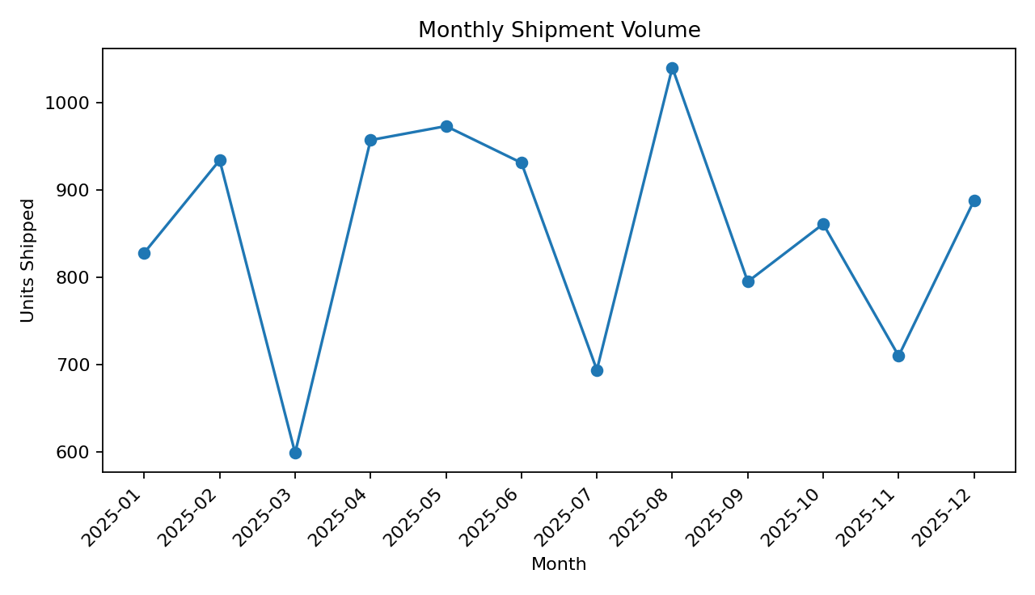
Interpretation: the monthly trend shows how workload changes over time. A volume peak is operationally important because higher shipment volume can increase warehouse workload, transport demand and congestion. Managers can use this view to anticipate staffing, vehicle capacity and inventory availability requirements. The line chart is appropriate because the x-axis is a chronological sequence and the primary question is how volume changes over time.
monthly = df.groupby(df["Date"].dt.to_period("M"))["Shipment_Volume"].sum()
monthly.plot(kind="line", marker="o")
plt.title("Monthly Shipment Volume")
plt.xlabel("Month"); plt.ylabel("Units Shipped")
plt.show()

5. Visualization 2 — Delivery-Time Distribution
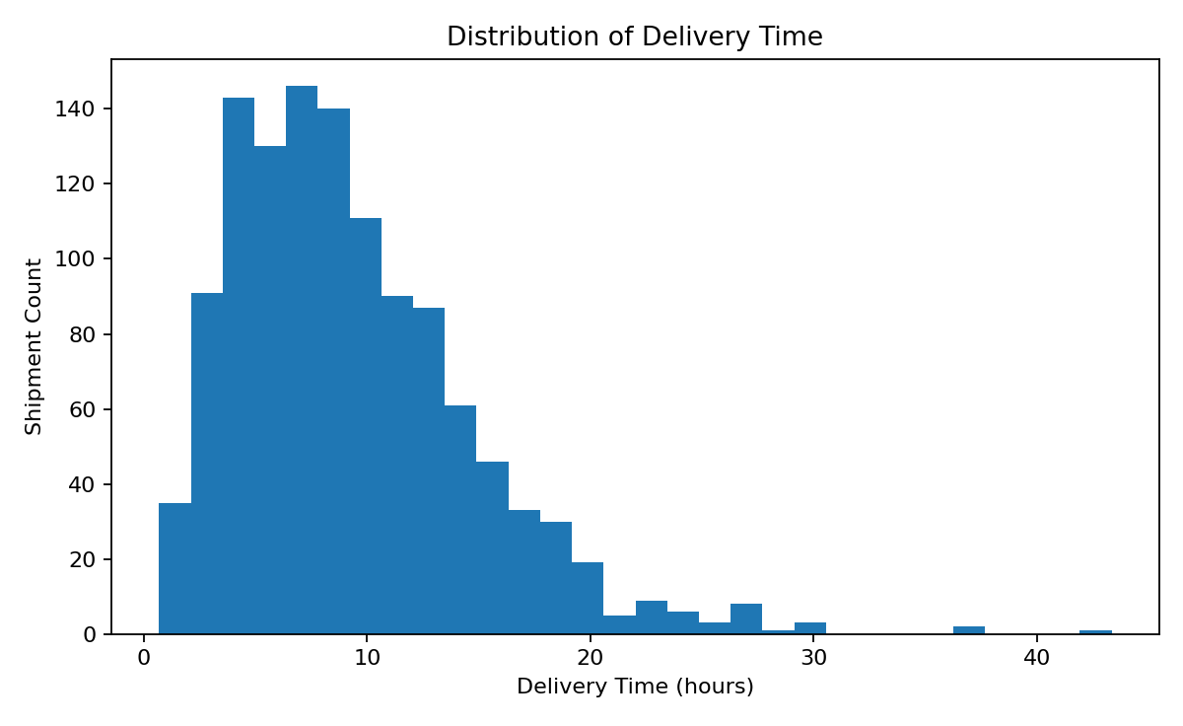
Interpretation: the histogram shows the concentration of delivery times and the size of the long tail. This matters because average delivery time alone cannot reveal whether most shipments are stable while a small number experience severe delays. A histogram is suitable for understanding distribution shape, spread and potential outliers.
plt.hist(df["Delivery_Time_Hours"], bins=30)
plt.title("Distribution of Delivery Time")
plt.xlabel("Delivery Time (hours)")
plt.ylabel("Shipment Count")
plt.show()

6. Visualization 3 — Delivery Time by Transport Mode
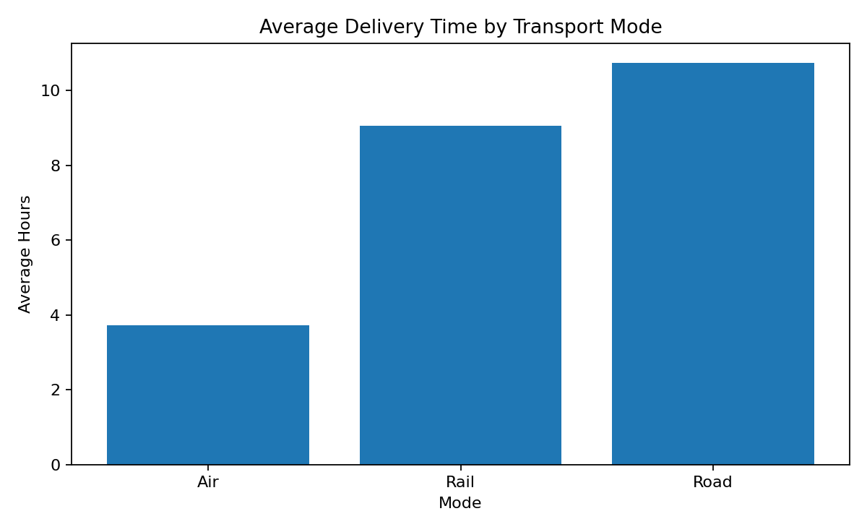
Interpretation: transport mode creates a clear strategic trade-off. Air generally provides shorter transit time in the simulation but carries a higher cost structure; road and rail are more suitable when cost efficiency is prioritized and time constraints are less severe. A bar chart is appropriate because the comparison involves a small number of discrete categories.
mode_summary = df.groupby("Mode")["Delivery_Time_Hours"].mean()
mode_summary.plot(kind="bar")
plt.title("Average Delivery Time by Transport Mode")
plt.ylabel("Average Hours")
plt.show()

7. Visualization 4 — Distance vs Transportation Cost
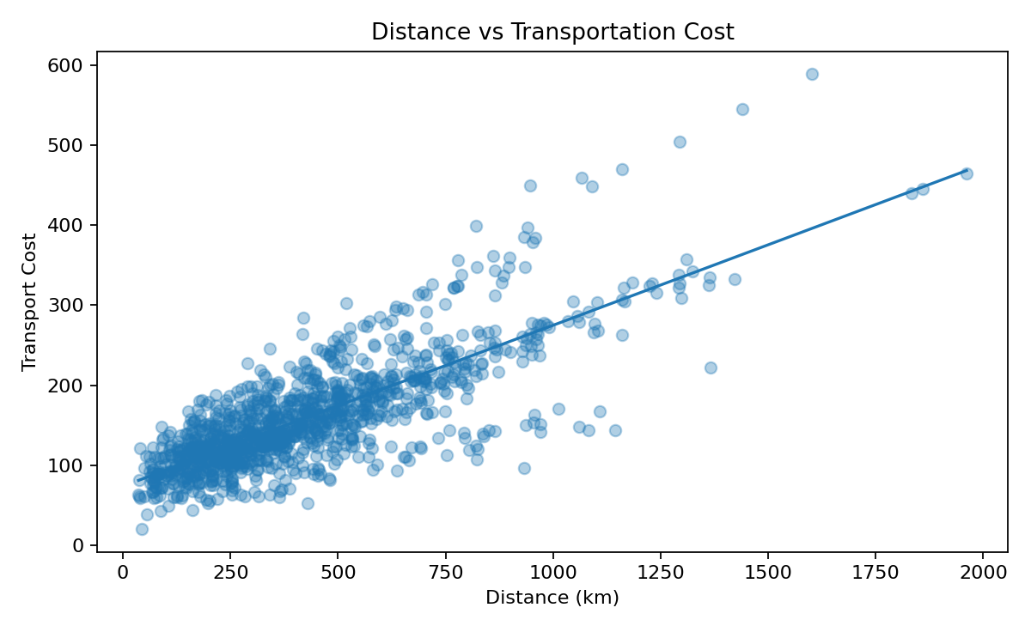
Interpretation: the scatter plot shows a positive relationship between distance and transport cost. In the simulated data, the Pearson correlation is 0.79. This indicates that route distance is an important cost driver, although the spread around the trend line shows that volume, handling, mode and random operating conditions also affect cost. A scatter plot is appropriate because it shows both relationship direction and individual observation variability.
plt.scatter(df["Distance_km"], df["Transport_Cost"], alpha=0.35)
plt.xlabel("Distance (km)")
plt.ylabel("Transport Cost")
plt.title("Distance vs Transportation Cost")
plt.show()

8. Visualization 5 — Regional On-Time Delivery
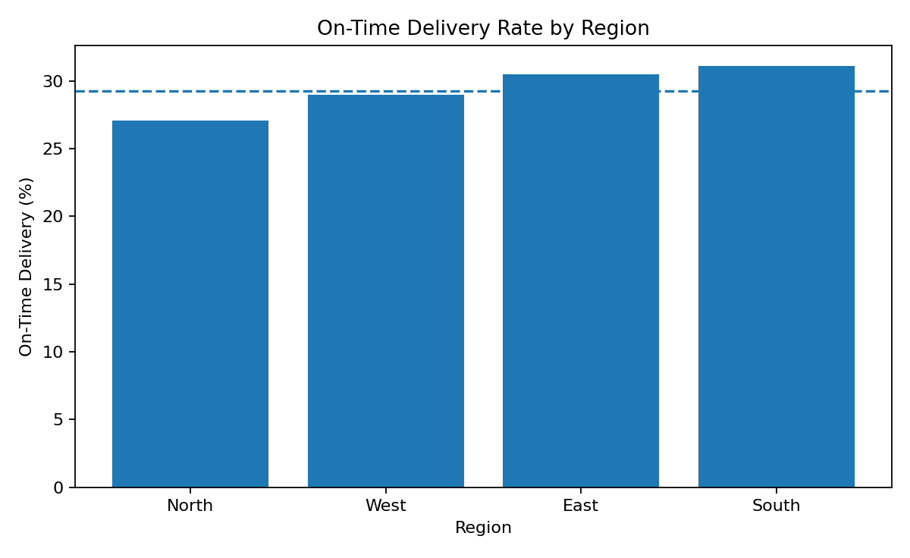
Interpretation: regional performance differs in the simulation. The highest OTD region is North at 31.1%, while South is lowest at 27.1%. A horizontal or vertical bar chart makes category-to-category service differences immediately visible. A region with persistently lower OTD should be investigated for route design, carrier mix, traffic exposure, warehouse handling or destination-specific constraints.
region_otd = df.groupby("Region")["On_Time"].mean() * 100
region_otd.plot(kind="bar")
plt.axhline(df["On_Time"].mean() * 100, linestyle="--")
plt.title("On-Time Delivery Rate by Region")
plt.ylabel("On-Time Delivery (%)")
plt.show()

9. Visualization 6 — Traffic Intensity and Delay
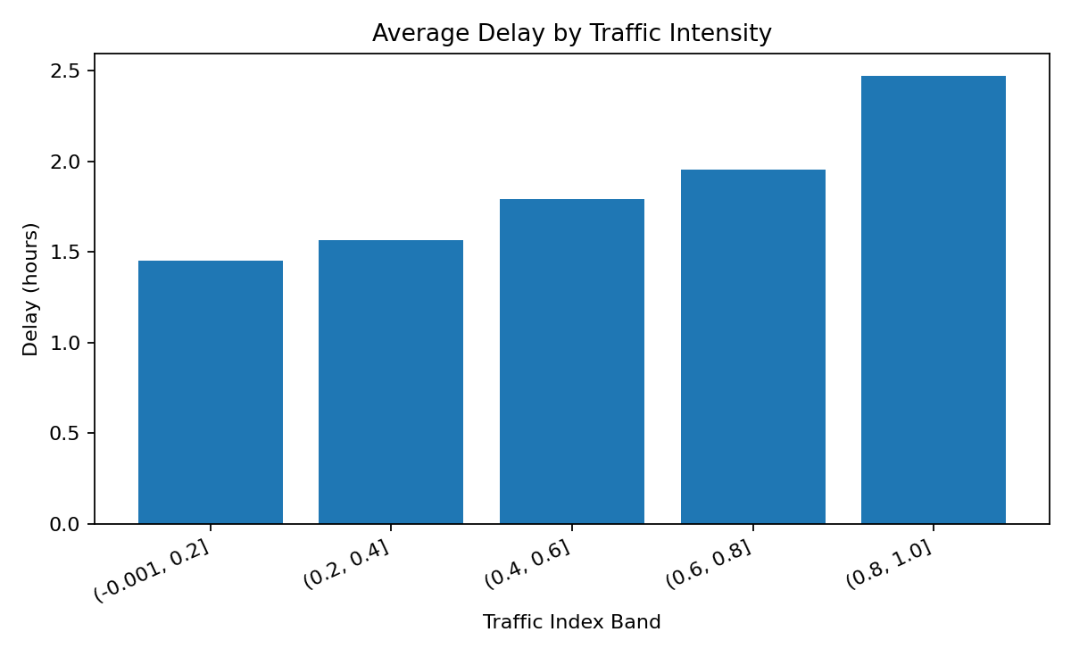
Interpretation: average delay rises as traffic intensity increases. This suggests that congestion is a useful operational risk signal. In a real deployment, the organization could combine historical traffic patterns with planned departure times to identify shipments that need earlier dispatch, alternate routes or different transport modes.
traffic_bins = pd.cut(
df["Traffic_Index"],
bins=[0, .2, .4, .6, .8, 1],
include_lowest=True
)
traffic_delay = df.groupby(traffic_bins, observed=False)["Delay_Hours"].mean()
traffic_delay.plot(kind="bar")
plt.title("Average Delay by Traffic Intensity")
plt.ylabel("Delay (hours)")
plt.show()

10. Correlation Analysis
Correlation analysis is used as an initial screening tool for relationships among numeric variables. It should not be interpreted as proof of causation. The strongest operational relationships in this simulation are expected between distance, delivery time and cost, while traffic and weather are associated with delay.
Variable Pair | Correlation | Interpretation
Distance_km ↔ Transport_Cost | 0.79 | Positive association
Distance_km ↔ Delivery_Time_Hours | 0.78 | Positive association
Traffic_Index ↔ Delay_Hours | 0.19 | Positive association
Handling_Hours ↔ Delay_Hours | 0.01 | Positive association
Shipment_Volume ↔ Transport_Cost | 0.20 | Positive association

11. Carrier and Regional Performance Analysis
Segment-level analysis should complement overall KPIs. A carrier with a strong average OTD may still perform poorly on particular regions or modes. Therefore, the next analytical step would be a carrier × region × mode performance matrix rather than relying only on a single carrier score.
Carrier | OTD % | Management Interpretation
Carrier C | 31.9% | Higher-performing carrier
Carrier B | 30.2% | Higher-performing carrier
Carrier A | 29.2% | Requires performance review
Carrier D | 25.9% | Requires performance review

12. Key Analytical Insights
- Service reliability: overall on-time delivery is 29.2%. Regional differences indicate that service performance should be managed at a granular level.
- Cost driver: distance has a Pearson correlation of 0.79 with transport cost, making network design and route length important cost levers.
- Congestion risk: traffic intensity is positively associated with delay; traffic-aware dispatch planning could reduce exposure to predictable congestion.
- Handling bottleneck: handling time contributes to total delivery time and cost in the simulated process, suggesting warehouse throughput should be measured alongside transport KPIs.
- Mode trade-off: transport mode affects delivery time and cost differently, so the right choice depends on service-level requirements rather than minimizing either time or cost in isolation.
- Tail risk: the delivery-time distribution should be monitored for severe delays, not just average performance.

13. Potential Bottlenecks
- High-traffic lanes can create predictable delay risk.
- Long-distance shipments can disproportionately increase cost and transit time.
- Warehouse handling variability can become a hidden bottleneck before a shipment reaches the carrier.
- Regional service differences may indicate network imbalance or carrier-specific problems.
- Volume peaks can cause temporary capacity shortages even when average capacity appears sufficient.

14. Recommendations
- Introduce a lane-level dashboard showing OTD, delay, cost per shipment and cost per unit.
- Use traffic and weather indicators as risk features for proactive dispatch planning.
- Benchmark carriers by comparable region, mode and shipment profile rather than using raw averages.
- Track warehouse handling time as a first-class logistics KPI and investigate high-variance processes.
- Use scenario analysis to compare transport-mode choices under different service-level targets.
- Move from descriptive dashboards toward predictive delay scoring once historical shipment-event data are available.

15. Python Implementation Structure
# Recommended project structure
# logistics_analysis/
# data/
# raw/
# processed/
# notebooks/
# 01_profiling.ipynb
# 02_eda.ipynb
# 03_visualization.ipynb
# src/
# cleaning.py
# features.py
# analysis.py
# visualization.py
# outputs/
# charts/
# reports/
import pandas as pd
import matplotlib.pyplot as plt
df = pd.read_csv("data/processed/logistics_clean.csv")
# KPI layer
kpis = {
"OTD": df["On_Time"].mean(),
"Avg_Delivery_Hours": df["Delivery_Time_Hours"].mean(),
"Avg_Cost": df["Transport_Cost"].mean(),
"Avg_Cost_per_Unit": df["Cost_per_Unit"].mean()
}
print(kpis)

16. Limitations
- The dataset is hypothetical and therefore cannot establish actual logistics performance.
- Relationships are intentionally simulated and should not be interpreted as empirical evidence.
- Real logistics analysis would require actual shipment timestamps, promised delivery times, carrier events, warehouse scans and route data.
- Correlation does not establish causation; operational experiments or causal methods would be needed to prove that an intervention changes outcomes.
- Visualization choices should be adapted to the decision-maker and reporting frequency.

17. Conclusion
Advanced logistics analytics requires more than calculating averages. Combining distributions, trends, category comparisons and relationship analysis makes it possible to identify where operational variability originates and which factors deserve management attention. The six visualizations in this report provide complementary views: workload over time, service-time distribution, transport-mode trade-offs, cost drivers, regional service gaps and congestion-related delay.
The next step after EDA is predictive and prescriptive analytics. Historical shipment data can support delay-risk models and demand forecasts, while optimization can use those predictions to allocate capacity and choose operational actions. The ultimate goal is therefore a closed analytical loop: measure → visualize → diagnose → predict → optimize → monitor.

18. Dataset Generation Code
np.random.seed(42)
n = 1200
df = pd.DataFrame({
"Date": np.random.choice(pd.date_range("2025-01-01", periods=365), n),
"Region": np.random.choice(
["North", "South", "East", "West"], n,
p=[0.27, 0.23, 0.25, 0.25]
),
"Mode": np.random.choice(
["Road", "Air", "Rail"], n,
p=[0.68, 0.17, 0.15]
),
# Additional variables are generated from plausible
# logistics distributions and relationships.
})

Appendix Visualization Inventory
Figure | Chart Type | Question Answered
1. Monthly Shipment Volume | Line chart | How does workload change over time?
2. Delivery-Time Distribution | Histogram | How variable are delivery times?
3. Delivery Time by Mode | Bar chart | Which transport modes are faster?
4. Distance vs Cost | Scatter plot | How strongly does distance relate to cost?
5. Regional OTD | Bar chart | Which regions have service gaps?
6. Traffic vs Delay | Binned bar chart | Does congestion coincide with longer delays?

