

CHAROTAR UNIVERSITY OF SCIENCE AND TECHNOLOGY

FACULTY OF TECHNOLOGY AND ENGINEERING

B. TECH (IT/CE/CSE/AIML)

Subject: Advanced Web Development Frameworks (ITUE301) | Semester: 5th

Problem Definition — Practical 13: AI API Integration into a Web Application
To integrate an AI-powered feature into the existing full-stack Task Management application using an external AI service such as OpenAI or Gemini. The system should allow users to generate task descriptions automatically based on task titles and display the generated suggestions in an editable format within the React interface.
The API key must be securely stored on the backend using environment variables and must never be exposed to the frontend. The application should handle API failures gracefully, display loading indicators and appropriate fallback messages, and continue functioning normally when the AI service is unavailable. The implementation should also consider responsible AI usage, data privacy, and user review of AI-generated content.

Screenshots:

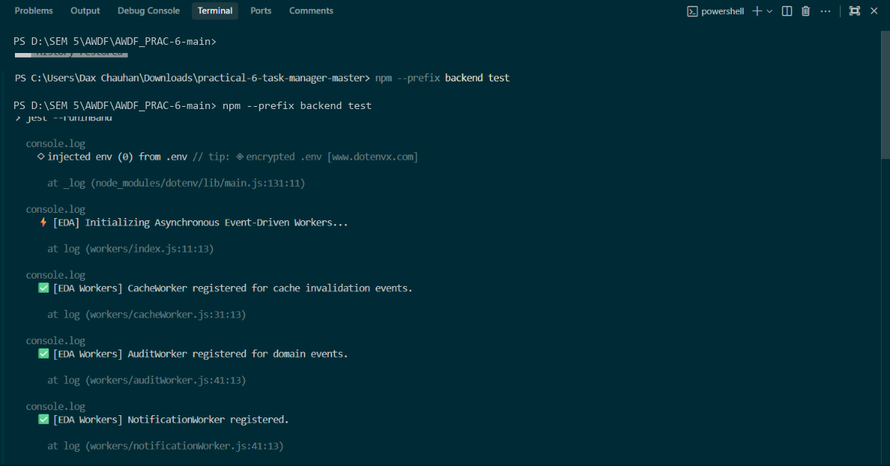

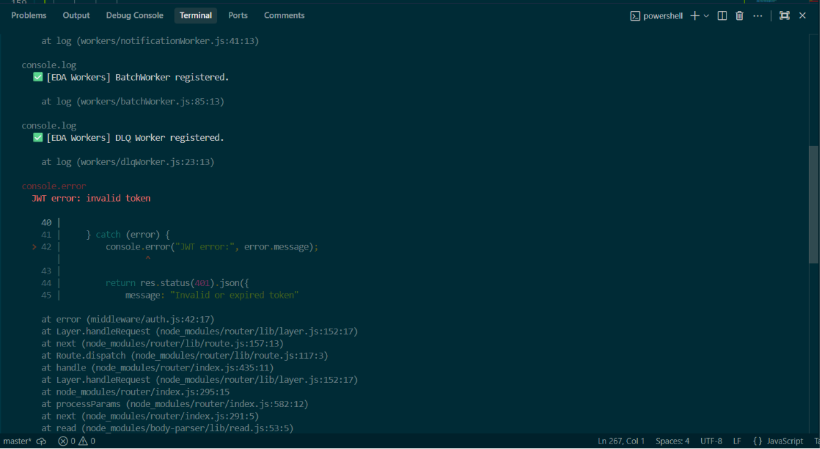

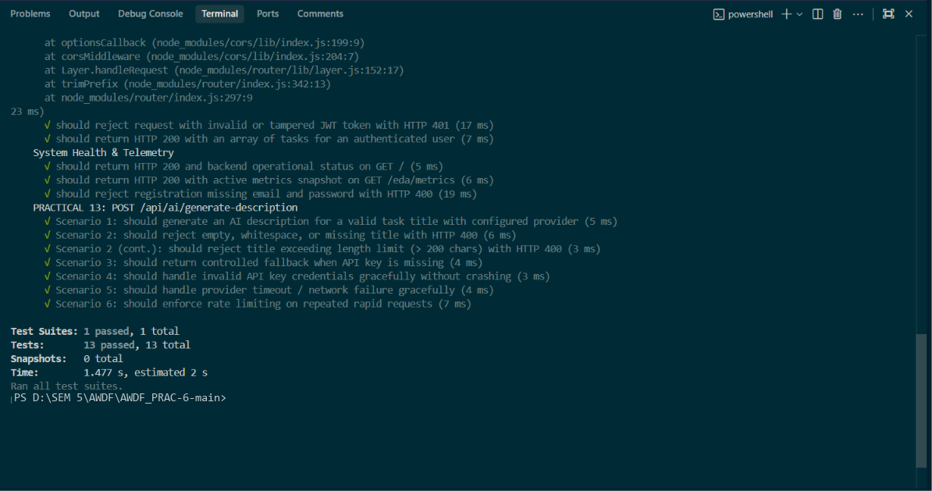

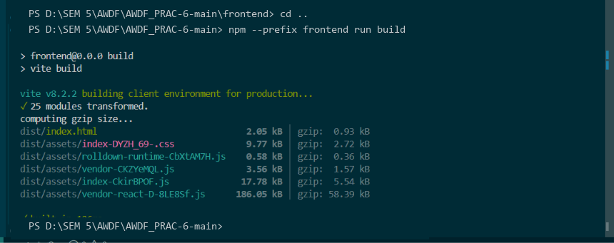
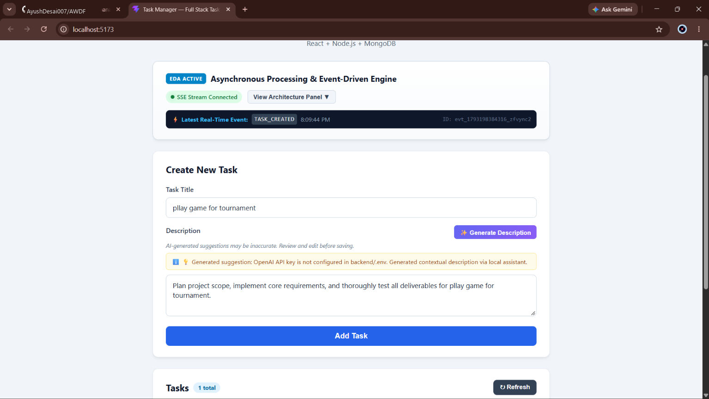

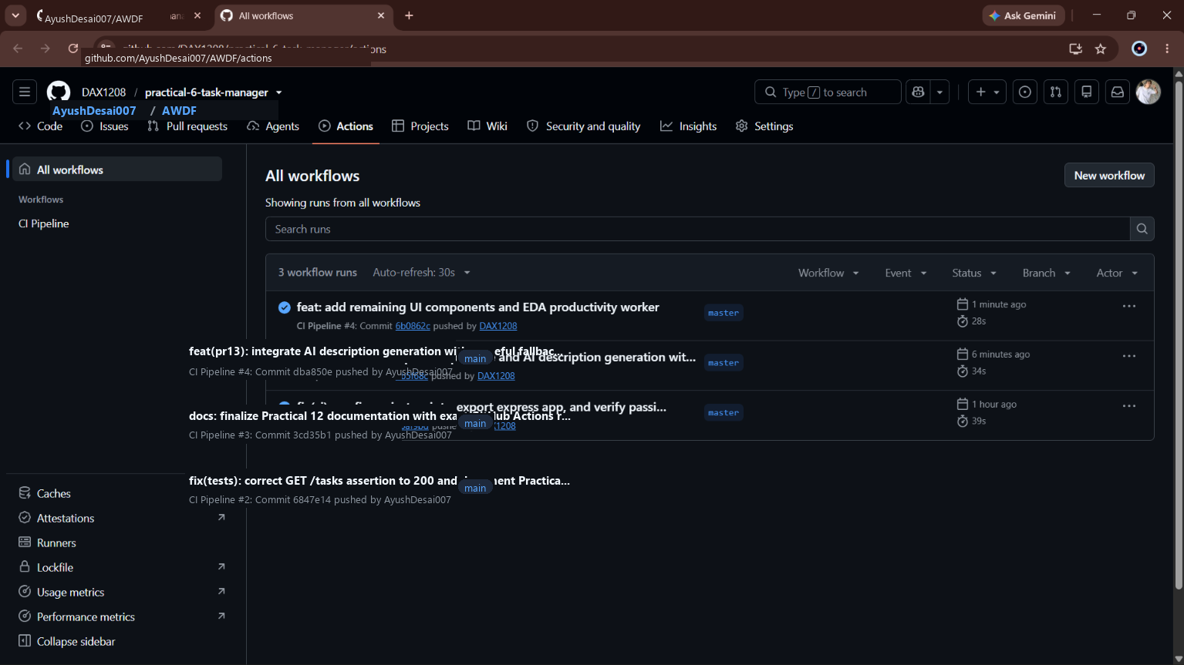

Github Repo Link: https://github.com/AyushDesai007/AWDF.git

