Experiment No. 2

Program:
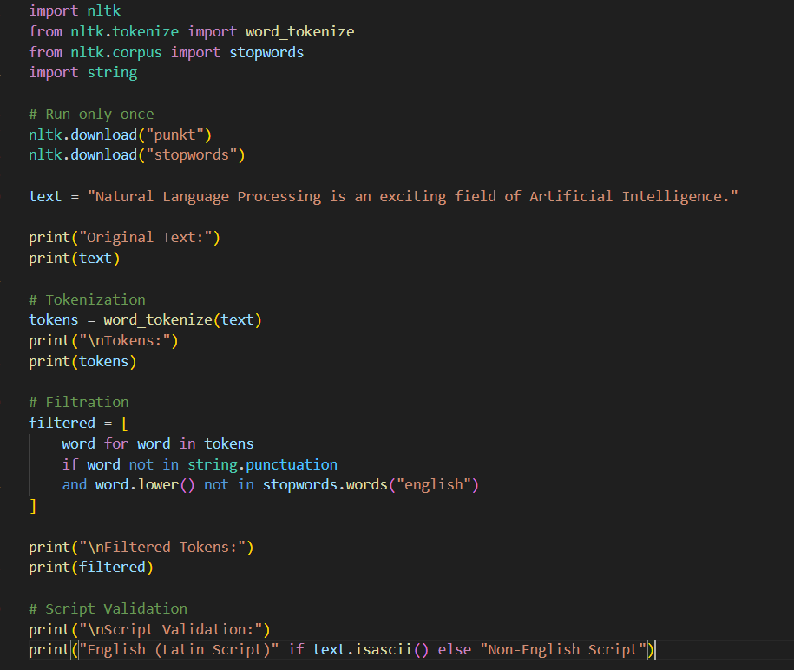
Output:
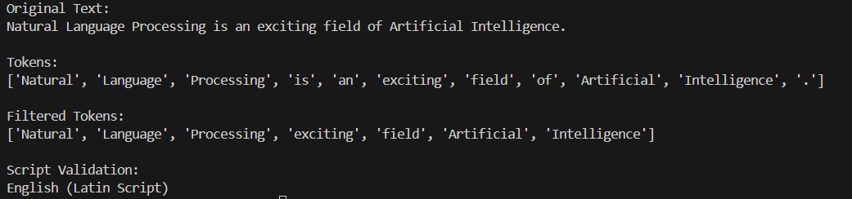

Experiment No. 3

Program:
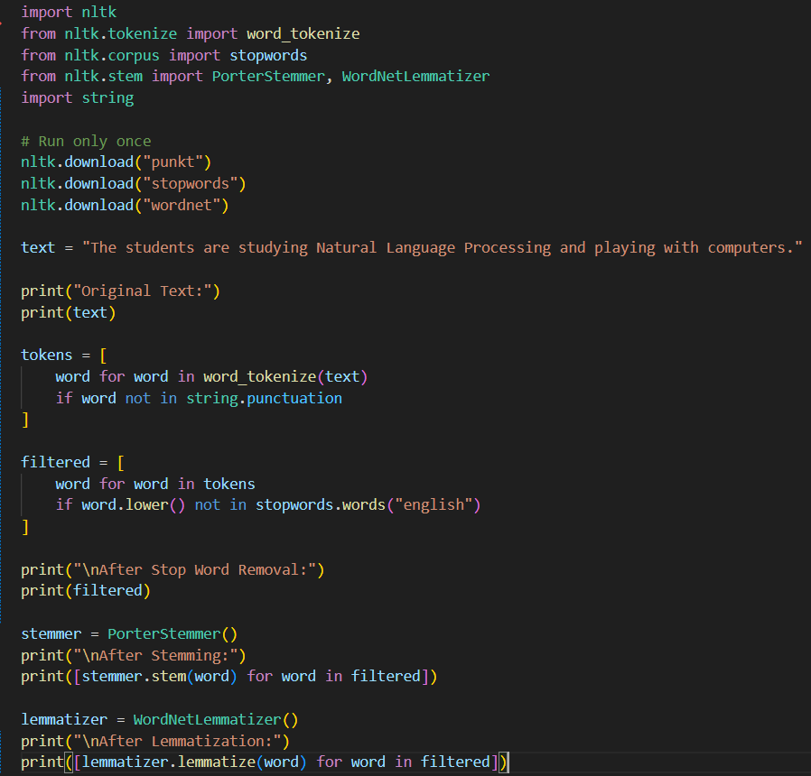
Output:
