A
Project Report on
FedLedger: Federated Learning with Blockchain Audit Trail
Submitted in partial fulfilment of the requirements
For the degree of
Bachelor of Engineering in
Computer Science and
Engineering (AIML)
By
Ayush Devadiga Roll no.12
Bhargav Ghawali Roll no.22
Mahesh Gawali Roll no.18
Soham Gawas Roll no.19
Supervisor
Prof. Shital Gujar

Department of Computer Science &
Engineering (AIML)
Innovative Engineers and Teachers Education society's
Bharat College of Engineering
Badlapur:- 421504

(Affiliated to University of Mumbai) 2025-26

Bharat College of Engineering
(Affiliated to University of Mumbai) 2025-26
Badlapur:- 421504
CERTIFICATE
This is to certify that, the Project titled
“FedLedger: Federated Learning with Blockchain Audit Trail”
is a bonafide work done by
Ayush Devadiga Roll no.12
Bhargav Ghawali Roll no.22
Mahesh Gawali Roll no.18
Soham Gawas Roll no.19
And is submitted in the partial fulfillment of the requirements for the degree of
Bachelor of Engineering in
Computer Science &
Engineering (AIML)
To the
University of Mumbai


________________  Supervisor  (Prof. Shital Gujar) | ___________________  Head of Department  (Prof. Pratiksha Shinde) | _______________  Principal  (Dr. Ulhaskumar Gokhale)

Department of Computer Science & Engineering
(Artificial Intelligence and Machine Learning)
Mini Project Report Approval for B.E.
This project report entitled
“FEDLEDGER: FEDERATED LEARNING WITH BLOCKCHAIN AUDIT TRAIL”
Submitted by Ayush Devadiga, Bhargav Ghawali, Mahesh Gawali, Soham Gawas is approved for the Degree of Bachelor of Engineering in Computer Science and Engineering (Artificial Intelligence and Machine Learning)
Examiner
1.
2.
Date:
Place: Badlapur

PROJECT REPORT

CONTENTS
Abstract i
List of figures ii
List of Tables ii
1. Introduction
1.1 Project Overview 01
1.2 Problem Statement 01
1.3 Scope of the Project 02
2. Review of Related Work
2.1 Existing Systems 03
2.2 Literature Survey 04
2.3 Overview of Similar Applications 05
3. Planning
3.1 Project Timeline & Milestones 06
3.2 Resource & Tool Planning 09
4. Methodology
4.1 Proposed System Overview 12
4.2 Algorithm Details 13
4.3 System Requirements 14
4.4 Frontend Development 15
4.5 Smart Contract Design 15
4.6 Testing 15
5. Design
5.1 Flow Diagram 17
5.2 Use Case Diagram 17
6. Experimental Results
6.1 Output 18

6.2 Advantages 22
6.3 Applications 22
7. Conclusion 23
8. References 24

ABSTRACT
The FedLedger project is a federated learning system with a blockchain-based audit trail. It allows several organisations to train one shared machine learning model without sharing their raw data, and it gives every participant a way to verify that the central server aggregated the model honestly. Unlike a conventional federated learning setup, where the participants must simply trust the aggregation server, this system combines local training, Federated Averaging (FedAvg), SHA-256 hashing, and a smart contract to create a tamper-evident record of every training round.
In the project, three organisations (OrgA, OrgB, and OrgC) each hold a private partition of the Iris dataset (50 samples each) and train a logistic regression model locally. Only the learned coefficients and intercepts are sent to the server, where they are combined using FedAvg. After every round, the server computes a SHA-256 hash of the aggregated global weights and writes it, together with the round number and the accuracy, to an append-only Solidity smart contract named FLAuditLog, deployed on a local Hardhat Ethereum blockchain. The contract has no function to update or delete a record once it is written.
The application provides a verification feature. A user supplies the weights of a particular round, the system recomputes their SHA-256 hash, reads the hash stored on the blockchain for that round, and compares the two. A match shows that the weights are the ones that were sealed on the chain; a mismatch shows that they differ. The system also provides a web dashboard with four tabs: Overview, Federation (animated live training), Ledger (blockchain audit log), and Verify.
The system is developed using Python, Flower, and scikit-learn for federated learning, Solidity and Hardhat for the smart contract and blockchain, web3.py for the connection between the server and the blockchain, and React with TypeScript for the dashboard. In the recorded run of 10 training rounds, the global model accuracy rose from 50.0% in round 1 to 93.3% in round 10, with a best value of 96.7% in round 9, and all 10 rounds were recorded on the blockchain. The main objective of the project is to demonstrate how federated learning can be combined with blockchain technology to create a privacy-preserving and independently verifiable model training process.

List Of Figures
5.1 Flow Diagram 17
5.2 Use Case Diagram 17
6.1 Overview Tab 18
6.2 Federation Tab (Live Training) 19
6.3 Ledger Tab (Audit Log) 20
6.4 Chain Receipt of a Round 20
6.5 Verify Tab 21
6.6 Global Model Accuracy per Round 21
List Of Tables
2.2 Literature Survey 04
2.3 Overview of Similar Applications 05
4.3 System Requirements 14
6.1 Round-wise Results Recorded on the Blockchain 21

INTRODUCTION

1. Introduction
1.1 Project Overview
FedLedger is a federated learning system with a blockchain audit trail. It allows several organisations to train one shared machine learning model without any of them handing over its raw data, and it records every training round on a blockchain so that the work of the central aggregation server can be checked independently. The main purpose of the project is to combine privacy-preserving model training with a record that cannot be quietly rewritten.
In the system, three organisations (OrgA, OrgB, and OrgC) each hold a private partition of the Iris dataset, which has 150 samples, 4 features, and 3 classes. Each organisation trains a logistic regression model on its own 50 samples. Only the learned numbers, called weights (a matrix of coefficients and a vector of intercepts), are sent to the central server. The server combines the weights from the three organisations using the Federated Averaging (FedAvg) algorithm and sends the improved global weights back. This cycle repeats for 10 rounds by default.
After every round, the server computes a SHA-256 hash of the global weights and writes the round number, the accuracy, and the hash to a Solidity smart contract named FLAuditLog. The contract is deployed on a local Hardhat Ethereum blockchain through the web3.py library. The contract has no function to update or delete a record, so a round that has been written cannot be edited afterwards.
The project is developed using Python, Flower, and scikit-learn for the federated learning part, Solidity and Hardhat for the blockchain part, and React with TypeScript for a four-tab dashboard (Overview, Federation, Ledger, and Verify). The whole system is started with a single command, python run_fedledger.py. Overall, the project demonstrates how federated learning, cryptographic hashing, smart contracts, and web development can be combined to build a privacy-preserving and verifiable training pipeline.
1.2 Problem Statement
Organisations such as banks, hospitals, and government bodies hold private data that they are not allowed to share with each other or with a central server because of privacy laws and ethics. Collecting all the data in one place to train a single model is therefore not possible. Federated learning solves this by keeping the data at each organisation and sharing only the model weights.
However, federated learning creates a second problem: the central server must be trusted. The server may modify the weights while combining them, or it may report an accuracy that was not actually achieved, and the participants have no way to check what the server really did. A normal results file or database does not solve this, because whoever controls the server can edit it.
The FedLedger project addresses this problem by developing a federated learning system in which every training round is sealed on a blockchain. The system hashes the global weights with SHA-256, stores the round number, the accuracy, and the hash in an append-only smart contract, and provides a verification interface that recomputes the hash and compares it with the stored record. The goal of the project is to give the participants cryptographic evidence, instead of trust, that the aggregation was carried out as recorded.

1.3 Scope of the Project
The scope of the FedLedger project includes the development of a federated learning system with a blockchain audit trail, together with a dashboard for watching the training and verifying the recorded rounds.
The major areas covered by the project are:
- Data Partitioning: The Iris dataset (150 samples, 4 features, 3 classes) is split once into three equal, private partitions of 50 samples each for OrgA, OrgB, and OrgC.
- Local Training: Each organisation trains a logistic regression model on its own partition; raw data never leaves the node.
- Federated Averaging: The server combines the weights of the three nodes using sample-weighted FedAvg to produce the global model.
- Weight Hashing: A SHA-256 hash of the global weights is computed after every round as a tamper-detection fingerprint.
- Smart Contract Audit Log: The FLAuditLog contract stores the round number, accuracy, and weight hash of each round and has no update or delete function.
- Blockchain Integration: The server writes each round to the contract through web3.py on a local Hardhat Ethereum chain.
- Independent Verification: A verify API recomputes the hash of the supplied weights and compares it with the hash stored on the blockchain.
- Live Dashboard: A React and TypeScript dashboard with four tabs (Overview, Federation, Ledger, and Verify) shows the training and the audit record.
- Tamper Demonstration: An "Alter one coefficient" button corrupts a single weight value to show how tamper detection works.
- One-Command Launcher: The script run_fedledger.py starts the blockchain, deploys the contract, runs the server and the three nodes, and opens the dashboard.
Future Scope
The project can be further extended by adding features such as deployment on a public Ethereum testnet or the real Ethereum network, more organisations and larger datasets, deeper models, recording of the participating nodes and of each organisation’s contribution on the chain, secure aggregation and differential privacy for stronger privacy of the weights, and authentication of the participating nodes.

LITERATURE SURVEY

2. Review of Related Work
2.1 Existing Systems
Several frameworks are available for federated learning. Examples include TensorFlow Federated, PySyft, Flower, and NVIDIA FLARE. These frameworks provide the machinery to train a model across several participants, so that the data stays where it is generated and only model updates are exchanged. Research systems such as BlockFL have also explored the use of a blockchain in federated learning.
However, federated learning frameworks generally focus on running the training, and not on giving the participants an independent record of what the aggregation server did.
Limitations of Existing Systems
- In a standard federated learning setup, the participants must trust the central server to aggregate the weights correctly.
- The server may modify the weights during aggregation, or report an accuracy that was not achieved, and the participants cannot easily detect it.
- Training logs and results files are normally kept by the party that runs the server, so they can be edited or deleted by that party.
- Training frameworks do not by themselves bind a hash of each round’s model to the round it belongs to in a record that the server cannot rewrite.
- A participant who wants to check a round has to rely on whatever the server reports.
- Combining federated learning with blockchain-based verification usually requires the user to put several technologies together.
Proposed System
FedLedger combines federated learning using Flower and FedAvg with SHA-256 hashing of the global weights and an append-only Solidity smart contract, FLAuditLog, in a single application. After every round, the round number, the accuracy, and the weight hash are written to the blockchain through web3.py. A verification interface lets any participant recompute the hash of the weights they hold and compare it with the stored record.
This makes the project different from a basic federated learning demonstration because it focuses not only on training a model without sharing data, but also on providing cryptographic evidence that the server’s aggregation was recorded and can be re-checked.

2.2 Literature Survey
Author / Source | Topic / Technology Studied | Key Findings | Relevance to Proposed System
McMahan et al. (2017) | Federated Averaging (FedAvg) | A model can be trained from decentralised data by averaging the updates that clients compute locally, without collecting the data in one place. | FedAvg is used by the server to combine the weights of the three nodes.
Kairouz et al. (2021) | Advances and Open Problems in Federated Learning | Surveys federated learning and discusses its open problems, including privacy, security, and robustness. | Motivates the need to verify the central server’s work.
Beutel et al. (2020) | Flower Federated Learning Framework | Provides a framework in which clients and a server exchange model parameters for federated learning. | Used for the three nodes (NumPyClient) and the server strategy.
Kim et al. (2020) | BlockFL: Blockchained On-Device Federated Learning | Proposes using a blockchain to exchange and verify local model updates in federated learning. | Supports the idea of backing federated learning with a blockchain record.
NIST FIPS 180-4 | SHA-256 / Cryptographic Hashing | Defines SHA-256, which produces a fixed-length 256-bit digest of its input. | Used to fingerprint the global weights of every round.
Ethereum Documentation / Solidity Documentation | Smart Contracts and Blockchain | Smart contracts can store and process data on a blockchain in a transparent and tamper-resistant manner. | Used to build FLAuditLog, which stores the audit record of each round.

2.3 Overview of Similar Applications
Application | Main Features | Privacy Approach | Blockchain Audit | Limitation Compared with Proposed System
TensorFlow Federated | Framework for federated learning computations and simulation | Training data stays with the clients | Not a built-in feature | Does not provide an on-chain record of each aggregation round
PySyft | Tools for privacy-preserving, remote data science and federated learning | Data stays with its owners | Not a built-in feature | Blockchain-based audit of aggregation is not a core feature
Flower | Federated learning framework with client and server abstractions | Training data stays on the clients | Not a built-in feature | Focused on training orchestration; no audit trail of its own
NVIDIA FLARE | Software development kit for federated learning | Training data stays on the participants’ sites | Not a built-in feature | Blockchain audit of aggregation is not a core feature
Proposed FedLedger | Federated learning with FedAvg, weight hashing, a live dashboard, and a verification tool | Local training; only weights leave a node | Yes (FLAuditLog smart contract) | Combines federated training with an append-only on-chain record of each round

PLANNING

3. Planning
Planning is a critical phase that ensures the systematic development, testing, and demonstration of the FedLedger system. This section describes the approach followed during the development of the system, including requirement identification, technology selection, data partitioning, smart contract design, federated learning implementation, blockchain integration, verification, dashboard development, testing, and future improvements.
3.1. Project Timeline and Milestones
1. Define Project Objectives
Identify the purpose of the system: to let several organisations train a shared model without pooling their data, and to record every training round on a blockchain so that the aggregation carried out by the central server can be independently verified.
2. Identify Key System Requirements
Determine the major functions required by the system:
- A private data partition for each organisation
- Local training at every node
- Exchange of only model weights, never raw data
- Federated averaging at the central server
- SHA-256 hashing of the global weights
- An append-only smart contract for audit records
- Recording of round number, accuracy, and weight hash on the blockchain
- Independent hash verification of any round
- A web dashboard for live training, the ledger, and verification
- A single command to launch the whole system
3. Select Technology Stack
- Programming language: Python
- Federated learning framework: Flower (NumPyClient on the nodes and a custom strategy on the server)
- Machine learning library: scikit-learn (logistic regression and the Iris dataset)
- Numerical computing: NumPy
- Blockchain development environment: Hardhat (local simulated Ethereum node on port 8545)
- Smart contract language: Solidity 0.8.19
- Blockchain connection: web3.py
- Hashing: SHA-256
- Dashboard: React 19 with TypeScript
- Verification interface: HTTP verify API on port 8088
- Federated learning server: Flower server on port 8080
4. Design System Architecture
The system architecture consists of the following major components:
- Three federated learning nodes (OrgA, OrgB, and OrgC)
- Federated learning server with a custom FedAvg strategy
- Weight hashing module
- Blockchain logger (web3.py bridge)
- FLAuditLog smart contract
- Hardhat local Ethereum blockchain
- Verify API server
- React dashboard and dashboard server
- Launcher script
5. Prepare the Data Partitions
Write a script that loads the Iris dataset from scikit-learn, shuffles it with a fixed random seed so that the results are reproducible, and splits it into three equal stratified parts of 50 samples each. Each part is saved as NumPy binary files in a separate folder for OrgA, OrgB, and OrgC. A dataset_meta.json file records the dataset name, the total samples, the number of features, and the row count per node, so that the dashboard shows accurate information.
6. Develop the Smart Contract
Write the FLAuditLog contract in Solidity. It defines a TrainingRound structure and stores an array of these records. The contract provides logRound() to write a record, getRound(index) to read one, and totalRounds() to get the number of records. It has no function to update or delete a record.
7. Deploy the Contract on the Local Blockchain
Start a Hardhat node on http://127.0.0.1:8545, compile FLAuditLog.sol, and deploy it using the deploy script. The script writes the contract address and the path of the contract ABI into contract_config.json, which the Python code reads to find the contract.
8. Implement the Federated Learning Nodes
Implement a Flower NumPyClient in node.py with the methods get_parameters(), set_parameters(), fit(), and evaluate(). The same script runs all three nodes, and a --node argument selects the data partition. Only model weights and the sample count are returned to the server.
9. Implement the Server and FedAvg
Implement a custom Flower strategy, FedLedgerStrategy, whose aggregate_fit() method is called at the end of each round. It converts the received weights to NumPy arrays, calls federated_average() from fedavg.py, computes the weight hash, logs the round on the blockchain, and writes the round result to app/round_results.json.
10. Implement the Blockchain Logger
Implement blockchain_logger.py using web3.py. The log_round() method computes the hash, converts the accuracy to an integer, calls logRound() on the contract, waits for the transaction receipt, and returns the transaction hash. The verify_round() method reads a stored round from the chain and compares its hash with the hash of the supplied weights.
11. Implement the Verification API
Implement verify_server.py, a small HTTP server on port 8088 that receives weights as JSON in a POST request to /verify, calls the blockchain logger, and returns whether the hashes match. CORS headers are included so that the browser can call it from the dashboard.
12. Develop the Dashboard
Develop the dashboard using React 19 and TypeScript with four tabs: Overview, Federation, Ledger, and Verify. The dashboard reads round_results.json every 2 seconds to follow the training, and reads the audit record directly from the blockchain.
13. Testing and Validation
Test the major functions of the system using the test files test_fedavg.py, test_blockchain.py, and test_verify.py, and by running the complete system:
- Data partitioning
- Local training at the nodes
- FedAvg aggregation
- Weight hash computation
- Writing rounds to the smart contract
- Reading rounds from the blockchain
- Hash verification (match and mismatch)
- Dashboard display of rounds, ledger, and verification
14. Launcher and Configuration
Write run_fedledger.py, which starts the Hardhat node, deploys the contract, starts the server, the three nodes, the verify server, and the dashboard server in the correct order, and opens http://localhost:5173 in the browser. Optional flags such as --rounds, --dataset, --no-ui, and --skip-build change how it runs. Each process writes to a log file in the logs folder.
The launcher starts the processes in the following order:
- Start the Hardhat node (wait 3 seconds for it to be ready).
- Run the deploy script (it must finish before the Python code starts).
- Start the FL server (wait 2 seconds for it to bind port 8080).
- Start the OrgA, OrgB, and OrgC nodes with a short gap between them.
- Start the verify server on port 8088.
- Start the dashboard server on port 5173.
- Open http://localhost:5173 in the browser.
15. Future Improvements
Possible future improvements include:
- Deployment on a public Ethereum testnet or the real Ethereum network
- More organisations and larger datasets
- Deeper models than logistic regression
- Recording the participating nodes and each node’s contribution on the chain
- Secure aggregation and differential privacy
- Authentication of the participating nodes
- Storing per-round weights so that rounds can be replayed
3.2. Resource and Tool Planning
1. Hardware Resources
- Computer or laptop for development and testing.
- Minimum 4 GB RAM, with 8 GB recommended.
- Minimum 10 GB available storage.
- Keyboard and mouse.
- Internet connection for installing dependencies.
2. Software Resources
- Operating System: Windows, Linux, or macOS.
- Python for the federated learning code.
- Node.js for Hardhat and for building the dashboard.
- Web Browser: Google Chrome, Microsoft Edge, or equivalent.
3. Programming and Development Tools
- Python: Federated learning nodes, server, blockchain logger, and verify API.
- Flower: Networking and orchestration of the federated learning rounds.
- scikit-learn: Logistic regression model and the Iris dataset.
- NumPy: Storing the data partitions and handling the model weights.
- web3.py: Communication between the Python server and the smart contract.
- Solidity: Writing the FLAuditLog smart contract.
- Hardhat: Compiling and deploying the contract and running the local Ethereum node.
- React and TypeScript: Development of the dashboard.
4. Federated Learning Resources
- The Iris dataset: 150 samples, 4 features, 3 classes.
- Three private data partitions of 50 samples each.
- Logistic regression model at every node.
- FedAvg aggregation at the server.
- Default of 10 training rounds.
5. Data Resources
- Iris dataset loaded from scikit-learn: 150 samples, 4 features (petal and sepal measurements), and 3 flower classes.
- Three stratified partitions of 50 samples each, stored as NumPy files (X.npy and y.npy) in the node1, node2, and node3 folders.
- dataset_meta.json, which records the dataset name, total samples, number of features, and row count per node.
- An optional handwritten digits dataset (1797 samples), selected with the --dataset digits flag.
- round_results.json, a JSON array in which each element is [round_number, accuracy, tx_hash].
6. Blockchain Resources
- FLAuditLog smart contract written in Solidity.
- Local Hardhat Ethereum node (no gas cost, no internet needed).
- web3.py for sending transactions and reading the contract.
- Contract address and ABI stored in contract_config.json.
- Transaction hash for identifying each round’s blockchain write.
7. Hashing and Verification Resources
- SHA-256 hash of the global weights for every round.
- Verify API on port 8088 for recomputing and comparing hashes.
- Weights in JSON format as [coef_matrix, intercept_vector].
- Demo weight files for demonstrating a mismatch.
8. Dashboard Resources
- React 19 and TypeScript frontend.
- round_results.json, polled every 2 seconds, for live training data.
- Direct blockchain reads (eth_call) for the Ledger tab.
- Dashboard server on port 5173.
9. Testing Resources
- Test files: test_fedavg.py, test_blockchain.py, and test_verify.py.
- Local Hardhat blockchain for testing contract writes and reads.
- Log files for each process in the logs folder.
- Browser for checking the dashboard.
10. Logging and Monitoring Resources
- logs/hardhat.log for the Ethereum node.
- logs/fl-server.log for training and blockchain write failures.
- logs/node-1.log, logs/node-2.log, and logs/node-3.log for OrgA, OrgB, and OrgC.
- logs/verify-server.log for the verification API.
- logs/dashboard.log for the dashboard server.
11. Documentation Resources
- Microsoft Word or similar software for the project report.
- Screenshots of the dashboard for the report figures.
12. Project Directory Structure
- run_fedledger.py: starts everything with one command.
- data/: generate_partitions.py and the private folders node1, node2, and node3 holding each organisation’s data.
- fl_nodes/node.py: the Flower client; one script runs all three nodes.
- fl_server/: server.py (Flower server and custom strategy), fedavg.py (federated_average and compute_weight_hash), and blockchain_logger.py (web3.py bridge).
- blockchain/: contracts/FLAuditLog.sol, scripts/deploy.js, hardhat.config.js, and contract_config.json.
- app/: round_results.json, verify_server.py, dashboard_server.py, and the React web frontend.
- tests/: test_fedavg.py, test_blockchain.py, and test_verify.py.
13. Deployment and Configuration Resources
- contract_config.json for the contract address and ABI path.
- hardhat.config.js (Solidity 0.8.19, port 8545).
- run_fedledger.py launcher with optional flags.
- Log files for Hardhat, the server, the nodes, the verify server, and the dashboard.

METHODOLOGY

4. METHODOLOGY
The methodology used for the development of FedLedger focuses on creating a federated learning system whose training can be audited. The system combines machine learning, cryptographic hashing, a smart contract, and web technologies to train a model without sharing data and to record every round on a blockchain.
4.1. Proposed System Overview
The proposed system, FedLedger, is a federated learning system with a blockchain audit trail. It is designed so that several organisations can train a shared model without exposing their data, and so that the aggregation done by the central server can be verified by anyone.
Each of the three nodes (OrgA, OrgB, and OrgC) holds a private partition of the Iris dataset and trains a logistic regression model locally. The nodes send only their updated coefficients and intercepts to the server. The server combines them using FedAvg, computes a SHA-256 hash of the global weights, and calls the logRound() function of the FLAuditLog smart contract through web3.py. The contract is deployed on a local Hardhat Ethereum blockchain. The weights themselves are not stored on the blockchain; only the round number, the accuracy, and the hash are recorded.
The main components of the proposed system are:
- Python federated learning nodes built with Flower.
- Federated learning server with a custom FedAvg strategy.
- SHA-256 hashing of the global weights.
- FLAuditLog Solidity smart contract.
- Hardhat local Ethereum blockchain.
- web3.py blockchain logger.
- Verify API for comparing hashes.
- React and TypeScript dashboard.
The proposed system provides a combination of data privacy, federated model training, blockchain-based audit logging, and independent verification in a single application.

4.2. Algorithm Details
4.2.1. Local Training Algorithm
- The Iris dataset is split once into three stratified partitions of 50 samples each and saved to the node folders.
- A node loads its own partition and receives the current global weights from the server (zeros in the first round).
- set_parameters() loads the global weights into the local logistic regression model.
- fit() trains the model on the node’s private data.
- The node returns its updated coefficients and intercepts and the number of samples it trained on.
- The raw data stays on the node and is never returned.
4.2.2. Federated Averaging (FedAvg) Algorithm
- The server waits until all three nodes have returned their results.
- The weights are converted to NumPy arrays and the sample counts are collected.
- For each layer (coefficients and intercepts separately), a weighted average is computed in which each node’s share is proportional to its number of samples.
- With three nodes of 50 samples each, every node contributes one third: global_weights = (50/150) × OrgA + (50/150) × OrgB + (50/150) × OrgC.
- The result is the global model for the round.
4.2.3. Weight Hashing and Blockchain Logging Algorithm
- The global weights are converted to a JSON string.
- A SHA-256 hash of the string is computed, giving a 64-character hexadecimal fingerprint.
- The accuracy is converted to an integer by multiplying it by 1000, because Solidity has no decimal type.
- The hash is converted to 32 raw bytes to match the bytes32 type of the contract.
- The server calls logRound() on the FLAuditLog contract through web3.py, which sends a transaction.
- The local Hardhat chain mines the transaction immediately.
- The server waits for the transaction receipt and saves the transaction hash with the round result.
- The round is appended to app/round_results.json for the dashboard.
- The global weights are sent to the nodes for the next round.

4.2.4. Verification Algorithm
- The user selects a round and supplies its weights as JSON, in the form [coef_matrix, intercept_vector].
- The dashboard sends the weights to the verify server at port 8088 (POST /verify).
- The verify server computes the SHA-256 hash of the weights in the same way as the training server.
- It reads the hash stored on the blockchain for that round, using getRound(index), which is a read-only call.
- The two hashes are compared.
- If they match, the weights are the ones that were sealed on the chain.
- If they do not match, the supplied weights differ from the recorded ones, and the dashboard shows a mismatch.
4.3. System Requirements
4.3.1. Hardware Requirements
Component | Minimum Requirement
Processor | Intel Core i3 or equivalent
RAM | 4 GB
Storage | 10 GB available space
Display | 1366 × 768 resolution or higher
Network | Internet connection for installing dependencies (the local blockchain needs none)
4.3.2. Software Requirements
Software | Requirement
Operating System | Windows / Linux / macOS
Federated Learning | Python with Flower, scikit-learn, and NumPy
Blockchain | Hardhat local Ethereum node, Solidity 0.8.19, web3.py
Dashboard | React with TypeScript (Node.js for building)
Browser | Google Chrome / Microsoft Edge / Mozilla Firefox

4.4 Frontend Development
The frontend is developed using React 19 and TypeScript. It provides the dashboard through which the user watches the training and checks the audit record. It is served on port 5173 and polls round_results.json every 2 seconds to know when a new round has completed.
The dashboard has four tabs:
- Overview: explains the project, the technology stack, how one round runs, and why a blockchain is used.
- Federation: an animated diagram of the three nodes, the FL server, and the blockchain, with a scrubber to replay rounds and a live round feed.
- Ledger: the audit log read directly from the blockchain, with an accuracy chart and a chain receipt for each round.
- Verify: recomputes the hash of supplied weights and compares it with the on-chain record.
4.5 Smart Contract Design
The FLAuditLog contract is written in Solidity. It defines one structure, TrainingRound, and stores an array of these records on the blockchain. A record holds the round number, the accuracy (an integer, multiplied by 1000), the participant names, the model hash (as bytes32), a timestamp, and the address of the account that logged it.
The contract has three public functions: logRound() to write a record, getRound(index) to read one, and totalRounds() to get the number of records. It has no function that updates or deletes a record, so a record cannot be changed once it is written. After deployment, the contract address and ABI path are saved to contract_config.json.
4.6 Testing
Testing was carried out to verify the functionality of the system. The test files test_fedavg.py, test_blockchain.py, and test_verify.py cover the aggregation, the blockchain logging, and the verification, and the complete system was run end to end with the launcher.
The main testing areas included:
- Data partitioning into three node folders.
- Local training at the nodes.
- FedAvg aggregation of the node weights.
- SHA-256 weight hash generation.
- Writing a round to the smart contract and reading it back.
- Hash verification for a match and for a mismatch.
- Communication between the nodes, the server, and the blockchain.
- Dashboard display of the live feed, the ledger, and the verification result.

The testing process helped ensure that the major features of FedLedger work correctly and that the different components of the system operate together properly.

DESIGN

5. Design
5.1 Flow Diagram
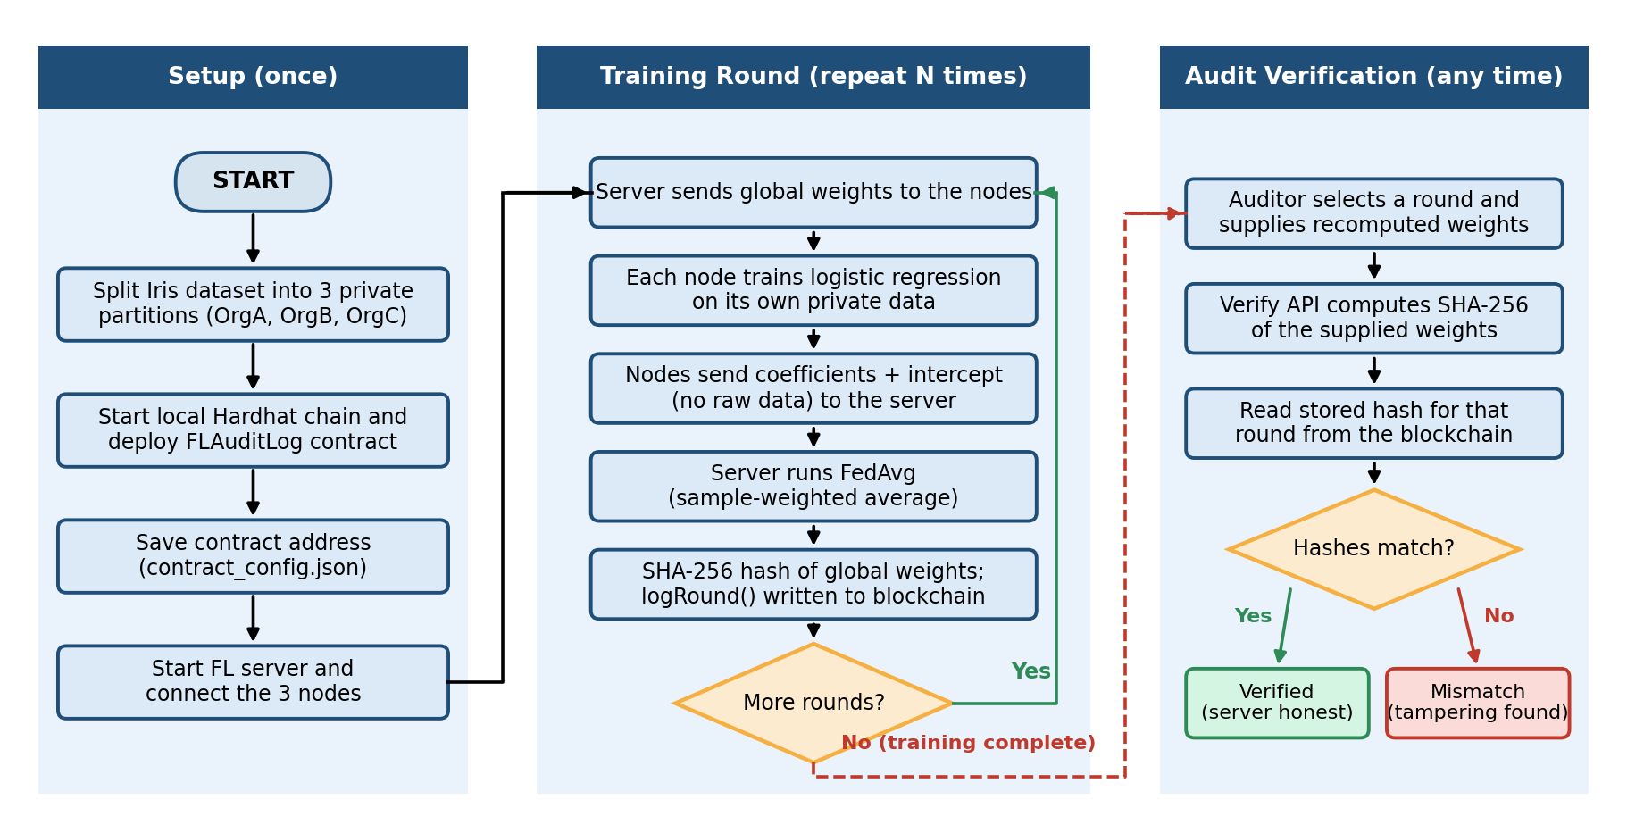
Fig 5.1 Flow Diagram
5.2 Use Case Diagram
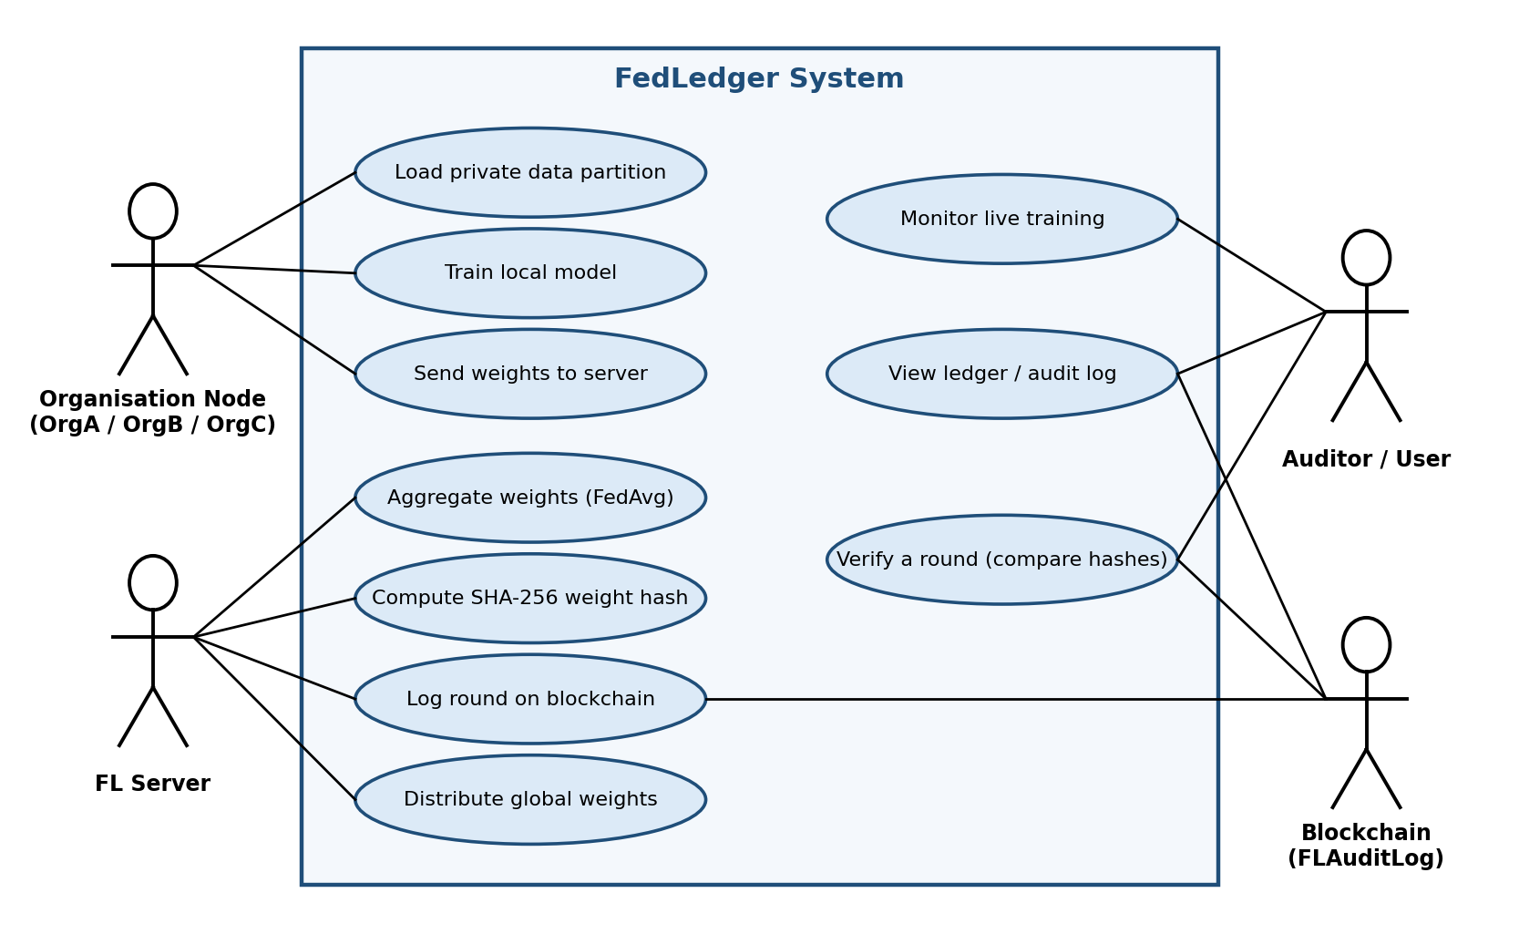
Fig 5.2 Use Case Diagram

RESULT

6. Experimental Results
6.1 Output/Result
1. Overview Tab
The Overview tab is the first screen of the dashboard. It explains what FedLedger is: three organisations that cannot pool their rows train one shared model, the server averages their updates, and every round is hashed with SHA-256 and sealed into FLAuditLog.
Main features of the Overview tab:
- Explanation of the constraint, what the system does, and what the hash buys.
- The one command that starts the system: python run_fedledger.py.
- The five phases of one round: Train, Send, Aggregate, Seal, and Distribute.
- A comparison of a plain results file with an append-only chain.
- A statement of what the dashboard does not show.
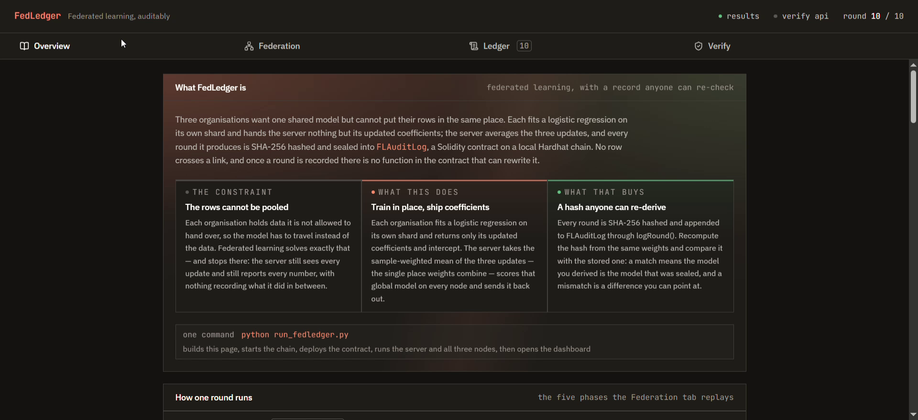
Fig 6.1 Overview Tab

2. Federation Tab (Live Training)
The Federation tab replays one training round as an animated diagram of OrgA, OrgB, OrgC, the FL server, and the blockchain. The round is shown in five steps: Train, Send, Aggregate, Seal, and Distribute. In the Send step, each node ships 15 floats (the coefficients and the intercept) and its box continues to show 0 rows sent, which shows that no raw records leave a node. A round feed on the right lists every committed round with its accuracy, its transaction hash, and its chain index.
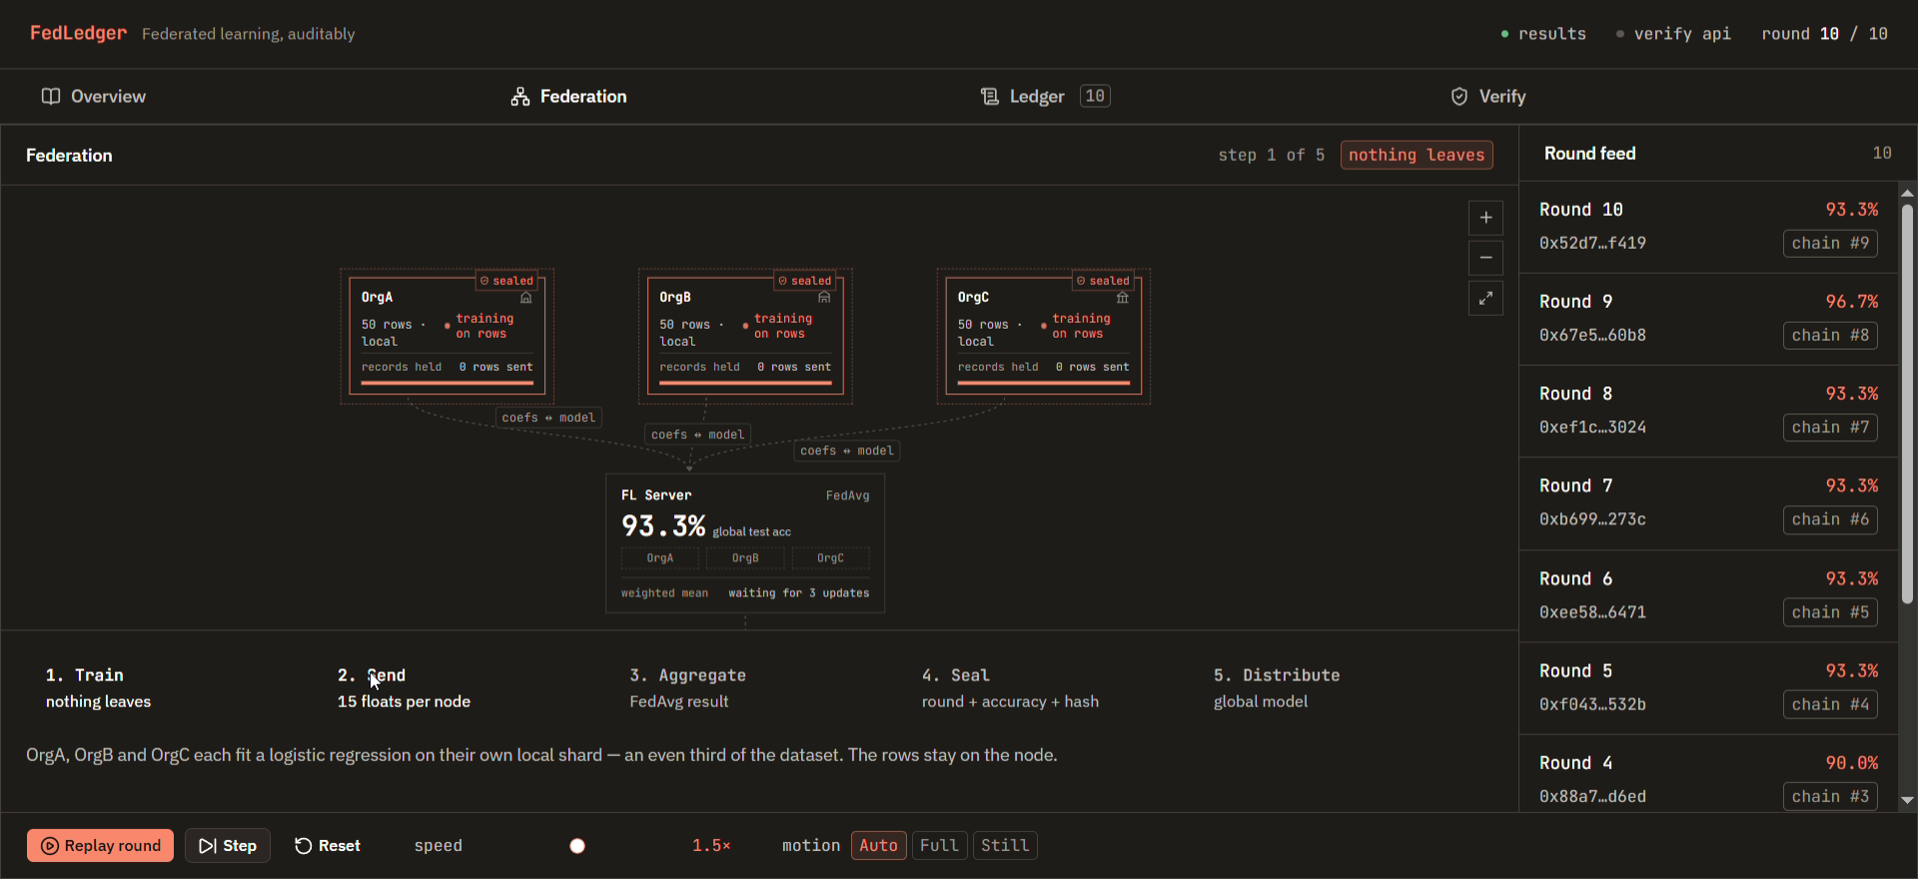
Fig 6.2 Federation Tab
3. Ledger Tab (Audit Log)
The Ledger tab lists one row for every training round, with the held-out accuracy, the transaction hash, the chain index, and the state, which is shown as on-chain. An accuracy chart on the right shows the model improvement across the rounds.

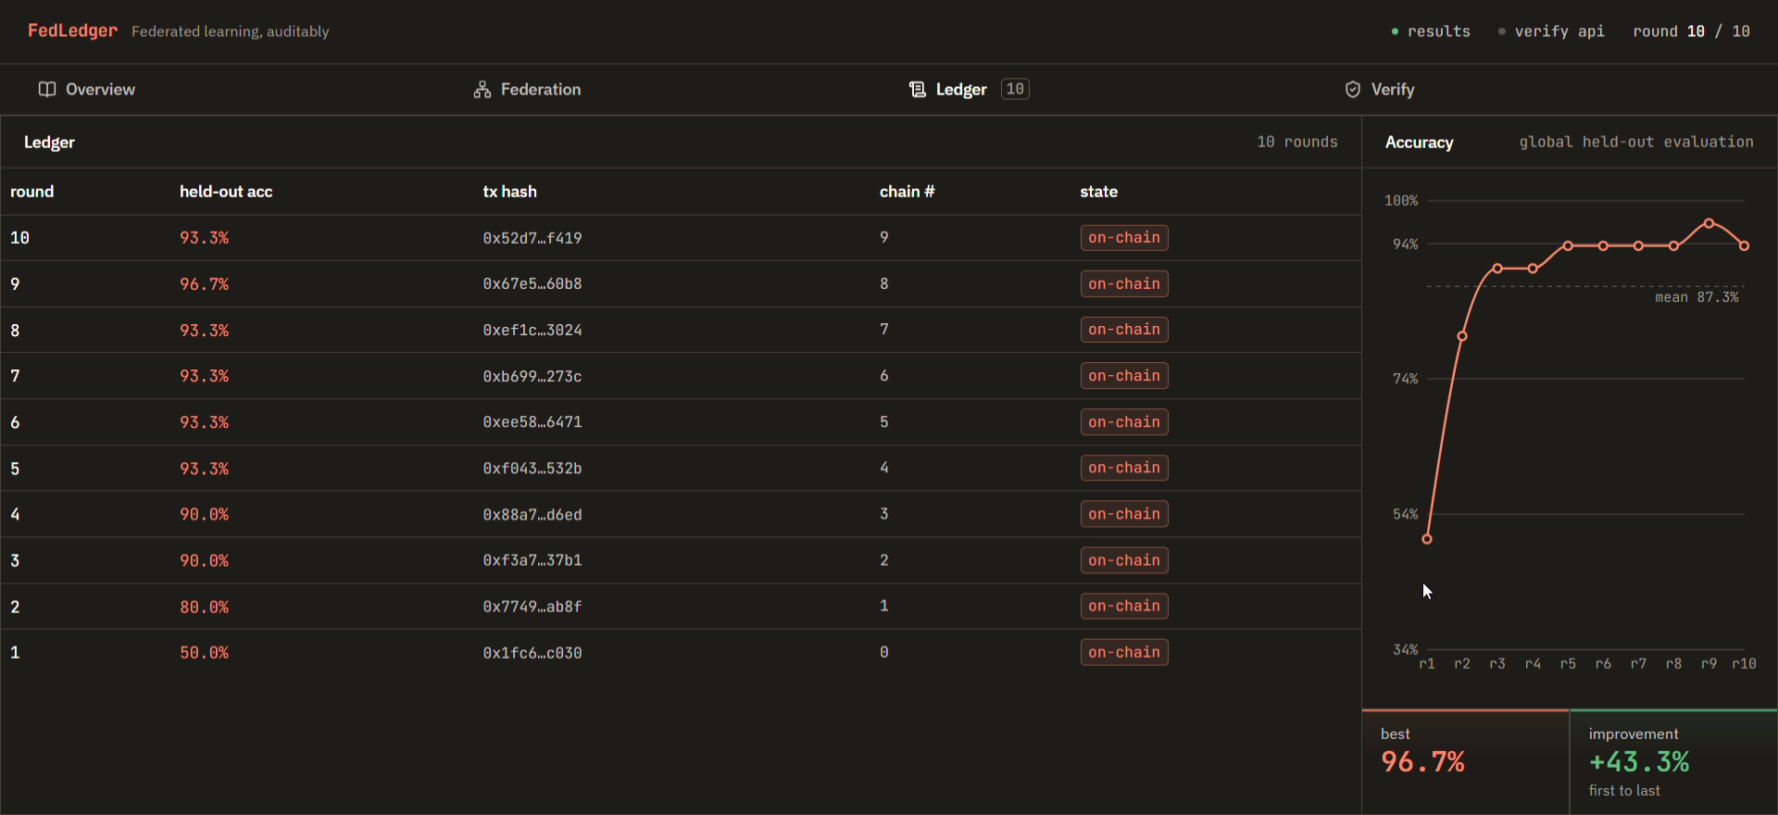
Fig 6.3 Ledger Tab
4. Chain Receipt
Selecting a round in the ledger opens its chain receipt, read from the blockchain. For round 10 the receipt shows the block number (113), the gas used (305,734), the time at which it was logged, the logging account, the accuracy stored on the chain (93.3%, stored multiplied by 1000), the model hash, and the transaction hash. The receipt also states what is not recorded anywhere: per-organisation accuracies and the per-round weights.
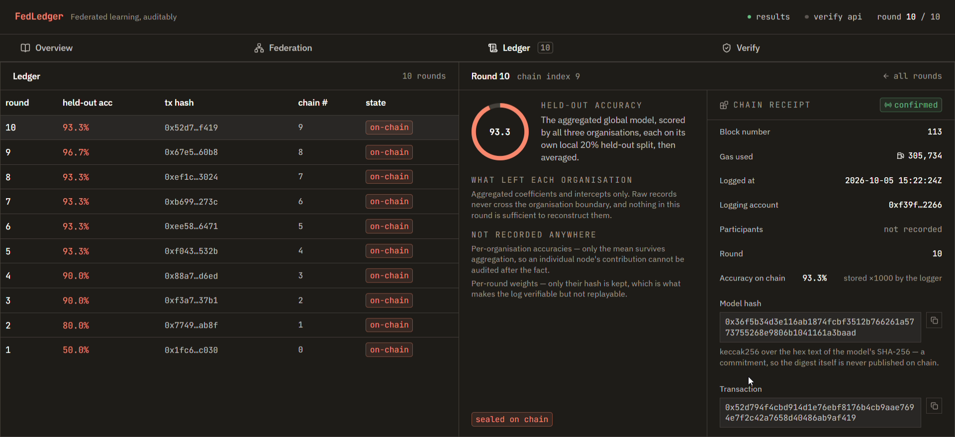
Fig 6.4 Chain Receipt of Round 10

5. Verify Tab
The Verify tab checks a round cryptographically. The user picks a sealed round (chain index 0 to 9 maps to rounds 1 to 10), drops or pastes the recomputed weights as JSON in the form [coef_matrix, intercept_vector], and clicks Compare hashes. The dashboard sends the weights to the verify API (POST :8088/verify), which recomputes the SHA-256 hash and compares it with the hash stored on the chain. An Alter one coefficient button corrupts a single weight to show how a mismatch is detected. The tab also explains that its demo weight files will not match the chain, because they are plausible but invented.
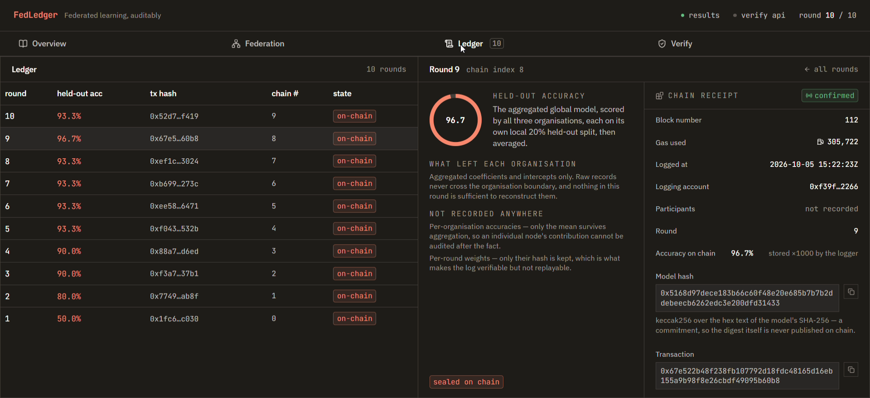
Fig 6.5 Verify Tab
6. Round-wise Results
The following table lists the 10 rounds recorded on the blockchain. The accuracy is the global model scored by all three organisations, each on its own 20% held-out split, then averaged.
Round | Held-out Accuracy | Transaction Hash | Chain Index
1 | 50.0% | 0x1fc6…c030 | 0
2 | 80.0% | 0x7749…ab8f | 1
3 | 90.0% | 0xf3a7…37b1 | 2
4 | 90.0% | 0x88a7…d6ed | 3
5 | 93.3% | 0xf043…532b | 4
6 | 93.3% | 0xee58…6471 | 5
7 | 93.3% | 0xb699…273c | 6
8 | 93.3% | 0xef1c…3024 | 7
9 | 96.7% | 0x67e5…60b8 | 8
10 | 93.3% | 0x52d7…f419 | 9
Table 6.1: Round-wise results recorded on the blockchain. Best accuracy 96.7% (round 9); mean 87.3%; improvement from the first to the last round +43.3%.
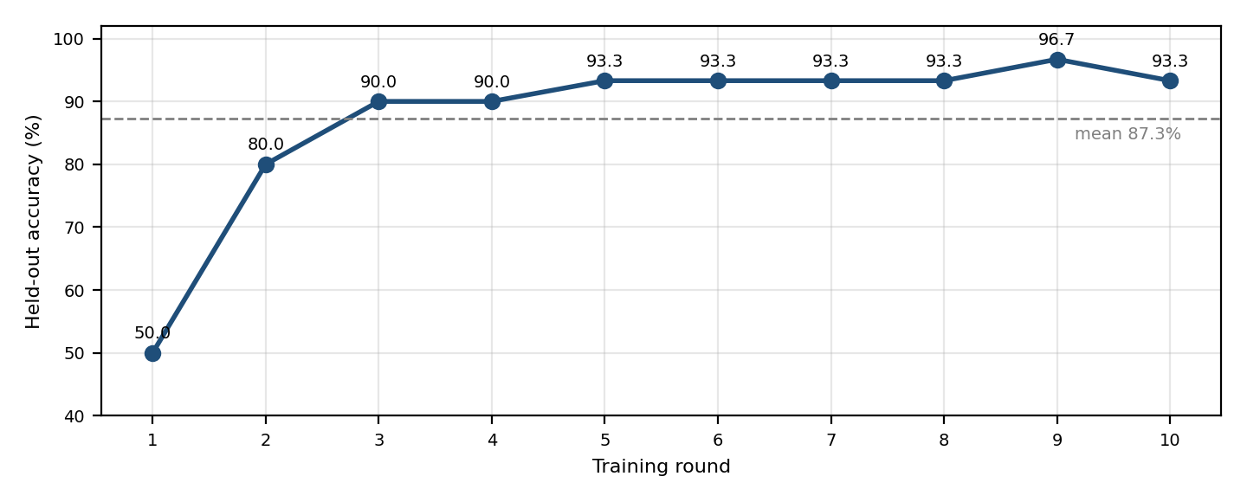
Fig 6.6 Global Model Accuracy per Round

6.2 Advantages
- Raw data never leaves an organisation; only weights are shared.
- Every training round is recorded on a blockchain.
- The smart contract has no update or delete function, so a written record cannot be edited.
- Uses SHA-256 hashing to detect any change in the model weights.
- Any participant can verify a round independently, without trusting the server.
- Provides a live dashboard that shows the training, the ledger, and the verification.
- Starts the whole system with one command.
- Runs on a local blockchain at no cost, and the same contract can be used on an Ethereum-compatible network.
6.3 Applications
- Collaborative model training between banks, hospitals, and government bodies.
- Training on sensitive data that cannot be pooled.
- Keeping an auditable record of how a shared model was produced.
- Checking that a distributed global model is the one that was recorded.
- Teaching and demonstrating federated learning and blockchain together.
- Any multi-party machine learning where the aggregator is not fully trusted.

CONCLUSION

7. Conclusion
FedLedger is a federated learning system with a blockchain audit trail, developed so that several organisations can train a shared model without sharing their raw data and can check the work of the central server. Three nodes train logistic regression models on private partitions of the Iris dataset, and the server combines their weights using FedAvg.
After every round, the server computes a SHA-256 hash of the global weights and records it, with the round number and the accuracy, in the FLAuditLog smart contract on a local Hardhat blockchain. In the recorded run, all 10 rounds were written on the chain, and the accuracy rose from 50.0% in round 1 to 93.3% in round 10, with a best value of 96.7% in round 9. Because the contract has no function to update or delete a record, a recorded round cannot be edited, and the Verify tab lets a user recompute a hash and compare it with the chain.
The system also has limits, which the dashboard itself states. Only the hash of each round’s weights is stored, so the weights have to be supplied again for verification. The accuracy is the average of the held-out results of the three nodes, and the individual accuracy of each organisation is not recorded. The immutability comes from the contract exposing no edit function on a local chain, and a real deployment would place the same contract on a chain that the FL server does not control.
Overall, FedLedger demonstrates how federated learning, cryptographic hashing, smart contracts, and a web dashboard can be combined to create a privacy-preserving and independently verifiable model training process. The project provides a simple interface while applying several techniques to protect the data and to make the training auditable.

REFERENCES

8. References
1. S. Nakamoto, “Bitcoin: A Peer-to-Peer Electronic Cash System,” 2008.
2. V. Buterin, “A Next-Generation Smart Contract and Decentralized Application Platform,” Ethereum White Paper, 2014.
3. H. B. McMahan, E. Moore, D. Ramage, S. Hampson, and B. A. y Arcas, “Communication-Efficient Learning of Deep Networks from Decentralized Data,” in Proc. 20th International Conference on Artificial Intelligence and Statistics (AISTATS), 2017.
4. P. Kairouz et al., “Advances and Open Problems in Federated Learning,” Foundations and Trends in Machine Learning, vol. 14, no. 1–2, 2021.
5. D. J. Beutel et al., “Flower: A Friendly Federated Learning Research Framework,” arXiv:2007.14390, 2020.
6. H. Kim, J. Park, M. Bennis, and S.-L. Kim, “Blockchained On-Device Federated Learning,” IEEE Communications Letters, vol. 24, no. 6, 2020.
7. National Institute of Standards and Technology (NIST), “Secure Hash Standard (SHS),” FIPS PUB 180-4, 2015.
8. R. A. Fisher, “The Use of Multiple Measurements in Taxonomic Problems,” Annals of Eugenics, vol. 7, no. 2, 1936.
9. F. Pedregosa et al., “Scikit-learn: Machine Learning in Python,” Journal of Machine Learning Research, vol. 12, 2011.
10. Solidity Documentation, “Solidity Programming Language Documentation,” Ethereum Foundation. Available at: https://docs.soliditylang.org/
11. Hardhat Documentation, “Hardhat: Ethereum Development Environment,” Available at: https://hardhat.org/docs
12. web3.py Documentation, “web3.py: A Python library for interacting with Ethereum,” Available at: https://web3py.readthedocs.io/
13. Flower Documentation, “Flower: A Friendly Federated Learning Framework,” Available at: https://flower.ai/docs/
14. React Documentation, “React: The Library for Web and User Interfaces,” Available at: https://react.dev/

