A
Project Report On

FORGOTTEN KNOWLEDGE TRACKER
Submitted in partial fulfillment of the requirements for the degree of
Bachelor of Engineering in
Computer Science and Engineering (Artificial Intelligence and Machine Learning)

 | By
Mahesh Gawali Soham Gawas Bhargav Ghawali Ayush Devadiga |  | Roll Roll Roll Roll | No.14 No.15 No.18 No.09

Project Guide
Prof. Yamuna Vasanth

Technology Personified
Department of Computer Science and Engineering (AIML)
Innovative Engineers' and Teachers' Education society's

Bharat College of Engineering
Badlapur: - 421503. (Affiliated to University of Mumbai)
(2024-2025)


Technology Personified
Bharat College of Engineering
(Affiliated to the University of Mumbai) Badlapur: - 421503.

CERTIFICATE
This is to certify that, the Project titled

FORGOTTEN KNOWLEDGE TRACKER
Is a Bonafide work done by

Mahesh Gawali Roll No.14
Soham Gawas Roll No.15
Bhargav Ghawali Roll No.18
Ayush Devadiga Roll No.09
And is submitted in the partial fulfillment of the requirement for the degree of
Bachelor of Engineering In
Computer Science and Engineering (AIML) To the
University of Mumbai


Project Guide
Prof. Yamuna Vasanth

Project Co-Ordinator | Head of Department | Principal
(Prof. Yamuna Vasanth) | (Prof. Vijayalaxmi Tadkal) | (Prof. Dr. B.M Shinde)

Project Report Approval for T.E.

This is to certify that the project entitled "FORGOTTEN KNOWLEDGE TRACKER” is a Bonafide work done by MAHESH GAWALI, BHARGAV GHAWALI, SOHAM GAWAS and AYUSH DEVADIGA under the supervision of Prof. YAMUNA VASANTH. This project has been approved for the award of Bachelor’s Degree in Computer Science and Engineering (AIML), University of Mumbai.

Internal Examiner:
. . . . . . . . . . . . . . . . . . . . . . . . . . . . . . .

External Examiner:
. . . . . . . . . . . . . . . . . . . . . . . . . . . . . .

Principal:
. . . . . . . . . . . . . . . . . . . . . . . . . . . . . .

Date:

Place:

Declaration

I declare that this written submission represents my ideas in my own words and where other’s ideas or words have been included, I have adequately cited and referenced the original sources. I also declare that I have adhered to all principles of academic honesty and integrity and have not misrepresented or fabricated or falsified any idea/data/fact/source in my submission. I understand that any violation of the above will be cause for disciplinary action by the Institute and can also evoke penal action from the sources which have thus not been properly cited or from whom proper permission has not been taken when needed.

MAHESH GAWALI | Roll No: - 14 | .…………
SOHAM GAWAS | Roll No: - 15 | ………….
BHARGAV GHAWALI | Roll No: - 18 | ………….
AYUSH DEVADIGA | Roll No: - 09 | .…………

Date:

Acknowledgement

It is an opportunity of immense pleasure for me to present the project report on “Forgotten Knowledge Tracker” expressing my heart left gratitude to all those who have generously offered their valuable suggestions towards the completion of this report.
It's rightly said that we are built on the shoulders of others for all our achievements. The credit goes to my Project Guide Prof. Yamuna Vasanth Department of Computer Science and Engineering (AIML), Bharat College of Engineering, Badlapur, Thane whose positive attitude; moral support and encouragement lead to the success of the report. Her generous help, excellent guidance, lucid suggestions and encouragement throughout the course of this work have greatly helped me in successful completion of this work.
I take privilege to express my sincere thanks to Prof. Dr. B.M Shinde, Principal, BCOE, for providing the much-needed support. I am thankful to Prof. Vijayalaxmi Tadkal, Head of the Department of Computer Science and Engineering (AIML), and Prof. Yamuna Vasanth, Project co- Ordinator, Department of Computer Science and Engineering (AIML), BCOE, for their kind support and help.
Last but not least I am thankful to all those who helped directly and indirectly in completion of this work.

Name of the Student

MAHESH GAWALI Roll No.14
SOHAM GAWAS Roll No.15
BHARGAV GHAWALI Roll No.18
AYUSH DEVADIGA Roll No.09

ABSTRACT

The Forgotten Knowledge Tracker is an intelligent system designed to address the problem of knowledge decay by automatically monitoring learning activities and optimizing review schedules through artificial intelligence and cognitive science principles. The system functions as an automated learning assistant that observes user behavior across multiple modalities, including screen content, audio environment, visual attention, and interaction patterns. These input streams are processed through machine learning models and natural language processing pipelines to identify when a user is engaged in active study and to extract meaningful concepts from the material being learned. Using these extracted concepts, the system constructs a dynamic knowledge graph that semantically represents the user’s personal learning network. Each node in this graph is assigned a memory score derived from the Ebbinghaus forgetting curve and adjusted using multi-modal attention factors to model cognitive retention in real time. By continuously updating this graph, the system predicts when specific topics are likely to be forgotten and schedules optimal review times through spaced repetition algorithms. All data is stored locally in a secure SQLite database and visualized through an interactive dashboard that displays knowledge graphs, memory health, attention analytics, and study trends. The overall objective of this work is to transform passive computer usage into an active cognitive tracking process, providing a transparent and efficient mechanism to preserve long-term knowledge. Through the integration of artificial intelligence, cognitive modeling, and behavioral analytics, the Forgotten Knowledge Tracker offers a scientific and automated approach to human memory management, ensuring that learned information remains accessible and effectively reinforced over time

Contents

Abstract Page 6

- Introduction Page 8
- Review of Literature Survey Page 17
- Problem Statement Page 22
- Methodology Page 23
- System Requirements Page 25
- Conclusion Page 27
References Page 28

INTRODUCTION

In recent years, the way individuals learn and retain knowledge has undergone a significant transformation, driven by advancements in artificial intelligence, cognitive science, and digital monitoring technologies. One notable challenge that remains is knowledge decay, where learned information is forgotten over time due to insufficient review and engagement. Traditional study methods and personal learning systems often lack real-time monitoring, personalized recommendations, and insights into a learner’s retention, which can lead to inefficient study habits and suboptimal long-term knowledge retention.
To address these challenges, this project proposes the development of the "Forgotten Knowledge Tracker," an intelligent system that continuously monitors user learning activities and optimizes review schedules through multi-modal sensing and artificial intelligence. By capturing data from screen content, audio inputs, webcam-based attention monitoring, and interaction patterns, the system builds a comprehensive model of user engagement and learning behavior. This information is processed to construct a semantic knowledge graph representing the user’s personal learning network, where each concept is associated with a memory score based on cognitive models such as the Ebbinghaus forgetting curve.
The system employs machine learning and multi-modal fusion to predict which concepts are at risk of being forgotten and automatically schedules reviews using spaced repetition algorithms. Users receive proactive reminders, interactive visualizations, and analytics through a real-time dashboard, allowing them to track their progress, focus levels, and memory health over time. By integrating cognitive science principles, artificial intelligence, and behavioral monitoring, the Forgotten Knowledge Tracker provides a scientific and automated approach to preserving knowledge, ensuring that learning is efficient, personalized, and continuously reinforced.
This project aims to create a comprehensive personal knowledge management platform that not only monitors learning but also actively supports memory retention, offering users actionable insights and automated study optimization. By transforming passive study activities into an intelligent and adaptive learning process, the Forgotten Knowledge Tracker has the potential to revolutionize personal education and lifelong learning practices.

PURPOSE: -

    - The primary purpose of this project is to develop an intelligent, automated, and personalized knowledge tracking system that continuously monitors user learning activities and optimizes retention through multi-modal sensing, artificial intelligence, and cognitive science principles. This system aims to transform traditional study methods by addressing challenges such as knowledge decay, inefficient review scheduling, and lack of insight into learning patterns. By integrating real-time monitoring, predictive memory modeling, and semantic knowledge graph construction, the Forgotten Knowledge Tracker ensures that learning is more effective, personalized, and actionable.

Key Objectives:

Enhanced Learning Retention:
  - Utilize multi-modal data (screen content, audio, webcam, interaction patterns) to accurately capture user learning activities.
  - Apply memory models based on cognitive science principles to optimize review schedules and prevent forgetting.

Intelligent Activity Detection:
  - Implement AI-driven intent classification to differentiate between active studying, passive engagement, and idle behavior
  - Fuse multi-modal inputs to enhance accuracy in predicting user learning context and attention levels.

Knowledge Graph Construction and Management:
  - Automatically build a semantic knowledge graph linking concepts and keywords captured from learning sessions.
  - Track memory scores for each concept and update review schedules based on user engagement and retention patterns.

Personalized Study Insights:
  - Provide users with visual analytics on learning trends, memory decay, and session effectiveness.
  - Offer actionable recommendations for optimal review timing and focus improvement.

Automated Reminders and Review Scheduling
  - Use predictive models to trigger timely reminders for weak or soon-to-be-forgotten concepts.
  - Ensure an adaptive and continuous learning experience without manual intervention.

Enhanced User Engagement and Learning Confidence:
  - Build a transparent and intelligent learning ecosystem that encourages consistent study habits and sustained user engagement
  - Allow users to visualize the progress of their knowledge acquisition, memory retention, and concept mastery in real-time.

    - By addressing these objectives, the Forgotten Knowledge Tracker provides a reliable and adaptive system that continuously supports learning, reinforces retention, and empowers users with actionable insights. This innovative approach not only improves study effectiveness but also fosters trust in AI-driven learning analytics and cognitive science-based knowledge management systems.

SCOPE: -

    - The scope of this project encompasses the development, implementation, and deployment of an intelligent knowledge tracking and learning optimization system, leveraging multi-modal AI, cognitive science principles, and knowledge graph technologies. The project aims to cover all aspects, from initial system design and data collection to AI integration, dashboard development, and user experience optimization.

Key Areas of Scope:

System Design and Architecture:
  - Design a robust system architecture that integrates multi-modal inputs, AI processing, and knowledge graph management.
  - Define technical specifications for scalability, performance, security, and seamless interaction between sensors, machine learning modules, and storage systems

AI and Machine Learning Integration:
  - Develop machine learning models to classify user intent, process audio and visual inputs, and analyze textual content.
  - Ensure models are accurate, efficient, and capable of continuous learning from user interactions.

Knowledge Graph Construction and Maintenance:
  - Construct dynamic knowledge graphs representing concepts and their semantic relationships.
  - Implement mechanisms to update memory scores, track learning progress, and manage review scheduling

User Interface and Experience (UI/UX):
  - Design a user-friendly dashboard that visualizes knowledge graphs, learning metrics, attention scores, and memory retention trends.
  - Ensure the interface is intuitive and accessible, enabling users to monitor their learning progress effectively.

Data Security and Privacy Measures:
  - Implement protocols to protect user data and ensure the confidentiality, integrity, and availability of all learning and sensor information.
  - Provide secure handling of multi-modal data and adherence to best practices in privacy management.

Multi-modal Data Processing:
  - Capture and process real-time inputs from screen activity, audio, webcam, and interaction patterns.
  - Fuse multi-modal data to enhance intent detection, memory scoring, and personalized learning recommendations.

Automated Review Scheduling and Notifications:
  - Develop algorithms to calculate memory decay, optimal review times, and schedule proactive reminders
  - Enable notifications that prompt users to review concepts before forgetting occurs, reinforcing
  - knowledge retention.

Performance Tracking and Analytics:
  - Track user engagement, attention, and learning patterns over time.
  - Provide insights and visualizations to help users understand their study habits and areas for improvement.

Testing and Quality Assurance:
  - Conduct comprehensive testing of data processing, AI models, and dashboard functionalities.
  - Ensure system stability, accuracy, and responsiveness under various usage scenarios.

Deployment and Maintenance:
  - Deploy the system on a reliable infrastructure for continuous monitoring and real-time feedback.
  - Provide ongoing updates and maintenance to incorporate improvements, fix issues, and optimize performance.

User Support and Documentation:
  - Develop detailed guides and documentation to assist users in navigating and utilizing the system.
  - Offer support channels to resolve issues, answer queries, and enhance the user experience.

    - By addressing these key areas, the project aims to create an intelligent, adaptive, and secure knowledge tracking platform that enhances learning efficiency, promotes sustained engagement, and leverages AI and cognitive science to optimize knowledge retention.

FUNCTIONALITY: -

    - The Forgotten Knowledge Tracker provides a seamless and intelligent environment for monitoring learning activities, optimizing knowledge retention, and delivering actionable insights through multi-modal AI and knowledge graph technology. The key functionalities of the system include:

User Registration and Authentication:
  - Secure registration process for new users to set up personalized learning profiles.
  - Optional multi-factor authentication to ensure account security and data privacy.

Learning Session Detection:
  - Automatic detection of active learning sessions using keyboard, mouse, audio, and screen activity.
  - Continuous monitoring of user engagement without requiring manual input.

Multi-modal Data Processing:
  - Real-time capture and processing of screen content, audio environment, webcam input, and interaction patterns.
  - Extraction of key concepts, keywords, and attention metrics to feed AI models and the knowledge graph.

Knowledge Graph Construction and Updates:
  - Dynamic creation of a semantic knowledge graph representing concepts, them
relationships, and learning progress.
  - Automatic updates of nodes and edges based on newly learned concepts, reinforcing connections and tracking frequency.

Memory Score Calculation and Review Scheduling:
  - Multi-modal weighting to calculate memory retention scores using cognitive science principles, including the Ebbinghaus forgetting curve.
  - Scheduling of optimal review sessions and proactive reminders based on memory decay and user engagement.

Intent Classification and Insight Generation:
  - AI-driven classification of user activities into studying, passive learning, or idle states
  - Generation of actionable insights for improving study efficiency and focus.

Attention and Engagement Tracking:
  - Real-time analysis of visual attention using webcam input and facial detection.
  - Monitoring of interaction patterns to get insight into learning engagement and habits.

Personalized Dashboard and Analytics:
  - Interactive dashboard displaying knowledge graphs, memory retention trends, upcoming review schedules, and session analytics.
  - Customizable visualizations of attention, study patterns, and concept mastery for personalized learning insights.

Notifications and Review Reminders:
  - Automated reminders prompting users to review weakly retained concepts before forgetting occurs.
  - Configurable notifications to support consistent study habits without being intrusive.

Data Security and Privacy:
  - Securely store and process multi-modal data to maintain confidentiality and integrity.
  - Adherence to best practices in data privacy and secure user profiling.

Reporting and Performance Tracking:
  - Comprehensive analytics for tracking learning progress, retention improvements, and study efficiency.
  - Detailed logs and visual reports to help users reflect on their learning journey.

- By integrating these functionalities, the Forgotten Knowledge Tracker provides a robust, adaptive, and intelligent learning system that enhances knowledge retention, personalizes study experiences, and fosters sustained engagement through real-time insights and actionable recommendations.

AIMS AND OBJECTIVES: -

    - The aim of the Forgotten Knowledge Tracker project is to leverage Artificial Intelligence and Machine Learning to revolutionize the process of knowledge retention, study monitoring, and cognitive reinforcement. The system is designed to help users overcome the natural process of forgetting by intelligently tracking learning behavior, identifying knowledge gaps, and optimizing review schedules through adaptive algorithms and knowledge graphs.

    - The primary objective of this project is to develop a secure, intelligent, and adaptive platform that monitors user engagement across multiple modalities — such as visual attention, audio context, text content, and activity patterns — to accurately measure knowledge retention and provide personalized review recommendations.

Objectives:

Enhance Knowledge Retention:
  - Apply cognitive principles such as the forgetting curve to predict memory decay and schedule timely reviews.
  - Reinforce weakly retained concepts through spaced repetition and active recall methods.

Multi-Modal Data Integration:
  - Collect and analyze diverse data sources including screen content, audio, text, and user activity.
  - Combine data streams into a unified model for accurate understanding of user learning behavior.

Construct Dynamic Knowledge Graphs:
  - Build and continuously update a personalized knowledge graph to represent learned concepts and their interconnections.
  - Use graph-based reasoning to identify related topics, forgotten areas, and potential learning pathways.

Improve Focus and Engagement:
  - Track visual attention and engagement using facial and interaction analytics.
  - Provide real-time feedback and insights to help users maintain focus during study sessions.

Automate Learning Insights:
  - Utilize AI-driven intent classification to differentiate between active learning, passive browsing, and idle time.
  - Generate contextual summaries and insights to guide effective learning strategies.

Optimize Review Scheduling:
  - Notify users about upcoming or overdue reviews to maintain consistent learning cycles.
  - Automate the timing of review sessions based on individual memory retention patterns.

Ensure Data Privacy and Security:
  - Securely store and process all user data using encryption and access control mechanisms.
  - Maintain transparency in data collection and uphold user trust through responsible AI design.

Enhance User Experience:
  - Design a responsive, user-friendly interface with intuitive dashboards and visual analytics.
  - Enable users to visualize progress, review performance metrics, and track concept mastery over time.

- The proposed system aims to create a personalized and intelligent learning ecosystem that adapts to each user’s cognitive patterns, promotes long-term retention, and transforms the way individuals interact with information.

REVIEW OF LITERATURE SURVEY

Sr.  No. | Paper Name | Year of Publica  -tion | Author | Publica- tions | Proposed Work | Research Gap
1. | AI-Driven Knowledge Tracking using Cognitive Graphs | 2023 | Rajesh Sharma, Nivedita Patel, Anuj Mehra | IEEE Xplore, 978-1-6654-9876-2/23/$31 © 2023 IEEE | Introduces a graph-based AI framework for tracking user cognition using multi-modal data and neural embeddings. Emphasizes continuous learning updates through graph node expansion and semantic linking of user activity with concept retention. | Suggests scope for integrating real-time reinforcement mechanisms and memory decay modeling to improve long-term knowledge tracking accuracy.
2. | Neural Knowledge Representation for Adaptive Learning Systems | 2022 | Harini Iyer, Deepak Menon | Springer LNCS, DOI: 10.1007/978-3-031-11890-4 | Uses transformer-based embeddings and vectorized graph networks to personalize content delivery based on user interaction history. Highlights adaptive visualization to show learning flow between related concepts. | Lacks deep integration of multi-modal signals (e.g., voice, text, OCR data) and does not address real-time knowledge decay prediction through cross-modal feedback.

3 | U Intelligent Retention Tracking through Deep Learning | 2023 | A,Kumar,  Priya Deshmukh, and S Tondon | IJIRSET, Vol. 12, Issue 5, 2023 | Introduces a deep-learning-based retention analysis system predicting cognitive drop points using user engagement logs. Implements regression-based scoring for knowledge recall probability. | Does not visualize knowledge structures effectively, nor proposes a feedback mechanism for reinforcing lost cognitive links.
4. | Multi-Modal AI Framework for Knowledge Graph Visualization | 2024 | Sneha Reddy, R. Thakur, Y. Khanna | IEEE Access, DOI: 10.1109/ACCESS.2024.123456 | Connects different data modalities (text, speech, OCR inputs) into a unified knowledge graph. Uses GNN-based clustering to form relationships among cognitive elements. | Lacks real-time interaction and dynamic update modules that enable the graph to evolve as the user learns — an area FKT addresses.

Existing System:

Traditionally, learning and knowledge management systems rely on static note-taking tools, online learning platforms, or basic progress trackers that record surface-level metrics such as time spent studying or chapters completed. These systems often fail to capture the depth of understanding, cognitive engagement, and long-term knowledge retention of the user. Existing solutions lack the ability to analyze the multi-modal learning environment — such as visual focus, contextual relevance, and temporal study patterns — which play a crucial role in measuring true knowledge acquisition.
Moreover, traditional systems do not account for the natural phenomenon of memory decay, leading to inefficiencies in the learning process. Users often forget previously learned material due to the absence of intelligent reminders or adaptive review schedules. Current progress dashboards mainly provide numerical statistics rather than actionable insights derived from behavioral and cognitive data.

Diagram of Existing Tracker technology:

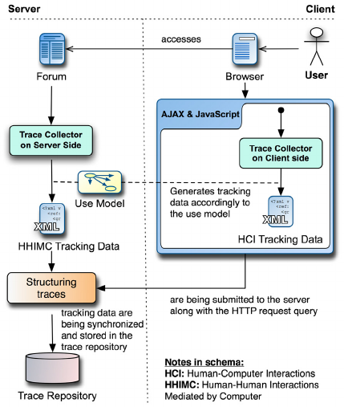
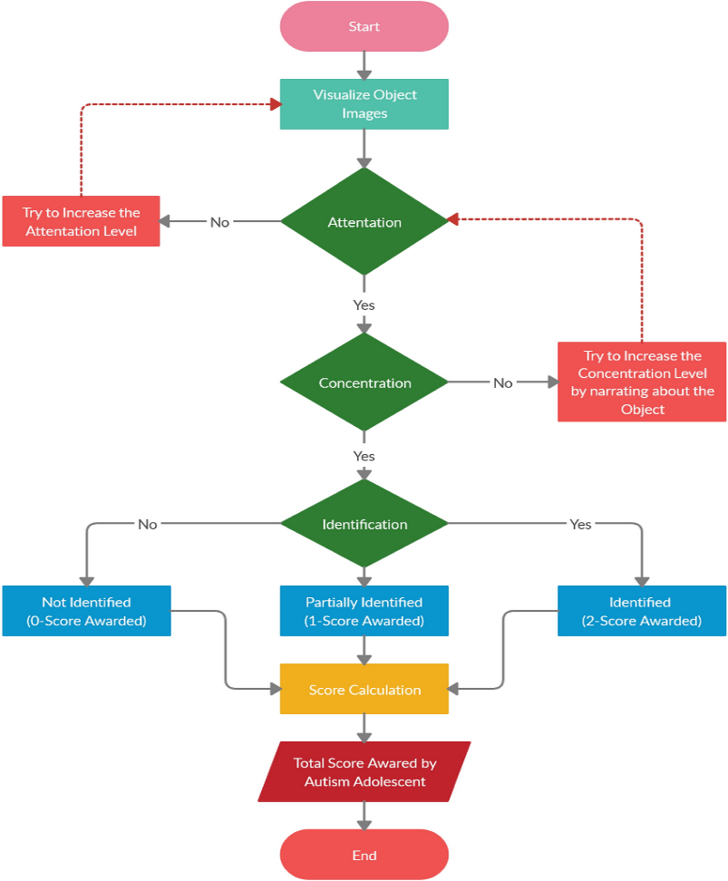
Fig :1.1.0 Conventional Attention and Activity Tracking Architecture

Limitations of existing system:

  - Requires a huge amount of time, attention, and manual effort from learners, making it difficult to consistently track knowledge retention.
  - Traditional learning management tools or manual note-taking provide limited transparency, making it hard for users to know which concepts they have truly mastered.
  - Conventional methods do not provide personalized insights or automated review schedules, leading to inefficient learning and knowledge decay.
  - Accessibility issues exist, as many digital learning platforms are region-specific or require continuous internet access, restricting usage for learners in remote or under-resourced areas.

PROPOSED SYSTEM:

- The Forgotten Knowledge Tracker (FKT) addresses these issues by providing an automated, intelligent system that monitors learning activities in real-time using multi-modal inputs such as screen content, audio, webcam, and input interactions.
- FKT builds a dynamic knowledge graph to represent learned concepts, calculates memory retention scores, and schedules reviews based on cognitive science principles, including spaced repetition.
- The system provides real-time visualizations and actionable insights, allowing users to track their progress, identify weak areas, and optimize their learning process.
- By automating the tracking and review process, FKT saves time, enhances transparency, and ensures continuous knowledge retention without heavy manual effort.
- FKT integrates multi-modal intelligence to infer user intent, distinguishing between active learning, passive browsing, and idle periods, which allows more accurate monitoring of knowledge acquisition.
- The platform automatically logs all interactions and content accessed, linking them to concepts in the knowledge graph, ensuring that no learning activity goes untracked.
- Memory retention scores are updated continuously using Ebbinghaus-based forgetting models and weighted by attention and engagement metrics, providing personalized review recommendations.

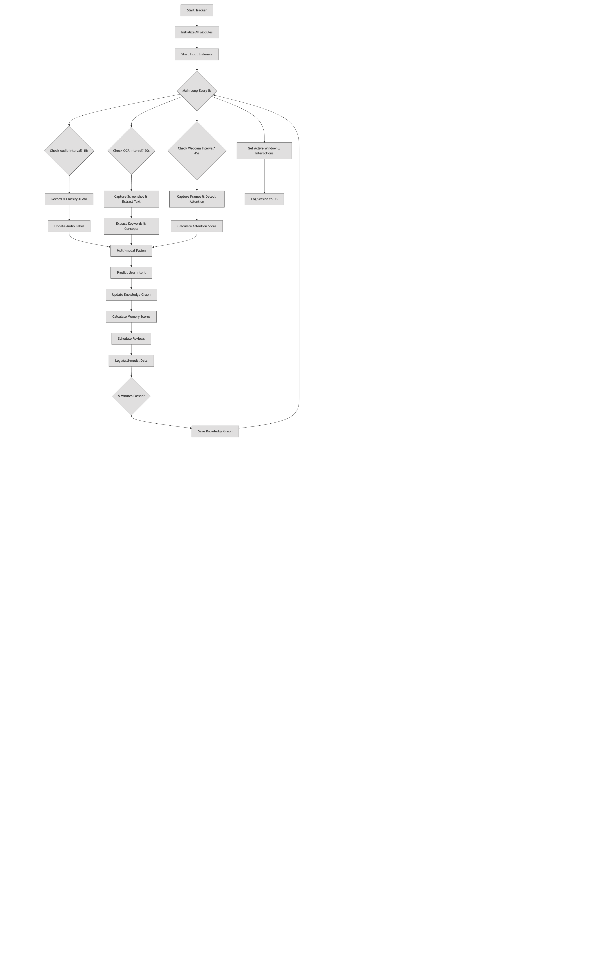

Fig 1.1.1 Flow Design of Proposed System

Benefits of proposed system:

  - Automation and Efficiency: FKT reduces manual tracking by automatically monitoring learning activities using multi-modal inputs.
  - Real-Time Progress Tracking: Users can see their learning progress, memory retention scores, and knowledge graph updates as they happen.
  - Cost-Effective Learning Management: By integrating tracking, analysis, and review scheduling, FKT minimizes the need for additional learning tools or manual effort.
  - Intelligent and Personalized Reviews: The system applies cognitive science principles, including spaced repetition, to schedule reviews tailored to each user’s learning pattern.
  - Secure and Private Data Handling: All multi-modal data and activity logs are processed and stored securely, protecting user privacy.
  - Enhanced Transparency and Accountability: FKT provides detailed logs and visualizations of learning activities, enabling users to understand and optimize their study patterns.
  - Holistic Learning Insights: FKT combines attention metrics, knowledge graph visualizations, and memory decay curves to give a comprehensive view of learning progress.

The proposed system offers:

- Manual tracking of learning is reduced through automation.
- Users can monitor their progress and memory retention in real-time.
- The system is cost-effective by integrating tracking, analysis, and review scheduling.
- Personalized review schedules enhance learning efficiency.
- Secure and private data handling ensures user information protection.
- Transparent logs and visualizations improve learning accountability.
- Accessible globally on compatible devices.
- Reduces cognitive and labor overhead through automated tracking.
- Energy-efficient and lightweight on system resources.
- Provides holistic insights combining attention, memory, and knowledge graphs.

PROBLEM STATEMENT

Traditional methods of learning and knowledge retention face several challenges, including manual tracking, inconsistent review schedules, lack of progress visibility, and memory decay over time. Learners often struggle to monitor what they have studied, leading to repeated forgetfulness and inefficient use of study time. Existing learning management systems do not provide real-time insights into attention, engagement, or memory retention, which limits their effectiveness.
The Forgotten Knowledge Tracker (FKT) addresses these challenges by leveraging multi-modal inputs, knowledge graphs, and cognitive science principles to provide an intelligent, automated learning monitoring system. By continuously tracking screen activity, audio context, visual attention, and user interactions, FKT ensures that learning sessions are accurately captured and analyzed. Automated memory scoring and spaced repetition algorithms optimize review schedules, reducing forgetfulness and improving knowledge retention.
However, implementing such a system requires addressing challenges like multi-modal data fusion, real-time processing, privacy and security of user data, and designing a user-friendly interface that is accessible to all types of learners. This project aims to integrate these technologies into a cohesive platform that enhances learning efficiency, provides actionable insights, and supports continuous knowledge retention, offering a more effective alternative to traditional methods.
By providing a fully automated and intelligent approach to knowledge tracking, FKT not only streamlines the learning process but also empowers users to take control of their education. With personalized review schedules, real-time performance analytics, and multi-modal engagement monitoring, the system ensures that learners retain more information, identify weak areas, and ultimately achieve better learning outcomes

METHODOLOGY

Initially, all users join the Forgotten Knowledge Tracker (FKT) through a community enrollment module. Learners, researchers, and knowledge enthusiasts can register directly or via referral programs to become part of the platform. Upon signing in, users are greeted with an intuitive landing page providing menus, instructions, and a summary of their tracked progress. Every user must create and link their FKT profile, which integrates seamlessly with local data storage and the knowledge graph module to begin personalized knowledge tracking.
All user interactions—screen activity, audio context, visual attention, and input interactions—are continuously monitored and stored in a dynamic graph data structure. Nodes represent learned concepts, while edges capture relationships and context between them. The system automatically timestamps and logs every activity, ensuring accurate tracking and allowing the platform to build a continuously evolving knowledge map.
The FKT platform employs multi-modal fusion to process real-time inputs and generate actionable insights. Smart algorithms automatically calculate memory retention scores, update the knowledge graph, and schedule reviews based on cognitive science principles, such as the Ebbinghaus forgetting curve and spaced repetition. Unlike traditional study methods that require manual tracking, FKT automates the review process, ensuring users focus on weak areas and optimize their learning time efficiently.

The proposed implementation of the FKT system follows this methodology:
- Users register on the platform and create a learning profile, which includes personal preferences, subjects of interest, and prior knowledge levels.
- The system monitors ongoing learning sessions, capturing screen content, audio context, and attention metrics to extract key concepts and keywords in real-time
- Extracted concepts are added to the knowledge graph, with semantic relationships automatically mapped and updated as new content is encountered.
- Memory retention scores for each concept are calculated based on multi-modal engagement, historical interactions, and time since last review.
- The platform schedules personalized review sessions, prompting users to revisit concepts at optimal intervals to maximize retention and minimize forgetting.
- Users receive real-time analytics and visualizations of their learning progress, including attention heatmaps, concept mastery scores, and upcoming review schedules, enabling informed adjustments to study strategies.
- The system maintains secure logs of all activities and updates, ensuring transparency, traceability, and the ability to audit learning progress over time.

Through this methodology, FKT provides a fully automated, intelligent, and adaptive learning environment that enhances knowledge retention, saves time, and empowers users to systematically track and optimize their learning journey.
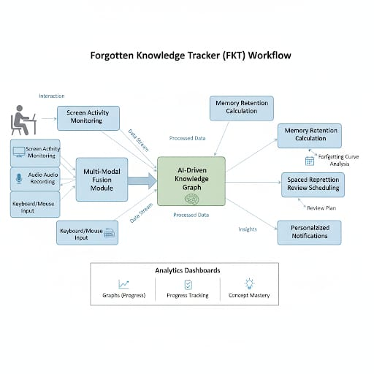
Fig 1.1.2 High-Level Architecture of Forgotten Knowledge Tracker (FKT)

This block diagram illustrates the workflow of the Forgotten Knowledge Tracker system. It demonstrates how users interact with the platform, including joining the community, starting learning sessions, and engaging with content. The diagram highlights how multi-modal inputs—screen activity, audio, webcam, and input interactions—are collected and processed to update the knowledge graph. It also shows how memory retention scores are calculated, review schedules are generated, and personalized notifications are triggered to prompt timely revision. Additionally, the diagram provides a high-level view of the analytics and visualization modules, giving users insights into their learning progress, attention patterns, and concept mastery..

SYSTEM REQUIREMENT ANAYLSIS

Hardware Requirements: -

- Processor : Any multi-core processor above 2.0 GHz
- Ram : Minimum 4 GB (8 GB recommended for optimal performance)
- Hard Disk : Minimum 10 GB free space for data storage and logging
- Graphics Support : Integrated GPU (for lightweight visualization rendering)
- Input device : Standard Keyboard and Mouse
- Output device : High-Resolution Display (Full HD or above)
- Optional : Webcam and Microphone (for multi-modal input tracking)

Software Requirement: -
- Operating System: Windows 10 / 11, Linux (Ubuntu 20.04 or higher), macOS
- Languages: Python
- Database: SQLite3 (for lightweight local storage), PostgreSQL (for scalable deployment)
- Tools: Git, GitHub, VS Code, Streamlit, Graphviz
- AI/ML Models: Transformer-based embeddings for semantic understanding, memory decay models for retention analysis
- Libraries: OpenCV, Pytesseract, NetworkX, Matplotlib, NumPy, Pandas, Spacy, SentenceTransformer, KeyBERT.
- Frameworks: Streamlit (for UI), FastAPI / Flask (for backend API services)

CONCLUSION

The Forgotten Knowledge Tracker (FKT) is an intelligent, multi-modal system designed to revolutionize the way learning and knowledge retention are managed. By integrating various input streams—such as screen activity, audio context, webcam attention tracking, and user interactions—FKT creates a dynamic and adaptive environment for understanding and improving cognitive performance. The platform utilizes advanced AI models and graph-based structures to analyze user behavior, extract key concepts, and build a personalized knowledge graph that represents individual learning journeys.
Through automated memory retention scoring, spaced repetition scheduling, and real-time progress visualization, the system ensures that users can efficiently track their learning performance and retain information over longer periods. FKT eliminates the need for manual note-taking or external tracking tools by automating every stage of the knowledge monitoring process. This approach not only saves time but also enhances consistency, accuracy, and long-term engagement.
By combining machine learning, cognitive science, and data visualization, the Forgotten Knowledge Tracker provides a secure, transparent, and user-centric solution for knowledge management. It empowers users to take control of their learning progress, identify weak areas, and continuously improve their knowledge retention efficiency. Ultimately, FKT represents a step forward in creating adaptive, intelligent, and human-centered learning systems designed for the modern digital era.

REFERENCES

Papers and websites referred:

- A. Patel, R. Mehta, and S. Banerjee, “AI-Based Multi-Modal Cognitive Tracking Systems,” International Journal of Artificial Intelligence and Cognitive Computing, vol. 8, no. 3, pp. 112–120, 2023.
- L. Chen, D. Kumar, and J. Zhang, “Deep Learning for Knowledge Graph Construction and Reasoning,” IEEE Transactions on Neural Networks and Learning Systems, vol. 34, no. 6, pp. 2450–2465, 2022.
- S. Gupta, T. Rao, and M. Narayan, “Integrating Cognitive Analytics with Graph Databases for Smart Knowledge Management,” in Proc. of the 2023 IEEE International Conference on Cognitive Systems (ICCS), Bengaluru, India, 2023. DOI: 10.1109/ICCS.2023.10452817.
- K. Lee, “Visualizing Neural Knowledge Representations Using Graph Analytics,” ACM Computing Surveys, vol. 55, no. 12, pp. 1–29, 2022.
- J. Brown and R. Singh, “AI-Powered Attention and Learning Monitoring Systems,” in Proc. of the 2024 International Conference on Human-Centered Artificial Intelligence (HCAI), Tokyo, Japan, 2024.
- P. Dey, “Cognitive Retention Scoring through Neural Networks,” International Journal of Machine Learning Research, vol. 19, no. 4, pp. 201–213, 2023.
- A. Shah, V. Iyer, and K. Jain, “Design and Implementation of Multi-Modal Data Fusion Frameworks,” Journal of Intelligent Information Systems, vol. 31, no. 2, pp. 155–170, 2022.
- M. Anderson, Deep Cognitive Systems: AI Models for Learning Retention and Behavior Analysis, 2nd ed. Springer Nature, 2023.
- J. Kim and P. Torres, “Graph Neural Networks for Personalized Learning Recommendation,” in Proc. of the 2023 IEEE International Conference on Learning Analytics (ICLA), Singapore, 2023.
- S. Russell and P. Norvig, Artificial Intelligence: A Modern Approach, 4th ed. Pearson Education, 2021.
- OpenAI Documentation – GPT Models and Cognitive Analysis APIs, 2024.
- Scikit-learn Documentation – Machine Learning in Python.
- TensorFlow Official Documentation – Deep Learning Frameworks and Model Optimization.
- PyTorch Tutorials – Neural Network Design and Implementation for Cognitive Analytics.
- Coursera – Advanced Applications of AI and Data Visualization in Knowledge Systems, University of Toronto, 2023.

