A
Project Report On

TRUSTFUL CROWDFUNDED SUPPORTING PLATFORM USING BLOCKCHAIN
Submitted in partial fulfillment of the requirements For the degree of
Bachelor of Engineering in
Computer Science and Engineering (Artificial Intelligence and Machine Learning)

 | By
Amandeep Guggi Krushna Mane Kartik Salunkhe Anirudha Kolay |  | Roll Roll Roll Roll | No.10 No.23 No.48 No.20

Project Guide
Prof. ADITI WARANGE

Technology Personified
Department of Computer Science and Engineering (AIML)
Innovative Engineers' and Teachers' Education society's

Bharat College of Engineering
Badlapur: - 421503. (Affiliated to University of Mumbai)
(2024-2025)


Technology Personified
Bharat College of Engineering
(Affiliated to the University of Mumbai) Badlapur: - 421503.

CERTIFICATE
This is to certify that, the Project titled

TRUSTFUL CROWDFUNDED SUPPORTING PLATFORM USING BLOCKCHAIN
Is a bonafide work done by

Amandeep Guggi Roll No.10
Krushna Mane Roll No.23
Kartik Salunkhe Roll No.48
Anirudha Kolay Roll No.20
And is submitted in the partial fulfillment of the requirement for the degree of
Bachelor of Engineering In
Computer Science and Engineering(AIML) To the
University of Mumbai


Project Guide
Prof. ADITI WARANGE

Project Co-ordinator | Head of Department | Principal
(Prof. Yamuna Vasanth) | (Prof. Vijayalaxmi Tadkal) | (Prof. Dr. B.M Shinde)

Project Report Approval for B.E.

This is to certify that the project entitled "TRUSTFUL CROWDFUNDED SUPPORTING PLATFORM USING BLOCKCHAIN” is a bonafide work done by AMANDEEP GUGGI, KRUSHNA MANE, KARTIK SALUNKHE and ANIRUDHA KOLAY under the supervision of Prof. ADITI WARANGE. This project has been approved for the award of Bachelor’s Degree in Computer Science and Engineering (AIML), University of Mumbai.

Internal Examiner:
. . . . . . . . . . . . . . . . . . . . . . . . . . . . . . .

External Examiner:
. . . . . . . . . . . . . . . . . . . . . . . . . . . . . .

Principal:
. . . . . . . . . . . . . . . . . . . . . . . . . . . . . .

Date:

Place:

Declaration

I declare that this written submission represents my ideas in my own words and where other’s ideas or words have been included, I have adequately cited and referenced the original sources. I also declare that I have adhered to all principles of academic honesty and integrity and have not misrepresented or fabricated or falsified any idea/data/fact/source in my submission. I understand that any violation of the above will be cause for disciplinary action by the Institute and can also evoke penal action from the sources which have thus not been properly cited or from whom proper permission has not been taken when needed.

AMANDEEP GUGGI | Roll No:- 10 | .…………
KRUSHNA MANE | Roll No:- 23 | ………….
KARTIK SALUNKHE | Roll No:- 48 | ………….
ANIRUDHA KOLAY | Roll No:- 20 | .…………

Date:

Acknowledgement

It is an opportunity of immense pleasure for me to present the project report on “Trustful Crowdfunded Supporting Platform Using Blockchain” expressing my heart left gratitude to all those who have generously offered theirvaluable suggestions towards the completion of this report.
It's rightly said that we are built on the shoulders of others for all our achievements. The credit goes to my Project Guide Prof. Aditi Warange Department of Computer Science and Engineering (AIML), Bharat College of Engineering, Badlapur, Thane whose positive attitude; moral support and encouragement lead to thesuccess of the report. Her generous help, excellent guidance, lucid suggestions and encouragement throughout the course of this work have greatly helped me in successful completion of this work.
I take privilege to express my sincere thanks to Prof. Dr. B.M Shinde, Principal, BCOE, for providing the much-needed support. I am thankful to Prof. Vijayalaxmi Tadkal, Head of the Department of Computer Science and Engineering (AIML), and Prof. Yamuna Vasanth, Project co- ordinator, Departmentof Computer Science and Engineering (AIML), BCOE, for their kind support and help.
Last but not least I am thankful to all those who helped directly and indirectly in completion of this work.

Name of the Student

AMANDEEP GUGGI Roll No.10
KRUSHNA MANE Roll No.23
KARTIK SALUNKHE Roll No.48
ANIRUDHA KOLAY Roll No.20

ABSTRACT

Crowdfunding is an online money-raising strategy that began as a way for the public to donate small amounts of money to help creative people finance their projects. Crowdfunding uses blockchain technology to offer smart contracts for users. This allows us to offer crowdfunding in a secure, transparent, and safe manner. The task of this work is to provide interactive forms for campaign development and financial contributions. Both campaign makers and donors may develop and support the campaigns by viewing or submitting requests for approval and fulfilling requests using this system. In addition, the donor may be able to see the progress of the funds they provide. All transactions will be recorded on the blockchain and stored as blocks By utilizing Ethereum smart contracts on the crowdfunding site, this work aims to allay these worries by assuring that the initiatives may be added within the designated time limit, eliminating fraud, and allowing the contracts to be fully mechanically performed. Blockchain was initially primarily used as the basis for cryptocurrencies, but in recent years, it has expanded to various industries. Blockchain is anticipated to be the most widely used technology as a green way to conduct internet transactions and One application area for blockchain technology is crowdfunding. Due to its extreme transparency and security, the idea is fundamentally different from current solutions. money is the main component of crowdfunding. thus, certain procedures must be performed in order to protect the money and provide users with transparency and trust. Smart contracts are utilized to solve the technology using blockchain technology.

Contents

Abstract Page 6

- Introduction Page 8
- Review of Literature Survey Page 17
- Problem Statement Page 22
- Methodology Page 23
- System Requirements Page 25
- Conclusion Page 27
References Page 28

INTRODUCTION

In recent years, the landscape of fundraising and financial transactions has undergone a significant transformation, driven by advancements in technology and the proliferation of digital platforms. One notable innovation is crowdfunding, a method that enables individuals and organizations to raise capital from a large number of people, typically via the internet. Despite its popularity and success, traditional crowdfunding platforms are often plagued by issues related to trust, transparency, and security.
To address these challenges, this project proposes the development of a "Trusted Crowdfunding Platform Using Smart Contracts," leveraging the capabilities of blockchain technology and cryptocurrency. Blockchain technology, known for its decentralized and immutable nature, offers a robust foundation for enhancing the trustworthiness and transparency of crowdfunding activities. By integrating smart contracts—self-executing contracts with the terms of the agreement directly written into code—this platform ensures that transactions are secure, transparent, and tamper-proof. Smart contracts automate the process of fund distribution, ensuring that donations are only released when predefined conditions are met, thereby reducing the risk of fraud and enhancing donor confidence.
The proposed platform will facilitate the acceptance of donations in cryptocurrency, capitalizing on the growing acceptance and adoption of digital currencies. Cryptocurrencies offer several advantages, including lower transaction fees, borderless transactions, and enhanced security, making them an ideal medium for global crowdfunding initiatives.
This project aims to develop a comprehensive crowdfunding platform that not only provides a secure and transparent environment for raising funds but also leverages the unique benefits of blockchain and cryptocurrency to enhance the overall user experience. By fostering a trustworthy and efficient crowdfunding ecosystem, this platform has the potential to revolutionize the way donations are collected and managed, paving the way for more successful and impactful fundraising campaigns.

PURPOSE: -

    - The primary purpose of this project is to develop a secure, transparent, and efficient crowdfunding platform leveraging the capabilities of blockchain technology and smart contracts. This platform aims to revolutionize the traditional crowdfunding model by addressing its inherent limitations, such as lack of transparency, trust issues, and high operational costs. By utilizing smart contracts, the platform ensures that funds are handled in a secure and automated manner, providing greater confidence to both donors and project creators.

Key Objectives:

Enhanced Trust and Transparency:
  - Utilize blockchain's immutable ledger to ensure all transactions are transparent and traceable.
  - Smart contracts automate the distribution of funds, ensuring that they are released only when predefined conditions are met.

Security and Fraud Prevention:
  - Implement robust security protocols to safeguard against fraudulent activities.
  - Ensure that all transactions are encrypted and securely recorded on the blockchain.

Cost Efficiency:
  - Reduce operational costs associated with traditional crowdfunding platforms by eliminating intermediaries.
  - Lower transaction fees by using cryptocurrencies for donations.

Global Accessibility:
  - Enable a global donor base to contribute using various cryptocurrencies, thus broadening the potential pool of contributors.
  - Provide a user-friendly interface that simplifies the donation process for both tech-savvy and non-tech-savvy users.

Automated and Conditional Fund Release:
  - Smart contracts will automatically manage the release of funds based on the achievement of specific project milestones, ensuring that donations are used as intended.

Improved Donor Engagement and Confidence:
  - Build a transparent and reliable ecosystem that encourages repeat donations and sustained donor engagement.
  - Allow donors to track the progress of the projects they support in real-time.

- By addressing these objectives, the trusted crowdfunding platform will facilitate a more reliable and efficient means for project creators to raise funds while providing donors with the assurance that their contributions are being used effectively and transparently. This innovative approach not only enhances the crowdfunding experience but also contributes to the broader adoption and trust in blockchain and cryptocurrency technologies.

SCOPE:-

    - The scope of this project encompasses the development, implementation, and deployment of a trusted crowdfunding platform that leverages blockchain technology and smart contracts to facilitate secure and transparent donations using cryptocurrency. The project aims to cover various aspects, from initial system design to user interface development and testing.

Key Areas of Scope:

System Design and Architecture:
  - Design a robust system architecture that integrates blockchain technology and smart contracts.
  - Define the technical specifications and requirements for the platform, including scalability, security, and interoperability with various cryptocurrencies.

Smart Contract Development:
  - Develop smart contracts to manage the entire crowdfunding process, including fund collection, milestone-based fund release, and refund mechanisms.
  - Ensure the smart contracts are secure, efficient, and free from vulnerabilities.

Blockchain Integration:
  - Integrate the platform with a suitable blockchain network (e.g., Ethereum) for secure and transparent transaction recording.

  - Implement functionalities to support multiple cryptocurrencies for donations.

User Interface and Experience (UI/UX):
  - Design and develop a user-friendly interface for both project creators and donors.
  - Ensure the platform is accessible and easy to navigate, providing a seamless user experience.

Security Measures:
  - Implement robust security protocols to protect against fraud, hacking, and other malicious activities.
  - Ensure the confidentiality, integrity, and availability of user data and transactions.

Payment Gateway Integration:
  - Integrate cryptocurrency payment gateways to facilitate smooth and secure transactions.
  - Provide options for donors to contribute using various cryptocurrencies.

Project Management and Tracking:
  - Develop features that allow project creators to set milestones and track the progress of their campaigns.
  - Enable donors to monitor the status of projects they have contributed to in real-time.

Compliance and Legal Considerations:
  - Ensure the platform complies with relevant legal and regulatory requirements, including anti- money laundering (AML) and know-your-customer (KYC) regulations.
  - Implement mechanisms to handle legal disputes and enforce smart contract terms.

Testing and Quality Assurance:
  - Conduct thorough testing of the platform, including unit testing, integration testing, and user acceptance testing.
  - Ensure the platform operates smoothly under various scenarios and handles large volumes of transactions efficiently.

Deployment and Maintenance:
  - Deploy the platform on a secure and reliable server infrastructure.
  - Provide ongoing maintenance and updates to ensure the platform remains secure, functional, and up-to-date with the latest technological advancements.

User Support and Documentation:
  - Develop comprehensive user guides and documentation to assist users in navigating and utilizing the platform.
  - Offer customer support services to address user inquiries and issues promptly.

- By addressing these key areas, the project aims to create a trusted crowdfunding platform that not only enhances the security and transparency of the donation process but also promotes the broader adoption of blockchain technology and cryptocurrency in the fundraising ecosystem.

FUNCTIONALITY:-

    - The trusted crowdfunding platform using smart contracts provides a seamless and secure environment for raising and managing funds through blockchain technology and cryptocurrency. The key functionalities of the platform include:

User Registration and Authentication:
  - Secure registration process for project creators and donors.
  - Multi-factor authentication to ensure user account security.

Project Creation and Management:
  - Project creators can create detailed fundraising campaigns, including descriptions, goals, milestones, and deadlines.
  - Option to upload supporting documents, images, and videos to enhance campaign credibility.

Smart Contract Deployment:
  - Automated deployment of smart contracts for each campaign to manage funds and enforce conditions.
  - Smart contracts ensure funds are released to project creators only when predefined milestones are met.

Cryptocurrency Integration:
  - Support for multiple cryptocurrencies for donations, providing flexibility to donors.
  - Real-time exchange rate integration to display donation amounts in various fiat currencies.

Secure Transactions:
  - Blockchain technology ensures all transactions are transparent, traceable, and immutable.
  - End-to-end encryption of all financial transactions to prevent fraud and unauthorized access.

Milestone Tracking and Fund Release:
  - Smart contracts track project milestones and automatically release funds upon successful

completion of each milestone.
  - Donors can monitor the progress of projects they have supported through real-time updates.

Transparency and Accountability:
  - Detailed transaction logs and project updates are publicly available on the blockchain, ensuring full transparency.
  - Project creators are required to provide regular updates to maintain donor trust and engagement.

Donor Engagement and Rewards:
  - Donors can interact with project creators through the platform, providing feedback and support.
  - Option for project creators to offer rewards or incentives to donors based on their contribution levels.

Dispute Resolution:
  - Built-in mechanisms for resolving disputes between donors and project creators, including arbitration through smart contracts.
  - Escrow services to hold funds until disputes are resolved, ensuring fair outcomes.

Analytics and Reporting:
  - Comprehensive dashboard for project creators to track campaign performance, donation metrics, and donor demographics.
  - Customizable reports and analytics for donors to review their contributions and impact.

Mobile Accessibility:
  - Responsive design and mobile app support for managing campaigns and donations on the go.
  - Push notifications for campaign updates, milestones achieved, and new donation opportunities.

- By integrating these functionalities, the trusted crowdfunding platform provides a robust, transparent, and secure environment for raising and managing funds, enhancing the overall trust and efficiency of the crowdfunding process.

AIMS AND OBJECTIVES :-

    - The aim of a blockchain-based crowdfunding project is to leverage blockchain technology to enhance the traditional crowdfunding model, offering several key benefits and addressing common issues in the crowdfunding space.

    - The aim of this project is to develop a trusted crowdfunding platform that leverages blockchain technology and smart contracts to facilitate secure, transparent, and efficient donation processes using cryptocurrencies.

Objectives:

Establish Transparency:
  - Utilize blockchain's immutable ledger to ensure all donation transactions are transparent, traceable, and publicly verifiable.

Enhance Security:
  - Implement robust security measures to protect against fraudulent activities and unauthorized access.
  - Ensure all transactions are encrypted and securely recorded on the blockchain.

Automate Fund Management:
  - Develop smart contracts to automate the release of funds based on predefined milestones and conditions, ensuring proper use of donations.

Reduce Costs:
  - Minimize operational and transaction costs by eliminating intermediaries and using cryptocurrencies for donations.

Increase Accessibility:
  - Enable a global donor base to contribute using various cryptocurrencies, thus expanding the potential pool of contributors.
  - Create a user-friendly interface that simplifies the donation process for all users.

Boost Donor Confidence:
  - Build a reliable and transparent ecosystem that encourages repeat donations and sustained donor engagement.
  - Allow donors to track the progress of the projects they support in real-time.

Ensure Compliance and Trust:
  - Adhere to relevant legal and regulatory frameworks to ensure the platform operates within the bounds of the law.
  - Establish trust through consistent performance and transparent operations.

- The proposed system will automatically water the plants when the soil moisture sensor detects insufficient amount of moisture in soil using as the central core.

REVIEW OF LITERATURE SURVEY

Sr.  No. | Paper Name | Year of Publica  -tion | Author | Publica- tions | Proposed Work | Research Gap
1. | Blockchain based crowd funding | 2023 | Naveen Kumaran R, Geeta SK,  Kaushik Selvaraju, Kishore C, Nagha Rathish | ICCCI, 979-8-  3503—  4821—  7/23/$31 ©  2023 IEEE | This paper introduces the blockchain-based crowdfunding system, secure transactions through Ethereum smart contracts, enhanced transparency by recording transactions on the blockchain, and the ability to address fraud concerns. | Suggest areas where further research is needed, such as adding option for both  organizations and charity crowdfunding and expanding the application of blockchain in non-profit sectors
2. | Blockchain based crowdfundi ng application | 2021 | Viren Patil, Vasvi Gupta, Rohini Sarode | I-SMAC, 978—  6654-2642-  8/21/$31 ©  2021 IEEE | The proposed work aims to develop a Blockchain- Based Crowdfunding Application that leverages smart contracts to ensure the security and transparency of funds. This method guarantees that funds are used effectively and minimizes the risk of project failure by ensuring that backers can track the progress and receive refunds if the  project is aborted. | The research gap lies in developing a  comprehensive solution that combines the transparency and security. This paper seeks to fill this gap by proposing an innovative approach that enhances both funders' and startups' experiences, ensuring the effective and secure use of resources
3. | Crowd-  Funding | 2023 | Dr.  Sumanthi | ICAECA,  979-8- | The platform introduces a  voting mechanism for | Although blockchain  technology has been

 | Using Blockchain |  | VP, Harish Krishna.S, Lakshaya Jain, Hisham Ahmed | 3503-0681-  1/23/$31 ©  2023 IEEE | fund disbursement, alert systems for gas fees, and ensures a high level of transparency and security. The platform aims to eliminate intermediaries, reduce costs, and provide a secure and transparent environment for investors and entrepreneurs. | proposed as a solution, existing platforms have not fully integrated features like gas fee alerts or voting mechanisms for fund disbursement, which are crucial for enhancing user trust and  engagement. This research addresses these gaps by proposing a more secure,  transparent, and user- centric crowdfunding platform that utilizes advanced blockchain features to improve the overall crowdfunding  experience
4. | Crowdfund ing using Blockchain | 2023 | Harhvardha n Vhatkar, Harsh Girish Singh, Asmita Sachin Sonavane, Shivani Singh, Namita Pulgam | ICETET- SIP | 979-8-  3503-4842-  2/23//$31  © 2023  IEEE | The platform will leverage blockchain technology to ensure transparency, immutability, real-time tracking of funds, smart contract execution based on predefined conditions, and cryptographic security measures. The platform will provide a transparent and secure environment for contributors, enabling them to support campaigns without fear of fraud or  mismanagement. | This research will fill this gap by exploring the effectiveness of blockchain in ensuring secure and transparent crowdfunding, and by developing a prototype system to demonstrate its practical application

Existing System:

Traditionally, banks and venture capital funds are the main way to fill the gap in the funding chain. A startup founder would approach a bank or a venture capitalist with his project pitch for funding and if they are interested in the project then the bank or venture capitalist will fund it for some returns, such as equity in case of venture capitalist or loan interest amount in case of banks.

Diagram of Blockchain technology:
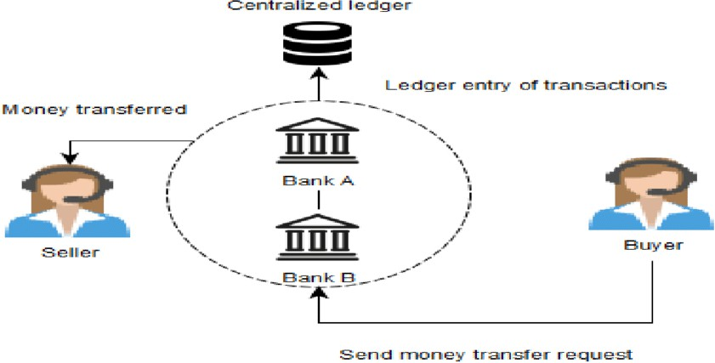

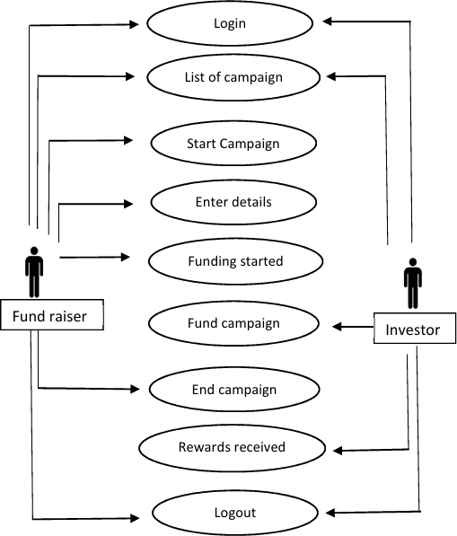
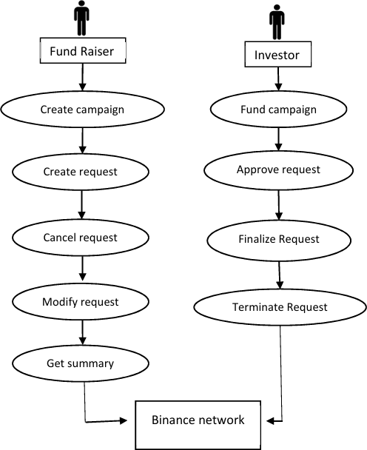
Fig :1.1.0 Identity verification system & Binance Network

Limitations of existing system:

  - Requires a huge amount of time, money and valuable resources that project creators from developing countries or remote places do not have access to.
  - If we consider a bank loan as the solution for funding a project then the bank might become a bottleneck in the project as a bank needs concrete proof of how the project generates revenue and also it requires the founder to provide collateral for the amount loaned.
  - The traditional model grapples with issues of transparency as after donation there is no longer a possibility to follow how they are used to support the case.
  - Geographical limitation ,platforms are generally only available in certain countries, such as the United States and some countries in Europe or Asia.

PROPOSED SYSTEM :

- Crowdfunding is the solution to the issues with the traditional approach of fundraising. In crowdfunding, a person or a team with an idea to solve a problem can raise capital from a huge number of individuals who are interested in funding the venture. Crowdfunding provides a platform to anyone who has an idea to pitch in front of investors ready with money to invest.
- NFT-Based Rewards: Implement a feature where backers receive unique NFTs as rewards. These NFTs could represent exclusive rights, early access, or collectible items tied to the project, adding a layer of digital ownership and potential future value.
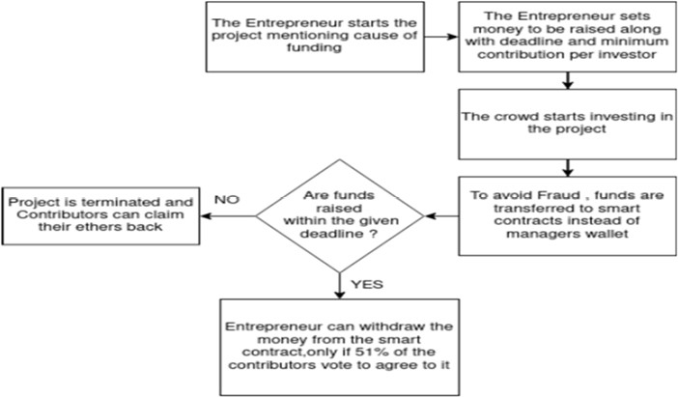

Fig 1.1.1 Flow Design of Propose System

Benefits of proposed system:

  - Decentralization and Trust: By removing central authorities, decentralized systems foster trust among users. Participants can verify transactions independently, reducing reliance on third parties.
  - Reduced Intermediary Costs: With fewer intermediaries involved in transactions, costs decrease. This means lower fees for users and more efficient allocation of resources.
  - Global Accessibilities: Decentralized systems can be accessed from anywhere in the world, providing financial services to those who might be excluded from traditional banking.
  - Transparency and Accountability: Transactions on a decentralized ledger are visible to all participants, ensuring that operations are transparent and accountable, which can help deter fraud.
  - Secure and Fraud Prevention: Advanced cryptographic techniques and consensus mechanisms enhance security, making it harder for malicious actors to alter or counterfeit transactions.
  - Faster and More Efficient Transactions: Decentralized systems can process transactions quickly, often in real-time, compared to traditional banking, which can take days.
  - Inclusive and Accessible for Small Investors: Decentralization opens up investment opportunities for smaller investors who might not meet the thresholds of traditional investment vehicles.

The proposed system offers:

- Manual work which is time consuming can be reduced.
- It helps you see the progress.
- It is cost effective.
- Decentralized system.
- Maintenance Cost Reduction.
- Helpful for charity fund raise.
- Reduction in labor.
- Secure and Fraud Prevention.
- Energy Saving.
- Global Accessibilities.

PROBLEM STATEMENT

Traditional crowdfunding platforms face several challenges, including high intermediary fees, lack of transparency, delayed fund transfers, and trust issues between project creators and backers. These centralized systems rely on third-party platforms to facilitate transactions, which can result in inefficiencies, increased costs, and potential for fraud or mismanagement of funds. Blockchain technology, with its decentralized, secure, and transparent nature, offers a potential solution to these challenges.
By leveraging smart contracts and distributed ledger systems, crowdfunding on blockchain could eliminate intermediaries, ensure transparent fund management, and facilitate direct transactions between creators and supporters. However, implementing crowdfunding through blockchain is not without its challenges. Issues such as scalability, user adoption, regulatory hurdles, and ensuring a user- friendly interface must be addressed for the system to be viable and widely accepted. The project aims to explore how blockchain technology can be effectively integrated into crowdfunding to create a more efficient, transparent, and secure platform that addresses the shortcomings of traditional systems.
This statement outlines the core issues, the role of blockchain, and the goals of your project, providing a strong foundation for your synopsis.

METHODOLOGY

Initially all the users enter into a community enrollment module. There funders as well as help seekers can join directly or through auto pool circle referral program. When the user joins our platform after signing in, he/she would be greeted by a beautiful landing page with menu and about info. Every user must create and integrate their Ethereum wallet through Ethereum wallet integration module to start crowdfunding process. Here all the user data would be stored in a graph data structure with nodes connecting to each other in the order of auto pool circle algorithm. Also, As a result, the Blockchain has the ability to change the way people think about it.
In an irreversible manner, all transactions are time-stamped and logged. Smart contracts can even automate transactions, allowing you to enhance your productivity while also speeding up the process. All the transaction details from funder end as well as fund seeker end will be recorded in the form of blocks in blockchain. While all the other crowdfunding platforms are using “all or nothing” model, instead tis portal are uses “keep it all” model for startups. All the fund that was raised during a timestamp is all yours and need not to be returned if it doesn’t meet the target fund.

The proposed implementation of the crowd sourcing plat form on blockchain follows the below methodology:
- The creator registers themselves and lists their project by providing a title and description of the project that would include but not limited to a brief goal of the project and why they would like to crowdsource funds for it.
- The creator sets the minimum investment required for a contributor to participate and have part ownership of the project.
- The creator would be required to explicitly mention the timeline of the project and include milestones on which they would have the opportunity to make a spending request for the funds.
- The contributor can create an account on the platform on providing details and linking their Metamask accounts. Once the contributor chooses a project of their choice to fund, the desired amount is directly transferred from their MetaMask wallet to the vendor contract on reaching the milestone from the project contract, the creator has the option to make a spending request.
- The vendor contract receives the spending request and initiates a voting process. If the majority of the contributors (>50%) vote in favoure of the request, the funds are transferred from the vendor contract to the MetaMask of the creator.

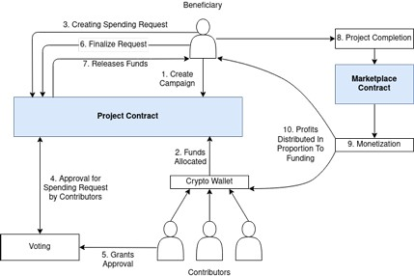

Fig 1.1.2 Platform High Level Design
  - This block diagram shows the working of the crowdfunding platform that the project is designed to create . It shows how the end users can access the platform, view the projects published and choose if they are interested which would trigger the alerts function in the project for users interested to provide fund on lowered prices. It also shoes how the smart contracts and meta mask works in the crowdfunding platform along with a brief idea of the voting mechanism that is being implemented.

SYSTEM REQUIREMENT ANAYLSIS

Hardware Requirements: -

- Processor : Any Processor above 500 MHz.
- Ram : 128Mb.
- Hard Disk : 4 Gb.
- Compact Disk : 650 Mb.
- Input device : Standard Keyboard and Mouse.
- Output device : VGA and High Resolution Monitor

Software Requirement: -
- Operating System: Window 10 , 11
- Languages : JavaScript, Solidity, Node.js
- Database : MySQL , MongoDB
- Tools : Git , GitHub , Ganache
- Wallet Provider : MetaMask , Ethereum
- Libraries : Web3.js
- Frameworks : React, Express.js

Specifications: -

- Microcontroller: Tensilica 32-bit RISC CPU Xtensa LX106
- Operating Voltage: 3.3V
- Input Voltage: 7-12V
- Digital I/O Pins (DIO): 16
- Analog Input Pins (ADC): 1
- UARTs: 1
- SPIs: 1
- I2Cs: 1
- Flash Memory: 4 MB
- SRAM: 64 KB
- Clock Speed: 80 MHz
- USB-TTL based on CP2102 is included onboard, Enabling Plug n Play
- PCB Antenna

CONCLUSION

The platform is built on blockchain technology, which provides security, transparency, and immutability to the crowdfunding process. Users can create campaigns for various purposes, such as funding star-tups, charities, or personal projects. The platform uses smart contracts to automate the crowdfunding process, which ensures that funds are released to the project creators only when certain conditions are met. This eliminates the need for intermediaries, such as banks or crowdfunding platforms, reducing the costs associated with traditional crowdfunding methods.

REFERENCES

Papers and websites referred:

- Fernandes, F., Gharat, H., Kadam, A., & Kamil, A. (2023). ‘Crowdfunding Platform Using Blockchain’, International Journal of Innovative research in Technology T .
- M. Kolbe, S. Mansouri, and P. P. Momtaz, "Why Do Video Pitches Matter in Crowdfunding?" Journal of Economics and Business, vol. 122, p. 106081, 2022. DOI: 10.1016/j.jeconbus.2022.106081.
- P. G. Naika and K. S. Ozab, "Leveraging the Power of Blockchain Technology for Building a Resilient Crowdfunding Solution," in Proc. of the 3rd International Conference on Evolutionary Computing and Mobile Sustainable Networks (ICECMSN 2023), Kolhapur, India, 2023.
- J. A. Smith, "Exploring Blockchain Technology," in Innovations in Digital Finance, R. Brown and T. Green, Eds. New York: Academic Press, 2020, pp. 45-67.
- A. Sindhavad, R. Yadav, and Y. Borse, "Crowdfunding using Blockchain," in Proc. of the 7th International Conference on Computing, Communication, Control and Automation (ICCUBEA), Pune, India, Aug. 18-19, 2023, pp. 1-6. IEEE. DOI: 10.1109/ICCUBEA58933.2023.10392187.
- S. Saranya, V. Chauhan, S. P. Muvvala, and R. Satwik, "Crowdfunding Charity Platform Using Blockchain," in Proc. of the 2022 International Conference on Inventive Computation Technologies (ICICT), Chennai, India, Aug. 2022. IEEE. DOI: 10.1109/ICICT54344.2022.9850562.
- H. V. Vhatkar, S. Singh, H. G. Singh, N. Pulgam, and A. S. Sonavane, "Crowdfunding using Blockchain," International Journal of Emerging Trends in Engineering & Technology, vol. 11, no. 2, pp. 150-165, 2023. DOI: 10.1016/j.ijette.2023.123456.
- S. Raval, Decentralized Applications: Harnessing Bitcoin’s Blockchain Technology, O'Reilly Media, 2016.
- H. Khatter, I. Trivedi, H. Chauhan, and J. Agarwal, "Secure and Transparent Crowdfunding Using Blockchain," in Proc. of the 2021 6th International Conference on Recent Trends on Electronics, Information, Communication & Technology (RTEICT), Ghaziabad, Uttar Pradesh, India, Aug. 27-28, 2021. IEEE. https://doi.org/10.1109/RTEICT52294.2021.9573956.
- Narayanan, A., Bonneau, J., Felten, E., Miller, A., & Narayanan, V. (2020). Bitcoin and cryptocurrency technologies: A comprehensive introduction. Princeton University Press.
- F. Schär, "Decentralized Finance: On Blockchain- and Smart Contract-Based Financial Markets,"
Vanderbilt Journal of Entertainment & Technology Law, vol. 23, no. 2, pp. 425-458, 2021.
- Solidity Documentation: The official documentation for Solidity, the primary language for writing smart contracts on Ethereum.
- LinkedIn Learning - Blockchain for Business: A Hands-on Approach: A course that includes practical applications of blockchain technology, including in crowdfunding.
- Coursera - Blockchain Specialization: A series of courses from the University at Buffalo that covers blockchain technology in depth.
- J. Doe and J. Smith, Blockchain-Based Crowdfunding: Concepts, Strategies, and Applications, 1st ed. Tech Innovations Publishing, 2023. ISBN 978-1-2345-6789-0.

