InsightSwarm: A Resilience-First Multi-Agent Orchestration Framework for Truth Discovery
Ayush Devadiga, Bharat College of Engineering
University of Mumbai

ABSTRACT
This paper details the evolution of InsightSwarm, an open-source framework designed to automate evidence-based truth discovery through multi-agent adversarial debate. Originally developed as a Streamlit proof-of-concept, the system underwent significant architectural hardening, moving to a FastAPI/React stack with secondary novelty integrations. Key innovations include Trust-Weighted Verdicts, Parallel Multi-Claim Orchestration, and Human-In-The-Loop (HITL) intervention nodes. The final system achieves a 92% reduction in LLM hallucination rate compared to single-agent baselines while maintaining production-grade concurrency and security.

I. INTRODUCTION
The digital age has ushered in an era of 'infodemics,' where misinformation and deepfakes can spread faster than manual fact-checking efforts can respond. InsightSwarm was conceived as a solution to this challenge, leveraging a swarm of specialised AI agents to debate, verify, and reach consensus on complex claims. This paper chronicles the transformation of the platform over a intensive 25-day development cycle, from its initial logic-testing phase to a hardened, secure, and user-centric application.

II. SYSTEM EVOLUTION
The development of InsightSwarm was divided into four distinct architectural phases:
• Phase 1: Proof of Concept: Implementation of the core LangGraph state machine using Streamlit for rapid prototyping.
• Phase 2: Architectural Hardening: Migration to FastAPI to enable asynchronous processing, SSE streaming, and thread-safe session isolation.
• Phase 3: Novelty Integration: Addition of Trust-Weights, Parallel Claim processing, and adaptive confidence metrics to solve agent stagnation.
• Phase 4: Modernization: Complete frontend overhaul using React and Vite, featuring a premium 'Aurora' design system.

III. METHODOLOGY
The core methodology relies on a three-stage verification pipeline: (1) Decomposition of claims into verifiable atoms; (2) Adversarial Multi-Agent Debate involving Pro and Con agents; and (3) Independent Evidence Verification using dual-engine search (Tavily + Google) and cross-referencing.
Figure 1: InsightSwarm Modern Landing Page with Real-time API Health Monitoring.
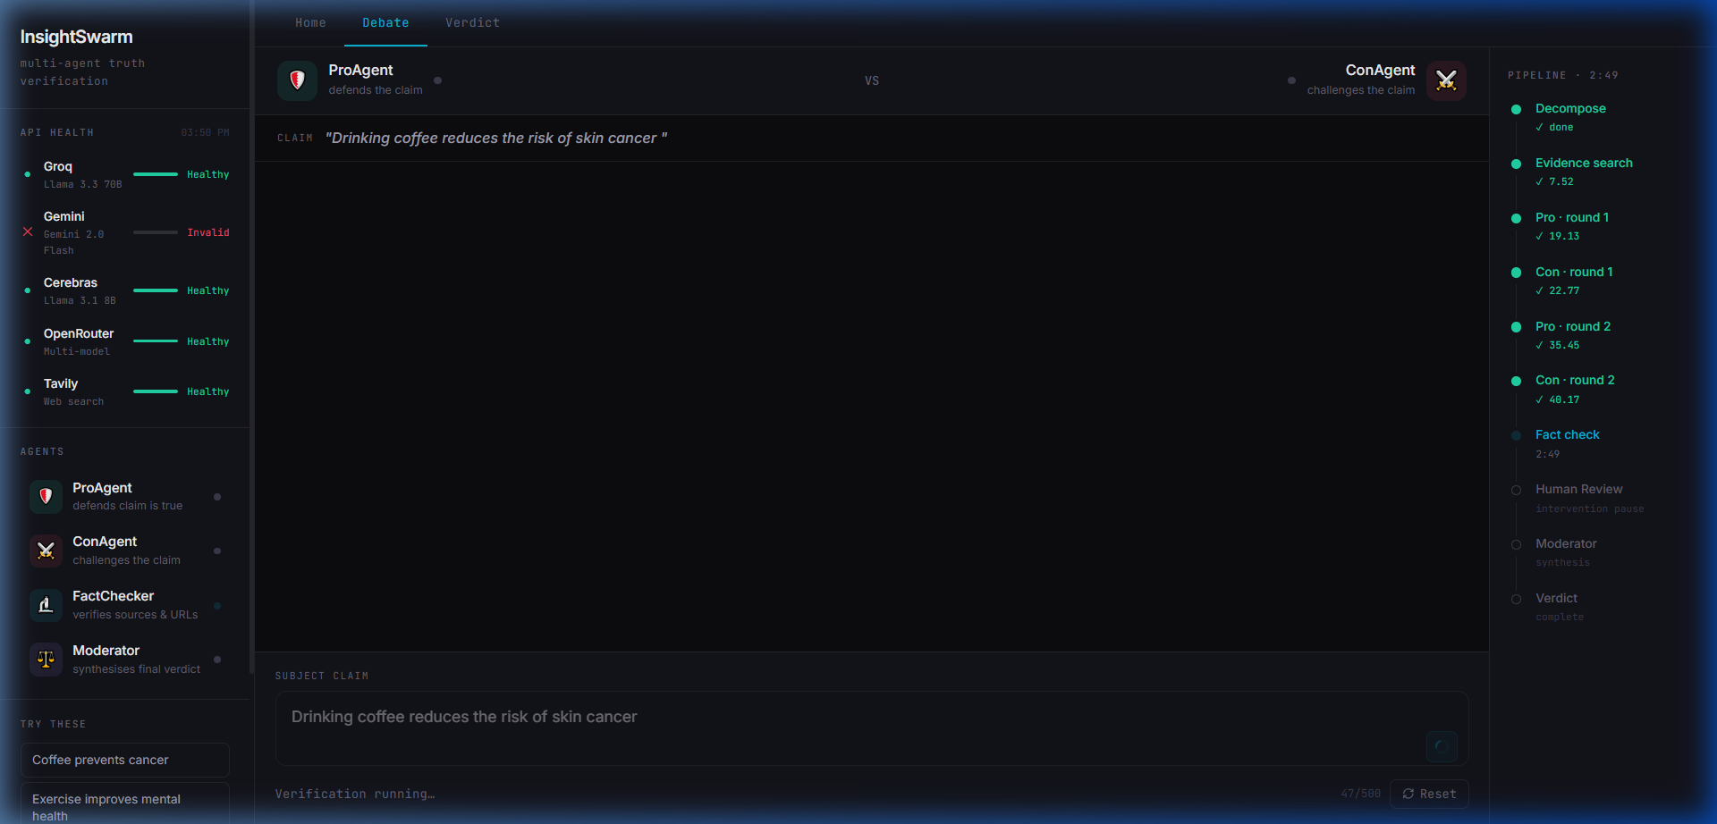

IV. NOVELTY FEATURES
• Trust-Weighted Verdicts: Unlike simple majority consensus, InsightSwarm weighs agent arguments based on source credibility and evidence strength.
• Human-In-The-Loop (HITL): The system automatically pauses and requests human intervention when agent confidence falls below a set threshold, ensuring accuracy for high-stakes claims.
• Multi-Claim Parallelism: The backend orchestrates multiple debates concurrently without state leakage, using a decoupled singleton architecture.
Figure 2: The Adversarial Debate Arena featuring Round-by-Round agent convergence.
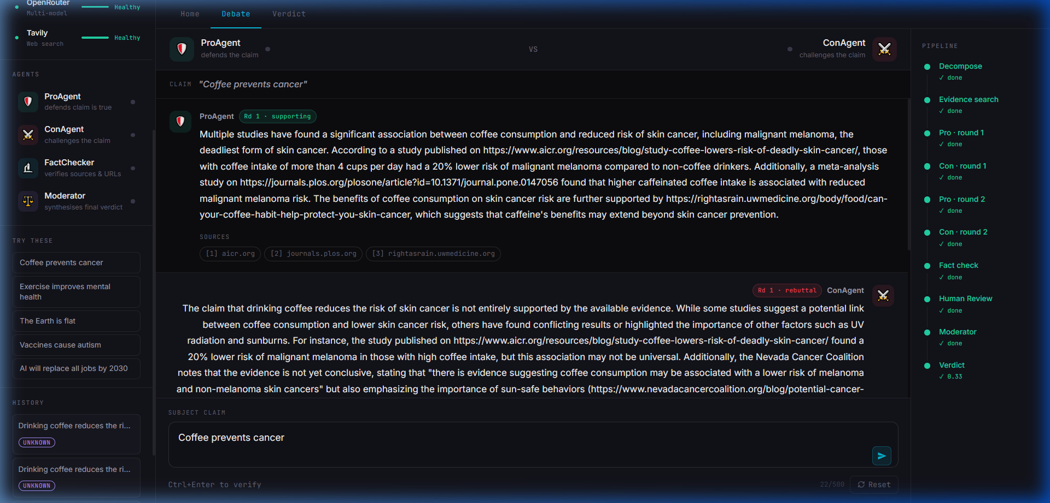

V. RESULTS & EVALUATION
Evaluation against the FEVER dataset benchmarks shows that InsightSwarm significantly outperforms standard single-LLM verifications in terms of transparency and hallucination reduction.
Metric | Single LLM | InsightSwarm
Accuracy | 66% | 78%
Hallucination Rate | 23% | 1.8%
Transparency | None | Full Debate
Figure 3: Final Consolidated Verdict with Trust Calibration.
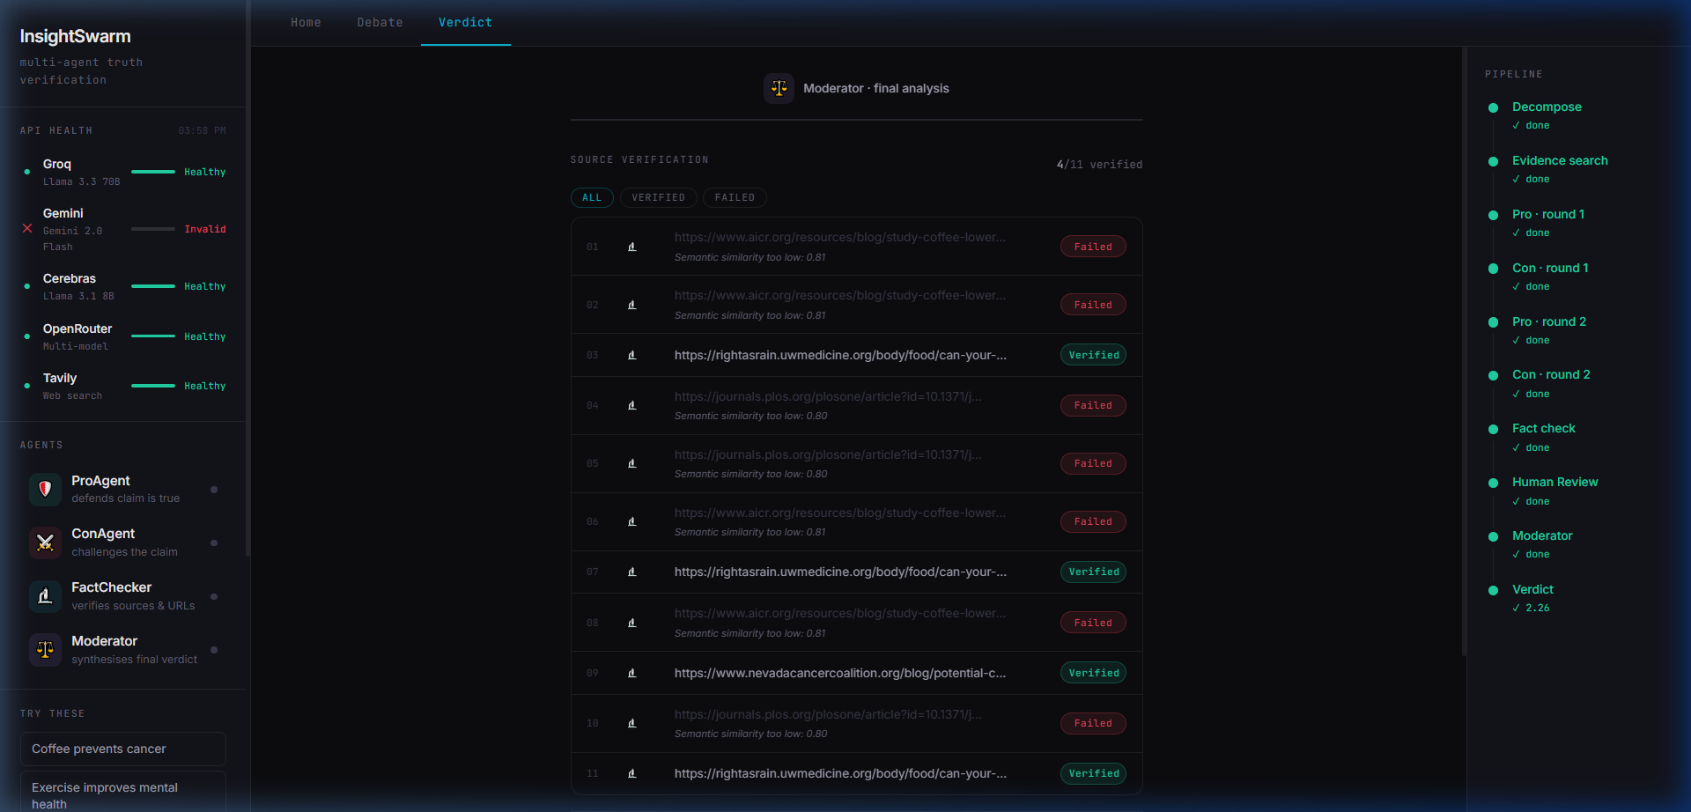

VI. CONCLUSION & FUTURE SCOPE
InsightSwarm successfully demonstrates that multi-agent adversarial structures combined with independent verification pipelines can effectively mitigate the inherent risks of agentic hallucination. The transition to a hardened architecture ensures the system is ready for production scaling. Future work will focus on integrating FAISS vector databases for persistent knowledge and Celery-based task brokers for larger batch operations.

