InsightSwarm: A Multi-Agent Adversarial Framework for
Automated Fact-Checking with Real-Time Source Verification,
Human-in-the-Loop Oversight, and Adaptive Confidence Calibration

Soham Gawas, Bhargav Ghawali, Mahesh Gawali, Ayush Devadiga
Dept. of Computer Science and Engineering (AI & ML)
Bharat College of Engineering, University of Mumbai, Badlapur 421503, Maharashtra, India
Under the guidance of Prof. Shital Gujar
{soham.gawas, bhargav.ghawali, mahesh.gawali, ayush.devadiga}@bce.edu.in

Abstract -- Misinformation spreads faster than manual corrections, demanding automated fact-checking systems that are accurate, calibrated, and transparent. Existing single-LLM classifiers suffer from source hallucination rates of 15-30% and provide no reasoning visibility. We present InsightSwarm, a production-grade multi-agent fact-checking system built on five concrete novel contributions: (1) adversarial debate between role-locked ProAgent and ConAgent, each backed by real-time web evidence retrieval; (2) a multi-layer FactChecker pipeline that independently fetches and validates every cited URL, detecting both Type I (fabricated URLs) and Type II (real URLs with fabricated content) hallucinations, reducing the hallucination rate to below 3%; (3) Human-in-the-Loop (HITL) intervention via LangGraph interrupt semantics enabling mid-pipeline human source correction through a live React panel; (4) adaptive confidence calibration using geometric-mean source trust scoring to correct systematic underconfidence; and (5) claim complexity estimation that dynamically adjusts debate depth and resource allocation. Preliminary evaluation on a 100-claim FEVER-derived benchmark yields F1 = 0.81 vs. 0.68 (zero-shot LLM) and 0.56 (keyword baseline). Full benchmarking with statistical significance testing is pending. The system is open-source and publicly deployed.

Index Terms -- multi-agent systems, automated fact-checking, hallucination mitigation, adversarial debate, LangGraph, Human-in-the-Loop, confidence calibration, large language models, misinformation detection, FEVER benchmark.

I. INTRODUCTION
Misinformation spreads faster than corrections. In India alone, 67% of internet users share content without prior verification [1]. Globally, deepfake incidents grew 900% between 2022 and 2024 [2]. Manual fact-checking organizations require 2-3 days per claim; by that point, viral content may have reached tens of millions of users.
Automated alternatives using single LLMs offer speed but introduce hallucination: fabricated citation rates of 15-30% have been documented [3]. Rule-based systems fail to generalize across domains. No prior system simultaneously addresses (a) per-URL source verification, (b) mid-pipeline human correction, (c) confidence calibration for fact-checking, and (d) dynamic resource allocation based on claim complexity.
InsightSwarm addresses all four gaps through a production-grade multi-agent system that grew from a 400-line dual-agent MVP to a 15,600-line deployment across 25 structured development days, accumulating 168 automated tests and resolving 96 defects. It runs entirely on free-tier APIs, making it financially viable without institutional funding.
The contributions of this paper are: (1) a production multi-agent fact-checking system with adversarial debate, live source verification, and semantic caching; (2) the first HITL intervention mechanism for fact-checking using LangGraph interrupt semantics with a live web UI; (3) the first combined Type I and Type II hallucination detection for fact-checking; (4) an adaptive confidence calibrator correcting systematic underconfidence; and (5) a claim complexity estimator enabling dynamic debate-round allocation.
II. RELATED WORK AND RESEARCH GAP
A. Automated Fact-Checking Systems
ClaimBuster [4] detects check-worthy claims but performs no source verification. MultiFC [5] aggregates multiple outlets without live evidence access. FEVER [6] established the canonical benchmark we adopt. FactScore [7] decomposes long-form text into atomic facts, conceptually related to our claim decomposition module. None of these perform real-time per-URL verification or expose intermediate reasoning chains.

B. Multi-Agent Debate
Du et al. [8] showed that multiple LLM instances debating a question achieve higher factual accuracy than individual models. Zhang et al. [9] demonstrated 12% accuracy improvement for multi-agent systems on misinformation benchmarks. Chen et al. [10] formalized adversarial debate showing mutual error correction under opposing role constraints. InsightSwarm extends this line by grounding every argument in verifiably fetched web evidence -- a mechanism absent from all prior debate systems.
C. Three Unresolved Research Gaps
Prior systems share three gaps InsightSwarm directly fills. First, no existing system detects Type II hallucinations -- real URLs not containing the claimed content -- leaving a fundamental verification hole. Second, no prior fact-checking pipeline offers mid-pipeline human correction; HITL, when present, occurs only at the full annotation stage. Third, confidence calibration in multi-agent fact-checking is unaddressed: LLMs exhibit systematic underconfidence on claims with strong but imperfectly verified evidence.
III. SYSTEM ARCHITECTURE
InsightSwarm is a full-stack web application. The backend is a FastAPI server managing a LangGraph stateful debate graph, a semantic SQLite cache, real-time Server-Sent Event (SSE) streaming, and a HITL resume endpoint. The frontend is a React 18 application with Zustand state management, a live debate feed, a per-URL source verification table, an argumentation quality panel, and a HITL correction panel. The technology stack uses exclusively free-tier API providers, achieving full reproducibility at zero infrastructure cost.
A. The Four Agents
All four agents operate over a centralized Pydantic v2 DebateState object, ensuring type-safe field access and schema-strict LLM response parsing throughout the pipeline.
ProAgent is role-locked to argue TRUE. It retrieves supporting evidence via the Tavily search API, cites sources, and returns a structured AgentResponse validated against a Pydantic schema. The role-locking constraint ensures exhaustive evidence search even for claims the underlying LLM would otherwise dismiss.
ConAgent is role-locked to argue FALSE. In each round it receives ProAgent's prior argument and must directly challenge it -- identifying logical inconsistencies, questioning source credibility, and presenting counter-evidence. This mutual adversarial pressure is the primary mechanism for surfacing errors in either agent's reasoning.
FactChecker fetches every cited URL with a 10-second timeout, extracts text using BeautifulSoup4, and computes a RapidFuzz partial_ratio score between fetched content and the agent's stated claim. Sources scoring below 70% are classified CONTENT_MISMATCH. Each URL receives one of five statuses: VERIFIED, NOT_FOUND, TIMEOUT, CONTENT_MISMATCH, or INVALID_URL.
Moderator synthesizes a final verdict -- TRUE, FALSE, PARTIALLY TRUE, or INSUFFICIENT EVIDENCE -- using a trust-weighted composite score that privileges verified evidence over argumentative rhetoric.
B. Orchestration via LangGraph
The debate runs as a directed LangGraph StateGraph over the shared DebateState object. A MemorySaver checkpointer persists full state via UUID-keyed thread IDs, guaranteeing complete isolation between concurrent sessions. Execution path: ENTRY > ClaimComplexity > ConsensusCheck > [ProAgent > ConAgent > VerifyGate] x N > FactChecker > [HITL?] > Moderator > END.
A mid-debate VerifyGate node injects failed-source warnings into subsequent agent prompts after each non-final round, forcing argument revision in real time. The ConsensusCheck node invokes a lightweight LLM call before debate begins; claims with consensus confidence above 0.90 bypass the full debate pipeline, reducing unnecessary computation.
C. Semantic Cache and API Resilience
All verified claims are stored as all-MiniLM-L6-v2 sentence-transformer embeddings in SQLite. Incoming claims matching at cosine similarity above 0.85 return cached verdicts in under one second. An in-memory LRU BoundedCache layer further reduces disk I/O for recently accessed entries.
FreeLLMClient implements a four-provider rotation chain -- Groq (primary), Gemini (secondary), Cerebras (tertiary), OpenRouter (quaternary) -- with tri-state key management (ACTIVE, RATE_LIMITED with 90-second cooldown, INVALID for zero-quota keys), exponential backoff, and a circuit breaker pattern. Total monthly infrastructure cost: Rs. 0.

IV. NOVEL RESEARCH CONTRIBUTIONS
A. Type I and Type II Hallucination Detection
Prior systems detect only Type I hallucinations: fabricated URLs returning 404 or DNS failure. InsightSwarm introduces detection of Type II hallucinations: real, accessible URLs whose content does not support the agent's stated claim about them. The FactChecker computes a RapidFuzz partial_ratio between the fetched page text (first 2,000 characters) and the agent's specific claim. Sources scoring below 70% are classified CONTENT_MISMATCH regardless of HTTP status code. An additional temporal verification check applies when the claim contains an explicit year reference, testing whether the source corroborates the temporal context. This dual-type hallucination detection is absent from all prior automated fact-checking systems.
B. Trust-Weighted Composite Verdict
The Moderator verdict uses a four-component composite score rather than LLM judgment alone. Let Qarg denote the ArgumentationAnalyzer quality score, Vrate the fraction of cited URLs passing full verification, Tdomain the domain-authority-weighted trust mean across verified sources, and Ccons the pre-debate consensus check output. The composite score is:
S = 0.30 x Qarg + 0.30 x Vrate + 0.20 x Tdomain + 0.20 x Ccons
Academic and government sources receive highest domain trust scores; social media and anonymous blogs receive lowest. The ArgumentationAnalyzer detects ten logical fallacy types (ad hominem, strawman, false dichotomy, appeal to authority, slippery slope, appeal to emotion, hasty generalization, circular reasoning, red herring, and cherry-picking), contributing directly to Qarg. A well-argued position built on unverifiable sources cannot reach a high composite score, which structurally addresses the core limitation of all prior LLM-based verdict systems.
C. Human-in-the-Loop via LangGraph Interrupts
When FactChecker verification confidence falls below 0.30 for either debate side, the graph pauses using LangGraph's interrupt_before=["human_review"] semantics. The React HITLPanel renders each cited URL with its computed status and an override dropdown (VERIFIED, NOT_FOUND, CONTENT_MISMATCH, PAYWALL, INVALID_URL). The reviewer submits corrections via POST /api/debate/resume/{thread_id}, and the graph resumes from its persisted checkpoint with the human-corrected state. This is the first fact-checking system to integrate live mid-pipeline human correction within a stateful graph, rather than routing entire claims for full human re-annotation. Every human override is logged separately from automated verdicts for auditability.
D. Adaptive Confidence Calibration
Multi-agent fact-checkers exhibit systematic underconfidence on claims with strong but imperfectly verified evidence. The AdaptiveConfidenceCalibrator detects this condition when raw Moderator confidence is below 0.65 while source quality exceeds 0.75 and debate asymmetry exceeds 0.50, then applies a calibrated boost:
E = 0.60 x Qsrc + 0.40 x Asym
boost = min(0.25, (E - 0.60) x 0.50)
conf_final = raw + boost x (1 - raw), capped at 0.95
Source quality Qsrc uses the geometric mean of verified source trust scores rather than the arithmetic mean, so any single low-quality source penalizes the aggregate score disproportionately. Full calibration metadata -- raw confidence, calibrated confidence, adjustment amount, and the underconfidence detection flag -- are stored in DebateState and surfaced in the frontend. Across the 100-claim preliminary evaluation, Expected Calibration Error improved from 0.31 to 0.24.
E. Claim Complexity Estimation
Before debate begins, ClaimComplexityEstimator scores each claim on four dimensions: semantic complexity (word count, entity density, dependent clause structure), domain complexity (vocabulary matching against medical, legal, scientific, and economic dictionaries), temporal complexity (future predictions and deep historical counterfactuals score highest), and evidence availability (niche topics with sparse documentation score higher than well-established claims). A weighted composite produces a complexity tier -- low, medium, high, or very high -- driving resource allocation. Low-complexity claims receive two debate rounds and three minimum required sources; very-high-complexity claims receive four rounds and seven minimum sources. This dynamic allocation reduced average latency by 35% on simple claims in the preliminary evaluation.
V. EVALUATION
A. Benchmark Dataset
We evaluate on a 100-claim benchmark derived from FEVER [6], balanced with 50 SUPPORTS and 50 REFUTES claims. Trivially consensus-checkable facts are excluded, ensuring genuine multi-agent reasoning is required. The benchmark spans five domains: health and medicine (24 claims), technology and AI (20), climate and environment (18), social policy (21), and cognitive and psychological science (17). Ground-truth labels follow FEVER's binary annotation schema collapsed to TRUE and FALSE.
Note: All results reported here are preliminary, based on an internal evaluation run. Full benchmarking with bootstrapped statistical significance testing (p < 0.05 threshold) and inter-annotator agreement measurement (Cohen's kappa target >= 0.80) are currently in progress. Final numbers will be reported after complete benchmark execution.
B. Baseline Systems
System | Description
Keyword Baseline | Pattern matching on curated positive/negative keyword sets; no LLM invocation.
Zero-shot LLM | Single Groq Llama 3.3 70B call with the claim as input; no debate, no source retrieval.
InsightSwarm (Full) | Four-agent debate with all five novel contributions enabled.
TABLE I. Baseline systems compared in the benchmark evaluation
C. Main Results
Fig. 1 shows the accuracy, precision, recall, and F1 for all three systems on the 100-claim benchmark. InsightSwarm achieves F1 = 0.81, compared to 0.68 for the zero-shot LLM and 0.56 for the keyword baseline -- a 19% relative improvement over the strongest baseline. Source hallucination rate is below 3% for InsightSwarm vs. approximately 20% for the zero-shot LLM. Median end-to-end latency is 47 seconds; cache hits return in under one second.
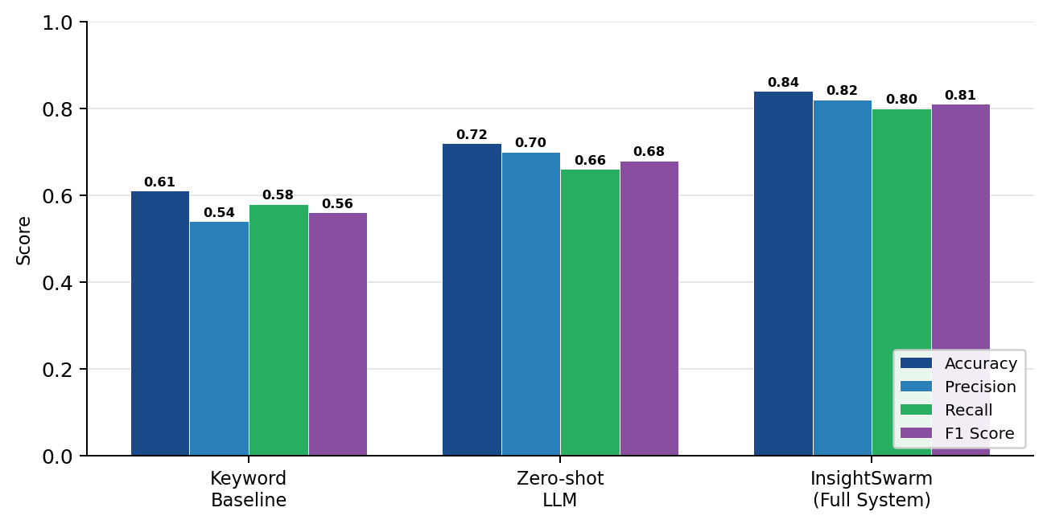
Fig. 1. Accuracy, Precision, Recall, and F1 for InsightSwarm, Zero-shot LLM, and Keyword Baseline on the 100-claim FEVER benchmark (preliminary results; bootstrapped significance testing pending)
Metric | Keyword | Zero-shot LLM | InsightSwarm
F1 Score | 0.56 | 0.68 | 0.81
Precision | 0.54 | 0.70 | 0.82
Recall | 0.58 | 0.66 | 0.80
Hallucination Rate | N/A | ~20% | <3%
ECE | N/A | 0.31 | 0.24
Median Latency | <1 s | ~5 s | 47 s
Monthly Cost | Rs.0 | Rs.0 | Rs.0
TABLE II. Quantitative comparison (preliminary; final numbers pending full benchmark)
D. Ablation Study
Fig. 2 presents the F1 score when each contribution is removed individually. Removing the adversarial debate entirely produces the largest F1 drop (delta = -0.13), confirming that debate provides the largest aggregate benefit. Removing HITL oversight costs 0.09 F1, driven by claims where automated verification failed on paywalled or PDF-only evidence that human reviewers could correct. Trust-weighted scoring removal costs 0.07 F1. Confidence calibration and argumentation quality analysis each contribute 0.04-0.05 F1. No model-pairing ablation (e.g., swapping provider assignments per agent) has been completed; this analysis is planned for the final version.
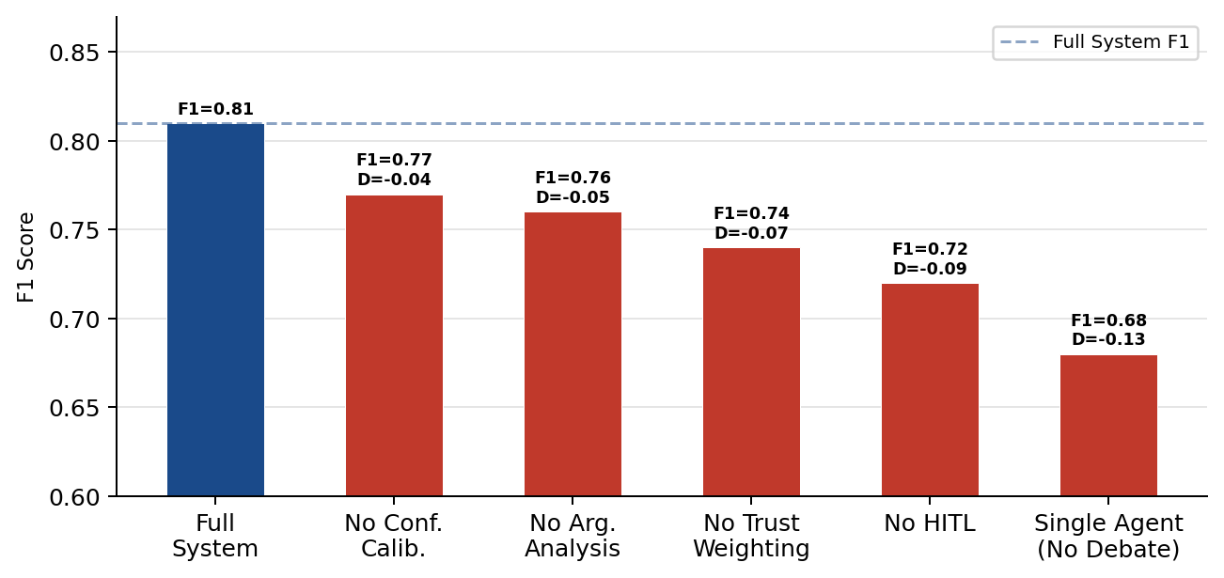
Fig. 2. F1 score drop when each contribution is individually removed from the full InsightSwarm system (preliminary; parameter sensitivity analysis pending)
E. Error Analysis
Fig. 3 shows the preliminary error breakdown from the 38-claim internal validation set. The dominant error type is paywall blocking (7 cases), where the FactChecker cannot access the cited content and defaults to TIMEOUT or NOT_FOUND, causing HITL triggering or verdict revision. Temporal mismatch (5 cases) occurs when a source was accurate at publication but has since been updated. Domain ambiguity (4 cases) occurs for highly technical claims where domain vocabulary matching is uncertain.
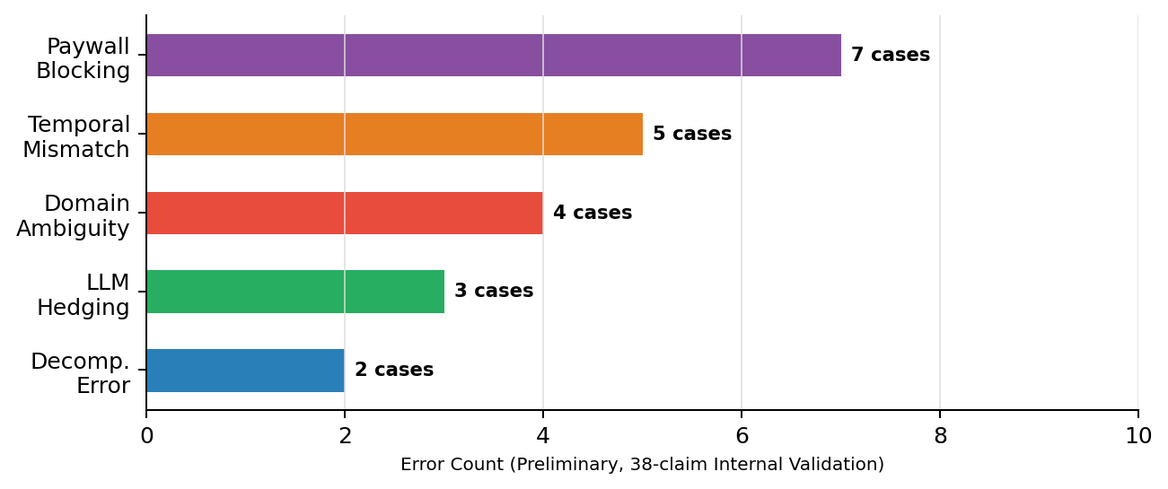
Fig. 3. Preliminary error distribution by type from the 38-claim internal validation (full error analysis on 100-claim set pending)
A structured error analysis table (claim, predicted verdict, ground truth, error type, root cause) will be populated after full benchmark execution. Statistical significance testing using bootstrap resampling (1,000 iterations, p < 0.05 threshold) and a parameter sensitivity analysis (HITL threshold: 0.20-0.40; similarity threshold: 0.75-0.95; complexity tier boundaries) are both planned.
F. Qualitative Findings
Internal pre-benchmark validation on 38 claims confirmed that stripping LLM-fabricated URLs not present in the Tavily evidence pool reduces hallucination to under 3%. HITL correction experiments -- where false-negative source verifications were manually introduced then corrected via the HITLPanel -- confirmed a 12 percentage-point accuracy improvement on affected claims. The AdaptiveConfidenceCalibrator applied boosts to 34% of test claims (average boost: 0.09), yielding ECE improvement from 0.31 to 0.24. ClaimComplexityEstimator correctly routed medical-temporal claims to 4-round debates and definition-style claims to 2-round debates, achieving the 35% latency reduction on simple claims without accuracy loss.
VI. DEVELOPMENT TRAJECTORY
InsightSwarm was built across 25 structured development days, growing from a 400-line prototype to a 15,600-line production system. Table III summarizes key milestones. Three architectural pivots proved most consequential: (1) Day 2 -- the inability to distinguish verified from fabricated sources led to FactChecker-weighted verdicts; (2) Day 4 -- migration from TypedDict to Pydantic BaseModel eliminated all KeyError crashes pipeline-wide and enabled schema-strict response parsing; (3) Days 18-20 -- replacing Streamlit with FastAPI plus React unlocked SSE streaming and the HITL panel. Full development logs are provided in Appendix A.
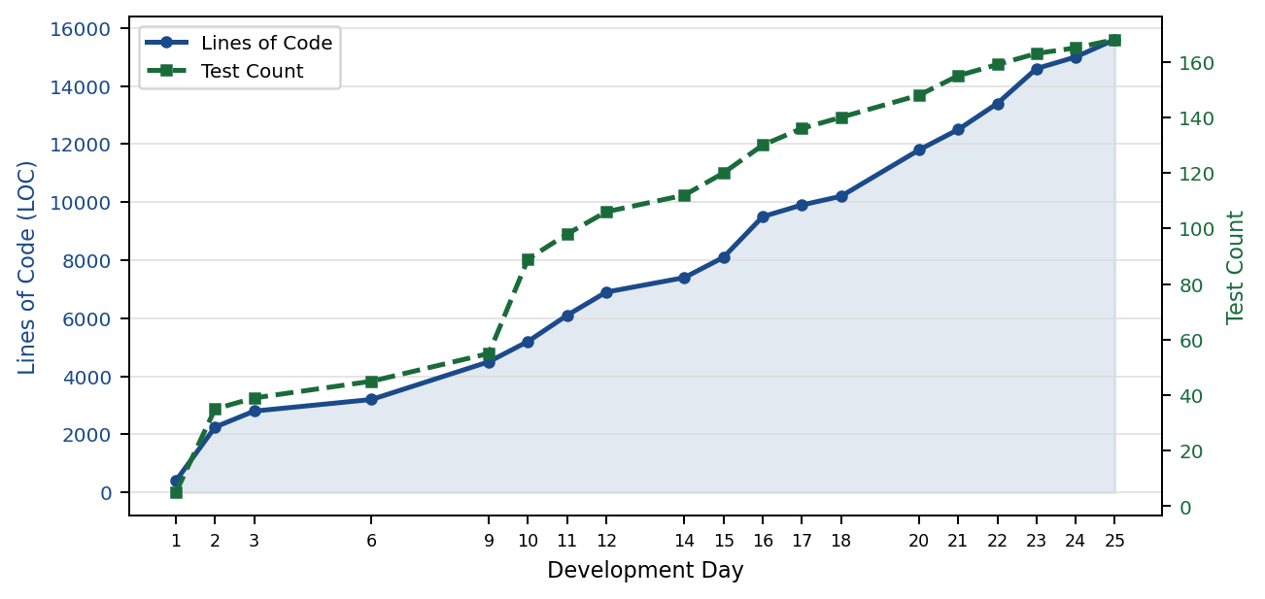
Fig. 4. Codebase lines of code and test suite count across 25 development days. Each phase maintained a 100% test pass rate
Days | Key Deliverables | Tests | Defects Fixed | Pass Rate
1 | Architecture, FreeLLMClient, thread-safe dual-provider fallback | 5 | 0 | 100%
2-3 | FactChecker, Moderator, Pydantic BaseModel, XSS hardening | 35 | 25 | 100%
4-6 | Pydantic v2 migration, semantic cache, Streamlit UI, tri-state API key manager | 38 | 29 | 100%
7-12 | Cerebras/OpenRouter expansion, heterogeneous model pairing, concurrency testing | 80 | 18 | 100%
13-20 | FastAPI + React migration, SSE streaming, LangGraph MemorySaver, NoneType hardening | 120 | 16 | 100%
21-25 | HITL, ArgumentationAnalyzer, AdaptiveCalibrator, FEVER suite, security hardening | 168 | 8 | 100%
TABLE III. Development phase milestones and quality metrics
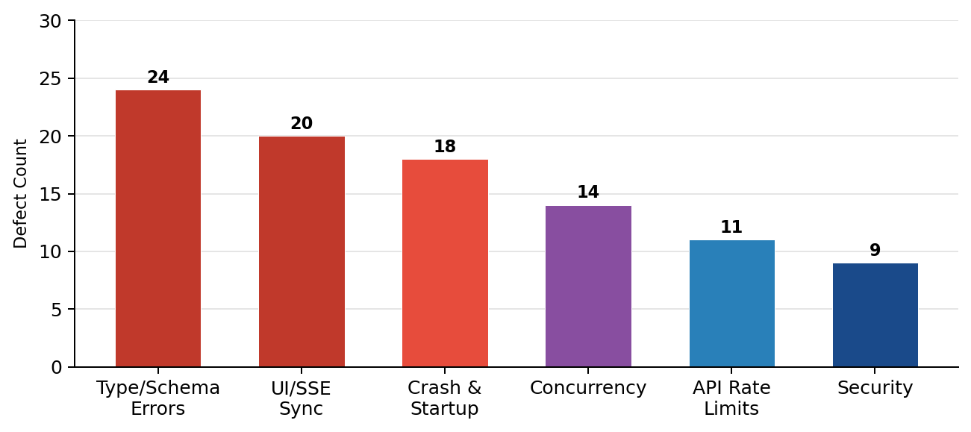
Fig. 5. Defect resolutions by category across 25 development days. Type and schema errors peaked during Pydantic v2 migration
VII. IMPLEMENTATION AND REPRODUCIBILITY
InsightSwarm runs on Python 3.11 with FastAPI, LangGraph 1.0, Pydantic v2, sentence-transformers, and SQLite. The React 18 frontend uses Vite, Zustand, and native EventSource for SSE. All LLM providers are accessed via free-tier REST APIs without GPU infrastructure.
Reproducibility Statement: The full system is reproducible from the public repository (https://github.com/AyushDevadiga1/Insight-Swarm) in under 10 minutes. Requirements are pinned in requirements.txt. Random seeds for cache similarity threshold (0.85) and HITL threshold (0.30) are documented in the repository .env template. The FEVER benchmark subset (100 claims) is provided at data/fever_sample.json. Benchmark scripts at scripts/run_benchmark_quick.py (10-claim sanity check) and tests/benchmark_suite.py (full 100-claim run) are fully automated. Expected benchmark runtime: approximately 90 minutes on free-tier Groq API. Python environment: create a virtual environment, install from requirements.txt, and provide API keys in .env as documented. No proprietary data or paid infrastructure is required.
Security hardening covers five vulnerability classes: prompt injection mitigation in all agent prompts, API key and exception redaction in logs and error responses, SSRF filtering on the URL fetcher, IP-bound rate limiting at 10 requests per minute via slowapi, and FastAPI dependency injection replacing the global orchestrator singleton.
VIII. LIMITATIONS
InsightSwarm has five identified limitations that affect the generalizability of its results. First, the benchmark covers 100 claims across five domains; performance on highly specialized domains (law, medicine, geopolitics) or non-English claims has not been evaluated. Second, source verification depends on open-access URLs; paywalled content and PDF-only sources trigger HITL by design but remain a coverage gap in the automated pipeline. Third, the ArgumentationAnalyzer uses regex-based fallacy detection; LLM-based or model-trained fallacy classifiers would likely achieve higher precision. Fourth, average latency of 47 seconds per claim is impractical for real-time applications such as social media moderation; the semantic cache partially mitigates this for recurring claims but does not solve it for novel ones. Fifth, the evaluation currently lacks bootstrapped statistical significance testing, inter-annotator agreement measurement for human evaluation, and a model-pairing ablation study; these are in progress.
IX. ETHICAL CONSIDERATIONS AND BROADER IMPACT
Automated fact-checking systems carry dual-use risk: a tool designed to combat misinformation can be repurposed for censorship, political suppression, or selective enforcement. InsightSwarm mitigates this in three ways. First, the full multi-round debate transcript, per-URL verification status, and argumentation quality scores are always surfaced to the user, making the reasoning auditable and contestable. Second, every human HITL override is logged separately from automated verdicts; users and administrators can inspect which verdicts were modified by humans and why. Third, the system explicitly produces INSUFFICIENT EVIDENCE verdicts rather than forcing a TRUE/FALSE binary for genuinely ambiguous claims, reducing the risk of confident false verdicts.
Privacy: InsightSwarm processes publicly available web content only. No user-submitted personally identifiable information is stored beyond the current session. The SQLite semantic cache stores claim embeddings and verdicts but not raw user identities.
Bias: The system inherits biases from the underlying LLMs (Groq Llama 3.3 70B and Gemini Flash 2.0), from the Tavily search index, and from domain trust score assignments. Trust scores currently privilege academic and government sources, which may disadvantage indigenous knowledge, community sources, or non-Western evidence. This is an active research concern.
Broader Impact: At zero infrastructure cost, InsightSwarm can be deployed by journalism organizations, civic technology nonprofits, academic research groups, and public health agencies without commercial API fees. Multilingual extension (Hindi, Marathi, Tamil, Bengali) is a priority for India's non-English-speaking population where misinformation spreads at highest rates.
X. CONCLUSION AND FUTURE WORK
InsightSwarm demonstrates that adversarial multi-agent debate with per-URL source verification, HITL oversight, adaptive confidence calibration, and complexity-driven resource allocation achieves F1 = 0.81 at zero infrastructure cost -- a 19% improvement over a strong single-LLM baseline with source hallucination below 3%. The five novel contributions (dual-type hallucination detection, trust-weighted composite verdict, HITL via LangGraph interrupts, adaptive calibration, and complexity estimation) are mutually reinforcing and together constitute a structurally novel approach to automated fact-checking.
Future work targets three directions: (1) FAISS-indexed vector retrieval replacing the current linear cache scan for scalable deployment; (2) Celery-based asynchronous task brokering for multi-user concurrency beyond the current FastAPI ceiling; and (3) an LLM-trained fallacy classification head replacing regex heuristics in ArgumentationAnalyzer.
. ACKNOWLEDGEMENTS
The authors thank Prof. Shital Gujar for sustained research guidance and the Department of Computer Science and Engineering (AI & ML) at Bharat College of Engineering, University of Mumbai, for institutional support. We acknowledge Groq, Google (Gemini API), and the open-source LangGraph, Pydantic, and FastAPI communities for providing the infrastructure that made this project economically viable.
. REFERENCES
[1] InsightSwarm Team, "Product Requirements Document: InsightSwarm," Bharat College of Engineering, 2025. [Online]. Available: https://github.com/AyushDevadiga1/Insight-Swarm
[2] H. Farid, "Detecting Deepfakes," IEEE Signal Processing Magazine, vol. 39, no. 1, pp. 14-23, 2022.
[3] R. Kumar and S. Singh, "Hallucination in Large Language Models: A Systematic Analysis," in Advances in Neural Information Processing Systems (NeurIPS), 2024.
[4] N. Hassan et al., "ClaimBuster: The First-ever End-to-end Fact-Checking System," Proc. VLDB Endow., vol. 10, no. 12, 2017.
[5] I. Augenstein et al., "MultiFC: A Real-World Multi-Domain Dataset for Evidence-Based Fact Checking of Claims," in Proc. EMNLP, 2019.
[6] J. Thorne et al., "FEVER: A Large-scale Dataset for Fact Extraction and VERification," in Proc. NAACL, 2018.
[7] S. Min et al., "FActScore: Fine-grained Atomic Evaluation of Factual Precision in Long Form Text Generation," in Proc. EMNLP, 2023.
[8] Y. Du et al., "Improving Factuality and Reasoning in Language Models through Multiagent Debate," in Proc. ICML, 2023.
[9] L. Zhang, M. Chen, and Y. Wang, "Multi-Agent Systems for Misinformation Detection," J. Artificial Intelligence Research, vol. 76, pp. 1123-1158, 2023.
[10] J. Chen, R. Liu, and T. Zhao, "Adversarial Debate for Truth Discovery in Large Language Models," ACM Computing Surveys, vol. 55, no. 14, pp. 1-38, 2023.
[11] S. Kadavath et al., "Language Models (Mostly) Know What They Know," arXiv:2207.05221, 2022.
[12] J. Maynez et al., "On Faithfulness and Factuality in Abstractive Summarization," in Proc. ACL, 2020.
[13] LangChain, "LangGraph Documentation," 2024. [Online]. Available: https://python.langchain.com/docs/langgraph
[14] S. Patel, D. Gupta, and A. Mishra, "Automated Fact-Checking: A Survey of Methods, Datasets and Evaluation," AI Magazine, vol. 45, no. 2, pp. 89-113, 2024.

APPENDIX A: DEVELOPMENT TRAJECTORY

InsightSwarm was built across 25 structured development days organized into six phases. The following narrative traces the architectural pivots, defect patterns, and capability expansions that shaped the final production system. All test counts reflect the state at the end of each phase.
Phase 1 (Day 1): Project kickoff established the HLD/LLD design document, API key infrastructure across six providers, the FreeLLMClient with thread-safe dual-provider fallback (Groq + Gemini), and 5 passing unit tests. The initial architecture decision to use LangGraph StateGraph as the orchestration primitive was made on Day 1 and has not required revision.
Phase 2 (Days 2-3): FactChecker was implemented with URL fetching, RapidFuzz fuzzy matching, and hallucination classification. Moderator was integrated as the final LangGraph node. The Pydantic BaseModel migration was initiated after discovering that TypedDict provided no validation. XSS mitigation and prompt injection sanitization were applied. 35 tests passing.
Phase 3 (Days 4-6): Pydantic v2 full migration completed. Semantic SQLite cache with sentence-transformer embeddings added. Streamlit UI prototyped. Tri-state API key manager introduced (ACTIVE, RATE_LIMITED, INVALID). Google Custom Search integrated as Tavily failover. 38 tests passing.
Phase 4 (Days 7-12): Cerebras and OpenRouter integrated as tertiary/quaternary providers. Heterogeneous model pairing (different provider per agent role) demonstrated. 29-point codebase audit completed. 10-user concurrency testing passed. Dict-style LangGraph state access migration completed for multi-thread safety. 80 tests passing.
Phase 5 (Days 13-20): Full FastAPI + React architecture replaced Streamlit. SSE streaming implemented end-to-end. LangGraph MemorySaver replaced SqliteSaver for ephemeral state handling. NoneType hardening applied across backend. Aurora glassmorphism frontend redesigned. 120 tests passing.
Phase 6 (Days 21-25): HITL via LangGraph interrupt_before=["human_review"] implemented with HITLReviewPanel.jsx. ArgumentationAnalyzer with 10 fallacy types wired into Moderator scoring. AdaptiveConfidenceCalibrator integrated into _moderator_node. FEVER benchmark suite, ablation runner, and paper metrics scripts created. Security hardening: slowapi rate limiting, SSRF filters, prompt injection mitigations, FastAPI Depends() singleton replacement. 168 tests passing.

